United States of America
Submission to the United Nations
INTERNATIONAL CONVENTION ON THE ELIMINATION OF ALL FORMS OF RACIAL DISCRIMINATION
85th Session of the Committee on the ICERD
Human Rights Council 13-14 August 2014 Geneva

I. Political Prisoners: No Access to Justice - Political Repression
IMPRISONED COINTELPRO / U.S. Civil Rights Era HR Defenders
And Political Activists, State Repression, Criminalization of Dissent

II. Reporting Organizations: Malcolm X Center for Self Determination, National Jericho Movement for Amnesty and Freedom for All U.S. Political Prisoners, and Yamasi People

III. SUMMARY OF THE ISSUE
1. As the United States government celebrates the 50th anniversary of the passage of the 1964 Civil Rights Act and prepares for next year’s anniversary of the now gutted 1965 Voting Rights Act, it continues to criminalize, imprison, and isolate COINTELPRO/Civil Rights Era racial justice activists and human rights defenders. The imprisonment of these aged, frail, and infirmed human rights advocates reflects continued persistent virulent systemic racial discrimination, pernicious suppression of dissent, and federal, state, and local government and law enforcement commitment to the disgraced and outlawed policies and practices of COINTELPRO, its predecessors and current configuration. Instead of preventing further victimization of these racial justice survivors of COINTELPRO’s massive human rights violations, found by the U.S. Senate’s 1976 Church Committee, the United States is trying to avoid its ICERD obligations to right the wrongs done to them by criminalizing them.

2. Under ICERD Article 1.4 General Recommendation #32, the Obama Administration should and can take corrective action. It can engage the Department of Justice, the U.S. Institute of Peace, and imprisoned activists/ representatives to form a South Africa-like National Truth and Reconciliation Commission.. He can use executive powers to release COINTELPRO survivors in federal custody and incentivize states to release or fairly retry state held political activists. The Department of Justice Cold Cases and Special Prosecution Unit should be tasked to investigate all COINTELPRO/ Civil Rights Era political activists’ convictions and deaths for human rights violations.

3. The United States’ use of its criminal punishment system for surveillance and suppression of African (African American/Black) people dates back to our forced migration and enslavement, 1619. It was institutionalized with the first state-sponsored police forces---“slave patrols” enforcing slave and Black codes, Jim Crow segregation come drug and, now, terrorism laws. Today, U.S. law protects vigilantism under “Stand Your Ground” statutes which results in the deaths of Black children, women, and men every 28 hours--- Operation Ghetto Storm. Police brutality against Native Americans has also been a constant in colonial U.S. culture. It continues today and is reflected in the treatment of the Yamasi People of the southeastern U.S, Appendix C.

4. The modern day surveillance and suppression of Africans and the U.S. freedom struggle began with the FBI assault on the Honorable Marcus Mosiah Garvey and the Universal Negro Improvement Association (UNIA), 1919. Activists in the modern Civil Rights Movement (for racial justice) were primary targets of Federal, State, and Local law enforcement and suffered massive human rights violations based on race, political ideas and affiliations. They were targeted under the covert program popularly known as COINTELPRO, mid-50’s into the 1970s, when it assumed another name.

5. In an official FBI memorandum, dated March, 1968, the U.S. government specifically set out to “…(1) prevent the “coalition of militant black nationalist groups;”
(2) prevent the rise of a “messiah” who could “unify and electrify” the movement, naming specially Martin Luther King, Stokley Carmichael, H. Rap Brown (Imam Jamil Al-Amin (currently held in Florence (Colorado) federal, super max prison, subject to medical neglect for cancer), Huey P. Newton, Max Stanford (Muhammad Ahmed), Malcolm X and Elijah Muhammad; (3) prevent violence on the part of black nationalist groups, by pinpointing “potential troublemakers” and neutralizing them ‘before they exercise their potential for violence;” (4) prevent groups and leaders from gaining “respectability: by discrediting them to the “responsible” Negro community, to the white community and the “liberals” (the distinction is the Bureau’s), and to “Negro radicals”; and (5) prevent the long range growth of these organizations, especially among youth, by developing specific tactics to “prevent” these groups from recruiting young people.”

6. Federal, state, and local governments, working under COINTELPRO, precipitated
hundreds of arrests, false prosecutions, incarceration, maiming, murder, destruction and mayhem throughout the country. It infiltrated every organization and association that aspired to bring about social change or self determination, whether sought through peaceful means or armed resistance. Prosecutors and the courts were complicit in the destruction meted out by the FBI and local law enforcement. Prosecutors routinely over charged and withheld exculpatory evidence. Courts handed down punitively long, draconian sentences.

7. Although some political prisoners have been exonerated, after serving years for crimes they did not commit, the majority still remain behind bars. They are subject to cruel, inhumane, and degrading conditions, including indefinite prolonged cellular isolation. Several have died in prison, most are aged and chronically or critically ill, others have endured years of solitary confinement, suffer poor to no medical health care, and various other forms of abuse. They are given perfunctory parole hearings resulting in routine denial of statutory and/or compassionate release--- despite exemplary prison records. Requests for new trials have been frustrated at every turn by law enforcement and the prosecution. Statutory release is denied despite having maxed out; even when court ordered. Most recently, the State of New Jersey, U.S. Department of Justice, and the FBI doubled the bounty on the head of former Black Panther Party member and Cuba refugee, Assata Shakur (fka Joann Chesimard), 65, to $2 million dollars and inappropriately labeled her a “terrorist.”

8. Today’s imprisoned human rights defenders and political activists were the targets of a racialized military onslaught by the U.S. government and are still criminalized and incarcerated as a direct result of the U. S. government’s COINTELPRO activities. The government particularly preyed on those who reached the same conclusion and action as did Nelson Mandela and the African National Congress in the1961 founding of Umkhonto we Sizwe, ANC’s paramilitary wing. U. S. political activists, like their South African Counterparts, were forced to resort to armed self defense and resistance. 'The time comes in the life of any nation when there remain only two choices – submit or fight. That time has now come to South Africa. We shall not submit and we have no choice but to hit back by all means in our power in defense of our people, our future, and our freedom,.” Manifesto of Umkhonto, published on 16 December 1961.

9. Today, these human rights defenders and political activists---political prisoners, prisoners of war, and exiles--- and their communities are entitled to the relief a National Truth and Reconciliation Commission would provide and is required at ICERD Article 1.4 and General Recommendation #32, with and without the activists’ political use of force, give the governments violative behavior. Now is the time to bring the United States of America to account for these egregious race based human rights violations and, like other countries, free these political activists and bring a close to a shameful chapter in United States history.

VI. LEGAL FRAMEWORK: Lack of Remedies and Redress (Articles 1, 2, 5 , 6 and 7)
10. As delineated throughout this report, the United States continues to deny access to justice, suppress dissent, criminalize, and imprison COINTELPRO/Civil Rights Era human rights defenders and political activists in violation of ICERD. The U.S. falls short regarding Article 1(4) Duty to take Special [Corrective] Measures; Article 2 (1) (a) and (b) and 2(2) Government’s duty to condemn, avoid, repair discriminatory policy or practice; Article 4(c) Duty to prevent official incitement of racial discrimination;Article5 Duty to Protect and Eliminate Discriminatory Polices and Practices, (a) Equal treatment before tribunals and bodies administering justice, (b) Right to security of person and state protection, (d)(vii) Freedom of thought, conscience, and religion, (viii) Freedom of opinion and expression, (ix) Freedom of peaceful assembly and association; Article 6 Government’s Duty to provide effective protection and remedies; and Article 7 Duty to adopt immediate and effective measures to combat prejudice, e.g. teaching, education, etc.

11. The U.S. government has failed to comply with its obligations to prevent human rights violations committed and maintained by law enforcement officials against people of color under article 5(b) of the Convention. The U.S. has also failed to comply with its obligations to “most severely punish violence, acts of torture, cruel, inhuman or degrading treatment and all violations of human rights” in conformance with article 5 of the Convention and General Recommendation XXX1. Moreover, the U.S. government has failed to satisfy its obligations to provide victims an adequate tribunal to seek financial compensation for their injuries, as required by Article 6 of the Convention.

- RECOMMENDED QUESTIONS
- For what reason does the United States and its state governments continue to criminalize, isolate, and hold the aforementioned COINTELPRO-Civil Rights Era political activists?;
- What steps have or will the Obama administration take to resolve this matter, e.g. form a National Truth and Reconciliation Commission, and close the book on this shameful chapter of U.S. history?.
- What steps will the Obama Administration take or direct to be taken for immediate and unconditional release of all critically or chronically ill COINTEL PRO – Civil Rights Era political activists?
- What steps will the Obama Administration take to ensure that the Church Committee safe- guards remain in place to avoid a recurrence of these events.

- SUGGESTED RECOMMENDATIONS

1. That the United States and its state governments immediately and unconditionally release all COINTELPRO-Civil Rights Era political activists?
2. That the Obama administration direct the Justice Department, the State Department and the U.S. Institute for Peace, join with COINTELPRO/ Civil Rights Era political activists and form a South Afrika-like National Truth and Reconciliation Commission to resolve these matters and close the book on this shameful chapter of U.S. history.
3. That the Obama Administration take or direct to be taken steps necessary for the immediate and unconditional release of all critically or chronically ill COINTEL PRO – Civil Rights Era political activists.
4. That the Obama Administration take steps to ensure that the Church Committee safe-guards remain in place to avoid a recurrence of these civil and human rights violation not re-occur.
5. That the a Special Prosecutor be named to investigate the deaths and imprisonment of al l COINTELPRO/Civil Rights Era human rights defenders and political activist to identify human and civil rights violation and right to compensation.

CONCLUDING OBSERVATIONS

12. CERD/C/USA/CO/6 Paragraph 15 The Committee reiterates that the adoption of special measures “when circumstances so warrant” is an obligation arising from Article 2, Paragraph 2, of the Convention. The Committee therefore calls once again
on the State party to adopt and strengthen the use of such measures when circumstances warrant their use as a tool to eliminate the persistent disparities in the enjoyment of human rights and fundamental freedoms and ensure the adequate development and protection of members of racial, ethnic and national minorities.

13. CERD/C/USA/CO/6 Paragraph 22. While welcoming the recent initiatives undertaken by the State party to improve the quality of criminal defense programmes for indigent persons, the Committee is concerned about the disproportionate impact that persistent systemic inadequacies in these programmes have on indigent defendants belonging to racial, ethnic and national minorities. The Committee also notes with concern the disproportionate impact that the lack of a generally recognised right to counsel in civil proceedings has on indigent persons belonging to racial, ethnic and national minorities. (Article 5 (a)) Committee also notes with concern the disproportionate impact that the lack of a generally recognised right to counsel in civil proceedings has on indigent persons belonging to racial, ethnic and national minorities. (Article 5 (a)).

14. CERD/C/USA/CO/6 Paragraph 36 The Committee regrets that despite the efforts made by the State party to provide training programmes and courses on anti-discrimination legislation adopted at the federal and state levels, no specific training programmes or courses have been provided to, inter alia, government officials, the judiciary, federal and state law enforcement officials, teachers, social workers and other public officials in order to raise their awareness about the Convention and its provisions. Similarly, the Committee notes with regret that informationabout the Convention and its provisions has not been brought to the attention of the public in general. (Article 7)

VII. U.S. GOVERNMENT REPORT/RESPONSE

15. Government Response to Paragraph 15
• United States is committed to using all the tools at its disposal to address disparities in outcomes, across a host of indicators, that disproportionately impact members of racial and ethnic minorities, and the United States has in place measures that are race-based as well as measures that may be based on other factors, such as economic factors. Under the U.S. Constitution, classification by race is permissible in some circumstances for certain purposes, such as redressing past racial discrimination and promoting diversity in educational settings. A substantial number of federal ameliorative measures.

Responsible federal actors:
Judiciary - existing law curtails some race-conscious strategies.

Developments: Ricci v. DeStefano (New Haven firefighters case) – striking down race-based employment actions by municipality used to avoid racially discriminatory impact where actions did not have strong basis in evidence.
Upcoming: potential ramifications of Fisher v. University of Tx. in Supreme Court re UT’s use of race in admissions.
State Developments: 2008, Nebraska approved legislation banning race-based affirmative action, while Colorado voters struck down such legislation.
Prop 209 in California (1996); Proposal 2 in Michigan (2006); Nebraska Civil Rights Initiative 424 (2008); Arizona Proposition 107 (2010)

16. Government Response to Paragraph 22
DOJ established the Access to Justice Initiative (ATJ) in March 2010. ATJ’s mission is to help the justice system efficiently deliver outcomes that are fair and accessible to all, irrespective of wealth and status. ATJ has worked to expand research and funding to improve the delivery of indigent defense services.
Responsible federal actors: Executive/Legislative – Legal Services Corporation (LSC); DOJ; Judiciary – Office of Defender Services with Federal Defender Organization and CJA Panel attorneys
Developments: DOJ established Access to Justice Commission in 2010. Turner v. Rogers (2011): no constitutional right to appointed counsel at a civil contempt proceeding that results in incarceration; In 2011, Obama administration requested that Congress increase funding for Legal Services Corporation and remove the restrictions on class actions, but Congress did not act on this; State indigent defense budgets have been cut; increased need due to foreclosure proceedings
Need for counsel in deportation proceedings.
Government Response:
DOJ established the Access to Justice Initiative (ATJ) in March 2010. ATJ’s mission is to help the justice system efficiently deliver outcomes that are fair and accessible to all, irrespective of wealth and status. ATJ has worked to expand research and funding to improve the delivery of indigent defense services.
17. Government Response to Paragraph 36
Responsible:
Executive - DOJ; EEOC, DHS, Inter-agency Working Group
Executive and Legislative – USCCR
Government Response:
DOS Legal Adviser Koh sent a memorandum to state governors providing information on our human rights treaty obligations and asking that they share the information with their Attorneys General and other relevant officials.
DOJ– DOJ/CRS trains community leaders and law enforcement officers, and conducts community dialogues and mediations to prevent discrimination and to promote peace. CRS has also reached out to identify ways the NGO and law enforcement communities can work together to facilitate reporting, investigation, and prevention of hate crimes.
HHS– HHS/OCR provides training and technical assistance to ensure that the more than 500,000 health care and human service programs that receive HHS funds comply with civil rights laws. In FY 2011 OCR provided training and technical assistance to more than 100,000 individuals, partnering with health agencies and professional associations.
DHS– In addition to the many training programs it offers for law enforcement and other officials at all levels of government, DHS/CRCL conducts regular roundtables and meetings to bring together federal, state, and local government officials with community leaders to raise awareness of issues related to racial profiling and discrimination. In 2011, CRCL expanded engagement with new communities and in new geographic areas, increased engagement with youth, raised CRCL’s online profile through social networking, continued to work with ethnic media outlets, and broadened DHS participation in major ethnic and religious community conventions and conferences.
ED– ED/OCR conducts hundreds of technical assistance and outreach activities each year with institutions and individuals. Extensive materials are posted on ED’s website in English and 19 other languages.
EEOC - In addition to technical assistance programs provided to educate employers on anti-discrimination laws, the EEOC conducts extensive public outreach and awareness programs, including special efforts to reach historically underserved populations. In FY 2012, the EEOC conducted 3,992 no-cost events for the public, and nearly 1,000 other educational events for employers.

VI. OTHER UN BODY RECOMMENDATIONS

18 Universal Periodic Review United States of America
Report of the Working Group on the Universal Periodic Review
Human Rights Council Sixteenth session Agenda item 6

92.94. End the discrimination against persons of African descent (Cuba);

92.153. Release the five Cuban political prisoners – arbitrarily detained, as
acknowledged by the Working Group on Arbitrary Detentions in its Opinion
No. 19/2005, serving unjust sentences that resulted from a politically
manipulated trial in open disregard for the rules of due process (Cuba);

92.154. End the unjust incarceration of political prisoners, including Leonard
Peltier and Mumia Abu-Jamal (Cuba);

19. Human Rights Committee
Concluding observations on the fourth report of the United
States of America

20. Conditions of detention and use of solitary confinement
The Committee is concerned about the continued practice of holding persons
deprived of their liberty, including juveniles and persons with mental disabilities under
certain circumstances, in prolonged solitary confinement, and about detainees being held in solitary confinement also in pretrial detention. The Committee is furthermore concerned about poor detention conditions in death row facilities (arts. 7, 9, 10, 17, and 24).The State party should monitor conditions of detention in prisons, including private
detention facilities, with a view to ensuring that persons deprived of their liberty be
treated in accordance with the requirements of articles 7 and 10 of the Covenant and
the UN Standard Minimum Rules for the Treatment of Prisoners. It should impose
strict limits on the use of solitary confinement, both pretrial and following conviction,
in the federal system, as well as nationwide, and abolish the practice in respect of
anyone under the age of 18 and prisoners with serious mental illness. It should also
bring detention conditions of prisoners on death row in line with international
standards.

21. The United States is a member of the United Nations. The UN Charter commits all member States to promote "universal respect for, and observance of, human rights and fundamental freedoms for all without distinction as to race, sex, language or religion,”

22. The United States played an active role in the preparation and adoption of the Universal Declaration of Human Rights. The UDHR lays down fundamental economic, social, cultural, political and civil rights which includes the right to life, liberty and security of person, right to recognition as a person before the law, freedom from torture and cruel, inhuman or degrading treatment or punishment;

23. The United States has obligations under the U.S. Constitutional and Legislative Framework, the Convention against Torture and Other Cruel, Inhuman or Degrading Treatment or Punishment, Universal Periodic Review, and the International Covenant for Civil on Political Rights, as well as
International Convention on the Elimination of All Forms of Racial Discrimination (CERD) which includes Article 2, in part, that the U.S. “…undertakes to engage in no act or practice of racial discrimination against persons, groups of persons or institutions and to ensure that all public authorities and public institutions, national and local, shall act in conformity with this obligation; (b) Each State Party undertakes not to sponsor, defend or support racial discrimination by any persons or organizations.
Article 5 of the CERD provides that the States shall “…undertake to prohibit and to eliminate racial discrimination in all its forms and to guarantee the right of everyone, without distinction as to race, colour; or national or ethnic origin, to equality before the law, notably in the enjoyment of the following rights: (a) The right to equal treatment before the tribunals and all other bodies administering justice; (b) The right to security of person and protection by the State against violence or bodily harm, whether inflicted by government officials or by any individual group or institution; and Article 5(d)(vii) guarantees the right to freedom of thought, conscience and religion; (viii) the right to freedom of opinion and expression; (ix) the right to freedom of peaceful assembly and association.

APPENDIX C: U.S. REPRISALS AGAINST YAMASI
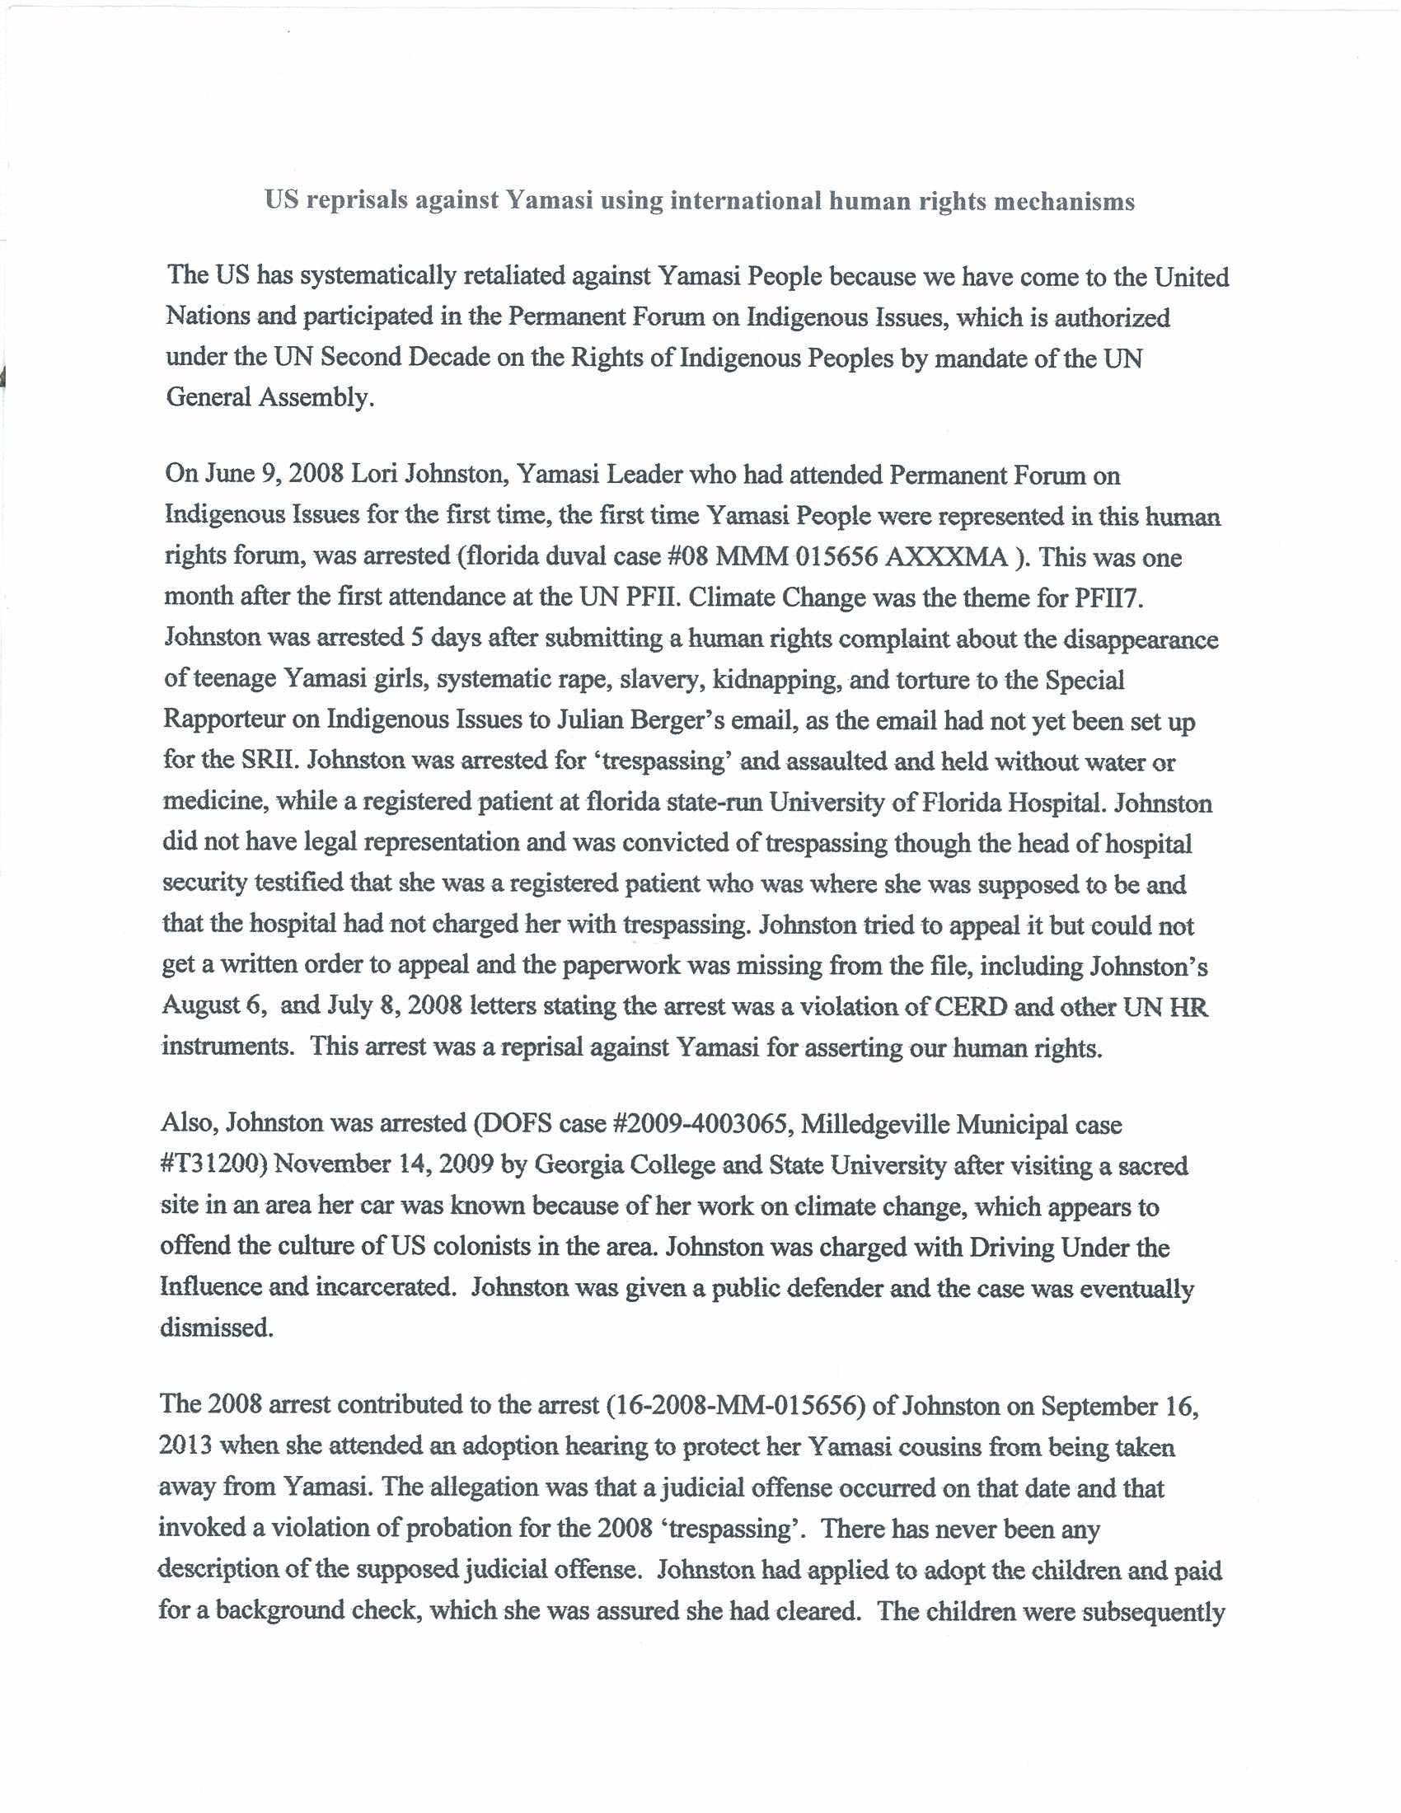
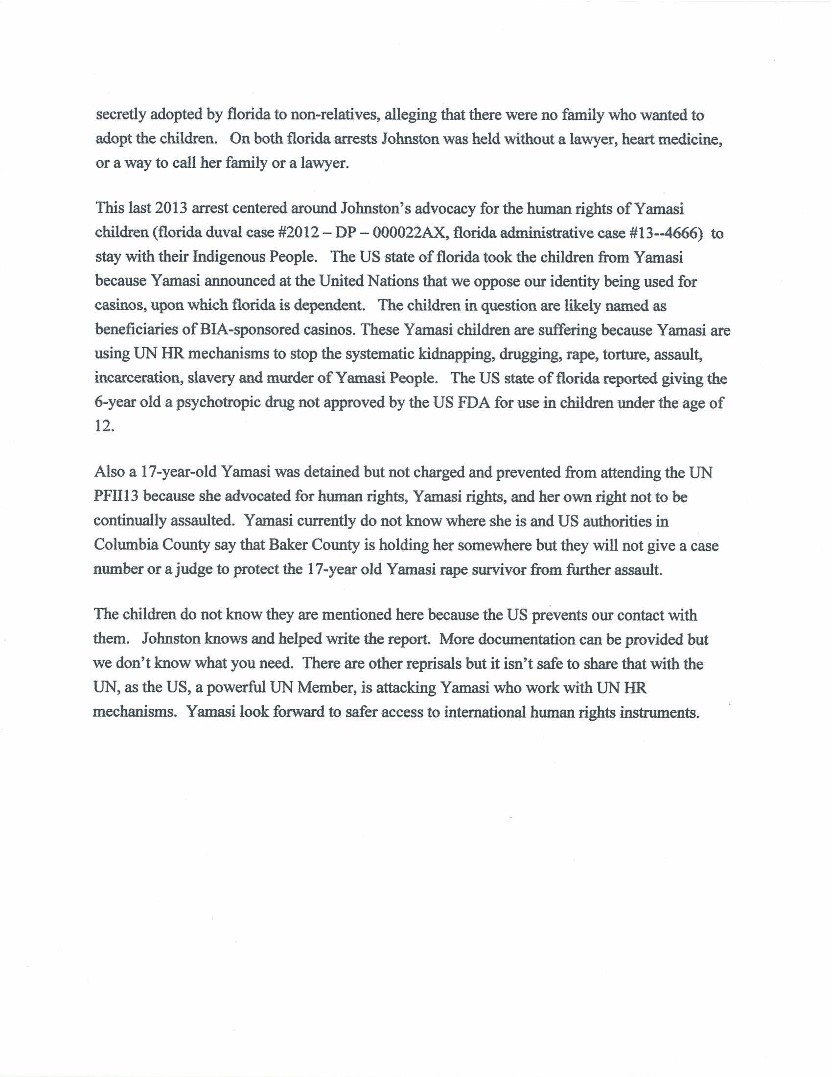
Footnote #17
Torture, Cruel, Inhuman, and Degrading Treatment:
Criminalizing Dissent in the United States Despite
International Covenant on Civil and Political Rights

- Reporting Organizations
Malcolm X Center for Self Determination and National Jericho Movement for Amnesty and Freedom of All (U.S.) Political Prisoners respectfully submit this report to supplement the United States’ response to the Committee’s List of Issues. We offer this shadow report to provide additional information on the torture, cruel, inhuman and degrading treatment of incarcerated political activists from the United States’ 1960-70s COINTELPRO/Civil Rights Era to today. This addition points to continued violation of ICCPR Articles 7, 9,10, 12, 13, 14, 15, 17 and questions raised in Paragraph Number 16 of the Committee’s List of Issues.

- Introduction and Issue Summary

- This report points to violations of the International Covenant on Civil and Political Rights (ICCPR) stemming from U.S. policy toward the more than 50 political activists, it has imprisoned for more than 30 years. They are held in “maximum security prisons…in prolonged cellular isolation” and consistently denied critical medical care, communication with lawyers and their families. Particularly egregious is the current case of terminally ill, federally held, political activist attorney, Lynn Stewart. She is being denied both medical care and compassionate release to obtain such needed care in violation of the ICCPR and Convention Against Torture (CAT), medical records attached. These violations continue against activists at the state and local levels with equally significant rights violations; medical records similar cases attached.

- This report describes how federal and state policies of criminalization of political dissenters and other unpopular persons in custody are routinely denied regular communications and contact with their family and are isolated in so-called Communications Management Unit (CMU) and Special Administrative Units (SMU). Both are prison units designed to isolate and segregate persons in the prison systems from the rest of the prison population. The administrators claim that the units are designed to hold dangerous terrorists and other high-risk inmates, requiring heightened monitoring of their external and internal communications. Many of these prisoners, however, are sent to these isolation units for their constitutionally protected religious beliefs, unpopular
political views, or in retaliation for challenging poor treatment or other rights violations in the federal, state, and local jails and prison systems, prime targets are the COINTELPRO/Civil Rights Era political activists. These are all violations of the ICCPR; namely, the right to liberty and security of the person (Article 9), the right to the family (Articles 17 and 23), the right to freedom of assembly (Article 21), as well as Article 7 and Convention Against Torture..

- Further chilling speech is the 2012 National Defense Authorization Act (NDAA), which contains provisions authorizing the U.S. military to pick up and imprison people, including U.S. citizens, without charging them or putting them on trial expands the specter of solitary confinement to again include ordinary unpopular citizens. Specifically, the legislation “affirms that the authority of the President to use all necessary and appropriate force pursuant to the Authorization for Use of Military Force (Public Law 107-40) includes the authority for the Armed Forces of the United States to detain covered persons (as defined in subsection (b)) pending disposition under the law of war.” It specifically authorizes “Detention under the law of war without trial until the end of the hostilities authorized by the Authorization for Use of Military Force.”

4. This “authority” has been extended, post facto, to challenge the political asylum of Black Panther Party member, Assata Shakur, formerly know as Joanne Cheismard. Although she has been in exile in Cuba for more than twenty-five years without incident. The U.S. government recently labeled her a “terrorist,” put her on it’s “Ten Most Wanted” list, and increased the bounty on her head to Two Million Dollars, a violation of ICCPR Article 15. Statements of the legal community’s is outrage attached.

III. Relevant Question in List of Issue

The U. S. government has failed to respond to the Committee’s Issue Number 16 regarding steps taken to reduce “prolonged cellular isolation,” “increase out-of-cell recreation,” to facilitate “regular family contact,” report complaints of human rights violations in prisons and jails or of such investigations. Indeed, violations of the International Covenant on Civil and Political Rights and the Convention Against Torture are maintained at all levels of government with impunity.

- Recommended Questions
As the Committee conducts its review, we respectfully request that the following questions and concerns be raised during the U.S. government’s hearing:

- Please provide justification for continued criminalization and imprisonment of COINTELPRO/Civil Rights Era political activists generally and those held in prolonged cellular isolation particularly.
- Has the federal government taken any steps to fashion a Truth and Reconciliation process to bring a close to this chapter in United States history?

- Suggested Recommendations

As all the COINTELPRO/Civil Rights Era activists and their allies are aged and /or infirmed, we respectfully suggest the Committee make the following Concluding Observations on the U.S. government report

  - That the State Party take immediate action to release the terminally and critically ill imprisoned COINTELPRO/Civil Rights Era activists, particularly Lynn Stewart and those cases cited here.
  - That the Obama Administration create a national Truth and Reconciliation Commission for review of COINTELPRO/Civil Rights Era political activists’ convictions and/or deaths and the release and compensation of all currently imprisoned COINTELPRO/Civil Rights Era political activists, political prisoners, prisoners of war and exiles.

APPENDIX D

CRITICAL / CHRONIC MEDICAL CASES AND RECORDS

Mohammad Koti, 86 years old

Imam Jamil Al Amin, needs immediate cancer diagnosis, treatment

Abdul Maumin Khabiir, wheel chair bound, copd

Robert Seth Hayes, uncontrolled diabetes

Edward Poindexter, “ “

Tom Manning, http://denverabc.wordpress.com/prisoners-dabc-supports/political-prisoners-database/thomas-manning/

Dr. Mutulu Shakur, http://mutulushakur.com/site/

Mondo we Langa (David Rice), http://denverabc.wordpress.com/prisoners-dabc-supports/political-prisoners-database/mondo-we-langa/
Wheelchair bound, copd

Jalil Muntaquin, http://www.freejalil.com/

Robert Seth Hayes, http://denverabc.wordpress.com/prisoners-dabc-supports/political-prisoners-database/robert-seth-hayes/

Abdullah Majid, http://denverabc.wordpress.com/prisoners-dabc-supports/political-prisoners-database/abdul-majid/

1. Malcolm X Center for Self Determination, founded in 1991, The Malcolm X Center is a multi-issue, volunteer, grassroots, community based resource and action center. It serves as a public space for developing, testing, training and implementation of approaches to community capacity building, popular education, strategic planning, technical, artistic and communications skill enhancement for self determination and human rights advocacy. 2. Jericho Movement for Amnesty & Freedom of All (U.S.) Political Prisoners The Jericho Movement, founded 1998, is the official international multi-movement prisoner organized voice of imprisoned and exiled USA political activists (pp/pows/exiles) and human rights defenders, COINTELPRO/Civil Rights Era survivors, still held by the U.S. federal and state governments in excess of 30 - 40 years. These activists belonged to civil/human rights organizations like the Student Non-Violent Coordinating Committee (SNCC), Black Panther Party for Self Defense, La Raza Unida, FALN, Los Macheteros, North American Anti-Imperialist Movement, May 19th, AIM, the Black Liberation Army, and were incarcerated because of their political beliefs and acts against social injustice, and in support of and/or defense of freedom and self determination. 3. Yamasi People Southeast indigenous People whose winds, waters, and lands were crossed by the states of Florida, Georgia, and South Carolina. Working with the Guale Nation and other indigenous Peoples, they address water issues, carbon-reduction
National Jericho Movement, http://www.thejerichomovement.com/prisoners.html
Churchill, Ward and Wall, Jim Vander, The COINTELPRO PAPERS: Documents From the FBI’s Secret Wars Against Dissent in the United States, South End Oress Classics, 1990 and 2002); Glick, Brian and Smith, Abbe, “Covert Action Against U.S. Activists and What We Can Do,” (South End Press, 1989), p.11, http://whatreallyhappened.com/RANCHO/POLITICS/COINTELPRO/gjp3.html ; “Political Repression - Political Prisoners,” USA UN Universal Periodic Review, Ninth Session of the Working Group on the UPR Human Rights Council,22 November - 3 December 2010, pp 148-159, Submitted by: National Conference of Black Lawyers , Malcolm X Center for Self Determination, Endorsed by 42 organizations and 50 individuals; http://www.ushrnetwork.org/sites/ushrnetwork.org/files/us_political_prisoners_joint_report.pdf, http://www.ushrnetwork.org/sites/ushrnetwork.org/files/political_prisoners_summary.pdf ; USA POLITICAL REPRESSION: CONTINUUM OF DOMESTIC REPRESSION, Submission to the UN Universal Periodic Review Ninth Session of the Working Group on the UPR Human Rights Council , Submitted by: African American Institute for Policy Studies & Planning ,October 22nd Coalition, Ida B.Wells Media Institute, 1-12 November 2010, Geneva, pp. 161-169, http://www.ushrnetwork.org/sites/ushrnetwork.org/files/political_repression_joint_report.pdf ; http://www.ushrnetwork.org/sites/ushrnetwork.org/files/us_state_repression_summary.pdf
Federal, state, and local governments, working under COINTELPRO, precipitated murders, injuries, false arrests, malicious prosecutions and lengthy imprisonments of scores of human rights defenders and political activists, in response to the U.S. Civil/Human Rights Movement’s campaign to realize ICERD ARTICLES 5(c) Political Rights, (d) (i-ix) (Civil Rights), and (e)(i-vi) (Economic, Social, and Cultural Rights), and (f) (Access to Public Accommodations) . Today, these human rights defenders---political prisoners, prisoners of war, and exiles--- and their communities are denied the relief a National Truth and Reconciliation Commission would provide and is required at ICERD Article 1.4, with and without their political use of force.
COMMITTEE ON THE ELIMINATION OF RACIAL DISCRIMINATION, Seventy-fifth session 3 - 28 August 2009, General recommendation No. 32, file:///C:/Documents%20and%20Settings/ Efia%20Nwangaza/My%20Documents/Downloads/G0945147.pdf, CERD/C/GC/32, 24 September 2009
U.S. Institute of Peace, http://www.usip.org/; Lyman, Princeton N., “Partner to History: The U.S. Role in South Africa's Transition to Democracy, 2002, http://www.usip.org/publications/partner-history; South Africa and other commissions http://www.usip.org/search/apachesolr_search/truth%2520 and%2520reconciliation%2520%2520south%2520africa;
Dr. Mutulu Shakur, Towards a Truth and Reconciliation Commission for New African/Black Political Prisoners, Prisoners of War and Freedom Fighters: A Discussion Paper by Dr. Mutulu Shakur (May 5th, 2010); Justice and Amnesty: Applying the South African Truth and Reconciliation Process to the North American Black Liberation Movement by Dr. Mutulu Shakur (January 1st, 2011) http://mutulushakur.com/site/truth-reconciliation/
Presidential pardons, commutations; Pardon Power: The President...shall have Power to grant Reprieves and Pardons for Offences against the United States, except in Cases of Impeachment. U. S. Constitution ARTICLE II, SECTION 2, CLAUSE 1; Department of Justice grants, awards, and conditions
Department of Justice Cold Cases Division, Office of Special Prosecution
Coramae Richey Mann, Unequal Justice: A Question of Color 165, 195 (1993); Born in Slavery: Slave Narratives From the Federal Writers’ Project, 1936-1938, Georgia Narratives, Vol. IV, Part 4, Slavery, at 321-329, http://www.ushrnetwork.org/sites/ushrnetwork.org/files/cerd2008policebrutality.pdf
IN THE SHADOWS OF THE WAR ON TERROR: PERSISTENT POLICE BRUTALITY AND ABUSE OF PEOPLE OF COLOR IN THE UNITED STATES, A report prepared for the United Nations Committee on the Elimination of Racial Discrimination on the occasion of its review of The United States of America’s Second and Third Periodic Report to the Committee on the Elimination of Racial Discrimination, Chicago, December 2007, p.3 http://www.ushrnetwork.org/sites/ushrnetwork.org/files/cerd2008policebrutality.pdf
Eisen, Arlene, with preface by Kali Akuno, Operation Ghetto Storm: 2012 Annual Report on the extrajudicial killing of 313 Black people by police, security guards and vigilantes. The Report exposes how every 28 hours someone inside the United States, employed or protected by the U.S. government kills a Black child, woman or man. These state-sanctioned killings are the casualties of what we call "Operation Ghetto Storm," a perpetual war to invade, occupy and pacify Black communities-- much like the U.S. invades and occupies the Middle East.; published by the Malcolm X Grassroots Committee,.available, with other important resources at www.mxgm.org.
See, e.g., Native Americans in South Dakota: An Erosion of Confidence in the Justice System, South Dakota Advisory Committee to the United States Commission on Civil Rights, March 2000; United States of America: Rights for All, Amnesty International, AMR 51/035/1998; Johnston, Lori, U.S. Reprisals Against Yamasi Using International Human Rights Mechanism, July, 2014, Appendix C.
J. Edgar Hoover, FBI Director, Memo to Neutralize Marcus Garvey and UNIA http://history.genius.com/Federal-bureau-of-investigation-marcus-garvey-neutralization-memo-annotated
J.Edgar Hoover, Director, Federal Bureau of Investigation, Memo to Neutralize Marcus Garvet, http://history.genius.com/Federal-bureau-of-investigation-marcus-garvey-neutralization-memo-annotated
Glick, Brian, “Covert Action Against U.S. Activists and What We Can Do,” (South End Press, 1989), pp 77-79, http://whatreallyhappened.com/RANCHO/POLITICS/COINTELPRO/gjp3.html
TORTURE: CRIMINALIZATION OF DISSENT, Malcolm X Center for Self Determination National Jericho Movement for Amnesty and Freedom of All (U.S.) Political Prisoners, List of Issues Submitted, United States Compliance with the ICCPR, 107th Session of the Human Rights Committee, Geneva 11-28 March 2013 http://www.ushrnetwork.org/sites/ushrnetwork.org/files/16._malcolm_x_center_for_self_determination_and_national_jericho_movement.pdf
Deaths include: Safiya Asya Bukari, Albert “Nuh” Washington, Teddy “Jah” Heath, Kuwazi Balagoon, Merle Africa, Celetayo Tabor, Herman Wallace, Bashir Hameed, Richard Williams, Eddie Hatcher, Marilyn Buck, Geronimo Ji Jaga, Dr. Alan Berkman; National Jericho Movement for Amnesty and Freedom of All US Political Prisoners, http://www.thejerichomovement.com/images17/safiya-poster.pdf
Health conditions,
Perfunctory hearings, routine denials,
Bim Adewunmi, The Guardian, Sunday 13 July 2014 13.00 EDT, http://www.theguardian.com/books/2014/jul/13/assata-shakur-civil-rights-activist-fbi-most-wanted; DEMOCRACY NOW: A DAILY INDEPENDENT GLOBAL NEWS HOUR with Amy Goodman & Juan González http://www.democracynow.org/blog/2013/5/2/ex_black_panther_assata_shakur_added_to_fbis_most_wanted_terrori; Our Sister, Assata Shakur: Life, Struggle, Justice, and Love By Lisa Brock and Beth E. Richie, THE FEMINIST WIRE, May 17, 2013 http://thefeministwire.com/2013/05/our-sister-assata-shakur-life-struggle-justice-and-love/
Umkhonto we Sizwe, Wikipedia, http://en.wikipedia.org/wiki/Umkhonto_we_Sizwe

