CLIMATE CHANGE AND WOMEN’S RIGHTS IN GERMANY
NGO PARALLEL REPORT

GERMANY’S REPORT TO THE 77TH PSWG FOR THE COMMITTEE ON THE ELIMINATION OF ALL FORMS OF DISCRIMINATION AGAINIST WOMEN

2 - 6 March 2020


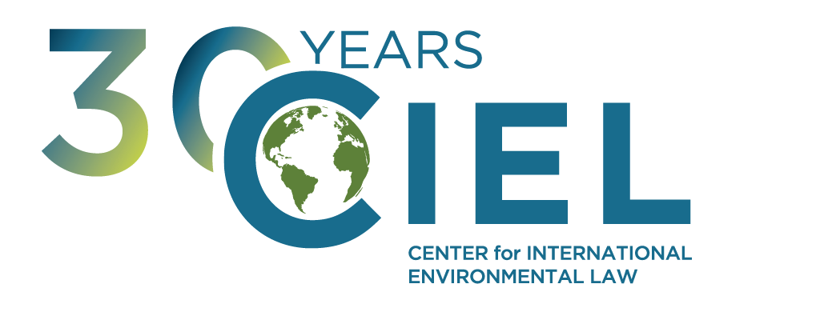
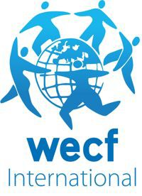

FOOD & WATER EUROPE

CENTER FOR INTERNATIONAL ENVIRONMENTAL LAW

WOMEN ENGAGE FOR A COMMON FUTURE

- Executive Summary -
Germany’s current climate policy violates the obligations of the State under the Convention on the Elimination of all Forms of Discrimination against Women as it permits the excessive emission of greenhouse gases resulting in the increase of adverse climate-induced impacts affecting disproportionately the rights of women both in Germany and abroad.
We thus urge the Committee on the Elimination of Discrimination against Women to ask Germany to:
- provide information regarding how the current climate mitigation policy of Germany, including both emissions reduction targets and actual emissions reductions achieved, is compatible with its obligation to protect the rights of women, both in Germany and abroad, taking into consideration the disproportionate impact of the consequences of climate change on women.1
Additionally, Germany continues to invest in infrastructure for the use of fossil fuels, particularly coal and gas, with economic live spans of several decades. These policies constitute significant obstacles in the transition away from fossil fuels which is essential to prevent the worst impacts of climate change and protect human rights while reducing the threat of greater gender-skewed climate adverse impacts, everywhere.
We thus also encourage the Committee on the Elimination of Discrimination against Women to ask Germany to:
- provide information indicating how Germany’s policies to continue to build new fossil fuel infrastructure - including related to the consumption of coal and gas - is compatible with its obligation to prevent gender-skewed climate adverse impacts.
Finally, as pointed out in the submission provided by the CEDAW Allianz in paragraph 7.2, Germany has not yet taken any steps towards integrating an effective gender perspective into its climate policy and action at national, regional and local government level.
We thus also encourage the Committee on the Elimination of Discrimination against Women to ask Germany to:
- provide information on concrete steps planned to integrate a gender perspective in its climate policy and action at the national, regional and local level.

Submitting Organizations

Food & Water Europe

Food & Water Europe champions healthy food and clean water for all, stands up to corporations that put profits before people, and advocates for a democracy that improves people’s lives and protects our environment.

Women Engage for a Common Future

Women Engage for a Common Future (WECF) is a nonprofit network dedicated to a gender just and healthy planet for all. WCEF works on transformative gender equality and women’s human rights in interconnection with climate justice, sustainable energy & chemicals, less toxic waste, safe water & sanitation for all.

Center for International Environmental Law

The Center for International Environmental Law (CIEL) uses the power of law to protect the environment, promote human rights, and ensure a just and sustainable society.

1 See CEDAW Concluding Observation on Norway (2017), Australia (2018) and South Korea (2018) for precedents of recommendations by the CEDAW in relation to the mitigation policy of individual states

Germany’s Climate Mitigation Targets

The current and anticipated impacts of climate change constitute one of the most significant global threats for the enjoyment of human rights – especially those protected under the Convention on the Elimination of Discrimination Against Women.2 As noted by the Committee on the Elimination of Discrimination Against Women (CEDAW), climate change and natural disasters that result from climate change disproportionately impact women, particularly in rural areas.3 The CEDAW has highlighted previously that climate change results in adverse impacts on many of the rights protected by the Convention on the Elimination of all Forms of Discrimination against Women, particularly the rights to live free from gender-based violence, to education and information, to work and social protection, to health, to and adequate standard of living and to freedom of movement.4 The magnitude of these impacts will keep increasing as temperatures continue to rise.

The 2015 Paris Agreement aims to limit the temperature increase compared to the pre-industrial level to "well below 2°C" and if possible even 1,5°C to prevent such large scale threats, and the 2018 special report on the impacts of global warming of 1.5°C by the IPCC further underlines the urgent need to avoid a 2°C global warming. The reductions in greenhouse gas (GHG) emissions necessary for this goal can only be achieved if emissions from fossil fuel consumption are significantly reduced and if the majority of oil, gas and coal reserves remain unexploited.5

Germany ratified the Paris Agreement on 5th October 2016 and submitted its Nationally Determined Contribution (NDC) jointly with other member states of the European Union. This joint NDC defines the emissions reduction target that EU member states will seek to achieve collectively up to 2030.6 Germany is one of the main global emitters of GHGs - both historically and considering current emissions, and Germany’s per capita emissions are significantly higher than the EU average.7 The country thus contributes to severe climate related impacts within but especially outside the country as GHGs emitted anywhere contribute to climate change globally.

In 2016, Germany set a target for an emissions reduction of 40% compared to 1990 by 2020. However, recent studies show that on the current trajectory, the reduction reached will only be 33-36%.8 Indeed, in the climate protection law passed in December 2019, the 2020 target has been omitted altogether. The law sets a target of a 55% reduction of GHG emissions compared to 1990 by 2030, in line with the previous (not legally binding) target set in 2016.9 It hence disregards the fact that due to the missed 2020 target, a steeper reduction path would be necessary. Research shows that firstly, the 55% target for 2030 is incompatible with the 1.5°C goal of the Paris Agreement, and secondly, Germany is not currently on track to meet even this insufficient target.10

2 See e.g. General Recommendation No. 37 on Gender-related dimensions of disaster risk reduction in the context of climate change CEDAW/C/GC/37 (CEDAW 2018) noting that “Women, girls, men and boys are affected differently by climate change and disasters, with many women and girls experiencing greater risks, burdens and impacts.” (para. 2)
3 CEDAW/C/ARG/CO/7 (CEDAW 2016) para. 38.
4 CEDAW/C/GC/37 (CEDAW 2018) para. 55 et seq.
5 See McGlade, C., & Ekins, P. (2015). The geographical distribution of fossil fuels unused when limiting global warming to 2 deg C.
Nature, 517(7533), 187-190.
6 http://www4.unfccc.int/ndcregistry/PublishedDocuments/European%20Union%20First/LV-03-06- EU%20INDC.pdf
7 http://unfccc.int/files/paris_agreement/application/pdf/10e.pdf, https://data.worldbank.org/indicator/EN.ATM.CO2E.PC
8 https://climateactiontracker.org/countries/germany/current-policy-projections/
9 The law is available here: https://www.bgbl.de/xaver/bgbl/start.xav?startbk=Bundesanzeiger_BGBl&start=//*[@attr_id=%27bgbl119s2513.pdf%27]# bgbl %2F% 2F*%5B%40attr_id%3D%27bgbl119s2513.pdf%27%5D 1582708762716
10 https://climateactiontracker.org/countries/germany/current-policy-projections/

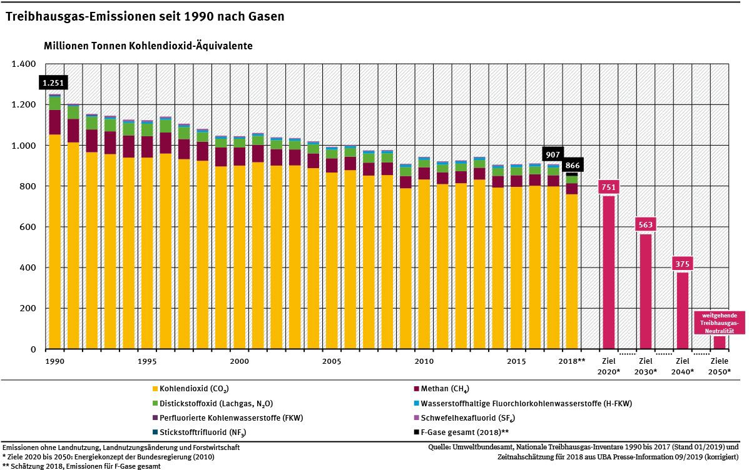

Fig. 1: Annual GHG emissions in Germany since 1990. Source: Federal Environmental Agency

As noted by the CEDAW in 2017, the obligations to ensure women’s substantive equality with men provided in the CEDAW requires State parties to reduce their emissions, as climate change “disproportionately impacts women, especially in situations of poverty, since they are more reliant on natural resources for their livelihoods than men and have lesser capacity to deal with natural hazards”.11 Along with four other UN Human Rights Treaty Bodies, CEDAW has clarified in a Joint Statement that policies to reduce emissions must “reflect the highest possible ambition”.12

The upcoming review of Germany’s obligations under the Convention on the Elimination of all Forms of Discrimination against Women offers an opportunity for the CEDAW to ask Germany to provide further information regarding whether its climate mitigation policy - both in relation to targets set by the government and to policies implemented in order to achieve those - complies with the legal obligations of the country to protect the rights of women as provided under the Convention on Elimination of all Forms of Discrimination against Women and in accordance with internationally agreed environmental standards.

New infrastructure for coal and gas

In its General Recommendation on the Gender-related dimensions of disaster risk reduction in the context of climate change, the CEDAW reiterated that “limiting fossil fuel use and greenhouse gas emissions (…) are regarded as crucial steps in mitigating the negative human rights impact of climate change and disasters.”13 In its Concluding Observations on Australia and South Korea in 2018, the CEDAW has explicitly expressed its concern over these States’ high reliance on coal due to the greenhouse gas emissions resulting from coal-fired power plants.14 In March 2019 CEDAW urged the British Government to “consider introducing a comprehensive and complete ban on fracking for gas.”15 Hence CEDAW has previously recognised the harmful impact of the consumption of both coal and gas. Other UN Human Rights bodies have also expressed concerns for both the adverse impacts of

11 CEDAW/C/NOR/CO/9 (CEDAW 2017) para. 14.
12 Committee on the Elimination of Discrimination Against Women, Committee on Economic, Social and Cultural Rights, Committee on the Protection of the Rights, of All Migrant Workers and Members of their Families, Committee on the Rights of the Child, Committee on the Rights of Persons with Disabilities, Joint Statement on "Human Rights and Climate Change", 16 September 2019, available here
13 General Recommendation No. 37 on Gender-related dimensions of disaster risk reduction in the context of climate change
CEDAW/C/GC/37 (CEDAW 2018) para 14
14 See CEDAW Concluding Observation on Australia (2018) and South Korea (2018)
15 CEDAW/C/GBR/CO/8 (CEDAW 2019)

fracking for local communities as well as the negative climate-induced consequences resulting from this method of fossil fuel extraction.16

The German government is currently drafting a law to set forth the timeline and framework for phasing out coal. The most recent draft foresees the completion of the phase out for 2038, whereas 2030 would be necessary in order to ensure compatibility of Germany’s emissions with the Paris Agreement.17 Moreover, the government has announced that it will allow a new coal power station, Datteln IV, to go on the grid in 2020. This breaches the commitment made by joining the Powering Past Coal Alliance to implement a moratorium on any new coal power stations without operational carbon capture and storage.18 While the government asserts that other coal plants will be taken off-grid earlier than previously foreseen to make up for the GHG emissions from Datteln IV, a study by the German Institute for Economic Research shows that the gap between the emissions produced by Datteln IV and those cut by the measures foreseen amounts to 40 Mio. tons of CO2 (for reference, 40 Mio. tons are approximately 4.6% of Germany’s emissions in 2018 - thus corresponding to the emissions of Greenhouse gases produced in one year by 3.8 millions of German citizens).19

Moreover, the most recent plans for the extraction of lignite coal in Germany still foresee the eviction of several communities in North Rhine-Westphalia and the Lusatia region and threaten the survival of the Hambach forest, one of the most ancient forests of Germany and home to a diverse ecosystem. The social upheaval created by these evictions threatens especially the rights of rural women as the impacts of such evictions are traditionally higher for women due to preexisting inequalities. Studies show that based on the most recent coal phase out plans, it is possible to power all remaining lignite coal power plants until they are supposed to be taken off-grid without any additional evictions.20

In addition, Germany also continues to build new infrastructure for natural gas. The coalition agreement between the governing parties holds that “we will make Germany a location for LNG (liquid natural gas) infrastructure”.21 In its first résumé of the “Dialogprozess Gas 2030” (gas dialogue process) from October 2019 the government states that “natural gas will continue to play an important role in energy supply and material use in industry beyond 2030”, that likely demand until 2030 will increase and that “the availability of natural gas until 2050 is not a problem.”22 According to media reports, the government plans to facilitate at least two terminals for the import of LNG at the North Sea Shore aiming to import fracked gas from the USA.23 To facilitate this, a regulation was passed in June 2019 stipulating that network operators instead of terminal operators will have to pay for the connection of LNG terminals to the transmission network, making the construction of the terminals more lucrative for investors.24 Both state and federal governments are also planning to directly subsidize the construction of the import terminals - thereby directing taxpayers’ financial resources to support on new fossil infrastructure.25 In addition, Germany also invests in LNG terminals overseas (for example Russia, Australia and Canada) through the instrument of the export credit loan guarantee - thereby providing another form of public subsidies to fossil fuels development.26 Moreover, in 2018 the relevant government agencies issued the necessary permits to build the North Stream 2 gas pipeline in order to increase gas imports from Russia.27 This pipeline has a projected 50 year lifespan up to 2070, while the environmental impact assessment carried out only covers the period up to 2035.28

In 2021, Germany will revise its current fracking policy, which includes a ban for shale gas and oil drilling but allows fracking for tight gas and oil. However, the current established expert commission has no mandate to assess and address the severe climate impacts of fracking and the very specific health impacts on women and

16 See CESCER Concluding Observation on Argentina (2018), E/C.12/ARG/CO/4.
17 See Oei, P. et al (2020). Klimaschutz statt Kohleschmutz: Woran es beim Kohleausstieg hakt und was zu tun ist. Deutsches Institut für Wirtschaftsforschung, Politikberatung kompakt N. 148
18 https://poweringpastcoal.org/about/declaration
19 ibid.
20 ibid.
21 Coalition Agreement between CDU, CSU and SPD for the 19th legislative period, available at https://www.bundesregierung.de/resource/blob/975224/847984/5b8bc23590d4cb2892b31c987ad672b7/2018-03-14-koalitionsvertrag-data.p df?download=1, line 3335
22 available at: https://www.bmwi.de/Redaktion/DE/Downloads/C-D/dialogprozess-gas-2030-erste-bilanz.pdf? blob=publicationFile&v=4
23 https://www.ndr.de/nachrichten/schleswig-holstein/Bundesrat-erleichtert-Investitionen-fuer-LNG-Terminals,lng166.html
24 ibid.
25 https://www.bmwi.de/Redaktion/DE/Parlamentarische-Anfragen/2019/1-283.pdf? blob=publicationFile&v=4,
https://www.kn-online.de/Nachrichten/Schleswig-Holstein/Millionen-Zuschlag-fuer-Infrastruktur-Digitalisierung-und-Klimaschutz
26 http://dip21.bundestag.de/dip21/btd/19/052/1905258.pdf
27 https://www.nord-stream2.com/de/permitting-germany/
28https://foreignpolicy.com/2017/05/10/russia-controversial-european-gas-project-under-fire-again-environment-energy-gazprom-nord-strea
m-two-pipeline-politics-geopolitics/

children.29

As explained by a study of the climate impact of natural gas by the University of Manchester, “natural gas is predominantly composed of methane so leakage and deliberate venting contribute to climate change over and above the carbon dioxide produced by its combustion.”30 While methane has a shorter atmospheric lifetime than carbon dioxide, its warming effect is 87 times stronger than that of CO2 over a period of 20 years.31 Moreover, almost all methane is ultimately oxidised to CO2 and thus contributes to warming far beyond its lifespan as methane.32 Therefore, despite assertions by governments and corporations that natural gas can serve as a “bridge fuel”, building new infrastructure for fossil fuels with a lifespan of several decades is fundamentally at odds with maintaining a safe climate and implementing the Paris Agreement.

At the same time, Germany is under-utilizing its potential for renewable energy. A cap on subsidies for solar energy
- which is projected to be reached as early as April 2020 - remains in place,33 despite the fact that Germany will miss its targets for the expansion of this sector as set in the current government’s coalition agreement if expansion remains at the current trajectory.34 Regarding wind energy, following changes in the regulations of feed-in tariffs, the rate of expansion has been reduced by 55% on-shore and 20% off-shore from 2017 to 2018.35

In this context, we urge the CEDAW to also ask Germany to provide information on how the expansion of infrastructure for coal and gas is compatible with its obligation under the Convention for the Elimination of all Forms of Discrimination against Women to prevent gender-skewed impacts of climate change.

  - Gender perspective in climate policy
Finally, as pointed out in the submission provided by the CEDAW Allianz in paragraph 7.2, Germany has not yet taken any steps towards integrating an effective gender perspective into its climate policy and action at national, regional and local government level, including the recommended activities of the gender action plan adopted in 2017 under the United Nations Framework Convention on Climate Change. In its most recent list of issues for Sweden, the CEDAW has asked for information about the measures taken: (a) to ensure that climate change and energy policies take into account the differentiated and disproportionate impact of climate change on women; (b) to better integrate a gender perspective into policies and programmes on climate change, including the recommended activities of the gender action plan adopted in 2017 under the United Nations Framework Convention on Climate Change; and (c) to ensure the effective participation of women in decision-making processes on climate change at the local and national levels, in line with the Committee’s general recommendation No. 37 (2018) on the gender-related dimensions of disaster risk reduction in the context of climate change.36
We thus also encourage the Committee on the Elimination of Discrimination against Women to ask Germany to provide information on concrete steps planned to integrate a gender perspective in its climate policy and action at the national, regional and local level.

This short briefing note was prepared by the Center for International Environmental Law (CIEL), Food & Water Europe, and Women Engage for a Common Future (WECF). Please do not hesitate to contact us for any additional information: Sébastien Duyck sduyck@ciel.org (+41786966362)

29 Compendium of Scientific, Medical, and Media Findings Demonstrating Risks and Harms of Fracking (Unconventional Gas and Oil Extraction), Fifth edition (March 2018), available at:
http://concernedhealthny.org/wp-content/uploads/2018/03/Fracking_Science_Compendium_5FINAL.pdf
30 Anderson, K., & Broderick, J. (2017). Natural gas and climate change. University of Manchester, available at https://www.research.manchester.ac.uk/portal/files/60994617/Natural_Gas_and_Climate_Change_Anderson_Broderick_FOR_DISTRIBUTI ON.pdf
31 https://www.ipcc.ch/site/assets/uploads/2018/02/WG1AR5_Chapter08_FINAL.pdf
32 ibid.
33 https://www.fr.de/wirtschaft/solardeckel-schnappt-13459157.html
34https://www.ise.fraunhofer.de/de/veroeffentlichungen/studien/aktuelle-fakten-zur-photovoltaik-in-deutschland.html#faqitem_826058992-a
nswer
35 https://www.windbranche.de/windenergie-ausbau/deutschland/windmarkt-2018
36 available at: http://docstore.ohchr.org/SelfServices/FilesHandler.ashx?enc=6QkG1d%2fPPRiCAqhKb7yhskcAJS%2fU4wb%2bdIVicvG05RyEHYqSgR IJ7szRWKLw0soTXBwjOBNCbBRDcGZ0hI4Mat0eeadKYMYQq5dQI0oVoC4sy82oZYIson8faP5Y4GzY1kfCh6f35l2BF9AAO3Zxjg%3 d%3d

