European Union Agency for Fundamental Rights, selected passages on the rights of persons with disabilities from published reports related to Malta
fra.europa.eu

June 2018, Vienna
Contents
1 Annual reports 3
1.1 Fundamental Rights Report 2018 3
1.2 Fundamental Rights Report 2017 3
1.3 Fundamental Rights Report 2016 4
1.4 Fundamental rights: challenges and achievements in 2014 – Annual Report 2014 (June 2015) …………………………………………………………………………………………………………………………………………..4
2 Thematic reports on the rights of persons with disabilities 5
2.1 From institutions to community living - Part I: commitments and structures 5
2.2 From institutions to community living - Part III: outcomes for persons with disabilities 5
2.3 Violence against children with disabilities: legislation, policies and programmes in the EU report (2015) 6
2.4 Implementing the UN CRPD: An overview of legal reforms in EU Member States (2015) 6
2.5 The right to political participation for persons with disabilities: human rights indicators (2014)…………………………………………………………………………………………………………………………………………….7
2.6 Legal capacity of persons with intellectual disabilities and persons with mental health problems (2013) 9
2.7 Involuntary placement and involuntary treatment of persons with mental health problems (2012) …………………………………………………………………………………………………………………………………………10
2.8 The legal protection of persons with mental health problems under non-discrimination law (2011) …………………………………………………………………………………………………………………………………………10
2.9 The right to political participation of persons with mental health problems and persons with intellectual disabilities (2010) 11

Annual reports

Fundamental Rights Report 2018
For more detailed information: http://fra.europa.eu/en/publication/2018/fundamental-rights-report-2018 .
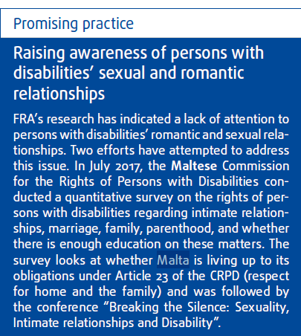 (p.230)

Fundamental Rights Report 2017
For more detailed information: http://fra.europa.eu/en/publication/2017/fundamental-rights-report-2017 .
“Notably, Germany and Malta in 2016 introduced national legislation on disability that mentions multiple discrimination. The Maltese Equal Opportunities (Persons with Disabilities) Act prohibits discrimination in a “multiple manner” of people with disabilities.” (p.69)
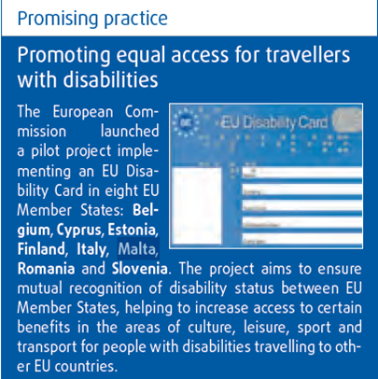 (p.225)

Fundamental Rights Report 2016
For more detailed information: http://fra.europa.eu/en/publications-and-resources/publications/annual-reports/fundamental-rights-2016.
“Cyprus, Malta, the Netherlands, Slovakia, Spain and the United Kingdom took action to counter discrimination based on disability. The Maltese Parliament adopted legislation imposing a quota of persons with disabilities in a number of public entities/authorities, including the national equality body. Should any such entity not hire at least one person with a disability or a representative thereof, the entity will not be considered to be legally constituted.” (p.68)
“FRA evidence shows that EU Member States have implemented a wide range of measures to bring persons with disabilities into the policy-making process. Two examples from 2015 highlight the variety of possible approaches. Malta moved to formalise the participation of persons with disabilities in decision-making by amending a number of legal acts to provide for persons with disabilities’ membership of the governing authorities of different public entities. For instance, the Housing Authority Act was amended to require that one of the up to 11 members of the Board of Directors of the Housing Authority will be a person with a disability; similarly, one of the seven to 10 members of the National Commission for Further and Higher Education must now be a person with a disability.” (p. 190-191)

Fundamental rights: challenges and achievements in 2014 – Annual Report 2014 (June 2015)
For more detailed information: http://fra.europa.eu/en/publications-and-resources/publications/annual-reports/fundamental-rights-2014.
“Given that the new ESIF regulation came into force on 1 January 2014, it was to be expected that Member States would begin implementing measures to fulfil these conditionalities only during 2014; the deadline to fulfil them is 31 December 2016. Concerning the third conditionality, some Member States have consulted or plan to consult with bodies in charge of protection of rights of persons with disabilities or disabled persons organisations (DPOs). This was the case in Austria, Belgium, Bulgaria, Cyprus, Denmark, Estonia, France, Greece, Hungary, Ireland, Italy, Latvia, Lithuania, Luxembourg, Malta, the Netherlands, Poland, Portugal, Romania, Slovakia, Spain and Sweden. The criteria to be met under this conditionality include having a plan in place to involve such organisations, identifying relevant actors and their roles and facilitating their active involvement in the process.” (p. 31)
“For the fourth conditionality, Member States took steps to ensure that relevant staff will be trained on applicable EU and national disability law and policy, including accessibility and the implementation of the CRPD. This happened in Austria, Belgium, Bulgaria, the Czech Republic, Denmark, Estonia, Finland, France, Germany, Greece, Hungary, Italy, Latvia, Luxembourg, Malta, the Netherlands, Portugal, Romania, Slovenia, Slovakia and Spain.” (p. 31)
“The other relevant conditionality Member States have to meet relates to arrangements to monitor the implementation of Article 9 of the CRPD on accessibility, in the context of disbursing structural and investment funds. Austria, Belgium, Bulgaria, Denmark, France, Hungary, Italy, Latvia, Lithuania, Luxembourg, Malta, Poland, Romania, Slovakia, Sweden and the United Kingdom took steps towards meeting this conditionality” (p.31)

Thematic reports on the rights of persons with disabilities

From institutions to community living - Part I: commitments and structures
For more detailed information: http://fra.europa.eu/en/publication/2017/independent-living-structures . Also available in easy-to-read: http://fra.europa.eu/en/publication/2018/institutions-community-living-part-i-commitments-and-structures-easy-read .
“For 2014–2020, the European Commission identified a need for measures for the shift from institutional to community-based care in 12 EU Member States […]. In a further five Member States (Denmark, Ireland, Malta, Portugal and Spain), partnership agreements contain a commitment to deinstitutionalisation and identify measures to support the process, FRA’s review of 2014– 2020 partnership agreements between the European Commission and individual EU countries reveals.” (p. 10)
“FRA’s analysis indicates that most Member States with strategies on or including deinstitutionalisation measures have set up mechanisms to monitor their implementation. However, the relevant strategies in Cyprus, Greece, Italy, Malta and Romania do not include provisions for any monitoring mechanisms.” (p. 13)

From institutions to community living - Part III: outcomes for persons with disabilities
For more detailed information: http://fra.europa.eu/en/publication/2017/independent-living-outcomes . Also available in easy-to-read: http://fra.europa.eu/en/publication/2018/institutions-community-living-part-iii-outcomes-persons-disabilities-easy-read .
“Unsurprisingly, the smaller populations of Cyprus and Malta mean lower numbers of assistive devices are provided. In Malta, 374 persons obtained funds from the special apparatus fund in 2014.” (p. 20)
“On average, persons with disabilities in the EU are more likely than other persons to have difficulty in using general services commonly available to the public. The ‘disability gap’ varies across EU Member States and different services. It is comparatively low in Luxembourg, Malta and Poland, and non-existent in France.” (p. 23)

Violence against children with disabilities: legislation, policies and programmes in the EU report (2015)
For more detailed information: http://fra.europa.eu/en/publication/2015/children-disabilities-violence. Also available in easy-to-read: http://fra.europa.eu/en/publication/2015/violence-against-children-disabilities.
“FRA research reveals that all Member States except for Germany, Malta and the Netherlands have legislation obliging professionals who work with children to report child abuse, neglect and violence.” (p. 40)
“The CRC Committee has expressed serious concerns about the high number of children with disabilities placed in institutions, reiterating, for example, the need for alternatives to institutionalisation in its Concluding Observations to Austria, Greece and Malta, as well as in its General Comment No. 9.” (p. 74)
“National bodies tasked with protecting and promoting human rights also have the right to visit and monitor different institutions, including long-term care institutions for people with disabilities and disability day centres. In some countries, there is a dedicated ombudsperson for children or child commissioners. This is the case in Cyprus, Finland, Croatia, Ireland, Italy, Lithuania, Luxemburg, Malta, the Netherlands, some regions of Spain, Poland, Sweden and the United Kingdom.” (p. 76)
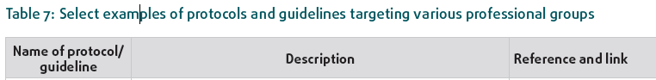
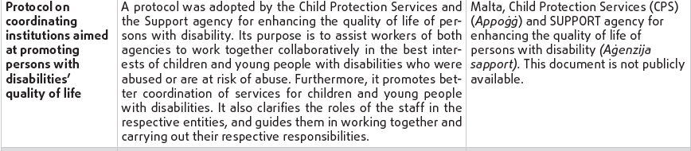 (p. 95)

Implementing the UN CRPD: An overview of legal reforms in EU Member States (2015)
For more detailed information: http://fra.europa.eu/sites/default/files/fra-2015-focus-05-2015-crpd_en.pdf.
“Following their ratification of the CRPD, several Member States have established systematic mechanisms for people with disabilities to be consulted on legislative processes that affect them. In Malta, a consultative body for the rights of people with disabilities was established. Bringing together people with disabilities, service providers, activists, policy makers, academics and relevant professionals, the body was heavily involved in the preparation of the National Disability Policy in 2014.” (p. 7)
“Member States, including the Czech Republic, Hungary, Latvia and Malta, have reformed their civil codes to comply with Article 12, although in several cases the law continues to permit some restrictions on legal capacity. In Malta, the Civil Code was amended in December 2012 to introduce a system of guardianship to replace incapacitation for people with disabilities. The legislation now states that “a major who has a mental disorder or other condition which renders him incapable of taking care of his own affairs may be subject to guardianship”. In addition, the legislation includes the establishment, which took place in 2014, of a Guardianship Board to regulate how guardianship orders are issued and implemented.” (p. 9)

The right to political participation for persons with disabilities: human rights indicators (2014)
For more detailed information: http://fra.europa.eu/en/publication/2014/right-political-participation-persons-disabilities-human-rights-indicators.
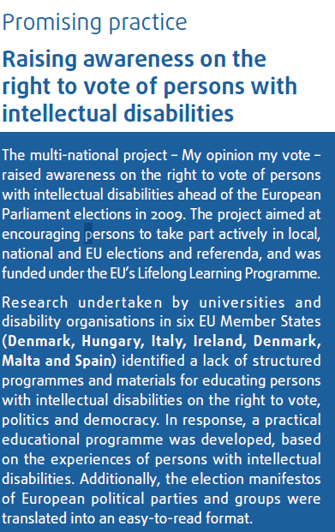 (p. 25)
“Malta is the only EU Member State that has made a reservation to Article 29 of the CPRD upon ratification of the CRPD […]. Malta’s reservation states that with regard to Article 29 (a) (i) it “reserves the right to continue to apply its current electoral legislation in so far as voting procedures, facilities and materials are concerned” and that with regard to Article 29 (a) (iii) it “reserves the right to continue to apply its current electoral legislation in so far as assistance in voting procedures is concerned”. This reservation is tied to the provisions for persons with disabilities who may require assistance to vote. The current system provides for such voters to vote in front of the assistant commissioners in their polling booth.” (p. 35)
“A further 15 EU Member States prohibit people with disabilities who have been deprived of their legal capacity from voting. The Member States are Belgium, Bulgaria, Cyprus, Denmark, Estonia, Germany, Greece, Ireland, Lithuania, Luxembourg, Malta, Poland, Portugal, Romania and Slovakia. This exclusion is either set out in the country’s constitution or in electoral legislation.” (p. 41)
“Sixteen EU Member States have no legal accessibility standards for providers of internet and web-based public information, the analysis shows. Only four Member States, Austria, Belgium, Malta and Spain, have statutory accessibility requirements for both public and private providers, set out in laws on electronic communication and/or equal treatment of persons with disabilities.” (p. 46)
“Providing accessibility to public buildings, such as polling stations and local and national government buildings, is vital to ensure that persons with disabilities can exercise the right to vote and participate fully in public discussions on political issues. The information provided for Malta, the Netherlands, Romania and Slovakia is insufficient to conclude whether accessibility standards apply both to new and existing buildings.” (p.46)
“The research indicates that in 12 EU Member States, Croatia, Estonia, France, Germany, Ireland, Lithuania, Luxembourg, Malta, Portugal, Spain, Sweden and the United Kingdom, have legal accessibility standards which apply to all polling stations.” (p. 48-49)
“In a second group of Member States, made up of Austria, Greece, Latvia, Lithuania, Malta and the Netherlands, electoral laws specify that assistance is only available to persons with physical or sensory impairments. Where assistance is available, legislation generally allows for it to be provided by a person chosen by the person with a disability. In Malta, however, such assistance can only be provided by electoral officials, a rule which forms part of the basis for the reservation Malta entered to Article 29 when it ratified the CRPD (see indicator 2.1.1).” (p. 51)
“Laws in force in Austria, Croatia, Cyprus, Finland, Germany, Italy, Latvia, Malta and the United Kingdom provide that all persons with disabilities, including those who have been deprived of their legal capacity, have access to redress mechanisms in cases where they have not been able to exercise their right to political participation.” (p. 53)
“The analysis indicates that in nearly half (13) of EU Member States, DPOs’ involvement in the development of laws and policies is provided for by law. This involvement takes several different forms. In Austria, Cyprus, Malta and Spain it is provided for in relevant disability-focused legislation.” (p. 56)
“The analysis shows that in six EU Member States – the Czech Republic, Lithuania, Malta, Poland, Spain and Sweden – information about how and where to complain about voting rights is provided on a website that declares it meets WCAG 2.0 AA standards or in other accessible formats. In some cases, such as the website of the National Commission of Persons with Disability in Malta, the information provided is on complaints in general and not specifically regarding political participation.” (p. 60)
“Before the 2008 General Election in Malta, the Society of the Blind opened a case regarding the right of persons with visual impairments to vote in secret, arguing that the lack of privacy was humiliating and in breach of Malta’s equality legislation. Although the court ruled that it did not have jurisdiction in the case, the General Elections Act was subsequently amended to include an obligation on the Electoral Commission to produce templates in Braille and facilitate the use of playback listening devices.” (p. 62)
“In Malta, Slovenia and Spain, this research found cases linked to the accessibility of information regarding elections, specifically for persons with visual and hearing impairments. In 2013, the Deaf Persons Association filed a complaint with the National Commission on Persons with Disability in Malta about the lack of Maltese Sign Language interpretation on national television during an election broadcast. As a result of the complaint, the Broadcasting Authority included Maltese Sign Language interpretation in its broadcasts on the elections.” (p. 63)
“In a second group of Member States, including France, Hungary, Ireland, Italy, Malta and Spain, data indicating that there are parliamentarians who identify as having a disability could be collected from unofficial sources such as candidate websites and the media.” (p. 69)

Legal capacity of persons with intellectual disabilities and persons with mental health problems (2013)
For more information: http://fra.europa.eu/en/publication/2013/legal-capacity-persons-intellectual-disabilities-and-persons-mental-health-problems. Also available in easy-to-read: http://fra.europa.eu/en/publication/2013/laws-about-being-able-make-important-decisions-yourself.
“In Malta, the Civil Code was amended in December 2012 to introduce a system of guardianship providing that “a major who has a mental disorder or other condition which renders him incapable of taking care of his own affairs may be subject to guardianship”. (p. 28)
“Four Member States have established special courts that deal exclusively with establishing and terminating protection measures and restricting legal capacity. In Malta, for example, this role is fulfilled by the Court of Voluntary Jurisdiction for matters of interdiction or incapacitation or by the Guardianship Board in case of a request for guardianship; in Latvia by the Orphan Court; in England and Wales by the Court of Protection; and, finally, in Spain, by incapacitation courts in several cities (Barcelona, Bilbao, Granada, Madrid, Valencia and Vitoria).” (p. 33)
“FRA’s research shows that only a few EU Member States set a maximum time limit for reviewing a protective measure. In Malta, when a guardian is appointed, the Guardianship Board “shall also order that a hearing for the review (…) be held within specific period, not being longer than two years”. (p. 37)

Involuntary placement and involuntary treatment of persons with mental health problems (2012)
For more information: http://fra.europa.eu/en/publication/2012/involuntary-placement-and-involuntary-treatment-persons-mental-health-problems.
“In 12 Member States, the existence of a significant risk of serious harm to oneself or others and a confirmed mental health problem are the two main conditions justifying involuntary placement. The need for a therapeutic purpose is not explicitly stipulated. This is the case, in Austria, Belgium, Bulgaria, Cyprus, the Czech Republic, Germany, Estonia, Hungary, Lithuania, Luxembourg, Malta and the Netherlands.” (p. 31)
“In other EU Member States, the use of less restrictive approaches applies only to involuntary treatment. Such is the case in Malta, where according to Section 14 (3) of the Mental Health Act the two medical practitioners applying for an involuntary treatment measure “must specify whether other methods of dealing with the patient are available and, if so, why such methods are not appropriate.” (p. 33)
“Many EU Member States laws refer to the persons’ opinion at times with respect to involuntary placement and more often to treatment. A small number of EU Member States laws do not refer to the person’s opinion in the course of an involuntary measure. This is the case in the Czech Republic, Greece, Latvia, Malta, Slovakia and the United Kingdom.” (p. 34)
“In most EU Member States the involuntary placement decision under a regular admissions procedure is decided by a non-medical body, generally a court. In a few EU Member States the final decision remains a medical one. For example, in Malta, the decision is taken by the manager of the psychiatric hospital; and in Romania by the “medical authority”. (p. 36-37)
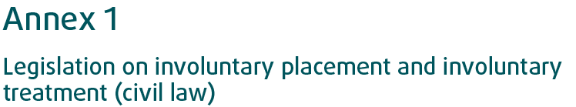
(p. 59)

The legal protection of persons with mental health problems under non-discrimination law (2011)
For more detailed information: http://fra.europa.eu/en/publication/2011/legal-protection-persons-mental-health-problems-under-non-discrimination-law.
“The Maltese Equal Opportunities (Persons with Disability) Act defines disability in Section 2 as “a physical or mental impairment that substantially limits one or more of the major life activities of a person”. It has been argued that the requirement that the impairment substantially limits one or more of the major life activities of a person may risk excluding persons with mental health problems from the scope of protection. However, the National Commission Persons with Disability (Kummissjoni Nazzjonali Persuni b’Diżabilita), which investigates complaints under the Equal Opportunities (Persons with Disability) Act, has accepted complaints from persons with mental health problems.” (p. 23)

The right to political participation of persons with mental health problems and persons with intellectual disabilities (2010)
For more detailed information: http://fra.europa.eu/en/publication/2010/right-political-participation-persons-mental-health-problems-and-persons .
“A majority of European Union Member States links the right to political participation to the legal capacity of the individual. These Member States have an automatic or quasi-automatic exclusion provision in their legal systems. In countries where there is an automatic exclusion it is either entrenched in the Constitution or prescribed in electoral legislation. The Hungarian Constitution provides an explicit exception from the universal right to vote – only persons with full legal capacity can exercise it. Similar constitutional provisions can be found in several countries: the Czech Republic, Denmark, Estonia, Greece, Lithuania, Luxembourg, Malta or Poland and Portugal, among others.” (p. 15)
Limited political participation
“These EU Member States […] have adopted a variety of practices falling between the two ends of the spectrum, in which an assessment is made of the individual’s actual ability to vote. […] in some cases, these countries have adopted either an exclusion policy coupled with an individualised assessment (such as Estonia and Malta) or a full participation policy complemented with a specific decision on voting capacity (Spain and France).”
“[…] the constitution of Malta denies voting rights to persons ‘interdicted or incapacitated for any mental infirmity by a court in Malta or […] otherwise determined in Malta to be of unsound mind’. A medical board, consisting of doctors, is set up to decide on any dispute related to the exclusion of persons ‘with mental infirmity’ or persons with ‘unsound mind’ as foreseen in the constitution. Unless a competent court takes a decision concerning the incapacity of an individual, the medical board’s decision will be needed before refusing to register a person as a voter.” (p. 17)
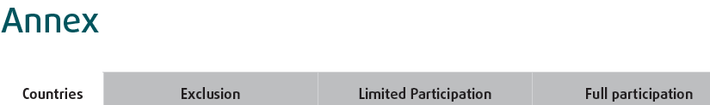
(p. 23)

