Parallel Report to the UN Committee on the Elimination of Racial Discrimination
Written by: Action Network for Environmental Rights (RADA, by its initialism in Spanish)

Temuco, Chile, November 2019.

Introduction
The Action Network for Environmental Rights (RADA) is a non-profit citizen organization that promotes and advocates for the environment as a human right. In January 2007, RADA members and Mapuche communities in the Araucanía region filed a complaint with the Committee for the Elimination of Racial Discrimination (CEDR, by its initialism in Spanish) against the State of Chile for environmental racism, due to landfills and sewage treatment plants located within or adjacent to Mapuche communities in the Araucanía region.

The complaint was received by the CEDR. On 24 August 2007 the CEDR sent a communication to the State of Chile requesting —by virtue of the article 9(1) of the Convention and the article 65 of its regulations— answers to the questions raised concerning the specific situation of Mapuche indigenous communities in the Araucanía region affected by harmful activities to the environment, health and their traditional ways of life. In March 2008, this request was reiterated to the State of Chile by the Committee.

In August 2009, the Committee issued its final observations to the State of Chile after the review of the State's reports 15 to 18 (CERD/C/CHL/CO/15-18). In comment No. 23, the Committee expressed concern about Mapuche communities in the Araucanía region being affected by the installation of landfills and sewage plants in their communities. In 2013, the Committee reiterated its concern about the impacts of landfills, water and subsoil contamination on indigenous territories in comment No. 13 of the recommendations to reports 19 to 21 of the State of Chile (CERD/C/CHL/CO/19-21).

As a result of the Committee's recommendations and RADA's ongoing work in maintaining coordination among affected communities and requesting the regional government of the Araucanía region to implement the Committee's recommendations, 8 landfills in Mapuche communities have stopped operating. Also, the sewage treatment plant in Temuco —the largest in the region— has been upgraded from chemical to biological treatment. In addition, the Regional Waste Management Policy was created, and in 2018 a diagnostic study was developed on the impacts of landfills and sewage treatment plants in Mapuche communities in the Araucanía region. However, none of these measures have been adequately implemented.
At present, 6 landfills located in Mapuche communities remain in operation (Villarrica, Gorbea, Vilcún, Cunco, Carahue and Traiguén). Landfill closure plans —measures to control contamination due to waste disposal— have mostly not been implemented, and the regional impact assessment study does not contain adequate indicators to account for the contamination the communities live with and that continues to affect their territory. In addition, at present, this study has not been translated into effective plans and programs by public services, or into reparatory or compensatory measures.

Furthermore, there are plans to install new waste disposal systems in the region: an intercommunal sanitary landfill in the Collipulli commune and a waste incineration plant in Lautaro commune. The former is approved for construction and the latter is in the process of environmental assessment. In both cases, there are Mapuche people and communities claiming that these projects could potentially affect them. However, in neither case has there been an indigenous consultation, as established in the International Labor Organization (ILO) Convention 169 and ratified by the State of Chile.

This report is an update of the information submitted to the Committee in 2007 in the context of the complaint of environmental racism, as well as an analysis of the effectiveness of the measures implemented by the State in compliance with the Committee's recommendations. It is concluded that the Committee's recommendations regarding the complaint of environmental racism against the State of Chile have not been effectively implemented. This allows the negative environmental effects to continue happening. We request the Committee to recommend to the State of Chile the following:

- To effectively comply with landfill closure plans.
- To monitor the adequate parameters in order to know scientifically the quality of the water consumed by the affected communities.
- To establish an integral plan of reparatory and compensatory measures for damages caused, in consultation and participation with the affected communities.

Contextualization
In January 2007, representatives of various communities and organizations from the Araucanía and Santiago Metropolitan regions of Chile, including RADA members, filed a complaint against the State of Chile for environmental racism, for the cases of 13 landfills and 9 sewage treatment plants located within Mapuche communities. The landfills within Mapuche communities correspond to Villarrica, Temuco, Gorbea, Lumaco, Perquenco, Melipeuco, Pitrufquén, Loncoche, Nueva Imperial, Vilcún, Cunco, Carahue, Collipulli and Traiguén communes.
The landfills of the Villarrica, Gorbea, Vilcún, Cunco, Carahue and Traiguén communes (except Traiguén and Carahue) have financed closure plans but have not been executed, and are in a state of collapse. In 2017-2018, these landfills were assessed by a study called "Diagnosis of the impacts of landfills and sewage treatment plants in the Araucanía region". One of its results indicates a probability of contamination due to the presence of landfills in the territories in both surface water and groundwater.

In the case of the sewage treatment plants the situation is even more complex because the facilities in the territories of Carahue, Curacautín, Loncoche, Toltén and Villarrica, excepting Temuco, continue to use primary treatment, and the companies have not considered changing to biological treatment. In addition, the continuous operation of these facilities on sites of cultural and/or spiritual significance for the Mapuche people has meant an affront to the spirituality and way of life of the affected communities for more than twelve years. This situation has worsened even more considering the constant complaints by the communities on the increase in the presence of bad smells, pollution at the place of unloading and the continuous presence of vectors (mice, dogs, flies, among others) that worsens year after year.

In the regional context, the situation demonstrates a frequent and normalized disregard for environmental impact, health and traditional ways of life, by not including in the diagnostic study all the landfills and sewage treatment plants that exist in the region; 21 landfills were prioritized and 7 were excluded. In the case of sewage treatment plants, 39 were prioritized and 21 excluded. This omission prevents a general assessment of the environmental (water quality, perception of smell, perception of vectors, gases, landscape, flora and fauna), socioeconomic and cultural (surveys/interviews) impacts of these facilities at the regional level.

In addition, this study did not include an epidemiological evaluation or permanent monitoring of water quality (surface and groundwater), applying only one sample in one season carried out in summer, an issue that shows a clear methodological shortcoming. Of the not evaluated territories, 3 are located in communities that became part of the complaint of environmental racism. These are Collipulli, Lumaco and Melipeuco. Although they are closed and not operating, and since they were not taken into account, the damages caused by these facilities (residues dumped and accumulated by years in the communities) were neither verified nor evidenced.

Current panorama of environmental racism in the Araucanía region: from landfills and sewage treatment plants to the impact of extractive sectors on natural resources of indigenous peoples and their territories.

Finally, twelve years after this first complaint to CERD, we denounce the worsening of environmental racism towards the Mapuche communities in the Araucanía region, broadening the outlook causing this situation to the extractive activities in the region. Specifically, we noted that most extractive projects have not been approved with adequate implementation of ILO Convention 169 on the Rights of Indigenous and Tribal Peoples. In 2008, it was ratified by the State of Chile. We would like to mention that the regulation of the consultation procedure has limited the participation and deliberation of Mapuche communities to the least number of cases.

For example, in the hydroelectric sector —cause of the greatest protest action by indigenous communities in the region— there has been only four cases of indigenous consultation (Añihuerraqui, El Rincón, Los Aromos, Hueñivales projects). Since 2008, 72 projects have been reported to the Environmental Evaluation Service either by Environmental Impact Study, Environmental Declaration or Consultation about Relevance.

Especially, the situation of communes with a high indigenous population such as Curarrehue and Melipeuco should be highlighted because of the high concentration of this type of investment and where only one indigenous consultation has been carried out in each case. One explanation for the scant implementation of this important deliberation mechanism on the impacts of the projects on indigenous rights is that it was regulated under two norms after its ratification, Decree 66 and Decree 40 of the Environmental Assessment Service. The latter Decree gives the Service the power to implement these processes when it deems that there is direct affectation.

Several communities have responded and taken cases to court due to the State's decision not to carry out indigenous consultations. For instance, the Llancalil project was recently approved without even implementing an Environmental Impact Study, affecting the economic and spiritual activities of three Mapuche communities. We believe that this arbitrary application of the indigenous consultation is being carried out under racial differentiation of the Mapuche population. These institutions, norms and decisions are designed and implemented by the Chilean population who does not suffer the effects of dispossession caused by this type of economic activities. We request the Committee to recommend to the State of Chile the following:

- To restrict the implementation of extractive projects that affect Mapuche communities without their free, prior and informed consent.
- To systematically establish mechanisms for indigenous consultation without minimizing the impacts on Mapuche communities resulting from the installation of extractive projects in their territories.
- To modify the current regulations that limit the exercise of indigenous consultation (Decree 66 regulating indigenous consultation and Decree 40 of the Environmental Assessment Service) in order to effectively guarantee the rights established in ILO Convention 169 with the full participation of indigenous peoples.

“Problematic" Cases: Events Demonstrating that Environmental Racism Continues

For the Committee's knowledge, four events will be named that show the continuity (and perhaps, the increase) of environmental racism experienced by Mapuche communities in southern Chile, mainly referred to the Araucanía region. These cases are as follows:

- Municipal landfill in Purén commune: Since December 2013, the municipality of Purén stopped using the municipal landfill located within the Mapuche community Pascual Huenupi II and adjacent to the communities Jose Railen and Jose Deumelao (see Annex 1). Along with the closure of the landfill, the municipality of Purén was obliged to initiate the implementation of the landfill closure plan, as stipulated by the environmental authority through Environmental Qualification Resolution (EQR) No. 41/2010. This plan has a series of measures that minimize the impacts produced by the landfill and the waste disposed there. To date, the municipality of Purén has not carried out any of the measures contemplated in the abovementioned resolution. Moreover, the Superintendence of the Environment —the administrative body of the State in charge of monitoring and inspecting the EQRs— has an open sanctioning process (http://snifa.sma.gob.cl/v2/Sancionatorio/Ficha/1852) against the municipality for acts constituting infractions, mainly because it does not have neither systems for the suction of leachate liquids, chimneys for the control of gas, nor a monitoring of the waters and gases emanating from the landfill, among other infractions. This shows the discrimination, abandonment and irresponsibility of the communal authority towards the Mapuche communities affected by the situation described.

- Landfill in Gorbea: It is a municipal landfill operating since 1996. It is located in the Ankue Mapuche community and adjacent to the communities Lorenzo Cariman, Mariano Llancaman, José Cariman, Juan Andrés Ancán, Anita Iniman, Felipe Hueraman, José Manuel Huichaman, Francisco Lefin Queleñam, Ignacio Huaiquimil, Antonio Millaman, Cleonardo Pilcoman and José Huillin (see Annex 2). The landfill interferes with the ancestral, cultural, and spiritual activities of the community because of its proximity to the guillatue (ceremonial site), eltun (cemetery), and the practice of the traditional authority roles of the community's longko (chief) and machi (shaman). In 2013, a 5-year closure plan was implemented for the landfill. However, the municipality of Gorbea decided to continue dumping the commune's waste and even expanding the landfill's surface area. This demonstrates the irregularity of the current situation and the persistence of discriminatory policies towards the Mapuche communities.

- Malleco Norte Solid Waste Management Center: This project, approved by EQR No. 96/2018, consists of the construction and operation of a sanitary landfill for the disposal of solid waste from the municipalities of the Malleco Norte municipalities association, made up by the municipalities of Ercilla, Renaico, Angol and Collipulli. This project will be installed in the latter commune. As is customary, this new project is also adjacent to the Mapuche community of Rankilko, an element that has also been overlooked in the evaluation process, without considering —according to international standards on the rights of indigenous peoples in relation to ILO Convention 169 ratified by Chile— the development of a free, prior and informed indigenous consultation with the indigenous population on issues that could directly affect them.

- WTE Araucanía Plant (waste incinerator): This project is currently under environmental evaluation and in a new process of citizen participation, due to changes made by the company in response to more than 3,400 observations made by citizens and more than 300 observations made by public services. It is necessary to mention that within the changes made in the project, the company has determined a study area of influence of 16 km x 16 km. The company has not considered the impact it would cause to the more than 40 Mapuche communities that inhabit that area (see Annex 3). Although the Mapuche communities of the area have requested the implementation of indigenous consultation, this has not been decreed to date, a situation that continues to lead to the non-recognition of the rights of indigenous peoples.

CONCLUSION

Despite progress in the partial implementation of the Committee's recommendations, environmental racism in the Araucanía region continues to be an ongoing problem and has taken on new forms. The denial of the right to prior, free and informed indigenous consultation in the environmental evaluation of waste treatment and hydroelectric plant projects is a new form of environmental racism. Mapuche communities affected for decades by the environmental, social, economic and cultural impacts of landfills and sewage treatment plants have not been repaired for the damage suffered and the necessary measures to mitigate the impacts have not been implemented. Therefore, we ask the Committee to recommend to the State of Chile the following:

- To effectively comply with landfill closure plans.
- To monitor the adequate parameters in order to know scientifically the quality of the water consumed by the affected communities.
- To establish an integral plan of reparatory and compensatory measures for damages caused, in consultation and participation with the affected communities.
- To restrict the implementation of extractive projects that affect Mapuche communities without their free, prior and informed consent.
- To systematically establish mechanisms for indigenous consultation without minimizing the impacts on Mapuche communities resulting from the installation of extractive projects in their territories.
- To modify the current regulations that limit the exercise of indigenous consultation (Decree 66 regulating indigenous consultation and Decree 40 of the Environmental Assessment Service) in order to effectively guarantee the rights established in ILO Convention 169 with the full participation of indigenous peoples.

Annex 1. Map of the location of Purén landfill and the presence of Mapuche communities 1 km away from the landfill installation point.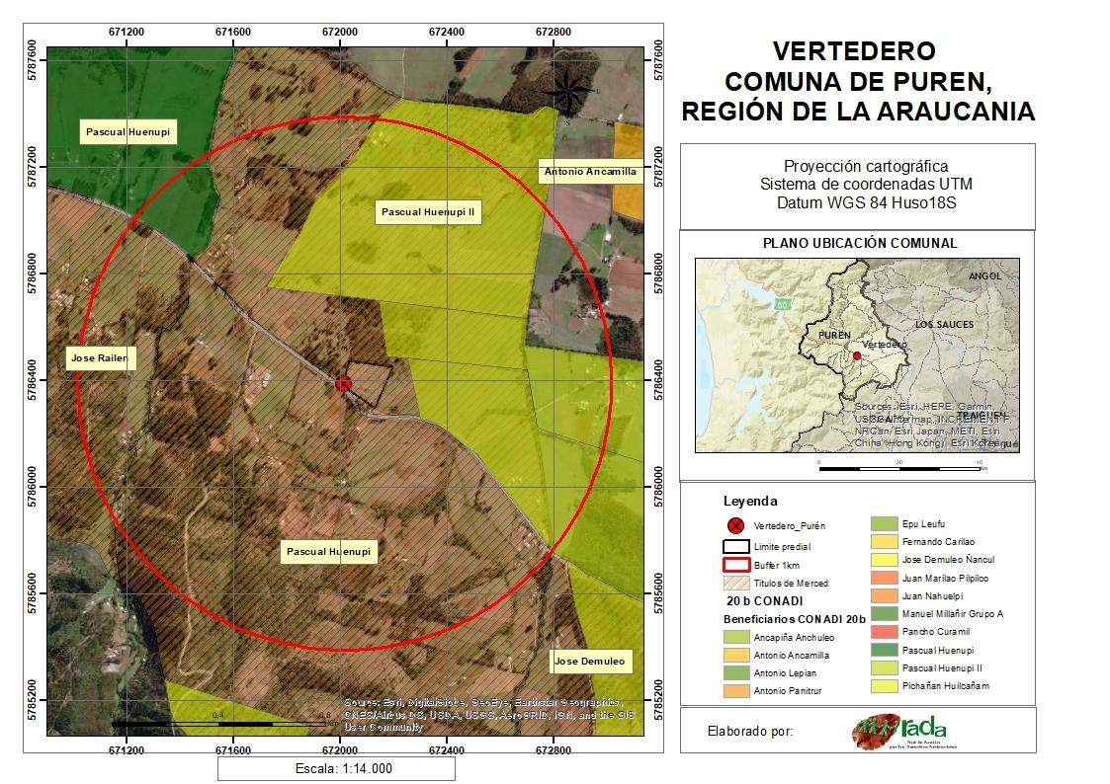

Annex 2. Map of a landfill located in Gorbea commune and Mapuche communities within 3 km.
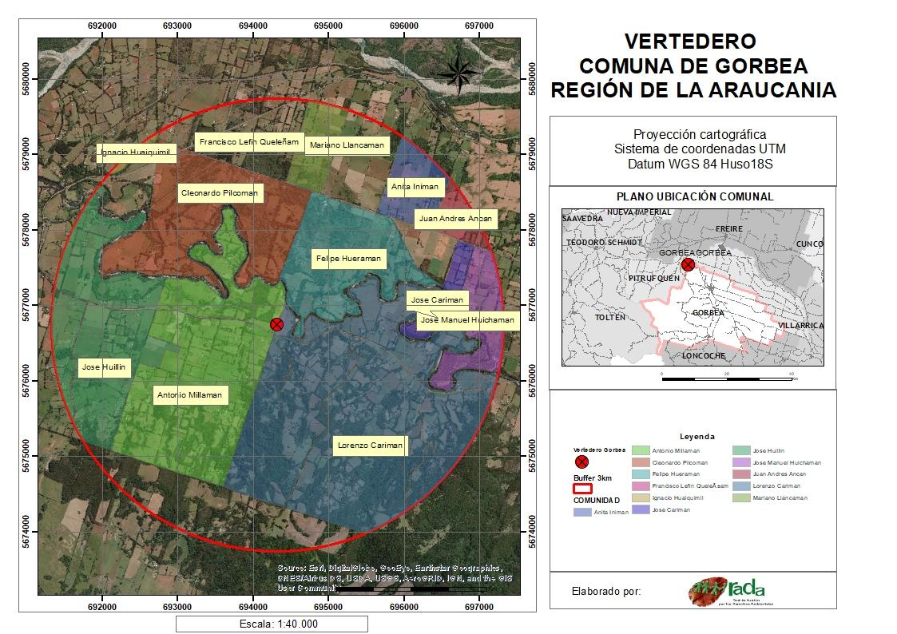

Annex 3. Map of the location of the incinerator, study area and Mapuche communities.



