SHADOW REPORT ON NEPAL’S SEVENTH PERIODIC REPORT ON THE IMPLEMENTATION OF CEDAW (90TH SESSION)

2024 December

Submitted by:

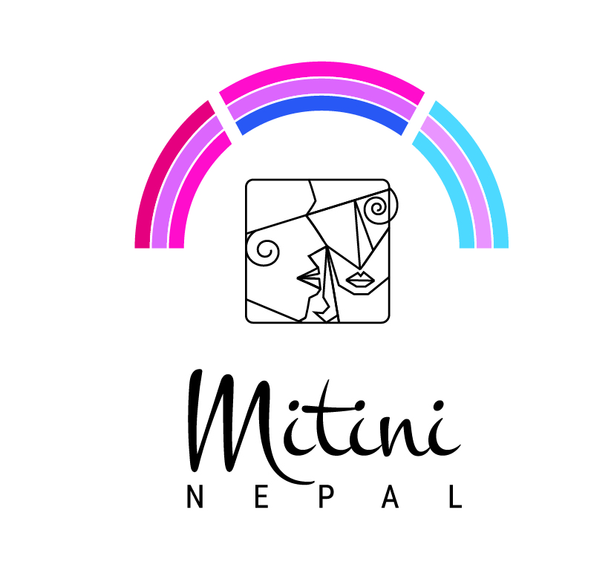

- INTRODUCTION
- This shadow report has been jointly prepared by Mitini Nepal and ILGA World. Mitini Nepal is a non-governmental organization dedicated to promoting the rights, dignity, and well-being of Lesbian, Bisexual, Transgender, and Queer (LBTQ) individuals in Nepal. The organization works tirelessly to address the unique challenges faced by LBTQ persons and advocates for their inclusion, equality, and recognition in society. ILGA World—the International Lesbian, Gay, Bisexual, Trans, and Intersex Association—is a global federation representing over 1,900 organizations from more than 160 countries and territories. The organization campaigns for the human rights of individuals regardless of their sexual orientation, gender identity, gender expression, and sex characteristics (SOGIESC). ILGA World envisions a future where everyone can live in equality, freedom, and dignity, with global justice and equity assured.

- This shadow report complements Nepal's official submission to the CEDAW Committee by highlighting the specific experiences and challenges faced by LBTQ individuals in the country. It seeks to provide an accurate portrayal of their lived realities, focusing on gaps in the implementation of CEDAW obligations as they pertain to sexual and gender minorities. Through this report, Mitini Nepal and ILGA World aim to ensure that the voices of LBTQ individuals are amplified, and their concerns adequately addressed in the Committee's review and subsequent recommendations.

- The report draws on different participatory tools with wide geographical ranges were covered and stakeholders were reached out involving consultative workshops with LBTQ members across all seven provinces of Nepal and a National Validation on CEDAW engaging diverse stakeholders to ensure representation. The contributors from Mitini Nepal are detailed in Annex 1. This report provides an overview of the status and enforcement of the rights of LBTQ women, as outlined in Articles 1-16 of the CEDAW Convention. While acknowledging areas where progress has been made, the report highlights key concerns regarding the protection and promotion of LBTQ women’s rights in Nepal. It also offers recommendations to be considered during constructive dialogue and included in the concluding observations, ensuring Nepal’s alignment with CEDAW and its General Recommendations (GR). This shadow report is a vital tool for holding the government accountable and advocating for policies that uphold the rights and dignity of LBTQ individuals in Nepal where main focus was on state of discrimination, access to health, education, employment and marriage equality.

- THE REPORTING PROCESS
- Mitini Nepal has been coordinating the Independent Shadow Report Writing Process of CEDAW since this year. Mitini Nepal also contributed in shadow report on sixth periodic report of Nepal on CEDAW submitted by CEDAW Shadow Report Preparation Committee (SRPC) on October 2018. As Government of Nepal submitted its seventh periodic report on CEDAW in 2024, Mitini Nepal is all set to submit an independent shadow report. For the purpose, MN conducted province-wise consultation on CEDAW report at all seven provinces with the participation of Lesbian, Bisexual, Transgender and Queer women. Similarly, a National Validation on CEDAW was successfully conducted in 2023 and revalidation on 11 December 2024 with diverse and inclusive participation from different LGBT community based organizations inviting participants from within the capital and outside to discuss the draft Shadow Report and recommendations from provincial consultations. During the national validation, province wise group work was conducted on the basis of the Article of CEDAW they were interested and specifically working on i.e. from Article 1 – 16.

- PREVALENCE OF THE PROBLEM

- The challenges faced by the LGBTI community in Nepal, particularly LBTQ women, are deeply rooted in societal norms and compounded by the inconsistent implementation of progressive legal frameworks. Despite constitutional protections and landmark court rulings aimed at ensuring equality, the practical realization of these rights remains limited. The LGBTI movement, which began in Nepal in 2000, has historically overlooked the specific issues faced by LBTQ women. This marginalization has resulted in inadequate advocacy and support, leaving this group highly vulnerable to social and economic inequalities. Additionally, many discriminatory laws persist, exacerbating their struggles and impeding access to justice, protection, and equality.

- Nepal’s 12th National Census 2021 reported that 2,928 individuals identify as part of gender and sexual minority communities, representing 0.01% of the total population. However, the census fails to recognize these communities within the definition of minorities or to disaggregate data specifically on LBTQ women. This omission contributes to a lack of visibility and policy focus on their unique challenges. Furthermore, LBTQ women are not included under the definition of “single women” after losing a partner, and they are denied marital rights such as spousal entitlements to property, adoption rights, and inheritance. These limitations violate Article 38 of Nepal's Constitution, which guarantees sexual and reproductive health rights for women. The absence of official recognition of same-sex partnerships further compounds these issues. Surviving partners in LBTQ relationships are unable to claim legal rights over shared property, leaving them economically and socially vulnerable. A writ petition to alter the definition on the marriage was filed by Mitini Nepal and the Forum for Women, Law, and Development (FWLD) on December 5, 2022, and the Supreme Court issued a directive on June 28, 2023, for temporary registration of same-sex marriages, these developments highlight the ongoing struggle for equal rights and the slow progress in addressing systemic inequities.

- Additionally, structural inadequacies, such as the lack of systematic data collection, weak monitoring mechanisms, and poor enforcement of Nepal’s obligations under international frameworks like the CEDAW, further entrench the vulnerabilities of LBTQ women. These gaps hinder their access to justice and equality, perpetuating their marginalization despite Nepal's progressive strides towards legal and social reform.

Thus, the problem discussed is the marginalization and systemic inequities faced by LBTQ women in Nepal, despite the country's constitutional and legal protections for gender and sexual minorities. These challenges arise from societal norms, inadequate legal frameworks, poor implementation of progressive laws, and structural inadequacies such as lack of data and enforcement mechanisms. Key issues include discrimination in marital and property rights, exclusion from census recognition and minority definitions, and denial of reproductive health rights, all of which contribute to social and economic vulnerability.

ARTICLE 1
- DISCRIMINATION AGAINST WOMEN

- LBTQ women in Nepal face widespread discrimination, violence, and injustice due to patriarchal and heteronormative mindsets, despite constitutional guarantees of their rights. They lack proper representation, quotas, and state protection, leading to exclusion in health, education, and employment. Social stigma, poverty, and rigid norms force many to hide their identities, face family rejection, and endure human rights violations. Intersectional challenges, including caste, class, and gender biases, further worsen their struggles, while their issues remain unaddressed in laws and policies.
- Despite constitutional guarantees under Articles 12, 18, and 42, Nepal’s LGBTI rights remain unreflect in laws, with existing provisions often regressive. LBTQ women face discrimination, violence, and denial of rights, such as claiming partner’s property or obtaining citizenship based on their gender identity, while authorities often ignore their cases, pushing them further into marginalization. The Constitution has prohibited discrimination on any ground and has amended gender discriminatory legal provisions.
Recommendations

1. The Government of Nepal should enact and enforce comprehensive anti-discrimination laws specifically addressing the rights of LBTQ women, ensuring legal protection from discrimination and violence in all spheres of life, including health, education, employment, and access to services. These laws should explicitly include gender identity, sexual orientation, and gender expression as protected characteristics.
2. Ensure that LBTQ women are adequately represented in political, social, and economic decision-making processes by instituting quotas or affirmative action measures in public office, legislative bodies, and leadership roles across all sectors. The representation of LBTQ women in state mechanism should be a priority in all public service and government bodies.
3. Establish specific state mechanisms for the protection of LBTQ women from violence, harassment, and discrimination. This should include training for law enforcement officials, healthcare providers, and other public service workers on LBTQ rights and gender-sensitive responses to violence and discrimination. Authorities must ensure timely and effective intervention in cases involving LBTQ women.
4. Amend and revise existing laws to explicitly recognize the rights of LBTQ women to inherit property, access partner’s property, and obtain citizenship based on their gender identity. The government should ensure that all legal processes are inclusive and equitable for LBTQ women, particularly concerning inheritance, family rights, and nationality.

ARTICLE 2

- STATE OBLIGATION

- Despite Nepal's recognition as progressive on LGBTI rights, deep-rooted patriarchal mindsets and ignorance among lawmakers hinder real progress. LGBTI individuals still face denial of equal rights to citizenship, marriage, health, education, employment, and social security. Gender equality is often limited to male and female, excluding LBTQ communities. Legal gender recognition, amending regressive laws, and inclusive implementation are essential for addressing these issues.

- Ministry of Women, Children and Senior Citizen plans targeted programs to promote awareness and dignified lives for LGBTI individuals. Despite these efforts, the Government of Nepal still has much to do to address longstanding legal and social challenges faced by the community.

Recommendations

- The Government of Nepal should amend existing laws to allow for legal gender recognition based on self-identification, ensuring that LGBTI individuals, particularly those from the LBTQ community, can access rights and services according to their gender identity. This includes creating a legal pathway for individuals to change their gender on official documents without unnecessary barriers.
- Redefine and expand the understanding of gender equality in Nepal’s legal and policy frameworks to be fully inclusive of LBTQ individuals. The government must recognize and guarantee the rights of LBTQ persons as part of the broader gender equality agenda, addressing disparities in access to citizenship, marriage, health, education, employment, and social security.

ARTICLE 3
- ADVANCEMENT OF WOMEN THROUGH NATIONAL MACHINERY
- Current laws and policies largely overlook LBTQ women, as they are framed within a binary gender understanding, leading to their underrepresentation and marginalization. The lack of specific quotas, comprehensive data, and gender-responsive budgeting at various levels hinders effective policymaking and resource distribution.
- Although the Constitution of Nepal (2015) guarantees LGBTI rights, these provisions are not fully reflected in laws, many of which remain regressive. Article 38 fails to address the unique challenges faced by LBTQ women in accessing education, health, employment, and social security. Sexual and Reproductive Health and Rights (SRHR) issues are also inadequately addressed. While some progress has been made through budget allocations and social security allowances, these measures remain inconsistent.

Recommendations

- Develop and implement targeted policies ensuring the inclusion and representation of LBTQ individuals in decision-making processes.
- Amend the definition of "single women" to explicitly include single LBTQ women enabling equitable access to helpless single women allowances starting at age 60.
- Establish and enforce uniform social security allowances across all provinces for LBTQ women.
- Launch awareness campaigns in order to foster understanding and respect for LBTQ individuals, with a focus on rural areas, aiming for measurable improvement in public attitudes.
- Introduce income-generating and skill-building programs tailored for LBTQ to increase in participants’ economic independence.
- Integrate gender-responsive budgeting into government planning processes in order to address the specific needs of LBTQ individuals effectively.
- Implement a system to collect disaggregated data on LBTQ populations ensuring informed policy decisions and tracking progress on their socio-economic status.

ARTICLE 4

- SPECIAL MEASURES FOR
SUBSTANTIVE EQUALITY

- State agents continue to discriminate, harass, and detain individuals based on sexual orientation and gender identity, fueled by deep-seated prejudice and a lack of understanding of sexual and gender diversity. The government lacks sufficient knowledge about the issues and challenges faced by sexual and gender minorities. Intersectional vulnerabilities of marginalized LBTQ women are overlooked, with no reservations or quotas provided, and sexual minorities are excluded from minority group categorization, depriving them of opportunities.

- No specific laws have been formulated to address LBTQ women as guaranteed and protected by the constitution.

Recommendations

1. The government must draft and enact specific laws that protect LBTQ women from discrimination, violence, and marginalization. These laws should ensure that LBTQ women have equal access to all rights and opportunities, in line with the guarantees provided by the Constitution, particularly in areas such as health, education, employment, and social security.
2. Amend existing laws to recognize LBTQ individuals as a protected minority group under the law, ensuring they are not excluded from benefits, protections, and opportunities available to other minority groups. This includes including LBTQ individuals in data collection, affirmative action programs, and legal frameworks aimed at empowering marginalized communities.
3. The government should design and implement policies that specifically address the intersectional vulnerabilities faced by marginalized LBTQ women. These policies should consider factors such as caste, class, ethnicity, and geographical location, ensuring that marginalized LBTQ women have access to social services, healthcare, education, and economic opportunities.

ARTICLE 5
- SEX ROLES AND STEREOTYPES

- Many are obliged to hide their sexual orientation and gender identity having fear of being expelled from job places and institutional settings. Not being able to address the diversity within women including LBTQ women. No specific laws and policies that directly address Intimate partner violence cases for the LBTQ women. Lack of support mechanism resulting in less reporting about the IPV cases. The larger community still does not respect sexual and gender minorities. Currently within the patriarchal dense society of Nepal LGBTIQ individuals are seen as corrupted or are frowned upon as the larger community assumes that they only spread negativity.
- Safe shelter homes for GBV victims are scarce, and most are neither LGBTI-friendly nor inclusive and accessible. Article 165 of Nepal's Criminal Code 2017 addresses crimes based on discriminatory acts but does not explicitly include discrimination based on gender. OCMC services have been established in all district hospitals to provide support to GBV victims, following a holistic approach. However, while they collect data on male, female, and other categories, they lack disaggregated data specifically for LBTQ women who are victims of domestic and gender-based violence. Additionally, those who have not reached out to OCMC are not benefiting from the available services, and their numbers are not being captured.
Recommendations
Landmark cases in Nepal, such as the 2015 Constitution recognizing gender and sexual minorities, the decriminalization of homosexuality in 2007, and the 2012 legal recognition of "living together" for same-sex couples, have advanced LGBTQ+ rights. However, these rulings haven't been fully translated into laws or protections for LGBTQ+ women. Therefore, there is a need for better implementation of LGBTQ+-inclusive laws and a more LGBTQ+ women-friendly institutional environment.

- The government should work with civil society organizations to establish safe, LBTQ-friendly shelters for victims of gender-based violence (GBV), ensuring these spaces are inclusive, accessible & equipped to handle the unique needs of LBTQ survivors. These shelters should provide comprehensive support services, including legal aid, counseling, and healthcare.
- The government should enact specific laws addressing intimate partner violence (IPV) within the LBTQ community, ensuring legal protections for LBTQ women who face IPV. These laws should ensure that IPV cases within same-sex or gender-diverse relationships are treated with the same seriousness and legal protection as those in heterosexual relationships. The laws should mandate clear procedures for reporting, investigation, and support for LBTQ victims of IPV.
- The government should mandate the collection of disaggregated data on LBTQ individuals who are victims of gender-based violence, particularly within the context of OCMC (One-Stop Crisis Management Center) services. This data should be used to design more inclusive and responsive policies and services for LBTQ survivors of violence, ensuring that they are not overlooked in existing support structures.

ARTICLE 6
G. TRAFFICKING AND EXPLOITATION OF PROSTITUTION

18. No separate law brought by the state till date directly addresses the issues and concerns of the LBTQ women cases related to violence and discrimination. Especially the transwomen are compelled to work as a sex worker and thus are facing various forms of violence including the verbal and sexual abuse and exploitation. Generally, there is a belief that only women are raped but a person can also be raped and it should be the major concern for the government and stakeholders that people’s honor and dignity should be respected. Additionally, societal beliefs that only women can be victims of rape ignore the reality that anyone, regardless of gender, can be sexually assaulted.
Ajita Bhujel, a 29-year-old transwoman, was raped and murdered in Hetauda in January 2020, but the police could not charge the perpetrators with rape due to existing laws recognizing only women or girls as victims. Recently, President Bhandari authenticated an ordinance changing the Criminal Code to include "person," allowing both women and men to be recognized as rape victims.
19. Lesbians, in particular, are also subjected to rape by their own family members in attempts to "correct" their sexuality. There are no laws in Nepal that specifically criminalize prostitution. Laws enacted in the 1980s that criminalize human trafficking inside and outside of Nepal are applied to sex work. The Human Trafficking and Transportation (Control) Act, 2064, Act Number 5, enacted in 2008, criminalizes prostitution and living of the earnings of prostitution by including it in the definition of human trafficking.
Recommendations
- Reform and restructure existing laws to more effectively address trafficking and the exploitation of prostitution with clear mechanisms to protect vulnerable groups.
- Formulate a separate law to specifically prevent and address the sexual exploitation of LBTQ women across various employment sectors.
- Launch targeted legal literacy campaigns focusing on displaced women, disaster-affected women, LBTQ women, and women from geographically disadvantaged areas, aiming to educate 80% of these groups within three years.
- Develop and implement national policies for the rescue, repatriation, rehabilitation, and reintegration of trafficking survivors, addressing both domestic and cross-border cases, with annual evaluations of their effectiveness.

ARTICLE 7
- PARTICIPATION IN POLITICAL AND PUBLIC LIFE

20. Despite Nepal's constitutional provisions ensuring 33% women’s representation in parliaments and 40% in local government, LBTQ women face significant barriers to political participation. Few LBTQ women ran in the 2022 elections, often through female quotas. While the law allows gender marker changes, bureaucratic hurdles make it difficult. Discrimination and hate speech further discourage their involvement in politics.
21. Article 42 of the Constitution mentions the right to social justice, under which provisions for proportional inclusive representation in all state bodies have been made for gender and sexual minorities, among others. However, the diversity within women has not been included in the seats allocated for women.

Recommendations

- Gradually increase participation of LBTQ women in political and public life through the implementation of quotas and reserved seats, and encourage political parties to prioritize LBTQ women as candidates.
- Revise the "Others" category to ensure inclusive and respectful recognition of diverse identities within the LBTQ community.
- Provide equitable social security concessions for LBTQ individuals, aligning them with benefits available to single women, Dalits, elderly people, and other marginalized groups.

ARTICLE 8
- PARTICIPATION OF WOMEN AT THE INTERNATIONAL FORUM

22. Inadequate data and non-identification of the areas to reflect LBTQ women participation in International Forums and the level of effort initiated to promote LBTQ women’s participation. Absence of information among LBTQ women on available opportunities and mechanisms for these positions. Community is not preferred for the choice by the government officials to take part in international forums and platforms.

23.There is no specific quota to participate in an international forum, however as a human right defender, few of them are provided an opportunity to represent their respective organization.
Recommendations
- LBTQ women should have equal and inclusive representation at international forums based on competency, not politicized.
- The community should have representatives in government, parliament and as election candidates. The state must actively conduct initiatives to increase their visibility and involvement.

ARTICLE 9
- NATIONALITY

24. Article 12 of Nepal’s constitution 2015, has guaranteed the right to citizenship based on descent along with gender identity however there is no provision to change the preferred name and gender marker on the citizenship. There is a mandatory requirement for a sex change certificate through gender reassignment surgery to obtain citizenship in the 'others' category, which is not feasible for everyone. Additionally, LBQ women face challenges in acquiring citizenship from their parents, as many do not support or accept their sexual orientation.
25. Transgender individuals can now obtain citizenship in Nepal based on their perceived gender identity, without the need for medical proof. This decision was made by the Supreme Court, which recognized the right of individuals to self-identify their gender. The court ruling allows transgender individuals to have their gender reflected in official documents based on their self-identified gender. However, the community still faces challenges in obtaining citizenship that aligns with their preferred gender.
Recommendations
- Abolish the requirement for a sex change certificate to obtain citizenship under the 'others' category.
- Ensure LBTQ individuals can access official documents, including citizenship, passport, national identity card, PAN card, voter card, and license, reflecting their preferred gender identity.
- Introduce flexible state mechanisms to grant citizenship to LBTQ women whose parents deny them citizenship upon disclosure of their SOGI.

ARTICLE 10
L. WOMEN AND EDUCATION
26. Nepal's education system lacks safe and inclusive spaces for LBTQ students, especially transgender individuals who face challenges like restrictive uniform policies, lack of gender-neutral toilets. LBTQ students, particularly transgender youth, experience bullying, abuse, and homophobic ridicule, leading to absenteeism, dropouts, and mental health issues.
27. Article 31 of constitution of Nepal 2015 has guaranteed the right of access to basic education however the LBTQ women are still deprived of higher education as soon as they disclose their identity and sexual orientation due to harassment and bullying at educational institutions.
Recommendations

- Educational institutions should implement mandatory training for both staff and students on LGBTQ issues, focusing on fostering an inclusive and respectful environment. This training should cover topics such as sexual orientation, gender identity, and the importance of combating homophobia and transphobia.
- Schools and universities should establish robust protection mechanisms to prevent and address homophobic and transphobic bullying. Clear anti-bullying policies should be enforced at all levels of education to create safe spaces for LGBTQ students.
- To promote diversity and inclusion, educational institutions should introduce scholarships and quotas specifically for sexual and gender minority students. This would provide greater opportunities for LGBTQ individuals to access higher education.
- Institutions should adopt quotas to ensure the recruitment of LGBTQ teachers and professionals, ensuring diverse representation and role models in educational environments.
- Comprehensive Sexual Education (CSE) curricula should be updated to include content on sexual orientation, gender identity, and LGBTQ issues. This should be integrated across all levels of education to foster understanding and acceptance from an early age.
- Educational institutions should provide in-house psychologists trained in supporting LGBTQ students. These professionals should offer confidential mental health services tailored to the unique challenges faced by LGBTQ individuals.
- Institutions should ensure the availability of gender-friendly washroom facilities for transgender students, promoting inclusivity and comfort for all students, regardless of gender identity.

ARTICLE 11
M. WOMEN AND EMPLOYMENT
28. Social stigma against the LBTQ community hampers their income, with many facing discrimination in service industries like beauty salons and food service. This stigma affects their self-esteem, mental health, and work quality. Many LBTQ individuals work in informal sectors with no contracts, low wages, and no benefits or health insurance, making them economically vulnerable. Workplace harassment, fear of job loss, and lack of acceptance lead many to hide their sexual orientation.
29. Article 33 of Constitution of Nepal 2015 has guaranteed that every citizen shall have the right to choose employment and unemployment benefits shall be provided for in the Federal Law.
Recommendations

- Amend the Labor Act 2017 to ensure gender equality and equal pay for all genders.
- Strengthen policies to protect LBTQ individuals in foreign employment.
- Expand the Sexual Harassment at Workplace Prevention Act, 2015, to include schools, hospitals, and other institutions, with specific measures to prevent harassment of LGBTIQ individuals.
- Penalize workplace discrimination and ensure LBTQ individuals have access to loans, financial aid, and training for income-generating activities.
- Ensure employment opportunities are based solely on academic qualifications.
ARTICLE 12

N. SEXUAL AND REPRODUCTIVE HEALTH

30. Nepal's healthcare system lacks LBTQ-sensitive services and trained professionals, with forms only offering "male" and "female" options, ignoring LBTQ health needs. Transgender individuals face health challenges, such as hormone-related complications and mental stress. The lack of access to psychological support and counseling, especially during transition, exacerbates emotional trauma and leads to depression and anxiety. Additionally, current SRHR programs focus mainly on safe motherhood, pregnancy, menstruation and family planning, overlooking the unique SRHR needs of LBQ women.

31. Article 35 of Nepal Constitution 2015 has guaranteed rights relating to health stating that every citizen has the right to free basic health services from the state and no one shall be deprived of emergency health services. The Curriculum Development Center in Nepal has integrated Comprehensive Sexuality Education (CSE) into the textbooks from Grade 6 to Grade 10. For Grades 6 to 8, it is included under the subject of Physical and Health Education. However, for Grades 9 and 10, CSE is offered only as an optional subject.
Recommendations
- Medical forms should be revised to include inclusive gender options, and health professionals must be trained to ensure proper service, diagnosis and care for the LBTQ community.
- The government should introduce inclusive programs covering comprehensive sex education, fertility counseling, hormone therapy, sex education, and other tailored services for LBTQ community members.
- The Government of Nepal should ensure universal access to safe abortion and reproductive health services for LBTQ women under the Right to Safe Motherhood and Reproductive Health Act, 2018.
- The healthcare system must be inclusive, addressing LBTQ health needs, improving access to basic care and ensuring a safe, non-discriminatory environment. Health institutions should adopt policies that provide inclusive sexual and reproductive health services, and healthcare providers should be trained and sensitized to the unique needs of the LBTQ community.

ARTICLE 13

O. ECONOMIC AND SOCIAL BENEFITS

32. Article 18 provides for the right to equality. It says that no person shall be denied ‘equal protection of the law’ and that discrimination on protected grounds is prohibited. The provision says that this shall not prevent special provisions for the ‘protection, empowerment or development’ of gender and sexual minorities. However, people of this community are still denied basic human rights to marriage, employment and social security. There is no provision of single women allowance for LBTQ women. LBTQ couples in Nepal face significant challenges when it comes to property rights and financial matters due to the lack of full marriage equality. They do not receive tax discounts or benefits typically afforded to married couples, and they are unable to designate each other as nominees on bank accounts.
33. Article 43 has guaranteed right to social security stating that indigent citizen, incapacitated and helpless citizens, helpless single women, citizen with disabilities, children, citizen who cannot take care themselves and citizens belonging to the tribes on the verge of extinction shall have the right to social security, in accordance with law.
Recommendations

- The government should address LBTQ rights by enacting anti-discrimination laws, mainstreaming LBTQ concerns in health, education and employment and ensuring access to social services.
- Policies should include equal wages, employment quotas and dignity rights.
- Additionally, low-interest loans for LBTQ women’s businesses and awareness campaigns promoting positive representations are essential.

ARTICLE 14
P. RURAL WOMEN

34. Conflict with their self-identity issues. Lack of Safe Space to share their sexual orientation and gender identity. Lack of networking agencies and government organizations working for the community.

35. Nepal has three tiers of government including the federal, provincial and local while the local government has also given the power authority and local government has included the minorities community in its programs.
Recommendations
- Safe space should be provided to rural LBTQ women in order to communicate their confusion regarding their identity.
- Strong network and rapport building should be increased. Different awareness raising campaigns and programs should be enacted at local and ground level.

ARTICLE 15
Q. EQUALITY BEFORE LAW

36. The Supreme Court of Nepal issued directive orders to the Government of Nepal to end discrimination against people of different sexual orientation or gender identity in 2007 decriminalizing homosexuality. The National Civil Code Act, 2017 states that every citizen shall be equal before the law. However sexual and gender minorities communities are facing discrimination due to regressive policies and laws not reflected in act.

37. Article 18 of the Constitution of Nepal 2015 has guaranteed the right to equality stating that all citizens shall be equal before law. No persons shall be denied the equal protection of law. No discrimination shall be made in the application of general laws on grounds of origin, religion, race, caste, tribe, sex, physical condition of health, marital status, pregnancy, economic condition, language or region, ideology or on similar other grounds.
Recommendations
1. The state should remove barriers preventing LBTQ women from owning property, obtaining insurance, or opening bank accounts.
2. Legal rights must be updated to allow LBTQ individuals to marry, obtain documents reflecting their gender identity, and access legal recognition of child adoption.
3. Government should ensure protection against violence and provide equal legal rights for all.
ARTICLE 16

R. MARRIAGE AND FAMILY RELATION

38. Section 67 of the National Civil Code defines marriage as “a man and a woman accepting each other as husband and wife”. This denial of marriage equality limits the rights of sexual and gender minorities. Despite some progress, the government and lawmakers lack understanding of the importance of marriage equality. The legal provisions in the constitution supporting equality are not reflected in laws, and many LGBTIQ individuals face rejection and abandonment by their families after disclosing their identities.

39. Mitini Nepal and the Forum for Women, Law, and Development jointly filed a writ petition on December 5, 2022, with the Government of Nepal, the Ministry of Law, and the Federal Parliament as respondents, demanding full legal recognition of same-sex marriage. Another petition was filed in the Supreme Court demanding the registration of marriages with gender identity, and on July 28, 2023, the Supreme Court ruled in favor of allowing temporary registration of same-sex marriages. In response, the Government of Nepal, through the Ministry of Home Affairs, directed local registrar offices to facilitate the registration of temporary marriages accordingly. As a result, some couples from the community have successfully registered their marriages. While this decision has provided some justice to the community, it is not a permanent solution, as LBTQ couples still face significant challenges in obtaining all the rights related to marriage that heterosexual couples enjoy.
Recommendations
- Amend Section 67 of the National Civil Code 2017, which defines marriage, to align with Article 18 of the Constitution, "Right to Equality," and provide full legal recognition to same-sex marriage.
- Gender neutral terms like "couple" instead of “husband and wife", "guardian" instead of using "mother and father," should be used to ensure gender inclusivity.
- Provide legal recognition of child adoption to couples from gender and sexual minority communities to enable them to form a family.
- Ensure equal property rights for gender and sexual minority couples allowing them to claim ownership of their partner's property, similar to the rights enjoyed by heterosexual couples in marriage.
- There should be a provision allowing community member to seek divorce if they are forcedly married.

ANNEXES
ANNEX 1
CONTRIBUTORS FROM MITINI NEPAL
Laxmi Ghalan
Sarita KC
Bimala Gurung
Samjhana Kumari Bishwakarma

ANNEX 2
PART OF REPORTING PROCESS (LIST OF LBT ORGANIZATIONS)
Sahara Samaj
Pariwartanshil Samaj
Jeevan Rekha Sewa Samaj
Sahayogi Samaj
Saino Nepal
Manav Sachet Samaj
Friends Hetauda
Maya Ko Sansar
Naulo Bihani
Eklo Lai Sahara Diney Brichhya Samuha
Sahasi Kadam Nepal
Naulo Srijana Nepal
Farak Pahichan Samaj Nepal
BDS Surkhet
Ekata Nepal
Sudurpaschim Samaj
Sahayatra Nepal

ANNEX 3
Sukmaya’s Struggle for Recognition and Support
Sukmaya Magar, a 54-year-old lesbian woman from Devghat, Tanahun has faced isolation and hardship since the death of her partner three years ago. Despite their loving partnership of almost three decades, Sukmaya is denied the single women’s allowance because same-sex relationships are still not legally recognized in Nepal. She cannot provide proof of their relationship and, as a result, is excluded from benefits meant for helpless single women. Sukmaya hopes for a law that supports single women in same-sex relationships and easier access to affordable healthcare.
ANNEX 4
A Lesbian Woman’s Plea for Citizenship
Puja is a lesbian woman who has been living with her partner over 17 years in Lumbini Province, Rupandehi. They consider each other husband and wife, but their marriage is not legally recognized. Puja has not been able to obtain citizenship. Puja’s father suggests she should get citizenship through her partner, but at 36, she still lacks it. This absence of citizenship deprives her of basic rights and services. Living openly as a couple from the sexual and gender minority community, the couple have adopted a daughter. However, due to the lack of legal recognition of their relationship, their daughter’s birth certificate remains unregistered.
ANNEX 5
A Call for Justice: Demand for Marriage Recognition
Sital Thapa and her partner have been together for eight years. They wish to legally register their marriage, but the state still denies legal and social rights to sexual and gender minority communities. Despite their commitment to each other, they are unable to adopt a child or access basic rights due to the lack of legal recognition. They face challenges like opening a bank account without proof of relationship. This couple call on the government to make marriage registration and other legal rights accessible to couples like them, or else they will continue to fight for their rights.

ANNEX 6
When Protection Becomes Abuse
Maya (name changed) is a third-gender sex worker from the sexual and gender minority community. One day, while she was at a restaurant in Swayambhu, she was taken by the DSP of the area. He subjected her to abuse, asking degrading and inappropriate questions such as, "What does your inner body look like? Like a man or a woman?" This verbal abuse was followed by both physical and mental violence. In a place where the community should feel safe to seek justice and protection, Maya became a victim of violence instead. It is deeply painful that the police administration, who are supposed to protect us by law, are the ones perpetrating such acts. This incident raises the critical question: where can as a community go to seek justice and demand their rights when the very authorities that should protect them turn against them?

Provincial Consultations on Draft Shadow Report
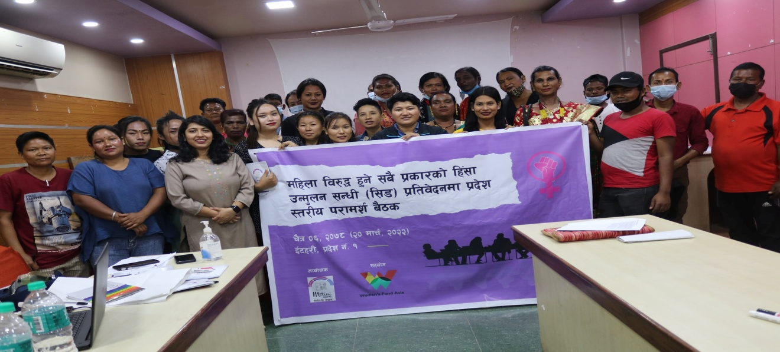
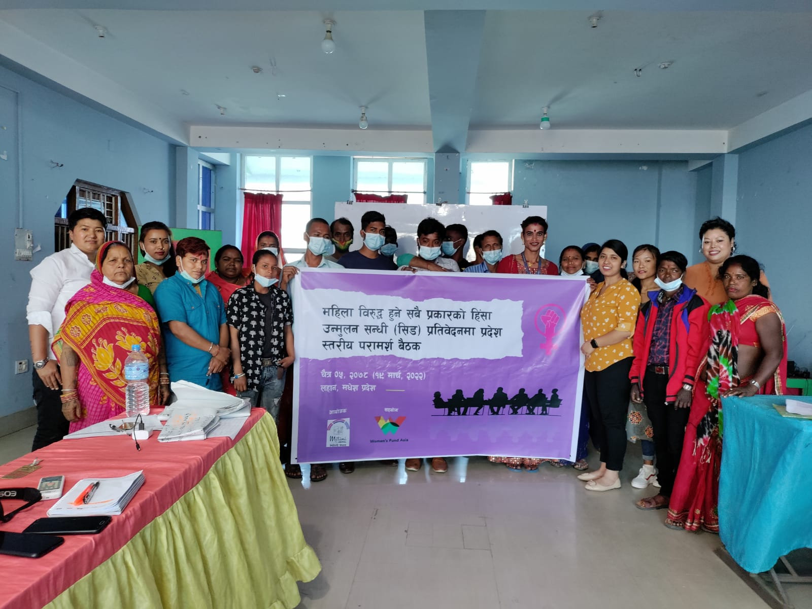
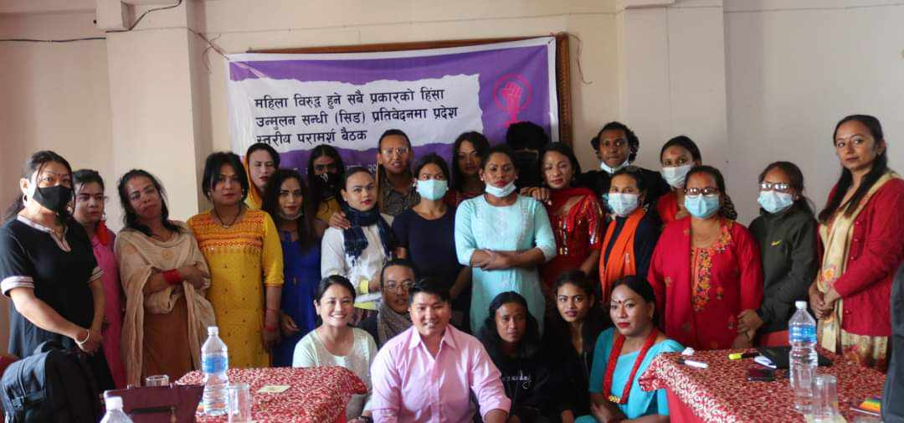
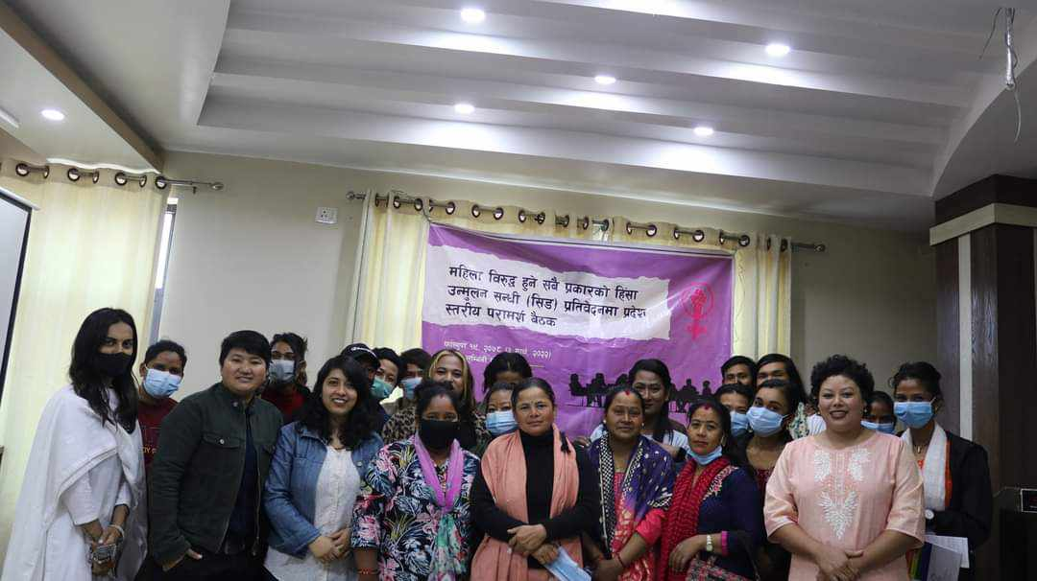
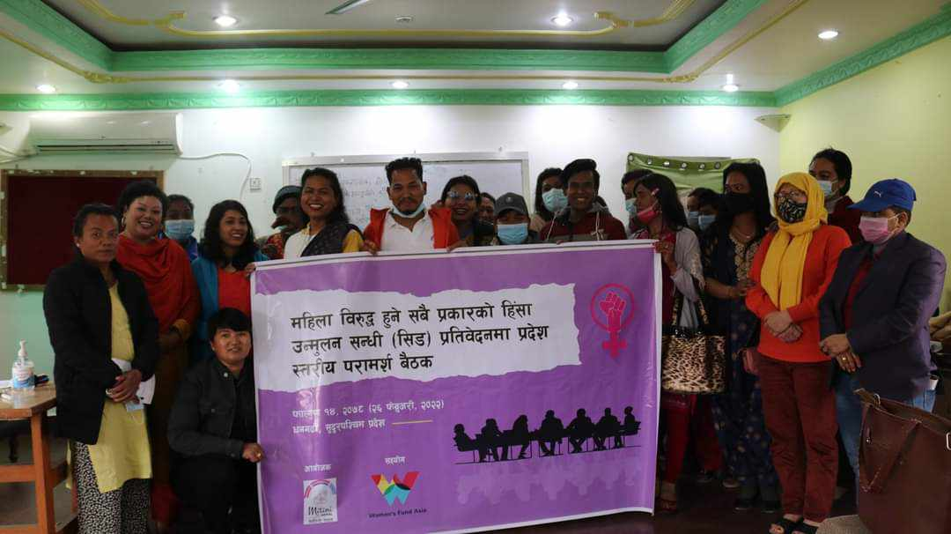

National Validation on Draft Shadow Report
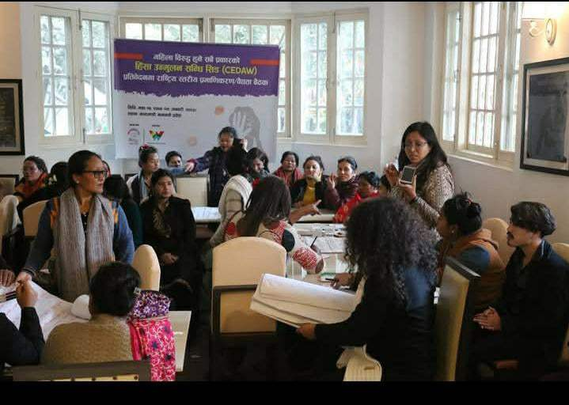

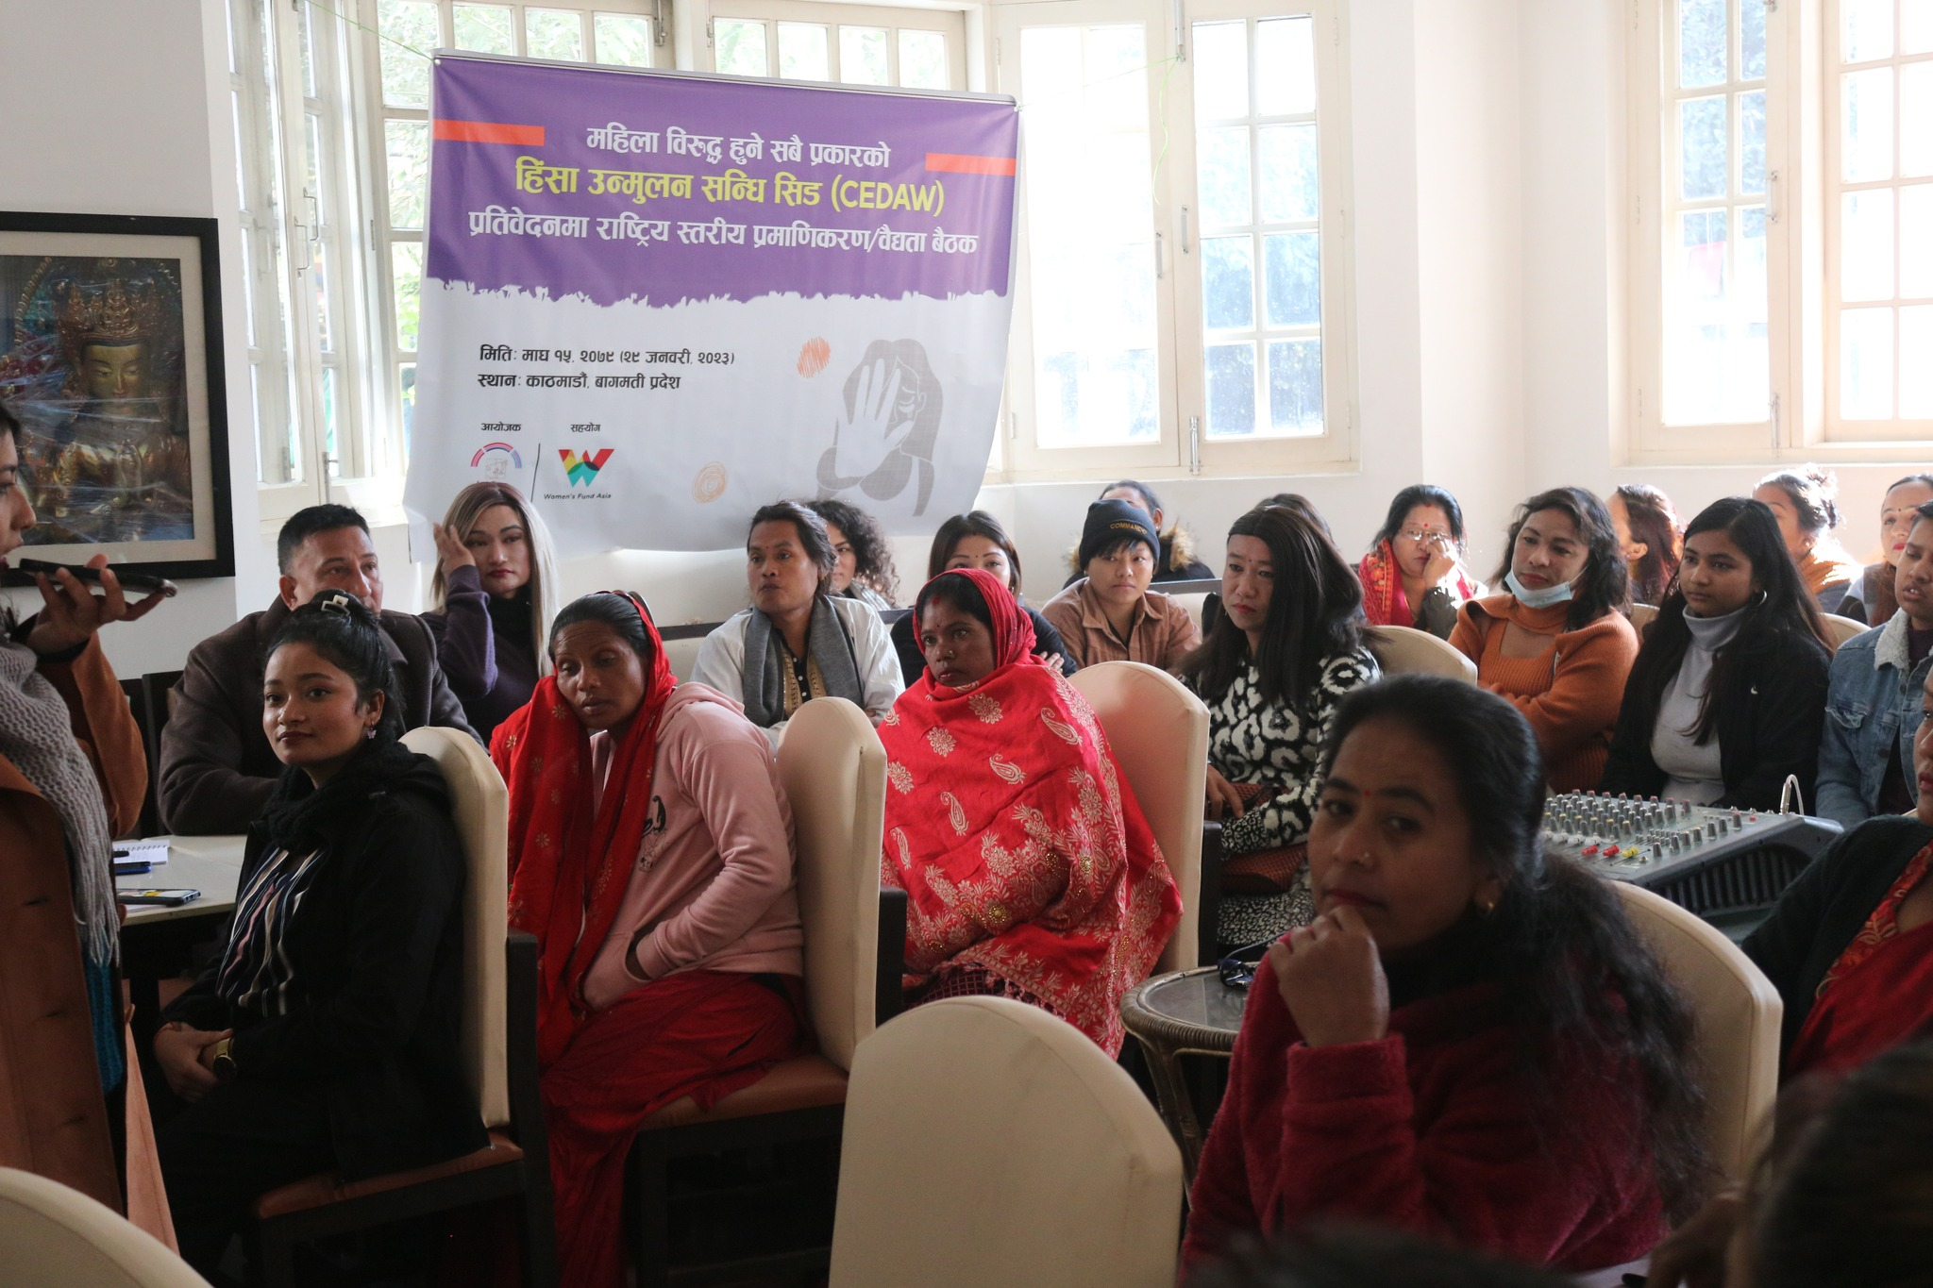
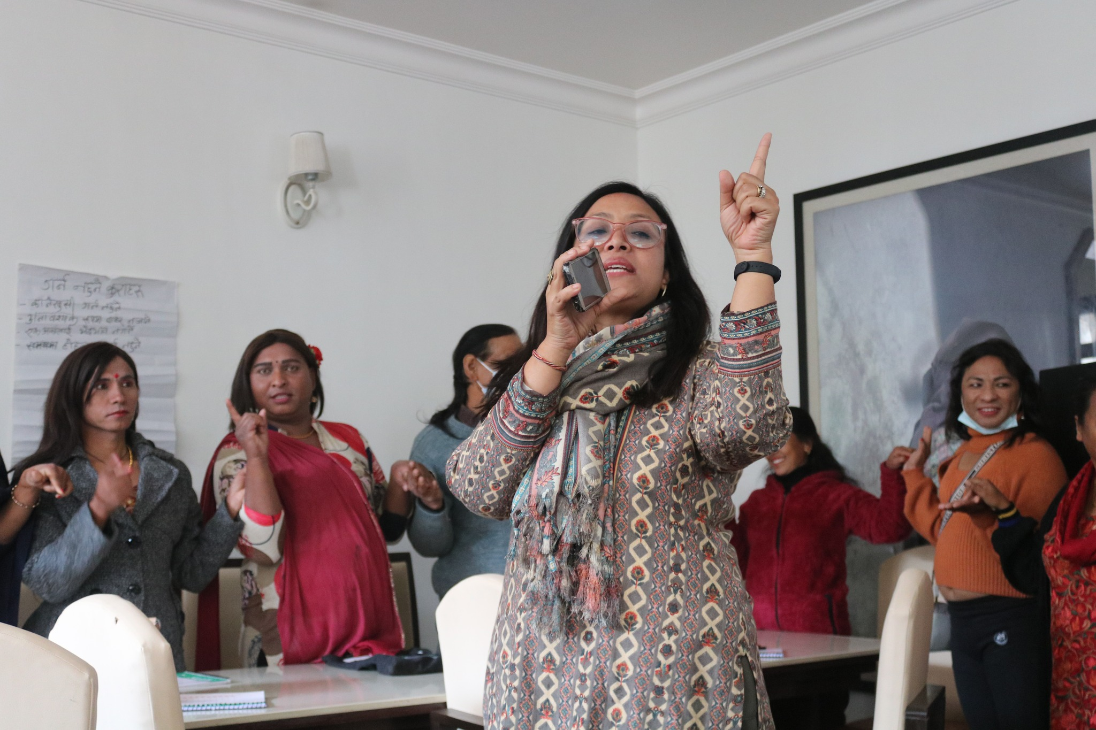

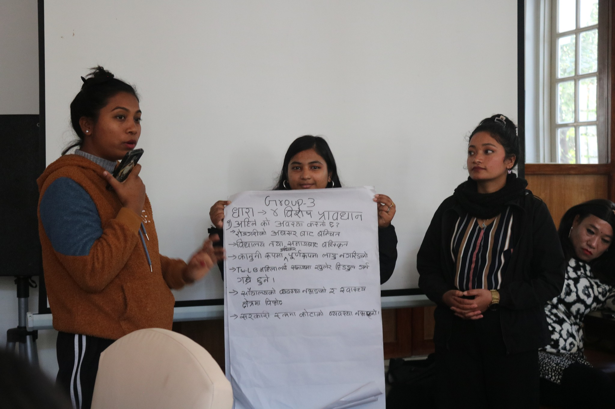
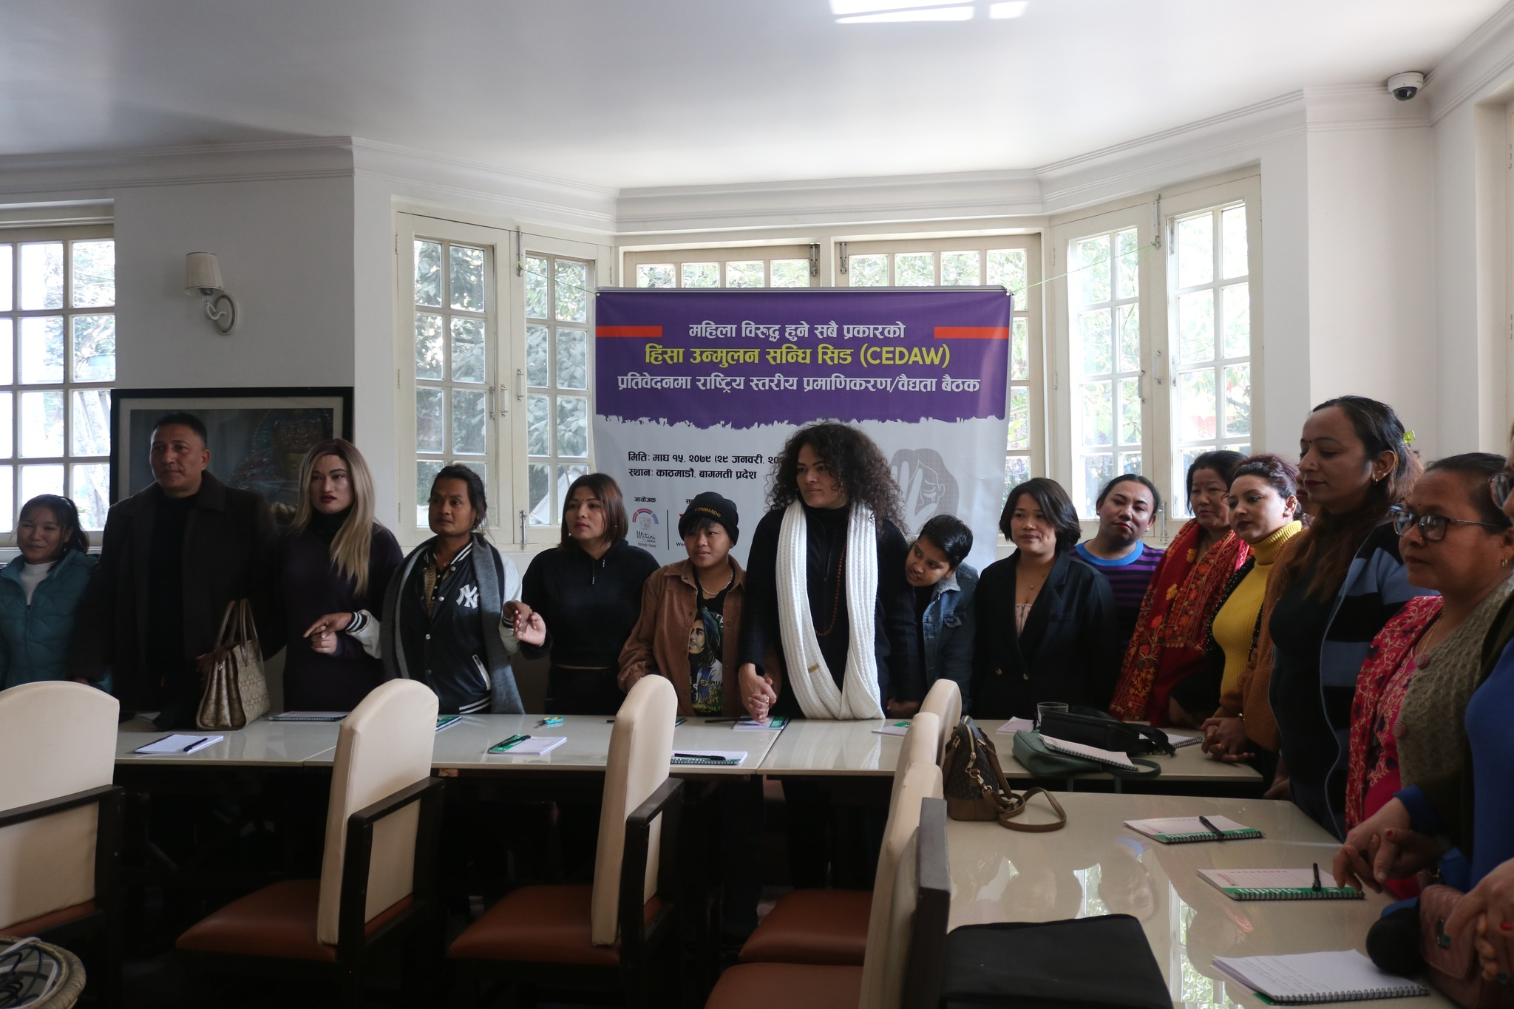

National Population and and Housing Census 2021 Results
Marriage equality writ petition – Marriage Equality
SC interim order legalises same sex marriage in Nepal - The Himalayan Times - Nepal's No.1 English Daily Newspaper | Nepal News, Latest Politics, Business, World, Sports, Entertainment, Travel, Life Style News
Article 18 of the Constitution prohibits discrimination on various grounds. The National Civil Code (2017), Sections 17-19, ensures equality, protection against discrimination, and affirmative action, while Sections 160-161 of the Penal Code (2017) criminalize discrimination.
Helpless Single Woman Allowance: (1) The following helpless single women who have completed the age of sixty years shall get the helpless single woman allowance in a sum as specified by the Government of Nepal as the social security allowance as prescribed: (a) Who have not had second marriage after getting divorced, (b) Widows, (c) Who are living upon getting legal separation, (d) Unmarried. The Social Security Act, 2075 (2018), Chapter 2 - Social Security, Section 7.
IPV-research-on-Lesbian-and-transman-couple-in-Nepal_Mitini-Nepal.pdf
Criminal Code, 2074 | Nepal Law Commission
Nepal sets historic precedent, legalises same-sex unions | SabrangIndia
Ordinance amends law on rape but fails to recognise rape of boy child and sexual minorities
PROSTITUTION AND SEX TRAFFICKING IN NEPAL | Facts and Details
Right to social justice: (1) Socially backward women, Dalits, Adibasi, Janajati, Adibasi Janajati, Madhesi, Tharu, minority groups, persons with disability, marginalized groups, Muslim, backward classes, gender and sexually minority groups, youths, peasants, laborers, the oppressed and the citizens of backward regions, and economically poor Khas Arya shall have the right to employment in state structures on the basis of the principle of inclusion.
Citizenship based on descent and gender identity: According to this Constitution, a person who acquires citizenship of Nepal by descent may obtain citizenship certificate of Nepal in the name of his/her mother or father with gender identity.
Nepal Supreme Court Rules Trans Woman Is a Woman | Human Rights Watch
Right to education: (1) Every citizen shall have the right to access to basic education. (2) Every citizen shall have the right to compulsory and free basic education, and free education up to the secondary level. (3) The physically impaired and citizens who are financially poor shall have the right to free higher education as provided for in law. (4) The visually impaired person shall have the right to free education with the medium of brail script. (5) Every Nepali community living in Nepal shall have the right to acquire education in its mother tongue up to the secondary level, and the right to open and run schools and educational institutions as provided for by law.
Right to employment: (1) Every citizen shall have the right to employment. Terms and conditions of employment and unemployment benefits shall be as determined by Federal law. (2) Every citizen shall have the right to select employment.
Right to health care: (1) Every citizen shall have the right to seek basic health care services from the state and no citizen shall be deprived of emergency health care. (2) Each person shall have the right to be informed about his/her health condition with regard to health care services. (3) Each person shall have equal access to health care. (4) Each citizen shall have the right to access to clean water and hygiene.
Safe Motherhood Act in English.pdf
Right to equality: (1) All citizens shall be equal before law. No person shall be denied the equal protection of law. (2) There shall be no discrimination in the application of general laws on the grounds of origin, religion, race, caste, tribe, sex, physical conditions, disability, health condition, matrimonial status, pregnancy, economic condition, language or geographical region, or ideology or any other such grounds. (3) The state shall not discriminate among citizens on grounds of origin, religion, race, caste, tribe, sex, economic condition, language or geographical region, ideology and such other matters. Provided that nothing shall be deemed to bar the making of special provisions by law for the protection, empowerment or advancement of the women lagging behind socially and culturally, Dalits, Adibasi, Madhesi, Tharus, Muslims, oppressed class, backward communities, minorities, marginalized groups, peasants, laborers, youths, children, senior citizens, sexual minorities, persons with disability, pregnant, incapacitated and the helpless persons, and of the citizens who belong to backward regions and financially deprived citizens including the Khas Arya.
Civil-code-1.pdf
Marriage deemed to be concluded: If a man and a woman accept each other as the husband and wife through any occasion, ceremony, formal or other act, a marriage shall be deemed to have been concluded.
SC interim order legalises same sex marriage in Nepal - The Himalayan Times - Nepal's No.1 English Daily Newspaper | Nepal News, Latest Politics, Business, World, Sports, Entertainment, Travel, Life Style News

