Annexes to the replies of the Government of the Republic of Moldova
to the List of issues in relation to the sixth periodic report of the Republic of Moldova
on the implementation of the Convention on the Elimination of all Forms of Discrimination Against Women
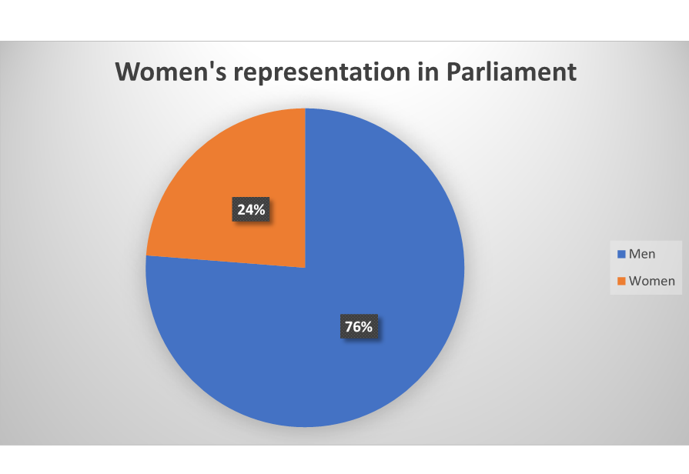
Women’s representation in the Government - 2019
Prime minister | Women | Men | Total members
Pavel Filip (until 08.06.2019) | 6 | 11 | 17
Maia Sandu (08.06.2019-14.11.2019) | 7 | 6 | 13
Ion Chicu (from 14.11.2019) | 2 | 10 | 12

Table 1. Share of protection ordinances issued by the court during 2018 and the first 6 months of 2019
Category/Year | 2018 | 6 months 2019
Total issued | 666 | 285
Violated protection ordinances | 408 | 140
Executed protection ordinances | 239 | 145

Table 2. Share of emergency protective orders (EPOs) issued by the police
Category/Year | 2018 | 6 months 2019
Total issued | 3877 | 2118
Violated EPO | 414 | 178
Executed EPO | 3463 | 1940

Table 3. The number of sex crimes during 12 months of 2017
SEX CRIMES | Total registered | Criminal prosecution has ended |  |  |  |  |  | Total persons ident.
SEX CRIMES | Total registered | Total | Sent to trial | Ceased | Classified | Conditionally suspended | Sent to another state | Total persons ident.
Art. 171 - Rape | 301 | 188 | 112 | 47 | 29 |  |  | 149
Art. 172 - Violent Actions of a Sexual Character | 89 | 40 | 30 | 4 | 6 |  |  | 42
Art. 173 - Coercion to Actions of a Sexual Character | 29 | 15 | 11 | 3 | 1 |  |  | 9
Art. 174 - Sexual Intercourse with a Person under the Age of 16 | 125 | 71 | 53 | 6 | 12 |  |  | 55
Art. 175 - Perverted Actions | 44 | 19 | 12 | 3 | 4 |  |  | 12
Art. 175-1 - Berthing children for sexual purposes | 4 | 2 | 1 |  | 1 |  |  | 1
T O T A L | 592 | 335 | 219 | 63 | 53 |  |  | 268

Table 4. The number of sex crimes during 12 months of 2018
SEX CRIMES | Total regist. C. year | CRIMINAL PROSECUTION HAS ENDED |  |  |  |  |  | Total pers. Ident.
SEX CRIMES | Total regist. C. year | Total | Sent to trial | Ceased | Classified | Conditionally suspended | Sent to another state | Total pers. Ident.
Art. 171 - Rape | 266 | 143 | 77 | 31 | 35 |  |  | 109
Art. 172 - Violent Actions of a Sexual Character | 110 | 61 | 45 | 7 | 9 |  |  | 52
Art. 173 - Coercion to Actions of a Sexual Character | 34 | 21 | 12 | 5 | 4 |  |  | 8
Art. 174 - Sexual Intercourse with a Person under the Age of 16 | 138 | 90 | 73 | 3 | 14 |  |  | 71
Art. 175 - Perverted Actions | 57 | 27 | 22 | 1 | 4 |  |  | 17
Art. 175-1 - Berthing children for sexual purposes | 7 | 1 |  |  | 1
T O T A L | 612 | 343 | 229 | 47 | 67 |  |  | 257

Table 5. Number of sex crimes during 12 months of 2019
Sex crimes | Total regist. C.year | Criminal prosecution has ended |  |  |  |  |  | Total pers. ident
Sex crimes | Total regist. C.year | Total | Sent to trial | Ceased | Classified | Condit. Suspended | Sent to another state | Total pers. ident
Art. 171 - Rape | 150 | 58 | 30 | 21 | 7 |  |  | 43
Art. 172 - Violent Actions of a Sexual Character | 45 | 10 | 9 | 1 |  |  |  | 9
Art. 173 - Coercion to Actions of a Sexual Character | 10 | 3 | 2 |  | 1
Art. 174 - Sexual Intercourse with a Person under the Age of 16 | 66 | 28 | 25 |  | 3 |  |  | 20
Art. 175 - Perverted Actions | 25 | 9 | 9 |  |  |  |  | 5
Art. 175-1 - Berthing children for sexual purposes | 6 | 2 | 1 | 1 |  |  |  | 1
T O T A L | 302 | 110 | 76 | 23 | 11 |  |  | 78

Table 6. Information on the intermediate result for the years 2018-2019 according to the National Program for the social inclusion of people with disabilities
Year | Number of beneficiaries (women) employed | Number of beneficiaries who gave birth, being placed | Number of beneficiaries (women) placed in alternative services | Total
2018 | 18 | 1 | 16 | 35
2019 | 12 | 2 | 8 | 22

