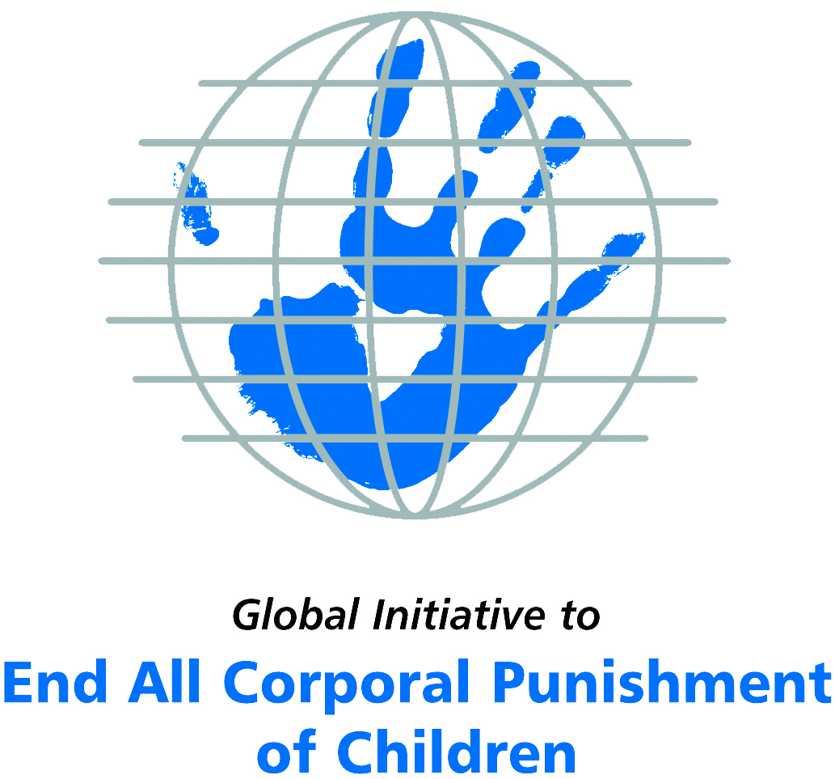
Briefing on the Philippines for the Committee on the Rights of Persons with Disabilities, 9th Pre-Sessional Working Group, March 2018
From the Global Initiative to End All Corporal Punishment
of Children, January 2018

(a) About the Global Initiative to End All Corporal Punishment of Children
1. The Global Initiative (www.endcorporalpunishment.org) promotes universal prohibition and elimination of corporal punishment in fulfilment of states’ obligations under the UN Convention on the Rights of the Child and other international treaties. Our aims are supported by UNICEF, UNESCO, human rights institutions and international and national NGOs. Since 2002, the Global Initiative has regularly briefed the Committee on the Rights of the Child on this issue, and since 2004 has similarly briefed the Committee Against Torture, the Committee on the Elimination of Discrimination Against Women, the Committee on Economic, Social and Cultural Rights, the Human Rights Committee and the Human Rights Council; we have briefed the Committee on the Rights of Persons with Disabilities since the beginning of its work.

(b) Summary
2. Corporal punishment of children in the Philippines is unlawful in all settings outside the home but it is not yet fully prohibited in the family, in violation of the fundamental right of all children to protection from corporal punishment and other cruel or degrading forms of punishment.
3. With reference to articles 7, 15, 16 and 17 of the Convention on the Rights of Persons with Disabilities, and in light of the particular vulnerability of children with disabilities to corporal punishment by adults, the jurisprudence of the UN treaty bodies, the emphasis on eradicating this form of violence given by the UN Secretary General’s Study on Violence against Children and the importance of the issue to achieving target 16.2 on ending violence against children in the 2030 Sustainable Development Goals, we hope the Committee on the Rights of Persons with Disabilities will:
- include the issue of corporal punishment in its List of Issues for the Philippines, in particular asking: “what steps are being taken to ensure the enactment of the Bill to explicitly prohibit all corporal punishment of children currently being discussed in Congress?”
- recommend to the Government of the Philippines, in the Committee’s concluding observations on the initial report, that “the Bill to explicitly prohibit all corporal punishment of children, however light, in all settings, is enacted as a matter of priority and that measures are put in place to ensure the law is properly implemented”.

(c) Detailed briefing
The right of children with disabilities not to be subjected to corporal punishment
4. The Convention on the Rights of Persons with Disabilities confirms that children with disabilities should enjoy all human rights and fundamental freedoms on an equal basis with other children (art. 7). The Convention also states that all persons have the rights to freedom from torture or cruel, inhuman or degrading treatment or punishment (art. 15), to freedom from exploitation, violence and abuse within and outside the home (art. 16) and to respect for their physical and mental integrity (art. 17). The jurisprudence of treaty monitoring bodies, led by the Committee on the Rights of the Child monitoring the Convention on the Rights of the Child, is clear that these rights put an obligation on states parties to prohibit and eliminate all corporal punishment of children, including within the family. However, the Philippines’ initial state report does not address the issue.
5. As confirmed in the UN Secretary General’s Study on Violence against Children, children with disabilities are particularly vulnerable to violence, including corporal punishment, and corporal punishment is a significant cause of impairment among children. Yet the obligation to prohibit corporal punishment is frequently ignored or evaded by governments. The near universal acceptance of violence in childrearing together with deeply held views that parents and other adults have a “right” to physically punish children can challenge efforts to achieve prohibition. It also means that corporal punishment – at least to some degree – is not readily perceived as violence in the same way as, for example, sexual and other socially unacceptable forms of violence.
6. The newly adopted Sustainable Development Goals under the 2030 Agenda include target 16.2 on ending all forms of violence against children. Violent punishment is the most common form of violence against children: ending it through the adoption and implementation of legislation prohibiting it in all settings including the home is critical.

The legality of corporal punishment of children with disabilities in the Philippines
7. In the Philippines, corporal punishment of children is unlawful in all settings outside the home, but children with disabilities may lawfully be subjected to physical punishment in the family.
8. Corporal punishment is lawful in the home. There are a number of legal defences for the use of corporal punishment in childrearing. The Family Code 1987 states that the rights and duties of those exercising parental authority over children include “to impose discipline on them as may be required under the circumstances” (art. 220). The Child and Youth Welfare Code 1974 confirms the right of parents “to discipline the child as may be necessary for the formation of his good character” (art. 45). The Code of Muslim Personal Laws confirms parents’ “power to correct, discipline, and punish [their children] moderately” (art. 74); the Revised Penal Code states that the higher penalties for serious physical injuries “shall not be applicable to a parent who shall inflict physical injuries upon his child by excessive chastisement” (art. 263); the Rules and Regulations on the Reporting and Investigation of Child Abuse Cases state that “discipline administered by a parent or legal guardian to a child does not constitute cruelty provided it is reasonable in manner and moderate in degree and does not constitute physical or psychological injury as defined herein” (art. 2). Since 2007, a number of bills which would prohibit corporal punishment have been introduced to Parliament but have failed to progress through both houses.
9. Corporal punishment is unlawful in alternative care settings under article 233 of the Family Code 1987: “The person exercising substitute parental authority shall have the same authority over the person of the child as the parents. In no case shall the school administrator, teacher or individual engaged in child care exercising special parental authority inflict corporal punishment upon the child.” It is prohibited in residential institutions under article 1.4 of the Standards in the Implementation of Residential Care Services 2002 (Administrative Order No. 141).
10. Corporal punishment is unlawful in early childhood care and in day care for older children, including for children with disabilities in article 233 of the Family Code 1987.
11. Corporal punishment is unlawful in schools in article 233 of the Family Code 1987 (see above), confirmed in the Public Schools Service Manual 1992 and the Manual of Regulations for Private Schools 1992 (s75, art. XIV), as well as in the 2012 Department of Education Child Protection Policy (Departmental Order No. 40 of 2012, s15). In 2013, a Bill which aims to strengthen implementation of the prohibition (SB 3073, the Ending Corporal Punishment in Schools Bill) was pending in the Senate.
12. Corporal punishment is unlawful as a disciplinary measure in penal institutions under article 61 of the Juvenile Justice and Welfare Act 2006: “The following and any other similar acts shall be considered prejudicial and detrimental to the psychological, emotional, social, spiritual, moral and physical health and well-being of the child in conflict with the law and therefore, prohibited: … (b) employment of abusive, coercive and punitive measures such as cursing, beating, stripping and solitary confinement; (c) employment of degrading, inhuman and cruel forms of punishment such as shaving the heads, pouring irritating, corrosive or harmful substances over the body of the child in conflict with the law, or forcing him/her to walk around the community wearing signs which embarrass, humiliate, and degrade his/her personality and dignity….” Further protection is given under Republic Act No. 9745 – “An Act Penalising Torture and Other Cruel, Inhuman and Degrading Treatment or Punishment and Prescribing Penalties Therefor” 2009. To support its implementation, the Bureau of Jail Management and Penology (BJMP) promotes non-violent discipline and in 2013 issued a Memorandum ordering the confiscation of instruments used for corporal punishment, including sticks, paddles and belts.
13. Corporal punishment is unlawful as a sentence for crime. It is not a permitted sanction under the Revised Penal Code and is explicitly prohibited in the Rule on Juveniles in Conflict with the Law 2002 (Administrative Matter No. 02-1-18-SC) and the Juvenile Justice and Welfare Act 2006 (see under “Penal institutions”).
14. Opportunities for law reform. House Bill 4907 – An Act Promoting Positive and Nonviolent Discipline of Children and Appropriating Funds Therefor” – was passed on third reading at the House of Representatives in December 2014 but failed to progress through the Senate. The Bill would have prohibited corporal punishment in the home and all other setting (s5). In 2016, House Representative Herrera-Dy reintroduced the text of House Bill No. 4907 as House Bill No. 516, which as of January 2018 was in the Committee stage. The Committee is set to present the revised bill in plenary for the second reading by June 2018. In parallel in 2017, senators who had filed separate bills to prohibit corporal punishment and promote positive discipline (Senate Bills No. 1136, 1170, 1189 and 1348) joined forces and introduced Senate Bill No. 1477, which closely mirrors the text of House Bill No. 4907, as a consolidated Bill. It is also in the Committee stage, with the aim to have the Bill approved in the second reading in the first half of 2018.
15. The Philippines is a Pathfinder country with the Global Partnership to End Violence Against Children, which was established in 2016. This commits the Government to three to five years of accelerated action towards the achievement of Target 16.2 of the Sustainable Development Goals. A Discussion Paper entitled “An historic opportunity to end violence against children” was published in May 2016 and suggested the enactment of the Positive Discipline Bill.

Recommendations by human rights treaty monitoring bodies and during the UPR
16. The Committee on the Rights of the Child has twice made recommendations to the Philippines to prohibit and eliminate corporal punishment in all settings including the home – in 2005 in concluding observations on the second state party report and in 2009 on the third/fourth report.
17. In 2016, the Committee Against Torture expressed concern that corporal punishment of children was still lawful in the home and recommended the expedited adoption of legislation prohibiting corporal punishment in all settings.
18. The Philippines was reviewed in the second cycle of the Universal Periodic Review in 2012 (session 13). A number of recommendations were made to prohibit all corporal punishment of children, all of which the Government accepted.

Briefing prepared by the Global Initiative to End All Corporal Punishment of Children
www.endcorporalpunishment.org; info@endcorporalpunishment.org

Pinheiro, P. S. (2006), World Report on Violence against Children, Geneva: United Nations. See also Krug E. G. et al (eds) (2002), World Report on Violence and Health, Geneva: World Health Organisation
28 January 2015, CAT/C/PHL/3, Third state party report, para. 4
Information provided by Save the Children Philippines, January 2018
21 September 2005, CRC/C/15/Add.259, Concluding observations on second report, paras. 41, 42 and 43
22 October 2009, CRC/C/PHL/CO/3-4, Concluding observations on third/fourth report, paras. 10, 11, 12, 42 and 43
(2 June 2016, CAT/C/PHL/CO/3, Concluding observations on third report, paras. 41 and 42)
9 July 2012, A/HRC/21/12, Report of the working group, para. 129(24)

