SUMMARY
PARTICIPATION IN PUBLIC AND POLITICAL LIFE AND ECONOMIC EMPOWERMENT

ECUADOR

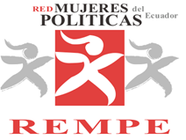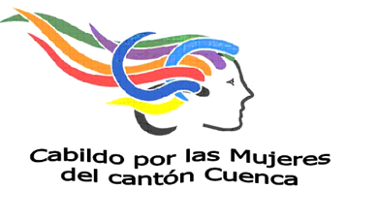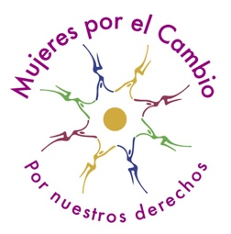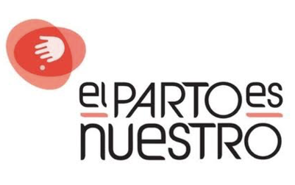
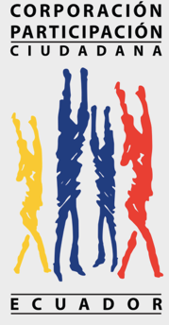

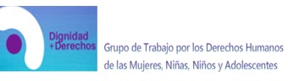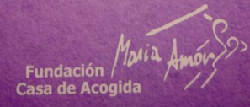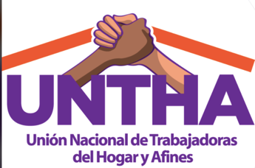

With the support of:
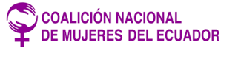
September, 2020

PARTICIPATION IN PUBLIC AND POLITICAL LIFE
Paragraph 10 LOIPR

PARITY
- In Ecuador, 50.18% of the electoral roll belongs to women voting. The country has 38% of women elected to the National Assembly, which would be ahead of the regional average (27%), but the figures available show that women still do not reach real parity in national elections and, much less, in sectional elections.
- The incorporation of women in the political sphere and in decision-making, in addition to pursuing equal participation, seeks the incorporation of the interests of half of the population, half that is also diverse, which means that their presence has a purpose of representativeness not only of general matters but also of the specific ones that concern women and their diverse demands and needs.
- Concerns come on how the State will really achieve the 2020 reforms of the Code of Democracy (Organic Law on Elections and Political Organizations): e.g. women to head 50% of the pluri-personal candidatures. This latter, by increasing to 15% in 2021 general elections and 30% in sectional elections, and 50% in general elections in 2025. In regards to the binomial presidential parity, it will apply 2025, as well as other local or executive authorities that should be selected based on parity and alternation standards by 2025.
INCLUSION
- The State has failed to achieve generational renewal in politics. The 2020 reforms of the Code of Democracy encourages the participation of youth by establishing quotas of at least 25% young women and men, achieving within a year a political training structure in each list. In addition, the CNE must deny the registration of lists who fail to achieve the principles of parity, alternation, sequentiality, and inclusion of youth required by law.
- The inclusion of peoples and nationalities is specified in the Art. 99 Code of Democracy. It requires the regulation of equal participation, including affirmative action for the participation of indigenous, afro-descendants and montubios. With great concern is observed that the internal regulations approved by the CNE failed to fulfill this last obligation.
POLITICAL VIOLENCE
- Presented with concern is the fact that in Ecuador women’s access to the exercise of political power has been constantly intimidated and therefore limited and impeded due to a phenomenon recognized as political violence against women in their diversity. Violent practices are actioned and manifested particularly in the internal processes of political parties majorly managed by men.
- The State has partially failed to recognize and act over the right to women being included in the political sphere and react against the unfavorable reactions in the traditional male groups installed in the political space. This situation is worsened for women from the peoples and nationalities where the majority of leaders are men and women feel discouraged to nurture and promote their leadership.
- The highest percentage (58%) of people who exercise political violence against women in their diversity are political actors (leaders, candidates, and electoral campaign personnel); 32% social actors (voters, family, community members, religious or traditional leaders, media, social networks, and others) and 10% state actors (police, military, government officials) (UN Women: 2019). According to the same source, in Ecuador’s political sphere 66% of women are victims of psychological violence (discrimination, ridiculization, rumors, verbal assault, marginalization); 30% affirm having suffered some sort of physical violence or threatening to their families and teammates; 16% experienced some sort of sexual harassment and other 4% said they were victims of sexual violence.
- Comes as a preoccupation that the State has not established clear and concise measures on how to apply the Code of Democracy in the latter regard, which considers political violence as a very serious offense, disaggregating periodic information on advancements.
Recommendations:
To the National Electoral Council - CNE:
- Implement in secondary regulations, a procedure for knowledge and prevention that, as a Single Section, establishes the guidelines that political organizations will apply to contribute to the eradication of political gender violence against women, taking into consideration that the Ecuadorian State is multi-ethnic and pluricultural, which would force political organizations to consider the languages ​​of cultural interrelation of peoples and nationalities and to provide clear and accessible information according to the cultural context of women aggrieved by political violence.
- Implement affirmative action measures for the participation of women of indigenous, Afro-Ecuadorian, and Montubio peoples and nationalities and promote community democracy practices.
- The Institute of Democracy should develop and coordinate with the Council for Gender Equality, training processes for political parties, their leaders and activists (men and women) on Human Rights of women, application of parity constitutional provisions, and eradication of political violence as a principle of democracy and a culture of peace.
- Urge Political Organizations to implement preventive actions, such as training and awareness-raising campaigns aimed at their candidates for popular elections, affiliates, adherents, employees, and managers, tending to identify the different modalities of gender political violence and promote its eradication, especially before and during the electoral period as well as when receiving new affiliations.

To the Contentious Electoral Tribunal (TCE):
- Comply with Art. 70 of the Code of Democracy and incorporate in the Regulations for Procedures, the power to expressly punish political gender violence and develop an agile and expeditious procedure, which reinforces reparation measures and opens the possibility that infractions for political violence are judged without exacerbating discrimination and increasing impunity.
ECONOMIC WOMEN’S EMPOWERMENT
paragraph 17 LOIPR

WOMEN’S ACCESS TO CREDIT AND ENTREPRENEURSHIP
- Concerning statistics show economic inequality in Ecuador, where 51% of women possess a bank account, compared to 58% of men. 15% of men manage to save compared to 9% of women. 24% of men have access to credit and loans compared to 18% of women.
- The civil society notes with concern that organisms that support autonomy processes for women victims of violence (BanEcuador, Banco Central, Banco del Pacifico, among others) do not provide technical assistance and accompaniment for women’s enterprises. Furthermore, access requirements remain complex and are not equilibrated to many women’s situations. Certain private entities still do not require a spouse's signature for products in which 72% of women are users.
ACCESS TO SOCIAL SERVICES - EFFECTS OF ECONOMIC CRISIS AND AUSTERITY MEASURES
- Concerns arise since according to the National Survey of Employment, Unemployment, and Underemployment (ENEMDU) as of December 2019, corroborated is that income poverty in women in the urban sector (13.41%) is higher than that of men (12.39%). The same source shows that women employed (41.5%) are less than men (58.5%), while unpaid employment is concentrated in women (28.4%) vs men (5.5%). Only 30.6% of employed women receive an equal or higher salary than the basic income one vs 44.8% of men.
- According to information from the Union of Domestic Workers. as of April 2020, only 23% of domestic workers have a contract. Only 4 out of 10 women are affiliated with social security.
CARE SERVICES
- According to public sources, 75% of care work falls in households. Women dedicate more hours per week (77:39) on average to unpaid care work than men (59:57).
- Preoccupying data is shown by ENSANUT 2018: where only 16.4% of children under 4 years old attend a public or private Child Care Center; 85.9% attend public centers and only 14.1% attend private ones. This data is of great importance since childcare services constitute a getaway to employment and other activities for women (INEC, 2018, p.14).
Recommendations: Universal access to social protection plays a fundamental role in reducing inequalities, as well as eradicating poverty in all its forms and dimensions. The State is called upon to redouble its efforts to make effective the constitutional guarantees of articles 340 to 342 of the Constitution, which establish the operation of specialized systems for the comprehensive protection of rights within the framework of the national system of inclusion and social equity.
To the Ministries of Economic and Social Inclusion and Finance:
- Design and implement the national policy for social protection of people of all ages, guaranteeing the comprehensive protection of human rights, gender, and intersectionality approach.
- Ensure that social protection, public services, and sustainable infrastructure contribute to the elimination and prevention of all forms of violence against women and girls, in the public and private spheres.
- Strengthen the economic, social, and legal recognition of the care and unpaid domestic work, through the design and implementation of the national care system, which should promote greater co-responsibility between men and women, based on the deconstruction of roles.
- Strengthen disaster risk management strategies to increase the resilience of communities and individuals, and help them cope with crises, within the framework of the long-term social protection system.

