Annex 2 – Jobseeker benefit graphic

Status of the Government target to have fewer people on the Jobseeker benefit
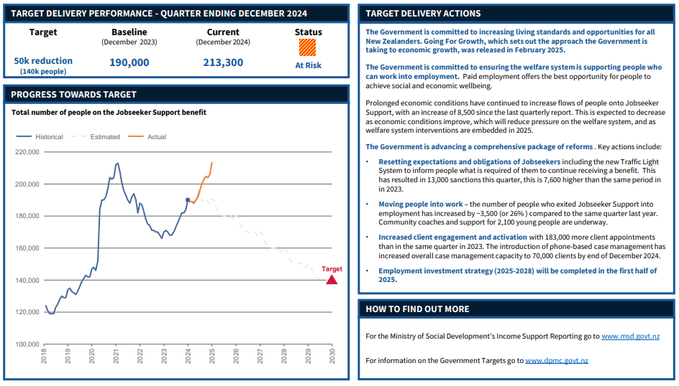
Data sourced from Department of Prime Minister and Cabinet

