
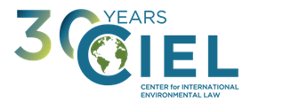
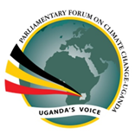

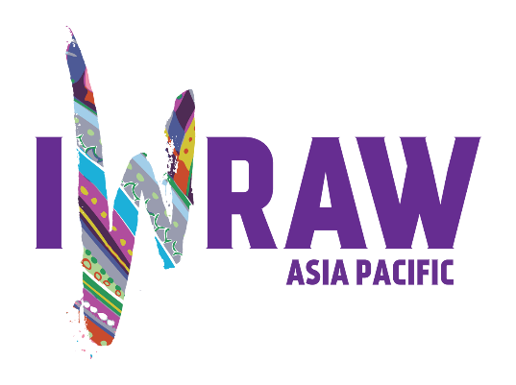
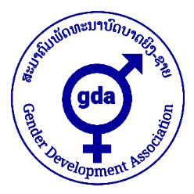

VISION FOR DEVELOPMENT
CENTRE FOR SOCIAL



Joint Parallel Report

submitted by

Association Femmes Leadership & Développement Durable,
Centre for Social Concern and Development,
Center for International Environmental Law (CIEL),
Fundación Plurales
Gender Development Association,
International Women's Rights Action Watch (IWRAW), and
Parliamentary Forum on Climate Change - Uganda
to the
Pre-Sessional Working Group of the Committee on the Elimination of all forms of Discrimination against Women
on the occasion of the consideration of the
List of Issues Prior to Reporting
on Norway
during the Working Group’s 78th Session
13 – 17 July 2020

Submitted 9 July 2020

This report is endorsed by the following organizations:

Association pour la Conservation et la Protection des Ecosystèmes des Lacs et l'Agriculture Durable (ACOPELAD),
Climate Change Adaptation, Mitigation Experiment & Training (CAMET) Park,
Environmental Law Research Institute (ELRI),
Inclusive Climate Change Adaptation for A Sustainable Africa (ICCASA),
Murna Foundation,
Spire, and
Women from Region for Community Development

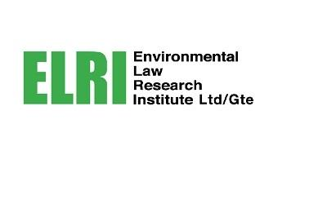
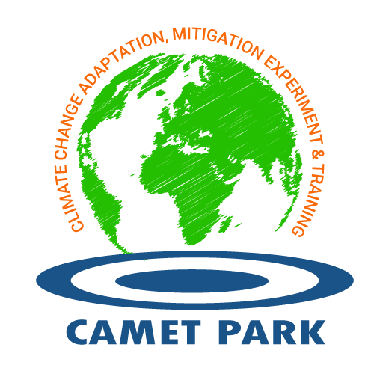


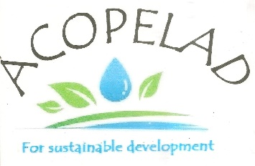
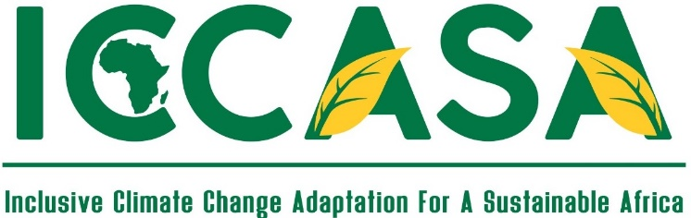

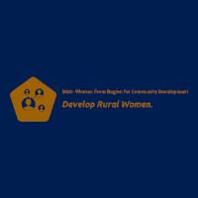


Executive Summary

As noted by CEDAW in its General Recommendation No. 37, women disproportionately face the adverse impacts of climate change as these impacts exacerbate preexisting vulnerabilities and inequalities.

As CEDAW noted in its Concluding Observations (COB) to Norway in 2017, 'continuing and expanding extraction of oil and gas in the Arctic by the State party and its inevitable greenhouse gas emissions undermines its obligations to ensure women’s substantive equality with men, as climate change disproportionately impacts women, especially in situations of poverty, since they are more reliant on natural resources for their livelihoods than men and have lesser capacity to deal with natural hazards.' The Committee thus recommended that Norway 'review its climate change and energy policies, and specifically its policy on extraction of oil and gas, to ensure it takes into account the disproportionate negative impacts of climate change on women’s rights'.
CEDAW, CRC and CESCR explicitly called upon Norway to review its ongoing fossil fuels extraction policies to comply with its international human rights obligations.

However, recent developments in Norwegian policies have demonstrated the unwillingness of the Norwegian Government to follow CEDAW and other treaty bodies' recommendations as the government has in fact implemented measures further intensifying the human rights threats that CEDAW and other UN human rights bodies had previously denounced. By allowing for reduced tax payments and new drilling activities, the country has experienced a significant increase in the number of licensing projects of exploration and extraction of fossil fuels in unexploited areas, such as the Arctic and the Barents Sea. This is undeniably contributing to climate change, exacerbating harms on women’s rights. Norway's recent activities have sparked widespread reactions from domestic civil society demanding that the government urgently upholds its duty to prevent climate-induced harms.

Similarly, while the government has announced new climate commitments in 2019, it refuses to take into account the emissions that Norway’s exported oil and gas are inevitably generating. The climate-induced harms resulting from these policies are further exacerbated by the expansion of the activities of State-owned petroleum companies, whose greenhouse gases are equivalent to several times that of the entire Norwegian population. Thus, the greenhouse gas emissions, resulting from oil and gas exploited in Norway, are fundamentally incompatible with the 1.5° Celsius global average temperature increase limit that the Intergovernmental Panel on Climate Change (IPCC) has identified in order to avoid catastrophic impacts on biodiversity, the environment and livelihoods across the globe - and that governments, including Norway, have endorsed as the ultimate objective of the Paris Agreement.
We urge CEDAW to include the following question in its List of Issues Prior to Reporting on Norway:

- Please provide information on what steps Norway is taking to review its climate change and energy policies, and specifically its policy on the extraction and export of oil and gas, as well as the activities of related State-owned companies, taking into account the disproportionate negative impacts of climate change on women’s rights both within and outside Norway’s jurisdiction.

- The impacts of climate change on women’s rights
It is well documented that the effects of climate change are felt most acutely by those segments of the population that are already in vulnerable situations. Women often constitute the poorest segment of society, are more dependent for their survival on natural resources, they face unequal access to resources and suffer from discrimination in decision-making processes. Thus, women suffer climate change impacts more frequently and more severely than men. Women are also more vulnerable to the negative impacts of disasters, which are becoming increasingly more frequent as a consequence of climate change.
The IPCC’s Special Report on 1.5°C reiterates the necessity of committing to a world below 1.5°C warming. The report warns that ‘[c]limate-related risks to health, livelihoods, food security, water supply, human security, and economic growth are projected to increase with global warming of 1.5°C and increase further with 2°C’. Global warming of 2 degrees Celsius rather than 1.5 would lead to even greater rates of poverty, increased water stress, heightened food insecurity, more heat-related health problems, increased sea level rise, ocean acidification, species loss, greater temperature extremes, and higher rates of drought, among other impacts. These phenomena, because of their disproportionate effects on women, have the potential to increase women’s substantive inequality in respect of their human rights to food, water, an adequate standard of living, health and life.

- Norway’s Obligations under CEDAW, including extraterritorially, in the context of fossil fuel extraction and export

Article 2 of CEDAW requires Parties to respect women’s right to non-discrimination and to the enjoyment of equality. This means that States must ‘refrain from making laws, policies, regulations, programmes, administrative procedures and institutional structures that directly or indirectly result in the denial of the equal enjoyment by women of their civil, political, economic, social and cultural rights’. This obligation also requires that States ‘take a wide variety of steps to ensure that women and men enjoy equal rights de jure and de facto, including, where appropriate, the adoption of temporary special measures’. In the context of the disproportionate effects of climate change on women, States have the obligation to take steps to prevent the further impoverishment of women and the undermining of women’s substantive equality, caused by the impacts of climate change, which encopasses both mitigation and adaptation measures.
CEDAW has stressed that Article 2 also relates to human rights violations occurring outside national borders, arguing that ‘States parties are responsible for all their actions affecting human rights, regardless of whether the affected persons are in their territory’. In its 2018 General Recommendation No. 37, the Committee further explained that ‘measures such as limiting fossil fuel use, reducing transboundary pollution and greenhouse gas emissions and promoting the transition to renewable energies are regarded as crucial steps in mitigating the negative human rights impact of climate change and disasters globally’. In its joint statement on climate change issued in 2019 along with four other human rights treaty bodies, CEDAW also stressed that:
In relation to efforts to reduce emissions, States parties should effectively contribute to phasing out fossils fuels, promoting renewable energy and addressing emissions from the land sector, including by combating deforestation. Additionally, States must regulate private actors, including by holding them accountable for harm they generate both domestically and extraterritorially. States should also discontinue financial incentives or investments in activities and infrastructure which are not consistent with low greenhouse gas emissions pathways, whether undertaken by public or private actors as a mitigation measure to prevent further damage and risk.
Therefore, as a State Party to the CEDAW, Norway has obligations under the Convention to take steps to avoid exacerbating climate change and its disproportionate adverse impacts on women in Norway and abroad - including by adequately regulating business actors operating in the country. This obligation requires Norway not only to reduce its domestic emissions, but also to take all measures appropriate to reduce any threat of climate-induced harms on women rights resulting from activities taking place in the territory of Norway or under the control of the Norwegian State.
Norway’s activities such as fossil fuel extraction as well as their consumption and export are incompatible with its extraterritorial obligations (ETOs) under the CEDAW, as the greenhouse gas emissions deriving from the aforementioned activities contribute to the generation of climate change-related events and further exacerbates pre-existing gender gaps between men and women. Thus, Norway’s ETOs include pursuing strong mitigation policies nationally, and halting all fossil fuel exploration and exports.
CEDAW already addressed Norway’s extraterritorial obligations with regard to climate change in its 2017 Concluding Observations, where it requested the country to ‘review its climate change and energy policies, specifically its policy on the extraction of oil and gas, to ensure that they take into account the disproportionate negative effects of climate change on the rights of women’. Both CRC and CESCR recently confirmed States’ obligations to prevent and mitigate climate-induced harms by phasing out fossil fuel exports.
In addition, in a recent Norwegian judicial ruling, the Court of Appeal of Oslo found that the responsibility of the State to protect the environment for the sake of present and future generations is also engaged in the context of exports of fossil fuels to third countries given the inevitable emissions of greenhouse gases that would result from such emissions.

The contribution of Norway’s energy policies to climate change
Norway has taken a range of measures to mitigate climate change. Norway’s 2020 updated Nationally Determined Contribution (NDC) - which identifies the emission reduction plans under the Paris Climate Agreement foresees an emission reduction target of ‘at least 50% and towards 55% reduction in greenhouse gas emission compared to 1990 levels’ by 2030. These commitments, however, remain incompatible with the imperative of preventing the most dangerous levels of climate change, such as the limit of 1.5°C temperature increase set forth under the Paris Agreement.
Based on Norway's current emission trends, future projections by 2030 indicate that the country will slightly decrease its emissions by 12% compared to 1990 levels, and that its contribution to global emissions will be consistent with a temperature rise between 3°C and 4°C, significantly higher than 1.5°C as suggested by the IPCC to avoid catastrophic consequences. Thus, it is clear that despite the recent advancement of Norwegian climate policies, they are still inefficient and mostly incompatible with the country’s international climate commitments.
Most importantly, Norway has focused its policies and emission reduction efforts on decreasing the amount of greenhouse gases produced within its national borders while simultaneously expanding the extraction and consequent export of fossil fuels. In fact, this approach actually obliterates any positive benefits from domestic climate action as the negative climate impact of fossil fuel exports from Norway dwarfs its domestic footprint. Each year, the greenhouse gases resulting from the inevitable combustion of the fossil fuels exported by Norway cause ten times more damage to the climate system, and thus to women’s rights globally, than the emissions generated domestically by the entire population and economy of Norway.
The country is continuing to pursue exploration and drilling activities, especially in the Norwegian Continental Shelf, which according to future projections will lead to the drilling of up to 50 wells per year by 2023. The country has also recently granted licenses in order to allow for private investments to undertake Arctic oil exploration activities in the Barents Sea.
Moreover, Norway owns 67% of former Statoil ASA, now Equinor, a petroleum company that generates, through its operations and oil and gas products, the equivalent of 247 millions tons of CO2 emissions annually and is currently planning to achieve a 7% increase in oil and gas production, with planned exploration activity of around USD 1.4 billion expenditure. Given that the carbon footprint of this State-owned company does over 4 times more damage to the climate than the emissions of all Norwegian population, any attempt by the Norwegian government to reduce domestic emissions without policing adequately such companies under its control is futile and ineffective. On the contrary, in response to the COVID emergency and the consequent global reduction in the demand for oil, the Norwegian Government has recently launched a plan to postpone and even reduce tax payments for Equinor and the oil sector in general.
It is clear that Norway’s fossil fuel consumption at the national level as well as its ongoing drilling and export of oil and gas are incompatible with a safe pathway to 1.5°C indicated by science, ultimately constituting a violation of Norway’s obligations under CEDAW. In order to stop contributing to climate change-related harms to women rights both within and outside its territory, Norway should halt the introduction and implementation of policies and actions that aim to further fossil fuel extraction and exports.

- The Impacts of climate change on women’s rights across the globe
It has been demonstrated that the ongoing extraction, exploitation and export of fossil fuels by Norway is significantly exacerbating climate change, and a wealth of literature shows that climate change has differentiated impacts on women when intersecting with pre-existing vulnerabilities and inequalities. This section collects various case studies from different regions of the world to highlight the impacts of climate change on the rights of women, which Norway must take into account to revise its energy and export policies.
Africa
Africa is highly vulnerable to climate change and the consequent impacts disproportionately affect women, youth and the elderly. According to the IPCC, failing to limit global warming to1.5°C would provoke a dramatic increase in temperatures throughout the whole continent, causing huge environmental and social impacts. At the same time, more intense rainfall is causing frequent cases of flooding and landslides, and cyclones are becoming recurrent in Sub-Saharan countries. One can here recall cyclones Idai and Kenneth, which hit Mozambique, Zimbabwe and Malawi harshly in 2019.
Uganda’s experience illustrates the harmful impacts of rising temperature. Traditionally a verdant nation, Uganda is increasingly suffering from prolonged and more severe dry seasons, which lead to frequent cases of crop failure. These extreme natural events all negatively impact the capacity of rural Ugandan women to carry out work, such as farming, fishing or the collection of firewood and water, for which they bear disproportionate responsibility, and consequently undermine their food security and survival. This is amplified by the fact that rural women are continually excluded from environmental policy-making processes.
For the first time in more than a decade, in 2017 Uganda witnessed an increase in poverty levels, largely due to droughts and crop failures. This has increased the vulnerability of women to climate change-related events, due to their dependence on crop farming as their source of livelihood. This is also confirmed by the high levels of anemia among women and children under five years old. Childhood illnesses also deprive women time for concentrating on income generating activities and important decision making sessions, hence remaining poorer and less consulted on developments that affect them.
Climate change does not only affect women’s rights to life, water and food, but also rights to health and education. In fact, climate-induced natural disasters limit women’s and adolescent girls’ access to sexual and reproductive health services, protection from gender-based violence, safe water and improved sanitation, and education. For instance, in Malawi, during Cyclone Idai - which ravaged the country in 2019 - pregnant women in rural communities found themselves giving birth in the most adverse of conditions.
Climate change is also having dramatic impacts on security, due to the increased scarcity of resources and consequent socio-political instability, as witnessed by the Sahel. For instance, the effects of climate change are reflected in the multiplicity of inter-community conflicts in Mali, like those between Fulani and Dogons in the center of the country, among others, which have caused several hundred deaths. The impacts of several human rights abuses committed by jihadists in Sahel, such as human trafficking or forced marriage for young girls, are exacerbated by high levels of poverty caused by climate change.
South East Asia
Southeast Asia is one of the most at-risk regions in the world to the impacts of climate change, and is experiencing a significant increase in the frequency of heat waves, heavy precipitation, sea level rise, and increasing intensity of floods, tropical cyclones, and droughts. Forecasted rankings are showing that 6 of the 20 countries that are most vulnerable to climate change worldwide are Indonesia, Malaysia, Myanmar, Thailand, the Philippines, and Vietnam.
The small landlocked country of Laos provides an interesting case study of the gendered impacts of climate change. The particularities of the Lao context result in arguably greater levels of vulnerability, although it does not face the same types of climate-related risks as its coastal neighbours. With a population of 7 million, 68% of people live in rural and remote areas and rely primarily on subsistence farming and agriculture-based income. As the most ethnically diverse country in the region, much of what defines Lao culture and way of life is intrinsically connected to the land and waterways. The testimony of Mrs. Chanthone, a 57-year-old fisherwoman living on Khone Island in Champassak Province, is exemplary. She explains, 'I don’t know what ‘climate change’ means, but I do realize that the weather is getting hotter every day and the rain sometimes comes at the wrong time. The level of the Mekong is falling rapidly, especially in the dry season, which is affecting fish breeding because fewer fish can migrate upstream to the places where they traditionally breed. In the past I could catch more than 30-40kg of fish per day, but now it’s hard to catch even just 7 or 8kg per day.'
‘Environmental income’, such as income from non-timber forest products and other ecosystem services, contributes significantly as not only a primary food source, but also income generation. Of the 72% of people employed in agriculture, forestry, and fishing, 51.3% are women. As such, crop crises, dwindling access to forest resources, and scarce fish populations that are a direct result of climate change, have inflicted devastating economic and social impacts on Lao women. Food shortages and the multidimensional effects of extreme poverty, which induce familial stress and exacerbate alcohol and drug abuse, have also been linked to an increased prevalence of gender-based violence, especially in rural and remote ethnic communities.
Latin America
Climate change is posing huge threats to indigenous women in Latin America. In the case of Paraguay, climate-induced prolonged droughts are causing increased water scarcity. Women must often walk many kilometers to collect water from the nearest cut-waters. These are large pools of land where rainwater accumulates and, especially when its level drops, it gets contaminated. Local communities call it ‘chocolate water’ because of its color, as explained by Lina Lopez, an indigenous woman, representative for her community and member of the Organización de Mujeres Mismo Indígena (OMMI), who powerfully adds ‘[w]e lack water, housing and health.’

Suggested Issue
In light of the impacts described above and considering that the Norwegian government has taken steps that are further undermining the concerns highlighted by the Committee in its 2017 country review, we urgently ask the Committee to renew these concerns by asking the State Party the following question:
- Please provide information on what steps Norway is taking to review its climate change and energy policies, and specifically its policy on extraction and export of oil and gas, as well as the activities of related State-owned companies, taking into account the disproportionate negative impacts of climate change on women’s rights both within and outside Norway’s jurisdiction.

Concluding observations on the combined fifth and sixth periodic reports of Norway, UN Doc. CRC/C/NOR/CO/5-6.
Concluding observations on the sixth periodic report of Norway, UN Doc. E/C.12/NOR/CO/6.
See New report: Norway one of world’s largest emissions exporters (2017), available at http://priceofoil.org/2017/08/09/new-report-norway-one-of-worlds-largest-emissions-exporters/ (last accessed on 8th July 2020), and Leading companies in the extraction of crude petroleum and natural gas industry in Norway as of March 2020, by turnover (2020), available at https://www.statista.com/statistics/825350/ranking-of-crude-petroleum-and-natural-gas-companies-in-norway-by-turnover/ (last accessed 8th July 2020)
Climate Action Tracker: Norway, available at https://climateactiontracker.org/countries/norway/ (last accessed on 23rd June 2020).
IPCC Special Report: ‘Global warming of 1.5°C. An IPCC special report on the impacts of global warming of 1.5 °C above pre-industrial levels and related global greenhouse gas emission pathways, in the context of strengthening the global response to the threat of climate change, sustainable development, and efforts to eradicate poverty’ (2018) (SR 1.5).
IPCC Fifth Assessment Synthesis Report (2014).
Gender and Climate Change. See: https://www.iucn.org/resources/issues-briefs/gender-and-climate-change (last accessed on 3rd July 2020).
Ibid.
IPCC Special Report: ‘Global warming of 1.5°C. An IPCC special report on the impacts of global warming of 1.5 °C above pre-industrial levels and related global greenhouse gas emission pathways, in the context of strengthening the global response to the threat of climate change, sustainable development, and efforts to eradicate poverty’ (2018) (SR 1.5).
Ibid., at 9 (B.5).
IPCC Special Report: ‘Global warming of 1.5°C. An IPCC special report on the impacts of global warming of 1.5 °C above pre-industrial levels and related global greenhouse gas emission pathways, in the context of strengthening the global response to the threat of climate change, sustainable development, and efforts to eradicate poverty’ - Summary for Policymakers (2018), at 7-10.
General Recommendation No. 28 on the core obligations of States parties under article 2 of the Convention on the Elimination of All Forms of Discrimination against Women, UN Doc. CEDAW/C/GC/28, para. 9.
Ibid.
Understanding human rights and climate change (2015), available at: https://www.ohchr.org/Documents/ Issues/ClimateChange/COP21.pdf (last accessed on 8th July 2020).
Ibid, para. 12.
General Recommendation No. 37 on Gender-related dimensions of disaster risk reduction in the context of climate change,UN Doc. CEDAW/C/GC/37, para. 43.
Joint Statement on "Human Rights and Climate Change", available at https://www.ohchr.org/en/NewsEvents/Pages/DisplayNews.aspx?NewsID=24998&LangID=E (last accessed on 9th July)
Concluding observations on the ninth periodic report of Norway, UN Doc. 2017 CEDAW/C/NOR/CO/9.
CESCR Concluding Observation on Australia, UN Doc. E/C.12/AUS/CO/5: ‘The Committee also encourages the State party to review its position in support of coal mines and coal exports’, para. 12; and CRC Concluding Observation on Australia, UN Doc. CRC/C/AUS/CO/5-6: ‘The Committee recommends that the State party [...] promptly take measures to reduce its emissions of greenhouse gases, establishing targets and deadlines to phase out the domestic use of coal and its export’, para. 41(b).
Judgement of the Borgarting Court of Appeal, Case No. 18-060499ASD-BORG/03. Unofficial English translation available at http://blogs2.law.columbia.edu/climate-change-litigation/wp-content/uploads/sites/16/non-us-case-documents/ 2020/20200123_HR-2020-846-J_judgment.pdf (last accessed on 8th July 2020).
In June 2019, the Norwegian Parliament decided to apply its divestment policies to the Government Pension Fund, in order to phase out companies’ investments for oil and gas exploration and production, and redirect the use of valuable resources towards renewable energy projects, mainly oriented towards wind and solar energy (See Climate Action Tracker: Norway, available at https://climateactiontracker.org/countries/norway/). Nevertheless, such divestment process is not solely driven by climate and environmental considerations; rather, it focuses on the potential economic benefits deriving from the diversification of the energy sector and the consequent lesser dependence of Norway on the fluctuations affecting the global oil and gas market. See Norway's $1tn wealth fund to divest from oil and gas exploration (2019), availalble at https://www.theguardian.com/world/2019/mar/08/norways-1tn-wealth-fund-to-divest-from-oil-and-gas-exploration#:~:text=The%20world's%20largest%20sovereign%20wealth,that%20have%20renewable%20energy%20divisions (last accessed 30th June 2020).
Norway’s Updated National Determined Contribution(NDC). 7th February 2020, available at https://www4.unfccc.int/sites/ndcstaging/PublishedDocuments/Norway%20First/Norway_updatedNDC_2020%20(Updated%20submission).pdf (last accessed on 3rd July 2020).
Ibid.
Ibid.
Supra note 6.
Supra note 4.
Greenpeace takes Arctic oil lawsuit to Norway’s supreme court (2020), available at https://www.climatechangenews.com/2020/04/21/greenpeace-takes-arctic-oil-lawsuit-norways-supreme-court/ (last accessed on 3rd July 2020).
Drilling activity in Norway nearing all-time high (2019), available at https://www.rystadenergy.com/newsevents/news/press-releases/drilling-activity-in-Norway-nearing-all-time-high/ (last accessed on 3rd July 2020).
Ibid.
State organization of petroleum activities (2019). available at https://www.norskpetroleum.no/en/framework/state-organisation-of-petroleum-activites/ (last accessed on 3rd July 2020).
As of 2019. See Equinor’s 2019 Sustainability Report (2020), available at https://www.equinor.com/en/how-and-why/sustainability/sustainability-reports.html (last accessed on 3rd July 2020).
Equinor’s 2019 Annual Report and Form 20-F (2020) https://www.equinor.com/en/investors/our-dividend/annual-reports-archive.html
Equinor fourth quarter 2019 and year end results (2020), available at https://www.equinor.com/en/news/fourth-quarter-2019-results-and-capital-markets-update-2020.html
Norway parliament grants more tax relief to oil sector (2020), available at https://www.reuters.com/article/us-health-coronavirus-norway-oil/norway-parliament-grants-more-tax-relief-to-oi-sector-idUSKBN23F1NV (last accessed on 8th of July 2020).
Global Warming: severe consequences for Africa (2019), available at https://www.un.org/africarenewal/magazine/december-2018-march-2019/global-warming-severe-consequences-africa (last accessed 3rd July 2020).
Ibid.
Cyclones Idai and Kenneth (2019), available at https://www.unocha.org/southern-and-eastern-africa-rosea/cyclones-idai-and-kenneth (last accessed on 9th July 2020).
Ibid.
Uganda: Climate change and its implications on women (2016), available at http://www.fao.org/fileadmin/templates/dimitra/pdf/dim_28_e_p3.pdf (last accessed on 3rd July 2020).
Ibid.
Ugandan Third National Development Plan: 2020/21-2024/2025 (2020), available at http://envalert.org/wp-content/uploads/2020/06/NDP-3-Finale.pdf (last accessed on 3rd July 2020).
The State of Food Security and Nutrition in the World. Building Climate Resilience for Food Security and Nutrition (2018), available at http://www.fao.org/3/I9553EN/i9553en.pdf (last accessed on 3rd July 2020).
Climate change and indicators of probable shifts in the consumption portfolios of dryland farmers in Sub-Saharan Africa: Implications for policy (2016), available at https://www.sciencedirect.com/science/article/pii/S1470160X16301340?casa_token=VuGJSCb8l10AAAAA:keq9H9a0yVCIR4UuACLTH9vUpa-5nRPnC7GfurwaRSIBzgf2XZTIEBpVEdgn226PRuZH3h-VRi8 (last accessed on 6th July 2020).
Catastrophic Cyclone Idai leaves pregnant women vulnerable in three countries (2019), available at https://reliefweb.int/report/mozambique/catastrophic-cyclone-idai-leaves-pregnant-women-vulnerable-three-countries (last accessed on 3rd July 2020).
Climate Change & Ethnic Conflict in Africa Part I: Mali (2019), available at https://www.americansecurityproject.org/ethnic-conflict-in-africa-mali/ ( last accessed on 3rd July 2020).
The Sahel: Europe’s African Border (2018), available at https://www.euromesco.net/wp-content/uploads/2018/03/EuroMeSCo-Joint-Policy-Study-8_The_Sahel_Europe_African_Border.pdf (last accessed 3rd July 2020).
As climate change impacts the frequency, intensity, timing, and spatial coverage of climatological and hydro-meteorological hazard-based disasters, the region has experienced a significant increase in the frequency of heat waves, heavy precipitation, sea level rise, and increasing intensity of floods, tropical cyclones, and droughts. See ASEAN Cooperation on Climate Change (2020), available at https://environment.asean.org/awgcc/#ref1 (last accessed on 29th June 2020).
Physical geography, along with population density (especially near coastlines), dependence on seasonal rains for water and food security, and other underlying drivers such as high rates of poverty and inequality, unplanned and rapid urbanization, and unsustainable use of natural resources, are all factors which have exacerbated regional climate change impacts. See Climate Change, Young Women, and Girls: Vulnerability, Impacts and Adaptation in Northern Thailand' (2018), at. 4, available at https://plan-international.org/publication/climate-change-girls-thailand (last accessed on 30th June 2020).
ASEAN Cooperation on Climate Change (2020), supra note 43.
The International Union for Conservation of Nature (IUCN) identifies Laos and Cambodia as the most vulnerable among the lower Mekong Basin countries, in part because of their limited capacity to cope with climate related risks. See Climate change and its impact on the Lao and Cambodian people (2012), available at https://www.iucn.org/content/climate-change-and-its-impact-lao-and-cambodian-people (last accessed on 30 June 2020).
Ibid.
Country Gender Assessment of Agriculture and the Rural Sector in Lao People’s Democratic Republic (2018), available at http://www.fao.org/3/CA0154EN/ca0154en.pdf (last accessed on 30th June 2020).
Ibid.
Climate change is directly affecting fishery production in Laos and reproduction, growth, and migration patterns are all affected by temperature, rainfall and hydrology. See Climate change and its impact on the Lao and Cambodian people (2012), available at https://www.iucn.org/content/climate-change-and-its-impact-lao-and -cambodian-people (last accessed on 30th June 2020).
Supra note 42, at 21
How rural women are adapting to climate change in Latin America and the Caribbean, available at https://www.oxfam.org/en/how-rural-women-are-adapting-climate-change-latin-america-and-caribbean (last accessed on 8th July 2020)
Climate Risk profile- Paraguay (2019), available at https://www.climatelinks.org/sites/default/files/asset/ document/Paraguay_CRP.pdf (last accessed on 8th July 2020).
Review of the Indigenous Peoples Program in Paraguay managed by Rainforest Foundation Norway (2010), available at https://www.scanteam.no/images/scanteam/pdfs/reports2010/2010_1044.pdf (last accessed on 8th july 2020).
Cambio Climático y desafíos para las comunidades rurales en Paraguay: El caso de la Organización de Mujeres Mismo Indígena (OMMI) (2019), available at https://www.ritimo.org/Cambio-Climatico-y-desafios-para-las- comunidades-rurales-en-Paraguay-El-caso-de (last accessed 8th July 2020).

