CEDAW - Convention on the Elimination of All Forms of Discrimination against Women
90th Session confirmed Session (03 Feb 2025 - 21 Feb 2025)

SITUATION OF THE RIGHTS OF INDIGENOUS WOMEN AND INDIGENOUS WOMEN WITH DISABILITIES IN NEPAL
Shadow Report for the Seventh periodic report submitted by Nepal under article 18 of the Convention, due in 2022*,**CEDAW/c/NPL/7

Submitted by
National Indigenous Women’s Federation (NIWF)
National Indigenous Women Forum (NIWF)
National Indigenous Disabled Women Association-Nepal (NIDWAN)
Indigenous Women’s Legal Awareness Group (INWOLAG)

31 December 2024

Submitting Organizations

- National Indigenous Women’s Federation (NIWF)
Address: Budhanagar-10, Kathmandu, Nepal
E-mail: niwf2057@gmail.com
Website: https://niwf.org.np/
- National Indigenous Women Forum (NIWF)
Kathmandu Metropolitan-35, Old Sinamangal, Pepsicola
Kathmandu, Nepal
E-mail: niwfnepal@gmail.com
Website: https://niwfnepal.org.np/

- National Indigenous Disabled Women Association Nepal (NIDWAN)
Kusunti- RingRoad,Lalitpur Nepal
Email: info@nidwan.org.np, nidwan2023@gmail.com
Website: https://nidwan.org.np/

- Indigenous Women’s Legal Awareness Group (INWOLAG)
Kumaripati, Lalitpur
E-mail: inwolag9@gmail.com; inwolag@yahoo.com
Website: https://inwolag.org.np/

Contents
Acronyms iii
INTRODUCTION, METHODOLOGY AND SCOPE 1
A. Introduction 1
B. Scope of the report 2
C. Methodology 2
Part II 2
The Situation of Indigenous Women & Indigenous Women with Disabilities in Nepal 2
A. Invisibility and deprivation of rights 2
B. Implementation of the CEDAW recommendation of 2018 and CEDAW GR No. 39 3
C. Right to a clean, healthy, and sustainable environment (arts. 12 and 14) 5
D. Prevention of and protection from gender-based violence [and Violence] against Indigenous women and girls [and Indigenous women with disability] (arts. 3, 5, 6, 10 (c), 11, 12, 14 and 16) 7
E. Rights to land, territories and natural resources (arts. 13 and 14) 9
F. Right to effective participation in political and public life (arts. 7, 8 and 14) 12
G. Rural women (art. 14) 13
H. Access to justice (Para 10 and 11) and plural legal systems & equality before the law – the legal rights of women (art. 15) 14
I. Right to culture (arts. 3, 5, 13 and 14) 16
Annex 1. 18
A List of Indigenous Women’s Organizations who endorsed this shadow report 18

Acronyms
AIPP Asia Indigenous Peoples Pact
C. Convention
CEDAW Convention on Elimination of All Forms of Discrimination against Women
CEDAW Committee Committee on Elimination of Discrimination against Women
CFUG Community Forest User Group
CRPD Convention on the Rights of Persons with Disabilities
FGD Focus Group Discussion
FIMI Foro Internacional de Mujeres Indigenas
FPIC Free Prior and Informed Consent
GR No. 39 General Recommendation Number 39
ICERD International Convention on Elimination of Racial Discrimination
ILO International Labor Organization
INWOLAG Indigenous Women’s Legal Awareness Group
IPs Indigenous Peoples
IW Indigenous Women
IW&G Indigenous Women & Girls
IW&GwD Indigenous Women and Girls with Disabilities
IWHRD Indigenous Women Human Rights Defenders
IWO Indigenous Women’s Organization
LBTQI+ Lesbian, Bisexual, Transgender, Queer, Intersex Plus
MoWCSC Ministry of Women. Children and Senior Citizens
NHRC National Human Rights Commission
NIDWAN National Indigenous Disabled Women Association-Nepal
NIWFederation National Indigenous Women’s Federation
NIWForum National Indigenous Women Forum
No. Number
Para. Paragraph
PSWG Pre-Sessional Working Group
UNDRIP United Nations Declaration on Rights of Indigenous Peoples

PART I

INTRODUCTION, METHODOLOGY AND SCOPE

A. Introduction
1. A consortium comprising the National Indigenous Women’s Federation (NIWF) (NIWFederation), National Indigenous Women Forum (NIWF (NIWForum), the National Indigenous Disabled Women Association Nepal (NIDWAN), and Indigenous Women's Legal Awareness Group (INWOLAG) prepared this Situation of the Rights of Indigenous Women and Indigenous Women with Disabilities in Nepal, a Shadow Report for the Seventh periodic report submitted by Nepal (CEDAW/c/NPL/7) for submission to the Committee on Elimination of Discrimination against Women for its consideration during CEDAW - Convention on the Elimination of All Forms of Discrimination against Women 90 session confirmed Session (03 Feb 2025 - 21 Feb 2025) scheduled at the United Nations Office in Geneva on Wednesday 05 February 2025. A list of Indigenous Women’s Organizations (IWO) endorsing this shadow report is in Annex 1.
2. Our heartiest thanks to the Committee on Elimination of Discrimination against Women (henceforth CEDAW Committee) for considering "Situation of the Rights of Indigenous Women and Indigenous Women with Disabilities in Nepal, a Shadow Report for the Seventh Periodic Report of Nepal (CEDAW/c/NPL/7)" submitted by our consortium for the 89 Pre-Sessional Working Group (PSWG) (19 Feb 2024 - 23 Feb 2024).
3. We highly appreciate CEDAW Committee for including the following in the List of issues and questions about the seventh periodic report of Nepal (CEDAW/C/NPL/Q/7; 26 February 2024):
Disadvantaged groups of Women
"21. In the light of the concerns expressed by the Committee in its previous Concluding observations (CEDAW/C/NPL/CO/6, para. 40), please specify the measures taken:
(a) To ensure the recognition of the rights of Indigenous Women in the Constitution and the right of Indigenous Peoples to self-determination, in line with the Committee's general recommendation No. 39 (2022) on the rights of Indigenous women and girls;"
"(c) To eliminate stigmatization and discrimination against disadvantaged groups of women and girls, including Indigenous women, … women with disabilities …, and to ensure their access to justice, employment, health care, including sexual and reproductive health services, social protection, housing, credit and income-generating opportunities."

B. Scope of the report
4. This shadow report provides emerging issues and additional supplementary and complementary information, facts, and data to our previous shadow report. Further, it presents additional facts, data, and concerns, focusing on CEDAW GR. No. 39, and on the CEDAW Committee's List of Questions to Nepal.

C. Methodology
5. The consortium has jointly prepared this shadow report in consultation with the rights holders and stakeholders. The NIWFederation, in coordination with the NIWForum, NIDWAN, and INWOLAG, jointly organized, a national consultation workshop on 7 December 2024 in Kathmandu and collected some primary data, facts, case stories, and incidences of violations of the rights of Indigenous Women & Girls (IW&G) and Indigenous Women & Girls with Disabilities (IW&GwD). Altogether, 84 participants, including rights holders, stakeholders, Indigenous experts, invited distinguished guests, including former Speaker of the Parliament Onsari Gharti Magar, shared their valuable information, insights, and suggestions. Furthermore, Consortium member organizations carried out several field research studies at the community level documenting violations of the rights of IW&G and IW&GwD, which we used in our previous and current shadow reports. Each of the four consortium members took responsibility for reviewing specialized thematic areas of Nepal’s 7th periodic reports and the list of questions, CEDAW GR No. 39, CEDAW Committee’s Concluding observations on the sixth periodic report, and reviewing published and unpublished reports, and writing reports for this shadow report.

Part II

The Situation of Indigenous Women & Indigenous Women with Disabilities in Nepal

A. Invisibility and deprivation of rights

6. IW&G and IWG&wD continue to be invisible not only in the government’s 7th periodic report but also in the Constitution, all levels and branches of Nepal government and its policies, plans, and programs, and also in the “mainstream” women’s movement, and Indigenous Peoples’ movement in Nepal. Hence, the government deprives IW&G and IWG&wD from enjoying the rights enshrined in the Convention on Elimination of All Forms of Discrimination against Women (CEDAW), CEDAW GR No. 39, UNDRIP, ILO Convention No. 169, and other international human rights instruments.

7. IW&GwD remains invisible, unseen, undebated and unrecorded within the disability rights, Indigenous rights, women’s rights discussions, and within state mechanisms, and thus continues to be voiceless, invisible, and underreported in all spheres of lives. According to a NIDWAN report,
“When the government and civil society treat us as a homogenous group, our individual needs, capacities, and vulnerabilities are assumed to be the same with other non-indigenous communities, but that is different and diverse, which are associated with our collective rights. The language we speak, our culture, our identity we have, the Indigenous accent, our way of life and our collectiveness, our Indigenous world views and challenges related to impairment, patriarchal mindset, stereotypes, and stigma come together. When it comes to addressing these challenges, they overlap and intersect. Most of these aspects are left out by others, and we are again framed in a single approach either related to our impairment or gender, which is visible and easy to describe. Our Indigenous identity remains undiscussed, which is how they frame the narratives. The dominant ideology of disability or gender remains visible rather than indigeneity.”

Question to the government
8. Why are IW&G and IW&GwD are not mentioned clearly or invisible in Nepal’s Constitution, policies, plans, programs, and reports, including CEDAW 7th Periodic Report?
Recommendation
9. Mention IW&G and IW&GwD formally visible in Nepal’s Constitution, policies, plans, programs, and CEDAW periodic reports.

B. Implementation of the CEDAW recommendation of 2018 and CEDAW GR No. 39
10. Nepal has been implementing CEDAW partially, but till now, there has been no meaningful implementation of the CEDAW Committee’s recommendation of 2018 and CEDAW GR. No. 39. The officials of the Ministry of Women, Children, and Senior Citizens (MoWCSC) and parliamentarians of the Women and Social Affairs Committee of the Parliament that they are interested in working for the implementation of CEDAW GR No. 39.
11. According to a news, “The two ruling parties [Communist Party of Nepal (United Marxist Leninist) and the Nepali Congress] have pledged to amend the constitution based on a broader understanding made through discussions, dialogues and consultations with political parties, civil society, intelligentsia, constitutional experts and the public.” Though the agenda of amendment of the Constitution is there, amendment ensuring the rights of IW&G and IW&GwD is not in their consideration.
12. NIWFederation’s, each of the 31-member organizations representing 31 Indigenous Nations assessed the implementation status of conventions, such as CEDAW, and International Convention on Elimination of Racial Discrimination (ICERD), ILO Convention No. 169, and Convention on the Rights of Persons with Disabilities (CRPD), and the United Nations Declaration on the Rights of Indigenous Peoples (UNDRIP), from 2015 to 2019, and published The Situation of Indigenous Women in Nepal (September 2015 to December 2019). All Indigenous Women’s Organizations (IWOs) reported that those recommendations and provisions have not been meaningfully implemented in their nations.
Questions to the government
13. In the government’s 7th periodic report, why is there no mention of progress made in ensuring the rights of IW&G and IW&GwD enshrined in CEDAW GR No. 39 and dozens of recommendations on the rights of Indigenous Women made by CEDAW Committee in its Concluding observations to Nepal of 14 November 2018?
14. Does the Nepal government have any time-bound plan to implement the CDEAW GR No. 39 and CEDAW recommendations meaningfully?
15. Given that the main political parties formed the present coalition government with a main primary agenda of amendment to the Constitution, is there any effort to include an agenda of amendment to ensure the recognition of the rights of Indigenous women in the Constitution and the right of Indigenous Peoples to self-determination in line with the Committee's general recommendation No. 39 (2022) on the rights of Indigenous women and girls?
16. What the government has done to legislatures, government officials ("civil servants"), justices, and law enforcement officials to make them aware of CEDAW GR No. 39 and its related provisions?
Recommendation to the government
17. Meaningfully implement, with the time-bound plan, para 41(a) of the CEDAW Committee’s recommendation to amend the constitution explicitly recognizing the right to self-determination of Indigenous Peoples (IPs) and all the rights of IW&G.
18. The MoWCSC ensures dialogue, orientation, and training in close collaboration with the organizations of IW&G and IW&GwD, and the UN Women, to parliamentarians, government officials, judiciary, and security personnel at federal, provincial, and local levels, and the leaders of political parties.
19. The MoWCSC, in close collaboration with the representative organizations of IW&G and IW&GwD, brings a time-bound action plan for meaningful implementation of CEDAW GR No. 39.
20. Carry out a five-yearly audit of CEDAW GR No. 39 by all federal and provincial ministries in close collaboration with the organizations of IW&G and IW&GwD.

C. Right to a clean, healthy, and sustainable environment (arts. 12 and 14)
Emerging issues of climate change, climate justice, and disaster risk reduction
21. Climate change has impacted IPs, especially IW&G and IW&GwD negatively through floods due to the burst of glacier lake (such as in Solokhumbu), heavy monsoon rains followed by floods and landslides (such as in Kagbeni in Mustang, Kathmandu Valley, and Sindhuli), and subsequent loss of life, properties, houses, settlements, highways, hydro-power plants, and crops. After a visit of the UN Secretary-General Antonio Guterres to base camps of Chymolungma (“Mt. Everest”) and Annapurna mountains and giving speeches drawing the attention of the world to save the Himalayas and Nepal government is trying to claim climate funds, climate finance, IW&G, and IW&GwD are suffering the most by being homeless, landless, and no food security.
22. The BBC News reported, “Members of local Sherpa communities, however, say they’ve seen more talk and less action over the years when it comes to dealing with risks from glacial lake outbursts”, and quotes Doma Sherpa saying “We hear all big plans, especially during conferences, and soon the plans are forgotten.”
23. The International Center for Mountain Development, quoting Nima Sherpa, writes, “Thame was a beautiful village, home to many generations of Sherpa people and their families. [These homes] now [lie] buried under debris. It’s sad to see how the mountain communities are paying the price of the global climate crisis. … impacting them directly and often catastrophically as we see in Thame, where almost an entire village has been wiped out in minutes.”
24. The BBC reported, “By 2016, 17 households consisting of 86 residents had been relocated from Samdzong to a new settlement they named "Namashung", meaning green meadow” as the drought that forced a Himalayan village in Nepal to relocate.
25. The Kathmandu Post reported on 29 September 2024, “A[t] least 87 people have been killed and scores have gone missing after the rains triggered floods and landslides around the country” , “After failing to escape to a safer place, the four had reportedly climbed to the roof of the hut that they were living in. They requested for a rescue with the local security officials but no help was forthcoming. Ultimately, the river overpowered the hut and swept them away.”
26. IW&G and IW&GwD face climate change impacts due to the increased temperature, heat, and unpredictable rainfall, landslides. The increase in temperature, with hurricanes, storms, and draughts with mosquitoes, throughout the year has affected their sexual health and reproductive rights. One of the participants said,
“The crops, food, and grains we used to have earlier are limited these days, and we don’t get such healthy food and enough water these days. Due to the temperature rise, we face posed communicable and non-communicable skin allergies, rashes, mental health issues, anxiety, depression, stress, and health-related changes like vomiting, headache, pain, abnormal behavior, and other new symptoms like hormone disbalance, irregular mensuration, menopause that has added extra care, stress, burden, work pressure for myself and among family members.”

27. The impact of climate change is adverse for IW&GwD like 58.2% faced impact on livelihood, 55.2% on environment, 50.7% on social lives and interaction, 50.7% in increase in food insecurity and hunger, 52.2% on mental health and psychosocial wellbeing, 47.8% on impact on health, 43.2% due to forced displacement and migration and other forms.
Questions to the government
28. Why are the voices of IW&G and IW&GwD not being heard by the government when it comes to creating climate change laws and provisions, and climate actions?
29. Is there direct representation and participation of Indigenous Peoples, especially IW&G and IW&GwD in decision-making in climate actions, climate funds, carbon trade, and climate finance?
30. What percentage of money received from carbon trade benefits IW&G and IW&GwD who are not decision-makers in Community Forest User Groups (CFUG) and are marginalized by non-Indigenous local people?
Recommendations to the government
31. Ensure direct representation and participation of Indigenous Peoples (IPs), especially IW&G and IW&GwD, at all levels of climate justice and climate actions, including carbon trade, climate funds, and climate finance.

D. Prevention of and protection from gender-based violence [and Violence] against Indigenous women and girls [and Indigenous women with disability] (arts. 3, 5, 6, 10 (c), 11, 12, 14 and 16)

32. Violence against IW&G and IW&GwD is complex and multi-layered, as it is often a constellation of factors based on identity, Indigeneity, gender, language, religion, culture, disability and region. IW&G and IW&GwD are facing violence not only as women & girls but also as IW&G and IW&GwD as being Indigenous and being rooted in ancestral lands having distinct languages, faiths, cultures, and distinct collective ways of life. IW&G and IW&GwD face discrimination and violence both in the private and public spheres. Mostly, IW&G with intellectual, autistic, psychosocial, and deaf disabilities are more vulnerable as their family members are unaware, uneducated, and do not have access to state mechanisms. They lack access to justice mechanisms and are unsafe and at risk.
Case of rapes
33. A deaf Indigenous woman who was raped by nearby relatives in the capital city has not received any measures and conducive space for the legal mechanism, so her case has remained in trial for more than 6 months, but the process is not moving forward.
34. One of the two cases presented in the national consultation involved a 16-year-old Indigenous girl, who is mentally disabled and unable to speak. She attended the program with her sister, who shared a written account of the case. The statement described how, after she was subjected to rape, and her family attempted to track down the perpetrator. Upon confronting him, the criminal threatened the family offering money and warning them not to report the incident. Despite these threats, her father bravely reported the crime to the police. A news interview was aired by the YOHO TV HD on 22 September 2024. However, the process of reporting the case was not easy as the family faced multiple threats, urging them to withdraw from the case. A particularly distressing issue arose when the victim was asked to explain what had happened to her. Although her sister, who was fluent in sign language was available to interpret, she was not allowed to do so. Instead, an unknown person was appointed as the interpreter which caused significant discomfort to the victim. This situation underscored a critical concern among the workshop participants that there should be a provision allowing a family member to act as an interpreter in cases involving sign language especially if the family member is familiar with the victim’s communication needs. This would help the victim’s comfort, and dignity are respected throughout the legal process.
35. Another case shared involved a woman who was the victim of an attempted rape by two men. Despite the attack, she managed to fight off the attackers and successfully saved herself though she suffered injuries. Afterward, she courageously reports the incident to the police. However, instead of receiving support, the police were unhelpful. She was threatened by one of the traffic police officers and the family of the perpetrators pressing her to withdraw the case. In addition to the threats, the woman faced severe social stigma within her community. She was falsely accused of fabricating the story and blaming innocent men. Since she lived in a rented house, her neighbors were not supportive. When the police came to gather statements (Muchulka) no one was willing to sign the document supporting her case, except for her house owner, who had always been supportive.
36. These cases of rape show that both rape survivors, IW&G and IW&GwD, are from low-income backgrounds. Hence, they are often targeted for rape and other forms of violations as they are unable to seek legal help or escape dangerous situations. Thus, Indigenous identity with no awareness, education, access and economic marginalization make it easier for perpetrators to exploit IW&G knowing that they may be reluctant or unable to report the crime or seek justice due to the fear of further victimization, social stigma, and retaliation.
Case of government’s excessive forces used against protestors of the “No Koshi Movement”
37. IW are leading hand in hand with Indigenous men in the “No Koshi” movements against the racial naming of Province No. 1 in the eastern part of Nepal. Frequent public demonstrations with the participation of IW&G and IW&GwD, and their suppression by the government by using excessive security forces, including gunshots using prohibited bullets, rubber bullets, tear gas, water cannons, batons, and arrests and later allegations of false charges have resulted in frequent violent clashes resulting one death, injuries, arrests, threats, and some languishing in police custody with inhuman treatment and jails. According to The Indigenous World 2024, “During the movement’s protests, one protestor, Padam Kumar Limbu “Lajehang”, died after injuries sustained from police brutality; 69 peaceful protestors, including six Indigenous women, were injured by rubber bullets, water cannon and batons; 13 Indigenous persons, including three Indigenous women, are facing court cases, and one Indigenous person was jailed.”
A case of sexual harassment
38. A case discussed during our session with the community Indigenous Women Human Rights Defenders (IWHRDs) from Koshi Tappu Wildlife Reserve revealed the vulnerability of speech-impaired women, who have been constantly physically abused by the park security personnel. According to the IWHRDs group, the woman had speech impaired, and the security personnel, in turn, abused her. They have even named her "Lati Gauda" as she was unable to speak and in turn, sexually abused at a particular spot.
39. This incident has yet to be reported to any official system. The social stigma and fear associated with disability, Indigeneity and class including, the power imbalance between the perpetrators and victims, legal support and reporting mechanism, language, and cultural barriers in accessing justice systems.
Human trafficking
40. The human trafficking of IW&G is a serious concern. Many IW&G are trafficked for forced labor or sexual exploitation.
Question to the government
41. How does the government plan to ensure the legal system for IW&G and IW&GwD to handle cases of rape and sexual harassment efficiently and fairly?
42. How is the government addressing language and cultural barriers that prevent IW&G and IW&GwD from accessing justice systems?
43. How will the government ensure and establish culturally sensitive and accessible reporting mechanisms for violence against IW&G and IW&GwD in remote areas?
Recommendation to the government
44. Come up with a time-bound plan, with the representation and participation of representative organizations of IW&G and IW&GwD, to implement para 42 (a to i) of CEDAW GR. No. 39 to recognize, prevent, address, sanction, and eliminate all forms of violence against IW&G and IW&GwD based on Indigeneity, ability, gender, sexual orientation, race, ethnicity, language, faith, spiritualism, religion, culture, region, and development aggression.
45. Provide necessary support to the organizations of IW&G and IW&GwD to raise awareness against all forms of violence against IW&G and IW&GwD.

E. Rights to land, territories and natural resources (arts. 13 and 14)

46. IW&G and IW&GwD continue facing violations related to the criminalization of custodianship of and customary practice in ancestral lands, territories, and resources, and during natural disasters and environmental and climate crisis. The national consultation noted, “The destruction of Indigenous land due to development projects such as national parks and highways in areas like the Chure region, Khokana, and Mukumlung was highlighted. Due to such development projects, Indigenous Peoples, especially Indigenous Women, are affected and depend on the land for their survival. The cases of the Shivapuri, and Chitwan National Parks were specifically mentioned as examples of how national parks have displaced Indigenous communities and disrupted their way of life.”

Self-determination, Autonomy & FPIC, and Customary Self-Government Systems
47. Local governments, especially Barbaridya Municipality took the lead by enacting a law on 9 January 2021 to protect, promote and develop Barghar, customary self-government systems of the Tharu Indigenous Peoples. Later other municipalities of Kanchanpur, Kailali, Bardiya and Dang also formally recognized Barghar/Bhalmansa/ Matwa. The Kirtipur Municipality declared the city as a cultural autonomous area by enacting a law on 7 July 2021. Except these, till now there has been no key achievements and no progress made in the meaningful implementation of CEDAW recommendations para 41(a) of 14 November 2018 and the related Directive Order of the Supreme Court of Nepal to bring laws to implement Article 56(5) about autonomous, protected and special areas for Indigenous Peoples.
48. As the CEDAW Committee from above and the communities from below have done their jobs, now the ball is in the court of the Nepal government to respect both by formally recognizing customary self-government systems and moving towards implementation of self-determination in line with the UNDRIP and recommended by the CEDAW Committee in 2018.
Violations of human rights in ancestral lands, territories and resources
49. According to a NIWFederation case study, “The Kumal of Yogi Tole experienced various forms of human rights violations. Physical assaults, harassment, arbitrary arrests, detentions, abuses, and blaming as poachers by the National Park are common. If someone is suspected, the National Park Authority takes him or her to detention immediately and takes instant action with cruelty. There is almost nil chance of clarification and ascertain of not guilty.”
50. The Free Prior and Informed Consent (FPIC) of IW&G and IW&GwD are not respected and implemented when such development projects are designed and implemented at a community level. One of the participants express:
“Road expansion is making us homeless, helpless and hopeless as state is grabbing our lives connected with our culture, belief, system, values and the space that we used to live. The space was open for us to sit, share our mutual sharing, feelings and care but today our lives are in threat and we are forcibly told to leave our places. Earlier there was open space, now I don’t know where I will I use my wheelchair and take rest and care.”
Questions to the government
51. When will the government recognize and uphold the self-determination of Indigenous Women and their communities?
52. Why does the Nepal government have no FPIC mechanism to obtain FPIC from IW&G and IW&GwD?
53. Why Nepal government, in the Annex to The Seventh Periodic Report on Implementation of the Convention on the Elimination of All Forms of Discrimination Against Women (CEDAW) submitted to the CEDAW Committee in June 2023, have no data disaggregated by IW&G and IW&GwD and Indigenous LBTQI+, and other caste, ethnic, and regional groups?
54. When will Nepal formally upscale formal recognition of customary self-government systems given by some local governments to all Indigenous Peoples of Nepal?
55. When will the Nepal government implement the long overdue Directive Order of the Supreme Court of Nepal to bring laws to implement Article 56(5) of the Constitution of Nepal, 2015, to form autonomous, special, and protected areas for Baram and other Indigenous Peoples?
56. What is the government doing to prevent both cultural and development-aggression?
Recommendation to the government
57. Amend the Constitution as per the CEDAW Committee’s recommendation para 41(a) of its Concluding observations made on 14 November 2018.
58. Formally apologize for the past wrongdoings of stealing IPs’ lands, territories, and resources, and return all stolen lands, territories, and resources, including protected areas (national parks, wildlife reserves, the hunting ground, conservation areas, buffer regions, and community forests, and rivers, forests, pastures, and mines) to IPs with a meaningful time-bound plan.
59. Formally recognize autonomy and customary self-government systems, including customary laws.
60. Develop FPIC mechanism and protocols, fully in line with CEDAW GR No. 39, UNDRIP, and ILO Convention No. 169, to obtain consent from IPs, including IW&G and IW&GwD.

F. Right to effective participation in political and public life (arts. 7, 8 and 14)
61. National consultation noted, “There is significant progress in securing political representation for Indigenous women through quotas. The quotas are a step toward inclusion though insufficient.”
62. The national consultation highlighted significant barriers IW&G and IW&GwD face when it comes to accessing information, participating in political processes, and being included in decision-making. Political representation for IW&G and IW&GwD is low, and they are excluded from key platforms such as the Public Service Commission and decision-making bodies.
63. Regarding representation of Indigenous Peoples (IPs) and IW in the election of 2022, according to The Indigenous World 2023, “The CERD issued two early warnings to Nepal with recommendations to ensure direct representation of Indigenous Peoples in the then Constituent Assembly ... “The recent General Election [of 20 November 2022] for the Elected House of Representative, i.e. Lower House of the Parliament, of the total 164 elected parliamentarians 94 (54%) were from the dominant Khas Arya caste group, 41 (25%) from Indigenous Peoples, 28 Madhesi (27%), one (0.6%) from Dalit and none (0.0%) from Muslim.” “… of the 41 elected Indigenous Peoples nine are Newar, six Tharu, five Magar, five Rai, five Gurung, and four Tamang. Although the elected members are Indigenous by birth, they do not represent Indigenous Peoples but only the political parties they run for…” According to the Kathmandu Post, “… as many as 62 of the 126 [caste and] ethnic groups have never been represented in Parliament.”
Questions to the government
64. Why has the mandamus issued by the Supreme Court of Nepal in 2018 to ensure direct representation of Indigenous Peoples in the general election not been implemented?
65. Is there any effort to ensure direct representation of IW&G and IW&GwD and their issues in executive, legislative, and judiciary, including the MoWCSC, the National Women Commission, National Human Rights Commission (NHRC), National Inclusion Commission, and the main political parties?
66. Why does the government neglect the participation of Indigenous Women in decision-making, especially in areas like disaster management and climate change?
67. How is the government ensuring full implementation of ILO 169 on Indigenous regarding the rights of Indigenous Women to participate in decision-making processes related to their land, culture, and communities?
Recommendation to the government
68. Ensure direct representation and participation of IPs, including IWG&WwD at all levels of decision-making through IPs’ own customary practices of collective self-selection processes.

G. Rural women (art. 14)
69. Rural IW&G and IW&GwD continue to suffer disproportionate effects of disasters and climate change in Nepal. For instance, during the Thame Flood of 2024, caused by a glacial lake outburst, depend on tourism and local resources for their livelihoods, and the flood has disrupted these economic activities, adding more vulnerabilities for them. Likewise, Dhye Village, located in the Upper Mustang region of Nepal, faces severe environmental challenges, including water scarcity, desertification, and declining agricultural productivity. These changes have led to displacement and significant disruptions in the social and economic fabric of the community, with Indigenous women bearing the brunt of the impacts.
70. Rural IW&G and IW&GwD have continued to face significant barriers to participation in decision-making processes. In the experience of NIWForum, despite their crucial role in agriculture, natural resource management, and community development, their voices are often marginalized, and they are not in leadership positions in public and government bodies. Furthermore, cultural norms, limited education, and lack of access to information and technology further hinder their participation, leading to a gendered digital divide. These factors contribute to a power imbalance, where the needs and perspectives of IW&G and IW&GwD are often overlooked in policy formulation and implementation.
Question to the government
71. How does the government plan to actively involve rural IW&G and IW&GwD in decision-making processes related to disaster management and climate change?
72. What steps has the government taken to ensure that rural IW&G and IW&GwD benefit from environmental conservation and sustainable development initiatives so that there will be less impact of climate change on livelihoods and well-being?
Recommendation to the government
73. Recognize and integrate Indigenous knowledge systems and practices into disaster management and climate change adaptation, mitigation, and conservation strategies.
74. Ensure that rural IW&G and IW&GwD are meaningfully involved in the development and implementation of all government policies and programs.
75. Provide training and capacity-building opportunities for rural IW&G and IW&GwD to enhance their leadership skills and participation in decision-making processes.
76. Collect disaggregated data on rural Indigenous women to inform policy development and program implementation.

H. Access to justice (Para 10 and 11) and plural legal systems & equality before the law – the legal rights of women (art. 15)

Human-wildlife conflict and harvest raids
77. The human-wildlife conflict in Nepal's protected areas is complex and multifaceted. In the protected areas, conflicts typically peak during two crucial periods: the harvest season, when crops are ready, and the dry season when wild animals venture closer to human settlements searching for water and food. The most frequently reported incidents involve large mammals such as elephants, rhinoceros, tigers, and leopards. These animals often raid crops, damage property, or in more serious cases, cause human casualties. While there are established compensation schemes for wildlife-related damages, the process often presents significant challenges. The documentation requirements can be particularly burdensome for IW&G and IW&GwD. They must provide evidence of damage, which sometimes requires photographic documentation - a challenge in remote areas with limited access to technology. The compensation process also involves multiple administrative steps, which can be particularly difficult for those with limited literacy or unfamiliarity with bureaucratic procedures.
78. A victim of the Koshi Tappu said,
“The elephant damaged my crops last year. However, due to the lengthy process for compensation, I did not apply for it. The required documents in the process are at times not available to us. A Personal Account Number card is essential, which we normally do not have. Likewise, the bank account should be in the A category Bank. The time process is normally 5/6 months and the amount for every damaged crop is Nepalese Rupees 10,000. Sometimes we have to spend more amount than the compensation amount. Like me, many families do not opt for the compensation process due to its nature. "
79. In the Chitwan National Park, one of Nepal's most prominent conservation areas, there are regular reports of rhinoceros damaging rice paddies and vegetable gardens.
80. The economic impact of these conflicts is particularly severe for IW&G and IW&GwD living in buffer zones. When wild animals destroy crops, families can lose their entire season's harvest in a single night. This is especially devastating because many of these households operate at subsistence levels, with limited financial reserves to cope with such losses.
81. Effective management of human-wildlife conflict requires a balanced approach that considers both conservation goals and the legitimate needs of local communities, particularly indigenous peoples who have historically been stewards of these landscapes.
82. An incident registered to the NHRC was shared by INWOLAG’s Indigenous Women Human Rights Defenders (IWHRDs). A male of 27 years had gone to collect fodder in the buffer zone when he was attacked by a tiger and was taken inside the core area of the Chitwan National Park where he was found dead. As his body was discovered in the core area, according to the Park Regulation he was not eligible for compensation. He was the bread-earner of the family, and his wife could not cope with it leading to take her life. They are survived by the two daughters who are now in the SoS Children’s Village.
Violence against Indigenous sexual minorities
83. Various cases documented by Indigenous Women’s organizations (IWO) show IW&G and IW&GwD, and Indigenous sexual minorities continue to face injustice, structural violence, multiple forms of discrimination, problems in accessing citizenship, and denial of the right to self-determination. For instance, a significant number of free Kamlari have not received identity cards and are struggling to continue their lives due to a lack of employment opportunities and education opportunities. They are yet to be properly rehabilitated in society as promised by the government.
84. They continue to face unique and intersecting forms of discrimination and marginalization due to conscious and unconscious biases in the systems. They don't enjoy equality before the law and equal protection before the law. On the community level, they often experience exclusion from traditional cultural practices and social structures, leading to limited access to resources, education, and healthcare.
85. In Nepal, laws are primarily based on Hindu jurisprudence, and also on common law and national law. Some gender-sensitive judges sometimes give due consideration to feminist jurisprudence in their court decisions, but Indigenous jurisprudence has been systematically excluded. Hence, except for one directive order and one mandamus, all other judicial decisions do not even consider international legal frameworks such as the UNDRIP, ILO Convention No. 169, and CEDAW GR No. 39.
Question to the government
86. Is there any time-bound land back program to IPs, IW&G, and IW&GwD?
87. How can the government integrate traditional Indigenous knowledge and practices into protected area management policies, particularly regarding sustainable resource use and wildlife conflict mitigation?
88. What steps can be taken to streamline and simplify the wildlife damage compensation process, especially considering the barriers faced by IW&G and IW&GwD?
89. Why Nepal government has not yet formally fully recognized Indigenous jurisprudence, and Indigenous feminist jurisprudence as a part of plural legal systems?
90. What specific measures are in place to ensure the complete rehabilitation and reintegration of former Kamlari girls into society?
91. How is the government supporting the economic empowerment of former Kamlari and women with disabilities through land back, microfinance, entrepreneurship training, and job placement services?
92. What steps are being taken to ensure the legal recognition and protection of the rights of Indigenous gender, disability and sexual minorities?
93. How is the government ensuring that Indigenous gender, disability and sexual minorities have access to justice and redress mechanisms?
94. How does the government ensure victims’ right to communication is respected in legal proceedings allowing a family member or someone familiar with the victim’s language and communication needs to interpret for them?
Recommendation to the government
95. Come up with a timebound land back plan to affected IPs, IW&G, and IW&wD by the protected areas.
96. Formally recognize Indigenous Jurisprudence, including Indigenous Feminist Jurisprudence.
97. Ensure strict enforcement of existing anti-discrimination laws to protect IW&G and IW&GwD, gender, and sexual minorities from harassment, violence, and discrimination.
98. Come up with a time-bound plan to ensure Kamlari’s rights, including rehabilitation, decent livelihood, food security, health, education, and training.
99. Conduct awareness campaigns and workshops in communities to educate people about the rights of Indigenous gender, disability and sexual minorities and challenge harmful stereotypes.

I. Right to culture (arts. 3, 5, 13 and 14)

Recognition of Indigenous languages
100. Given the highly appreciated action of the provincial government of Province Number 3 for enacting official recognition of Tamang and Newa Indigenous Peoples’ languages as official languages of the province, is there any plan for federal, provincial, and local government to officially recognize Indigenous languages?
Indigenous knowledge & skills
101. Indigenous knowledge, skills, technology, and practices are disappearing fast as there has been a gap in its transfer from the elders to the younger generation because of globalization, colonization, militarization, and criminalization.
Questions to the government
102. Are there any plans with the government to document, preserve, and promote, in collaboration with IWOs, Indigenous knowledge and skills?
103. How is the government ensuring the traditional practices of Indigenous communities particularly considering modern legal frameworks?
104. When will the federal government formally recognize Indigenous languages as official languages of Nepal?
105. When will the government ensure the security of IW&G and IW&GwD, especially those with mental disabilities?
106. When will the government stop discriminating against IW&G and IW&GwD in the distribution of identity cards, especially in relation to disabilities?
107. When will the government provide adequate public infrastructure, enabling environment and implement the CEDW GR 39 for women and girls with disabilities and LGBTQI?

Annex 1.

List of Indigenous Women’s Organizations endorsing this shadow report
Endorsement from Member Organizations of National Indigenous Women’s Federation (NIWF)
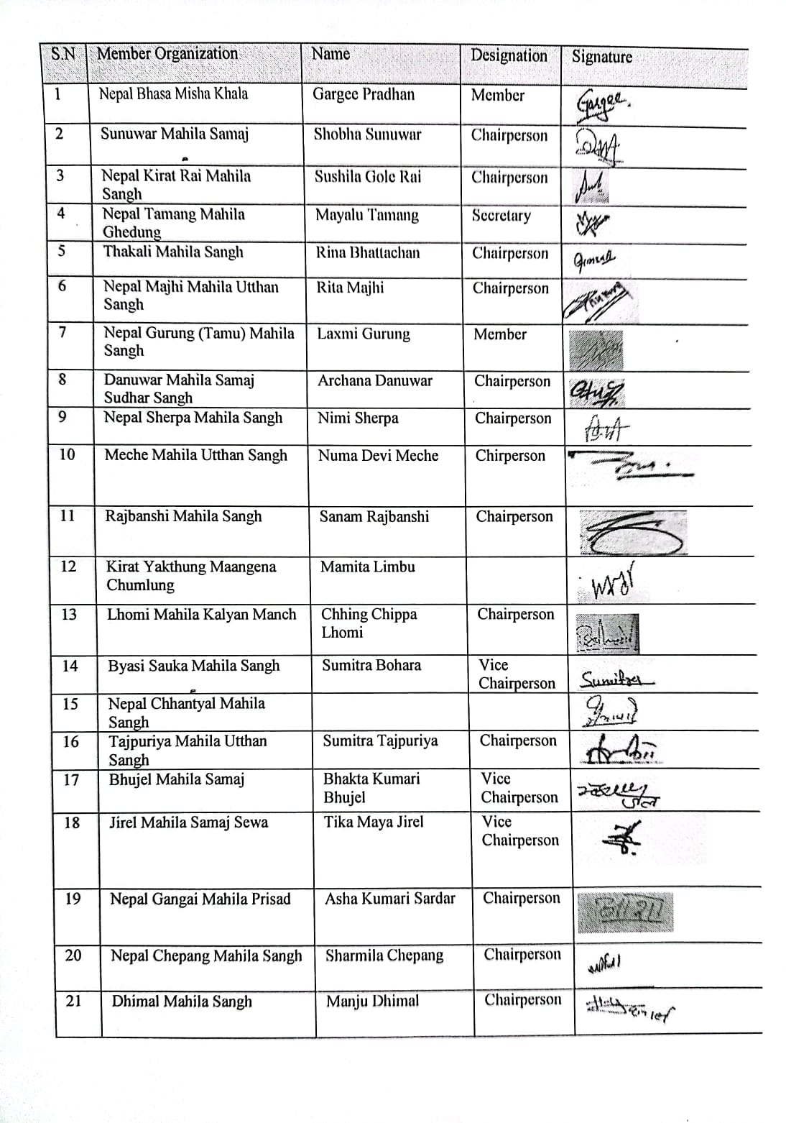
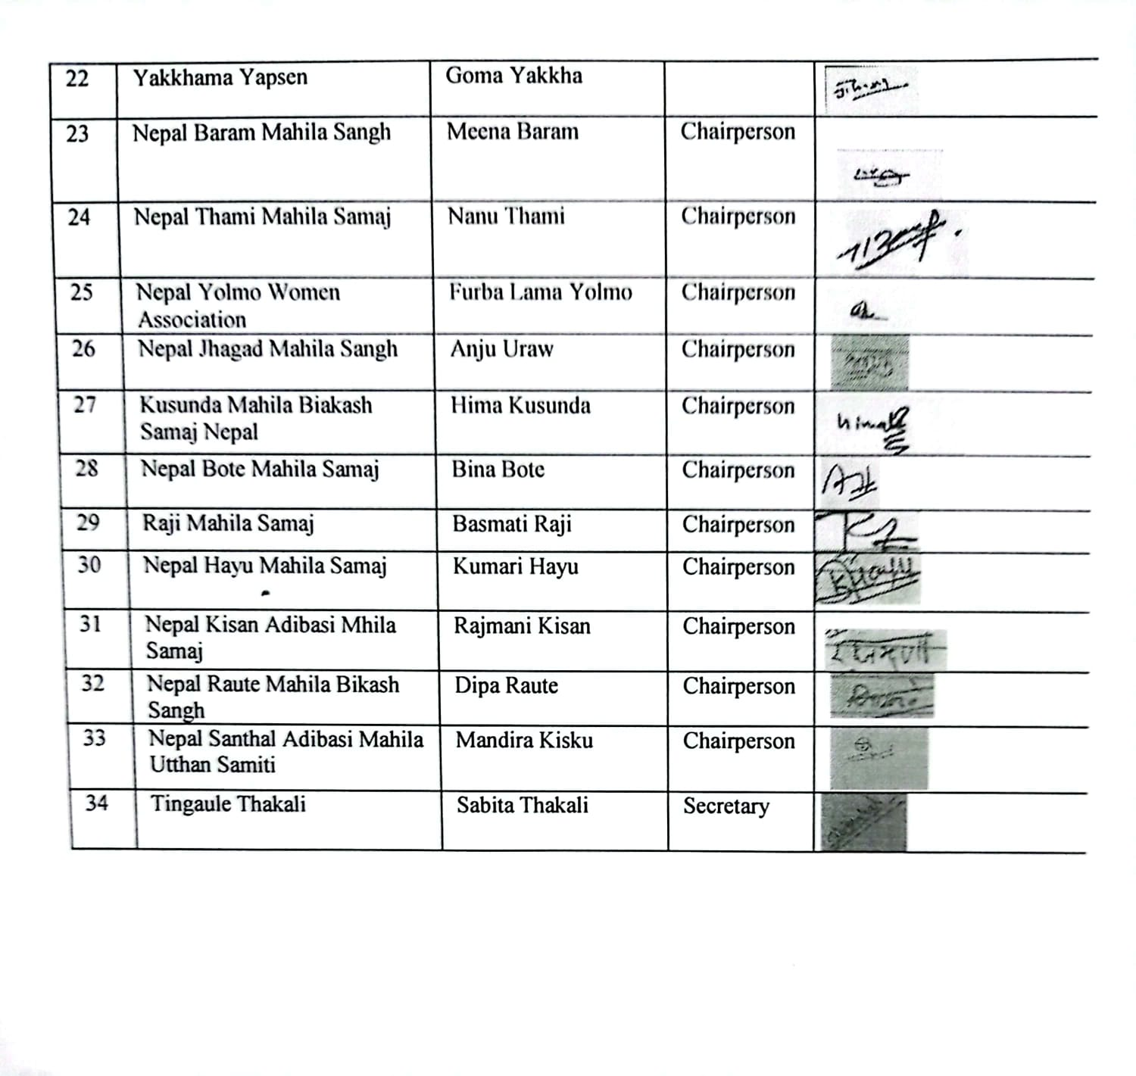

Endorsement from District Coordination Council Members of National Indigenous Women’s Federation (NIWF)

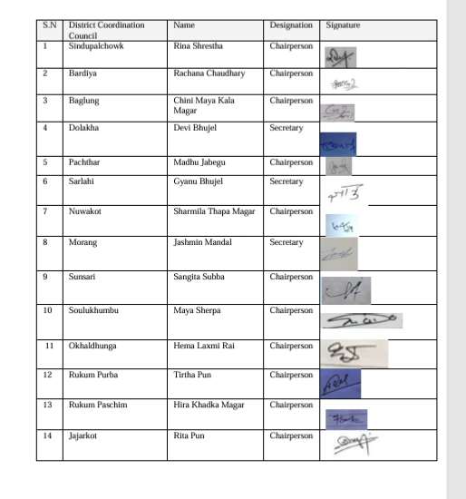

Endorsement from Province Coordination Council Members of National Indigenous Women’s Federation (NIWF)
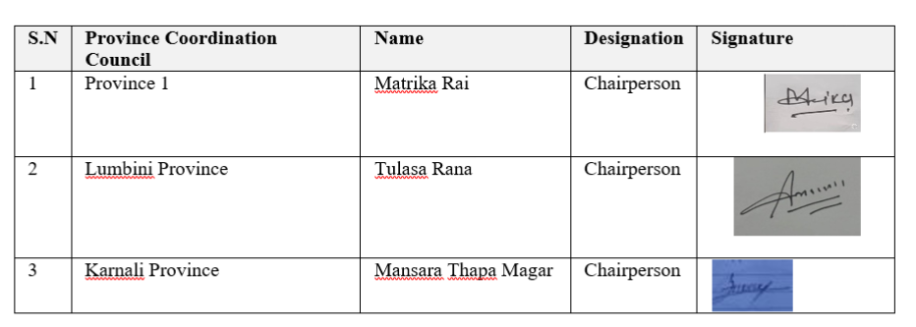

Endorsement from Member Organizations of National Indigenous Women’s Forum

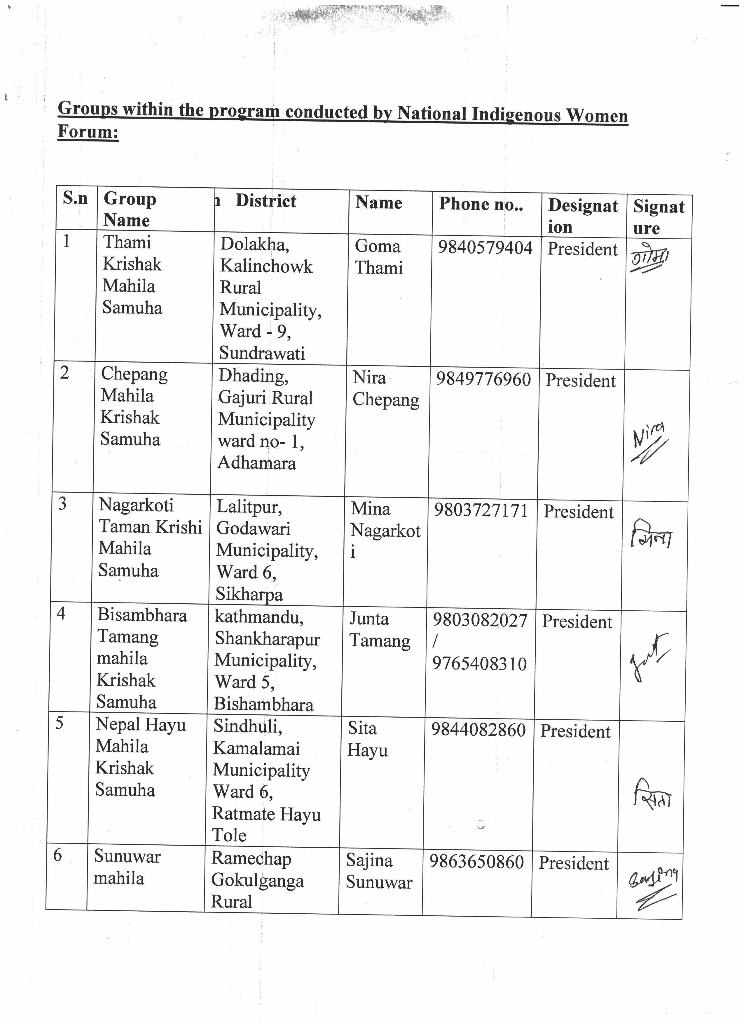
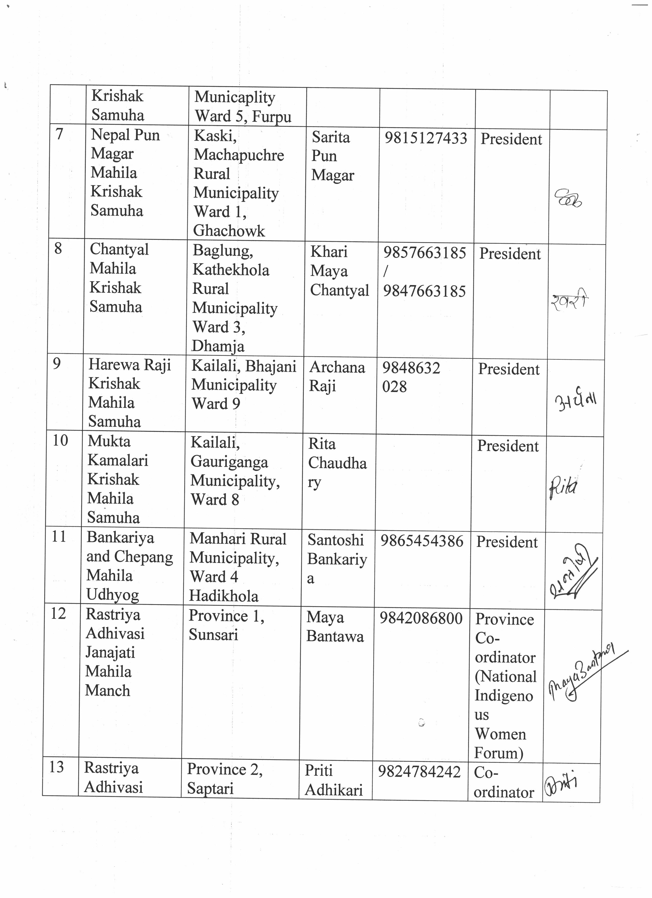
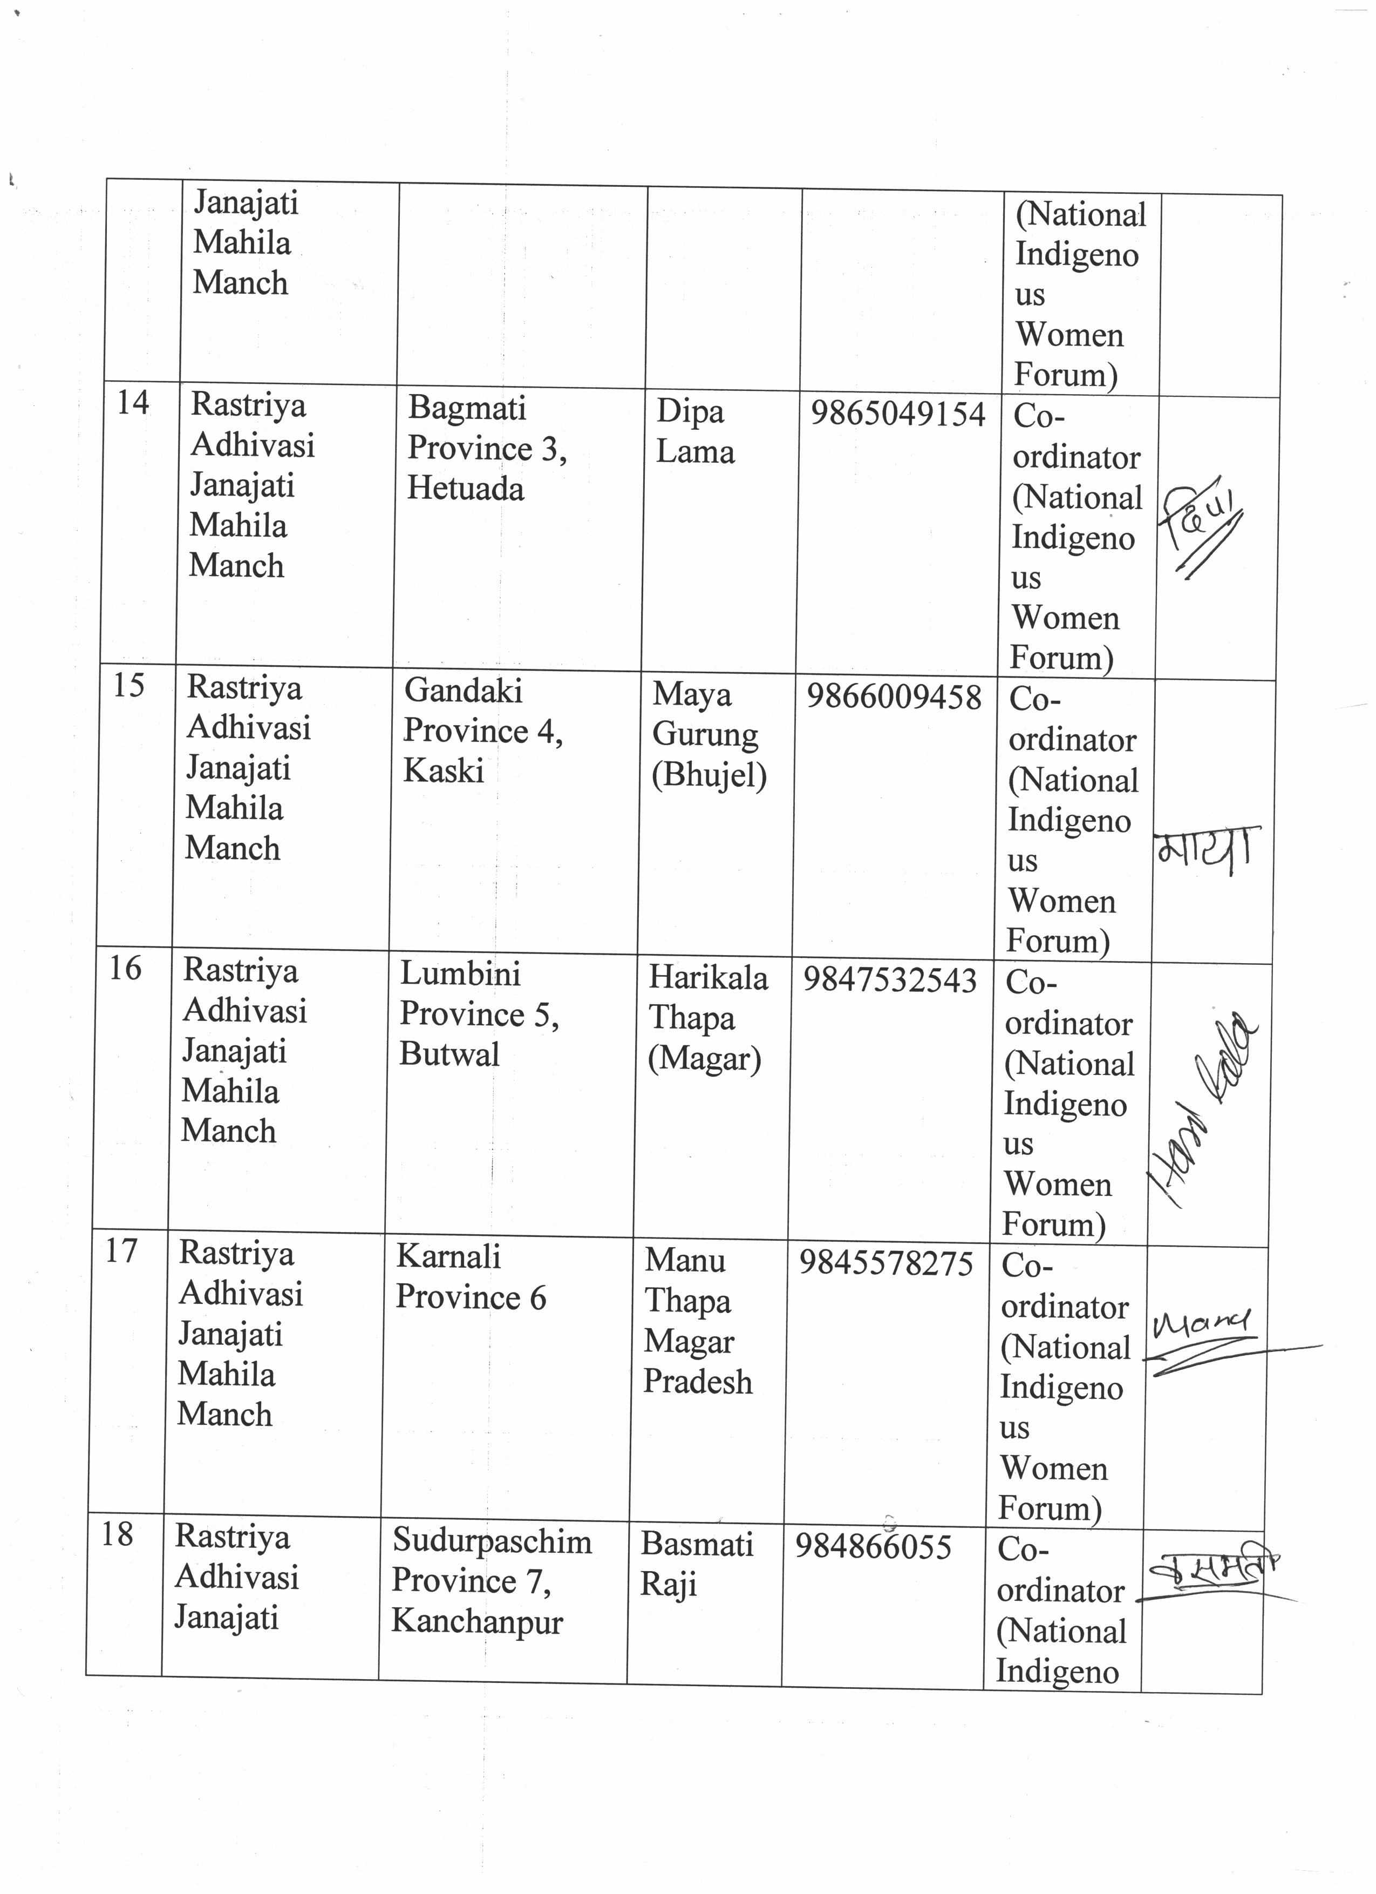
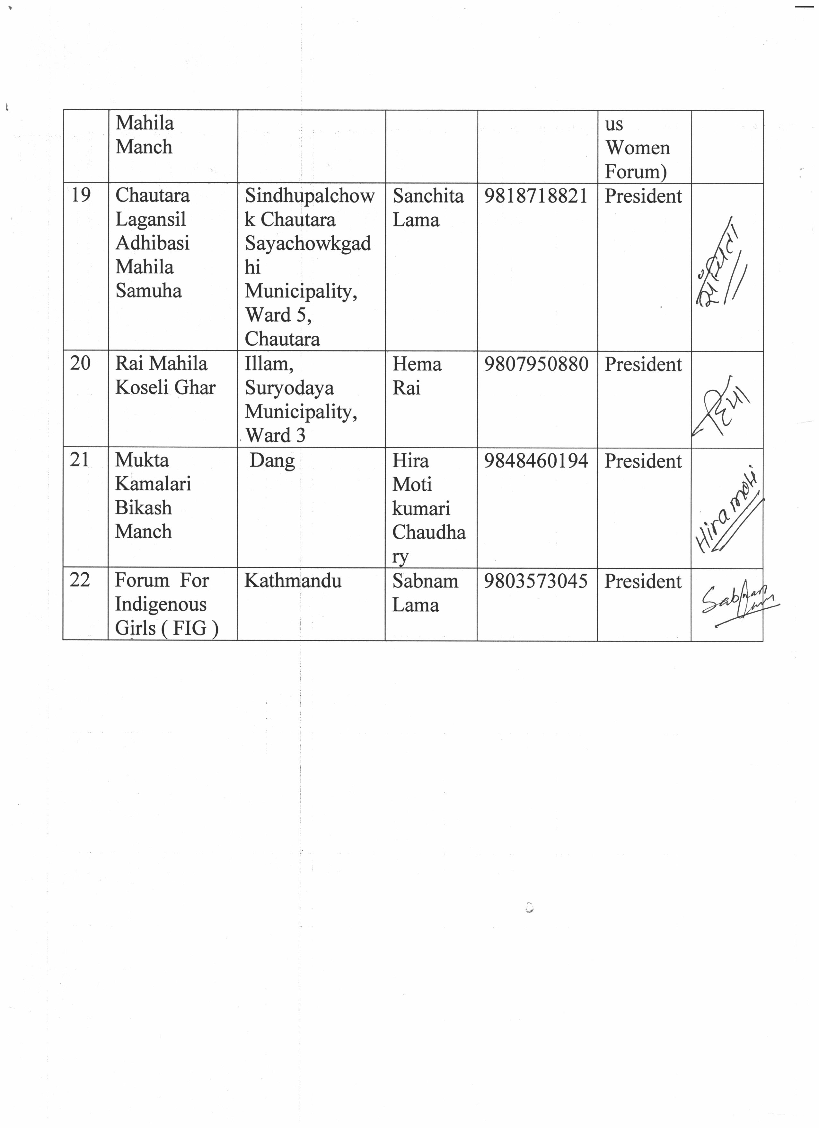
Endorsement from Member Organizations Of NIDWAN
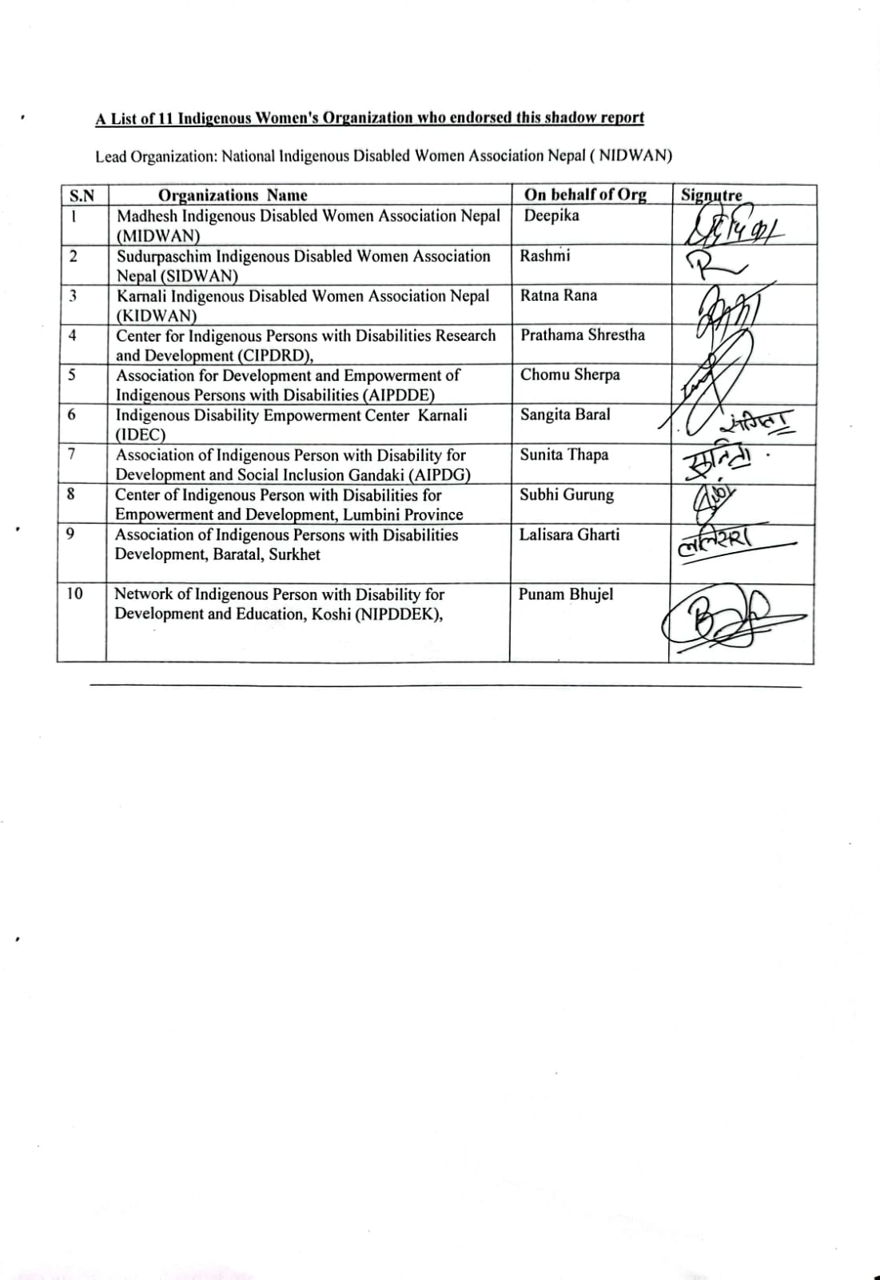

Member Organizations of INWOLAG
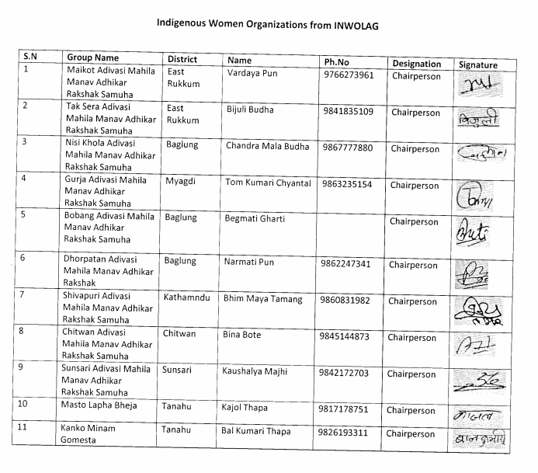

https://niwf.org.np/
https://niwfnepal.org.np/
https://nidwan.org.np/
https://inwolag.org.np/
tbinternet.ohchr.org/_layouts/15/treatybodyexternal/SessionDetails1.aspx?SessionID=2774&Lang=en
https://tbinternet.ohchr.org/_layouts/15/TreatyBodyExternal/DownloadDraft.aspx?key=KzddR3ISX+UGm9533MtadsgR3Zj9AtRJRJ5p6adcuJSOBdhIt8FOx8wmPqXGyYrifuJWFCsNuLT/wqIUQYtgeA==
https://tbinternet.ohchr.org/_layouts/15/treatybodyexternal/Download.aspx?symbolno=CEDAW%2FC%2FNPL%2FFCO%2F6&Lang=en
https://tbinternet.ohchr.org/_layouts/15/TreatyBodyExternal/DownloadDraft.aspx?key=KzddR3ISX+UGm9533MtadsgR3Zj9AtRJRJ5p6adcuJSOBdhIt8FOx8wmPqXGyYrifuJWFCsNuLT/wqIUQYtgeA==
IW&G comprise 18% of the total 29.1 million total population of Nepal. Persons with disabilities comprise 2.26% of the total population of Nepal, and among them, 1.3 million are Indigenous persons with disabilities and 700,000 are Indigenous women with disabilities in Nepal. https://nidwan.org.np/wp-content/uploads/2021/10/Overview_Nidwan.pdf https://tbinternet.ohchr.org/Treaties/CERD/Shared%20Documents/NPL/INT_CERD_ALE_NPL_7100_E.pdf
https://asksource.info/resources/covid-19-nepal impact-indigenous-peoples-and-persons-disabilities
Excerpt from focus group discussion meeting held with Indigenous peoples with disabilities organizations NIDWAN National consultation event at Kathmandu, 11th Feb 2024.
https://kathmandupost.com/politics/2024/09/19/congress-uml-coalition-reaffirms-pledge-to-review-and-amend-statute
Text in Khas Nepali language. https://niwf.org.np/wp-content/uploads/2022/01/22_IPs-Women-in-Nepal-Edited-2021-LastGG.pdf
https://www.bbc.com/news/articles/c785nwq568zo
https://ui.adsabs.harvard.edu/abs/2024EGUGA..26.2563F/abstract
https://kathmandupost.com/national/2024/10/01/death-toll-from-recent-floods-and-landslides-rises-to-219
https://press.un.org/en/2023/sgt3369.doc.htm
https://www.bbc.com/news/articles/c785nwq568zo
https://www.icimod.org/press-release/glof-from-thyanbo-glacial-lake-sweeps-away-thame-village/
https://www.bbc.com/future/article/20240522-the-drought-that-forced-a-himalayan-village-in-nepal-to-relocate
https://kathmandupost.com/national/2024/09/29/government-faces-criticism-over-slow-rescue-as-disasters-claim-lives-property
https://arrow.org.my/publication/nepal-scoping-study-amplifying-voices-of-indigenous-women-and-girls-with-disabilities-on-the-nexus-of-climate-change-and-srhr
Provincial Consultation with representatives from the Center for Research and Development of Indigenous Women with Disabilities in Karnali Province_2024
NIWFederation 2024. Notes from a National Consultation workshop for CEDAW Shadow Report
See pp. 259-60 in The Indigenous World 2024 at https://www.lahurnip.org/uploads/resource/file/iwgia-book-the-indigenous-world-2024-eng-compressed.pdf
INWOLAG report.
NIWFederation report.
Local Gazette. Part 1 Section 4 No. 2. Barbardiya Municipality. Text in Khas Nepali language. https://barbardiyamun.gov.np/barghar_aen_2077
Local Gazette Section 1 Part 4. Kiritpur Municipality.Text in Khas Nepali language. https://kirtipurmun.gov.np/sites/kirtipurmun.gov.np/files/%E0%A4%B0%E0%A4%BE%E0%A4%9C%E0%A4%AA%E0%A4%A4%E0%A5%8D%E0%A4%B0%20%E0%A4%95%E0%A5%80%E0%A4%B0%E0%A5%8D%E0%A4%A4%E0%A4%BF%E0%A4%AA%E0%A5%81%E0%A4%B0%20%E0%A4%A8%E0%A4%97%E0%A4%B0%20%E0%A4%B8%E0%A4%BE%E0%A4%81%E0%A4%B8%E0%A5%8D%E0%A4%95%E0%A5%83%E0%A4%A4%E0%A4%BF%E0%A4%95%20%E0%A4%B8%E0%A4%B0%E0%A4%95%E0%A5%8D%E0%A4%B7%E0%A4%BF%E0%A4%A4%20%E0%A4%95%E0%A5%8D%E0%A4%B7%E0%A5%87%E0%A4%A4%E0%A5%8D%E0%A4%B0%20%E0%A4%B8%E0%A4%AE%E0%A5%8D%E0%A4%B5%E0%A4%A8%E0%A5%8D%E0%A4%A7%E0%A4%AE%E0%A4%BE%20%E0%A4%B5%E0%A5%8D%E0%A4%AF%E0%A4%B5%E0%A4%B8%E0%A5%8D%E0%A4%A5%E0%A4%BE%20%E0%A4%97%E0%A4%B0%E0%A5%8D%E0%A4%A8%20%E0%A4%AC%E0%A4%A8%E0%A5%87%E0%A4%95%E0%A5%8B%20%E0%A4%90%E0%A4%A8.pdf
Text in Khas Nepali. https://www.lahurnip.org/va-sha-shha-sa-raka-shha-ta-va-sa-va-yata-ta-ka-shha-ta-ra-gha-shhanae-ka-l-ga-na-ra-tha-shana-ta-maka-aatha-sha-na-va-thana
See pp. 29-30 in NIWFederation 2021. Case Study Indigenous People’s Human Rights Violation. Chitwan National Park and Valley Road Expansion Project. Submitted to Protecting Indigenous Peoples Defenders and Promoting Land Rights in the Selected Communities Affected by Land Conflict in Peru and Nepal Project. Funded by European Union. https://niwf.org.np/wp-content/uploads/2022/12/Case-Study-English.pdf
NIDWAN National Consultation Event in Indigenous Women and Girls with Disabilities Issues at Kathmandu, 11th Feb 2024.
See pp. pp. 266-267 in https://www.iwgia.org/en/resources/publications/5507-the-indigenous-world-2023.html
https://kathmandupost.com/politics/2022/10/15/nearly-half-of-ethnic-groups-unrepresented-in-parliament-in-15-years-of-pr-exercise
https://www.icimod.org/press-release/glof-from-thyanbo-glacial-lake-sweeps-away-thame-village/
https://www.samadhannews.com/2024/09/18/95253/
INWOLAG report.

