Alternative Report for CEDAW examination for the ninth periodic report of New Zealand

(89th Session)

Submitted by

The Coalition for the Safety of Women and Children

August 2024

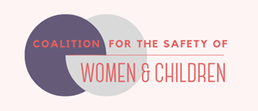

Please find below an alternative NGO report prepared by The Coalition for the Safety of Women and Children (the Coalition – members in Appendix 2) to assist the committee in the examination of (NZ) State Party. This report can be posted on the CEDAW website.

Introduction
The Coalition and The Backbone Collective (Backbone) have previously made submissions to the CEDAW committee (2018, 2020, 2022, 2023) regarding the NZ State’s Party response to gender-based violence against women and children.
We provide evidence in this alternative report contradicting some of the State party’s statements to CEDAW. We provide information relating to the everyday experiences of women and children who face severe discrimination when attempting to escape abuse, recover and live freely. Importantly, hundreds of women victim-survivors (VS) tell us the responses of some state agencies (including the Family Court, NZ Police and Oranga Tamariki – child protection) create an unsurmountable barrier to safety, further traumatise them and their children, and can place them in greater danger, as the infographic below shows.
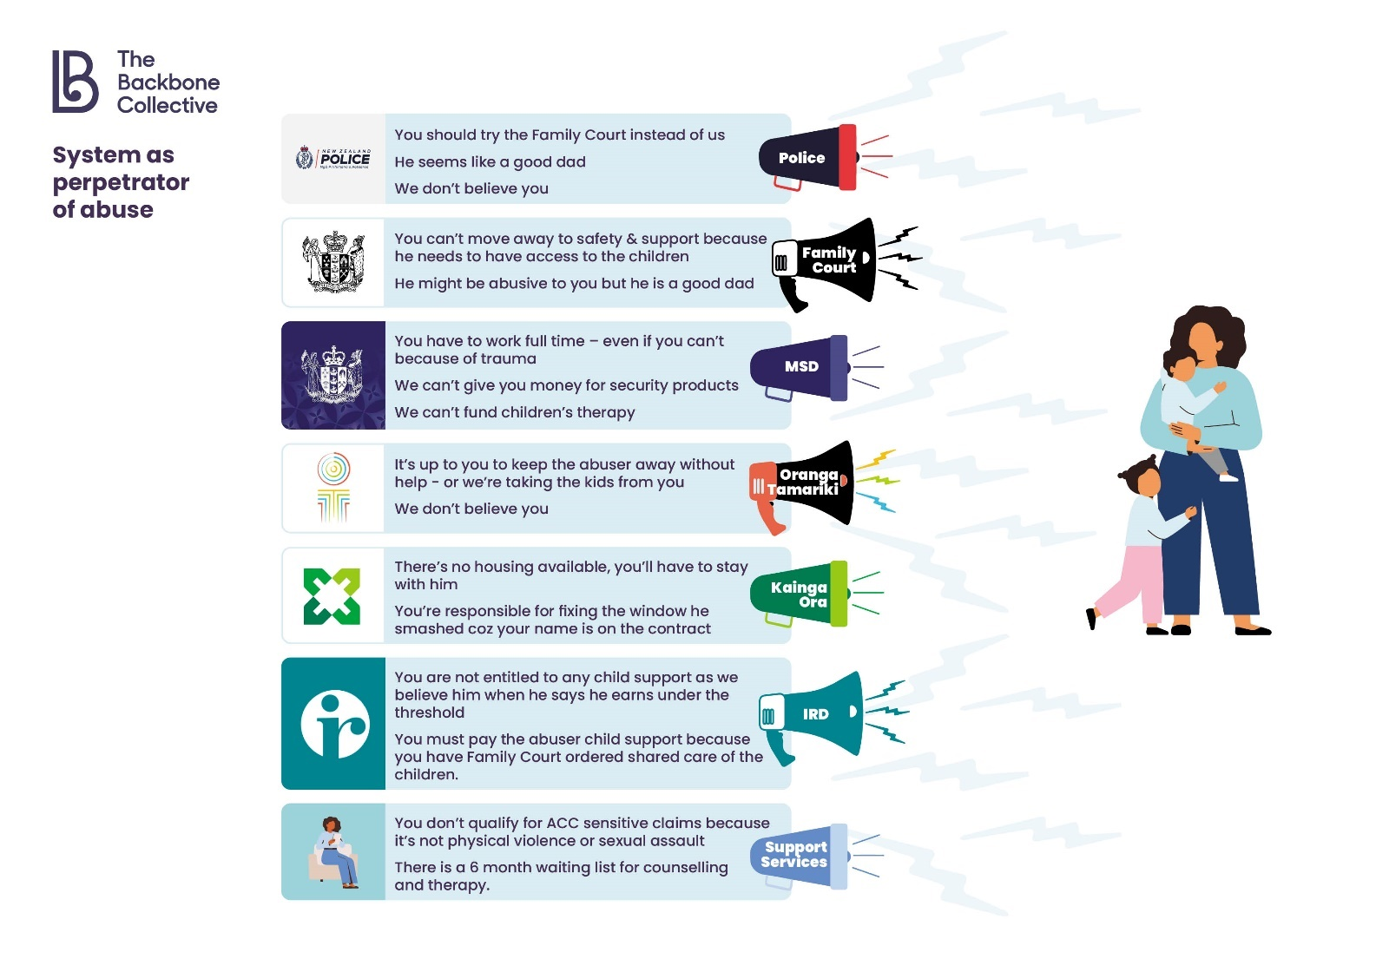
In 2022, we made a submission to inform the List of Issues that NZ would be questioned on in this examination. We ask that the Committee also draws on that submission in this examination.
We urgently need the Special Rapporteur on violence against women and girls and the Working Group on discrimination against women and girls to conduct a mission to Aotearoa New Zealand. We ask that in that visit, particular focus be given to the Family Court response to women and children victim-survivors.
Our submission presents five priority themes that relate to the NZ state’s poor response to family and sexual violence (FV/SV). The table below provides a list of the themes and our recommendations for addressing them.

Recommendations for NZ State Party
Priority theme | Recommendation
State response to gender-based violence is poor and worsening | - Create an independent complaints body / Commissioner for Victim Survivors.  - Create a stronger conduit between state agencies and victim survivor and FV/SV specialist organisations.  - Resource accessible FV/SV services for disabled women.  - Extend provisions for FV Visas to make them easier and less costly to obtain.
Family Court (NZFC) response to VS is often unsafe | - Urgently mandate all cases be screened when lodged at NZFC to identify those cases most likely to involve FV/SV, as happens in overseas jurisdictions.  - Where FV/SV allegations are present, require cases to have a thorough specialist risk assessment.  - Establish the role of Independent Specialist Child Advocate to i. carry out required risk assessments; ii. represent the welfare and best interests of children, and ensure their voices are heard in court; and iii. provide information to assist the judiciary with safe decision-making. (This frees the Lawyer for the Child to focus on legal duties.) These specialist advocates must be specialists in FV/SV, child development, trauma and tikanga Māori.  - Allow specialist community violence risk assessments and reports to be admitted as evidence.  - Legislate to prohibit the use of parental alienation and related pseudo-concepts in family law cases.  - Urgently independently review the use of Police uplifts of children ordered under sections 72 and 73 of the Care of Children Act. Without notice uplifts should stop immediately.  - Be guided by iwi, hāpū and whānau Māori to make the substantial changes needed for the NZFC to respect mana and best serve Māori VS, including tamariki Māori (children).  - Participate in international reform of Hague Convention S13 Grave Risk of Harm to ensure that it provides for the safety of women and children escaping violence.
Police response to VS is often unsafe | - Develop, resource and train all police to ensure responses to FV/SV are always based on best practice, evidence, and informed understandings of gender, trauma and violence and the needs of diverse population groups.  - Ensure VS provide informed consent before any information is shared with other agencies and services.  - Apply a perpetrator focus that upholds the safety of VS and children. Where a VS indicates this preference, prioritise actions which prevent an abuser having contact with the VS and children, including arrest.  - Establish specialist FV police units in all areas.  - Prioritise VS voice and FV/SV specialists in development of training and policy.
System response to sexual violence is not safe, just or accessible for VS | - Implement changes to consent law to protect children from being accused of having consented to sexual violation; introduce a reasonable belief defence; and codify in law a positive definition of consent.  - Enable and resource alternative justice processes by and for tangata whenua.  - Stop NZFC decisions which order children who have disclosed sexual abuse into the care of the person wo has abused them.  - Implement Treatment Courts.  - Extend free counselling to VS whose experiences of SV happened outside of NZ and those who experienced online SV (voyeurism, grooming, harassment and spread of sexual or sexualised photos).  - Mandate all VS’s (including children’s) counselling/therapy notes to be considered confidential and privileged, and therefore not eligible for third party disclosure in criminal or Family Court cases.
Lack of financial support for VS | - Provide financial support to VS – which is flexible, easy-to-access, and non-means-tested – to support them to escape violence and abuse, and help them and their children to recover, based on the model of Family Violence Flexible Support Packages in Victoria, Australia.

Gender-Based Violence (10)
FV/SV are prevalent in NZ and directly affect nearly half (46%) of all women over their lifetimes. Even when women and children are able to “escape”, violence and abuse continue long after separation.
The Luxon Government (formed in November 2023) has introduced many changes which are disproportionately and negatively impacting women VS and significantly Māori, Pasifika, immigrant, disabled and trans and non-binary people. These include:
- Moves to repeal section 7AA of the Oranga Tamariki Act – this will remove a legal initiative which has led to a reduction in tamariki Māori (children) being taken into care. (VS often have Oranga Tamariki (child protection) involvement in their lives.)
- Cuts to funding of FV/SV frontline services.
- Increase in welfare sanctions: disproportionately impacts VS as they are far more likely than others to rely on state sole parent support.
- Cuts to Whaikaha disability support: high rates of disabled people are VS.
- Proposed cuts to the digital safety team preventing online sexual exploitation.
- Human Rights Commission appointments of two people who have made anti-trans comments publicly, including the Chief Human Rights Commissioner and the race relations commissioner, who was also described by leading Kaupapa Māori researcher Leonie Pihama in 2018 as showing “a fundamentally flawed understanding of racism and racial hierarchies and how they operate within power dynamics within society”, positioning which “is uninformed and therefore extremely dangerous for Māori”.
- Police withdrawing from responding to “Family Harm” – see below.
The introduction of Te Puna Aonui (TPA) (multi-agency board and business unit) and Te Aorerekura strategy to eliminate FV/SV has not yet improved the material experiences or safety of women and children VS. The TPA business unit is not structured or given the mandate to hold government agencies to account for how they deliver actions, work collaboratively with agencies and community, or respond individually to VS.
Community groups have committed large amounts of time to writing submissions, meeting with TPA teams, creating research and reports to help advise (and TPA funds some groups to do so). However, our ongoing experience is that the business unit is not responsive to our input. Action Plans reflect the priorities of government agencies and not VS. Te Aorerekura Outcomes and Measurement Framework (OMF), published Oct 2023, states that the 'inclusion of the voices of victim-survivors' for learning and monitoring purposes is a priority (p.22). However, none of the planned outcomes and measurements mention VS directly, and they carry a high risk of silencing, de-prioritising, and ignoring VS experience – even though the services being measured are ostensibly for VS. Many of the planned data sources relevant to VS experience of system response are assessments by the workforce, rather than assessments by VS and end users. TPA consultations have short time-frames and planned analysis of community-offered data lacks both transparency and a gendered analysis.
Stalking
The Coalition has advocated for a law to criminalise stalking for many years. At the presentation of a petition with over 21,000 signatures, the current Minister of Justice publicly committed to getting a bill in the House by the end of 2024. The Coalition, in consultation with others, have submitted to the Ministry of Justice (MoJ) critical aspects that need to be in the bill, including that the bill defines stalking as a pattern of intrusive behaviour; not require proof from the victim of fear or harm, thus minimising further harm to victims during prosecution; and that the bill be followed by publication of guidance and training informed by FV specialists for police, lawyers and the judiciary.
FV Visa settings
Changes to FV Visa settings this year were welcomed. However, there remain substantive barriers for FV victims – many of which are already known to Immigration NZ, including time delays, cost, understanding of FV and wide exclusion clauses. We have written to Ministers asking Government to reform the various barriers and provided general principles relevant to immigration cases where FV is a factor, whether or not the woman’s visa or residency application is tied to her partner. Furthermore, women who apply for FV visas need access to healthcare at resident rates and be eligible for state income support.

Unsafe Family Court response
Marriage and family relations (23,24)
Backbone and the Coalition have repeatedly raised the issue (locally and internationally) of the NZ government’s failing to respond safely to women and children VS of FV/SV in the NZFC. Since the most recent examination of NZ in 2020, there have been no practical or material improvements made, contrary to claims made in the State report to CEDAW (2023). Our organisations continue to hear from hundreds of women who explain that the NZFC is the biggest barrier to their and their children’s safety and recovery from violence.
A high number of cases before the Family Courts – perhaps the majority – involve VS and their abusers. Court-ordered co-parenting arrangements are often exploited by abusers to continue physical and psychological violence on their ex-partner and children. Current state and judiciary responses put victims at further risk and embolden abusers who receive the backing of the Court and state agencies to continue – and increase – their violence. With nowhere left to turn, the horror and hopelessness for VS can increase by an order of magnitude.
Many mothers have reported to us that their own lawyers advised them the NZFC would see them as obstructive if they mentioned the FV/SV experienced by themselves or their children either during their relationship, or since separation, in their court proceedings. That advice from lawyers is based on accurate assessment of the court’s current response to FV/SV.
We have identified a number of contributing issues which we have repeatedly raised to the NZ State party, most recently to incoming Ministers in March 2024. Separately, a 2022 report commissioned by the MoJ identified many of the same serious issues. However, no action has been taken by the State party to respond to these urgent and serious issues.
- Family Court risk assessments for FV/SV are exceedingly rare. In a 2018 Backbone victim-survivor survey about NZFC experiences, only five of 236 mothers (or 2%) reported that their children were the subject of a NZFC risk assessment for FV – and practice has not changed since then.
- The Lawyer for the Child role carries neither the responsibility nor mandated training for assessing and monitoring child safety. These issues with the role are exacerbated by the lack of appropriate oversight: there is no independent monitoring or auditing of Lawyer for Child practice. Instead, complaints about them during active proceedings are referred to the presiding judge who appointed them.
- Family Court judges do not read or consider comprehensive risk and safety information (about the specific people they are presiding over) which is created by specialist social services who are already interacting with the whānau or family. In practice if not in theory, there is very little – if any – information flow between specialist FV/SV services interacting with VS and the NZFC (with the exception of Oranga Tamariki in some cases). The analysis of FV/SV specialists is not used to help inform NZFC decision making (Figure 1).

Figure 1: Lack of information flow between frontline agencies/violence experts and the NZFC
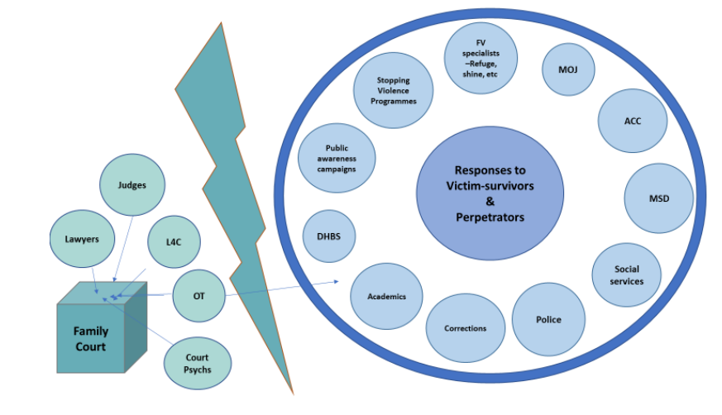
- Mothers who disclose abuse risk removal of their child from their protection and/or accusations of what UN experts call “the discredited and unscientific pseudo-concept of parental alienation”.
Backbone research shows many professionals working in the NZFC (lawyers and judges) hold unsafe views that: women frequently lie or exaggerate about their experiences of violence and abuse; are mentally unwell (while discounting the idea that any mental distress could be because of the effect of ongoing abuse) and therefore unreliable; and/or are trying to get back at their ex-partner by refusing contact and care. The majority of respondents to a Backbone survey (65%) reported that when children or mothers told NZFC professionals about concerns for the child while at the abuser’s house, these were not reported accurately to the Court or taken into consideration when care and contact orders were made.
In Backbone surveys, 55% to 62% of responding mothers said the Court accused them of parental alienation (PA). Rather than believing these VS, NZFC professionals deny that abuse occurred, or reframe it as minor, historical, irrelevant, situational or their fault. Once PA becomes part of a case’s accepted narrative, all evidence of abuse becomes perversely reframed as evidence of alienation. The more children disclose abuse or demonstrate fear of the abuser, the more the mother may be vilified and seen as the abuser. Subsequent judgments reflect the poor understanding of FV/SV dynamic and result in further harm to children. Mothers sometimes lose day to day care of the children (including very young children) on the grounds that their “unreasonable” anxiety over the children’s safety with the father is psychologically abusive.
Forced uplifts to enforce parenting orders. Some children are physically forced by police into the care of the abuser. The NZ media investigated this practice in 2017. There was public outcry at the time yet the NZFC continues to order these uplifts which are traumatic for children and women VS. In most cases they are made without notice – the parent they are made against has no prior knowledge of it; Police arrive to execute the uplift warrant without warning.
Applications granted for these uplifts have remained steady throughout 2016 – 2021 with numbers ranging from 485 to 594 warrants granted per year. Each warrant applies to one or more children. The percentage of total applications that were granted for both s72 and s73 applications rose in 2020/21, as shown in Figure 2 below.

Figure 2: Granted warrants to uplift children in Aotearoa NZ

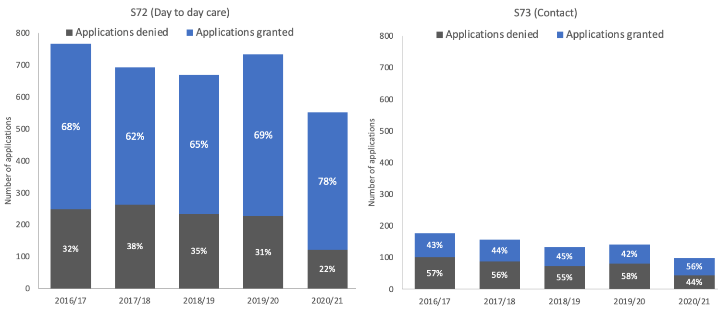

*percentage granted based on total number of determined applications - excludes those that are still active/undecided or have been lapsed, withdrawn or discontinued.

Hague Convention. Our organisations are regularly contacted by women involved in Hague Convention proceedings. Frequently they have fled FV/SV in another country, returning home to Aotearoa NZ where they have support networks. In the vast majority of cases, children are ordered back to their ‘habitual residence’ – even if that involves an unsafe/unsupportive environment. The bar for not returning children is exceptionally high and the NZFC almost always presumes that legal systems in the other country are adequate to protect the child. This compromises the safety of women and children as they are returned to situations of FV/SV in which they have no support and inadequate protection.

Response to NZ State report to CEDAW regarding Family Law
The NZ Government has stated that Aotearoa New Zealand’s family laws do not refer to parental alienation syndrome theory. Nonetheless, the NZFC frequently subscribes to PA theory. Our review of Family Law cases from 2016 to 2023 shows the concept is in wide use in NZFC – please see Appendix 1 for excerpts from judicial decisions since 2020.
CEDAW’s 2018 periodic review recommended that NZ ‘Review the reliance on the Parental Alienation theory, with a view to limit its usage in child custody disputes’ (48,d). The United Nations Special Rapporteur made her 2023 recommendation to “legislate to prohibit the use of parental alienation or related pseudo-concepts in family law cases and the use of so-called experts in parental alienation and related pseudo-concepts”
The NZ Government has stated that it has a multiyear programme underway to transform the family justice system and lists a number of activities. However, VS and women’s organisations have not seen any improvement in the response to VS in the NZFC over the last four years. For example:
The implementation of the Family Court (Supporting Children in Court) Legislation Act is questionable. As part of the Act, the MoJ was to commission a report on child participation models and make recommendations. The report was commissioned in 2021, and delivered in early 2022. It is highly critical of the Lawyer for the Child role. Yet the Ministry has taken no action in response to the report’s recommendations to introduce child specialists into the NZFC, screen cases for FV/SV, undertake risk assessments, provide training for court professionals and ensure principles of Tikanga are used to inform the development of the new child participation process. To date MoJ have not commenced any specific training for Lawyer for Child nor met with the Law Society to discuss the Inder report.
The MoJ has commissioned a FVSV Response Training package and delivery to people working in the NZFC. It is intended to include Lawyer for Child and Specialist s133 report writers (court appointed psychologists), however, to date it appears only a very small number of these types of participants have attended. Training elsewhere remains inadequate
It is extremely difficult – often impossible in rural areas – for women to secure legal representation (either legally aided or not) as few lawyers have been willing to take on new clients since COVID 19. Women are increasingly forced to represent themselves in proceedings against their abuser. In some cases that person may also be unrepresented, meaning she must cross-examine him in court herself.
The new role of Kaiārahi – Family Court Navigator has not been established as a FV/SV specialist role. This role cannot advocate for VS in court. It has not changed the unsafe way the court responds to FV/SV.
The legislative reform regarding litigation abuse announced by government in 2023 was not supported by specialist victim-survivor organisations because we believe there is a genuine risk that the Bill will be used against VS who legitimately try to use the court process by filing multiple and ongoing applications/submissions to raise safety concerns for their children or progress other proceedings under the Family Violence Act or Relationship Property Act. Therefore, we recommended the MoJ extend their consultation on litigation abuse to include VS (in a safe and appropriate way) and allocate resources to urgently develop a specialist Family Court model for responding to cases involving FV/SV. However, the Justice select committee has recommended the Bill be made into law, and we understand justice officials are currently drafting the legislation.

Police response (lack of) is often unsafe
Access to Justice (Issue 5 c/d)

Police retreat from family violence cases
FV/SV are crimes. NZ Police is responsible for upholding the maintenance of law and order, including:
- Making and keeping VS and potential VS safe, including children; for example, by issuing Police Safety Orders, and by enforcing Protection Orders.
- Arresting and removing perpetrators/offenders where a crime has been committed. No other agency has the power to do this, and with this power comes a responsibility to use it astutely.
Therefore, we are deeply concerned about current NZ Police signals that they are moving away from responding to FV callouts – what they call “family harm”. Family harm is a police term and it refers to what is generally known as ‘family violence’. The police have repeatedly suggested that ‘family harm’ is not ‘core policing.’ Police say they will refer callers to community agencies instead of responding themselves – this is inappropriate as FV is a crime.
The police believe their recent phone pilot to triage responses to FV calls has relieved frontline pressure. It involves officers on light duties calling VS in a follow up call, on average eight hours after the 111 call, rather than sending a police car urgently. The police claim:
- the pilot led to increased victim trust in the police - however no VS in the pilot were directly involved in the evaluation, or knew they were part of a pilot.
- the pilot was based on earlier UK phone pilots. However, the UK research had significant differences from the NZ pilot – for example, one of the UK phone pilots excluded FV cases and the other did not include cases where the perpetrator was present - in the NZ pilot, calls where a perpetrator is present (Priority 2 calls) were included.
VS have said they want NZ Police to step up, not down, when they make the often-risky decision to call police. They want the NZ Police to use the statutory power they alone possess to remove the perpetrator and hold them to account, like they would for any other kind of violent crime.

The police response to FV/SV is often unsafe
VS who contact police do so because they need help urgently and hope police will protect them – often contacting the police is their ‘last resort’. Yet a 2022 survey undertaken by Backbone and Hohou Te Rongo Kahukura of nearly 600 (women, trans and non-binary) VS regarding police response, shows that inadequate police action makes many VS and their children less safe. Unsafe and harmful police responses were particularly likely for trans and non-binary people, wāhine Māori and disabled people.
Police did not always take VS concerns seriously. Police took the side of the abuser for nearly a third of all survey participants. Police inaction which offered few or no consequences emboldened the abuser. Many VS described experiences where police actions were not informed by an understanding of psychological abuse and its effects, nor of typical abuser presentation as ‘rational’ ‘charming’ and ‘nice’, nor of what trauma and distress looks like in person.

“I went to police to report being strangled, and was told they would follow up. They did, then told me my husband was handsome, charming and [they] didn't believe me.”
Some VS experienced police whose actions and/or who were overtly discriminatory.

“[Police] told me it was my fault I got raped because it's what trans freaks like me deserve.”

“[Police] made sexist comments when I asked for a female officer.”
VS in areas of low deprivation were judged critically and not believed because of where they lived or because the abuser was a professional, and VS in areas of high deprivation said police did not believe them and blamed them for the abuse.

“When they arrived, they didn't believe [my child’s] story, they told me and the abuser that we seemed like a nice family in a nice area and that they knew we were 'good people'.”
VS were also blamed for the violence and abuse.

“ They asked me if it was so bad why had I stayed so long with my husband… I was so traumatised by the way police dealt with me and minimised me I don't think I will ever trust them again.”
The result of a poor police response to FV/SV is that VS and children are less safe, feel hopeless and without support or options and less likely to contact police in the future. Abusers continue and increase their violence taking revenge against victims for police involvement and only one in ten VS said involving police had stopped the abuse. Other agencies and services withhold support as Police action (e.g. arrest) is generally viewed as the evidential benchmark that FV/SV has occurred. When police don’t act, VS are not believed and labelled ‘trouble makers’ by others. Police inaction influences agencies’ and services’ response to VS and their children for many years, impacting NZFC Care of Children decisions, Oranga Tamariki proceedings, support and services available to VS and children and support from friends, family, whānau, workplaces and members of their community.
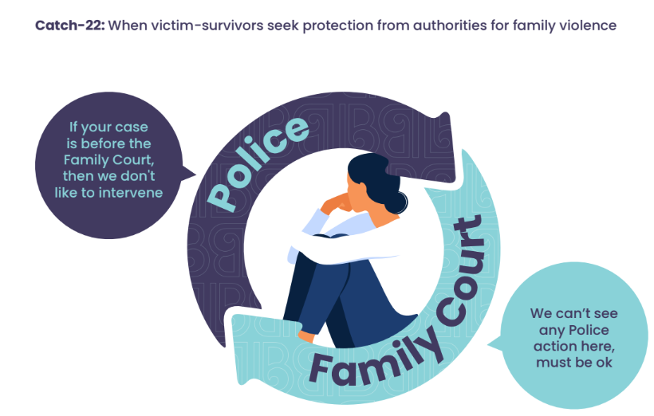
Infographic produced by The Backbone Collective 2024

Sexual violence
Gender based violence 10 (e)
There is a 1% conviction rate for SV in NZ, and the pathway to these convictions is almost always traumatic for complainants. We would like to see progression of possible solutions explored in a Law Commission Report (2013) - this included such changes as moving away from an adversarial system, development of treatment courts, and formalising alternative restorative models.
The NZ State party has referred to the Strengthening Sexual Violence Bill, which aims to reduce the potential re-traumatisation that SV victims and witnesses experience when attending or giving evidence in court. Specialists and advocates understand the Bill is a positive step towards addressing some of the ways VS are traumatised and harmed by the current response. However, it is of concern the Bill is only looking to protect under 12-year olds regarding questioning about consent, leaving 12-15-year olds still being challenged.
There is much more work to be done to improve our justice response in order to achieve both safety of VS and accountability of offenders. We recommended that the Government focus resources to work closely with specialist SV/FV organisations on recommendations proposed in this report.

Lack of financial support and funded counselling for VS
Economic and social benefits and economic empowerment (18)
Safety is achieved for VS and their children by the right support and services being available to them at the right time and for as long as it takes to be safe and recover. Financial support is vital for VS for two reasons:
1. getting safe, staying safe and recovering from violence and abuse cost a lot, and
2. violence reduces financial wellbeing.
Currently, there is very little financial support specifically targeted for VS, and it is very hard to access. There is no state funded counselling/therapy for VS who have experienced coercive control. Work and Income NZ (WINZ - agency that delivers state financial support) offer limited specialist staff to work with VS but women have shared with us that accessing financial support via WINZ is very difficult because:
- It’s hard to find out about grants/benefits and eligibility criteria
- They are too traumatised to fill out the multiple forms required
- Staff have a very poor understanding of FV/SV
- They may ostensibly have assets which make them ineligible for support, but they are unable to use that asset as it is held by the abuser (e.g., he lives in the family home).
When attempting to access financial support, some women are penalised by their association with the abuser. For example, joint home ownership, on paper – even if the VS no longer have access to the house – is taken as evidence of an ongoing “relationship” with the abuser, and therefore impacts on VS’ eligibility for support (e.g. Accommodation Supplement, Training Incentive Allowance, Disability Allowance) and Legal Aid etc. – or can even lead them to be investigated for benefit fraud.
For those VS seeking to be in paid work, state-mandated employment assistance is not designed to address the barriers they face, which are often psychological (PTSD, anxiety and low self-confidence) rather than capability based. VS tell us that jobseeker services are a very poor fit for supporting them to overcome the specific employment barriers they face.
Very recently the NZ State Party introduced a new system of benefit sanctions which we believe will disproportionately negatively impact sole mothers who are often forced to rely on state support as a result of their experience of FV/SV. The Mako Mama research found that a key factor facing single parents and impacting their ability to rebuild their lives is their experience of intimate partner violence (IPV), with two-thirds (67%) of the single māmā in their sample having experienced IPV. In addition, rates of IPV experience for disabled sole mothers – mostly those who have a diagnosed psychological condition (such as clinical depression or PTSD) – are around a third higher than for non-disabled single mothers – and the IPV will have been a contributing factor to the disability for some. FV/SV affects the earning ability of some VS.
In Victoria Australia, the Flexible Support Packages (FSP) have been in place since 2016, and the first-year evaluation found the packages to “have had a transformational impact in supporting thousands of victim survivors to achieve safety and recover from their experience of family violence”. VS are provided with a lump-sum, non-income-tested, non-refundable flexible grant of up to AUS$10,000 each which can be used for anything they need to help them get safe and recover. A fund like this in NZ would make an immediate difference to women and children's safety.
Furthermore, while funded counselling is available for those harmed by many forms of SV if it was perpetrated in NZ, funded counselling is not generally available for those who have been hurt by online voyeurism, grooming, sexualised harassment, or digital harm, such as due to sexual or sexualised photos being shared on the internet.

Appendix 1
Excerpts from a sample of judicial decisions from NZFC illustrating the use of PA concepts in family law cases (2020 -2023)
Re: Jacobs [2023] NZFC 8318
“The concept, now referred to in the Family Court jurisdiction as ‘refuse/resist’ rather than parental alienation is widely accepted as being a complex issue.”
Shirley v Richmond [2023] NZHC 913
“[A] ‘resist/refuse’ relationship has developed in that Matthew is strongly opposed to a return to unsupervised contact with his father.”
Simpson v Ministry of Justice [2023] NZHC 28
“I accept that the phenomenon of alienation is well-recognised.”
Fayen v Lees [2022] NZFC 8870
“The concept of alienation is where one parent ‘deliberately and either overtly or covertly, sabotages a child's relationship from a previously favoured parent’.”
Blair v Blair [2022] NZFC 4030]
“An assessment of the nature of the relationship between children and the rejected parent pre-separation appears also to be relevant in assessing whether there is evidence of parental alienation, resist/refuse or justified estrangement.”
Simpson v Family Court [2021] NZHC 2601
“The sad fact is that Anna has grown to her present age alienated from her father.”
GLE v MMW [2021] NZHC 1862
“Ms Lightfoot said O has become alienated from his father and his refusal to have contact with his father has been supported and enabled by his mother.”
Smith v Shackman [2021] NZFC 3002
“[A] lot of the features of alienation identified by [counsel for the respondent] have been proven in this case and there is alienating type of behaviour.”
Marlowe v Gardiner [2021] NZFC 5151
Ms Lightfoot was clear in her evidence that [Owen] has become alienated from Mr [Marlowe], and that his refusal to have contact with Mr [Marlowe] has been supported and enabled by Ms [Gardiner]”

Schofield v Hargrave [2021] NZFC 4244
“Ms Hargrave has actively continued to alienate [Steph] from her father.”
Armstrong v Mann [2020] NZFC 1319]
“The report writer is very concerned that this appears to be a case of parental alienation by Ms [Armstrong] towards Mr [Mann] and if this is not addressed then [Gilbert] will continue to believe the lies that he has already in his head about his Father, Mr [Mann].”
KP v AZ [2020] NZHC 1340]
“The focus of this case was on alienation and its effect on the welfare and best interests of M. The main basis for the Family Court's decision was that Ms K was responsible for alienating M from his father to such an extent that M's future development and mental health called for a change in the parent carer and for no contact with Ms K until at least M had settled with his father.”
“The Judge therefore concluded that M could not remain with his mother due to the severity of the alienation in which was found to exist in the influence of the mother and the maternal family on M.”

Appendix 2

Members: Auckland Women’s Centre – Te Wāhi Wāhine o Tāmaki Makaurau, Eastern Women’s Refuge, the NZ Human Rights Centre, HELP Support for Sexual Abuse Survivors, Hestia Women’s Refuge, Inner City Women’s Group, Kia Haumaru - Personal Safety Education, National Council of Women, Auckland, North Shore Family Violence Prevention Coordinator, North Shore Women’s Centre, Pacific Women’s Watch, New Zealand, Rape Prevention Education – Whakatu Mauri, Respect, Rodney Women’s Centre, Shakti Community Council NZ, SHINE Safer Homes in NZ Everyday, The Backbone Collective, Women’s Health Action Trust, Women’s Refuge - Tāmaki Makaurau, YWCA, Auckland.

The Domestic Abuse Commissioner model in the UK is an effective example of a similar role: https://domesticabusecommissioner.uk/. For Family Court improvement work, see the Domestic Abuse Commissioner Family Court Report (2023).
Federal Circuit and Family Court of Australia (n.d). Lighthouse Overview > Family DOORS Triage. https://www.fcfcoa.gov.au/fl/fv/lighthouse#_ftn1
Alsalem, R. (2023.) Custody, violence against women and violence against Children: Report of the Special Rapporteur on violence against women and girls, its causes and consequences. United Nations.
Boulton, A., Wikaira, M., Cvitanovic, L., & Blyth, T. W. (2020). Te Taniwha i Te Ao Ture-ā-whānau: Whānau Experience of Care and Protection in the Family Court. Te Kōpū Ed.
NZ Law Commission. Alternative pre-trial and trial processes possible reforms: Issues paper no. 30. Pgs 44-47.
For more information, see the Victorian government page on Family Violence Flexible Support https://www.vic.gov.au/flexible-support-packages
Ministry of Justice. (2023). New Zealand Crime and Victims Survey: Key Findings Cycle 5. NZ
The Backbone Collective (2020) Victim-Survivor Perspectives on Longer-Term Support After Experiencing Violence and Abuse A report prepared for the Ministry of Social Development. NZ.
https://nzfvc.org.nz/news/pre-budget-2024-announcements-impacts-budget-cuts-government-agencies ; also: https://www.rnz.co.nz/news/top/523783/kids-in-south-auckland-to-lose-support-from-frontline-social-workers-due-to-govt-cuts
https://kaupapamaori.com/2018/08/12/444/
For examples see previous CEDAW submissions (2018 and 2020, 2022), local submissions and media articles.
NZ’s ninth periodic report for CEDAW 2023
Research in Australia found that 54% of families in court to make parenting arrangements reported physical violence, and 85% reported emotional abuse. See Kaspiew et al., (2015) Experiences of Separated Parents Study (Evaluation of the 2012 Family Violence Amendments). Melbourne: Australian Institute of Family Studies.
Backbone Collective (2017). Out of the Frying Pan and into the Fire: Women’s experiences of the New Zealand Family Court.NZ
Backbone Collective (2024). Briefing to the incoming Justice Minister.
Inder D. Review of Children's Participation in the Family Justice System of Aotearoa New Zealand. 2022
Herbert, R. and D Mackenzie (2018). Seen and not Heard: Children in the New Zealand Family Court. Part Two - Lawyer for Child? Backbone Collective NZ.
In Backbone’s children in the Family Court survey Māori mothers were more likely to report Oranga Tamariki involvement in their Family Court case (52%) than non-Māori mothers (39%). See The Backbone Collective (2017). Seen and not Heard: Children in the New Zealand Family Court. Part One - Force. NZ. P10 7
Alsalem, R. (2023.) Custody, violence against women and violence against Children: Report of the Special Rapporteur on violence against women and girls, its causes and consequences. United Nations.
Mackenzie, D., R. Herbert & N. Robertson (2020): “‘It’s Not OK’, but ‘It’ never happened: parental alienation accusations undermine children’s safety in the New Zealand Family Court”, Journal of Social Welfare and Family Law.
Backbone Collective (2017). Out of the Frying Pan and into the Fire: Women’s experiences of the New Zealand Family Court. NZ. For examples of advice VS have for each other about protecting themselves when dealing with the Family Court, see Backbone’s 2023 guide: Reducing risk and harm when going to Family Court An Information Guide for VS.
See pp. 25-27 of https://www.backbone.org.nz/reports/report-four-seen-and-not-heard-force20171214
Backbone Collective (2017). Out of the Frying Pan and into the Fire: Women’s experiences of the New Zealand Family Court. NZ.
Mackenzie, D., et al. (2020) ‘It’s Not OK’, but ‘It’ never happened: parental alienation accusations undermine children’s safety in the New Zealand Family Court. Journal of Social Welfare and Family Law 41(1).
Some children are ordered into unsupervised contact or increased care with the abuser or have no contact at all with their protective parent. See https://www.backbone.org.nz/reports/report-two-family-court-survey-report201768 particularly pp. 30-32 on prohibitive orders.
See Mazar v Holloway [2019] NZFC 9520, available at https://www.districtcourts.govt.nz/
Under sections 72 and 73 of the COCA the Court can impose a warrant to uplift the child/ren and place them in the care of the parent who under current orders would ordinarily have them in their care or whom the court now orders should have day to day care. These are separate from uplifts ordered under s39 of the Oranga Tamariki Act 1989.
A short video by NZ media about S72, S3 police uplifts is available at https://www.newsroom.co.nz/2017/08/07/41459/taken-by-the-state
We cannot ascertain from the OIA report which parent filed the application. In some cases, a protective parent will make an application to enforce a parenting order if an abuser refuses to return the child/ren to their care, e.g. as happened during the COVID 19 lockdowns. However, there are other ways to ensure compliance, where appropriate https://www.1news.co.nz/2022/11/06/petition-calls-to-end-practice-of-child-uplifts-in-custody-battles/
Specifically, Article 13(b): There is grave risk of physical or psychological harm to the child if he or she is returned or the return will place the child in an intolerable situation.
Also referred to in NZFC as Resist-Refuse, Enmeshment, coaching a child.
Alsalem, R. (2023.) Custody, violence against women and violence against Children: Report of the Special Rapporteur on violence against women and girls, its causes and consequences. United Nations.
Inder D. Review of Children's Participation in the Family Justice System of Aotearoa New Zealand. 2022
As per meeting with MoJ policy officials 15 August 2024.
Backbone meeting with MoJ officials, August 2024
A three-day workshop for Lawyers for Child was held in June 2022. Course material did not include FV/SV dynamics, risk assessment, or reference to Te Aorerekura. However, presenters focussed on parental alienation-based theories and court ordered ‘treatment programmes’ for children who resist contact with a parent even when FV/SV has been disclosed. https://www.lawyerseducation.co.nz/shop/Books/Family/Advanced+Lawyer+for+Child.html
The NZ Police Briefing to the Incoming Minister (published February 2024) draws attention to a perceived need of “Supporting Police to re-focus on our core business and away from ‘expanded’ activities, particularly in the social domain…for example, reducing Police’s role in mental health crisis response is a clear opportunity, as is right sizing our response to family harm.” Pg 9. The most recent media example is Assistant Commissioner Sam Hoyle, describing the need for a ‘managed withdrawal’ from ‘family harm’ and mental health callouts. One of Hoyle’s examples was the need to stop responding to ‘fighting because there is no food in the cupboard, [and] mum needs a hand with the kids.’
Evidence Based Policing Centre. Family Harm Non-Emergency Triage (FHNT) evaluation report : September 2023.
Backbone Collective & Hohou Te Rongo Kahukura 2024, Make it about us: Victim Survivors’ recommendations for building a safer police response to intimate partner violence, family violence and sexual violence in Aotearoa New Zealand.
Ibid.
The following quotes are from the Make It About Us report (2024).
The Backbone Collective (2020) Victim-Survivor Perspectives on Longer-Term Support After Experiencing Violence and Abuse A report prepared for the Ministry of Social Development. NZ.
Child Poverty Action Group (2023). Remove the blocks to whānau wellbeing generated by outdated relationship income rules. Policy Brief, CPAG NZ
https://www.1news.co.nz/2024/08/12/government-increases-benefit-sanctions/
Domett, T., et al. (2023). Mako Mama – Mangopare Single Parents Project Final Report. The Peter McKenzie Project and Ngāti Kahungunu.
https://www.vic.gov.au/family-violence-recommendations/expand-provision-family-violence-flexible-support-packages
FSP program guidelines, available at: https://providers.dffh.vic.gov.au/program-requirements-delivery-family-violence-flexible-support-packages

