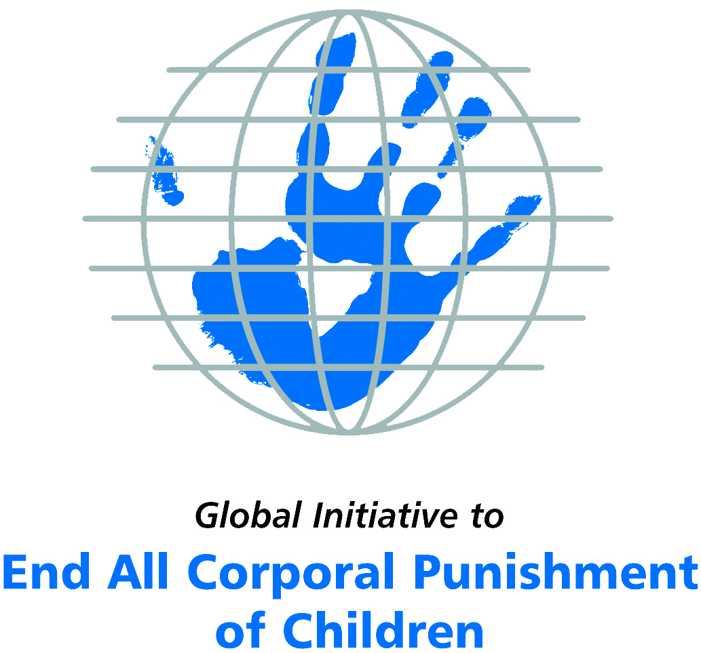
Briefing on South Africa for the Committee on the Rights of Persons with Disabilities, 9th Pre-Sessional Working Group, March 2018
From the Global Initiative to End All Corporal Punishment
of Children, January 2018

(a) About the Global Initiative to End All Corporal Punishment of Children
1. The Global Initiative (www.endcorporalpunishment.org) promotes universal prohibition and elimination of corporal punishment in fulfilment of states’ obligations under the UN Convention on the Rights of the Child and other international treaties. Our aims are supported by UNICEF, UNESCO, human rights institutions and international and national NGOs. Since 2002, the Global Initiative has regularly briefed the Committee on the Rights of the Child on this issue, and since 2004 has similarly briefed the Committee Against Torture, the Committee on the Elimination of Discrimination Against Women, the Committee on Economic, Social and Cultural Rights, the Human Rights Committee and the Human Rights Council; we have briefed the Committee on the Rights of Persons with Disabilities since the beginning of its work.

(b) Summary
2. Corporal punishment of children in South Africa is unlawful in all settings outside the home but it is not yet fully prohibited in the family, in violation of the fundamental right of all children to protection from corporal punishment and other cruel or degrading forms of punishment.
3. With reference to articles 7, 15, 16 and 17 of the Convention on the Rights of Persons with Disabilities, and in light of the particular vulnerability of children with disabilities to corporal punishment by adults, the jurisprudence of the UN treaty bodies, the emphasis on eradicating this form of violence given by the UN Secretary General’s Study on Violence against Children and the importance of the issue to achieving target 16.2 on ending violence against children in the 2030 Sustainable Development Goals, we hope the Committee on the Rights of Persons with Disabilities will:
- include the issue of corporal punishment in its List of Issues for South Africa, in particular asking: “what steps are being taken to enact legislation explicitly prohibit all corporal punishment of children, including in the home, as a matter of priority?”
- recommend to the Government of South Africa, in the Committee’s concluding observations on the initial report, that “legislation explicitly prohibiting all corporal punishment of children, including in the home, is enacted as a matter of priority and that measures are put in place to ensure the law is properly implemented”.

(c) Detailed briefing
The right of children with disabilities not to be subjected to corporal punishment
4. The Convention on the Rights of Persons with Disabilities confirms that children with disabilities should enjoy all human rights and fundamental freedoms on an equal basis with other children (art. 7). The Convention also states that all persons have the rights to freedom from torture or cruel, inhuman or degrading treatment or punishment (art. 15), to freedom from exploitation, violence and abuse within and outside the home (art. 16) and to respect for their physical and mental integrity (art. 17). The jurisprudence of treaty monitoring bodies, led by the Committee on the Rights of the Child monitoring the Convention on the Rights of the Child, is clear that these rights put an obligation on states parties to prohibit and eliminate all corporal punishment of children, including within the family. Although South Africa’s report refers to legislation protecting all individuals from domestic violence, it does not address the issue of corporal punishment of children with disabilities. The near universal acceptance of corporal punishment in childrearing necessitates clarity in law that all forms of corporal punishment, however ‘light’, are prohibited.
5. As confirmed in the UN Secretary General’s Study on Violence against Children, children with disabilities are particularly vulnerable to violence, including corporal punishment, and corporal punishment is a significant cause of impairment among children. Yet the obligation to prohibit corporal punishment is frequently ignored or evaded by governments. The near universal acceptance of violence in childrearing together with deeply held views that parents and other adults have a “right” to physically punish children can challenge efforts to achieve prohibition. It also means that corporal punishment – at least to some degree – is not readily perceived as violence in the same way as, for example, sexual and other socially unacceptable forms of violence.
6. The newly adopted Sustainable Development Goals under the 2030 Agenda include target 16.2 on ending all forms of violence against children. Violent punishment is the most common form of violence against children: ending it through the adoption and implementation of legislation prohibiting it in all settings including the home is critical.

The legality of corporal punishment of children with disabilities in South Africa
7. In South Africa, corporal punishment of children is unlawful in all settings outside the home, but children with disabilities may lawfully be subjected to physical punishment in the family.
8. Corporal punishment is lawful in the home. In October 2017, the High Court of Gauteng ruled that the common law defence of “reasonable or moderate chastisement” breached children’s rights upheld by the 1996 Constitution and as such was unconstitutional. The common law recognised parents’ power “to inflict moderate and reasonable chastisement on a child for misconduct provided that this was not done in a manner offensive to good morals or for objects other than correction and admonition”. This power could be delegated to a person acting in the parent’s place, though not in the case of teachers. But despite this ruling of unconstitutionality, the near universal acceptance of corporal punishment in childrearing necessitates clarity in law that no level of corporal punishment is acceptable: an explicit prohibition of all corporal punishment of children must be enacted in legislation. Freedom of Religion South Africa (FORSA), which acted as amicus curiae during the hearing, has applied for leave to appeal the decision, arguing that there is a clear and fundamental difference between moderate chastisement by a parent motivated by “love” and physical violence.
9. The Children’s Act 2005 defines abuse in relation to a child as “any form of harm or ill-treatment deliberately inflicted on a child” including “assaulting a child or inflicting any other form of deliberate injury to a child” and “exposing or subjecting a child to behaviour that may harm the child psychologically or emotionally” (art. 1), but the Act does not explicitly prohibit all corporal punishment. Similarly, provisions against violence and abuse in the Constitution 1996 and the Domestic Violence Act 1998 are not interpreted as prohibiting all corporal punishment in childrearing. The Children’s Act was amended in 2007 to provide for prevention and early intervention programmes on positive discipline, but a clause which would have prohibited corporal punishment in the home was removed from the Amendment Bill before it was passed by Parliament, pending further investigation.
10. Corporal punishment is unlawful in alternative care settings. Regulations under the Children’s Act 2005 explicitly prohibit corporal punishment and other forms of humiliating and degrading punishment in foster care (art. 65), cluster foster care schemes (art. 69) and child and youth care centres (arts. 73 and 76). National Norms and Standards for Drop-In Centres states that corporal punishment should not be used (s1).
11. Corporal punishment is unlawful in early childhood care and in day care for older children, including for children with disabilities. National Norms and Standards for Early Childhood Development Programmes (s3) state that corporal punishment should not be used and it is prohibited in preschool and educational day care provision under education legislation (see below).
12. Corporal punishment is unlawful in schools under the South African Schools Act 1996 (art. 10): “(1) No person may administer corporal punishment at a school to a learner. (2) Any person who contravenes subsection (1) is guilty of an offence and liable on conviction to a sentence which could be imposed for assault.” Prohibition is also included in the National Education Policy Act 1996 (art. 3) and the Further Education and Training Colleges Act 2006 (art. 16). In 2000, the Constitutional Court dismissed a bid by 196 Christian schools to make an exception to the prohibition on grounds of religious conviction.
13. Corporal punishment is unlawful as a disciplinary measure in penal institutions. The Correctional Services Second Amendment Act 1996 abolished disciplinary corporal punishment in prisons in respect of civil debtors, though there is no explicit prohibition of corporal punishment in the Correctional Services Act 1998. Regulations under the Children’s Act 2005 explicitly prohibit corporal punishment in child and youth care centres and put a duty on the manager and staff of such centres to promote positive discipline (arts. 73 and 76). The Child Justice Act 2008 states that in applying the Act “the rights and obligations of children contained in international and regional instruments, with particular reference to the United Nations Convention on the Rights of the Child and the African Charter on the Rights and Welfare of the Child” must be taken into account (art. 3(i)).
14. Corporal punishment is unlawful as a sentence for crime under the Abolition of Corporal Punishment Act 1997, enacted following a Constitutional Court judgment in 1995 that whipping is unconstitutional, stating that “at this time, so close to the dawn of the 21st century, juvenile whipping is cruel, it is inhuman and it is degrading” and “[a] culture of authority which legitimates the use of violence is inconsistent with the values for which the Constitution stands”. The judgment also states: “There is no dignity in the act [of corporal punishment] itself; the recipient might struggle against himself to maintain a semblance of dignified suffering or even unconcern; there is no dignity even in the person delivering the punishment. It is a practice which debases everyone involved in it.” There is no provision for corporal punishment in the Child Justice Act 2008.
15. Opportunities for law reform. The Government signalled its commitment to law reform in accepting the recommendation to prohibit corporal punishment in the home and other settings made during the Universal Periodic Review (UPR) of South Africa in 2012 and in the support of the Department of Social Development for proposals to include explicit prohibition made in the context of the review of the Children’s Act. The Government reiterated its intention to prohibit corporal punishment in 2014. Amendments to the Children’s Act were then drafted which would explicitly prohibit all corporal punishment and repeal the common law defence of “reasonable chastisement”. But in May 2015, the Minister of Social Development tabled the Children’s Amendment Bill and the Children’s Second Amendment Bill in Parliament, neither of which includes prohibition of corporal punishment or repeal of the “reasonable chastisement” defence. According to the South African Human Rights Commission, the purpose of the Bills was primarily to align the Children’s Act with Constitutional Court judgments, and a Children’s Third Amendment Bill addresses corporal punishment in the home though there are no indications when this Bill will be published for public engagement. The prohibition clause proposed in this Third Amendment Bill states that “no child may be subjected to corporal punishment or be punished in a cruel, inhuman or degrading way” and “the common law defence of reasonable chastisement … is hereby abolished”: it was expected to be tabled in 2016. As at October 2017, it has not yet been introduced in Parliament. The Government ‘noted’ (did not support) recommendations to prohibit corporal punishment in all settings during the Universal Periodic Review in September 2017.
16. South Africa became a Pathfinder country with the Global Partnership to End Violence Against Children in early 2018. This commits the Government to three to five years of accelerated action towards the achievement of Target 16.2 of the Sustainable Development Goals.

Recommendations by human rights treaty monitoring bodies and during the UPR
17. In 2000, the Committee on the Rights of the Child recommended that corporal punishment be prohibited in the home and care institutions in South Africa. In the Committee’s Concluding Observations on South Africa’s second report in 2016, the Committee welcomed the prohibition in penal institutions and in care settings but again recommended the prohibition of all corporal punishment in the home, including “reasonable chastisement”.
18. In 2016, the Human Rights Committee expressed concern at the legality and prevalence of corporal punishment and recommended that South Africa take legislative measures to end corporal punishment in all settings.
19. In 2006, the Committee Against Torture recommended to South Africa that legislation prohibiting corporal punishment in schools be strictly implemented.
20. In 2014, the African Committee of Experts on the Rights and Welfare of the Child recommended that South Africa “expedite the process of amending the Children’s Act to explicitly ban corporal punishment in all settings including in the home”.
21. South Africa was reviewed in the Universal Periodic Review process in 2008 and 2012, and recommendations to prohibit all corporal punishment were made. On both occasions, the Government indicated that it considered existing law to be adequate, but in 2012 the Government accepted the recommendation. In 2017, two recommendations to explicitly prohibit corporal punishment and repeal the defence of “reasonable chastisement” were ‘noted’ (not accepted) by the Government, which explained generally that ‘noted’ recommendations were those “which South Africa is in the process of considering and cannot commit to at this stage”.

Briefing prepared by the Global Initiative to End All Corporal Punishment of Children
www.endcorporalpunishment.org; info@endcorporalpunishment.org

Pinheiro, P. S. (2006), World Report on Violence against Children, Geneva: United Nations. See also Krug E. G. et al (eds) (2002), World Report on Violence and Health, Geneva: World Health Organisation
YG v. The State, High Court of Gauteng Local Division, Case No. A263/2016
R v Janke and Janke 1913 TPD 382
See https://www.iol.co.za/news/south-africa/gauteng/ngo-seeks-leave-to-appeal-spanking-judgment-11951332, accessed 13 November 2017
Christian Education South Africa v Minister of Education, 2000 (4) SA 757 (CC)
S v Williams et al, 1995 (3) SA 632 (CC), para. 52
S v Williams et al, 1995 (3) SA 632 (CC), para. 89
9 July 2012, A/HRC/21/16, Report of the working group, para. 124(88)
National Department of Social Development, Media Statement, 3 June 2014
South Africa Human Rights Commission, communication with the Global Initiative, October 2015
Information provided to the Global Initiative, November 2015
19 September 2017, A/HRC/36/16/Add.1, Report of the working group: Addendum, para. 32
23 February 2000, CRC/C/15/Add.122, Concluding observations on initial report, paras. 3, 8 and 28
27 October 2016, CRC/C/ZAF/CO/2, Concluding observations on second report, paras. 35 and 36
[April 2016], CCPR/C/ZAF/CO/1 Advance Unedited Version, Concluding observations on initial report, paras. 24 and 25
7 December 2006, CAT/C/ZAF/CO/1, Concluding observations on initial report, para. 25
[October 2014], Concluding observations on initial report, paras. 34 and 35
23 May 2008, A/HRC/8/32, Report of the working group, para. 67(1); 1 September 2008, A/HRC/8/52, Report of the Human Rights Council on its eighth session, para. 567 ; 9 July 2012, A/HRC/21/16, Report of the working group, para. 124(88) ; 18 September 2012, A/HRC/21/16/Add.1, Report of the working group: Addendum, annex
19 September 2017, A/HRC/36/16/Add.1, Report of the working group: Addendum, paras. 4 and 32

