REPORT ON THE SITUATION OF RELIGIOUS RACISM IN BRAZIL
ELABORATED BY BLACK WOMEN LEGAL EXPERTS
FOR THE COMMITTEE ON THE ELIMINATION OF RACIAL DISCRIMINATION

Salvador-BA, 24 October 2022

Shadow Report submitted by Selo Juristas negras, to the 108th Session of the Committee on the Elimination of Racial Discrimination (CERD) on the examination of the 18th to 20th periodic report presented by Brazil pursuant to article 9 of the Convention, in Geneva, November 14 to December 2, 2022.

- INTRODUCTION

Created in 2020, in the midst of the COVID 19 pandemic, Selo Juristas Negras (“Black Women Legal Experts Seal”) is an organization of women of African descent who work in the most diverse functions of the Brazilian justice system, focused on confronting racism, sexism and all forms of oppression, through the production, dissemination and articulation of Afro-diasporic and pluriversal legal knowledge. Conceived by two black women legal experts from the Northeast of Brazil (Chiara Ramos, from Recife-PE, and Lívia Sant'Anna Vaz, from Salvador-BA), our organization is intergenerational and formed by women legal experts of African descent - academics, lawyers, delegates, public prosecutors, public defenders, judges, prosecutors, advisors and legal assistants - from all regions of the country.
This report aims to present legal and factual grounds on the urgency for action by national and international human rights organizations to combat religious racism and to protect and promote religious freedom equally for religions of African origin in the Brazilian social and legal context.
Religious racism is one of the most serious manifestations of Brazilian racism that assumes a ubiquitous and fluid character, intersecting with other mechanisms of oppression. The phenomenon needs to be appointed in this way as a form of recognition that the violence and discrimination suffered are directly associated with the black background of religiosities of African origin.
Brazil is a national State declared secular by the current Federal Constitution of 1988, having committed to the separation of State and religion and to the protection of religious freedom. In its territory, Brazil is home to countless religious denominations of various types, such as Christianity, Protestantism, Buddhism, Spiritualism, Judaism, Islam, Shamanism, as well as Candomblé and Umbanda, the last two being religions of African origin. All these forms of profession of faith are inviolable under the terms of Article 5, item VI, of the Federal Constitution, which ensures the free exercise of religious worship and guarantees, as provided by law, the protection of places of worship and their liturgies.
However, in practice, Afro-Brazilian religions have never experienced religious freedom equally in Brazil, being a constant target of discrimination and violence - including by state agents and bodies - a reality that has worsened in recent years, especially in the current political context of explicit violation of the principle of secularity of the State and the spread of hate speech.
It is urgent that mechanisms be established to protect the freedom of belief and to combat religious racism in Brazil, failing would worsen the violence and violations of rights imposed on religions of African origin.
Therefore, this document will essentially deal with Articles 5, VII and 6 of the International Convention on the Elimination of Racial Discrimination.

- HISTORICAL CONTEXTUALISATION

Throughout the history of Brazil, Afro-Brazilian religions have been subjected not only to social marginalization, but also to repression by the State, through its legal, political and police apparatus. Although it currently assumes other guises, religious racism continues to be reproduced by public entities - notably the justice system.
The criminalization of religions of African origin began even before Brazil had its own legal order, when it was still governed by the Ordinances of the Kingdom of Portugal. The Philippine Ordinances (1603-1830), in Book V (The Crimes), criminalized heresy, with corporal punishment (Title I) and witchcraft (Title III), with capital punishment. There were many cases of enslaved black people accused of witchcraft because of their religious practices.
The way in which Afro-Brazilian religions developed - in a domestic environment, from and around the “família/comunidade de santo” (saint family/community), with a detailed ritualistic legacy of African origin and often associating Orixás with Catholic saints - resulted, to a large extent, from ancestral technologies applied as survival strategies in the face of restrictions imposed by the prevailing legal order.
In effect, the Constitution of 1824 defined Catholicism as the official religion of the Empire, guaranteeing, however, freedom of worship of other religions, provided they were exercised in a domestic environment and without ostentatious temples.
In line with the constitutional norms, the Criminal Code of 1830, in its article 276, criminalized the public celebration, in a house or building with the external form of a temple, of services of a religion other than the official state religion.
As a way of maintaining control over enslaved people of African descent and their religious practices, there was also a Decree of 1832 that forced enslaved individuals to convert to the Catholic religion.
The 1890 Penal Code, in turn, typified spiritism (art. 157) and curandeirismo (art. 158), practices directly associated with religions of African origin.
Not even the formalization of the principle of secularity of the State at constitutional level, with the promulgation of the Republican Constitution of 1891 - which established the separation between State and Church and revoked part of the restrictions on non-Catholic cults - was able to ensure equal freedom of belief and worship for Afro-Brazilian religions.
Already under the aegis of the secular state, a still not well-known historical fact occurred in Alagoas, in a context of a local political power dispute. The then governor, who was in his third term and about to elect his successor in the upcoming elections, was accused of making a pact with Xangô. That was the ideal pretext for violent acts of religious racism, practiced by people associated with the League of Fighting Republicans, a type of militia opposing the Republican Party of Alagoas. Thus, on 1 February 1912, by means of the paramilitary operation known as Quebra or Operação Xangô (Operation Xango), the main terreiros in the capital of Alagoas were destroyed, their sacred objects were broken, and Afro-Brazilian religious men and women were beaten in a public square. The event spread to the countryside and resulted in a phenomenon of silencing of Afro-Brazilian rituals, known as xangô-rezado-baixo, which perpetuated itself in the following decades. The rituals began to be performed silently, without the use of drums, without singing and without clapping, which represents a significant loss of character of the very essence of these religions.
Even in the second half of the 20th century - a much more recent past - repression of religions of African origin continued to be perpetrated by the existing legal order. The 1940 Penal Code itself, still in force, criminalizes charlatanism (art. 283) and curandeirismo (art. 284), practices that have historically also been associated with Afro-Brazilian religions. In Paraíba, Law nº 3443 of 1966 required priests and priestesses of these religions to submit to a mental health examination and issue a psychiatric report. In Bahia, Law nº 3097 of 1972 required that terreiros be registered with the Prefectures of Gambling and Customs. In this period, ostensive police repression of terreiros was common, with interruption of religious activities, imprisonment of saint daughters and sons and seizure of sacred objects.
Throughout history, Afro-Brazilian religions were the only ones that had sacred objects systematically seized and exposed in crime museums, a fact that highlights the selective criminalization of the exercise of a fundamental right: freedom of belief. It should be recalled that only in September 2020 the sacred Afro-Brazilian objects exposed in the Civilian Police Museum of Rio de Janeiro were transferred to the Republic Museum.
Only with the Constitution of 1988 has Brazil consecrated the right to broad freedom of belief and worship, excluding the conditions of respect for public order and morals established in previous constitutions. Nevertheless, even after the constitutional guarantee of unrestricted religious freedom, religions of African origin continue to face unfavorable legal, political and social treatment in various spheres.
Indeed, the history of religious discrimination centered on the interiorization of enslaved African and people of African descent is reflected to this day in restrictions on the fundamental rights of the followers of Afro-Brazilian religions, affecting the enjoyment of their rights and establishing unequal treatment in various dimensions of their public and private lives. This reality can be seen in the daily refusal of care in health units, in the embarrassment in the use of public transport - in which religious proselytism has been a vehicle for hate speech against religions of African origin -, and even in the restriction of access to public bodies with religious garments.

- RELIGIOUS RACISM AND THE JUSTICE SYSTEM

It is not rare to identify decisions of the Brazilian justice system that reproduce religious racism, violating several constitutional precepts, such as equality, the best interests of the child and religious freedom. In this context, it is possible to point out decisions that determine the loss of custody, and even of family power, of children and adolescents because their parents and/or legal guardians - usually women, which reveals the importance of an intersectional perspective on this issue - profess religions of African or Amerindian origin.
A case of great national repercussion occurred in December 2019, when housewife Josileide da Gama was forced to hand over her two children to her sister. The court prohibited the mother from talking to the children by phone and ordered her to keep a distance of at least 300 meters from her own children. This was because the judiciary found her suspected of negligence and of exposing the children to an "inappropriate environment", which would be, according to Josilene, the Jurema terreiro that operates in her residence. Due to the way in which the Afro-American religion is described in the process - as "a racket, with drinking, smoking and the presence of people of doubtful character" - the defense believes that the suspension of custody is mainly driven by religious racism.
Lawyer Hédio Silva Junior, former Secretary of Justice of the State of São Paulo and current executive coordinator of the Institute for the Defense of the Rights of Afro-Brazilian Religions has registered three similar cases in which he has directly engaged, since 2019, in addition to another three that he has learned about from colleagues - all related to the relation of children and adolescents with rituals of religions of African origin.
Current data shows that five years ago, São Paulo police stations recorded 5,124 occurrences of the crime of religious intolerance, last year this figure rose to an alarming 15,296 records, all of these cases are related to the relation of children and adolescents with rituals of religions of African origin and impacts on family custody.
The secrecy of justice - common to these judicial actions of childhood and youth and family, aiming at protecting children, adolescents and their families - ends up contributing to hindering the monitoring of such legal processes, covering up religious racism and the related abuses, unconstitutionalities and illegalities practiced by members of the justice system in those cases.
In recent years, the defense of an absolutization of freedom of expression has legitimized the proliferation of hate speech, in some cases with ratification by the judiciary. In May 2014 - on the occasion of the trial of a lawsuit filed by the Federal Public Ministry requesting the removal from YouTube of offensive videos to Umbanda and Candomblé religions - the judge of the 17th Federal Court of Rio de Janeiro, when rejecting the request for a preliminary injunction, argued that, given the absence of a basic text (such as the Bible or the Koran), as well as of a hierarchical structure and a God to be worshipped, these manifestations did not contain the necessary traits to be considered religions. Although he reviewed the decision about the non-recognition of Afro-Brazilian beliefs as religions, the magistrate maintained the denial of the injunction, on the grounds that the content of the videos would be protected by the right to freedom of expression.
The abovementioned examples, among other countless that can be identified, reveal that the Brazilian justice system - whose main profile is of white, heterosexual and Christian men, according to the 2018 Sociodemographic Profile produced by the National Justice Council - is a vehicle for the reproduction of religious racism.

- VIOLENCE AGAINST RELIGIONS OF AFRICAN ORIGIN IN BRAZIL

Over the years, Brazil has collected several reports of violence that affect religious freedom, with religions of African origin as the main victims.
In the 2000s, the Iyalorixá of the Ilê Axé Abassá de Ogum, a candomblé terreiro - located in the neighborhood of Itapuã in Salvador/BA, Gildásia dos Santos e Santos, better known as Mãe Gilda de Ogum, died as a result of repeated practices of religious racism. She had her terreiro invaded by members of an evangelical church, on which occasion the radicals depredated the terreiro and assaulted Mãe Gilda's husband.
Days after the invasion of the terreiro, Mãe Gilda de Ogum was again a victim of religious extremists. In November 2021, Black Women Legal Experts spoke with Mãe Gilda's daughter and successor, Mãe Jaciara, who told us that after the invasion of the terreiro, Mãe Gilda had her face printed in the newspapers of the Universal Church of the Kingdom of God, with a banner saying "charlatan macumbeiros harm the lives and pockets of their clients. Her daughter says that when she saw the report in the newspaper of the Universal Church, her mother had a heart attack (cardiorespiratory arrest) and did not resist. The date of her death became, by federal law, the National Day of Combat Against Religious Intolerance.
The graphs in appendix I demonstrate that, in fact, the greatest victims of religious intolerance in Brazil are the adepts of religions of African origin, which, associated to historical factors and persistent violations of rights, unveils the phenomenon of religious racism.
In recent years, attacks on terreiros and spaces related to Afro-Brazilian religions have been intensified, especially after declarations from the current President of the Republic, Jair Messias Bolsonaro, who stated that Brazil is a Christian country and makes important political decisions based on religious interests, which has legitimized even more acts of religious racism.
The project of power of the neo-Pentecostal religions in Brazil involves the domination of public entities - notably the Executive and Judiciary Powers and the dispute for territory in various dimensions. In recent years, it is possible to identify the intensification of processes of "evangelization" of criminal organizations that, "in the name of God," have practiced violence against sacred spaces of Afro-Brazilian religions, as exemplified in the image in appendix II.

- RIGHTS VIOLATIONS

The absence or restriction on the full enjoyment to certain rights is also evident when it comes to religions of African origin.
This is what happens, for example, in the case of tax immunity, guaranteed by the Federal Constitution, in its Article 150, item VI, line "b", when it prohibits the Union, the States, the Federal District, and the Municipalities from instituting taxes on any worship temples. Operating in informal structures - whether due to socioeconomic factors or a long history of juridical and political persecution - terreiros do not effectively receive the tax benefits provided for the current legal order. Because of the tradition of Afro-Brazilian religions, with activities usually developed around families, many terreiros are set up in the homes of their leaders, which has generated doctrinal and case-law debates about the scope of tax immunity in these cases. Even so, terreiros are being forced to become more bureaucratic in order to access tax immunity, resulting in most temples not having it.
Based on the principle of secularity of the State, the Federal Constitution of 1988 established tax immunity for any worship temples, provided in Article 150, VI, paragraph "b". The immunity is nothing more than a limitation to the tax competence (SCHOUERI, 2019) that has the purpose of protecting places of worship (CAPELONI; BRITO, 2021).
The expression "any worship" should comprehend all religious denominations, however, it does not translate into practice. As already exposed, tax immunity is a way to ensure freedom of belief, but it is noticeable that the effectiveness of this right does not reach all religions. Indeed, in practice, such right has been guaranteed only to a specific set of religions, namely, Catholicism and evangelical cults, verifying the existence of a gap regarding religions of African origin (DUARTE; QUEIROZ; NASCIMENTO, 2017).
Despite the existence of this constitutional right and countless national and international norms that seek to safeguard respect for the right to belief and religious pluralism, the Traditional Peoples of African Origin have suffered violations of various rights, such as the tax benefit already mentioned.
It is evident that the Public Power, in addition to the institutional violence typical of religious racism, which demonizes non-Christian traditions, brings barriers and documentary requirements that are difficult to be met when observing the historical implications of religious racism. Therefore, it is necessary to think of mechanisms to remove bureaucracy, under the responsibility of the State, so that there is effectively social justice and therefore tax justice.
As an example of a possible instrument to mitigate access to justice, the Municipal Prefecture of Salvador, through the initiative of the Municipal Secretariat for Reparation (SEMUR), makes possible, through registration on the site, exemption from Urban Territorial Tax (IPTU), only with the CPF of the religious leader, as provided for in the Municipal Tax Code of Salvador (2006). It is observed that this measure contemplates about two thousand terreiros of diverse origins registered in the city, even though that more than 80% of them have not fully regularized their access to land.
Although beneficial, this measure is still limited, firstly because it treats a constitutionally enshrined right as an exemption. Furthermore, this procedure does not contribute to regularization and legalization of the terreiros, nor does it guarantee the restitution of the IPTU values unduly paid before the concession of the benefit.
The issue of the lack of access to tax immunity is just one example that ratifies that the rights of terreiro peoples are under constant threat in the face of the gap between legislation and what is actually put into effect, largely as a perverse effect of structural and religious racism, which not only produces inequalities in access to justice, but also imposes obstacles to the pluriversality of epistemes and world cosmoperceptions.

- RELIGIOUS ENVIRONMENTAL RACISM AND THE NEED FOR THE PROTECTION OF SACRED PUBLIC SPACES

The places of worship transcend the perimeter of the property, in a true instrument of occupation of the city, being discontinuous territories (HEIM, 2021). The liturgical spaces that occupy the city were the target of deterritorialization (HEIM, 2021), since, with the urbanization process and the sprawl of the city with the supposed "arrival of progress", the temples of religions of African origin had their unbuilt spaces - and even the built spaces, with the violent capitalist real estate speculation - brutally affected. Depredations and invasions that are often driven by the Public Power itself.
Still, these spaces are generally not regularized, both because of the bureaucratization of access to land rights and because of the mistrust of religious leaders in the justice system, given the historical persecution they have suffered.
In this sense, aiming at effective protection, it is necessary to consider that the places of worship of religions of African origin encompass not only the internal dependencies of the terreiros (which involve, for example, the shrine, the rooms of the Orixás and the surrounding sacred forests), but also public places and places of nature traditionally consecrated by the afro-religious, all of which are considered sacred spaces and require legal protection and legitimacy (legal and social recognition) in order to ensure full exercise of freedom of belief.
Among the goods that need to be protected in order to guarantee religious freedom are sacred public and private places, images, settlements, igbás, vestments and accessories, sacred objects and plants, liturgies and chants, languages and traditions of the Yoruba, Jêje and Nagô nations, which are transmitted orally etc. All these elements make up an Afro-Brazilian religious tradition that needs to be recognized and respected, as they constitute a collection of legal, cultural and environmental goods of a material and material nature, of inestimable value to Brazilian society and to the Brazilian State.
The religions of African origin have a direct connection with nature, from the conception of their archetypes, orixás, inquices, caboclos and other spiritual entities, the spiritual manifestation itself, the rituals, the use of plants and herbs, thus requiring the protection of the environment such as forests, rivers, seas, waterfalls, woods, stones, animals, leaves and fruits. For this reason, Afro-Brazilian religions are environmental defenders and, in the same way, victims of deforestation, fires, pollution, disorderly growth of cities, lack of recognition of their sacred spaces in urban zoning, speculation in the real estate market, among other forms of violence and invasion of their spaces.
The destruction of the physical space, due to the supposed capitalist economic development, reaches the very perception of the terreiro people, which is not separated from the environment. The destruction of the physical space, therefore, results in the impossibility of practicing the rituals both symbolically and in their praxis, because without nature, there is no axé.
In this context, the epistemicide (CARNEIRO, 2003) constitutes one of the main manifestations of the genocide of people of African descent , one of the most effective and lasting instruments of ethnic/racial domination, by the denial of knowledge and culture produced by counter-hegemonic groups and, consequently, of their members as citizens. It is evident, therefore, the fundamental role that traditional peoples of African origin play in favor of environmental education and confrontation of environmental racism.
Under these circumstances, religions of African origin have their freedom of movement curtailed, their territoriality forgotten, isolated, peripheral. Non-citizenship is a consequence of environmental racism, which circumscribes the limits of non-access to development in its entirety. Environmental racism is characterized by extreme inequality in access to social goods that the built and natural environment should provide to city dwellers: decent housing, income and work, basic sanitation, health, education, leisure, in short, general well-being.
Therefore, it is necessary that the Public Power, in all its spheres and bodies, but especially in the municipal sphere, recognizes the ritualistic sites of religions of African origin as sacred spaces, in order to include them in the urban planning norms of the cities (Urban Development Master Plan, City Statute, Law on Land Use and Occupation, Zoning, among others), to ensure their rights.
The city of Salvador - considered the blackest city outside Africa - has 1,296 terreiros, approximately 70% of which are considered slab terreiros, consisting of buildings of two to three floors in dense areas, with approximately 360 square meters, hence the emergency to the protection of the remnants of sacred natural resources in public spaces for the preservation of traditions, ensuring access to water, floodplains, mangroves and forests for the gathering of water, herbs and liturgical plants.(SILVA, 2017).
Lagoa do Abaeté - Itapuã, Parque São Bartolomeu and Stone of Xangô are sacred natural sites that intertwine, weaving networks. Areas of remnants of the Atlantic Forest biome, areas of remnants of quilombos, former indigenous people’s villages. These territories have been fragmented throughout their existence, with the endorsement or omission of public authorities.
Nevertheless, as an example of good practice, we can mention an emblematic case, in the city of Salvador, of achievement of effective protection of public places linked to spaces of worship and rituals of the religions of African origin: the case of the Stone of Xangô.

Stone of Xangô

Area of remnants of the Atlantic Forest biome, area of remnants of quilombos, former Tupinambás indigenous villages, the lithic monument is also a sacred Afro-Brazilian natural site, temple of orixás, voduns, nkisis, caboclos and enchanted ones. Contemporary quilombo, temple, place of history and memory of the black people in the diaspora, the Stone of Xangô houses significant sites, both for its symbolic value, as for its historical, cultural, environmental, and geological importance.
The rock monument is located in the central region of the city of Salvador-Bahia, "in the southern limits of the State Environmental Protection Area (APA) Joanes-Ipitanga, in the sub-basin of the Ribeirão, Itapuã-Mirim - (tributary of the Ipitanga), more precisely on the Avenue Vale do Assis Valente - main logradouro that interconnects Cajazeiras X, Fazenda Grande I, Fazenda Grande II, Boca da Mata and the Estrada Velha do Aeroporto, in Salvador". (SILVA, 2019, p. 17).
In 2005, the Stone of Xangô was almost imploded to make way for a valley avenue. Thanks to the popular outcry, the action of public authorities was interrupted. From then on, the local community, especially the terreiro people, came out in defense of the symbol of the quilombo, the otá, the stone of the Afro-Brazilian deities. During the mobilization process, we had auspicious results, namely creation, in the Urban Development Master Plan - PDDU, of the Environmental Protection Area - APA Municipal Vale do Assis Valente, of an Urban Park and of a Networked Park (2016); toppling of the Sacred Stone, as cultural heritage of the city of Salvador by the Gregório de Mattos Foundation (2017); recognition, as geological heritage, i.e., geosite of national relevance, given its scientific, cultural, educational and touristic importance in the System of Registration and Quantification of Geosites and Sites of Geodiversity - GEOSSIT of the Geological Service of Brazil - CPRM (2018); construction of the support equipment (urban furniture) of the Stone of Xangô Park (2022).
The conquests are the result of articulations, of the performance of the tripod in the academy, civil society and public power. The Stone of Xangô has an ethno-environmental-social differential, with great prospects of becoming a reference worldwide. The work developed strengthens the historical and cultural peculiarities (the black origin, the candomblé tradition, the sacred leaves), together with environmental issues (it is the best-preserved Atlantic Forest area in the municipality).
With such an important legacy, the Stone of Xangô is, at the same time, "the place and the line in which the web of the candomblé terreiros of the city of Salvador's Miolo is woven, becoming the religious, community and political crossroads of the “povo-de-santo". (SILVA, 2019).

- BRAZIL'S COMMITMENTS AND DRAFT RECOMMENDATIONS

The Brazilian State signed various international human rights documents, including the Convention on the Elimination of All Forms of Racial Discrimination - incorporated into the Brazilian legal system through Decree no. 65,810 of 1969. More recently, Brazil approved and ratified the Inter-American Convention against Racism, Racial Discrimination and Related Forms of Intolerance which, after being voted in two rounds, with the approval of at least 3/5 of the members of the Federal House (308) and Senate (49), acquired the status of a constitutional amendment, as determined by the Federal Constitution, in its article 5, § 3.
Furthermore, the Brazilian legal system, in addition to the constitutional norms already mentioned, has an important legislative framework for protecting the rights of terreiro peoples and religions of African origin. The Statute of Racial Equality (Law nº 12.288/2010), which dedicates Chapter III to the "Right to freedom of conscience and belief and the free exercise of religious cults", is of particular importance as it express concerns on the protection of rituals of religions of African origin.
Despite the legislative support for the assumption of commitments on behalf of the Brazilian State, the lack of assertiveness of the country with regards to the prevention and confrontation of religious racism in its various manifestations is evident. Moreover, we consider as a cause for concern the attempts of representatives from the Government to institutionalize the idea of religious supremacy, with stimulus to the conflict between Pentecostal religions and those of African origin, in total disregard to the Constitutional Charter, international agreements and infra-constitutional laws and, especially, the National Human Rights Program, edited through Decree No. 7.037/09, built from the dialogue between public authorities and civil society. It is also necessary to point out the anti-democratic attitude of the current government as it neglects reviewing of the abovementioned program, under the responsibility of the Ministry of Women, Family and Human Rights, in which a commission was created through Ordinance number 457/2021, without promoting plural and transversal dialogue between the various social stakeholders.
Considering all of the above, we present the following proposed recommendations to the Brazilian State:
I - Carrying out a review of the National Human Rights Program so that new guidelines may be created or its effectiveness reassessed, with the meaningful participation of the various sectors of civil society, especially representatives of all religious faiths, especially those of African origin;
II - Respect for the principle of transparency, allowing access to data on the actions carried out, evaluated and monitored, so that they may be improved, replaced or extinguished if the objectives have already been surpassed;
III - Effective social participation in the process of building public policies concerning the promotion of religious freedom equally and the combat of religious racism;
IV - Articulation of anti-discrimination programmatic actions with the guiding axis of public security, access to justice and the combatting violence;
V - The inclusion, in professional training courses for members of all organs of the justice and social security system, of training on diversity and the history of religions, including those of African origin, with emphasis on the recognition of cultural differences, the promotion of peaceful coexistence and the reaffirmation of the secular nature of the State;
VI - The inclusion of the educational activities on diversity and the history of religions, including those of African origin, in the public and private elementary, primary and secondary schools, with emphasis on the recognition of cultural differences, the promotion of peaceful coexistence among religions and the affirmation of the secularity of the State;
VII - Establishment of mechanisms that ensure the protection of sacred spaces, including public ones, restraining manifestations of religious racism, whether by private persons or by the public entities themselves;
VIII - Effective protection of the practice of rituals, the holding of meetings related to religiosity and the establishment and maintenance of places reserved for such purposes, whether they are public or private, in accordance with local regulations;
IX – Ensuring the right of prior consultation with traditional terreiro communities (terreiro peoples) regarding public policies, works and other urban interventions that affect their rights, in accordance with ILO Convention 169;
X - Promotion of awareness campaigns on religious diversity and inter-religious respect, to disseminate the culture of peace and respect for different beliefs;
XI - Creation of mechanisms for preventing and combatting religious hate speech;
XII - Enforcement of access to tax immunity for religious temples of African origin, in accordance with article 150, VI, "b", Federal Constitution / 1988;
XIII – Ensuring religious assistance to practitioners of religions of African origin hospitalized in hospitals or other public and private collective inpatient institutions, including those subjects to deprivation of liberty;
XII - Institution of proportional participation of representatives of religions of African origin alongside the representation of other religions in commissions, councils, organs and other deliberative bodies connected to governmental sphere;
XIII - Broad recognition of civil effects of marriages performed within the scope of religions of African origin;
XIV - Inventory, restoration and protection of documents, works and other assets of artistic and cultural value, monuments, springs, flora and archaeological sites linked to religions of African origin;
XV - Registration of terreiros and public sacred spaces of religions of African matrix in all Brazilian municipalities, for the purposes of data collection and ensuring access to rights;
XVI - Tombamento, registration and legal provision for historical/tourist routes associated with religions of African origin;
XVII - Institution of Councils and Working Groups that integrate members of Afro-Brazilian and quilombola religious communities with the goal of establishing a historical-cultural conceptual cut-out with regard to the scope and territorial delimitation of sacred spaces and historical circuits;
XVIII - Rescuing the historical memory of Afro-Brazilian religions, including returning sacred objects seized by the State and/or guaranteeing pertinent space in museums related to the theme;
XIX - Establishment of Specialized Police Stations, Public Prosecutors' Offices and other bodies to combat racism (including religious racism) throughout the Brazilian territory, as already recommended in the Simone Diniz Case by the Inter-American Commission on Human Rights;
XX - Encouragement of agreements and measures in judicial and extra-judicial proceedings that contemplate the reparation of moral and material damages, as well as the restoration of sacred spaces degraded and destroyed as a result of acts of religious racism.

- REFERENCES

BRASIL de Fato: Em 2021, foram feitas 571 denúncias de violação à liberdade de crença no Brasil. Brasília: Flávia Quirino, 21 jan. 2022. Disponível em: https://www.brasildefato.com.br/2022/01/21/em-2021-foram-feitas-571-denuncias-de-violacao-a-liberdade-de-crenca-no-brasil. Acesso em: 19 out. 2022.
CAPELLONI, Paulo Victor Lisboa; BRITO, Victoria Cascaes. A Imunidade a Templos de Qualquer Culto: uma Análise Crítica da Jurisprudência dos Tribunais Superiores. Revista Direito Tributário Atual, São Paulo, nº 49. ano 39, p. 310-344, 3º quadrimestre de 2021. Disponível em: https://revista.ibdt.org.br/index.php/RDTA/article/view/905/1644. Acessado em: 13 de maio de 2022.
CARNEIRO, Aparecida Sueli. A construção do outro como não-ser como fundamento. Tese (Doutorado em Educação junto à Área de Filosofia da Educação) – Programa de Pós-Graduação da Universidade de São Paulo, Universidade de São Paulo, São Paulo, 2005.
DENÚNCIAS de intolerância religiosa nos estados aumentam 45,6% no primeiro semestre: De janeiro a junho, foram feitas 383 denúncias ao Ministério da Mulher, da Família e dos Direitos Humanos. [S. l.], 31 ago. 2022. Disponível em: https://oglobo.globo.com/brasil/direitos-humanos/noticia/2022/08/denuncias-de-intolerancia-religiosa-nos-estados-aumentam-456percent-no-primeiro-semestre.ghtml. Acesso em: 19 out. 2022.
DUARTE, Evandro; QUEIROZ, Marcos; NASCIMENTO, Guilherme. O silêncio dos juristas: a imunidade tributária sobre templo de qualquer culto e as religiões de matriz africana à luz da constituição de 1988. Revista Quaestio Iuris, v. 10, n. 2, Rio de Janeiro, 2017, p. 1162-1180. Disponível em: https://www.e-publicacoes.uerj.br/index.php/quaestioiuris /article/view/23635. Acessado em: 28 mar. de 2022.
HEIM, Bruno Barbosa. Dificuldades e limites da regularização fundiária de territórios dos povos de terreiro. In: HEIM, Bruno Barbosa; ARAÚJO, Maurício de Azevedo; HOSHINO, Thiago de Azevedo Pinheiro. Direitos dos povos de terreiro. 1. ed. Salvador: EDUNEB, 2018, p.173-212. Disponível em: http://www.saberaberto.uneb.br/bitstream/20.500.11896/1438/1/Direito%20dos%20povos%,%20terreiro.pdf. Acessado em: 26 maio de 2022.
PARQUE Pedra de Xangô. O que é Certo e errado no Vale do Assis Valente. [S. l.], 13 abr. 2022. Disponível em: https://www.instagram.com/tv/CcbTqb5okGm/?igshid=MDJmNzVkMjY%3D. Acesso em: 19 out. 2022.
PROTESTO. [S. l.], 25 abr. 2022. Disponível em: https://www.instagram.com/reel/Ch_GTVkoqYt/?igshid=MDJmNzVkMjY%3D. Acesso em: 19 out. 2022.
SCHOUERI, Luís Eduardo. Direito tributário. 9. ed. São Paulo: Saraiva Educação,2019
SECRETARIA DE REPARAÇÃO. Prefeitura realiza cadastramento de terreiros no Mês da Consciência Negra. Prefeitura de Salvador, 2022. Disponível em: http://www.reparacao.salvador.ba.gov.br/index.php/noticias/1805-prefeitura-realiza-cadastramento-de-terreiros-no-mesda-consciencia-negra. Acessado em: 06 jun. 2022.
SILVA, Maria Alice Pereira da. Pedra de Xangô: um lugar sagrado afro-brasileiro na cidade de Salvador/Maria Alice Pereira da Silva; Fundação Gregório de Mattos; coordenador Magnair Santos Barbosa; prefácio Fábio Macedo Velame, Wilson Rogério Penteado Júnior. Recife: Liceu, 2019.
TERREIRO NO NÚCLEO RURAL SÍTIOS AGROVALLE É INVADIDO E VANDALIZADO. [S. l.], 23 mar. 2022. Disponível em: https://www.youtube.com/watch?v=jnj9Ukfp2WM. Acesso em: 19 out. 2022.
TERREIROS na mira. [S. l.], 5 jun. 2019. Disponível em: https://www.generonumero.media/reportagens/terreiros-na-mira/. Acesso em: 19 out. 2022.
UOL, Live. Michelle Bolsonaro fazer 'comício' em culto pegou mal no meio evangélico, diz Madeleine Lacsko. [S. l.], 2 ago. 2022. Disponível em: https://www.youtube.com/watch?v=C4Ch7NVuRwQ. Acesso em: 19 out. 2022.

APPENDIX I

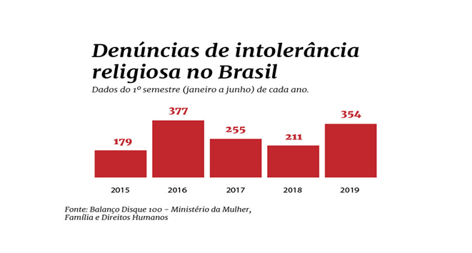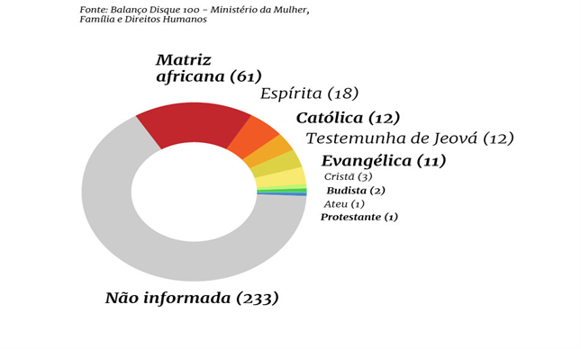
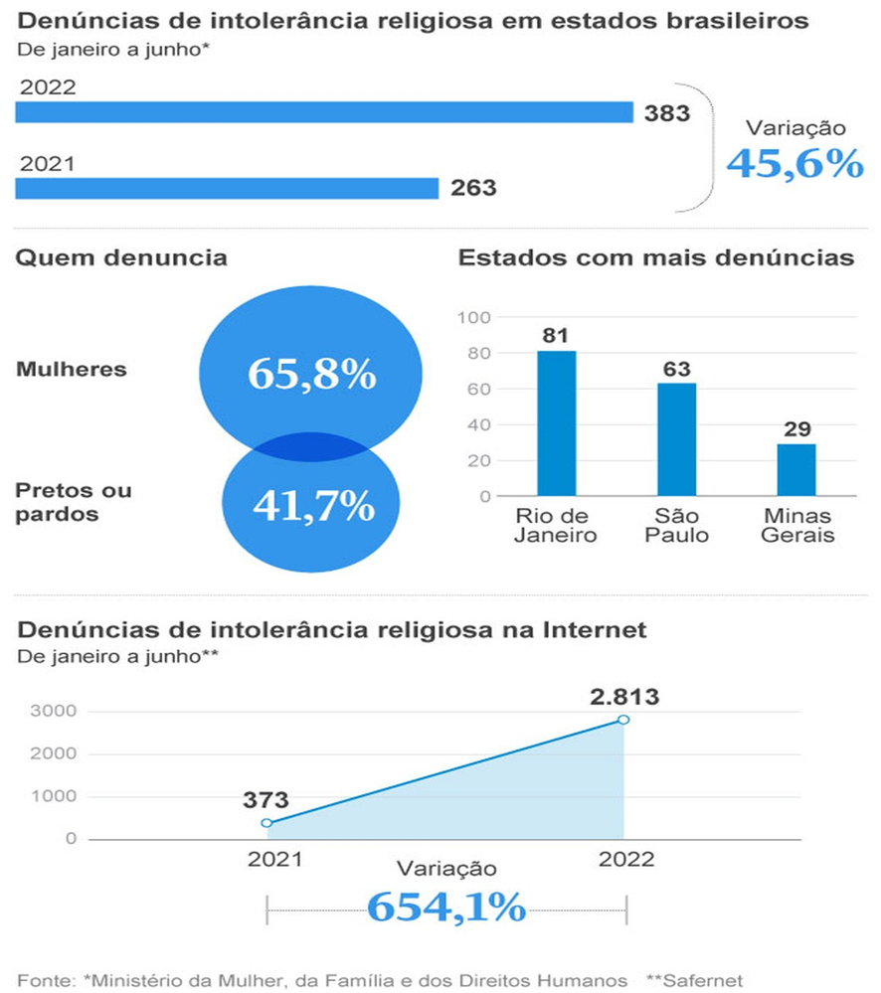

APPENDIX II

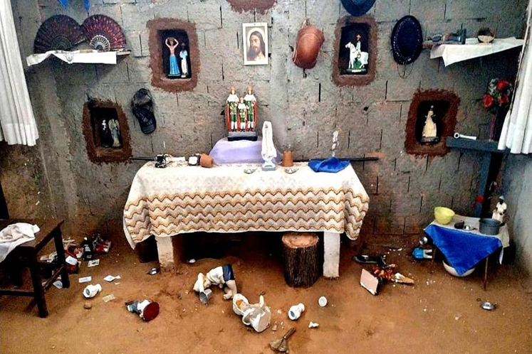

Support: Race & Equality - The International Institute on Race, Equality and Human Rights.
Art. 157: To practice spiritism, magic and its sorceries, to use talismans and cartomancy to arouse feelings of hate or love, to inculcate cures for curable or incurable diseases, in short, to fascinate and subjugate the public credulity.
Art. 158: To administer, or simply prescribe, as a curative means for internal or external use, and in any prepared form, a substance from any of the kingdoms of nature, thus making or exercising the profession of the so-called healer.
Xangô was the name given to Afro-Brazilian religions in Alagoas.
Terreiro is the name given to the space where African religions are practiced and celebrated in Brazil, such as candomblé, umbanda and others.
The terms "macumba" and "macumbeiro" are used in a pejorative way in Brazil, but they also name a religious cult of African origin and are re-signified by its practitioners (macumbeiros) as a way to affirm the religion. More information at: https://www.uol.com.br/ecoa/ultimas-noticias/2022/07/17/o-que-e-macumba-termo-deriva-do-instrumento-e-se-tornou-nome-de-culto.htm?cmpid=copiaecola
In the following links, we present some declarations of the President of Brazil and his wife, the first lady, Michelle Bolsonaro: https://youtu.be/kyau9uEcJ4E https://www.youtube.com/watch?v=mnlzylDdcxI (17) Michelle Bolsonaro doing 'rally' in cult has caught on badly in evangelical circles, says Madeleine Lacsko - YouTube People connected to Jair Bolsonaro's political group have expressed themselves in a similar way, spreading religious hatred against religions of African origin and encouraging the violation of their sacred spaces. Let's see from the links below: Elionai Muralhaa on Instagram: "Pedra de Xangô Park. What's Right and Wrong in the Assis Valente Valley !!!!!" Instagram video of Elionai Muralhaa - Sep 1, 2022 at 10:28 PM
Below are some videos that demonstrate the seriousness of the acts of violence against religions of African matrix in Brazil. https://www.youtube.com/watch?v=jnj9Ukfp2WM https://www.youtube.com/watch?v=fU76WV-CVKo https://www.youtube.com/watch?v=wo3H9xMqWF0 https://www.youtube.com/watch?v=gTsABiS9bR4
They are culturally differentiated groups, with their own forms of organization, for which the use of tradition to occupy and use the territory and natural resources is a condition for their cultural, social, religious, ancestral and economic reproduction, as conceptualized by Decree No. 6040/2007, influenced by Convention 169 of the International Labour Organization (ILO). And it is in the classification of traditional people that terreiro peoples are inserted, among other twenty-eight traditional peoples recognized by Brazilian legislation - Decree nº 8750/2016.
The word Axé comes from the Yoruba term àṣẹ, meaning “soul, light, spirit or good vibrations”. Axé is also present in the Candomblé religion, as “the imagined spiritual power and energy bestowed upon practitioners by the pantheon of orixás”.
“Genocide” is how the civil society in Brazil describe the high number of murders of Afro-descendants in Brazil). In this matter, IACHR in its last report on the Human rights situation in Brazil even suggest “social cleansing” process, with the consent of the State (...) and also say "they constitute a systematic and generalized process led by State security institutions and judicial organs and geared to exterminating people of African descent with using extremely and deliberately cruel methods" in IACHR, Human Rights Situation In Brazil, February 12, 2021 par. 29.
The word quilombo originates from the African language quimbundo, which means: "society formed by young warriors who belonged to ethnic groups uprooted from their communities." The quilombo remaining are defined as ethnic-racial groups that also have their own historical trajectory, endowed with specific territorial relations, with presumption of black ancestry related to the resistance to the historical oppression suffered, and their characterization should be given according to criteria of self-attribution attested by the communities themselves, as also adopted by the Convention on Indigenous and Tribal Peoples (ILO). More information in: http://conaq.org.br/quem-somos/ (acess: October 24, 2022).
Povo de santo, or simply "do santo" is how people devoted to Brazilian-African religious are defined in Brazil.
By way of example: Law 9.982/2000 - Provides for religious assistance in public and private hospitals, as well as in civil and military prisons. Decree nº 3.551, of 4 August 2000 - Institutes the Registration of Cultural Property of an Immaterial Nature that constitutes Brazilian cultural heritage, creates the National Immaterial Heritage Program and makes other provisions. Decree No. 7.387, of 9 December 2010 - Creates the National Inventory of Linguistic Diversity and makes other provisions.
The National Human Rights Program/2009, in its third edition, presents us with guideline number ten - Ensuring Equality in Diversity, and Strategic Objective VI - Respect for different beliefs, freedom of worship and guaranteeing the laicity of the State, with important programmatic actions: a) institute mechanisms that ensure the free exercise of the various religious practices, ensuring the protection of their physical space and restraining manifestations of religious intolerance; b) promote dissemination campaigns on religious diversity to disseminate the culture of peace and respect for different beliefs; c) establish the teaching of diversity and history of religions, including those derived from African matrix, in the public education network, with emphasis on the recognition of cultural differences, promotion of tolerance and the affirmation of the laicity of the State;

