ANNEX 1

AGENDA- Preparation Workshop for Grenada CRC 3 report (2017)

Workshop Objective: To refine state party response to CRC Committee concerns and recommendation re CRC Grenada

This task requires the consultant 3 things:
Task one
To conduct Desk review and verification of information already obtained
Task two
Verification workshop with relevant stakeholders to obtain and additional information
Presentation workshop
To prepare the first Draft Report
Task Three
To prepare the Final Report for submission to Cabinet
Today represent task 2 presumes the desk review has already been done. Implies that the remaining takes is still to be done and hinges on the successful outcomes of this one. Bearing in mind that the deadline is close and the aim is to get as the contract stated “submission of as quality report” by due date January 31st.

Needless, to underscore that the time in which to produce this kind of report is short, and so we need your input to make this successful. It is for this reason why we were so selective in the persons/groups/individuals to participate in the workshop. We believe that the depth and quality of information is available from you to fine tune quality of the content, the meaningfulness of the content and proper referencing of the details that comprise the report.
How have we approach this?
We have tried to put some structure what we need out of this workshop having completed the initial desk review which was made available to us:
Grenada CRC State report
Grenada Concluding Observation
Grenada CRC Concluding Matrix (Workshop results)
CRC Reporting guidelines
We have come to a few conclusions that it was necessary to review beyond what was made available
Grenada CRC State report
Grenada Concluding Observation
Grenada CRC Concluding Matrix (Workshop results)
CRC Reporting guidelines
We also conclude based on the State of response to the committee concerns certainly some of the comments needed clearer articulation, others did not have a response, some needed a rationale to present in the report for why there were “no response”, in those few areas, based on the response other questions were raised in our minds which we think needed to be responded to so that we could build a cogent report, substantiated as much as possible in all the areas of concerns and recommendations.
1.What we have done as you can see before you, we have used the very same structure in the form that we have presented to you we have noticed that we have only added an additional column where we have highlighted with our questions, missing detail, new questions, not compliant . It is very organized and you can see what we need to add in this workshop.
2. In addition to your table we have also summarized and group these same issues and concerns on the second sheet that is provided for you. If the table is problematic you can also reference the summary sheet.
3. How do we proceed?
This is an open workshop, it is an open concept, there is no group, and we may have one or two person from the same ministry or organization. We are doing it this way……. We have carefully selected the participant because you are the persons with the deepest possible knowledge and can speak openly on these issues. The information we received from each other will be cross fertilized with other participants who can further “inform”, up-date”, “checkmate” as necessary.
In the end we expect if we do it this way we will have a successful and authentic, verifiable product at the end of these 3 hours. I would like you to know that we have a rapporteur and that everything that is articulated here will be recorded and made ready for us to use as necessary.
Format
We would like that each issue be raised in sequence as they are on the table or on the summary sheet. We would like that you address the issues as it pertains to you, department, organization and Institution. You will provide us with the information that is needed.
In the meantime we are asking all other participants if there is other information that you can provide to articulate as well.
Just to remind you that all information will be recorded so we will have a comprehensive report. Are there any questions, concerns….baring such we will begin?

ANNEX 2

CRC STAKEHOLDER GROUPS
MONDAY 16 JANUARY – FOR THE WRITING OF THE STATE OF GRENADA CONVENTION ON THE RIGHTS OF THE CHILD REPORT
Mrs. Anna St. John-John – Director of Special Education, Ministry of Education
Mrs. Lydia Browne – Director - Grenada Food & Nutrition Council
Mrs. Susan Parke
Ms Cynthia Isaac – Early Childhood Education – Ministry of Education
Mrs. Rachael Mathurine – School Feeding Programme – Ministry of Education
Director of Grenada Solid Waste Authority
Mrs. Elizabeth Cyrus – Ministry of Labour
A member of the Grenada Royal Police Force – Community Relations Office (CRO) – ASP Sylvan McIntyre& Officer Garraway
Mrs. Buckmire – Director of SEED PROGRAMME – MOSD&H
Mrs. ONealy – Operations Manager - Child Protection Authority
Ministry of Health – Chief Health Planner, Mr. Clement Gabriel and assistant
Ms. Lydia Francis & Mrs. Clouden - Chief Community Health Nurse
Mr. Hamilton Assistant Director Social Services Ministry of Social Development & Housing
Mr Bartholomew – Director Bacolet Juvenile Centre
MsMelisse Ogilvie - Manager Bacolet Juvenile Centre
Ms Marcia Anne Polius – Director Child Protection Authority
Mrs. Jacqueline Sealy-Burke Director Legal Aid & Counseling Clinic
Ms Jasmine Redhead – Family Law (Lawyer) LACC
Mr. Dave Alexander – Drug Avoidance Unit (Ministry of Education)
Mr. Leon Charles - Past UNICEF country representative
Mrs. Roxie Hutchinson – Desk of the Human Rights (Ministry of Foreign Affairs)
Mrs. Hilary Gabriel – Grenada National Council of the Disabled
Mrs. Deborah Baveghems – Chair Grenada National Coalition on the Rights of the Child
Mr. Milton Coy – Chair of the Grenada Human Rights Organization (GHRO)
Mrs. Elaine Henry McQueen – Senior Programme Officer (Gender & Family Affairs Unit) MOSD&H
Mrs. Jeannie Sylvester-Gill – Director Grenada Planned Parenthood Association
Mrs. Alva Lawrence - Programme for Adolescents Mothers (PAM)
Ms. Kenitia Paul - Ministry of Finance – (Central Stats Office)
Mrs. NadicaMcIntyre -Ombudsman
Mr. Terry Walters/or Mrs. Samantha Dixon- NADMA
Ms. Jicinta Alexis – Gender Analyst – Ministry of Social Development & Housing

ANNEX 3

CONVENTION RIGHTS OF CHILD REPORT
January 17th, 2017
J. Lorice Pascal: Interview with Simon Granger, NaDMA
Environment and Climate Change

Over the past 5 years NADMA engaged all the school s in Grenada. This engagement was only in the form of presentations on climate change and adaptation.

Currently NADMA is developing an education programme to engage students in schools – Educational Thrust
The Tool for Disaster Risk Reduction/Climate Change was developed
This was a project idea developed for a workshop in Columbia (? – or is Colombia?) in 2015.

Thematic area – establishing synergies between climate change and Disaster Risk Reduction in Grenada.

Vision: to encourage disaster Risk Reduction Climate Change Adaptation/Mitigation through Education

Tasks:
Develop plans for climate change and Disaster Risk Reduction
Develop cogent messages
Use audio/video platforms to send the messages

Activities:
Project to include risk management - regular activities to promote climate mitigation and adaptation that would have an impact on risk factors
Climate SMART
Organic farming
Aquaponics
Develop hazard plans –Vis-à-Vishow to respond to hazards, prepare and mitigate

Based on National Climate Change Adaptation Plan

Students will develop own programme for mitigation
Choose topic
Objectives for programmes
Use of equipment – cameras, recorders
Teaching by NADMA on how to use equipment
Develop messages for radio/TV/social media platforms on general climate change and disaster risk management

ANNEX 4

CONVENTION ON THE RIGHTS OF THE CHILD REPORT FOR GRENADA

WORKSHOP MONDAY 16 JANUARY, 2017

GRENADA NATIONAL STADIUM, ROOM 216

Summary sheet

- All Questions

Concluding Observation | Status of Response – What has been done since the last report 2008?/Committee Recommendation in 2010 | Questions/ additional information
Legislation | The status of the Child Bill is before parliament.  The optional protocols on the involvement of Children in Armed conflict (CRC- OP – AC) and on the sale of children, prostitution and child pornography (CRC-OP - SC) were assented to on the 6th February 2012  Education amendment Act(2012)  Electronic crimes act(2013) | Provide a synopsis of what this entails.  Please explain  Details on the provision  In Education Act and  Electronic Crimes Act
Coordination | There is no progress towards a national coordinating body at this time  Although the Child Protection Authority has enhanced their human resources, there are still inadequate human and financial resources for full implementation and monitoring of these laws. | Is there a Plan of Action For the National  Coordinating Body?  What happens when there is no implementation because of lack of human and financial resources?
Allocation of Resources (for children) | The SEED Programme has approximately 3688 children presently on the programme.  - As of December 2011 – there was a total of 2,353 children  - As of December 2012 – there is a total of 2,427 children  - As of December 2013 - there was a total of 2,108 children  - As of December 2014 – there was a total of 1854 children  - As of December 2015 – there was a total of 3634 children  - As of March 2016 – there was a total of 3688 children with an allocated amount of EC $ 357,075.00 | What are the children receiving the SEED for?  What is the budget allocation trendline, for example – more or less $
Data Collection | Progress has been made .devinfo has been implemented. The database has been established and will be implemented and launched shortly | Time to be specified
Dissemination and awareness raising (of/on the Convention and its principles) | Devinfo will have a webbase platform and everyone would be able to access the data | How have they involved The primary stakeholder groups in the dissemination?
Non-Discrimination | concluding observations (CRC/C/15/Add.121, paras. 13 and 14), the Committee regrets that the State party’s legislation has not been amended to also offer boys protection against sexual abuse and exploitation and that the minimum age of consent to sexual activity refers only to girls.  The Committee urges the State party to amend its legislation in order to ensure that provisions referring to the minimum age of consent to sexual activity apply to both boys and girls and to ensure that the law provides equal protection for boys and girls against sexual abuse and exploitation. | Bacolet centre and the father Mallagan home – what kind of clients are enrolled in the institutions.  What are the ratios and cost for maintaining these institutions?  Is there a section for age of consent?
Respect for the views of the Child | The Child Protection and Adoption Act 2010 indicate that the based on the age and maturity of the child, their views must be considered when discussing their best interest | Only in the Act? What about other means of public education – Campaigns, social media platforms, friendly publication
Name, Identity and Birth Registration | Grenada has implemented the bedside registration and it is has been noticed that the father’s name are also included on the birth certificate | Compliance
Follow-up to the UN Study on Violence against Children | (b) Use the recommendations of the Study as a tool for action in partnership with civil society and, in particular, with the involvement of children to ensure that all children are protected from all forms of physical, sexual and psychological violence and to gain momentum for concrete and time-bound actions to prevent and respond to such violence and abuse. | What were the recommendations of the study?
Children Deprived Of A Family Environment | The Committee encourages the State party to continue its efforts to improve and strengthen the foster care programme in order to ensure that children who must be taken out of their family environment can be placed in appropriate care situations.  independent complaints mechanisms for children in alternative care and that placements in institutions be periodically reviewed, as required under article 25 of the Convention | Are the foster care homes adequate?  What does that look like?
Abuse and Neglect | theNational Child Abuse Protocol was launched,  the publication of a child abuse handbook | Elaborate on this, how does it work?  Is there a hard copy available?
Children with disabilities | The Ministry of Education is currently in the process of writing a Special Education Policy  (b) | What are the basic substantives of the policy?
Health and access to health services | The Committee also notes with concern that sickle cell anemia is a major health issue in the State party.  The Committee also recommends that the State party implement as soon as possible its planned strategy to address the issue of sickle cell anemia  Collaboration with the Grenada Food and Nutrition Council affords at risk infants the opportunity of clinic and home follow up to ensure proper feeding practices.  There are also plans to embark on a public awareness campaign.  Other initiatives are now being undertaken to prepare us for certification in 2017. | What is the situation currently with persons with sickle cell anemia?  Any state provision?  How is it facilitated?  What stage is the campaign at?  What those include?
Adolescent health | The Ministry of Health, developed a National Adolescent Health Policy and Plan  The Ministry of Health is now in the process of implementing the Policy in collaboration with stakeholders.  Last year (2015)UNFPA facilitated a stakeholder Consultation on the CARICOM Framework for the Reduction of Adolescent Pregnancies. | Any additional information?  Who are they?  Any formative review so far on the implementation process?
HIV/AIDS | Grenada also has a National Sexual and Reproductive Health Policy which was developed  - The responsibilities of parents and legal guardians in protecting the SRH of children, adolescents, and persons with disabilities should be consistent with the evolving capacities of those groups. | Any detail on this policy?  Has there been any Plan of Action developed of the policy through this instrument?
Sexual Exploitation and Abuse |  | Conceptualized the national approach and response to sexual exploitation and abuse  Is there a national policy on this?
Administration of Juvenile Justice | The juvenile justice act is now in effect  Treatment and rehabilitation centres for both boys and girls who have come in conflict with the law have been established and fully operational | New institutions – how have they  Worked? Who do they network  With?  What is their line of authority?  How do they operate?  Any comprehensive policy document  for measurement of effectiveness  and efficiency  What is the relationship to  Institution such as the Bacolet  Centre and the Father Mulligan  Home?

- Incomplete Information

Concluding Observation | Status of Response – What has been done since the last report 2008?/Committee Recommendation in 2010 | Questions/ additional information
International Cooperation (vis-à-vis  Social Protection Programmes) | Progress has been made in the area of child rights and responsibilities
National Plan of Action (for children) | There is a national plan of action but it does not cover all issues by the convention  The Committee encourages the State party to adopt a National Plan of Action on “A World Fit for Children”  No Progress | Which aspects of the Convention does it cover?
Independent Monitoring (on the implementation of human rights) | Some progress. The commonwealth is undertaking the study | Information if available on where they are with the study  Why have they under-taken a study?
Dissemination and awareness raising (of/on the Convention and its principles) | Devinfo will have a webbase platform and everyone would be able to access the data | How have they involved The primary stakeholder groups in the dissemination?
Training (of professionals who work with / for children) | Training is on-going | What form do they take and for who and for whom are the training directed?
Respect for the views of the Child | The Child Protection and Adoption Act 2010 indicate that the based on the age and maturity of the child, their views must be considered when discussing their best interest. | Only in the Act? What about other means of public education – Campaigns, social media platforms, friendly publication

- Missing Information

Concluding Observation | Status of Response – What has been done since the last report 2008?/Committee Recommendation in 2010 | Questions/ additional information
Corporal Punishment |  | State does not agree with the explanation. Explain the rationale for assumed disagreement  What about other methods of disciplining? –  - Saving Brains  - . Conscious discipline
Follow-up to the UN Study on Violence against Children |  | What were the recommendations of the study?
Family Environment |  | Child maintenance Act – what are the specifications?  What size budget needed?  What is the size of budget have now and is available?
Right to an adequate standard of living |  | Any implementation on policy on sanitation and waste disposal?
Any implementation on policyon sanitation and waste disposal? |  | What is the policy on climate change for children?  Do the Ministry of Education and  NADMA have a policy on climate  Change for children?
Education, including vocational training and guidance |  | This information on education is  Not reflecting the information in the documents in education –  Please comment?  What is the role of PAM?  Are there any truancy monitoring programme?
Economic exploitation, including child labour |  | What is being implemented for minors in the Labour Code?
Protection of witnesses and victims of crime |  | Is there a protocol?  How does it work?
Ratification of International Instruments |  | Have they been ratified?  If so which ones?

ANNEX 5
(Excerpted Grenada Country Report OECS Assessment of Child Protection Service, Commissioned by the OECS Commission, September 2016)

Disaggregated - Children in residential care
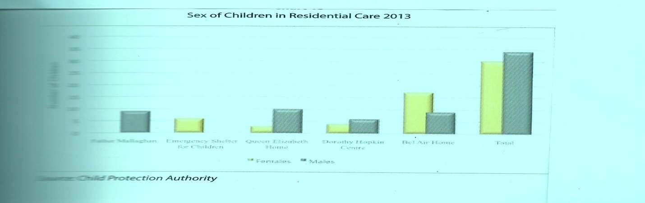

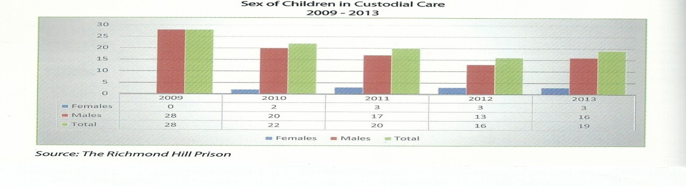

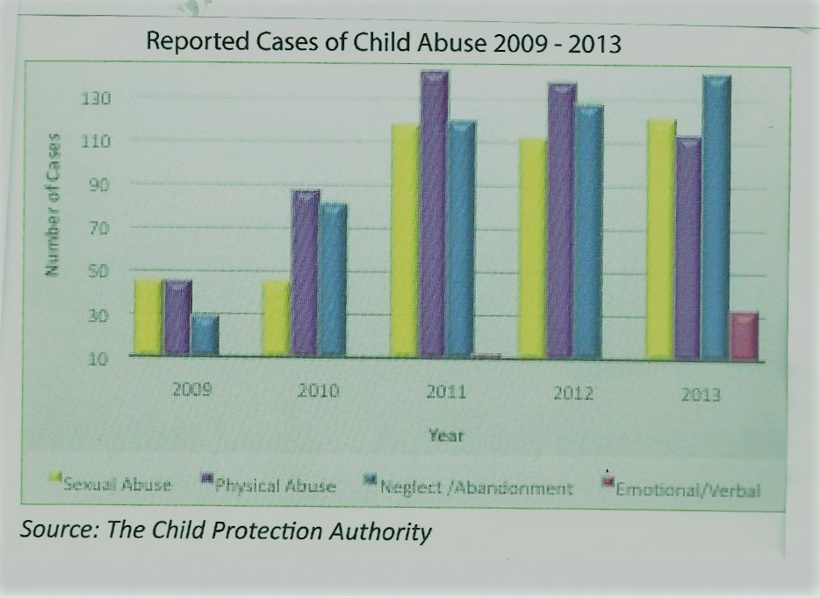

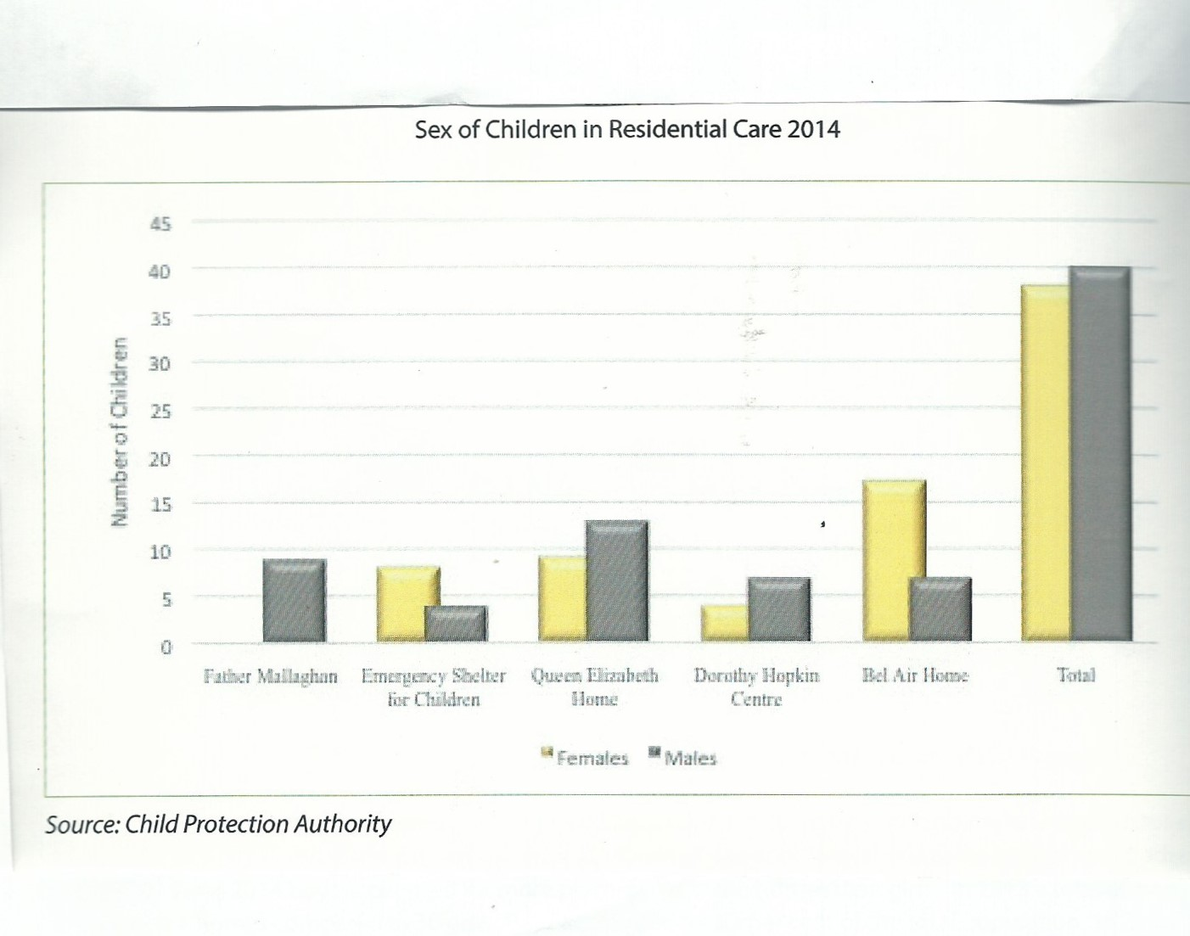
Annex 6

SOCIAL AND ECONOMIC DATA

TABLE: 1

SELECTED DEMOGRAPHIC INDICATORS 2012 - 2016

 | 2012 | 2013 | 2014 | 2015 | 2016
Estimated Mid - Year Population | 107,599 | 108,580 | 109,374 | 110,096
Population > 65 Years | 11,348 | 11,566 | 11,666 | 11,755
Population < 15 Years | 24,318 | 24,109 | 24,302 | 24,418
Population < 15 Yrs + Population > 64 Yrs | 35,666 | 35,675 | 35,968 | 36,173
Population 15 - 64 Years | 71,933 | 72,905 | 73,406 | 73,923
Number of Women Aged 15 - 49 | 27,437 | 27,681 | 27,856 | 27,914
Live Births | 1,661 | 1,838 | 1,750 | 1,694
Female Births | 820 | 922 | 850 | 784
Male Births | 843 | 916 | 900 | 910
Deaths | 857 | 822 | 958 | 869
Infant Deaths Under 28 days | 9 | 15 | 27 | 19
Crude Birth Rate (CBR) | 15.4 | 16.9 | 16.0 | 15.4
Infant Deaths | 22 | 32 | 33 | 28
Crude Death Rate (CDR) | 8.0 | 7.6 | 8.8 | 7.9
Infant Mortality Rate (IMR) | 13.2 | 17.4 | 18.9 | 16.5
Neo-Natal Rate | 5.4 | 8.2 | 15.4 | 11.2
Post Neo-Natal Rate | 7.8 | 9.2 | 3.4 | 5.3
Rate of Natural Increase | 7.5 | 9.4 | 7.2 | 7.5
General Fertility Rate | 60.5 | 66.4 | 62.8 | 60.7
Gross Reproduction Rate | 0.9 | 1.1 | 1.0 | 1.0
Total Fertility Rate (TFR) | 1.9 | 2.1 | 2.0 | 2.0
Age Dependency Ratio | 49.6 | 48.9 | 49.0 | 48.9
Youth Dependency Ratio | 33.8 | 33.1 | 33.1 | 33.0
Old Age Dependency Ratio | 15.8 | 15.9 | 15.9 | 15.9
Sex Ratio (at birth) | 103 | 99 | 106 | 116
Source: Central Statistical Office
Registrar General Department, Ministry of Health

TABLE: 2 |  |  |  |  |  | LIFE- EXPECTANCY TABLES 2010 - 2014
AGE |  | 2010 |  |  | 2011 |  |  | 2012 |  |  | 2013 |  |  | 2014 |  |  | 2015
GROUP | Male | Female | Total | Male | Female | Total | Male | Female | Total | Male | Female | Total | Male | Female | Total | Male | Female | Total
0 | 70 | 76 | 73 | 74 | 78 | 76 | 73 | 77 | 75 | 73 | 78 | 76 | 72 | 77 | 74 | 72 | 79 | 76
1 – 4 | 69 | 76 | 73 | 74 | 78 | 76 | 73 | 77 | 75 | 73 | 78 | 76 | 72 | 77 | 74 | 72 | 79 | 76
5 – 9 | 66 | 72 | 69 | 70 | 75 | 72 | 69 | 74 | 71 | 70 | 75 | 72 | 68 | 74 | 71 | 69 | 75 | 72
10 - 14 | 61 | 67 | 64 | 65 | 70 | 67 | 64 | 69 | 67 | 65 | 71 | 68 | 63 | 69 | 66 | 64 | 71 | 67
15 - 19 | 56 | 62 | 59 | 60 | 65 | 63 | 59 | 64 | 62 | 60 | 66 | 63 | 59 | 64 | 61 | 59 | 66 | 62
20 - 24 | 51 | 57 | 54 | 56 | 60 | 58 | 55 | 59 | 57 | 55 | 61 | 58 | 54 | 59 | 56 | 54 | 61 | 58
25 - 29 | 46 | 52 | 49 | 51 | 55 | 53 | 50 | 54 | 52 | 50 | 56 | 53 | 49 | 54 | 52 | 50 | 56 | 53
30 - 34 | 42 | 47 | 44 | 46 | 51 | 48 | 45 | 49 | 47 | 46 | 51 | 48 | 45 | 49 | 47 | 46 | 51 | 48
35 - 39 | 37 | 43 | 40 | 41 | 46 | 44 | 41 | 45 | 43 | 41 | 46 | 44 | 40 | 45 | 42 | 41 | 47 | 44
40 - 44 | 33 | 38 | 35 | 37 | 41 | 39 | 36 | 40 | 38 | 37 | 42 | 39 | 36 | 40 | 38 | 36 | 42 | 39
45 - 49 | 28 | 33 | 31 | 32 | 37 | 35 | 32 | 36 | 34 | 32 | 37 | 35 | 31 | 36 | 33 | 32 | 38 | 35
50 - 54 | 24 | 29 | 26 | 28 | 33 | 30 | 28 | 32 | 30 | 28 | 33 | 30 | 27 | 31 | 29 | 28 | 33 | 30
55 - 59 | 20 | 25 | 19 | 24 | 29 | 26 | 24 | 28 | 26 | 24 | 29 | 26 | 23 | 27 | 25 | 24 | 29 | 26
60 - 64 | 17 | 22 | 20 | 21 | 25 | 23 | 21 | 24 | 22 | 21 | 24 | 23 | 19 | 23 | 21 | 21 | 25 | 23
65 - 69 | 14 | 18 | 16 | 18 | 21 | 19 | 18 | 20 | 19 | 17 | 21 | 19 | 16 | 20 | 18 | 18 | 21 | 19
70 - 74 | 11 | 14 | 13 | 14 | 17 | 16 | 14 | 17 | 16 | 15 | 17 | 16 | 13 | 16 | 14 | 14 | 18 | 16
75 - 79 | 9 | 11 | 10 | 11 | 14 | 13 | 11 | 14 | 13 | 12 | 14 | 13 | 10 | 13 | 11 | 12 | 14 | 13
80 - 84 | 7 | 9 | 8 | 9 | 11 | 10 | 9 | 10 | 10 | 10 | 11 | 11 | 8 | 10 | 9 | 9 | 11 | 10
85+ | 6 | 7 | 6 | 7 | 8 | 8 | 7 | 8 | 8 | 9 | 9 | 9 | 6 | 8 | 7 | 8 | 9 | 9
Source: Central Statistical Office
Registrar's General Office

TABLE: 3
GRENADA
GROSS DOMESTIC PRODUCT BY ECONOMIC ACTIVITY
AT BASIC PRICES, IN CURRENT PRICES 2010-2015

INDUSTRIES | 2010 | 2011 | 2012 | 2013 | 2014 | 2015
 |  |  |  | Rev. | Prelim. | Prelim.
Agriculture | 67.94 | 69.44 | 74.28 | 79.85 | 120.65 | 170.12
Crops | 52.99 | 53.46 | 58.71 | 63.38 | 102.32 | 152.45
Bananas | 0.48 | 2.18 | 3.95 | 3.54 | 3.18 | 3.93
Nutmegs | 2.16 | 7.89 | 6.60 | 7.62 | 10.49 | 11.34
Other Crops | 50.35 | 43.39 | 48.16 | 52.22 | 88.64 | 137.18
Livestock | 11.36 | 12.29 | 11.78 | 12.56 | 14.31 | 13.56
Forestry | 3.58 | 3.68 | 3.79 | 3.91 | 4.03 | 4.11
Fishing | 26.02 | 24.07 | 30.08 | 30.16 | 29.51 | 32.21
Mining & Quarrying | 6.61 | 4.95 | 4.25 | 5.22 | 5.56 | 7.82
Manufacturing | 71.88 | 71.01 | 70.12 | 76.91 | 84.19 | 96.92
Electricity & Water | 80.71 | 80.25 | 86.27 | 86.76 | 91.26 | 86.92
Electricity | 64.95 | 64.00 | 69.55 | 70.51 | 75.09 | 70.53
Water | 15.76 | 16.26 | 16.72 | 16.25 | 16.18 | 16.39
Construction | 147.01 | 124.31 | 105.39 | 135.92 | 134.26 | 142.52
Wholesale & Retail Trade | 142.57 | 148.13 | 153.01 | 158.47 | 162.71 | 182.49
Hotels & Restaurants | 72.08 | 79.67 | 70.90 | 81.16 | 111.98 | 136.42
Hotels | 52.60 | 56.73 | 50.68 | 57.91 | 77.87 | 102.22
Restaurants | 19.48 | 22.94 | 20.21 | 23.24 | 34.11 | 34.20
Transport, Storage and Communications | 235.69 | 233.39 | 227.06 | 237.18 | 243.34 | 252.09
Transport and Storage | 165.57 | 157.06 | 151.49 | 166.79 | 181.07 | 196.91
Road | 111.23 | 104.07 | 95.39 | 106.80 | 112.70 | 121.91
Sea | 21.79 | 20.79 | 18.04 | 18.12 | 20.86 | 19.84
Air | 2.41 | 2.06 | 2.78 | 1.38 | 1.59 | 2.59
Supporting and auxiliary transport activities | 30.14 | 30.13 | 35.28 | 40.49 | 45.92 | 52.57
Communications | 70.12 | 76.33 | 75.57 | 70.39 | 62.26 | 55.18
Financial Intermediation | 130.03 | 117.87 | 134.57 | 124.44 | 121.98 | 129.76
Banks & Other Financial Institutions | 106.83 | 94.68 | 111.50 | 100.82 | 97.44 | 105.30
Insurance and pension funding | 22.13 | 22.36 | 22.18 | 22.23 | 22.60 | 22.58
Activities Auxiliary to Financial Intermediation | 1.07 | 0.84 | 0.89 | 1.39 | 1.94 | 1.88
Real Estate, Renting and Business Activities | 244.88 | 253.61 | 254.47 | 257.84 | 267.17 | 265.90
Owner Occupied Dwellings | 169.60 | 174.56 | 176.29 | 177.36 | 179.52 | 175.81
Real estate activities | 21.61 | 22.24 | 22.46 | 22.60 | 22.87 | 22.40
Renting of machinery and equipment | 2.59 | 2.64 | 2.85 | 2.92 | 3.30 | 3.52
Computer and related activities | 2.34 | 2.67 | 2.71 | 2.65 | 3.07 | 3.19
Business Services | 48.74 | 51.49 | 50.17 | 52.31 | 58.40 | 60.97
Public Administration, Defence& Compulsory Social Security | 148.90 | 153.43 | 161.75 | 175.31 | 178.13 | 165.44
Central | 144.51 | 148.65 | 156.58 | 169.99 | 172.75 | 159.25
NIS | 4.38 | 4.78 | 5.17 | 5.32 | 5.38 | 6.20
Education | 350.02 | 368.93 | 419.25 | 445.62 | 484.07 | 516.59
Public | 82.88 | 86.87 | 86.73 | 96.37 | 99.65 | 91.34
Private | 267.15 | 282.06 | 332.52 | 349.25 | 384.42 | 425.25
Health and Social Work | 44.95 | 46.70 | 46.63 | 51.66 | 52.92 | 49.69
Public | 41.06 | 44.08 | 43.58 | 47.31 | 48.65 | 45.27
Private | 3.89 | 2.62 | 3.05 | 4.35 | 4.26 | 4.42
Other community, social & personal services | 35.34 | 33.30 | 34.96 | 35.40 | 38.80 | 39.63
Public | 1.03 | 1.35 | 1.42 | 1.30 | 1.02 | 0.93
Private | 34.31 | 31.95 | 33.55 | 34.10 | 37.77 | 38.70
Private Households with Employed Persons | 18.75 | 18.64 | 19.26 | 19.42 | 19.37 | 19.47
Less FISIM | 26.10 | 23.81 | 28.31 | 21.96 | 21.55 | 23.78
Gross Value Added at Basic Prices | 1,797.27 | 1,803.88 | 1,863.92 | 1,979.36 | 2,124.35 | 2,270.20
GROWTH RATE | -1.52 | 0.37 | 3.33 | 6.19 | 7.33 | 6.87
Taxes on products | 284.47 | 298.47 | 295.76 | 295.23 | 336.86 | 386.77
Less Subsidies | 0.00 | 0.00 | 0.00 | 0.00 | 0.00 | 0.00
GDP at Market Prices | 2,081.74 | 2,102.35 | 2,159.68 | 2,274.59 | 2,461.21 | 2,656.97
GROWTH RATE | -0.03 | 0.99 | 2.73 | 5.32 | 8.20 | 7.95

TABLE: 4

GROSS DOMESTIC PRODUCT BY ECONOMIC ACTIVITY, AT BASIC PRICES
YEARS | GDP - EC$'M |  |  |  |  |  | POPULATION | PER CAPITA EC$
YEARS | CURRENT PRICES | MARKET PRICE | GROSS NATIONAL INCOME | GROSS NATIONAL DISPOSABLE INCOME | CONSTANT PRICES | GROWTH RATE | POPULATION | CURRENT PRICES | CONSTANT PRICES | GDP MARKET PRICE
2010 | 1797.27 | 2081.736 | 1974.073 | 2059.885 | 1621.1 | -1.98615 | 105037.9 | 17110.68 | 15433.47 | 19818.9
2011 | 1803.88 | 2102.351 | 2016.565 | 2081.575 | 1623.43 | 0.14373 | 106667 | 16911.32 | 15219.61 | 19709.48
2012 | 1863.924 | 2159.682 | 2067.12 | 2148.856 | 1614.073 | -0.57638 | 107599 | 17322.87 | 15000.82 | 20071.58
2013 | 1979.356 | 2274.59 | 2194.674 | 2244.113 | 1665.466 | 3.184096 | 108580 | 18229.47 | 15338.61 | 20948.52
2014 Rev | 2124.349 | 2461.21 | 2368.261 | 2438.64 | 1773.456 | 6.484061 | 109596 | 19383.45 | 16181.76 | 22457.12
2015 Rev | 2270.2 | 2656.97 | 2442.691 | 2498.377 | 1865.032 | 5.163658 | 110566 | 20532.53 | 16868.04 | 24030.62
2016 Est | 2395.395 | 2799.027 | 2508.817 | 2565.82 | 1921.575 | 3.031768 | 111229.4 | 21535.63 | 17275.78 | 25164.45
2017 Proj. | 2516.426 | 2935.82 | Na | Na | 1975.268 | 2.794231 | Na | Na | Na | Na
2018 Proj. | 2641.375 | 3082.215 | Na | Na | 2027.299 | 2.634119 | Na | Na | Na | Na
Source: Central Statistics Office
Rev Feb 2017

References
2013, Innis, Lorna. Preliminary Road Map to “The Coast Grenada Wants”: Imperatives, initiatives, successes, challenges, opportunities. A position paper. Ministry of Agriculture, Grenada, WI
February, 2015. Roberts, Diane. National Action Programme for Grenada’s commitment under the United Nations convention to combat Desertification and Drought.
May 2015. Institutional Appraisal Of The Child Protection Authority, Grenada WI.
November 2014. Institutional Appraisal Of The Child Protection Authority, Grenada WI.
2012. Caribbean Human Development Report: Human Development and the Shift to Better Citizens Security, Child Protection and Adoption Act 20, 2010
2015. Treaty Specific Guidelines, 55 regarding the form and content of periodic reports to be submitted by state parties on the article 44, paragraph 1 (b) of Conventions on the Rights of Child.
2015. Grenada Child Protection Statistical Digest, UNICEF
May 2009. Grenada Convention on the Rights of Child Report
2013. Grenada Country Gender Assessment Caribbean Development Bank, Barbados
September 2016. Grenada Country Report: OECS Assessment Of Child Protection Service, Commissioned by the Organisation of Eastern Caribbean States.
2015. Grenada National Human Rights Report Prepared For The Second Cycle Of The Universal Periodic Review.
2011. National Domestic Violence & Sexual Abuse Protocol for Grenada, Grenada National Organisation of Women
November 2015. Situation Analysis UNICEF, Government of Grenada.
2015. Strategic Health Plan, Ministry of Health, Grenada WI
CRC Stakeholder Workshop Verification Rapporteur’s Report, January 16, 2017
CRC Stakeholder Workshop Verification Rapporteur’s Report, February, 2017.
Grenada Child Protection and Adoption (Amendment) Act 19, 2011
Grenada Criminal Code (Amendment) Act 29, 2012
Grenada Domestic violence Act 19, 2010
Grenada Concluding Observation Committee on the Rights of the Child (CRC/CGRD/, June 2010
Government of Grenada National Disaster Management Plan, Version 5.0, July, 2011
Juvenile Justice Act 24, 2012

