Liechtenstein

Report to the Human Rights Committee concerning the second periodic report of the Principality of Liechtenstein under Article 40 of the International Covenant on Civil and Political Rights of 16 December 1966.

June 5th 2017

Submitted by: Association (Verein) Hoi Quote
Lavadinastrasse 21
9497 Triesenberg
info@hoiquote.li / www.hoiquote.li

Endorsed by: Association (Verein) Frauen in guter Verfassung

Floraweg 19

LI - 9490 Vaduz

About the submitting association

The association “Hoi Quote” was founded only very recently after the 2017 parliamentary elections in March 2017. The association is committed to legally established gender quotas in order to ensure a fair representation of both sexes in political decision-making processes and to reduce structural discrimination on grounds of sex in elections at the state and municipal level as well as in the appointment to public bodies.

Summary

Liechtenstein, 33 years after the introduction of women's voting rights, has not succeeded in significantly increasing the number of women holding positions in public bodies and committees and at a decision-making level. Recent municipal and state elections have in fact shown a drop in the proportion of females elected.

This development has accompanied a decline in governmental measures and financial support for the promotion of women’s rights. The recommendations of the Human Rights Committee of 2004 (CCPR / CO / 81 / LIE, paragraph 7) and the Committee on the Elimination of Discrimination against Women of 2011 (CEDAW / C / LI / C0 / 4 paragraphs 17 and 29) have not been complied with.

In view of this, Hoi Quote turns to the Human Rights Committee with the following concerns:
- Changes in the political electoral system, including the introduction of quotas, is required in order to reduce discrimination against female candidates.
- The Government must monitor and report on the participation of women in political decision-making processes on an ongoing basis. There must be sufficient financial resources for this monitoring.
- Binding regulations must be introduced for the nomination of candidates in public bodies, such as commissions, advisory boards and administrative boards of state enterprises.

1. In the parliamentary elections (Landtagswahlen) in February 2017 a worrying trend in the representation of women became evident. At present only 3 out of 25 parliamentary members are female, which corresponds to a share of 12%. This continues the decline in female representation since 2009 (Fig.1).
2. The analysis of a post-election survey shows that women's chances of election are significantly lower than for men. Voting behavior in regard to women appears strongly discriminatory. Discrimination is favored by a system that uses unranked candidate lists and the possibility to cross-vote. It has been shown that women are more frequently removed from the list of candidates and replaced by male candidates from other parties (Fig. 2).
3. The parliamentary elections were preceded by an equally poor performance of female candidates in the municipal elections in 2014 (Fig.3). The proportion of women in the municipal councils currently amounts to 16.8% (19 out of a total of 113).
4. The situation has also not improved significantly for women when it comes to filling positions in public commissions, administrative and foundation boards. The 1997 government ruling, which sought to bring about gender equality in public bodies and set a one third minimum as the starting point, has never been implemented with concrete measures. According to the most recent figures, the amount of women in public commissions as well as administrative and foundation boards of public law institutions or companies where the State is majority shareholder is 27.6% (Fig.4). However, a closer examination recently conducted reveals the following (Häfele, 2016: p. 18):
“In the National Gazette a total of 56 commissions are listed.
- 11 commissions, equivalent to 20%, are managed by a woman. Another commission has both a man and a woman in the leadership position. A leadership position was vacant at the time of the survey.
- In 18 commissions, all members are male, this is around one third of the commissions (32%).
- Four commissions, all of whom have a female head, are occupied by more than 50% female members of the Executive Board. "

5. The state budget has been weakened by serious losses resulting from a tax reform in 2008 and the global financial crisis. From a social standpoint, many painful budget cuts were then made and Equal Opportunities Unit, which was once directly assigned to the ministries, would have been dissolved had not continuous pressure from various stakeholders and associations prevented it. Unfortunately, the length of time that the Unit was near dissolution, cuts in human and financial resources as well as delays in pending personnel decisions, impacted severely on the effectiveness and influence of the Equal Opportunities Unit. Projects were only carried out, if at all, at an absolute minimum.
6. In 2013, members of the Gender Equality Commission, which played an advisory role to the Equal Opportunities Unit, unanimously stepped down in protest to the Equal Opportunities Unit being provisionally staffed since 2008. In addition, the Steering Committee for Gender Mainstreaming and the Working Group on Gender Equality in National Administration positions have not, to the best of our knowledge, been refilled or re-staffed. The same applies to the Equal Opportunities Unit.
7. It is only thanks to the continuing commitment of various civil society organizations that the founding of the Human Rights Association (an independent, national human rights institution that meets the stipulations of the Paris principles) was finally approved. The financial resources allocated to the association are, however, minimal relative to its broad mandate and multitudinous issues. It is questionable whether there will be sufficient financial resources for the promotion of equality between men and women.
8.The former Equal Opportunities Unit has been integrated into the Office of Social Services as a specialist division, which has no leadership and answers directly to the Head of Office. This integration into the linear organizational hierarchy, has caused a loss in visibility to the outside world, and a decline in influence and recognition. Furthermore, those responsible no longer have independent decision-making abilities. According to the new Liechtenstein Human Rights Association Act, the division is assigned official duties and responsibilities only with the Association for Human Rights being responsible for autonomous functions.
9. As much as we welcome the long-sought establishment of an independent institution on human rights issues, we are also concerned that the State or governing bodies are increasingly relinquishing responsibility for societal concerns by assigning tasks to civil society organizations. Here the signatories see a link to a political move towards the right and a growing conservative economic liberalism where state services are seen as consumer goods or citizens as customers and companies are exempted from their societal responsibilities.
10. The few remaining provisions and activities the Government has in place to promote women in politics, which are listed in the country report as well as in the reply to the list of issues (eg. political education), are aimed at qualifying women for political positions. In light of the past elections however it must be noted that, despite excellent qualifications, previous political engagement and leadership experience, women have considerably lower electoral chances than men. Hence, women are quite capable of carrying out the duties and tasks required but they still lack acknowledgement.
11. To this effect, we also see a need for action in the current system of co-opting into public bodies from political parties. The Steering Committee for Gender Mainstreaming came to the following conclusion based on a study commissioned by the Equal Opportunities Unit in 2003, which states that "the interconnection between public bodies and the party membership exacerbates the problem and the majority of women remain excluded from parties and public bodies. This despite their political interest and competence, and many women see themselves as being involuntarily confined to the role of voter. " (2005: p. 5)
12. For the abovementioned reasons, it is clear to us that only a change in the electoral system through the introduction of a quota can lead to an appropriate representation of women. This is the most effective and efficient measure.
13. We would like to draw attention to the concluding observations of the Human Rights Committee of 12 August 2004 on the occasion of Liechtenstein's first report (CCPR / CO / 81 / LIE). The Committee noted a persistently passive attitude towards the role of women in society and in particular in the public sphere. In paragraph 7 of its concluding observations, the Committee called for effective measures, including legal measures, to eliminate gender inequality and, in particular, to improve the participation of women in governance and decision-making.
14. A similar judgment can be found in the concluding observations of the Committee on the Elimination of Discrimination against Women of 5 April 2011 on the occasion of Liechtenstein's fourth report (CEDAW / C / LI / C0 / 4). It noted with concern the under-representation of women to elected and appointed bodies such as the Parliament, municipal councils, commissions and advisory councils. In paragraphs 17 and 29 of its concluding observations, the Committee recommends the adoption of measures, including temporary special measures under Article 4 (1) of the Convention on the Elimination of all Forms of Discrimination against Women, to speed up the full and equal participation of women in all sectors and at all levels. These (temporary) special measures include the introduction of a statutory quota, a system of gender parity in the filling of state bodies, as well as party financing being conditional on the equal representation of women in the party-internal bodies and candidate lists. The Committee further recommended training activities aiming at male decision makers and party members. None of these recommendations have been considered, although the Equal Opportunities Unit has put forward concrete proposals for implementation.
15. The demands for a quota are, of course, accompanied by demands for accompanying measures which address general conditions, gender roles in society and the compatibility between family and working life. As these, however, require fundamental social changes their impact is long-term in nature.

Graphics
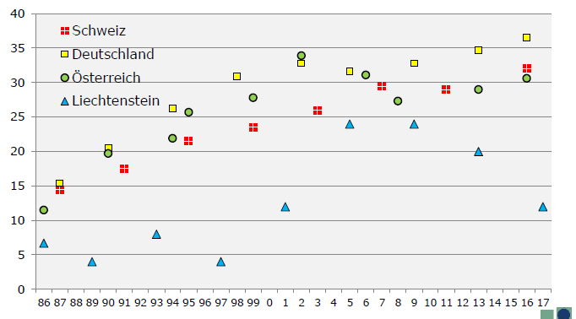
Figure 1: Percentage of women in national parliament elections since 1986 – status 2/2017. Source:
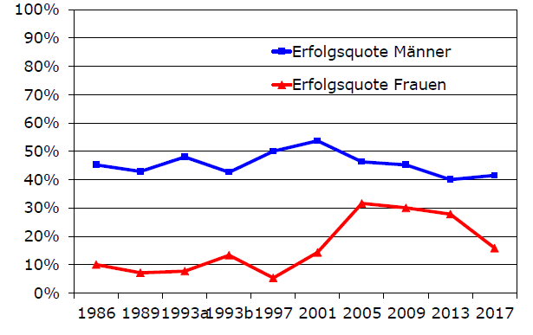
Figure 2: Success rate of male (blue) and female (red) candidates in state elections since 1987. Source: W. Marxer (2017)

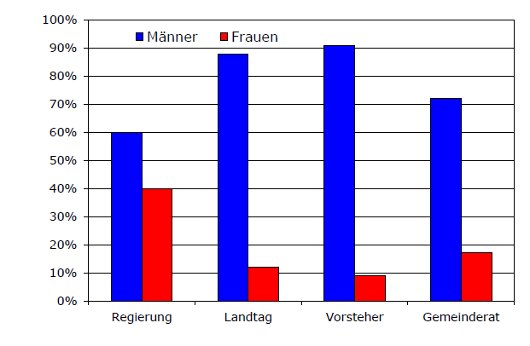
Figure 3: Mandates of women and men 2017 (in percent). Source: Menschenrechte Liechtenstein: Zahlen und Fakten 2016.

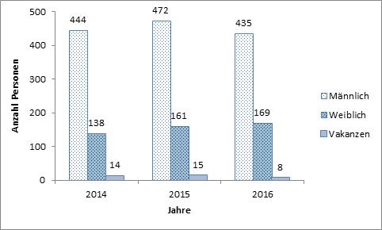
Figure 4: Gender distribution in public commissions, as well as administrative and foundation boards of public-law institutions or companies where the state holds majority shares. Source: Report of Parliament, Government and Court 2016 (Regierungskanzlei):

Sources/Reference documents
- second periodic reports of States parties due in 2009, Liechtenstein* [Date received: 24 March 2016]. URL: http://docstore.ohchr.org/SelfServices/FilesHandler.ashx?enc=6QkG1d%2fPPRiCAqhKb7yhsrEWMzrPHTVcApVAi%2fTFB%2bnB32r1ELQxObS4Yp87X%2b1mZrSdJmsbEhxg%2fJTcayYsmlGgv459k5UXWmbjmlrZ8XrTtcJ%2bQkhzm6dPcckOH%2bcL
- Concluding observations of the Committee on the Elimination of Discrimination against Women Forty-eighth session, 17 January – 4 February 2011 [5 April 2011]. URL: http://docstore.ohchr.org/SelfServices/FilesHandler.ashx?enc=6QkG1d%2fPPRiCAqhKb7yhsvxlfhYepfIYmW0eRMA3oVvWMKF%2biiVigVelL%2b4GNayra8mqbkZ%2bHY0daZBpRtb7axr5ZMWQJ9LNYDopGXRyKcS8bGBtxdTa3E%2fhqJhxq2jj
- General recommendation No. 25: Article 4, paragraph 1, of the Convention (temporary special measures). URL: http://tbinternet.ohchr.org/Treaties/CEDAW/Shared%20Documents/1_Global/INT_CEDAW_GEC_3733_E.pdf
- Gesetz vom 4. November 2016 über den Verein für Menschenrechte in Liechtenstein (VMRG). URL: https://www.gesetze.li/lilexprod/ifshowpdf.jsp?lgblid=2016504000&version=1&signed=n&tablesel=0
- Marxer, Wilfried, 2017, „Ergebnisse der Nachwahlbefragung 2017“, Hrsg. Liechtenstein-Institut. URL: http://www.liechtenstein-institut.li/contortionist/0/contortionistUniverses/397/rsc/Publikation_downloadLink/LI_Aktuell_2017_01_v5.pdf
- Foliensatz des Vortrages von Wilfried Marxer vom 7. März 2017: http://www.liechtenstein-institut.li/Portals/0/docs/Lehre/2017/2017-03-07_LI_Landtagswahlen_Marxer_final.pdf
- "Die politische Partizipation von Frauen und Männern in öffentlichen Gremien (Eine Untersuchung der Mechanismen und AkteurInnen)", EQuality, Agentur für Gender Mainstreaming, Zürich, 2004. Zusammenfassender Bericht des nationalen Lenkungsausschusses Gender Mainstreaming vom Juli 2005. URL: http://www.llv.li/files/scg/die_politische_partizipation_von_frauen.pdf
- E. Häfele. „betrifft: Frauen entscheiden. Bericht für das Fürstentum Liechtenstein, August 2016. URL: http://www.llv.li/files/scg/final-liechtenstein-v-3docx.pdf
- Menschenrechte Liechtenstein: Zahlen und Fakten 2016.URL: http://www.liechtenstein-institut.li/contortionist/0/contortionistUniverses/397/rsc/Publikation_downloadLink/Menschenrechtsbericht_2016_27022017.pdf
- Regierungskanzlei. "Landtag, Regierung und Gerichte 2016" - Bericht des Landtages, Rechenschaftsbericht der Regierung an den Hohen Landtag, Berichte der Gerichte, Landesrechnung. URL: http://www.llv.li/files/srk/rb16-rechenschaftsbericht-2016.pdf
- Märk-Rohrer, Linda, 2017. “Mythos Chancengleichheit. Frauen und Gleichberechtigung in Liechtenstein”. Bendern: Arbeitspapiere Liechtenstein-Institut, 59. URL: http://www.liechtenstein-institut.li/de-ch/publikationen/publikation.aspx?shmid=414&shact=-1859536421&shmiid=IltP89jxoQ4__eql__

* The present document is being issued without formal editing.

