ALL WOMEN
ALL RIGHTS
Report of Dominican Civil Society Organizations on the International Convention on the Elimination of all Forms of Discrimination against Women

Santo Domingo, Dominican Republic
2020-2021
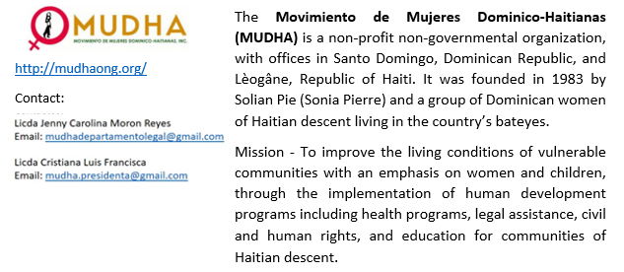
- SUSTAINING ORGANIZATIONS
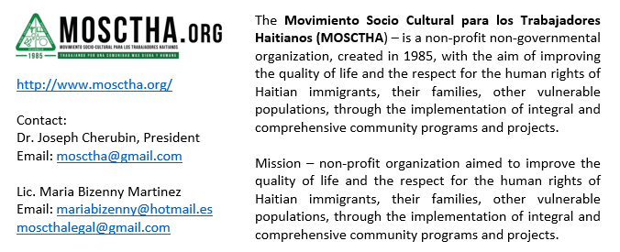

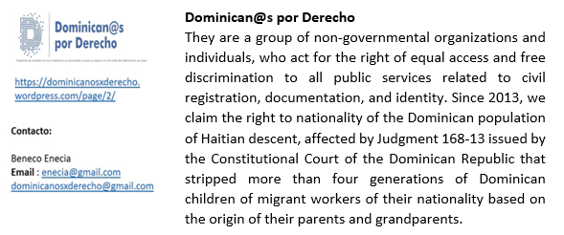

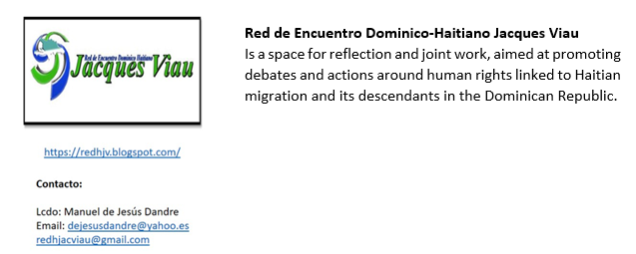

- TABLE OF CONTENT

SUSTAINING ORGANIZATIONS
EXECUTIVE SUMMARY
CONTEXT
DEVELOPMENT REPORT
VIOLENCE AGAINST WOMEN (ART. 1)
SITUATION OF MIGRATION AND MIGRANT WOMEN (ART 12)
DEFINITION OF DISCRIMINATION AND LEGISLATIVE FRAMEWORK (ART 4)
CHILD MARRIAGE AND SEX EDUCATION (ART 10)
TRAFFICKING IN PERSONS AND ILLICIT TRAFFICKING OF MIGRANTS (ART 6)
ARTICLE 28 OF THE GENERAL MIGRATION LAW No. 285-04 (ART 4)
LAW 169-14 ON SPECIAL NATURALIZATION (ART 4)

- EXECUTIVE SUMMARY
This report presents the situation of the rights protected under the Convention for the Elimination of Discrimination against Women (CEDAW), but, in particular way, the rights of Afro-descendant women, Dominican women with Haitian descent and Haitian migrants residing in the Dominican Republic.
The Dominican State has now received a number of observations from the CEDAW committee, the most recent of these, was the presentation of the seventh periodic report in 2019, which generated a list of issues to which the Dominican State must respond in the presentation of the eighth report in this period.
The signatory organizations hereby submit the following alternative report, with which we intend to highlight the gaps in the institutional framework established by domestic legislation for the protection of the rights enshrined in the Convention, in relation to practices, State officials' attitudes and omissions; the non-observance of due process guarantees; as well as the failure to implement legislative mechanisms adapted to the new times.
The information presented, responds to the collection of reports, events, testimonies, studies carried out by social organizations, leaders and community promoters.

- CONTEXT
At the global level, women according to The Economic Commission for Latin America and the Caribbean, suffered a greater burden at 21:30 hours more than men for the care of the household, children, and the elderly, as a result of the COVID-19 pandemic. Women who work in care homes and in jobs outside of it, have been exposed not only to make them more susceptible to infection but also to domestic and labor violence.
The economic crisis that has prevailed in some households, the prolonged confinement to reduce the contagion, resulted in women and girls being the most impacted with the havoc left by the COVID-19, not only in the region, but in the Dominican Republic, which in the following paragraphs we will show in order for the Dominican government can chart a new course, where there is true equity and gender equality.

- DEVELOPMENT REPORT
VIOLENCE AGAINST WOMEN (ART. 1)
Despite the progress that the Dominican Republic has made in gender matters, the pandemic caused by COVID-19 showed some warnings, which were analyzed in several reports highlighting the one carried out by the (UNDP) on violence against women and girls in the workplace and community. The report reveals that more than 95% of women were victims of violence at work and/or in public spaces without reporting it, with 60.4% of the perpetrators being the boss and employers.
Gender-based violence is not a problem that is based only in the social context but also in the legal context, Law 24-97 is full of shortcomings and limitations that do not allow it to fulfil the role of effectiveness and efficiency, adding the fact that it is out of context, therefore it is urgent to adopt new legislation adapted to the needs of the population.
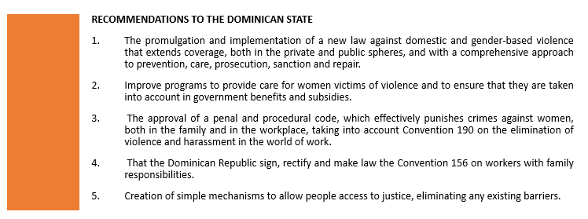
SITUATION OF MIGRATION AND MIGRANT WOMEN (ART 12)
Currently, hundreds of black women, Afro-descendants, Haitian migrants, and Dominican of Haitian descent are victims of deportations and expulsions, most of them pregnant, prioritizing the denial of access to health services for women without documentation.
Women are inhumanely removed by migration agents from hospitals, violating the Dominican constitution, this convention in its article (12) . The Movimiento Socio Cultural para los Trabajadores Haitianos, Inc. (MOSCTHA) , through its first level health care center, has had to support the follow-up of pregnant mothers who are afraid to go to mother and child healthcare centers, On the other hand, the Centro de Desarrollo Sostenible (CEDESO) and the Centro de Observación Migratoria y Desarrollo Social en el Caribe (OBMICA), present the testimonies of Haitian women expelled to Haiti in November 2021 in a video.
The Dirección General de Migración (DGM) on September 28th, ordered by statement, that access to public hospitals of non-resident or illegal immigrants should not be allowed, with the intention that pregnant women do not receive medical attention, knowing that; 1) Approximately 94% of the immigrant women who participated in the Plan for the Regularization of Foreigners (PNRE) obtained a non-resident migratory category, 2) That there are a considerable number of Dominicans of Haitian descent, who have not been able to obtain national documentation being more vulnerable, because they cannot show a document at the time of requesting medical service. A resolution of the Inter-American Commission on Human Rights (CIDH) on December 1st that has already expressed its concerns in this regard received an unsatisfactory response from the Foreign Ministry Dominican.
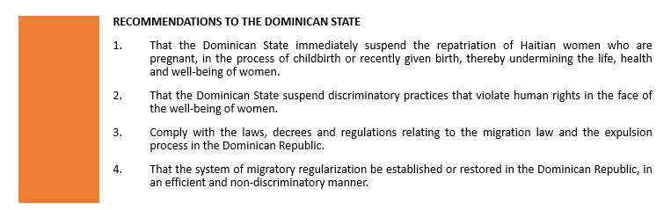

DEFINITION OF DISCRIMINATION AND LEGISLATIVE FRAMEWORK (ART 4)
We recognize that the Dominican Republic has taken certain actions to combat racial discrimination against Dominicans of Haitian descent, such as the criminalization of discrimination in its Criminal Code; the elimination of the classification as a dark-Indian and light-Indian person on identity documents; and the bill to modify the electoral law to allow Dominican people to identify themselves as black, mulatto, and the creation of gender and equality sections within ministries, among others.
In this sense, despite the efforts (considered by the signatories here to be limited) carried out by the State, in our expanded response we explain how discrimination against the Dominican population of Haitian descent and Haitian migrants continues. It should be noted that there is currently no general law against discrimination and xenophobia, despite recommendations to the country in this regard, including from other States.
In the same line, although the State prepared a National Human Rights Plan (2018-2022), in which it establishes an anti-discrimination program, it does not specify any action to counteract discrimination against Dominicans of Haitian descent, Moreover, it makes no mention of this sector of the population.
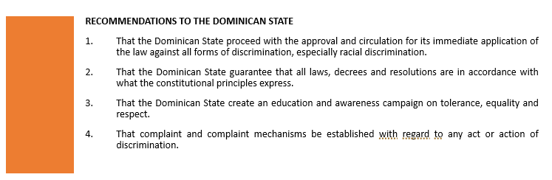

CHILD MARRIAGE AND SEX EDUCATION (ART 10)
We recognize that efforts have been made to counteract child marriages and early unions in the country, however we must highlight the latest studies and research which reveal that non-marital unions are more frequent than legal and formal marriages, therefore the promulgation of a law that prohibits child marriage reflects the good intentions of the authorities, but it is not the effective solution to the problem, without additional measures.
We highlight the fact that this problem is intertwined with other issues such as: the issue of sexual and gender violence, sex education, abortion, trafficking, sexual exploitation, poverty, lack of documentation, drug addiction, the lack of comprehensive educational programs as the case of L M shows. Representatives of the Movimiento de Mujeres Dominico-Haitianas (MUDHA) clubs during the national congress of parents pointed out a series of circumstances that allow and promote this problem and that it would be strategic from the State to counteract them.

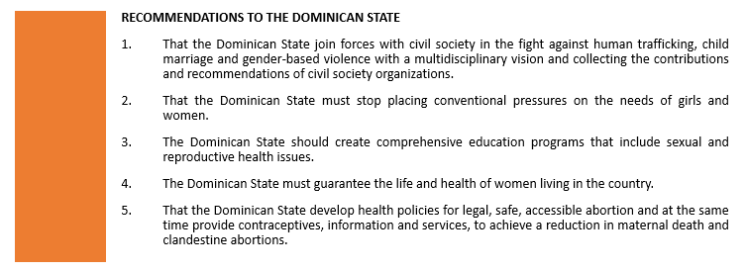

TRAFFICKING IN PERSONS AND ILLICIT TRAFFICKING OF MIGRANTS (ART 6)
We recognize the efforts being made by the Dominican State in relation to the issue, however, we can overlook situations identified in relation to human trafficking in recent reports by the Movimiento de Mujeres Dominico-Haitianas (MUDHA) and the Centro de Observacion Migratoria y Desarrollo Social en el Caribe (OBMICA) and other national studies which revealed and identified that there is a system of internal trafficking in the country and profiles linked to the system of violence, poverty, undocumentation, migration, among others.
Efforts are many but minimal results, there are still weaknesses in the system that do not allow in cases such as those that occurred in Puerto Plata even though it has been reported and arrested, a firm decision on the perpetrators is not reached and they are finally left in freedom, we believe that the Dominican State and society must assume a serious commitment to counteract human trafficking and sale in the country.
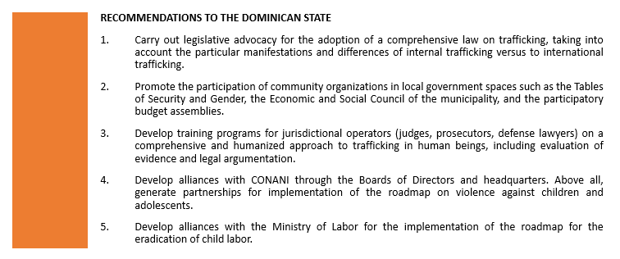
ARTICLE 28 OF THE GENERAL MIGRATION LAW No. 285-04 (ART 4)
Since the writing of this report, we continue to support the discrimination that exists in law 285-04 specifically in its article 28, which establishes a register of foreigners through a subjective law when the current constitution established the right to nationality by the system of jus soli, the unconstitutionality of this article becomes an act of discrimination, an act of institutionalized violence against migrant women and their children.
Seeing the publication of the Listin Diario newspaper, it would seem that Article 28 of Law 285-04 only applies to women of Haitian nationality since the publication details that in 2017 and 2018 the birth of 34,947 children of non-resident mothers was registered, of which 34,188 are Haitian nationals. Although we recognize that within the migrant population in the country are majority, the impact of this figure is questionable when it comes to classifying and excluding and yet not all births are registered leaving a significant part of the children of Haitian immigrants outside of any kind of registration, and therefore outside of the option of benefiting from services, care and public policies.
Another questionable aspect is the functionality of the book on foreigners in people’s lives. The supposed beneficiaries of this inscription are caught in a vicious and confusing cycle. Currently, there are two types of registry: the fact that of being registered in one or the other determines the extent to which they can have access to an effective registry. An example is the case of E. J. which reflects the reality of 34,188 people referred to in the press and the case of M. P. which reflects the reality of the beneficiaries of that instrument.

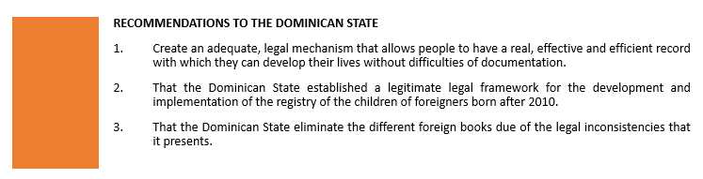
LAW 169-14 ON SPECIAL NATURALIZATION (ART 4)
We recall that judgment TC168-13 is still in force and that a law is not above the decisions of the Constitutional Court, is why everyday people of Haitian descent are still denied the issuance of their documents or are required to provide evidence of the legal status of their parents or descendants , is instructed to do the procedure to be audited and transcribe your birth certificate, applying indirectly and inexplicably the aforementioned sentence and law 169-14 which from its design presents a set of weaknesses and is currently in a state of action before the Constitutional Court for its nullity, which puts the beneficiaries of this at risk of being left without civil registration, without identity.
Law 169-14 has not been the best solution to the impact caused by judgment 168-13. The mere fact that the terms irregular and naturalization are used in its main statement implies fraud and foreignization, which creates stigmatization for the beneficiaries. In our expanded response we clearly explain how this solution has become a segregation system where there are groups and sub-groups with different contexts and situations.
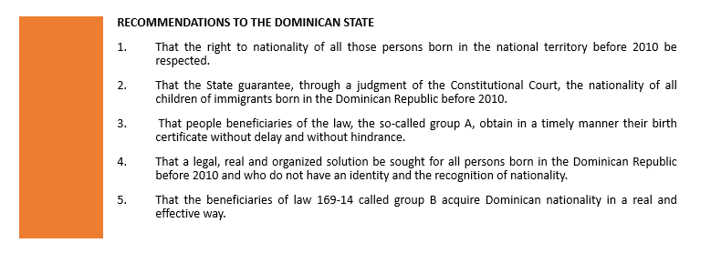

ACRONYMS

MUDHA Movimiento de Mujeres Dominico Haitianas
(Haitian Dominican women’s movement)

MOSCTHA Movimiento Socio Cultural para los Trabajadores Haitianos
(Socio Cultural Movement for Haitian Workers)

CEDESO Centro de Desarrollo Sostenible
(Center for Sustainable Development)

OBMICA Centro de Observación Migratoria y Desarrollo Social en el Caribe
(Centre for Migrant Observation and Social Development in the Caribbean)

Red Jacques Viau Red de Encuentro Dominico Haitiano Jacques Viau
(Dominican Haitian Encounter Network Jacques Viau)

CEDAW Convention for the Elimination of Discrimination against Women

UNDP United Nations Development Programme

DGM Direccion Nacional de Migracion
(National Migration Directorate)

PNRE Plan Nacional de Regularización de extranjeros
(Plan for the Regularization of Foreigners)

CIDH Comisión Interamericana de Derechos Humanos
(Inter-American Commission on Human Rights)

Profile sustaining organizations https://drive.google.com/file/d/1_cP8P3cCUIPJ84_GsgM01m4Bx82XrCxz/view?usp=sharing
http://obmica.org/images/Resumen_investigacion_RD_COVID_JUN_2021-compressed.pdf
United Nations Development Program (UNDP)
https://www.do.undp.org/content/dominican_republic/es/home/presscenter/articles/2021/mas-del-95--de-las-mujeres-victimas-de-violencia-en-el-trabajo-y.html
Migrant women, although they have received the same impact, are forced to remain silent due to threats of being deported or returned to their country of origin.
file:///C:/Users/ARCUS%20COMP/Downloads/JS1_UPR32_DOM_S_Annexe1.pdf
https://www.oas.org/dil/esp/Ley%2024-97,%20sobre%20Violencia%20Intrafamiliar%20Republica%20Dominicana.pdf
A law is needed that can share the global context and the global instruments and mechanisms for gender-based violence that have emerged in recent decades, such as the 2030 Development Agenda, the 2010 Constitution of the Republic, and the 2030 National Development Strategy, to mention a few.
More than 31,000 people have been deported from the Dominican Republic to Haiti in 2021, and over 12,000 in the last three months. https://listindiario.com/las-mundiales/2021/12/05/699733/maltratos-y-expulsiones-de-haitianos-de-republica-dominicana
https://cnnespanol.cnn.com/2021/11/12/republica-dominicana-detiene-y-deporta-grupo-de-haitianas-embarazadas-y-con-bebes-recien-nacidos-en-las-afueras-de-hospital/
Non-compliance of the Dominican State with General Recommendation No. 32 on the gender dimensions of refugee status, asylum, nationality and statelessness of women.
https://www.efe.com/efe/america/sociedad/deportadas-a-haiti-con-un-hijo-en-el-vientre/20000013-4688881
Article 64 Health Rights
States Parties shall adopt appropriate measures to eliminate discrimination against women in the field of health care in order to ensure, on a basis of equality of men and women, access to health care services, including those relating to family planning. Paragraph 2. Without prejudice to paragraph 1 above, States Parties shall ensure to women appropriate services in relation to pregnancy, childbirth, and the post-natal period, providing free services where necessary, and ensure adequate nutrition during pregnancy and lactation". On the other hand, the International Covenant on Economic, Social and Cultural Rights, article (10), paragraph (02), which states that special protection should be granted to mothers for a reasonable period of time before and after childbirth.
https://www.facebook.com/mosctha/, http://www.mosctha.org/
http://tratodigno.obmica.org/index.php/2021/12/13/deportaciones-indignas/
https://www.oas.org/es/CIDH/jsForm/?File=/es/cidh/prensa/comunicados/2021/320.asp
https://www.diariolibre.com/actualidad/ciudad/gobierno-dominicano-se-le-planto-a-la-cidh-por-parturientas-haitianas-DH30264887
https://drive.google.com/file/d/1xwIvjbZiYaQ-mfg7dGYxqPIHQJGVKNLA/view?usp=sharing
https://dominicanrepublic.unfpa.org/sites/default/files/pubpdf/Planteamientos%20Masculinidades%202020.pdf
https://webcache.googleusercontent.com/search?q=cache:8jCuzAv0pQcJ:https://plan-international.org/es/case-studies/el-matrimonio-infantil-forzado-tambien-existe-en-republica-dominicana+&cd=1&hl=es-419&ct=clnk&gl=do
The lack of information for young people has led to an increase in the number of teenage pregnancies to 22% https://www.resumendesalud.net/40-clinicas-y-hospitales/25134-aumentan-embarazos-en-adolescentes revealing the inefficiency of the State´s plans and program Dominican Republic is among the countries in the region with the highest number of pregnancies at an early age; according to data from the National Health Service only in 2019, 27 were registered,734 adolescent births representing 23.5% of the total number of registered births in the country (117,882 births) National Health Service (online). Summary of production of services primary and complementary levels. January-December 2019. Dynamic production table, updated in: 17.02.2020. Dom. Rep. https://es.search.yahoo.com/search?fr=mcafee&type=E210ES91215G0&p=https%3A%2F%2Frepositorio.+sns.gob.do%2Festadisticas-y-produccion%2F%2351-wpfd-2019-1569266980
The Dominican Republic, among the countries with the highest rate of maternal deaths, 8% of deaths are due to the unhealthy conditions of clandestine abortions as a result of the absolute criminalization of abortion, according to a study disseminated by the organization Human Rights Watch. https://www.hrw.org/sites/default/files/report_pdf/dr1118sp_web.pdf) According to data from the Ministry of Health, with 101 deaths per 100,000 inhabitants, this nation has one of the highest maternal mortality rates in the region. And of that amount, 8% is directly related to the clandestine nature of abortionshttp://www.opd.org.do/index.php/noticias/2409-mortalidad-materna-cobro-1-135-vidas-en-los-ultimos-anos-en-rd-por-causas-prevenibles
A 16-year-old girl who decided to join her 20-year-old boyfriend in order to get out of the constant physical and sexual abuse by her parents.
https://drive.google.com/file/d/1E95cCrxgdBgpj1czdWjrGhtMomjIGOvL/view?usp=sharing
http://www.bibliotecadigital.gob.do/cgi-bin/koha/opac-detail.pl?biblionumber=59221
http://obmica.org/index.php/publicaciones/informes
https://eldia.com.do/apresan-extranjero-que-intento-abusar-sexualmente-una-nina-de-siete-anos/
https://www.imparcialrd.do/2019/01/liberacion-de-canadiense-tras-ser.html
General La won Migration
- Non-resident foreign women who, during their stay in the country, give birth to a child (a) must go to the Consulate of their nationality for the purpose of registering their child there(a). In cases where the father of the child is Dominican, they may register the same with the corresponding Office of the Dominican Civil Status as provided by the relevant laws.
- The subjective right is born of a law or a contract, through which someone acquires a right to something or to someone, by mutual agreement and always.
http://www.consultoria.gov.do/Documents/GetDocument?reference=529f0575-b936-4a51-b403-b9d8eb905288
Dominicans are all persons born in the territory of the Republic, with the exception of the legitimate children of foreigners residing in the country on diplomatic representation or those who are in transit there.
Expanded response https://drive.google.com/file/d/1bMoK6i0XHC1PdRGIqs_IrzG4MhJF4eqB/view?usp=sharing
https://listindiario.com/la-republica/2019/01/22/550367/en-libro-de-extranjeria-casi-todos-son-haitianos
https://www.elcaribe.com.do/panorama/pais/solo-el-40-de-haitianos-nacidos-en-rd-en-2021-figura-en-el-libro-de-extranjeria/
They have a name but do not have nationality when they are old enough to start a life as a citizen, does not have the recognition nor the legal personality in the Dominican Republic or in Haiti are people who are in a legal limbo Registration done in an ordinary way as established by law 285-04 in its article 28 and the registration that stable on the basis of law 169-14 for group B
Registration carried out in an ordinary manner according to what the law 285-04 in its article 28 and the registration that stable on the basis of the law 169-14 corresponding to group B
The Young Ernesto Jean was inscribed in the book of foreigners in an ordinary way based on law 285-04 Article 28 when he turned 18 he went to the Central Electoral Board (JCE) in order for an identity card to be issued, as stated in Dominican law when contacting the employees of the institution, they explained to him that it was not for him to make the request in that entity and told him to go to the Haitian embassy at the time of Presenting the minutes and requesting the issuance of documents, the embassy employees told him that it was not his job because the document he was displaying was not a valid document in Haiti.
Miguelina Pettit is a young woman of 18 years was inscribed in the book of foreigners through processes of law 169-14 , she has a foreigner’s certificate and needs a university registration card where she has been told that she can be issued a foreigner’s certificate after the Interior and Police and Immigration issue the authorization
Judgment issued by the Constitutional Court of the Dominican Republic which orders the denationalization of hundreds of people for the fact of having Haitian descent with proof that their parents entered the country in an irregular manner for persons born in the national territory irregularly registered in the Dominican Civil Registry and on naturalization.
Act establishing a special regime for persons born in the national territory who are irregularly registered in the Dominican Civil Registry and on naturalization.
https://listindiario.com/la-republica/2018/04/10/509910/cuatro-acciones-buscan-nulidad-de-la-ley-169-14
The instances mainly promote the nullity of articles 1, 2 and 8 of this legislation
The vast majority of persons transcribed before the procedure of this law have been sued in the nullity of the main birth certificate.
https://migracion.gob.do/transparencia/wp-content/uploads/2019/10/Ley-No-169-14-de-Naturalizaci%C3%B3n.pdf
irregular is an adjective that allows to name what is out of order or is contrary to it.
Naturalization is the process by which a citizen of one foreign country acquires the nationality of another.
Expanded response https://drive.google.com/file/d/1MXoay6ce11bbGkJQr3setsglMXib7vlt/view?usp=sharing

