
COMMITTEE ON THE ELIMINATION OF DISCRIMINATION AGAINST WOMEN

Submission to the Pre-sessional Working Group of the Committee on the Elimination of All Forms of Discrimination Against Women at its 94th Session

September 2025, Geneva, Switzerland

INDIA
Submission by:

ADF International
Rue Pré-de-la-Bichette 1
1202 Geneva, Switzerland

Web: www.ADFinternational.org
Email: UN@ADFinternational.org

ECOSOC Special Consultative Status (2010)

Introduction
- ADF International welcomes the opportunity to submit information concerning India’s implementation of its obligations under Articles 1, 2, and 5 of the Convention on All Forms of Discrimination Against Women (CEDAW).
- This submission highlights the deeply entrenched culture of son preference in the country and its societal consequences, including widespread violence and discrimination against women and girls. Furthermore, it provides an analysis of the legal and policy frameworks addressing sex-selective practices, highlighting enforcement gaps and the urgent need for comprehensive strategies to tackle its root causes.
- Sex-selective Practices: Trends, Root Causes and Consequences
Current Trends
- The term ‘sex-selective practices’ (SSPs) encompasses all practices that involve the direct or indirect elimination of girl children because they are female. They range from prenatal practices, such as the destruction of female embryos before implantation and sex-selective abortion, to postnatal practices, such as infanticide and fatal neglect. The most common method of sex selection is prenatal sex selection, particularly through sex-selective abortion.
- India has historically maintained one of the most skewed sex ratios at birth globally. Between 2013 and 2017, the country recorded an average of over 460,000 “missing” girls annually, accounting for more than one-third of all sex-selective abortions worldwide. Approximately two-thirds were due to prenatal sex selection; the remainder resulted from post-natal practices.
- The Sample Registration System tracks the sex ratio at birth on a rolling three-year basis. The latest Sample Registration System Report (2021-2023) places India’s sex ratio at birth at 917 females per 1,000 males—a marginal improvement over 2019-2021 but still well below compared to the natural ratio of approximately 952 females per 1,000 males.
- Although data from the sixth National Family Health Survey (NFHS) covering the period from 2023 to 2024 is pending, previous data from 2019-2021 reveal severe regional disparities. In particular, Punjab and Haryana have recorded the lowest sex ratios at birth in the country at 904 and 893, respectively. Even more concerning is Tamil Nadu, which saw a steep decline in female births from 954 to 878 during the aforesaid survey period, reflecting a worsening trend.
- Postnatal sex-selective practices also continue to be widespread in India, particularly in the country’s economically disadvantaged regions. Historically manifested as female infanticide and neglect, these practices persist where families lack access to sex-determination technologies. In such contexts, girls are reportedly suffocated, drowned, poisoned, or deliberately starved. With the surge of modern prenatal sex-determination technologies, there has been a shift from female infanticide to prenatal sex selection. However, lower-income households that do not have access to sex-determination technologies and medical clinics still resort to female infanticide as a method of sex selection.
- Sex-selective practices contribute to India's higher under-five mortality rate for girls, despite boys’ generally higher biological susceptibility to early-life diseases. While the overall under-five mortality rate in India has improved, rural populations continue to contribute a higher proportion of the under-five deaths. Regions such as Uttar Pradesh (60 deaths per 1,000), Jharkhand (45), Odisha (41), and Rajasthan (37) not only report high female child mortality but also exhibit deeply skewed sex ratios at birth. According to the latest NFHS, Uttar Pradesh has a sex ratio at birth of 941, Jharkhand of 899, Odisha of 894, and Rajasthan of 891.
Root Causes
- As recognized inter alia by the Special Rapporteur on violence against women and girls, its causes and consequences, sex-selective practices are rooted in a culture of son preference and daughter aversion, linked to persistent socioeconomic conditions that lead to men and boys being perceived as economically and socially more valuable than females.
- In India, girls born to a family are often referred to as “Paraya Dhan” (literally, “someone else’s property”), signifying their perceived future transfer from their family home to another household upon marriage. They are often viewed as an economic burden, largely because families must pay a dowry for their marriage, with some payments continuing throughout the daughter’s life.
- Sons, by contrast, are viewed as economic assets and cultural custodians. They are expected to inherit property, carry on the family name, and fulfill specific religious and ceremonial duties.
- The profitability of prenatal sex selection also drives its persistence. A 2012 study by the European Parliament valued the sex-selection industry at over USD 100 million annually, benefiting manufacturers of diagnostic equipment and private clinics alike.
Consequences
- Sex-selective practices constitute an extreme form of discrimination and violence. They not only violate the inherent dignity and fundamental rights of girls but also carry broader legal, societal and ethical, consequences for all women and girls. These practices perpetuate and intensify systemic violence and discrimination, undermining the full realization of women’s rights, including the right to equality.
- Countries with imbalanced sex ratios often experience increased violence and societal instability. Research indicates that skewed sex ratios at birth correlate with reduced economic and social cohesion. In such contexts, men are driven towards ‘alternatives’ such as illegal occupations, affiliation with criminal gangs, and sexual violence.
- In areas with low female populations, forced marriage and human trafficking are common. Women, often minors, are commodified and sold into marriage, with intermediaries exploiting poverty and caste hierarchies to fuel a growing “bride market”.
- Crimes against women and girls in India continue to surge. According to the National Crime Records Bureau (2022), the most common offenses include rape, dowry deaths, abduction for forced marriage, trafficking, and the sale of children. These crimes are most prevalent in states with skewed sex ratios at birth: Gujarat, Karnataka, Tamil Nadu, and Uttar Pradesh.
- Legal and Policy Framework on Sex-selective Practices
Legal Framework
- The Pre-Conception and Pre-Natal Diagnostic Techniques (Prohibition of Sex Selection) Act 1994 (hereinafter, “the PCPNDT Act”) is India’s primary legislation addressing sex-selective practices.
- The PCPNDT Act prohibits all forms of sex selection, both before and after conception. It regulates the use of prenatal diagnostic tools, including by prohibiting the sex determination as well as advertisements promoting such procedures. The PCPNDT Act also mandates record-keeping by medical practitioners for at least two years, ensuring accountability for the use of these tools.
- The PCPNDT Act penalizes not only those performing or facilitating sex selection but also those seeking it. A presumption of coercion protects women from prosecution, unless proven otherwise.
- Sections 315, 316, and 318 of the Indian Penal Code criminalize acts of infanticide in general. Section 315 punishes any act done with the intention of preventing a child from being born alive or causing the child’s death after its birth with imprisonment for a term that may extend to ten years, with a fine, or with both. Section 316 makes it an offence to cause the death of an unborn child by act amounting to culpable homicide, and Section 318 criminalizes the concealment of birth by secretly burying or otherwise disposing of the dead body of a child whether such child died before or after, or during its birth.
Enforcement Challenges
- Responding to a query in the Lok Sabha (lower house of the Parliament), the Minister of State in the Ministry of Health and Family Welfare stated that 615 cases had been registered under the PCPNDT Act between 2021-2024, of which 82 resulted in convictions.
- The government’s record on filing appeals against acquittals is equally dismal. In a public interest litigation (PIL) filed before the Supreme Court of India in 2022, it was noted that appropriate authorities failed to appeal acquittals—despite being legally obligated to do so by the Act and the related rules.
- The PIL also revealed that the central and many state governments have not appointed the requisite number of appropriate authorities, limiting legal follow-through and enforcement.
- A study across 18 Indian states found that the reasons for the poor implementation of the law stems from poor evidence, lack of trained personnel, insufficient courts, and frequent, often unlawful, case withdrawals—despite offenses under the PCPNDT Act being non-compoundable under Section 27.
- Strengthening the financial and human resources for the effective enforcement of the PCPNDT Act is essential to realizing its full potential as a deterrent. Furthermore, with respect to the enforcement of Indian Penal Code provisions related to the prohibition of infanticide, the Report on Crime in India 2022 indicates that, during the reporting period, there were 1,239 cases categorized under Miscarriage, Infanticide, Foeticide, and Abandonment. Of the overall number of cases reported, 185 were categorized as infanticide, of which 102 were from the previous reporting period, while 83 were reported in 2022. Out of the 102 cases from previous years, only 9 were prosecuted during the reporting period. Only 3 cases of infanticide (which were from previous years) ended with a conviction.
Government Programmes
- Federal and state authorities in India have taken important steps by introducing programmes aimed at curbing sex selection. However, strengthening those initiatives is necessary to address the deep-rooted cultural norms underlying daughter aversion and to achieve a lasting, long-term impact. The flagship Beti Bachao Beti Padhao (“Save the Girl Child, Educate the Girl Child”) programme, launched in 2015 to raise awareness of sex selection and its causes, represents a promising foundation that can be further developed to achieve more sustained outcomes.
- A parliamentary committee found that from 2016 to 2019 nearly 79% of its budget went to media advocacy, while central funding for districts—earmarked across six components such as health, education, and capacity-building—was only about 25% disbursed, crippling state-level implementation. As a result, the campaign has not improved girls’ educational outcomes as intended: the gross enrolment ratio for girls at the secondary level fell from 80.10 in 2015 to 77.83 by 2020, and despite near-universal primary enrolment, only about half of girls remain through higher secondary. According to the Ministry of Education, this steep drop-out rate stems from factors such as inadequate school infrastructure—including lack of girls’ toilets—early marriage, and persistently low aspirations for girls’ education.
- Incompatibility of Sex-selective Practices with CEDAW Obligations
- Sex-selective practices are amongst the most direct and blatant forms of sex-based violence and discrimination, beginning at the earliest stages of life.
- Article 1 of CEDAW defines discrimination against women as including any sex-based distinction, exclusion, or restriction that impairs or nullifies their equal enjoyment of human rights and fundamental freedoms. As observed by the Committee on the Elimination of Discrimination against Women in its General Recommendation No. 19, these rights and freedoms include the right to life and the right to equality and non-discrimination. By targeting girl children because they are female, sex-selective practices violate not only their human rights but also their inherent dignity.
- Article 2 of CEDAW mandates States Parties to promptly take all appropriate measures to prevent and eliminate discrimination against women. As noted in General Recommendation No. 35, this obligation is of immediate effect and cannot be deferred on any grounds, including economic, cultural or religious.
- Furthermore, Article 5 requires States Parties to eliminate prejudices and customary and all other practices which are based on the idea of the inferiority or the superiority of either of the sexes or on stereotyped roles for men and women. Among these harmful prejudices are son preference and daughter aversion, which can result in sex-selective practices. By reinforcing the false notion that female lives are less valuable than male lives, sex-selective practices entrench harmful stereotypes that portray women and girls as inferior. Addressing these attitudes and behaviours is essential to advancing substantive equality between women and men.
- In line with its obligations, the government of India must redouble its efforts to address both the enforcement of existing laws and the underlying drivers of sex selection.
- Conclusions and Recommendations
Suggested Questions
- In the light of the aforementioned, ADF International respectfully recommends that the Committee on the Elimination of Discrimination against Women include the following questions in its list of issues to be transmitted to the government of India:
  - Provide information on the collection of data on sex ratios at birth, female infant mortality, female infanticide and other sex-selective practices, as well as on the measures taken to identify high-risk areas and address related trends;
  - Detail the measures taken to enforce prohibitions on prenatal sex determination for non-medical purposes, sex-selective abortion, and female infanticide;
  - Outline initiatives to promote and protect the equal enjoyment by women and girls of their rights, and to effectively combat all forms of discrimination against them.
Suggested Recommendations
- ADF International also respectfully suggests that the Committee on the Elimination of Discrimination against Women formulates the following recommendations in its forthcoming Concluding Observations on India:
  - Ensure the full and effective implementation of the Pre-Conception Pre-Natal Diagnostic Techniques Act of 1994, including by allocating increased human and financial resources for the prevention and prosecution of all acts covered under the Act;
  - Provide targeted training for law enforcement, the judiciary, medical professionals, and other relevant stakeholders on the provisions of the Pre-Conception Pre-Natal Diagnostic Techniques Act of 1994;
  - Intensify awareness-raising and educational initiatives to challenge son preference, affirm the equal value of girls, and support mothers of daughters, working with community leaders and the media to drive attitudinal change.

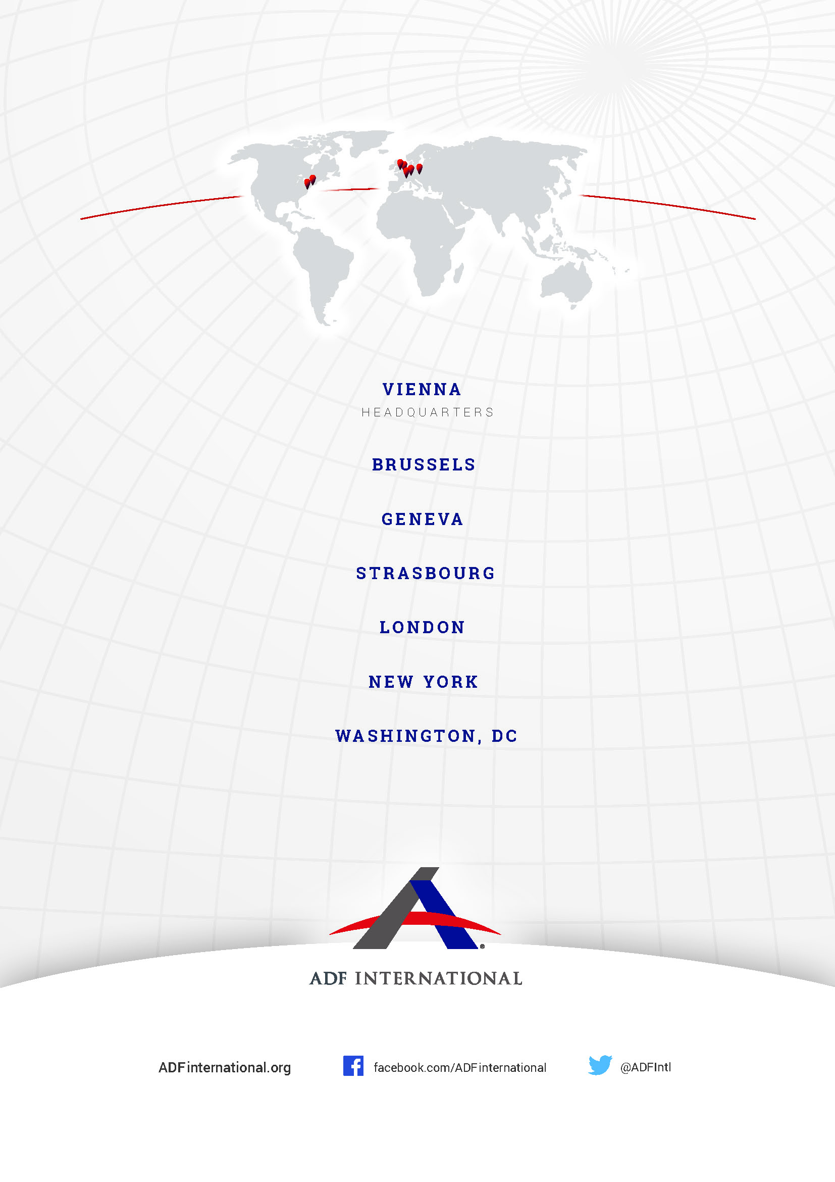

© 2025

World Bank ‘Sex ratio at birth (male births to female births) - India’ (2022) <https://data.worldbank.org/indicator/SP.POP.BRTH.MF?locations=IN>.
UN Population Fund ‘State of World Population 2020’ (2020), p. 45 <https://www.unfpa.org/sites/default/files/pub-pdf/UNFPA_PUB_2020_EN_State_of_World_Population.pdf>.
Census of India ‘Sample Registration System Statistical Report 2023’ (2023) <https://censusindia.gov.in/nada/index.php/catalog/46172/download/50420/SRS_STAT_2023.pdf>.
Bosky Khanna ‘NFHS-6 indicator fact sheet to be made public’ The Indian Express <https://www.newindianexpress.com/nation/2025/Aug/26/nfhs-6-indicator-fact-sheet-to-be-made-public>.
UNFPA ‘Trends and Differentials in Sex Ratio at Birth in India Based on NFHS Data’ (September 2023) <https://india.unfpa.org/sites/default/files/pub-pdf/analytical_paper_5_-_trends_and_differentials_in_sex_ratio_at_birth_in_india_based_on_nfhs_data_-_final_1.pdf>.
Liisanantti, Anu and Karin Beese, Gendercide: ‘The Missing Women?’ (March 2012) Overseas Development Institute, Ecologic Institute <https://www.ecologic.eu/12000>.
Jérémy Terpant, ‘To be born a woman in India. Foeticide and infanticide: origins, consequences and solutions’ (26 May 2021) Gender in Geopolitics Institute <https://igg-geo.org/?p=5229&lang=en>.
Roland Pongou, ‘Why is infant mortality higher in boys than in girls? A new hypothesis based on preconception environment and evidence from a large sample of twins’ (April 2013) <https://pubmed.ncbi.nlm.nih.gov/23151996/#:~:text=Infant%20mortality%20is%20higher%20in,to%20diseases%20and%20premature%20death>.
Manya Rathore, ‘Under-five mortality rate in India 2021’, by gender (10 July 2023) <https://www.statista.com/statistics/1317218/india-under-five-mortality-rate-by-gender/#:~:text=In%202021%2C%20the%20under%2Dfive,for%20the%20same%20time%20period>.
Chandan Kumar Piyasa and Nandita Saikia, ‘An update on explaining the rural-urban gap in under-five mortality in India’ (2022) BMC Public Health, <https://bmcpublichealth.biomedcentral.com/articles/10.1186/s12889-022-14436-7>.
Ministry of Health and Family Welfare, ‘National Family Health Survey (NFHS-5)’, 2019-2021, p. 63 <https://main.mohfw.gov.in/sites/default/files/NFHS-5_Phase-II_0.pdf>.
Id., p. 27.
Id., p. 39.
Id., p. 51.
Special Rapporteur on violence against women and girls, its causes and consequences, Reem Alsalem, ‘Sex-based violence against women and girls: new frontiers and emerging issues’ A/HRC/59/47 (16 June 2025) p. 12 <https://www.ohchr.org/sites/default/files/documents/hrbodies/hrcouncil/sessions-regular/session59/advance-version/a-hrc-59-47-aev.pdf>.
Pew Research Center ‘India’s Sex Ratio at Brith Begins To Normalize’ (23 August 2022), p. 9 <https://www.pewresearch.org/religion/2022/08/23/indias-sex-ratio-at-birth-begins-to-normalize/>.
N. Chakravarty et al., ‘Cultural and Social Bias Leading to Prenatal Sex Selection: India Perspective’ (13 June 2022) Frontiers in Global Women’s Health, p. 2-4 <https://www.ncbi.nlm.nih.gov/pmc/articles/PMC9234277/pdf/fgwh-03-903930.pdf>.
Liisanantti, Anu and Karin Beese, Gendercide: ‘The Missing Women?’ (March 2012) Overseas Development Institute, Ecologic Institute, p. 18 <https://www.europarl.europa.eu/RegData/etudes/etudes/join/2012/433777/EXPO-DEVE_ET(2012)433777_EN.pdf>.
Id., p. 10.
Sonia Vaze, ‘Un-Natural Selection: Female Feticide in India’ (2021) The Public Heath Advocate, <https://pha.studentorg.berkeley.edu/2021/04/10/un-natural-selection-female-feticide-in-india/>.
Id.
Id.
Jérémy Terpant, ‘To be born a woman in India. Foeticide and infanticide: origins, consequences and solutions’ (26 May 2021) Gender in Geopolitics Institute, <https://igg-geo.org/?p=5229&lang=en>.
Bhagyashree Das, ‘Violence Against Women in India’ (23 June 2022) The Times India <https://timesofindia.indiatimes.com/readersblog/talkingpoint/violence-against-women-in-india-43462/>.
National Crime Records Bureau Ministry of Home Affairs, ‘Crime in India’ (2022), p. 268-274 <https://www.ncrb.gov.in/uploads/nationalcrimerecordsbureau/custom/1701607577CrimeinIndia2022Book1.pdf>.
Id.
Pre-Conception Pre-Natal Diagnostic Techniques Act 1994.
Id., art. 3A.
Id., arts. 4-6.
Id., art. 29.
Id., art. 23.
Id., art. 24.
Indian Penal Code, Section 315.
Id., Section 316 and Section 318.
India Ministry of Health and Family Welfare ‘Lok Sabha Question No.1202’ (9 February 2024) <https://sansad.in/getFile/loksabhaquestions/annex/1715/AU1202.pdf?source=pqals>.
Shobha Gupta and & Another vs. Union of India, W.P.(C) No. 301/2022, Supreme Court of India <https://www.livelaw.in/top-stories/pcpndt-act-supreme-court-issues-notice-to-states-seeks-response-on-steps-taken-for-enforcement-232063>.
See Rule 18A, sub-rule 5(vi), The Pre-Conception and Pre-Natal Diagnostics Techniques (Prohibition of Sex Selection) Rules, 1996.
Shobha Gupta and & Another vs. Union of India, W.P.(C) No. 301/2022, Supreme Court of India <https://www.livelaw.in/top-stories/pcpndt-act-supreme-court-issues-notice-to-states-seeks-response-on-steps-taken-for-enforcement-232063>.
CYDA, PRAYATAN, ADITHI, VIMOCHANA, PHFI, ‘Implementation of the PCPNDT Act in India, Perspectives and Challenges’ (April 2010) <https://www.wbhealth.gov.in/uploaded_files/PNDT/IMPLEMENTATION%20OF%20THE%20PCPNDT%20ACT%20IN%20INDIA.pdf>.
Pre-Conception Pre-Natal Diagnostic Techniques Act 1994, art. 27.
National Crime Records Bureau Ministry of Home Affairs, ‘Crime in India’ (2022), p. 2 <https://www.ncrb.gov.in/uploads/nationalcrimerecordsbureau/custom/1701607577CrimeinIndia2022Book1.pdf>.
Id., p. 338.
Id., p.340.
Id., p.352.
Ministry of Women and Child Development ‘Beti Bachao Beti Padhao’ (2017) <https://wcd.nic.in/bbbp-schemes>.
Lok Sabha ‘Fifth report of the Committee on Empowerment of Women’ (December 2021) p. 52 <https://eparlib.nic.in/bitstream/123456789/835432/1/17_Empowerment_of_Women_5.pdf#search=pcpndt>.
Special Rapporteur on violence against women and girls, its causes and consequences, Reem Alsalem, ‘Sex-based violence against women and girls: new frontiers and emerging issues’ A/HRC/59/47 (16 June 2025) p. 12 <https://www.ohchr.org/sites/default/files/documents/hrbodies/hrcouncil/sessions-regular/session59/advance-version/a-hrc-59-47-aev.pdf>.
CEDAW Committee ‘CEDAW General Recommendation No. 19: Violence against women’ (1992) para. 7 <https://www.refworld.org/legal/resolution/cedaw/1992/en/96542>.
CEDAW Committee ‘General recommendation No. 35 on gender-based violence against women, updating general recommendation No. 19’ para. 21 <https://docs.un.org/en/CEDAW/C/GC/35>.

