
Annexes 1-4 to the Response of the
KINGDOM
OF THE NETHERLANDS
to the List of issues (CRC/C/NLD/Q/4) in relation to the fourth periodic report
submitted by the Netherlands under Article 44 of the
Convention on the Rights of the Child

March 2015
Annexe 1 – Statistical information for the Netherlands including the Caribbean Netherlands

Note: Where personal details are registered in the Netherlands, for instance in the Personal Records Database (BRP), ethnicity is not among the details registered. The Netherlands opted instead for the objective criteria of country of birth and parents’ country of birth as the point of departure for registration. Consequently, no information on ethnicity can be given in this part of the report. As some data for 2014 is not yet available, we have chosen to report on data from 2011-2013.

Budget information on budget lines regarding children and social sectors
 | 2011 | 2012 | 2013
Education | 5.4% | 5.5% | 5.5%
Health care | 10.4% | 10.7% | 10.7%

Fig. 1. Public expenditure on health care and education as a percentage of GDP
Source: Netherlands Bureau for Economic Policy Analysis

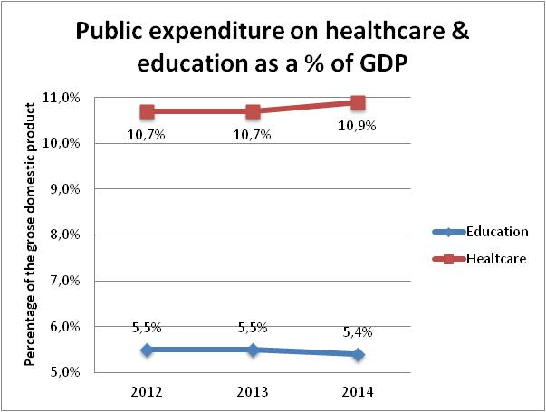
Fig. 2. Source: Netherlands Bureau for Economic Policy Analysis (CPB), Central Economic Plans for 2013 and 2014.

Number of persons below 18 who have been trialed as adults
In 2011 five boys aged 17 were detained at an adult prison. Two of these cases involved provisional detention and three involved detention in lieu of payment of a fine. In 2012 another five 17-year-olds (three boys and two girls) were detained in an adult prison. Two of these cases involved alternative detention and three were provisional detention. Finally, no minors were detained in prison in 2013.

 | 2011 | 2012 | 2013
Males aged 17* | 5 | 3 | 0
Females aged 17 | 0 | 2 | 0
Total aged 17 | 5 | 5 | 0

Fig. 3: Number of people under 18 years of age who were tried as adults
* Two cases of provisional detention and three cases of detention in lieu of a fine.

Number of children involved in sexual exploitation
In 2013, 259 underage victims (or possible victims) of human trafficking were registered, according to the figures of the National Rapporteur on Human Trafficking. In the Netherlands, human trafficking victims are eligible for assistance (e.g. for social reintegration), and may put in claims for recovery, damages and social reintegration services. No data is available on the number of underage victims who were given access to these options.

A multidisciplinary working group has been set up in the Caribbean Netherlands to fight human trafficking and people smuggling. It is responsible for collecting data and has initiated anti-trafficking measures, such as the development of a prevention campaign in October 2014. It accords explicit priority to combating trafficking in children.

Data regarding the situation of children deprived of a family environment
Until the end of 2014, the geographical location of these children was not reliably recorded. This information is therefore not included here. As of 2015 the children’s geographical location is being reliably recorded. Information which is available, is included hereunder.

Children Separated from their parents
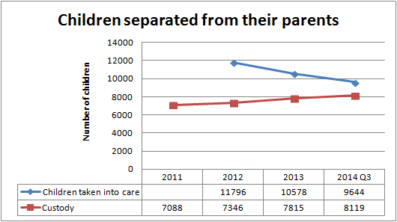
Fig. 4: Children separated from their parents: taken into care or placed in custody.

Children placed in institutions
Age when placed in the institution | 2011 |  |  | 2012 |  |  | 2013
Age when placed in the institution | male | female | total | male | female | total | male | female | total
12 | 0 | 1 | 1 | 2 | 0 | 2 | 2 | 0 | 2
13 | 5 | 1 | 6 | 4 | 0 | 4 | 5 | 0 | 5
14 | 6 | 0 | 6 | 18 | 2 | 20 | 12 | 1 | 13
15 | 45 | 0 | 45 | 47 | 4 | 51 | 54 | 3 | 57
16 | 45 | 4 | 49 | 73 | 1 | 74 | 88 | 9 | 97
17 | 64 | 4 | 68 | 76 | 10 | 86 | 103 | 11 | 114
18 | 6 | 2 | 8 | 18 | 3 | 21 | 15 | 1 | 16
19 | 2 | 0 | 2 | 3 | 0 | 3 | 5 | 0 | 5
20 | 1 | 0 | 1 | 3 | 0 | 3 | 4 | 0 | 4
22 | 1 | 0 | 1 | 2 | 0 | 2 | 1 | 0 | 1
24 | 1 | 0 | 1 | 0 | 0 | 0 | 0 | 1 | 1
Total | 176 | 12 | 188 | 246 | 20 | 266 | 289 | 26 | 315
Fig. 5: number, gender and age of children placed in institutions.

Children placed with foster families
Fig. 6 shows the age distribution of foster children. For the years 2011, 2012 and 2013, 49% of the children were boys and 51% were girls.
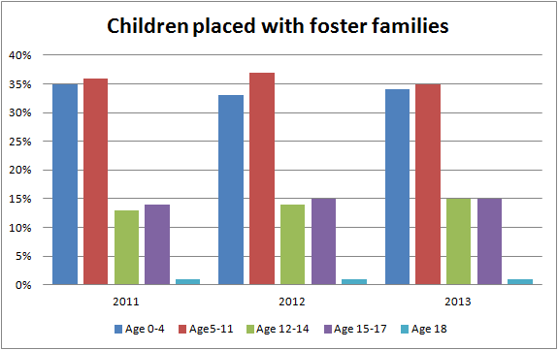
Total of 20,489 20,949 21,606 foster children
Fig. 6. Source: https://www.pleegzorg.nl/over-pleegzorg/factsheet/

Children adopted domestically or through inter-country adoptions
In 2011 the Child Protection Board issued 1,281 recommendations to grant provisional permission for adoption. The number of positive recommendations issued in 2012 was 1,041, and in 2013 there were 938. These figures may include duplicates, since in a number of cases a positive recommendation was issued both in the investigation relating to the adoption of a child born in another country as well as in the investigation relating to the adoption of a child born in the Netherlands.
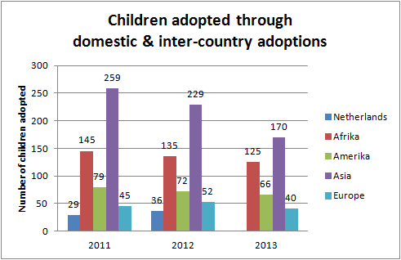
Fig. 7: Number of children adopted through domestic and inter-country adoptions.
Source: Statistics Netherlands
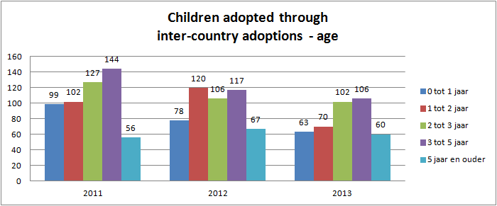
Fig. 8: Age of children adopted through inter-country adoptions.
Source: Statistics Netherlands

Data on the number of children with disabilities
There are between 109,000 and 129,000 children with disabilities in the Netherlands (not including psychiatric disorders). This figure represents around 3.5% of all children under 18. In 2012, more than 68,000 of these children received specialist care or used specialist care facilities due to their disability.

These 68,000 children can be divided into three groups: children with a physical disability (20,000), children with an intellectual disability (45,000) and children with a sensory disability (10,000). More than 6,500 children have multiple disabilities. In 2012, there were more boys with disabilities (61.6%) than girls (38.4%).

Children with disabilities living with their families

Age |  | Physical disability | Visual disability | Auditory disability | Total
0 - 5 years |  | N/A | N/A | N/A | N/A
6 - 19 years | Slight disability | 65,000 | 50,000 | 10,000 | 115,000
6 - 19 years | Moderate to severe disability | 65,000 | 80,000 | 35,000 | 140,000
Figure 9: Disabled children with care entitlement living at home.
Source: Netherlands Institute for Social Research, 2011.

Children with disabilities in institutions
 | 2010 | 2011 | 2012
Intellectual disability | 5,660 | 5,885 | 5,440
Slight intellectual disability | 6,310 | 5,970 | 5,510
Slight intellectual disability with severe behavioural problems | 30 | 20 | 10
Physical disability | 245 | 215 | 185
Visual disability | 120 | 115 | 95
Auditory disability | 215 | 205 | 195
Total | 12,580 | 12,410 | 11,435
Fig. 10: Disabled children under 18 requiring residential care.
Source: Statistics Netherlands, Chronic Care Monitor

Children with disabilities attending special schools

 | 2011 | 2012 | 2013
Children with disabilities  attending primary education | 21,014 | 20,137 | 21,435
Children with disabilities  attending secondary education | 19,687 | 20,797 | 20,809
Children with disabilities  attending special education | 70,160 | 70,422 | 71,100
Fig. 11: Children with disabilities by type of education.

Children with disabilities out of school

 | 2010-2011 | 2011-2012
Exempt from compulsory education | 3,107 | 4,128*
* Estimated figure.
Fig. 12: Children granted exemption from compulsory education.

Children with disabilities abandoned by their families.
Every year, one or two children are abandoned. There are no known figures on any disabilities these children may have had, and whether this may have been the reason for their abandonment. In addition, a number of dead bodies of infants are found each year. In total, 31 dead bodies of children under two years of age were found in the period 2000 to 2008.

Areas affecting children that the state considers to be of priority with regard to the implementation of the Convention
Research published by the Centre for Children’s Rights on 22 January 2015 shows that the Dutch courts are applying the Convention on the Rights of the Child with increasing regularity and in a positive manner. More than 650 cases covering the period 1 September 2011 to 31 August 2014 were examined for the purposes of discovering how the Convention had been applied by the courts. The trend towards applying the Convention, first identified in the previous survey covering a period of almost ten years, has continued to gather pace. The current research shows that there are now positive developments in areas which were problematic at the time of the previous survey (aliens law and criminal law).

Annexe 2: Statistical information for Aruba

Data on number of children with disabilities

Fig.13 : Number of children with disability by gender, age category and type of disability, 2010
Source: 2010 Aruba Population and Housing Census - Central Bureau of Statistics Aruba
*: Too few cases to depict in the table

Fig. 14: Number of children with disability by gender, age category and type of disability, 2010
Source: 2010 Aruba Population and Housing Census - Central Bureau of Statistics Aruba
*: Too few cases to depict in the table

Fig. 15 : Number of children with disability byage category and type of disability, 2010
Source: 2010 Aruba Population and Housing Census - Central Bureau of Statistics Aruba

Children with disabilities living with family

Fig. 16: Number of children with disability in normal households, 2010
Source: 2010 Aruba Population and Housing Census - Central Bureau of Statistics Aruba

Children with disabilities attending school

Fig.17: Number of children with disability visiting school by age category and type of school (ISCED), 2010
Source: 2010 Aruba Population and Housing Census - Central Bureau of Statistics Aruba
*: Too few cases to depict in the table
ISCED 1997

Children with disabilities out of school

Fig.18: Number of children with disability not visiting school by gender and age category, 2010
Source: 2010 Aruba Population and Housing Census - Central Bureau of Statistics Aruba
*: Too few cases to depict in the table

Enrolment rates of the relevant age group in pre-primary schools, primary schools and secondary schools

Fig.19: Enrolment rate by level of education, school year and gender
Source: Department of Education, Central Bureau of Statistics Aruba, Population Registry Office and Aruba Population and Housing Census 2010
* Possibility of small inconsistencies in the enrolment and/or population data

Completion rates of the relevant age groups in primary schools and secondary schools

Fig. 20: Gross Completion rate by level¹ of education, school year and gender
Source: Inspectorate of Education, Department of Education and Population Registry Office
Population is Public schools and Government aided schools (Private schools not included)
¹ Primary Level Special Needs Education not included

Percentage of repetitions (repetition rate and percentage of repeaters)

Fig. 21: Repetition rate in Primary Level of education¹ by school year and gender
Source: Inspectorate of Education and Department of Education
¹ Regular Education
Population is Public schools and Private Government aided schools (Private schools not included)

Fig. 22 : Percentage of repeaters¹ in Secondary Level of education² by school year and gender
Source: Department of Education and Central Bureau of Statistics Aruba
¹Repeaters is calculated as the sum of pupils repeating a given grade and pupils demoting to a lower educational level.
The share of pupils demoting to a lower level of education ranges between 2%-5% of the amount of enrolled pupils in a given school year
² Regular Education
Population is Public schools and Private Government aided schools (Private schools not included)

Pupil-teacher ratio

Fig. 23 : Pupil-Teacher ratio by level of education and school year
Source: Department of Education
¹ Pre Primary Level and Primary Level
² Only Regular Secondary Education
Population is Public schools and Government aided schools (Private schools not included)

Annexe 3: Statistical information for Curaçao
Population aged 0-24 years by disability status and sex, 2011 census
 | Male | Female | Total
No disabilities | 24,171 | 23,582 | 47,753
Disabilities | 342 | 258 | 600
NR/Unknown | 267 | 257 | 524
Total | 24,780 | 24,097 | 48,877
Population aged 0-24 years with disabilities by age and sex, 2011 census
 | Male | Female | Total
0 – 4 | 151 | 109 | 260
5 – 9 | 40 | 10 | 50
10 – 14 | 44 | 45 | 89
15 – 19 | 53 | 57 | 110
20 – 24 | 54 | 37 | 91
Total | 342 | 258 | 600
Population aged 0-24 years with disabilities by types of disability and sex, 2011 census
Disabilities | Male | Female | Total
Visual disability | 45 | 53 | 98
Auditory disability | 22 | 19 | 41
Difficulty in walking | 103 | 79 | 182
Difficulty in remembering/concentrating | 150 | 95 | 245
Difficulty in looking after themselves | 184 | 147 | 331
Difficulty in communicating | 128 | 84 | 212
Total | 342 | 258 | 600
Totals are based on information supplied by respondents. Respondents may have more than one disability.

Enrolment and completion rates of the relevant age groups in pre-primary schools, in primary schools and in secondary schools

Enrolment in early childhood settings for three-year-old children in the Netherlands is almost 90%. Public spending on early childhood education and care (ECEC) settings in the Netherlands is approximately 0.9% of GDP.
 | 2010 | 2011 | 2012
Ages 3 and 4 |  | 93% | 91%
Ages 5 to 14 | 100% | 100% | 100%
Ages 15 to 19 | 91% | 93% | 93%
Fig. 24. Enrolment data.
Source: Education at a Glance 2014, 2013, 2012 (OECD)

 |  |  |  | Total |  |  |  | General (HAVO, VWO) |  |  |  |  | Vocational (MBO)
Year used for new entrants |  | Total | Men |  | Women |  | Total |  | Men | Women |  | Total |  | Men | Women
2007 | within N | 61.4% | 57.1% |  |  | 65.9% | 69.2% |  | 66.4% |  | 71.7% | 57.3% |  | 52.5% |  | 62.4%
 | 2 years after N | 80.3% | 77.2% |  |  | 83.4% | 94.3% |  | 93.2% |  | 95.3% | 72.7% |  | 69.3% |  | 76.3%
Fig. 25. Completion rates of upper secondary programmes.
HAVO = senior general secondary education; VWO = pre-university education; MBO = secondary vocational education

The number and percentage of dropouts and repetitions
This relates to the percentage of young people aged 18 to 24 who are not enrolled in education and have not attained a basic qualification level (MBO-2 certificate, HAVO or VWO).
 | 2011 | 2012 | 2013
Males | 10.8% | 10.2% | 10.9%
Females | 7.2% | 7.3% | 7.4%
Netherlands total | 9.1% | 8.8% | 9.2%
Fig. 26. Dropout rates: proportion of early school-leavers from education and training.
Source: Eurostat.

 | Pre-primary |  | Primary
Age | 4-5 yrs | 5 -6 yrs | 6-7 yrs | 7-8 yrs | 8-9 yrs | 9-10 yrs | 10-11 yrs | 11-12 yrs | AV
Retention rates per group | 4.2% | 10.5% | 5.0% | 3.8% | 2.0% | 1.3% | 1.0% | 0.4% | 3.4%
Fig. 27. Retention rates in primary education per age category. Source: ITS, 2012

 | School  year | 2008/  2009 | 2009/  2010 | 2010/  2011 | 2011/  2012 | 2012/  2013 | 2013/  2014
Transitional year | 1 | 1.8% | 2.2% | 2.4% | 2.4% | 2.6% | 2.7%
 | 2 | 3.6% | 4.0% | 4.3% | 4.2% | 4.1% | 4.0%
VMBO B | 3 | 4.8% | 5.0% | 5.7% | 6.4% | 6.1% | 6.2%
 | 4 | 1.5% | 1.9% | 2.5% | 3.0% | 2.7% | 2.4%
VMBO K | 3 | 3.4% | 3.7% | 4.2% | 4.5% | 4.3% | 4.3%
 | 4 | 3.1% | 3.2% | 3.3% | 4.2% | 4.4% | 3.8%
VMBO G/T | 3 | 6.9% | 7.3% | 8.2% | 8.3% | 8.0% | 7.7%
 | 4 | 3.8% | 4.4% | 5.3% | 6.8% | 6.3% | 5.3%
HAVO | 3 | 8.0% | 8.7% | 9.4% | 8.7% | 7.9% | 6.8%
 | 4 | 13.0% | 14.0% | 14.2% | 14.5% | 14.1% | 13.5%
 | 5 | 6.7% | 7.0% | 7.3% | 6.4% | 6.1% | 5.9%
VWO | 3 | 3.0% | 3.5% | 3.4% | 3.3% | 3.6% | 3.0%
 | 4 | 10.0% | 10.9% | 11.6% | 11.1% | 10.3% | 9.5%
 | 5 | 9.1% | 9.9% | 10.8% | 11.7% | 10.4% | 9.3%
 | 6 | 1.0% | 4.1% | 5.0% | 5.0% | 3.7% | 4.4%
Fig. 28. Retention rates in secondary education per school year. Source: Education Executive Agency (DUO)
VMBO = pre-vocational secondary education

Teacher-pupil ratios
 | 2010 | 2011 | 2012
Pre-primary | 16 | 16 | 16
Primary | 16 | 16 | 16
Secondary | 16 | 17 | 17
Fig. 29. Ratio of students to teaching staff based on full-time equivalents.
Source: Education at a Glance 2014, 2013, 2012 (OECD)

Dropout rates, based on the 2011 census (Statistics Netherlands)
 |  |  |  |  |  |  |  |  | 2011 census
Dropout rates: entire population
Numerator = Dropouts = people with no school leaver’s certificate i.e.: no education whatsoever, primary school only, incomplete secondary education (junior general secondary education (MAVO), secondary pre-vocational education (VSBO), senior general secondary education (HAVO), pre-university education (VWO)) |  |  |  |  |  |  |  |  | 39,596
Denominator = Population aged 15 or over no longer in education |  |  |  |  |  |  |  |  | 107,412
Dropout percentage of the total population (aged 15 or over and no longer attending school) |  |  |  |  |  |  |  |  | 36.9%
Dropout rates for young people aged 15-24
Numerator = Dropouts = people aged 15-24 with no school leaver’s certificate i.e.: no education whatsoever, primary school only, incomplete secondary education (junior general secondary education (MAVO), secondary pre-vocational education (VSBO), senior general secondary education (HAVO), pre-university education (VWO)) |  |  |  |  |  |  |  |  | 2,380
Denominator= Population aged 15-24 no longer attending school |  |  |  |  |  |  |  |  | 6,811
Dropout percentage of young people (15-24 and no longer attending school) |  |  |  |  |  |  |  |  | 34.9%

Figure 30: Total students in primary and secondary education in Curaçao (Statistics Netherlands)

Primary education | 2010/2011 | 2011/2012 | 2012/2013 | 2013/2014
Foundation Based Education | 17,652 | 17,361 | 17,131 | 16,840
Basic Special Education | 1,160 | 1,122 | 1,127 | 1,127
Secondary education
Special Secondary Education (VSO, AGO, ZMLK) | 1,210 | 1,225 | 1,121 | 1,006
Basic Secondary Education (VSBO) | 7,577 | 7,269 | 7,077 | 6,913
Basic Secondary Education (HAVO/VWO 1,2) | 1,079 | 1,044 | 936 | 984
Higher Secondary Education (HAVO/VWO 3,4,5,6) | 2,371 | 2,308 | 2,194 | 2,121
Senior Secondary Vocational Education (SBO) | 3,395 | 3,510 | 3,621 | 3,779
Total students | 34,444 | 33,839 | 33,207 | 32,770

Note: Education not subsidised by the government is not included.

Annexe 4 – Statistical information for St Maarten

Number of children involved in sexual exploitation, including prostitution, pornography and trafficking, and the number of those children who were provided access to recovery, damages and social reintegration services.

Figure 31: Number of cases in which the Court of Guardianship intervened:
2011 | 42
2012 | 31
2013 | 43

Number of children separated from their parents, placed in institutions, placed with foster families and adopted domestically or through inter-country adoptions

Figure 32:
Year | Separated from parents | Placed in institutions | Placed with foster families | Number of reported submitted by CoG for adoption
2011 | 30 | 28 | 2 | 5
2012 | 37 | 34 | 3 | 2
2013 | 42 | 42 | 0 | 3
2014 | 62 | 57 | 5 | 2

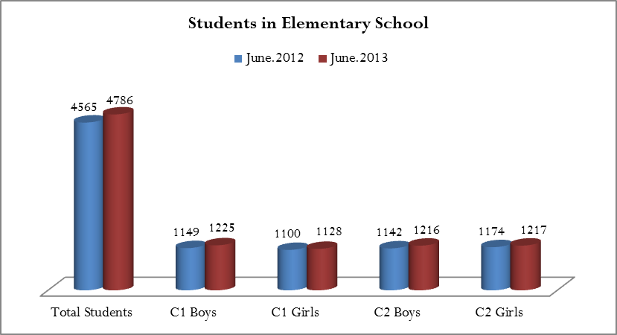
Figure 33: number of students in primary education

The number and percentage of dropouts and repetitions.

 | 2011/2012 | 2012/2013 | 2013/2014
Expelled | 7 | 3 | 12
Dropouts | 26 | 11 | 36
Figure 31: number and percentage of students expelled or dropped out.

Teacher-pupil ratio 2011-2014, primary education (PE)

School type | Teachers |  |  |  | Students
 | 2011/2012 | 2012/2013 | 2013/2014 |  | 2011/2012 | 2012/2013 | 2013/2014
PWAS* | 18 | 18 | 15 |  | 83 | 75 | 66
FBE** | 328 | 354 | 348 |  | 4,532 | 4,707 | 4,757
* Prins Willem Alexander School (PWAS) caters to special primary education needs
** Foundation Based (primary) Education

School | Teachers |  |  |  | Students
 | 2011/2012 | 2012/2013 | 2013/2014 |  | 2011/2012 | 2012/2013 | 2013/2014
SDHSª | 33 | 35 | 33 |  | 343 | 373 | 352
SMVTS^{b} | 24 | 26 | 26 |  | 209 | 222 | 228
MPC –havo^{c} | 35 | 44 | 39 |  | 266 | 277 | 264
MPC-vwo^{d} | 23 | 26 | 26 |  | 42 | 58 | 55
MPC-tkl^{e} | 38 | 40 | 40 |  | 438 | 424 | 383
MPC-pkl/pbl^{f} | 32 | 30 | 33 |  | 248 | 243 | 249
Sundial | 36 | 31 | 32 |  | 356 | 317 | 339
SMA-Academic^{g} | 48 | 40 | 40 |  | 478 | 470 | 489
SMA-PSVE^{h} | 36 | 50 | 46 |  | 601 | 499 | 465
CBA^{i} | 0 | 8 | 13 |  | 0 | 35 | 73
MAC-CSE^{j} | 0 | 0 | 8 |  | 0 | 0 | 38

ª St. Dominic High School
^{b} St Maarten Vocational Training School
^{c} Milton Peters College, senior general secondary education
^{d} Milton Peters College, pre-university education
^{e} Milton Peters College, theoretical education
^{f} Milton Peters College, practical education
^{g} St Maarten Academy – Academic
^{h} St Maarten Academy – Vocational
^{i} Charlotte Brookson Academy of the Performing Arts
^{j} Methodist Agogic Center Comprehensive Secondary Education
Note: Primary school pupils do not drop out of school, but may be deregistered if they leave the island or transfer to another school. When secondary school pupils drop out the reason given is usually long-term absenteeism. In some cases the school is unable to locate the pupil in question as the contact address and/or telephone numbers are incorrect.
Figure 32: teacher-pupil ratio 2011-2014 in primary education

Areas affecting children that the state considers to be of priority with regard to the implementation of the Convention
- Since the previous report, the HIV programme management team has been suspended and its tasks transferred to the St Maarten AIDS Foundation.
- The Court of Guardianship is continuing to act as a central reporting centre for child abuse.
- Cases are being registered and more support is available to victims. Additional staffing will be needed if this service is to continue to expand.
- Protocols agreed with other stakeholders (doctors, police, education department, daycare facilities etc.) are being finalised.
- The new youth care and rehabilitation centre (Miss Lalie Center) is finding its feet. Additional staffing will be needed if existing services and programmes are to expand.

