Additional written response to the Human Rights Committee

Rights of Migrants
- The Government is aware of migrant workers’ vulnerability to exploitation and spares no effort to protect their legal rights and enhance their access to social services.
- The current number of documented migrant workers in Thailand, as of the end of 2016, is 1.3 million, mainly from three neighboring countries including;
- 900,000 migrant workers who passed national verification and received identification documentation, e.g. certificate of identity (CI), passport or temporary passport, from
the authorities of their countries of origin; and
- 400,000 legally imported migrant workers.
- Documented migrant workers are entitled to rights and benefits as stipulated in
the relevant Thai laws.
- In addition, there are 1.4 million undocumented migrant workers registered and allowed to temporarily stay and work in Thailand for a specific duration or until they leave Thailand. Each of these workers is issued an identity card, or the so-called “pink card” and are protected by the Labour Protection Act 1998.
- Pink card holders with work permit and other identity document(s) from their countries of origin can register as insured persons under the Social Security Act 1990.
- At present, pink card holders with work permit who do not have any other identity document from their countries of origin cannot use the pink card to register in the social security system, but they are still protected under the workmen’s compensation system as prescribed by the law as well as provided medical and health care services by
the Ministry of Public Health.
- The Thai agencies concerned are in consultation with the relevant authorities of our
three neighboring countries to speed up national verification in order to allow pink card holders to receive official identity documents so that they can be protected and access social services.
- In 2016, Thailand launched a special project to allow pink card holders to return home for a specific duration in April to join their family during the traditional new year festival. We are planning to allow pink card holders to travel home for 20 days in April 2017.

Trafficking in Person and Combatting Forced Labour in Fisheries Sector
- With regard to measures taken to suppress and prevent human trafficking in
the fisheries sector during the past three years, significant legal developments include;
- Ministerial Regulation of 2014 regulating the working condition on fishing vessels;
- Announcement of the Prime Minister’s Office in September 2016 which stipulates the issuance of Sea Book for migrant workers employed on Thai fishing vessels; and
- Royal Ordinance on Fisheries 2015 prohibiting employers of fishing vessels and seafood processing factories to employ unregistered migrant workers.
- From May 2015 to December 2016, there were 76 human trafficking cases in
the fisheries sector, 10 of which are under investigation, 21 cases are under review by the public prosecutors, 40 cases have been submitted to the court and 5 cases have already been finalized.
- In 2016, 35 factories were ordered to suspend their operation for 10-30 days on account of their failure to comply with the Royal Ordinance on Fisheries 2015.
- In order to increase channels for migrant workers to file complaints and access social services, the Ministry of Labour;
- established 2 special phone numbers as a support mechanism;
- set up assistance centers for migrant workers on 1 August 2016, namely Post-arrival and Re-integration Centers and Migrant Workers Assistance Centers. From August to December 2016, Post-arrival and Re-integration Centers rendered assistance to 48,982 migrant workers while Migrant Worker Assistance Centers provided consultation and assistance to 14,446 migrant workers.
- hired more qualified migrant workers as language coordinators.
- Thailand has signed 4 MOUs on Labour Cooperation and 4 Agreements on Employment with its neighboring countries in order to promote legal employment channels and prevent human trafficking. The Ministry of Labour has also been consulting with the neighboring countries on the possibility of establishing a G to G procedure on employment.

Child Labour
- In order to eradicate child labour, several new laws and regulations have been adopted as follows:
- Ministerial Regulation concerning Labour Protection in Sea Fishery Work 2014, prohibiting employment of persons under 18 years of age on fishing vessels;
- Ministerial Regulation concerning the Prohibited Workplace for Employees under 18 Years of Age 2016, prohibiting employment of persons under 18 years old in factories or enterprises involving aquatic animal production and processing;
- Labour Ministerial Rule 2015, requiring labour inspectors to immediately file criminal charge(s) against any employer who violates child labour laws; and
- Amendment No. 5 to the Labour Protection Act 1998, increasing penalties for
any employer of under-aged children or young workers (15 – 17 years old) to perform hazardous work or to perform work in prohibited places. The penalties are a fine of 12,000 – 24,000 USD per child and/or an imprisonment of no longer than two years. In the case that such employment causes harm (either physically or mentally) or death of a child or young worker, the employer will be penalized with a fine of 24,000 – 58,000 USD per child and/or an imprisonment of no longer than 4 years. This law became effective on 23 February 2017.
- In 2016, the Ministry of Labour found 51 cases of child labour law violation, 23 of which involved employment of children under the age of 15, and 28 cases involved employment of children between 15 – 17 years old in hazardous work or prohibited places. As of now, 13 cases have been finalized with 17,000 USD fine in total,
36 cases are with inquiry officers, and 2 cases are under investigation by labour inspectors.
- In December 2015, the Ministry of Labour and the National Statistical Office conducted the National Working Children Survey. The survey found that there were 692,819 working children and 312,675 were classified as child labour. The majority of these working children were in agriculture, forestry and fishing (53%), wholesale and retail trade (18.7%), hotel and food service and manufacturing (6.8%).
- In 2016, the survey on working children in the sugarcane sector was conducted in 47 provinces with a sample size of approximately 32,000 households. The survey found 16,355 children between 15-17 years old (99.95% Thai nationals). Among them 563 were working children (3.44%), 144 were considered child labour (0.88%). 323 working children were involved in sugarcane production, 76 of which were considered child labour (0.46%).
- In 2017, the Ministry of Labour and the National Statistical Office, with support from ILO, will conduct a comprehensive National Working Children Survey in Thailand
(a 21-month long project) based on the ILO statistical methodology.

Education for Children
- The current Constitution of Thailand stipulates that the Government shall provide 15 years free education, starting from kindergarten to senior high school levels. This free education covers 5 main expenditures in schools, covering tuition fees, textbooks, uniforms, learning materials, and extra-curricular activities. Therefore, this is a way that we are able to keep the children in schools, until they graduate from senior high schools at the age of around 17 years old.
- Furthermore, the Government also encourages young children to continue to study in post-secondary by providing scholarships, in particular to those who are in remote areas and those who do not readily have access to higher education. Each year, the Government has offered almost 5,000 full scholarships to students all over the country. There are also some partial scholarships that each university also offers to students so as to enable them to study in higher education.
- However, if worst comes where children have to leave school earlier and enter into labour force, the Ministry of Education allows workplaces to set up education centres and use the national core curriculum in the workplace. These workplaces are also eligible to get financial support partially from the Ministry of Education. Furthermore, this group of children is also able to study in non-formal education in any non-formal education centres convenient to them.

Computer Crime Act
Regarding the committee’s question on meta data, in which the Computer Crime Act uses the term “computer traffic data”, the clarification is provided as follows:
- Computer Traffic Data is not a personal data but rather data related to computer system-based communications showing sources of origin, starting points, destinations, routes, time, volumes, time periods, types of services or others related to that computer system’s communication.
- Traffic data is crucial for investigation as it is used as an evidence and trace to prove the wrongdoing.
- Due to the sophisticated nature of cyber threats, the extension of the period that service provider need to retain such data, for longer than 90 days but not exceeding 2 years, is crucial, especially for the benefit of the investigation into certain cases that are complicated and needs a long period of investigation.
- However, any investigation and acquisition of evidence under the Act shall be carried out in accordance with normal criminal procedure. Moreover, sections 22 to 24 of the Act stipulates that officials who disclose and deliver such data for intentions other than for the benefit of the purpose of the lawsuit shall be subject to both criminal offences. Moreover, persons knowing of such data acquired by official and disclose it shall be subject to certain punishment.
- In practice, there has yet to be a case in which competent official instructs a service provider to retain such data longer than 90 days under the previous Act.

Statistics on Lèse-Majesté cases
- As with other criminal offences, proceedings on lèse-majesté cases are conducted in accordance with due legal process. Under the Thai Criminal Procedure Code,
a person who finds a suspected lèse-majesté act may, on his or her own, set in motion legal prosecution by lodging a formal complaint. Facts and evidence must then be gathered and investigated first by the police to establish the case before it can be submitted to and be screened by the public prosecutor. Only thereafter may the public prosecutor bring the case before the court.
- According to the Office of the Attorney General, in 2015, 24 cases out of 112 cases on lèse-majesté during prosecution phase ended with non-prosecution order. This reflects that over 20% of all lèse-majesté cases were screened out before reaching the court.
- Persons who are charged for lèse-majesté is entitled to the same rights as those charged for other criminal offences.
- Despite a number of complaints filed for lèse-majesté charge, the Court always maintains its independence in their decisions. Due consideration is taken for each cases based on proof and evidences bearing in mind the sensitive nature of such cases.
- According to the information from the Court of Justice, from 2014-2016, out of total 45 lèse-majesté cases that the Court reached final verdict, 5 cases were dismissed, and 4 cases were struck out. The 2 struck out cases involved suspension of judicial proceeding as the defendants are with mental illness.
- According to the information from the Office of Judge Advocate General, from May 2014 – January 2017, there have been 92 lèse-majesté cases out of total 1,745 civilian cases under the Military Court. Lèse-majesté cases in fact accounted for only 5.27%, while over 91.57% of cases under the consideration of the Martial Court are related to the possession or the use of heavy firearms, ammunition or explosive substance that are used in warfare.
- Many cases that are ill-founded have finally been dismissed. For instance,
- The Criminal Court dismissed a case on the ground that the prosecutor's evidences are not enough to hear that the accused person had committed such offence, complying with the Criminal Procedure Code Section 185.
- Phra Khanong Provincial Court dismissed a case on the ground that reasonable doubt exists, complying with the Criminal Procedure Code Section 227 that stipulates that no judgment of conviction shall be delivered unless and until the Court is fully satisfied that an offence has actually been perpetrated and that the accused has committed that offence.
- At least 2 cases were suspended or struck out temporarily from the Case-List on the ground that the accused was of unsound mind, complying with the Criminal Procedure Code Section 14.
- Details of the statistics mentioned are attached in Annex.
- Bails are usually granted in accordance with section 108 of the Criminal Procedure Code by taking into consideration several factors such as the severity of the charges, or the amount of evidence attained etc.
- There are only few cases in which the court can refuse to grant bail. Section 108/1 of the Criminal Procedure Code provides limited reasons for such refusal such as there are reasons to believe that the accused or the defendant might escape, the accused or the defendant might tamper with evidence etc.
- It is incorrect to generally allege that bails are commonly not allowed for lèse-majesté cases.
- According to the Millitary Court, from May 2014 to January 2017, of all 32 suspects in pre-trial detention for lèse-majesté offence, about half (16 suspects) actually put request for provisional release. Out of these 16 requests, 8 (or 50%) were granted with provisional release.
- As for the on-trial period under the Military Court, out of total 134 lèse-majesté defendants that requested for bail, 48 were granted bail, which is accounted for 35.8%.
- According to the Court of Justice, from 2014 to 2016, of all 127 defendants on trial for lèse-majesté offence, about 30% actually did not request for release. Out of 33 requests, 16 (or almost 50%) were granted with provisional release.

Persons being called by the NCPO
- From May to early July 2014, the NCPO issued orders instructing 471 persons who are important political figures to report to the NCPO. The reason was that, in time of political transition and increased acts of violence, the NCPO deemed it necessary to engage political figures and influential groups with extremely different political views in a dialogue, in order to seek cooperation, to stop the on-going political conflict from aggravating, and put an end to deep polarization of the Thai society.
- That is a part of the efforts to reconcile different parties of conflict and prevent the escalation of the situation.
- In addition, the NCPO also invited some persons who had a tendency to commit crimes or instigate violence or political conflict for a talk with the NCPO or the police, where they were asked for information as well as requested to refrain from pursuing activities that may cause further divisiveness and public disorder.
- Those persons were not held in severe conditions. While they were staying at facilities provided by the NCPO, they had the right to access lawyer, see doctors on site upon request, and communicate with family members.
- As of now, all persons who were invited for such talks were released.

The Criminal Procedure of the Human Trafficking Code B.E. 2559 (2016)
- The Criminal Procedure of the Human Trafficking Code was adopted in May 2016 to streamline the adjudication process of the Court for Human Trafficking Cases.
- The Criminal Court and the Court of Appeals have established a division for human trafficking in order to adjudicate human trafficking cases more effectively. Furthermore, Provisional Courts will also take into account the Criminal Procedure of the Human Trafficking Code when they consider human trafficking cases.
- Under the new Criminal Procedure of the Human Trafficking Code, the courts will use an inquisitorial process, whereby the courts will be able to acquire evidence on its own.
A measure for testimonial witness through webcam is also in place.

Conditions of Immigration Detention Center
- Facilities at the Suan Phlu Immigration Detention Center (IDC) in Bangkok include a daycare center for underage children and a clinic for those who are sick. Children who are less than 18 years old are held separately from adults, usually at shelters under the care of the Ministry of Social Development and Human Security, unless the parents request them to stay in the IDC.
- The Suan Phlu IDC can accommodate up to 1,370 detainees. There are currently 886 detainees. The Police Immigration Bureau works closely with UNHCR, IOM and other NGOs to improve conditions of the detention center.
- Other temporary detention places are meant to be temporary holding sites before detainees are transferred to Suan Phlu IDC. There is a possibility of overcrowding when a large influx of detainees arrives, but the detainees will be transferred to Suan Phlu IDC as soon as possible.
- In the next two years, the construction of a new Immigration Detention Centre in Pathum Thani Province, around 30 km from Bangkok, will be completed. The center will be able to hold of 3,000 detainees and have better facilities.
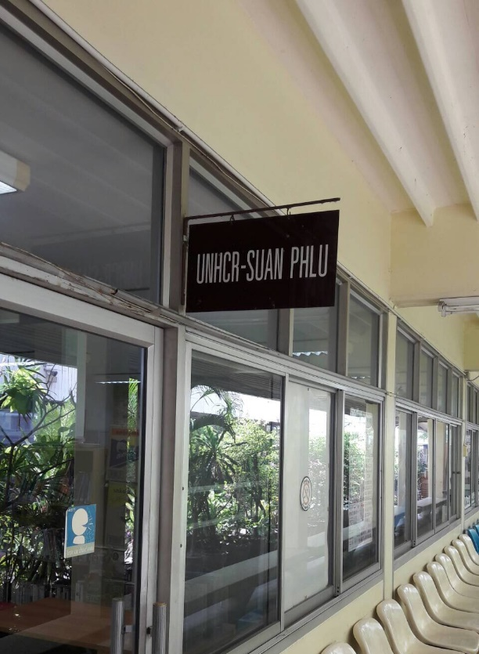
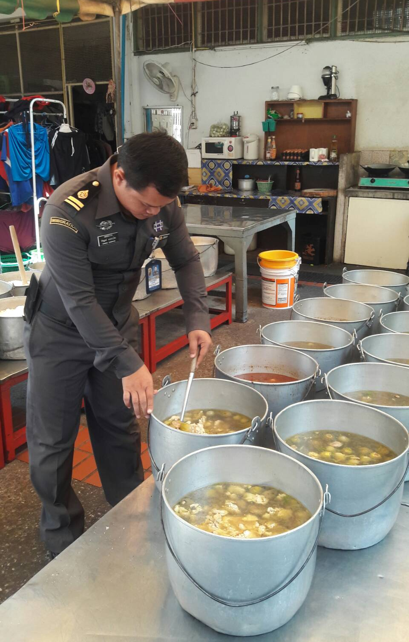
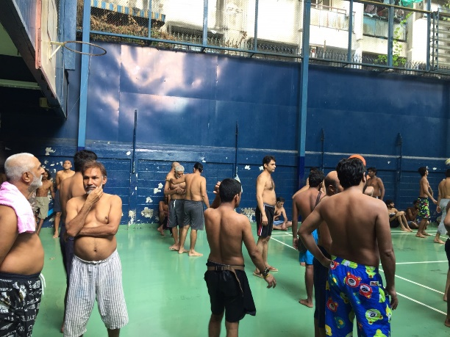
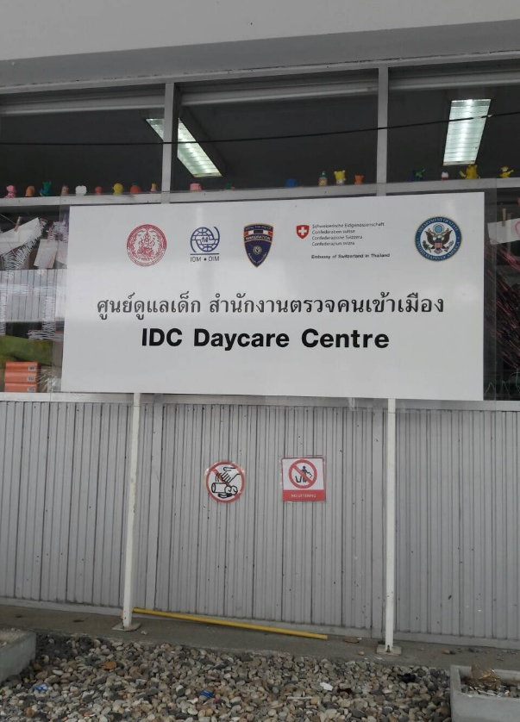
Photos from Suan Phlu Immigration Detention Center in Bangkok (taken on 14 March 2017)





