Committee of Defense of the Right to Self-determination
of Western Sahara People
and
Asociación Profesional de Abogados Saharauis en España

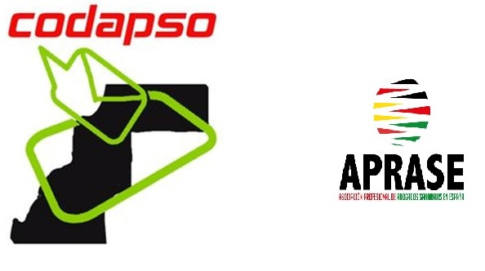

Written contribution / Shadow report
6th periodic review of the Kingdom of Morocco
United Nations Human Rights Committee 118th session

CODAPSO:
Contacto: 00 212 648192369 Info.codapso@gmail.com
APRASE:
Contacto: 0034 622 27 23 86 info@aprase.org CIF: G-87429270
C/ Río Esmeralda 4, Local 4, 28018 Madrid
Overview
1 The international legal status of Western Sahara is clearly defined by international law.
2 On 10/16/1975, the International Court of Justice (The Hague) stated that there was no tie of territorial sovereignty between the territory of Western Sahara on one hand, and the Kingdom of Morocco or Mauritania on the other hand. Therefore, the Court concluded that there was no legal ties able to modify the application of Resolution 1514 (XV) with respect to the decolonization of Western Sahara and, in particular, the principle of self-determination through the expression of the free and genuine will of the people of the territory.
3 After that, in a speech delivered the same day of the publication of the consultative opinion of the International Court of Justice, Morocco's King Hassan II, believing that "Everyone" has recognized that Western Sahara belonged to the Kingdom of Morocco and that Moroccans could occupy [their] territory ", called for the organization of a" peaceful march " to Western Sahara, which was attended by 350,000 people. Thus began the invasion of Western Sahara.
Article 1: Right to self-determination
4 Thirty-five years ago, in this same chamber, at the 14th session of the Human Rights Committee held on 27/10/1981, Mr. Ermacora, complained about the report submitted by Morocco, saying, "I regret that nothing is said about issues related to self-determination, especially with regard to Western Sahara ".
5 Unfortunately, today, thirty five years later, neither Morocco moved one millimeter in his position, nor the Committee has been able to convince this country to stop blocking the realization of this right for Saharawi people.
6 CODAPSO would recall an essential fact for understanding the overall question: "Morocco's presence in Western Sahara is the result of a fact that the international community has called "deplorable" (Resolution 380 of the Security Council 11/11/1975)".
7 It is difficult to believe that at present, the international community, through the United Nations Human Rights Committee, is waiting hopefully that Morocco would accept what he had already rejected in 1975.
8 Indeed, far from accepting the principle of self-determination, as enshrined in the scientific doctrine, the practice of States and international law, Morocco, aims to poison the concept of self-determination to validate his behavior in Western Sahara.
9 In its official statements, Morocco publicly says that it is not prepared to hold a referendum on self-determination and that the most it can offer is autonomy in the alleged sovereignty of the Kingdom. This official position is reflected in the reports of the Secretary General of the UN on Western Sahara.
10 CODAPSO insists to recall that already in 1974, when the UN was preparing the holding of the referendum on self-determination in Western Sahara, the options available were: remaining a part of the Kingdom of Spain or constituting ourselves as an independent State. The laxity of the international community made that, 40 years later, we are hearing that we are left no choice but to live within another kingdom, this time, the Kingdom of Morocco.
11 Since 1993, the United Nations Human Rights Committee has always emphasized, among its main concerns, the one on "issues of self-determination in Western Sahara." From this time, until today, the Human Rights Committee continues to be "concerned" about the issue.
12 For our part, the people of Western Sahara suffered, before that date of 1993, "denial of our basic rights, and submission to foreign domination", as taught resolution 1514 (XV) 1960 of the UN General Assembly. All this, without the Committee deign to adopt a condemnation of Morocco.
Article 16: The legal personality of every human being.
13 If the right to self-determination is to allow people to decide their future, its equivalent, at the individual level, is the right to legal personality, which allows people to develop their own personality. In Western Sahara, Morocco violates both the first and the second rights.
14 In Western Sahara, the system for naming people is a "tri-compound" system. In other words, at birth, is given a name to the new born, which is added to a first name that is the name of the father, then a second name which is the name of the grandfather. This system is also applied in Mauritania and has an authentically Arab origin. Thus, the Prophet of Islam is called Mohammed ibn Abdullah ibn Abdulmuttalib.
15 During the long century of Spanish colonization, this system remained intact. But in 1975, when Morocco and Mauritania divided and shared Western Sahara, the first country began to change the names of all persons remaining under his control. Mauritania did not need to do that, because it uses the same system.
16 Morocco proceeded to impose new names to all Saharawis under its control, violating the right to legal personality of the hole population. Instead of using his/her name, the name of his/her father and of his grandfather, Saharawis under Moroccan control were submitted to the system in force in Morocco, consisting of a first name and a unique (family) name.
17 In 1979, Morocco, after invading the Saharawi territory under control of Mauritania, had again made the same changes by imposing to the population of the new territory, new names. So today, the right to legal personality of all Sahrawis living under Moroccan control had been violated.
18 The outrage was so great, that for newborns, Moroccan authorities imposed new names, different from those used, and the system was changed so that, from that date, all new births were submitted to a new system, different from the naming system of their parents and grandparents³.
19 Although the assimilation of occupied territories and populations is an act prohibited by the Geneva Conventions, the Kingdom of Morocco had no qualms to assimilate the population of the occupied territory to the population of its territory. And so, it imposed the same system: first name plus family name, existing in Morocco.
20 Sahrawis who settled in refugee camps in southern Algeria, or in the diaspora, still continue today to use the system in force in Western Sahara since immemorial times.
21 Thus, by usurping the legal personality of all members of a population, the right to self-determination, as the power to decide by itself, loses its essence. What will determine Saharawis collectively, whether individually, many of them underwent a change of legal personality?
22 The population identification done by MINURSO (UN Mission for the Referendum in Western Sahara) to organize the referendum was accomplished according to the Saharawi traditional naming system. However, the population living under Moroccan control has a different name, comparing to the name reflected in the census of MINURSO.
23 The devastating effects of this violation reach all the Saharawi society and are harmful to the basic unit of any society: the family. We know, for example, that the High Commissioner for Refugees organizes family visits to Western Sahara, which allow families divided by wall and war to meet after 40 years of separation. But there is another element that separates these families that, unfortunately, the High Commissioner for Refugees cannot resolve: the difference of surnames among brothers. In other words, the enormous difficulties that many people will face to recognize their brothers, since their names were changed. Therefore, the United Nations Human Rights Committee is called to assist the High Commissioner for Refugees, in this regard.
Recommendations
24 Ensure full respect for the right of the Saharawi people to self-determination through a free, democratic and transparent referendum, including all possible options.
25 Ensure full compliance with the legal personality of Sahrawis, allowing them to retrieve the names they used before 1975.

1*. Paragraph 6 of the UN SG report on Western Sahara dated 10 April 2015 S/2015/246- P 6: On the 6 November 2014 anniversary of the 1975 “Green March”, King Mohammed VI stated that “the Sahara will remain part of Morocco until the end of time”. Regarding the negotiating process, he declared that “[t]he fact that Morocco chose to cooperate in good faith with all parties should not be interpreted as a sign of weakness; nor should it be used as a means to ask for more concessions”. He continued that “[t]he autonomy initiative is the maximum Morocco can offer … to achieve a final solution to this regional conflict”.
2*. A) Links of Spanish courts where appear names names of Saharawi members according to the Saharawi naming system: http://www.congreso.es/portal/page/portal/Congreso/Congreso/SDocum/ArchCon/SDHistoDipu/SDIndHistDip?_piref73_1340024_73_1340023_1340023.next_page=/wc/servidorCGI&CMD=VERLST&BASE=DIPH&FMT=DIPHXLDA.fmt&DOCS=1-25&DOCORDER=FIFO&OPDEF=Y&QUERY=%28250%29.NDIP. http://www.congreso.es/portal/page/portal/Congreso/Congreso/SDocum/ArchCon/SDHistoDipu/SDIndHistDip?_piref73_1340024_73_1340023_1340023.next_page=/wc/servidorCGI&CMD=VERLST&BASE=DIPH&FMT=DIPHXLDA.fmt&DOCS=1-25&DOCORDER=FIFO&OPDEF=Y&QUERY=%281750%29.NDIP. http://www.congreso.es/portal/page/portal/Congreso/Congreso/SDocum/ArchCon/SDHistoDipu/SDIndHistDip?_piref73_1340024_73_1340023_1340023.next_page=/wc/servidorCGI&CMD=VERLST&BASE=DIPH&FMT=DIPHXLDA.fmt&DOCS=1-25&DOCORDER=FIFO&OPDEF=Y&QUERY=%281760%29.NDIP. http://www.congreso.es/portal/page/portal/Congreso/Congreso/SDocum/ArchCon/SDHistoDipu/SDIndHistDip?_piref73_1340024_73_1340023_1340023.next_page=/wc/servidorCGI&CMD=VERLST&BASE=DIPH&FMT=DIPHXLDA.fmt&DOCS=1-25&DOCORDER=FIFO&OPDEF=Y&QUERY=%2816920%29.NDIP. http://www.congreso.es/portal/page/portal/Congreso/Congreso/SDocum/ArchCon/SDHistoDipu/SDIndHistDip?_piref73_1340024_73_1340023_1340023.next_page=/wc/servidorCGI&CMD=VERLST&BASE=DIPH&FMT=DIPHXLDA.fmt&DOCS=1-25&DOCORDER=FIFO&OPDEF=Y&QUERY=%2853380%29.NDIP. http://www.congreso.es/portal/page/portal/Congreso/Congreso/SDocum/ArchCon/SDHistoDipu/SDIndHistDip?_piref73_1340024_73_1340023_1340023.next_page=/wc/servidorCGI&CMD=VERLST&BASE=DIPH&FMT=DIPHXLDA.fmt&DOCS=1-25&DOCORDER=FIFO&OPDEF=Y&QUERY=%2873950%29.NDIP. http://www.congreso.es/portal/page/portal/Congreso/Congreso/SDocum/ArchCon/SDHistoDipu/SDIndHistDip?_piref73_1340024_73_1340023_1340023.next_page=/wc/servidorCGI&CMD=VERLST&BASE=DIPH&FMT=DIPHXLDA.fmt&DOCS=1-25&DOCORDER=FIFO&OPDEF=Y&QUERY=%28102760%29.NDIP. 2*. B) Link of the so called “Conseil Royale Consultatif pour les Affaires du Sahara “, a body established by the Kingdom of Morocco, where names of Saharawi people appear according to the system imposed by Morocco. 3*.- The enclosed document contains 5 examples that prove the original name included in the Spanish ID 1975; the modification of the name imposed by Morocco which appears in the Moroccan passport and the UN Commission document, where the original identity appears. Finally, the Spanish Police Certificate which confirms that the carrier of the Spanish ID is the same person that has the Moroccan passport. The Spanish ID. in which appears the identity of the bearer : Mustafa Aali Bachir. 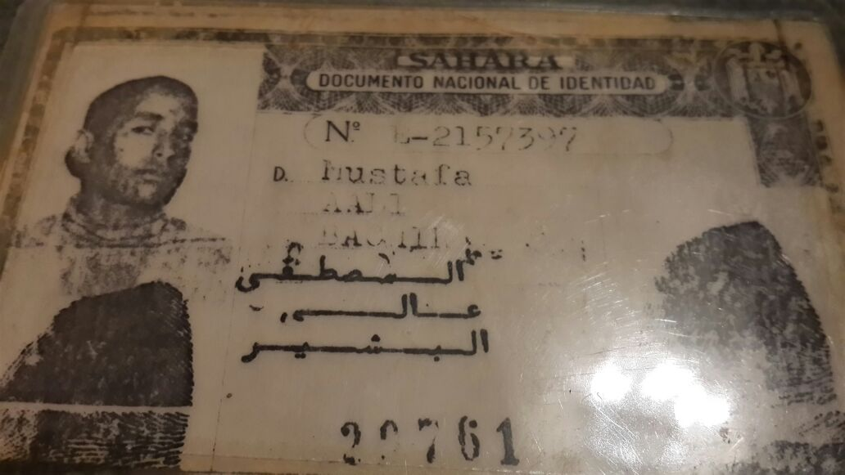 Reverse of the Spanish ID. 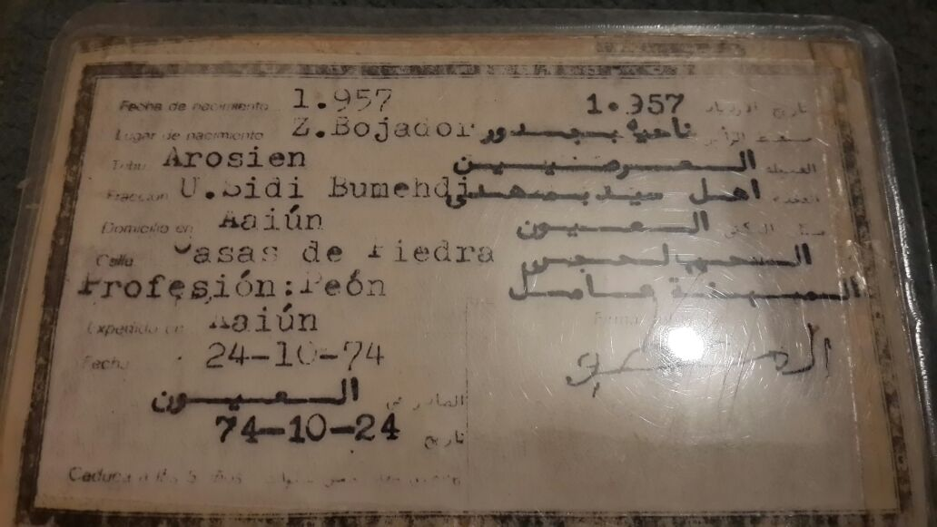 Moroccan Passport, in which the new identity is imposed. Dah Mustafa. 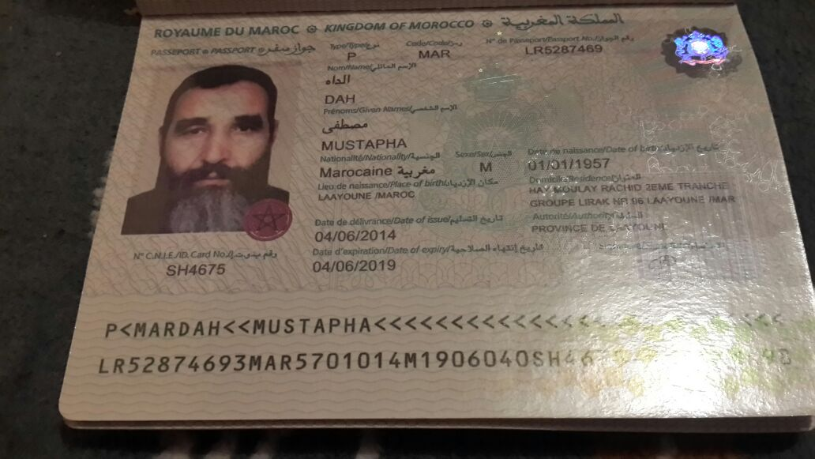 Below, the census document of the United Nations Mission for the Referendum in Western Sahara, which includes the identity of the person concerned appears. 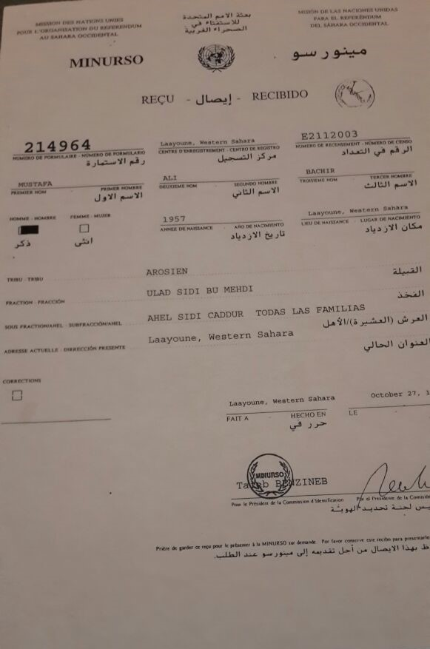 Certificate of Technical Operations Section of the Spanish Police on the review of the fingerprint certifying that the person called Aali Bachir Mustafa, in the Spanish DNI, is the same person, Dah Mustapha, in the Moroccan ID card. 

