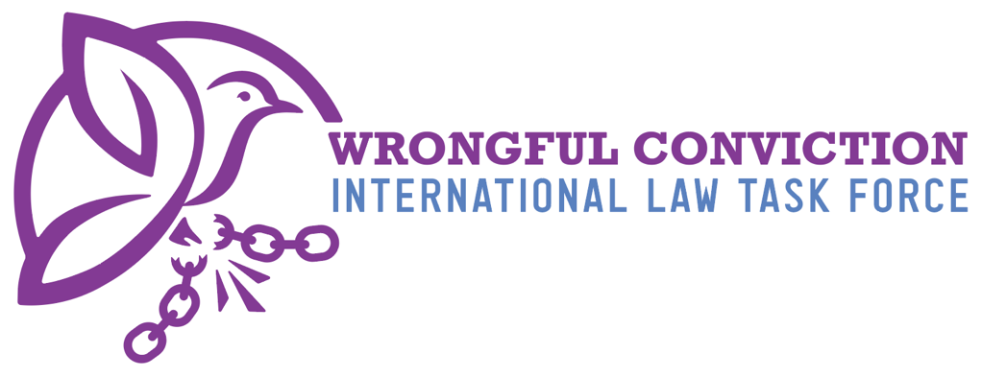

Concerning Latvia, for Consideration by the
United Nations Human Rights Committee
Submitted on May 26, 2025

- Authors
The Wrongful Conviction International Law Task Force (WCILTF) is a global coalition of law professors, attorneys and activists working together to fill the “Innocence Gap” in international law. The WCILTF is supported by a pro bono legal team at the international law firm Proskauer Rose (www.proskauer.com/) located in New York City.
In the past twenty-five years, wrongful conviction of the innocent has emerged as a major problem in criminal justice systems around the world. Research indicates that the problem has always existed but has only come to light in recent decades due to forensic advancements allowing for post-conviction DNA testing of crime scene evidence. Wrongful convictions occur because of human limitations in investigation and evidence collection, such as memory weaknesses and malleability (leading to misidentifications by eyewitnesses), unreliable or faulty forensic evidence, false confessions, confirmation bias or tunnel vision on behalf of investigators, inadequate defense lawyering, and many other human problems. Thus, wrongful convictions exist in all legal systems around the world, as all nations use the same types of evidence and investigation techniques regardless of the precise legal procedures employed in their courtrooms.
NGOs called “Innocence Projects” have sprung up around the globe to combat this problem, and now entire networks of innocence projects exist in Asia, Europe, North America and South America. Innocence Projects are often housed at law schools and are operated by law professors and law students. In one member state, for example, more than 3,000 innocent people have been released from prison in recent years due to the work of NGOs like Innocence Projects. Exonerations of the innocent have occurred across the globe in the past three decades.
For a brief video overview of the global problem of wrongful convictions, and the efforts of Innocence Projects to combat the problem, please view: https://youtu.be/jMATkuFaRU8?si=fO0wXGhPr-oCyhBA
As the innocence movement has developed a global presence in recent years, it has become apparent to legal scholars that an “Innocence Gap” exists in international law. The WCILTF formed to combat this problem and help fill the Innocence Gap. The WCILTF is comprised of more than twenty-five law professors and Innocence Project leaders from across Asia, Europe, North America and South America.

- Filling the Innocence Gap
Due to the relatively recent discovery of wrongful convictions, international law covenants and treaties predate awareness of this problem and thus do not speak directly to issue. In recent years, however, the United Nations Human Rights Committee (HRC) has identified key rights to the benefit of incarcerated person claiming innocence to be derived from the right to a fair trial and other existing rights. For example, in Abdiev v. Kazakhstan, 2023, the HRC stated that the right of incarcerated persons to re-open a criminal case in order to present new evidence of innocence after conviction and appeal have concluded, in order to achieve exoneration and freedom, is essential to the right to a fair trial under Article 14(1) of the ICCPR. Similarly, on October 3, 2023, in Concluding Observations on the Fifth Periodic Report of the Republic of Korea, the HRC observed that South Korea should “provide adequate legal and financial assistance to enable individuals sentenced to death to re-examine convictions on the basis of newly discovered evidence, including new DNA evidence.”
Likewise, on July 25, 2024, in Concluding Observations on the Second Periodic Report of Maldives, the HRC expressed concern “about the lack of information on the existence of a procedure enabling individuals sentenced to death to seek a review of their convictions and sentences based on newly discovered evidence of their innocence, including new DNA evidence, and, if wrongfully convicted, to provide them with compensation.” The HRC recommended that Maldives take all necessary measures to ensure that “death sentence can be reviewed based on newly discovered evidence of their innocence, including new DNA evidence, adequate legal and financial assistance is provided to enable this review and, if wrongfully convicted, individuals have access to effective remedies, including compensation” para. 28(e). See Brandon Garrett, Laurence Helfer and Jayne Huckerby, Closing International Law’s Innocence Gap, S. Cal. L. Rev. 95 (2021), available at: https://papers.ssrn.com/sol3/papers.cfm?abstract_id=3803518#

- Rights of Innocent Incarcerated Persons in Latvia
Post-Conviction Petition Based on New Evidence
Based on our research, it appears that Latvia has post-conviction revision based on new evidence. When filing an appeal, the defendant must indicate the kind of evidence being presented and why the evidence was not submitted in the first proceeding (Latvia Criminal Code §551). Additionally, cases may be reopened for newly discovered circumstances, which may include the false testimony of a witness or expert, or falsification of material or other evidence that served as the basis for the adoption of the unlawful decision (§655). The time limit for these appeals remains unclear. (§656). It appears that there may have been one successful motion in the Supreme Court of Latvia, quashing a conviction due to new evidence submitted by the defense (Criminal Case No. 1840002002).
However, this seems to be the extent of the post-conviction evidentiary rules. In our research, we were not able to find any law allowing for incarcerated persons to petition for DNA testing of crime scene evidence to prove their innocence. The Latvia Criminal Code does not discuss biological evidence or DNA in any sense. Even the preservation of material evidence, which potentially could include biological evidence, does not have a pre-determined length of time for preservation. According to the criminal code, the prosecutor can choose what is to be done with this material evidence when the case ends (§240). This is highly problematic.
Latvia should create rules allowing access to DNA testing and the preservation of key evidence from trial, including biological material.
Lack of Public Record Language
Our research indicates that Latvia has a Freedom of Information Law (FOIL). FOIL has a stated purpose of ensuring the public has access to information. However, it does not specifically include criminal cases. Indeed, Article 12 of the Criminal Code says that official criminal proceedings carry an obligation of privacy.
Latvia should allow post-conviction access to police investigation files so that innocence projects and interested parties may review police work and uncover possible wrongful convictions.

Other lapses in best practices
Our research indicates that Latvia does not follow rules designed to reduce wrongful convictions or discover and overturn wrongful convictions that have already occurred. Specifically, these lapses include:
- No rule requiring pre-trial police or prosecutorial disclosure of exculpatory or favorable information to the defense.
- No rules or procedures requiring police to make an audio or video recording of police interrogations of suspects from beginning to end; and
- No rules of procedures regarding eyewitness identifications that ensure investigators use the most accurate “best practices” to increase accuracy and reduce the risk of misidentification. See https://www.ojp.gov/ncjrs/virtual-library/abstracts/double-blind-sequential-police-lineup-procedures-toward-integrated

This document created by the following members of the WCILTF:
Name, title, email address of the individuals and Proskauer attorneys who worked on this
To contact the WCILTF generally, please email:
Prof. dr. mr. G.J. Alexander Knoops. Professor Mark Godsey
Advocaat/Attorney at law University of Cincinnati College of Law
Professor Politics of International Law Director, Ohio Innocence Project
alex@knoopsadvocaten.nl markgodsey@gmail.com

