Palestine - Follow-up Dialogue about the situation of persons with disabilities affected by armed conflict in Gaza and the West Bank.

Date: 4 July 2025
Submitted by: Stars of Hope Society
Session: Public Session
Title: Women and Children with Disabilities During the Genocidal War in Palestine

ABOUT STARS OF HOPE SOCIETY:
Stars of Hope Society (SHS( is a Palestinian DPO founded in 2007 to advocate against all kinds of bias against women with disabilities. SHS emerged due to discrimination and bias against women with disabilities, stemming from their dual identities as women and women with disabilities. SHS aims to meet the needs of women with disabilities to access their rights. Since its establishment, the association has devoted all its efforts to raising public awareness of the rights and requirements of women with disabilities, in addition to advocating for disability issues at various levels.
SHS is proudly and intentionally led by women with disabilities, who make up 100% of the General Assembly and the Board of Directors. This leadership model is not merely symbolic-it is a strategic and transformative framework that places rights-holders at the core of governance, decision-making, and accountability.
SHS’s organizational structure embodies its feminist, participatory, and rights-based approach to inclusion and social change. The composition and functioning of the team are designed to ensure that those most affected by exclusion are the ones shaping the response.

INTRODUCTION:
For nearly 76 years, Palestinians have been subjected to systematic violence by the Israeli occupation, which has employed all forms of violence, including direct killings, forced displacement, land confiscation, apartheid, siege, and starvation. Most recently, the occupation is committing a genocide in the Gaza Strip, alongside a sharp escalation of its violations in the West Bank.
During this period, Palestinians have been facing catastrophic conditions, including the denial of all necessities of life due to the siege imposed by the Israeli occupation and the prevention of humanitarian aid from entering Gaza. At the same time, the majority of the population in the Gaza Strip has been displaced. Meanwhile, many homes in the West Bank have been demolished, and the occupation has stormed numerous refugee camps and displaced their residents. This has been accompanied by a daily expansion of military checkpoints and ongoing land confiscation.

In these dire circumstances, persons with disabilities and particularly women with disabilities and children are experiencing extremely difficult and compounded conditions, facing multiple and intersecting challenges. This report aims to critically examine the impact of the ongoing genocide on persons with disabilities in the Gaza Strip and the West Bank, with a specific emphasis on women and children with disabilities.

GENERAL CONTEXT:
Since 1948, Palestinians have endured systemic displacement, loss of land, fragmentation, and denial of national rights. The Nakba initiated a structure of ongoing occupation, apartheid, and dispossession. In the 1990s, the Oslo Accords granted Palestinians very limited self-rule embodied in the Palestinian Authority, while the occupation had full control of all economic and political structures. The Palestinian Authority’s reliance on Western funding has contributed to weakening economic development due to the conditions and restrictions imposed by donors. This funding was linked to Western liberal policies that undermined the institutions' ability to achieve genuine development. Consequently, this led to increased marginalization of the most marginalized groups, such as persons with disabilities, especially in light of the shift toward a market economy and the weakness of social protection programs.
The Occupation continues to isolate Palestinians from each other through a territorial division and a stifling siege, which is imposed by establishing a group of settlements, military checkpoints, and the apartheid wall since 2002, which increased land confiscation and reinforced the division of the West Bank, leading to the fragmentation of Palestinian society. For over 75 years, the Palestinians experienced a great catastrophe marked by the forced displacement of hundreds of thousands from their lands and villages, and the destruction of hundreds of Palestinian villages a tragedy whose effects are still felt to this day. Palestinians suffer from deep geographical and social isolation as a result of territorial division and a stifling siege, enforced by the Israeli occupation through a vast network of settlements, military checkpoints, and the apartheid wall. The West Bank is fragmented into isolated areas surrounded by settlements, connected by settler-only roads that Palestinians are not allowed to use.
Israeli occupation practices multiple forms of systematic violence against Palestinians, including deliberate killings, house demolitions as a policy of collective punishment, and causing serious bodily injuries that result in permanent disabilities. This system severely restricts freedom of movement and prevents natural interaction between Palestinian towns and villages, while also isolating residents of Jerusalem from the rest of the Palestinian territories. As for the Gaza Strip, it has been under a comprehensive blockade since 2007, imposed by Israel by land, sea, and air. This has led to a severe humanitarian crisis, including shortages of electricity, water, medicine, and necessities and strict restrictions on travel and movement. Meanwhile, the Gaza Strip today is facing genocide and a strict siege aimed at killing and starving its people.
Palestinians are currently experiencing a dire reality in the Gaza Strip and the West Bank because of the ongoing massacres and the genocide committed by Israeli occupation since October 7, 2023. So far, there have been 56,991 martyrs and 138,259 injured Palestinians since the start of the genocide war on the Gaza Strip, and these numbers are expected to increase daily as the war continues. The continuous bombardment and the deliberate denial of access to food, water, medicine, and energy, as the occupation prevents the entry of humanitarian aid into the Gaza Strip until now led to catastrophic conditions.
Marginalized groups, including persons with disabilities, are suffering from even more severe and complex conditions amid the large-scale destruction of infrastructure, ongoing shelling and killings, and the deprivation of basic necessities such as food and water. The continuous bombardment has led to the loss of assistive devices and caregivers for persons with disabilities, posing a grave danger to their lives, especially during evacuations and displacement. They are currently facing disastrous conditions in shelters and tents, which lack even the minimum standards of accessibility. While the denial of access to medicine and health services has resulted in the worsening of existing disabilities and the emergence of new ones, especially given the systematic targeting by the occupation of health institutions, as well as civil society organizations including the rehabilitation sector.
The targeting of infrastructure, including hospitals, rehabilitation centers, and schools, constitutes a blatant violation of international law. Its impact is catastrophically amplified on marginalized groups, those who are already excluded from even the most basic forms of protection and care.
The Genocidal War on Gaza has coincided with a significant escalation in the West Bank, particularly in the northern areas. From the beginning of the genocidal war on Gaza the occupation escalated its violations against Palestinians in the West Bank, with the number of 6700 injured, and martyrs reaching 993, including 176 children, Among them were several martyrs killed by settlers, as well as the killing prisoners under torture.
The occupation also intensified its arrest campaigns, with the number of prisoners reaching nearly 18700 since October 7th. The occupation worked to isolate all the governorates of the West Bank from each other, imposing a large number of closures, as well as reinforcing military checkpoints and inspection campaigns.
Recently, more than 40,000 people have been displaced from refugee camps, most of them from the areas of Jenin, Tulkarm, and Tubas. The Jenin and Tulkarm governorates and their camps have experienced the highest levels of violations and large-scale displacement.

The raids carried out by the occupation have become almost daily in several Palestinian cities, villages, and camps, witnessing severe campaigns accompanied by bombings and demolitions of houses, as well as the destruction of streets, infrastructure, and homes, along with arrests, abuse, killings, and closures. These have had a severe impact on persons with disabilities, who face compounded challenges during times of war and emergencies.

DISABILITY AND COLONIALISM IN PALESTINE:
From the very beginning, the occupation has deliberately worked to annihilate all forms of life in the Gaza Strip, including the most vital sectors, hospitals, displacement centers, educational institutions, and service providers of all kinds. As the war continues, the means of survival for Palestinians in the Gaza Strip are rapidly diminishing, becoming nearly nonexistent for marginalized groups amid the collapse of basic life necessities such as food, water, and medicine. This is particularly true for persons with disabilities, whose numbers are expected to rise significantly due to the war.
Persons with disabilities in Palestine already face movement restrictions due to a lack of inclusive infrastructure, weak social protection systems, and limited access to sustainable empowerment opportunities. These constraints have worsened dramatically since the beginning of the war on Gaza. With the massive destruction of life-sustaining infrastructure, persons with disabilities have lost what limited environmental adaptations were available prior to the war, significantly increasing their risk of death either directly through bombing or indirectly through starvation, lack of medication, and the absence of rehabilitative and therapeutic services, which are now nearly non-existent in the Strip. A large number of individuals have also lost their assistive devices, making it even more difficult for them to move, access any services, or escape indiscriminate attacks.
During the First Intifada, the Israeli occupation escalated its assaults on civilians, various sectors, and Palestinian civil institutions, leading to more than 80,000 injuries, including approximately 15,000 individuals who sustained permanent disabilities. At that time, the national healthcare system lacked the capacity to handle the large number of injuries and disabilities, which resulted in serious health complications for many.
In the current war on Gaza, the occupation is systematically destroying all forms of life in the Strip. It is deliberately killing civilians, inflicting targeted injuries, and causing permanent disabilities—reproducing the same conditions experienced during and after the First Intifada, but on a far larger and more devastating scale, reaching the level of genocide. So far, over 70,000 people have been injured, with many expected to suffer long-term disabilities. By targeting hospitals and vital institutions across Gaza, the occupation is further increasing the number of disability cases and the severity of complications due to the lack of access to essential medical and rehabilitative services.
The occupation’s creation of disabilities weakens the Palestinian economy and increases poverty, especially as many persons with disabilities face barriers to employment and need family caregivers, limiting workforce participation. Due to weak social protection, families often bear the heavy costs of disability, deepening poverty and impacting the overall economy. These costs are long-term, continuing to affect Palestinian society even if initial aid is provided.

PERSONS WITH DISABILITIES IN PALESTINE DURING THE GENOCIDE:
According to the Palestinian Central Bureau of Statistics (PCBS) data from 2017, the percentage of individuals with at least one difficulty, based on the wide definition of disability, was about 6% in Palestine 7% in the Gaza Strip, and 5% in the West Bank. Among them, 6.2% were males and 5.3% were females. According to the narrow definition of disability, the percentage of persons with disabilities in Palestine was 2% of the total population. with 2% in the West Bank and 3% in the Gaza Strip, this percentage has significantly increased recently in the Gaza Strip due to the substantial rise in the number of injured people during the genocide. The PCBS indicates that already in Palestine, the occupation actions and the wars on the Gaza Strip caused at least one disability in about 6% of individuals aged 18 and over, with 8% in Gaza compared to 4% in the West Bank.
In general, Persons with disabilities (PWD) are among the most marginalized and impoverished groups in Palestine. They face systemic exclusion from basic rights and essential services, including healthcare, education, protection, and employment.
Persons with disabilities are subjected to marginalization and exclusion from the system of rights in general, including fundamental rights, most importantly, the right to work. They face various barriers that prevent them from enjoying these rights, which are among the essential pillars of social justice, especially due to their close connection with poverty. The absence of such rights increases poverty levels, which in turn weakens the framework of social justice.
The barriers faced by PWD include social obstacles manifested in practices that contribute to their exclusion and exploitation, as well as institutional, legislative, and policy-related barriers. Current legislation and policies remain inadequate and non-inclusive of the rights of PWD, leading to their exclusion from accessing their basic rights and exposing them to various forms of exploitation and violence (whether actual or symbolic violence).
PCBS data indicate that 37.6% of persons with disabilities aged 15 and over have never enrolled in education, 33.8% dropped out, and 53.1% are illiterate. These factors affect their labor market participation, which does not exceed 22.3%, highlighting the importance of empowering them in education and employment. For example, the unemployment rate among persons with disabilities is approximately 37% (Those who are willing to work and actively seeking employment).
Women with disabilities (WWD) are subjected to compounded violence and exclusion, as they experience discrimination both as women and as women with disabilities. The Convention on the Rights of Persons with Disabilities indicates that women and girls with disabilities are often at greater risk of experiencing violence, abuse, neglect, mistreatment, and exploitation, whether at home or in public spaces. This intersectional marginalization further increases the likelihood of women with disabilities being subjected to violence and exploitation in all its forms, A 2019 national survey found that 37% of women with disabilities who are married or formerly married experienced at least one form of violence by their husband within the past year. Their voices and needs are often ignored in both mainstream gender services and disability-specific interventions.
Women with disabilities face significant difficulties accessing the labor market, similar to other persons with disabilities, but their challenges are compounded. According to the PCBS, only 2% of women with disabilities participate in the Palestinian labor force. These difficulties stem from institutional, environmental, and cultural barriers that limit their ability to enter the labor market, in addition to their limited access to education.
All these difficulties have now been compounded during the war, and persons with disabilities are in urgent need of even the most basic necessities, including water, food, and medicine. In a comprehensive survey conducted by the Stars of Hope Society and the Social and Economic Policies Monitor on the situation of persons with disabilities in the West Bank and Gaza Strip, which included nearly 900 participants, the following Preliminary findings emerged regarding violations by the Israeli occupation against PWD in Gaza and West Bank:
- 92% of respondents were unable to access food.
- 80% were unable to access medications and medical supplies.
- 45% reported that their homes were completely destroyed.
- 38% said their homes were partially destroyed.
- 24% stated that the occupation confiscated their homes and forced them to evacuate.
- 22% experienced the loss of one or more family members.

Moreover, 21.2% of respondents reported a loss of access to medications and healthcare services, while 13.6% mentioned experiencing violations in displacement locations. Additionally, 11% lost their assistive devices, and 12.7% stated that they were unable to evacuate due to their disability. At the same time, 94% confirmed that they had not been contacted by any organization or authority. Regarding their urgent needs, 29% identified medications as a priority, followed by assistive devices, 28%.
WOMEN WITH DISABILITIES DURING THE GENOCIDE:
In the Palestinian context, the intersectionality experienced by women with disabilities is shaped by the overlapping forms of discrimination and oppression they face, based on gender, disability, and the colonial context. WWD are affected by a cultural and social environment that limits their access to services and opportunities, particularly in the absence of inclusive policies that address their diverse needs. This marginalization is further exacerbated in environments lacking accessible infrastructure and adequate social support, restricting their independence and limiting their participation in public life.
Moreover, the Israeli occupation intensifies these challenges through restrictive policies and systematic violence that directly impact women with disabilities as Palestinians. Restrictions on movement, destruction of infrastructure, and the lack of basic services all contribute to deepening their social and economic isolation. From an intersectional perspective, understanding the reality of women with disabilities in Palestine requires recognizing the structural factors that reinforce exclusion, including occupation, gender-based discrimination, and the absence of social justice and social protection.
The consequences of this war have had a compounded impact on women, particularly women with disabilities, especially amid the lack of essential hygiene supplies and the absence of healthcare services, including SRH services. These challenges are further exacerbated by overcrowding and the loss of family breadwinners during the war.
- Gaza Strip:
Women with disabilities in Gaza have faced deeply personal challenges during displacement, especially concerning their dignity, hygiene, and reproductive health. The lack of accessible sanitation facilities in shelters has severely impacted their ability to manage basic needs. This situation is particularly distressing during menstruation, when privacy and hygiene become even more critical. Many women have been forced to adopt coping mechanisms that compromise their health, such as using birth control pills to delay or stop their periods due to the absence of menstrual hygiene products and clean, accessible bathrooms.
The consequences of this war have a compounded impact on women, particularly women with disabilities. This is especially true amid the absence of basic hygiene supplies, the collapse of health services, including sexual and reproductive healthcare, overcrowding, and the loss of family breadwinners during the war. On top of that, many have been forced to live in tents that do not meet even the most basic requirements for safe living and are completely lacking in accessibility for women with disabilities.

According to the survey previously mentioned about the situation of PWD, 85.9% of women with disabilities reported that their area was subjected to almost daily shelling, while 16.3% stated that their area was bombed multiple times during the war. Additionally, 45.2% reported that their homes were completely destroyed, and 38.9% said their homes were partially destroyed. Regarding the intensity of the bombardment, 72.1% described it as extremely intense, while 18.3% said it was intense.
As for the violations experienced by the women and their families, 82.2% reported being unable to access medications and medical supplies, and a staggering 95% said they could not access food.
In terms of displacement, 21.7% reported the loss or martyrdom of one or more family members. 17.2% had their homes confiscated and were forced to evacuate. Furthermore, 23.2% indicated that one or more family members were injured, while 5.2% stated that one or more family members acquired a new disability as a result of injuries. The Following Chart illustrates this:
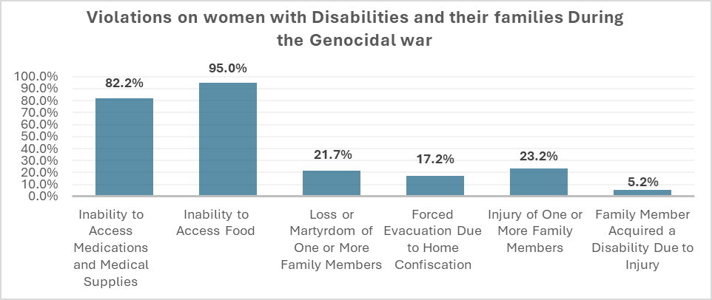
In addition to all of this, the sexual and reproductive health of women with disabilities has been affected. There is a severe shortage of water in the shelters, which further worsens the suffering, making it difficult for people to maintain basic hygiene. One woman with a disability said: "We are staying in a school where water is extracted from the well once a day using solar power. Not everyone can access it, as water is available for only a limited number of hours." One woman with a disability said, “I couldn't shower during or after my menstrual period because the school bathroom was not accessible.” Another added: “Many women are taking birth control pills due to the lack of hygiene supplies.”
This reality was confirmed by Iyad Krunz, Director of the Stars of Hope Society office in Gaza, in an interview where he stated: "Sometimes tents are not even available, forcing women to stay in public spaces and open courtyards. When tents are available, they are extremely overcrowded, often housing more than 15, and sometimes up to 30, people in a single tent. These tents are usually set up on sandy ground, which is not suitable at all for the movement of persons with disabilities. Even when assistive devices are available, they become ineffective due to the lack of accessibility. In addition, there is a severe shortage of water and bathrooms, which are not adapted for persons with disabilities and are located far from the tents all of this multiplies the suffering of persons with disabilities during the war."

At the same time, the occupation has been targeting all vital sectors and service-providing institutions. Since the beginning of the war, many institutions working in the disability sector have been either completely or partially destroyed. These institutions provide essential rehabilitative and occupational therapy services, as well as assistive devices. They are among the few organizations that have access to databases and information on persons with disabilities and their locations.

With the destruction of these institutions and most of them ceasing operations, it is estimated that approximately 118,000 persons with disabilities have lost complete access to services, while 38,000 have lost partial access. In the context of poverty and limited access to basic needs, the closure of these institutions, which many persons with disabilities rely on as a lifeline, has further exacerbated their suffering and significantly diminished their chances of survival during the war.
The following chart shows the Urgent Needs of Persons with Disabilities including Women with Disabilities as mentioned during the Genocidal war (Gaza Strip and West Bank):
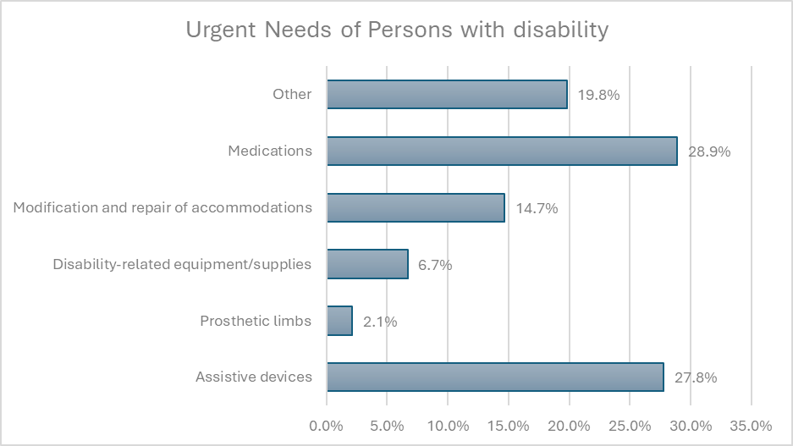

Children, and particularly children with disabilities, are among the most marginalized and most affected groups during wars. Currently, children in the Gaza Strip are living under extremely harsh and catastrophic conditions amid the genocide being carried out by the occupying forces. According to the Palestinian Ministry of Foreign Affairs, 700,000 Palestinian children are currently deprived of access to education. Additionally, 15 children per day in Gaza are reported to be acquiring permanent disabilities as a result of the occupying forces’ use of internationally prohibited weapons.

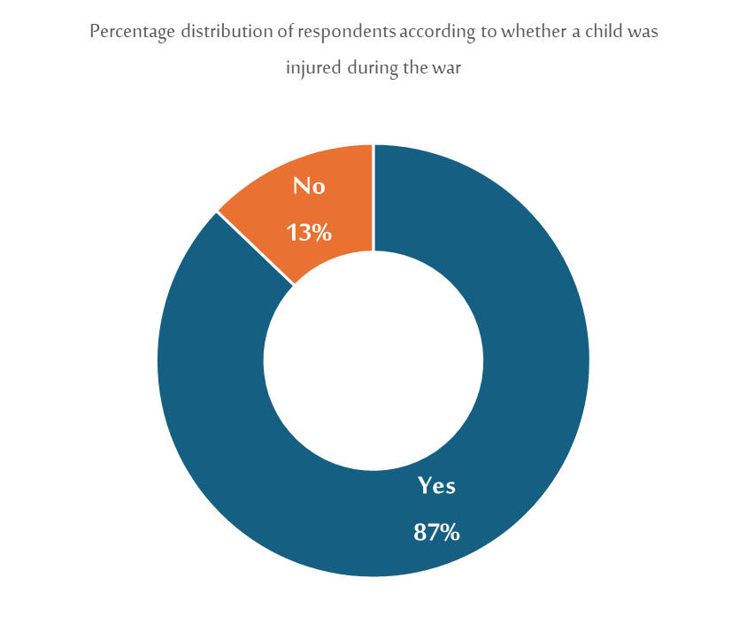
Preliminary results of a survey conducted by the Stars of Hope Society and the Social and Economic Policies Monitor (Al Marsad) regarding the reality of children with disability in light of the genocidal war on the Gaza Strip indicate the following:

- 87% of surveyed children were injured during the war, while 75% of surveyed children had no previous injuries before the war.
- 36% of surveyed children developed new injuries as a result of the war.
- 7% of the surveyed children had previous disabilities and developed a new disability due to the war.

In a recent survey, the number of unaccompanied children separated from their mother, father, or both during the genocidal war in Gaza reached 136 out of a total of 325 children included in the sample, representing 41.8% of the total. The reasons for this included martyrdom, travel abroad for medical treatment, or being reported missing. This situation significantly impacts the well-being of the children, especially as they are either children with disabilities or children who are injured. It increases the likelihood that they will not receive adequate care in general, including proper healthcare, which may lead to an injury developing into a disability or to a worsening of a pre-existing disability. This makes these children more vulnerable to challenges both during war and in the long term.

West Bank:
The most prominent violations faced by women with disabilities in the West Bank were the loss of income sources, as 81.3% confirming that their households lost their primary sources of income. Additionally, 14.1% reported that their homes were raided and their property damaged, while 14% stated that they were subjected to direct violence by the occupation. The displaced women who participated in the survey were distributed according to their place of residence after displacement as follows: 37.1% in a relative’s home, 5.7% in a tent or shelter center, and 54.2% in a rented house.

Most displaced persons have moved further away from essential centers, increasing transportation costs, especially since accessible transport options are unavailable. Many participants reported that road demolitions by the occupation severely hindered their mobility before and during displacement, restricting access to workplaces, educational facilities, and other services. Some also described lacking basic necessities during this period, including water and electricity, compounded by direct violence from the occupation.

Several participants shared that during the incursions, their homes were turned into military barracks where they were forced to stay with soldiers, who denied them access to basic needs such as water, food, and sanitation. One woman recounted being left outside in the cold after soldiers ate their food and slept on their beds.

A father of a child with an intellectual disability described how the child experienced extreme fear and insomnia during the incursions due to bombings, prompting multiple relocations to relatives’ homes for protection. Others mentioned psychological distress caused by the invasions and ongoing threats. Women with physical disabilities faced daily mobility challenges even before displacement. One woman reported difficulty moving in the camp during rainy weather, falling multiple times, and needing assistance.

Displacement and destruction of infrastructure created significant challenges for persons with disabilities, especially those reliant on assistive devices. Among surveyed women with disabilities, 30.5% used assistive tools, but 8.7% reported currently lacking the aids they previously had. Some devices were damaged or destroyed, including one woman’s visual disability, confiscated and broken by soldiers, which impeded her education.

Most displaced PWD had to leave their assistive devices behind during evacuation. Some visually disability participants could not retrieve their tools due to home demolitions. The destruction of roads and infrastructure forced many to travel on foot without their assistive devices.

Currently, many live in homes unsuitable for their disabilities. A visually disability woman said she used to move comfortably in her old home, but now, with a destroyed assistive device and an inaccessible house, she suffers injuries from collisions. Another participant with a physical disability struggles to access the fourth floor of her current residence. Most participants, especially those with complex physical and cognitive disabilities, faced significant difficulties during evacuation and movement. Persons with cognitive disabilities, in particular, require family members to carry them during the evacuation, especially those with combined cognitive and physical disabilities. One caregiver stated: "I left some of them with relatives and returned another day to bring them, while I managed to evacuate two of them with great difficulty in a car amid heavy incursions, gunfire, and aerial bombardment".

GENERAL RECOMMENDATIONS:
- There is a pressing need to advocate for the cessation of the genocide in the Gaza Strip and the escalation in the West Bank.
- Advocate for the immediate, sustained, and unconditional entry of humanitarian aid into Gaza, with a focus on addressing the specific needs of persons with disabilities, especially women and children, in all stages of relief efforts and services, including SRH.
- Palestinian institutions must be included in all international programs and not marginalized as in the current case.
- International bodies and donors should provide unconditional funding to support the resilience of Palestinian institutions and refrain from restricting their work.
- Implement proactive emergency plans and unconditional funding, drawing from the current experience in the West Bank and Gaza Strip, while considering providing comprehensive services to marginalized families in these areas, taking into consideration the needs and requirements of persons with disabilities.

“The Occupation Continues to Escalate in the West Bank: Raids and Abuse of Palestinians,” Al Mayadeen, accessed July 4, 2025, website: https://www.almayadeen.net/news/politics/الاحتلال-يواصل-التصعيد-في-الضفة--اقتحامات-وتنكيل-بالفلسطينيين.
Eileen Kuttab et al., The Illusion of Development: A Critical Assessment of the Palestinian Development Discourse (Ramallah: Bisan Center for Research and Development, 2010).
For More Details, Visit the Following link: https://www.palestine-studies.org/ar/node/1656288.
Ibid.
The Palestinian Central Bureau of Statistics, status last update (6/27/2025). Website: https://www.pcbs.gov.ps/.
The Palestinian Central Bureau of Statistics, status last update (6/27/2025). Website: https://www.pcbs.gov.ps/.
“Dozens Martyred Under Torture and Testimonies About Violations in Occupation Prisons,” Al Jazeera, accessed July 4, 2025, https://www.aljazeera.net/news/2024/6/20/استشهاد-العشرات-تحت-التعذيب.
Ibid.
Humanitarian Situation Update #264 | West Bank (5 February 2025). Website: https://n9.cl/9wlevh.
A War Without Human Rights: Cutting Off All Means of Survival: Organizations Working in the Field of Disability in Light of the Genocide (Ramallah: Stars of Hope Society for the Empowerment of Women with Disabilities and the Social and Economic Policies Monitor, 2024)
For more visit the Following Paper: https://n9.cl/qijeh.
Wide definition: Includes any difficulty in movement, vision, hearing, speech, understanding, or daily activities, whether mild or severe. Narrow definition: Focuses on severe disabilities that significantly limit daily functioning and require specialized support.
Characteristics of Individuals with Disabilities in Palestine (Ramallah: Palestinian Central Bureau of Statistics, 2017).
“Palestinian Central Bureau of Statistics issues a press release on the occasion of the International Day of Persons with Disabilities, 12/03/2019.” Palestinian Central Bureau of Statistics (December 3, 2019). Online link: https://n9.cl/go3ps
Palestinian Central Bureau of Statistics, “Press Release on the International Day of Persons with Disabilities,” December 3, 2019, https://n9.cl/go3ps.
Palestinian Central Bureau of Statistics, “Press Release on the International Day of Persons with Disabilities,” December 3, 2019, https://n9.cl/go3ps.
Unpublished Research: Preliminary Results of the Survey on the situation of Persons with Disabilities During the Genocidal War on Gaza and the West Bank (Ramallah: Stars of Hope Society for the Empowerment of Women with Disabilities and Social and Economic Polices Monitor Al-Marsad, 2025).
Ibid.
Ibid.
A War Without Human Rights: Conditions of persons with disabilities in Shelters in the Light of the Forced Displacement (Ramallah: Stars of Hope Society and The Social and Economic Monitor Al-Marsad, 2023).
A War Without Human Rights: Ethnic Cleansing through Weaponizing Food, Water and Medicine (Ramallah: Stars of Hope Society and The Social and Economic Monitor Al-Marsad, 2023).
Interview with Iyad Karanz, Director of the Stars of Hope Society Office in the Gaza Strip, conducted on January 21, 2024.
A War Without Human Rights: Cutting Off All Means of Survival: Organizations Working in the Field of Disability in Light of the Genocide (Ramallah: Stars of Hope Society for the Empowerment of Women with Disabilities and the Social and Economic Policies Monitor, 2024)
For More Data on this, Visit the following link: https://n9.cl/13i22.
Unpublished Report: Children with Disabilities in Gaza Strip During the Genocidal War (Ramallah: Stars of Hope for the Empowerment of Women with Disabilities and the Social and Economic Policies Monitor, 2024)
Visit the following link to see the full infographic: https://n9.cl/e1gl4c.
Hala Ali, Fact Sheet: Women with disabilities and families of persons with disabilities in the northern West Bank: Displacement and ongoing violations! (Ramallah: Stars of Hope Society, 2025).
Ibid.
Ibid.
Ibid.
Ibid.
Ibid.

