Representation of Palestinian Citizens in Israeli Schoolbooks
Prof. Nurit Peled-Elhanan
Hebrew University
Sakharov Prize Laureate

Israeli school books teach not about the state of Israel but about the Land of Israel which is the 'Greater Israel' that includes Palestine and the Golan Heights – an all-white Jewish society, modern and Western, living by the Jewish scriptures that promote Jewish-democratic values; a society of victims who fight to defend their "defensive democracy" against potential enemies who are hardly ever shown but who want to "exterminate us" at all costs. Israeli Education fosters "heterophobic" attitudes toward Palestinian co-citizens and non-citizens, nourished by the fear of a second Shoa that can be inflicted on "us" not by the Germans with whom Israel has made its peace but by "Arabs".
Palestinian natives, whether citizens or subjects, are perceived and represented in textbooks as a threat to the very existence of the state, and their expulsion and killing usually solve "a huge demographic problem," and save us from another Auschwitz. The books promote the idea that we must preserve a demographic advantage, qualifying quantity as quality: as long as we are numerous we are safe, or rather, unless we outnumber them we shall never be safe. Therefore the distancing of Palestinians through confinement, ethnic cleansing and killing is legitimated in Israeli schoolbooks in the name of "security". The message is that we must control "them" lest they become strong and numerous and take over "our" country. For instance, in a textbook called The Geography of the Land of Israel we find reasons given for expelling and excluding Palestinian citizens:
“[we must] preserve the national land and protect it from illegal invasion by the non-Jewish population, […] for fear that an Arab sequence would cause the detachment of Galilee from the state of Israel.“
Geography of the Land of Israel 2003:240

Israeli teaching regarding the Palestinian citizens is based on the biblical phrase : "Kill whosoever rises to kill you" which is translated in schoolbooks into "deterrence" . That is why we find in a History school books, following the report about Kibya Massacre and other such "reprisals", that as the books insist " brought about some confidence to Jews in their homes (Avieli-Tabibian 2001, Domka et al. 2009) , "restored the morale and dignity to the army and helped it become a deterring vigorous army whose long arm can reach the enemy deep in its own territory."
Inbar 2004, Blank 2006

The questions regarding this massacre are:
- Do you think the reprisals were enough to deter the Arabs from acting against Israel"?
- why do you think Israel chose the way of reprisal though it involved the killing of innocent people?
(Eyal Naveh et al. 2009).

Or, regarding the 1956 war with Egypt:

"50 Egyptians were killed, 40 were taken prisoners."
In what way can such a headline influence the morale of Israeli citizens?
Domka et al. (2009:161)

These questions not only teach to legitimate the distancing and elimination of Palestinians (who are never called Palestinians, only Arabs) and other "Araqba" but also to justify future actions of discrimination and segregation.

To legitimate distancing, segregation and killing, either in general propaganda or in textbooks, people must be de-humanized either by their representation in racist stereotypes or by turning them into abstract entities. Israeli School books use these methods both verbally and visually. The very few photographs that depict them are only "evidence" of terror and backwardness: Primitive farmers, terrorists, nomads and refugees. in none of the books can you find a photograph of a Palestinian citizen who is a doctor, a teacher, a writer or an actor, although there are many such people. Verbally Palestinians are never presented in textbooks as individual professional citizens but as "problems" we may never wish to be close to or identify with: a “developmental problem,” a “demographic problem” and a “security threat”. These problems often act as "a self-directed phenomenon, independently of human action or cause." (Van Leeuwen 2008). For instance:

Although Israel came victorious out of the survival-war that was forced upon her, the Palestinian problem would poison for more than a generation the relationships of Israel with the Arab world and with the international community. Barnavi 1998:184.
Visually the Palestinian Problem is presented in the following photograph:
"The Palestinian problem”
The 20th Century/Modern Times II:
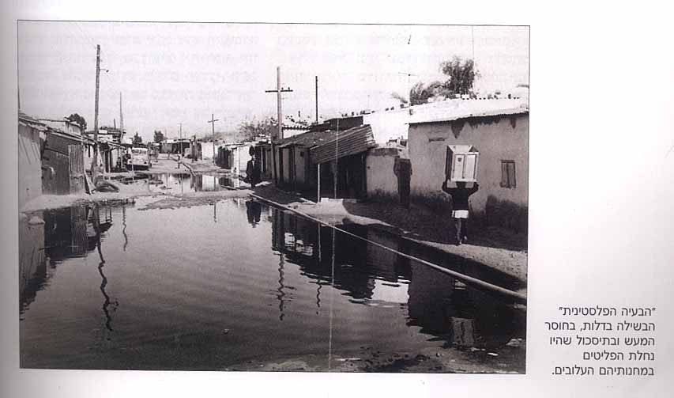

The problem is acting by itself. Nobody activates it. Furthermore, labeling a whole nation and nearly 25\5 of the citizens 'a problem to be solved' in a Jewish textbook only 70 years after the Jews were called “The Jewish problem” and were victims of the Final Solution, implicitly equates Palestinians' status to that of the Jews and other unwanted groups in Nazi-dominated Europe.
Edward Said contends:
All the constitutive energies of Zionism were premised on the excluded presence, that is, the functional absence of “native people” in Palestine’. Palestinians are being out or absent even when they are all too present. (1979: 29)
This is best manifested in diagrams, graphs and photographs where Palestinian citizens are not depicted as part of the Israeli population, or in maps where the absence of Palestinian cities such as Nazareth or Akka, villages or cultural institutes create blind spots.
One example from a Geography book:

Israel- Man and Space

Arab Population in Israel 2000

No Arab city is depicted (Nazareth, Akka) so according to this map the "Arabs" live in "our" cities. The West Bank is described in the legend as a region (within Israel) for which we have no data.
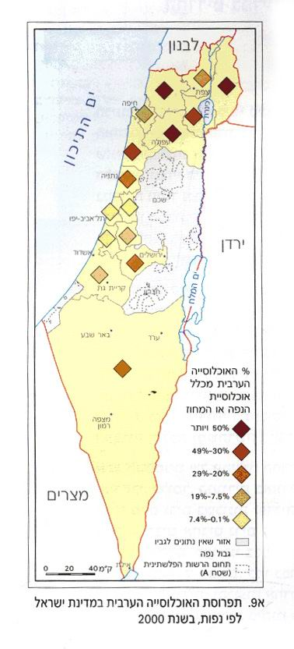

While the books published until 2009 mention Palestinians albeit in a racist fashion through racist icons and caricatures such as nomads Ali Baba types with camels, primitive farmers and face-covered terrorists, legitimating thereby their discrimination and killing, the books published since 2009 hardly mention Palestinians. They present Israel as a defensive Democracy that must protect itself against some abstract "terror".

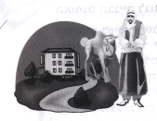
“The Arabs refuse to live in high buildings and insist on living in land-ridden one - storey houses.” GLI p.303

The Palestinian citizens are described in this book in a racist fashion:
The Arab society is traditional and objects to changes by its nature, reluctant to adopt novelties […] Modernization seems dangerous to them […] They are unwilling to give anything for the general good."
"In the Jewish sector there is no objection to allocate some of the private lands for public building. In the Arab sector there is an expectation that all public services and needs be provided from the land reservoir of the state."
(Geography of the Land of Israel p.303)

Israeli schoolbooks hardly mention the Occupation. The Occupied territories are presented as part of Israel and their Palestinian population is absent from all the reports. The civic studies textbook published by the Ministry of Education in 2016 emphasizes time and again that the land belongs to the Jews wherever they are and not to the citizens of Israel. The West Bank is presented in all books as a part of Israel which is empty of Palestinian people, monuments or universities. When the Occupation is mentioned it is in an abstract manner. For example, Going the Civilian Way (2012) mentions some Occupational practices in a chapter titled: "The right of Democracy to protect itself," justifying them by the argument that being a democracy does not mean committing national suicide. The book explains that a defensive democracy may use any measure it sees fit to protect its citizens against potential terrorists and their supporters. Separation walls, Check-points, targeted assassinations, administrative detention ("detaining a person without trial, without the possibility to meet a lawyer for an indefinite span of time"), house demolition, confiscation of land, curfew and the use of mild physical and psychological pressure ("not torture") are thereby legitimated. The students are asked to look at newspapers and internet sites for more information about "security censorship" and find one advantage and one disadvantage in its use. The book presents an empty "flying" checkpoint, placed at random without warning. Several concrete blocks, loosely placed, against which two groups of people are leaning leisurely, talking. Some of them are police, some soldiers. One sees an open empty police van, the flag of Israel on top of a canteen and a bare slope of a hill in the distance. This relaxed checkpoint is placed against abstract "terror".

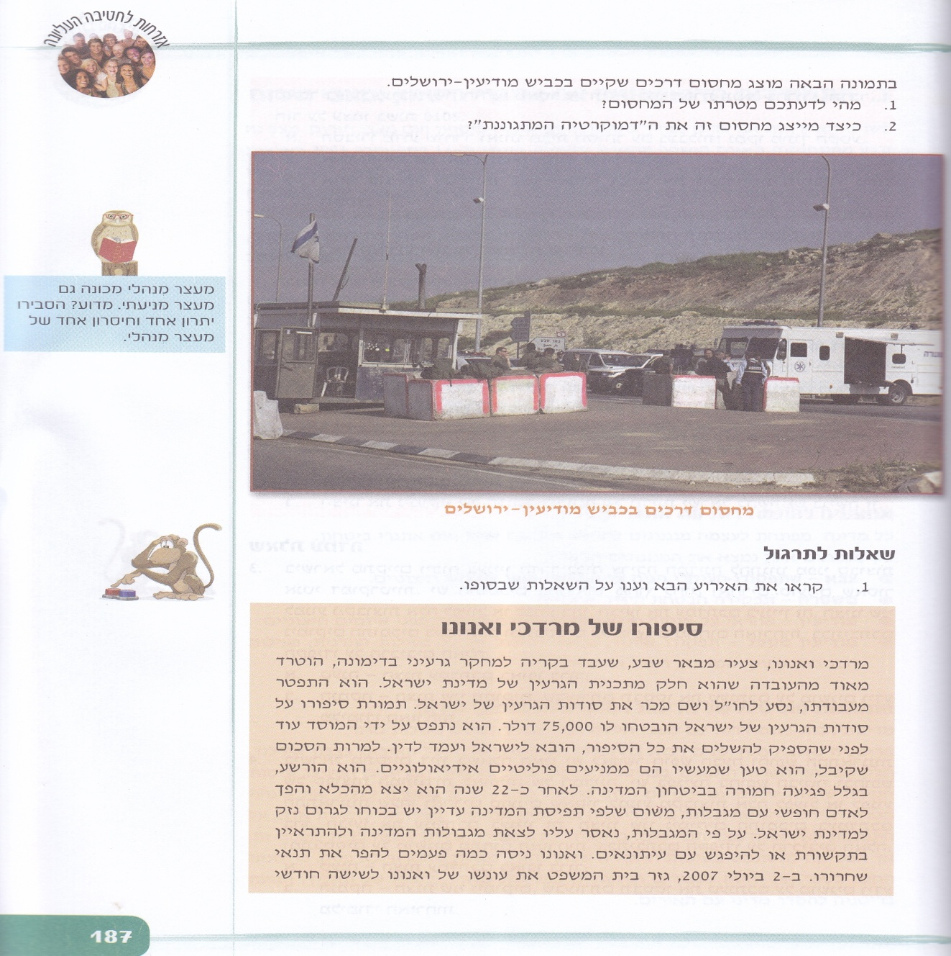Figure 4. Road Checkpoint on the Modiin-Jerusalem Road.

Choosing the image of an unusually empty check point allows an abstract discussion that does not take into consideration the people against whom it was placed. An image of a regular checkpoint may raise questions Israeli Education is not interested in tackling: Is this what terrorists look like? How can you tell? Is every Palestinian a potential terrorist, old people and babies included?
The students may realize that despite the unbearable crowdedness and stress in the tiny space between iron cages and automatic iron gates, the people seem self-possessed people going to work and not blood thirsty terrorists who want to exterminate Israelis.
Abstraction allows rational questions based on the criterion of effectiveness, such as those following this sub-chapter:
-What is the purpose of the check-point in your opinion?
-How does it represent the defensive democracy?

Owl tells the students:
Administration detention is also called preventive detention. Explain why. Count one advantage and one disadvantage of administrative detentions.

This way, Israeli Colonialist practices are presented as normal and therefore "rational" in view of the obvious need to keep a Jewish majority at all costs for fear of a second Holocaust.

Legitimating Confinement and distancing
Turning human beings into abstractions such as 'problems' and describing them by demeaning stereotypes, as we see in Israeli schoolbooks, lead to the rational conclusion that this 'nuisance' or threat should be distanced or confined in strict boundaries.
This situation is legitimated in school books either by describing Palestinian citizens as outlaws and vile, or in the name of security and ethnic purity.
One example is the law of citizenship or the Nation-State Law, by which Palestinian married couples of which one is an Israeli citizen and the other is not, need to have a permit to live together. The result is hundreds of torn families and "illegal infiltrators". This law should be studied in all schools, starting this year (2019-2020) and the teachers are instructed to teach it while avoiding any discussion of the controversy around it.

A Civic Studies textbook (2010) presents the law and legitimates it:
The law denies citizenship from Palestinians who live in Judea and Samaria or Gaza and who marry Israeli citizens.
Some defend the law in the name of Israel’s Defensive Democracy and Israel’s right to eliminate the danger of terror attacks. Some commend the law for national reasons and the need to prevent Palestinian immigration and keep the Jewish character of the state. The supreme court ruled that this law is unconstitutional but rejected the petition against it because it was an emergency law, adding that “Human rights are not a recipe for national suicide".
Shahar 2010:138
In the same book, the military government during 1948-1967 that held Palestinian citizens in constant siege, is justified by the need to Jewify the land: "The military government helped Jewish settlement all over the country and prevented Arab seizure of vacant lands."

Legitimating Palestinians' state of Exception

Their painful defeat, Zionist ideals and Israel’s definition as the state of the Jewish people make it hard for Israel’s Arabs to accept their minority status. Shahar 2010:300.
"Accept their minority status" means accepting their life in a permanent state of exception. For instance:

Part of the Bedouin population dwells in 45 settlements unrecognized by the authorities. Therefore, they do not receive regular services such as municipal budgets, water, electricity, health and welfare services. Shahar, 2010:45.
The assertive causal structure of this passage does not invite discussion or questions and does not give an explanation why citizens of a democratic state who have been living on the same land for generations should be unrecognized and hence deprived of all services. It presents the dire conditions of Israeli Bedouins as a rational cause and effect procedure.
In the same vein, another Civic Studies textbook assures the students that there is no contradiction between being a democracy and being an exclusionary and segregationist state.

There is no contradiction between the fact that Israel is comprised of a civil nation of citizens and the fact that several ethno-cultural minorities live in it, but the only nation that enjoys self-determination is the Jewish one. Diskin 2013:165.
As was mentioned before, Israeli fear of becoming a minority again is equal to the fear of a new Holocaust, that would be committed this time by a Palestinian minority that would grow to become a genocidal majority if not controlled. Therefore, every victory over Palestinians is presented in schoolbooks as a salvation from another Shoa. Hence, "weeding out" Palestinians is a creative, not a destructive activity. It does not differ in kind from other activities which combine in the construction of the purely Jewish society. This explains the fact that we find descriptions of successes, improvement and salvation of the Jewish people whenever Palestinians are being killed. For instance:

In the months after that (=The Dier Yassin Massacre) the Jewish Yishuv was privileged with many military successes. Tabibian 2001:284
Or:
Although the Massacre of Dir Yassin did not inaugurate the panicked flight of Israel's Arabs[…]it accelerated it greatly. The escape of the Arabs solved a terrifying demographic problem and even a moderate person such as [the first president] Weitzman spoke about it as "a miracle". Barnavi 1998:184.
Regarding Plan D for the ethnic cleansing of the road from Tel Aviv to Jerusalem:

From the Jewish point of view Plan D was a great success. It strengthened the military power of the Jewish community. It created a [Jewish] territorial sequence as a 'strategic asset.' It had positive effects at the diplomatic level for it convinced the Americans and the Russians that the Jewish community is strong militarily and can fend for itself. Blank 2006:323
As these examples show, Israeli schoolbooks do not excuse the killing, but rather legitimate it by the far- reaching positive consequences for Israel, that are turned a-posteriori into cause.

Blaming the Victim
Regarding the reasons for eradication and discrimination the United Nations Expert Group on Managing Diversity in the Civil Service (2001) agreed on the following conclusions about the social causes of race prejudice, that reflect the Israeli reality:
In settler societies in […] which individuals are deprived of equal access to employment, housing, political participation, education, and the administration of justice […] discrimination deprives a group of equal treatment and presents that group as a problem. The group then tends to be blamed for its own condition, leading to further elaboration of racist theory.
In addition to being guilty of their backwardness, the Palestinians are guilty of their minority status:

"When you go to war you cannot lament your defeat." (Diskin 2013:200).

Or:
"The Arabs brought it upon themselves for they fought the Jews to perdition." (Blank 2006:323)

Usually the "Arabs" bring death upon themselves because they refuse to do as they are told or because of technical problems

"The loud-speaker encouraging the inhabitants of Dir-Yassin to leave the village did not work […] the people did not leave the village and that is the reason why the number of casualties among them was so great."
Nave et al. 2009:113.

"The soldiers did not know the people were hiding in their homes that night."
Inbar 2004:244 Kibya massacre. Domka et al. 2009

The overall message regarding Palestinian elimination is:
Positive outcome (for us) may condone or overlook evil (done to them) Zizek. 1989

Afterword
Schoolbooks in Israel command the students to ignore ‘the other drama’ – that of the victims and their circumstances – to disregard international laws and decisions, and to look ahead of injustice to the favorable consequences for the Israeli-Jewish nation.
They teach the students the discourse of power, of politicians and generals, and put at stake ‘the disciplinary politics of truth’.
Israeli education Establishes the rule of power as an existential necessity and strengthens the "us vs. anything Arab" stance.
The books justify Palestinian cultural and physical elimination as the only logic that pertains to the relationships between the Jewish Majority and Palestinian minorities. They reproduce and legitimate social othering of Arab minorities and thus promote 'elite racism' (Wodak and Resisigl 2001) – racism that is dictated from above and is inculcated through schoolbooks, papers, parliamentary speeches and culture. This racism inscribes itself in practices of violence, contempt, intolerance, humiliation and exploitation, in discourses and representations which express the need "to purify the social body, to preserve 'one's own‘ or 'our' identity from all forms of mixing, interbreeding or invasion and which are articulated around stigmata of otherness - name, skin colour, religious practices"(Balibar 1992:17) or, as I have tried to show, the very presence of people where they are not wanted.

Bibliography

The cited textbooks

Alperson Bilhah. Dubi Tamir. Shtrakman Dana. (2016). Being Citizens in Israel – A Jewish Democratic State. The Ministry of Education. Jerusalem.
Aharony. Y and Sagi T. (2003): The Geography of the Land of Israel - A Geography textbook for grades 11-12. Tel Aviv. Lilach Pub.
Bar-Navi, E. (1998) The 20th Century: A History of the People of Israel in the Last Generations, for Grades 10–12. Tel Aviv: Sifrei Tel Aviv.
Blank, N. (2006) The Face of the 20th Century. Tel Aviv: Yoel Geva.
Diskin Abraham (2013) Israel in Politics and Government. Maggie Publishers Ltd. Israel.
Domka, E., Urbach, H. and Goldberg, Z. (2009) Nationality: Building a State in the Middle East. Jerusalem: Zalman Shazar Centre.
Fine Tz., Segev. M. and Lavi R. (2002): Israel-The Man and the Space – selected chapters in geography. Tel Aviv. The Centre for Educational Technologies Pub.
Naveh Eyal, Verd Naomi and David Shahar 2009. Nationality in Israel and the Nations – Building a state in the Middle East. Reches Publishers. Tel Aviv

Shahar David (2010). Citizenship in the State of Israel. Kineret Puiblishers. Tel Aviv Israel.

General Bibliography
Balibar Etienne (1991). Is There a 'Neo-Racism'? In: Etienne Balibar nand Immanuel Wallerstein 1991. Race, nation, class: ambiguous identities I. Verso.
Reisigl and Wodak (2001). Discourse and Discrimination: Rhetorics of Racism and Antisemitism. Routledge.
Peled-Elhanan (2012). Palestine in Israeli School Books – Ideology and Propaganda in Education. London. I.B. Tauris.

Peled-Elhanan, N. (2014). The De-Humanization of Palestinians in Israeli
Schoolbooks: a Multimodal analysis. In D. Machin, (ed.), Visual communication
(pp. 327-340). Boston, MA: Degruyter Publishing House.
Edward W. Said, (1979). ‘Zionism from the Standpoint of its Victims’, Social Text, No. 1. (Winter, 1979), pp. 7-58. y Duke University Press.
Van Leeuwen Theo 2008. Discourse and Practice. New Tools for Critical Discourse Analysis. Oxford Studies in Sociolinguistics
Žižek, Slavoj . (1989) Violence. New York: Picador

OR Kashti: https://www.haaretz.com/israel-news/.premium-israel-s-civics-exam-to-require-students-to-memorize-controversial-nation-state-law-1.8029077

