Preventing ill-treatment in detention in the United Kingdom

United Kingdom National Preventive Mechanism submission to the 66th session of the Committee against Torture

Table of Contents

1. Introduction

2. Scope of Submission

3. Response to List of Issues

i. National Preventive Mechanism (Paragraph 10)

ii. Issues in places of detention

Paragraph 6 Legal aid reforms
Paragraph 11 Support to women who have experienced violence
Paragraph 12 Trafficking
Paragraph 22 Complaints and NPM recommendations
Paragraph 23 Prison conditions
Conditions in court custody
Paragraph 20 and 23 Use of force and health care in police custody
Paragraph 24 Children and women in detention
Paragraph 26 Inter-prisoner violence
Paragraph 27 Deaths in detention
Paragraph 21 and 28 Decision to detain and maintain immigration detention and identification of torture
Paragraph 29 Mid Staffordshire NHS Foundation
Paragraph 30 Detention and deprivation of liberty in mental health settings
Paragraph 31 Restraint in health care settings
Paragraph 32 Recording of instances of torture and ill-treatment
Medway Secure Training Centre
Paragraph 37 and 42 Sexual abuse of children in detention
Paragraph 40 Restraint of children in STCs and YOIs
Paragraph 48 TACT detention
Paragraph 49 Other information (Brook House)

4. Additional Issues arising from Inspection and Monitoring

Transfer of detainees within the UK
Removal of detainees and use of force on overseas escorts

5. Appendices

i. NPM Membership
ii. NPM Detention Population Data Mapping Project 2016–17
iii. Correspondence from UN SPT on NPM independence, 29 January 2018
iv. Glossary

1. Introduction

This submission to the Committee Against Torture’s sixth periodic review of the UK has been prepared by the UK National Preventive Mechanism (NPM), which is made up of 21 bodies that monitor all types of detention in the UK. To shed light on the issues raised by the Committee, we provide information relating to the NPM itself, as well as evidence from NPM inspection and monitoring visits as they relate to places of detention. Although our submission focuses on areas of concern, it is important to note that NPM members have also found numerous examples of good practice, real and sustained efforts to drive improved outcomes for those detained in some establishments and many staff who work hard to provide detainees with a good level of care.

This introduction highlights the key issues relating to the NPM and to different types of detention. The main body of the submission is then organised in accordance with the paragraphs of the Committee’s List of Issues Prior to Reporting.

The National Preventive Mechanism

The UK NPM was established in 2009. Its 21 member bodies are supported by a small secretariat housed at HM Inspectorate of Prisons (HMIP). The NPM’s activities have expanded significantly since it was first established, and now include joint work focused on specific areas of OPCAT compliance, as well as on thematic detention issues.

The NPM’s coordination budget is inadequate and the NPM has made requests for it to be increased, as well as ringfenced in the future. NPM members experience some constraints on their own budgets. We consider it essential that the NPM be placed on a statutory footing, but despite making substantial efforts to persuade the government on this, no progress has been made. This affects the NPM’s independence and its ability to prevent ill-treatment in detention (see paragraph 10 below).

Issues in detention

Prisons

The living conditions for some prisoners in male prisons in England and Wales are extremely poor and in some cases not fit for habitation. Some men spend unacceptable amounts of time locked in small cells in poor condition. Levels of violence and the use of force and restraint are high in a number of prisons and too little is being done to address the underlying causes of this. We are very concerned about high levels of self-harm and suicide in men’s prisons and that not all prisons implement and learn from recommendations made by inspectors and ombuds bodies with the aim of preventing further deaths in custody. The provision of mental health care is not always adequate and there are also significant delays in transferring some prisoners to mental health inpatient beds. For some men, the regime and conditions they experience may amount to ill-treatment.

Living conditions and regimes for prisoners in Scotland and Northern Ireland are generally found to be better. However, there are concerns, including very little time out of cell for young men in Scotland and in relation to the oversight of use of force in Northern Ireland (see paragraphs 23, 26 and 27 below).

The conditions and regime for women in prison are generally much better, but women continue to report high levels of need, including mental health needs, and not all prisons are doing enough to support them. Inspections in England and Northern Ireland found that many staff were not aware of how to identify and/or support women who may have been trafficked. The NPM has also raised concerns about the location of women’s prisons, including the number of women being held far from home (see paragraphs 11, 12 and 24 below).

Immigration detention and overseas escorts

NPM members continue to find individuals in immigration removal centres (IRCs) who appear to be too vulnerable to be detained. Despite improvements being made in recent years, the safeguards put in place to prevent vulnerable people from being detained or to allow for their release are still not working effectively. HMIP continues to find some Rule 35 reports that are inadequate and inappropriate decisions to maintain the detention of vulnerable people (including cases where there is evidence of torture in the country they left). HMIP has also found many IRC custody staff have limited knowledge of the national referral mechanism for identifying and referring potential victims of modern slavery, including trafficking.

NPM members regularly encounter detainees who have been detained for unacceptably long periods of time and the environment in some IRCs is prison-like with disproportionate security measures. We continue to raise concerns about the ability of those detained in immigration detention to access free legal advice (see paragraphs 6, 12, 21 and 28 below).

Detainees who are removed on charter flights may experience distress during the removals process. NPM members have raised serious concerns about the use of restraints on these charter flights, which are sometimes used without justification, including for prolonged periods of time. The NPM is concerned that detainees being removed experience treatment and conditions that may, for some, amount to ill-treatment (see section 4, additional issues, below).

Police custody

The NPM is particularly concerned about weaknesses in the governance of the use of force in police custody in England and Wales and incidents of disproportionate force being used, including in relation to PAVA incapacitant spray. Inspections found weaknesses in the governance and oversight of use of force in all forces inspected.

The disproportionate approach to risk management in some police custody suites is also a serious concern. NPM members have raised repeated concerns about the removal of clothing from detainees who are considered at risk of harm as a first resort. Inspectors have also reported incidents of detainees having their clothing forcibly removed, being left naked in cells or having clothing removed in the presence of an officer of the opposite gender. These measures are disproportionate and for some detainees they may amount to degrading treatment (see paragraph 23 below).

Not enough is being done in all police custody suites to meet the needs of women and girls. Girls are not always assigned a female member of staff to care for them and not enough attention has been paid to menstrual care of females in police custody. A number of children (both boys and girls) continue to spend the night in police custody when charged and refused bail due to a lack of available alternative accommodation (see paragraphs 11, 12 and 24 below).

Court custody and transport of detainees within the UK

Improvements to conditions in court custody in England and Wales in recent years have been from a very low base and NPM members continue to find poor physical conditions. In addition, members have raised serious concerns about the assessment and management of detainee risk in court custody (see paragraph 23 below).

Men, women and children continue to be inappropriately transported together and cellular vehicles are unsuitable for transporting children. Too many detainees face long journeys and the NPM is particularly concerned about the number of boys arriving at young offender institutions (YOIs) late at night after long journeys (see section 4, additional issues below).

Children in detention

In February 2017, HMIP concluded that, at that time, there was not a single establishment that it had inspected in England and Wales in which it was safe to hold children and young people. Although there have been some subsequent early signs of improvements in safety, all three secure training centres (STCs) were assessed as requiring improvement in relation to safety at their most recent inspection (see paragraph 24 below). This included Medway STC, where inspectors reported concerns about inadequacies in child protection arrangements and governance of use of force and restraint during the most recent inspection in December 2018 (see paragraphs 32 and 37 and 42 below).

The conditions and regime in segregation units in YOIs are generally poor and there are also concerns about the limited time that boys in residential units in YOIs spend out of their cells – in some instances only 30 minutes per day. The use of force and restraint in both YOIs and STCs continues to be of concern, including the continued use of pain-inducing techniques, failures to de-escalate situations and weaknesses in governance and oversight (see paragraphs 24 and 40 below).

Mental health detention

The use of detention under mental health legislation in England and Scotland appears to be increasing, in the context of severe pressures on acute psychiatric inpatient beds and community services. There has also been an increase in the use of Deprivation of Liberty Safeguards in England and Wales, which has led to delays in processing these orders. There is no equivalent system of safeguards in either Scotland or Northern Ireland. The government is working to amend and/or introduce new legislation in each jurisdiction, but there have been criticisms of proposed laws or delays in implementing new laws (see paragraph 30 below).

The use of restraint in health and social care settings continues to be a concern to NPM members. Data on the use of restraint is not collected in Scotland and Wales and is incomplete in England. The NPM welcomes new legislation which will require recording of the use of force in mental health settings (see paragraph 31 below).

Conclusion

The NPM is not aware of any published data across the UK which collates information about alleged or actual instances of torture or other ill-treatment, or of any place of detention which records incidents in this way. However, NPM members have found conditions, regimes and/or treatment in some places of detention they have inspected and monitored which are so poor that, for some persons detained, they may amount to ill-treatment. It is therefore of serious concern that a number of NPM members make repeated findings and recommendations to relevant government bodies in light of the failure of these bodies to sufficiently improve conditions and learn lessons from past incidents. The recommendations made following a number of independent and parliamentary inquiries concerning places of detention have also not been implemented or have been implemented too slowly to improve outcomes for those detained.

2. Scope of Submission

Overview of the National Preventive Mechanism

The UK National Preventive Mechanism was designated in 2009 to fulfil the UK’s obligations under the Optional Protocol to the Convention against Torture and Other Cruel, Inhuman or Degrading Treatment or Punishment (OPCAT). The NPM has 21 member bodies, which carry out inspections (scrutiny of places of detention by paid staff acting in professional roles) and monitoring (visits and observation carried out by volunteers) in the four nations of the UK: England, Wales, Scotland and Northern Ireland. Most of these bodies were already operating as inspectorates and monitoring bodies before their designation to the NPM. Members of the NPM conduct largely unannounced inspections and visits of all types of detention in the four nations of the UK – including prisons, police custody, court custody, customs custody facilities, secure accommodation for children, immigration facilities, mental health and military detention – and make recommendations to the relevant authorities based on their findings.

Scope of Submission

This submission brings together evidence from inspection and monitoring visits carried out by NPM members in England, Wales, Scotland and Northern Ireland since 2013. It also sets out the NPM’s concerns regarding its ability to perform its role as required by OPCAT.

Focusing on the queries raised by the Committee Against Torture in the List of Issues Prior to Reporting (LoIPR), this submission provides an overview of NPM members’ concerns arising from their inspection of and monitoring visits to places of detention in the UK. The submission provides information that the NPM considers significant rather than an exhaustive account. Although this submission primarily covers concerns identified, it is important to note that NPM members have found numerous examples of good practice, real and sustained efforts to drive improved outcomes for those detained in some establishments and many staff who work hard to safeguard, and treat with respect, those in their care.

The main body of our submission (section three) responds to the LoIPR, focusing first on the NPM itself and second on issues in places of detention. The latter is largely set out in order of the LoIPR but issues which are relevant to multiple paragraphs have been joined together where possible. Paragraph numbers in section 3 refer to the paragraph numbers in the LoIPR. Section 4 of the submission outlines further concerns, not covered in the LoIPR, that the NPM believes may be of interest to the Committee. The submission provides recommendations to the State party which the NPM considers important to the prevention of ill-treatment in the UK. These can be found at the end of each part.

3. Response to List of Issues

i. National Preventive Mechanism (paragraph 10)

Background

The UK NPM was established in 2009, when the then Minister of State at the Ministry of Justice, Mr Michael Wills, announced the designation of 18 statutory bodies in a written statement to Parliament. The number of bodies that have been designated and form part of the NPM has now increased to 21. No legislation or other formal document or process was created or enacted to establish the NPM in law, and written ministerial statements are the only basis for the NPM’s existence.

The NPM is supported by a small secretariat housed at HMIP. The responsibility for coordinating the NPM is not part of HMIP’s statutory duties, but is performed at the request of ministers and was formally set out in a Protocol between HMIP and the Ministry of Justice in 2017. In 2016, NPM members appointed an independent chair to support them in fulfilling their NPM responsibilities and to represent the NPM externally.

The 21 organisations that are part of the NPM were designated because of their existing detention monitoring functions. All were deemed by the UK Government to have sufficient independence and to fulfil the main criteria of an NPM set out in OPCAT (Articles 18–20). Given the prior experience of these organisations, and the well-accepted processes they already had in place for visiting, monitoring and inspecting places of detention, this was considered by the Government a more useful way of establishing an NPM than by creating a new organisation.

NPM activities

The NPM’s coordinating activities and the promotion of the OPCAT mandate have expanded significantly since it was first established. All members complete an annual self-assessment of their OPCAT compliance, using a questionnaire based on Subcommittee on Prevention of Torture and other Cruel, Inhuman or Degrading Treatment or Punishment (SPT) guidance. This process has informed joint work around areas requiring greater attention and members have peer-reviewed each other’s assessments with a view to learning from good practice. For example, several NPM members have adopted policies or improved practices around potential sanctions or reprisals that detainees report during or after their visits.

The NPM has published data showing the number of people detained in different settings and in different jurisdictions, with a view to addressing the absence of readily available or comparable data about many detention settings. In 2017, after conducting joint research into the issues, the NPM published comprehensive guidance on monitoring isolation in detention. This has been used to inform all NPM members’ approaches and strengthen the consistency of the criteria that monitoring bodies use to monitor restrictive practices. The NPM has contributed to many policy discussions, government consultations and parliamentary inquiries relevant to the prevention of ill-treatment and its own mandate. The NPM maintains its own website and Twitter feed.

Four NPM subgroups provide forums for sharing information, strengthening monitoring approaches, and coordinating responses to government policy developments and consultations. There are three thematic subgroups (children and young people; police; mental health) and one that brings together NPM members in Scotland.

The UK NPM also plays a leading and active role in European NPM forums; assists other NPMs and those setting up NPMs in Europe and the rest of the world and supports the work of international NGOs focusing on detention monitoring.

NPM budget

The NPM’s coordination is funded in part by the Ministry of Justice, via HMIP, and in part by its members who make annual contributions. For the year 2017–18, HMIP received a nominal income of £61,155 for NPM coordination from the Ministry of Justice and £19,500 from NPM members. In 2018, the Scottish Government agreed to support the NPM’s activities in Scotland by funding a 0.5 FTE member of staff to help coordinate the work of NPM members in Scotland.

The NPM believes that the resources provided to coordinate an NPM of such complexity are inadequate. They are only sufficient to cover the costs of two part-time members of staff (an NPM coordinator and assistant coordinator), hold bi-annual business meetings, travel and subsistence for staff and the Chair, and to produce an annual report. A request for minimal additional resources (£59,707 per annum) submitted in February 2017 was turned down, and we await a response to our renewed request made in December 2019. Additional resources would be used to increase the staffing of the secretariat (and associated costs) and pay the NPM chair a daily rate (he is currently unpaid), in line with other public roles with similar stature and responsibility. If granted, the resources requested would undoubtedly make a significant difference to the NPM’s ability to coordinate preventive work between the 21 members. However, given the scale of NPM members’ work we consider it would still be a minimal budget to perform our functions beyond the bare minimum.

We are also concerned that the NPM secretariat’s budget is not ringfenced, and that there is currently no separate mechanism for the NPM secretariat to request an increase in its budget or account for its expenditure.

In addition, some NPM members face challenges with the budgets necessary to carry out their NPM work and in some cases are significantly under-resourced. This is due a range of factors including budget cuts and freezes (leading to less funding in real terms), budgets for NPM work within the 21 organisations not being ringfenced and so being allocated alongside competing priorities, and budgets being awarded on an annual basis making forward planning difficult. Further budget cuts to NPM members would result in many having to reduce the number of inspections and monitoring visits undertaken; this has already been the case for one NPM member. In addition, most members report that additional funding would allow them to increase their preventive work through providing training to their own staff and those working in places of detention, promoting best practice, carrying out stakeholder engagement work and contributing to research and thematic work (including jointly with other NPM members).

Statutory basis and independence

The NPM has made considerable efforts to strengthen its internal structures and working arrangements with a view to improving its ability to implement OPCAT. This has included setting up an NPM steering group and establishing the role of Chair. We are currently in the process of drafting a protocol between the NPM and the government. There is more to do to make the UK NPM fully OPCAT-compliant, and we have been disappointed not to have been able to make as much progress as we would have liked on this, despite considerable efforts.

In particular, we have repeatedly raised the need for the NPM to be placed on a statutory footing, in line with SPT advice (see Appendix iii). Currently, only two of the 21 members of the NPM have any reference to their OPCAT mandate written into the legislation that created them and which defines their role. The Police and Fire Reform (Scotland) Act 2012 and the Public Services Reform (Inspection and Monitoring of Prisons) (Scotland) Order 2014 set out that the purpose of independent custody visiting and the functions of HM Chief Inspector of Prisons for Scotland respectively are ’pursuant to the objective of OPCAT’. The NPM itself is not recognised more generally in any legislation and has no separate legal identity.

In 2017 the Government introduced legislation – the Prisons and Courts Bill – which would have strengthened the legislative basis of HM Chief Inspector of Prisons and referred specifically to the OPCAT role (clause 2, proposed amendment to the Prison Act 1952) but the legislation fell when the Government called an election. The Government has stated that it does not intend to bring the legislation before Parliament again in the near future. We suggested to the Government and Bill Committee that they could use the legislation to recognise the UK’s NPM and we drafted a short amendment to the Bill, but unfortunately the Government did not take up that suggestion. It was, however, promoted by the Opposition in Parliament. We have also raised the need for NPM legislation with the Parliamentary Joint Committee on Human Rights and the Justice Committee, who supported this proposal.

In addition, we have raised the need for individual NPM members to have their responsibilities under OPCAT included in their legislation.

We are disappointed that despite sustained efforts, we have not been able to make progress on any of these points. Without strong safeguards for our independence as an NPM and our role in preventing ill-treatment, our contribution to preventing ill-treatment cannot be as significant as we would like it to be.

Secondees

In 2014, we wrote to the Committee to provide information about how we intended to follow up on its concerns regarding the practice of seconding State officials working in places of deprivation of liberty to NPM bodies. We informed the Committee that NPM members would work towards a reduction in their reliance on seconded staff allocated to NPM activities.

In order to take this forward, NPM members agreed guidance on ‘Ensuring the Independence of NPM Personnel’, which cited the Committee’s Concluding Observations. The guidance states:

NPM members have agreed to work progressively towards a reduction in their reliance on seconded staff for NPM work. Until this is achieved, and in the cases where it is ultimately not possible, NPM members will implement procedures to avoid conflicts of interest as a safeguard to preserve the independence of the NPM. To achieve this, they will work to establish a clearer delineation of staff assigned to NPM work, particularly among members whose work extends beyond the NPM mandate.

The NPM tracked progress made and reported that in 2014–15 four NPM members had reduced the overall number of secondees involved in NPM work. A review of progress is included in our business plan for 2019–20. In some instances, NPM members have been unable to hire staff with sufficient expertise (which is also a requirement under Article 18(2) of OPCAT) who are not seconded. In all cases decisions on secondment are made by the NPM member itself on the basis of their own assessment of the need for specific expertise and not by the government. We have no examples of any pressure being put on the NPM by the State to accept secondees.

Recommendations

Make available sufficient resources to allow the coordination of the NPM’s work in such a way that it is able to meet the requirements of OPCAT in full and strengthen its contribution to preventing ill-treatment in places of detention.

Ensure the budget for NPM coordination is ringfenced and establish a separate mechanism for it to negotiate any necessary increase in its budget.

Commit to providing a clear legislative basis for the NPM and for its member bodies to have their responsibilities under OPCAT clearly included in their legislation.

ii. Issues in places of detention

Paragraph 6 – Legal aid reforms

The Committee asked for information about the impact of legal aid reforms on access to justice. NPM monitoring examines the access immigration detainees have to legal advice, given that such advice can be key in determining asylum claims and in detainees being able to understand their bail rights. The NPM has found that access to legal aid support varies between immigration removal centres (IRC). Generous Scottish legal aid funding ensures that detainees receive particularly good access to legal support at the one IRC in Scotland, Dungavel. In England, however, Legal Aid Agency (LAA)-funded surgeries provide limited legal advice of around half an hour. In short-term holding facilities (STHF), inspections generally find, at best, the contact details for the Civil Legal Advice helpline (which can direct detainees to sources of publicly funded legal advice). At some recent inspections, notices for such helplines were not displayed.

The government’s reply to the Committee states that in cases relating to applications for leave to enter or to remain in the UK, legal aid is available if there has been a conclusive determination or a reasonable grounds decision that the individual is a victim of trafficking, slavery, servitude or forced or compulsory labour. NPM monitoring has identified that detainees in the relevant categories are receiving legal aid. However, accessing legal advice may rely on detainees being identified as possible victims of trafficking and the NPM has concerns about the ability of IRC custody staff to do so (see paragraph 12).

Recommendation

Ensure all immigration detainees (including those in short-term holding facilities) have access to good quality, free, legal advice.

Paragraph 11 – Support to women who have experienced violence

The Committee is interested in support services available to women who have experienced violence. This is particularly relevant to women in custody – the government’s recently published Female Offender Strategy for England and Wales notes that almost 60% of female offenders have experienced domestic abuse. The support provided to women who have experienced domestic abuse and other forms of gender-based violence in prisons is therefore assessed by NPM members on inspection. Recent inspections in England and Scotland have identified generally good levels of support to women who had experienced gender-based violence (with the exception of trafficking, see paragraph 12 below).

In Northern Ireland, Criminal Justice Inspection Northern Ireland (CJINI) has concerns that prison policies and management data relating to the resettlement of women after prison did not adequately take account of the needs of women who had been abused, raped, experienced domestic violence or had been involved in prostitution. CJINI also found that many staff working in key roles with women prisoners had not received any relevant training and some staff told inspectors that they would not be confident to encourage or discuss disclosure, or know how to refer victims to appropriate specialist support.

In relation to police custody, inspections in England and Wales identify the extent to which police forces assign female officers to detained girls (a legal obligation under the Children and Young Person’s Act 1933) and provide adult women the opportunity to speak with a female member of staff. We are concerned that not all police forces do this, which we consider may reduce the opportunities to identify and support girls and women at risk of violence. In addition, NPM members have found that the support offered to detainees, and referrals to other agencies on release varies across forces, which means that women at risk of, or experiencing violence, do not receive consistent levels of support.

Similarly, inspections in Scotland found that some signposting to support services (such as domestic abuse support) does take place in police custody, but there is scope for this to be developed further. In addition, there is scope for the rights and needs of women in custody to be better safeguarded and promoted and for more gender-sensitive care. For example, HM Inspectorate of Constabulary in Scotland (HMICS) has found that, although occupying single cells, women and men are often held on the same corridor in a custody centre. Women with experience of being held in police custody tell inspectors that they can find this environment intimidating and threatening. HMICS has therefore recommended that women and men are held separately.

Recommendation

Provide support which meets the needs of women and girls in detention who have experienced violence, including by ensuring staff have appropriate training.

Paragraph 12 – Trafficking

NPM members assess whether detention authorities identify and address the needs of those who may be most vulnerable in detention. A number of members therefore consider the support and referral mechanisms available to suspected victims of trafficking.

In its most recent inspections of the 12 prisons in England holding women, HMIP found that three lacked any support mechanisms for those who may have been trafficked and staff had little or no understanding of trafficking. In the remaining nine establishments there was evidence of work to address the issues but this was at varying stages of implementation and was often based around a small number of trained staff rather than a whole prison approach, and consequently the understanding of many staff needed to improve. Some good practice in working jointly with charities was identified and there were some referrals to the National Referral Mechanism (NRM) being made in some prisons.

In Northern Ireland, CJINI’s inspection of Ash House Women’s Prison in 2016 found that prison landing and Prisoner Development Unit staff did not know how to identify women who might have been trafficked and were not aware of the NRM (although they knew of support agencies in the community).

In relation to policing, HM Inspectorate of Constabulary and Fire & Rescue Services (HMICFRS) has found that despite the introduction of the Modern Slavery Act 2015, there remain significant failings in identifying victims of modern slavery and human trafficking and taking appropriate steps in relation to those who were, or should have been, identified as victims. Victims coming into contact with police were not always recognised as such or were often arrested as offenders or illegal immigrants. Frontline staff were often unaware of their responsibilities around the NRM process, or not sufficiently trained to recognise and undertake these actions where appropriate.

On inspections of places of immigration detention, HMIP has found generally good awareness of the NRM among Immigration Enforcement and Border Force staff, but much more limited knowledge among IRC custody staff. For example, the latest inspection of Harmondsworth IRC showed delays in referring potential trafficking victims to the NRM and widespread ignorance of the NRM among custody staff.

Recommendation

Improve training for staff across detention settings to make sure they can identify and support victims of trafficking and make referrals to the NRM.

Paragraph 22 – Complaints systems and NPM recommendations

The Committee is interested in the procedures in place to ensure compliance with Article 11 of the Convention. A functioning internal and external complaints systems and government dialogue with NPM members in relation to their recommendations are both key to preventing ill-treatment.

Complaints

HMIP and the Independent Monitoring Boards (IMBs) both identify concerns with complaints processes. HMIP data from 2017–18 shows that only 29% of adults responding to surveys (which are carried out as part of each inspection) who had made a complaint felt their complaint had been dealt with fairly, and even fewer noted their complaint had been responded to within seven days. IMBs also report delays in dealing with complaints and the failure of complaints systems in resolving particular types of issues. For example, at women’s prison HMP Downview, less than half (47.5%) of complaints were answered within the time limit in 2017–18.

In Northern Ireland, CJINI found, on two recent inspections, that although most replies to complaints were reasonably good, some were superficial and did not demonstrate that sufficient investigation had taken place. A few were particularly dismissive. Inspectors were not confident that complaints against staff were always dealt with adequately and too many said they had been prevented from making a complaint

When inspecting police custody, NPM members have found variation in the extent to which information explaining how to complain and the arrangements for taking and dealing with complaints is promoted. This extends to information relating to the appeals processes available through the Independent Office for Police Conduct and Police and Crime Commissioners. In one example, a 16-year-old girl complained to a custody sergeant that she felt violated after having her clothing removed by staff, yet no complaint was recorded, nor was the matter referred to the local safeguarding authority.

Recommendation

Ensure complaints procedures are understood by staff and detainees, and all complaints are handled consistently, effectively and fairly.

NPM recommendations

It is of concern to the NPM that recommendations its members make with a view to preventing ill-treatment are not always implemented. A number of NPM members report that they repeatedly make the same or similar recommendations about the places of detention they inspect and monitor. For example, CJINI has repeatedly raised concerns that the location of Ash House Women’s Prison in the grounds of Hydebank Wood Secure College (where young men are detained) is inappropriate and recommended there be a dedicated prison for women. IMBs have repeatedly raised significant concerns about the impact on prisoner safety and decency of poor maintenance such as crumbling windows at HMP Pentonville. HMIP made a recommendation at HMP Bedford during its May 2016 inspection that actions taken in response to Prisons and Probation Ombudsman (PPO) recommendations arising from investigations of deaths in custody be kept under review to ensure that improvements in practice are embedded. This recommendation was repeated at the September 2018 inspection. HMIP analyses the extent to which prisons achieve inspection recommendations, and reported in 2016–17 that the number of recommendations achieved by prisons had, for the first time, dropped below the number not achieved, a trend which continued in 2017–18.

Recommendation

Publish a clear, measurable and time-limited action plan in response to all recommendations from NPM members.

Paragraph 23 – Prison conditions

The Committee requests information on a number of issues relating to the conditions and regime in prisons. NPM monitoring has identified a number of areas of concern relating to overcrowding, the use of force and isolation and prison health care in adult men’s prisons and we refer to these findings below (findings in relation to women’s prisons are in paragraph 24).

Overcrowding and living conditions

We are concerned about the number of prisoners living in overcrowded conditions and the extremely poor living conditions in several prisons in England and Wales. In many prisons, two prisoners are accommodated in a cell designed for one and there are also some instances of three prisoners being held in a cell designed for two. Although some prisoners may benefit from sharing a cell, other prisoners report that it impacts on their privacy and/or makes them feel unsafe. HMIP inspections have highlighted examples of prisoners sharing cells without a proper risk assessment. Cell sharing arrangements may disproportionately impact on older prisoners, for example, at HMP Brixton, some older prisoners have had to climb onto bunkbeds.

Shared cells often do not have properly screened shower and toilet facilities. A number of toilets are found to be without lids and/or dirty and prisoners may be required to eat their meals or sleep close to toilets. A small number of prisons do not have in-cell toilets and so rely on night sanitation systems. This may lead to delays of over an hour in prisoners being able to use the toilet, or the sanitation system may break down altogether. Delays and breakdowns mean prisoners may be forced to use buckets in their cell.

Recent inspections of Wormwood Scrubs, Liverpool, Bedford and Birmingham found some of the worst living conditions that inspectors have ever seen, with inspectors concluding that some prisoners were being held in conditions not fit for habitation. For example, at Birmingham, inspectors reported that ‘[s]ome particularly vulnerable prisoners were living in squalid cells which were not fit for habitation. One prisoner on assessment, care in custody and teamwork (ACCT) case management procedures (for those at risk of self-harm) was living in a filthy, flooded cell. The blood of another prisoner, who had self-harmed two days previously, had not been cleaned from the cell floor (…) communal areas on many wings were filthy and access to cleaning materials was problematic. Rubbish was left lying around in bags and there were problems with fleas, cockroaches and rodents.’ The IMB at HMP Liverpool also reported unacceptable conditions including no electrics, blocked toilets, no running water, and broken windows. Such conditions, particularly when combined with a poor regime (see below in relation to time out of cell) may amount to ill-treatment for some prisoners.

Time out of cell and segregation

The NPM also has concerns about the inadequate amount of time that many men held in prisons in England and Wales spend out of their cell. In a joint NPM project looking at isolation and solitary confinement of detainees across all forms of custody in 2014–15, we identified concerns that some prisoners held on basic regimes or who were unemployed were often locked in their cells for long enough periods for the regime to amount to solitary confinement. This was of particular concern because there were no governance processes or oversight for what were essentially informal practices, and as a result the potential for harm to detainees, including vulnerable detainees, was not fully considered.

Inspections continue to identify concerns about the time men are spending locked in their cells. Twenty per cent of adult men responding to HMIP’s survey in 2017–18 reported that they were out of their cell for less than two hours a day on weekdays, and only 16% reported that they were out of their cell for at least 10 hours. In YOIs holding those aged 18–21, 38% reported in the survey that they were unlocked for less than two hours a day, and only 4% reported being out for more than 10 hours. Inspectors continue to find examples of men spending an hour or less out of their cell each day, including those who are self-isolating or otherwise vulnerable. Time out of cell for many young men in Scotland was reported to be poor by HMIPS, with some young men, particularly those held on remand, being locked in their cell for up to 22 hours a day.

The conditions and regime in dedicated segregation units inspected in England and Wales during 2017–18 were poor for many men. Insufficient oversight of the use of segregation and insufficient attempts to reintegrate prisoners in a number of prisons contribute to some men spending prolonged periods of time segregated. For example, at HMP Whitemoor, inspectors reported that '-a small but significant number of men had been segregated for much longer [than 28 days]. The Independent Monitoring Board reported that in December 2016, for example, 11 men had been held in segregation for between 11 and 25 months. During the inspection, we found eight men who had been segregated for more than six months.’ Some cells were dirty and the regime was poor with men being offered half an hour of exercise each day and a shower and phone call every other day. Inspectors found that reviews of segregation did not address the underlying issues that led to men being segregated. The IMB at HMP Lowdham Grange expressed serious concern about some prisoners who were in segregation for over 100 days and one prisoner who was segregated for 200 days.

Inspectors have found instances where special accommodation (a dedicated cell that might have bedding, furniture or sanitation removed) has been used without appropriate safeguards. For example, at HMP Leeds, use of special accommodation was high and governance was very poor. Prisoners spent an average of over 12 hours in special accommodation and not all prisoners held in special accommodation received adequate care – ‘in one case, records indicated that a prisoner who said he could not cope in the cell and wanted a Listener was neither assessed for an ACCT nor spoken to. He was left crying in his cell for over an hour before being moved out.’

In Northern Ireland, the most recent inspection noted improvements in the governance of segregation at Maghaberry and in the conditions and regime. However, outcomes for Catholic prisoners were poorer in key areas such as adjudications, use of force and segregation, despite some good initial work to try to understand why.

Use of force and strip-searching

NPM members are concerned by weaknesses in the use of force and its governance in prisons and YOIs holding men and young men in England and Wales. In around of two-thirds of prisons inspected in 2017–18 and 2016–17, the use of force was found to have increased and there were significant gaps in governance, including failures to complete documentation on time, body-worn cameras not being turned on and incidents not being reviewed or reviews significantly delayed. Fourteen per cent of male prisoners responding to HMIP’s surveys during 2017–18 who identified as being from a black or minority ethnic background reported being physically restrained by staff in the six months prior to an inspection, compared with 11% of men who identified as being white. For those who identified as being Muslim, the figure was 17% compared with 11% for those who did not.

Inspectors are not always assured that use of force is proportionate or necessary. For example, at HMYOI Aylesbury, inspectors reported that ‘[n]early 500 use of force documents were outstanding. One officer alone accounted for 40 from different incidents, yet there had been no challenge or follow up to ascertain why one person had been involved in such a high number of restraints. These concerns had not been properly identified by the quarterly safer custody meeting. The minutes did not indicate relevant actions to address the volume of force or to identify trends or concerns. For example, it was noted that the majority of force was used on prisoners from a black or minority ethnic background, but this was not explored further and no action was taken.’ The use of batons had considerably increased since the previous inspection and inspectors were not fully satisfied that their use was always proportionate. At HMP Liverpool, inspectors reported that many recent use of force records were incomplete and some contained ‘accounts of actions such as an officer "threw a punch at a prisoner” and an officer said he -“threw” a prisoner to the floor that were not legitimately explained. These examples had not been identified and reviewed by managers until we pointed them out.’ Some staff wore fire-retardant hoods (which look like balaclavas) during planned incidents without obvious reason. We are concerned that the use of these hoods may intimidate prisoners and prevent them from being able to identify the officers involved in incidents. The inspection of HMP Preston found cases ‘where staff had forcibly strip-searched prisoners under restraint by cutting off their prison clothing with anti-ligature knives. In another case, an officer had applied several ‘“forceful kicks” to a prisoner. These apparently excessive and potentially unlawful uses of force had not been identified and we referred them all to senior managers for further action during the inspection.’ Inspectors continue to find some prisons which routinely strip-search prisoners. For example, at Preston, all prisoners entering and leaving reception, including to be released, were searched regardless of individual risk.

An inspection of Hydebank Wood Secure College in Northern Ireland found the oversight of use of force was not effective in some aspects. This included use of force forms being incomplete or missing, and accounts from officers which did not assure inspectors that force was always used as a last resort. It was unacceptable that 75% of operational staff had not completed up-to-date Control and Restraint training.

The government announced in October 2018 that it plans to issue all prison officers in adult male prisons in England and Wales with PAVA incapacitant spray. This announcement followed a pilot of the use of the spray in four prisons. The HM Prison and Probation Service (HMPPS) report of the pilot, released following a Freedom of Information request, reached a number of conclusions about how it was used that are of significant concern to the NPM. In particular, we are concerned by reports of the ‘potential for over-use’ and reliance on PAVA rather than using de-escalation techniques, and its use outside ‘policy or training boundaries’. In some incidents it was not used as a last resort and staff described it as a ‘minor use of force’.

Health care

HMIP inspections have found that health provision is at least reasonably good in most adult male prisons, but there are some gaps in provision. In light of the highest levels of self-harm and suicide over many years in prisons, the effective provision of mental health care to prisoners is of significant interest to the NPM. In 2017–18, recommendations to improve provision of mental health care were made in just over half of all prisons inspected in England and Wales. In most cases, this related to gaps in the range of provision, including due to insufficient staff or a lack of specific interventions such as psychological services, counselling, and support for those with learning disabilities or groups. In addition, there were delays in transferring prisoners requiring inpatient mental health care in just over 70% of adult male prisons reported on in 2017–18, with excessive delays reported in some cases (105 days in one case). When the NPM considered this issue in thematic work carried out in 2016–17, data we obtained from NHS England showed that 7.1% of prisoners waited for 140 days or longer to be transferred to hospital.

Primary care is usually comprehensive although waiting times can be excessive, compounded in recent years by problems of staffing shortages (both of health care providers and prison staff) and the increase in serious incidents due to the use of psychoactive substances. The system for making complaints about health care (which is separate to the main procedure for prisoners to make complaints) in a number of prisons requires improvement, including to response times. We are also concerned that there is insufficient learning from complaints. The governance of pharmacy services continues to be a significant concern, including unacceptable delays in prisoners receiving medication.

Recent thematic inspections in Scotland and in England and Wales have raised concerns about the failure to take a strategic approach to meeting the needs of the ageing prison population. HMIPS have subsequently noted developments in Scotland with the introduction of the Scottish Government’s Health and Justice Collaboration Board, with a workstream looking specifically at prisoner health care.

Recommendations in relation to the above can be found at page 27.

Paragraph 23 – Conditions in court custody

The Committee notes concerns about conditions of detention in court custody, an area that the NPM continues to have concerns about. Although there have been improvements in conditions in recent years, these have come from a low base. In its 2015 thematic review of court custody, which considered findings from inspections taking place between August 2012 and August 2014, HMIP identified ‘some of the worst custody conditions we have inspected.’ It noted that ‘despite, in many cases, the best efforts of custody staff, we found a dangerous disregard for the risks detainees might pose to themselves or others.’

While there have been some subsequent improvements, HMIP and Lay Observers (LO) continue to report poor physical conditions in many court custody cells in England and Wales. This includes cells containing potential ligature points, offensive graffiti, including that which names individuals, unacceptably dirty cells due to inadequate cleaning and poorly ventilated and/or heated cells. For example, on one inspection, among other concerns, HMIP found that all but one of the random sample of cells checked had potential ligature points and in one court custody suite, cells had not been cleaned for over a week.

In addition to poor physical conditions, NPM members have raised serious concerns about the assessment and management of individual risk in many court custody suites. This has included concerns about detainee well-being and safety (such as individual risk assessments not always being completed for each detainee, inadequate risk management, agreed levels of observation for vulnerable detainees not being adhered to and detainees sharing cells before risk assessments have been completed) and detainee security (including adults and children routinely being handcuffed in secure areas regardless of the individual risk posed).

The last time court custody was inspected in Northern Ireland, a number of concerns were raised about the conditions in which detainees were held. We were pleased that the recommendations made at the time were accepted, and as a result of this and work undertaken by Northern Ireland Courts and Tribunals Service, plans were developed to close some court houses. A follow-up review in 2015 found some progress had been made to improve conditions. However, the plans to close court houses were overturned by the Minister for Justice in October 2016. CJINI therefore remains concerned that conditions have not improved sufficiently in the court estate and a proposed further inspection of court custody is planned for 2019.

Recommendations in relation to the above can be found at the end of the final part relating to paragraph 23 (page 27).

Paragraph 20 and 23 – Use of force and health care in police custody

The Committee notes concerns previously highlighted by the NPM about the need to improve the collection and monitoring of information on strip searching and the use of force and in the quality of risk assessments and custody records. NPM members continue to report significant concerns about governance of the use of force and the management of risk in police custody suites.

Use of force

Inspections of police custody suites in England and Wales continued to find weaknesses in the governance and oversight of use of force in forces inspected. These included inadequate completion of use of force forms to justify why force was necessary and poor review and monitoring, including poor collection and analysis of use of force data. HMICFRS and HMIP stressed the need for improved governance in a letter to all Chief Constables and have consistently recommended that police forces improve their governance and oversight of use of force. In Northern Ireland, use of force data is monitored centrally but records are not kept for use in particular custody suites, which makes issues difficult to identify.

Inspectors have found incidents of force being used that was not proportionate to the risk posed and/or incidents of poor technique. For example, an inspection report from October 2017 notes ‘-[c]oncerns from the CCTV footage included some cases where force was heavy-handed, not used as a last resort and not proportionate to the risk posed, and poor use of techniques, one of which was potentially injurious to the detainee when pressure was placed on his back in the prone position.’ De-escalation was not always sufficient: ‘[i]n one case we reviewed on CCTV, a boy with ADHD was handcuffed for over 30 minutes during a close proximity cell watch. We saw no attempts to de-escalate the situation before the handcuffs were applied.’ Inspectors continued to find compliant detainees remaining in handcuffs for too long.

In four of the eight forces inspected in 2017–18 in England and Wales, inspectors reported concerns about proportionality, governance and oversight of the use of spit hoods. For example, inspectors reviewed one case which involved the use of a spit guard on a 17-year-old child: ‘ [w]e referred this case to the force on several grounds, including concerns about the proportionality and governance of the use of spit guards in the custody environment and, in particular, on a child.’

Disproportionate use of PAVA incapacitant spray has been found in some forces. Avon and Somerset police reported to inspectors that PAVA had been used in custody suites 107 times in the six months leading up to the inspection. Governance of its use was inadequate. Inspectors found incidents where PAVA had been used to enforce detainee compliance: ‘in two incidents in which detainees had put their hands through the cell hatch, incapacitant spray had been used to force them to put them back inside the cell.’

Disproportionate use of Taser has also been reported by inspectors. Inspectors reported concerns during two inspections that the use of Tasers had been disproportionate to the threat posed in some situations and that on one of these inspections, there was no policy on or governance of their use. However, inspections since April 2018 found that Taser use in incidents reviewed was in response to a clear threat or danger, and was not used to gain compliance or in drive stun mode.

There are inconsistences in the publication of use of force data across the UK; this data is published in England and Wales but not in Scotland and Northern Ireland, despite recommendations from NPM members that this should occur. Data on police use of Tasers is published in England and Wales, but no equivalent data is published in Scotland or Northern Ireland. No data on strip-searching is published across the UK. These inconsistences and gaps limit effective monitoring, analysis and learning.

NPM members have often recommended that the quality of the information recorded on custody records should be improved. Recurring themes from inspection findings include that not all relevant information is included on records, that the rationale for decisions made in custody is unclear based on the information recorded, and that there is little narrative to show the outcomes for detainees. NPM members have urged police forces to improve their arrangements for scrutinising and quality assuring custody records.

Managing risk

NPM members generally find that initial assessment of the risk of self-harm in police custody is thorough, although HMICS continues to find too many cases where the reasoning for why a detainee is considered high or low risk is not clear (or not clearly recorded). However, the NPM has serious concerns about the approach to risk management in many forces. Across the UK, inspectors see blanket policies and responses being applied to manage risk instead of more individualised and dynamic risk management. For example, in Scotland, until very recently police detainees were roused every hour while in police custody, regardless of the risk posed. Custody staff reported this was one of the most common complaints from detainees about their treatment, and HMICS recommended in 2014 that this policy be reviewed. The policy has very recently been revised to allow a more proportionate approach to risk management and HMICS will monitor the implementation of this new approach. In England, Wales and Northern Ireland, a number of forces routinely remove belts, footwear and clothing with cords even for detainees who pose no known risks. Inspectors also find anti-rip clothing (reinforced clothing that makes it more difficult, but not impossible, to tear and use as a ligature) used as a first response to the risk of self-harm, instead of higher levels of observation. Inspectors have identified some incidents where clothing has been forcibly removed from detainees considered at risk of self -harm, with some detainees left naked for considerable periods of time. Removal of clothing has not always been carried out by staff of the appropriate gender and some detainees have been visible on CCTV screens while naked. For example, on one inspection, it was noted that ‘[t]wo cases that we reviewed on CCTV showed detainees left naked for significant periods as a strategy to reduce the potential for self-harm.’ The NPM recognises the need to prevent detainees from coming to harm, but these measures are disproportionate, and for some detainees we are concerned that these measures amount to degrading treatment. Inspectors continue to recommend that forces use alternate measures which respect detainee dignity and provide appropriate care to manage risks, such as carrying out higher levels of observations.

In addition to clothing being removed for reasons of safety, inspectors continue to find insufficient justification for strip searches in a number of forces. Inspectors reported a high proportion of children and a disproportionately high proportion of black or minority ethnic detainees were strip-searched in Metropolitan Police custody suites and the searching of a 14-year old girl without a parent/guardian or other independent adult there to ensure her welfare in West Midlands.

Health care

The NPM has concerns about inadequate health care provision in police custody. Health services in police custody continue to be commissioned by individual forces in England and are outside the NHS England commissioning portfolio. This approach creates variable governance and oversight and therefore varying access to health professionals and waiting times, even within forces. Not all custody suites have on-site 24-hour cover, which can lead to significant delays while health care staff travel to suites. In Scotland, the NHS has assumed responsibility for the delivery of health care in police custody. However, this is not currently subject to independent scrutiny, which limits the ability to ensure there is good provision for detainees.

We are pleased to note that recent inspections of police custody in England and Wales have found improvements in mental health support and a marked reduction in the use of police stations as a place of safety under section 136 of the Mental Health Act 1983 (MHA). Welcome changes to section 136 (and related regulations) came into force in December 2017; they prevent the use of police stations as a place of safety for children and impose strict conditions on when adults may be held in police stations as a place of safety. However, we are concerned that this sometimes results in people being held at the side of the road or in police vehicles while waiting for a mental health assessment to be arranged, or waiting with police officers at hospitals until a mental health assessment can be carried out. In addition, those who are brought into custody having allegedly committed an offence (i.e. not detained under section 136) who require assessment or transfer under the MHA sometimes face excessive delays, including due to a lack of available mental health beds and delays in ambulances attending.

Recommendations

Ensure all prisoners receive at least 10 hours out of their cell each day.

Strengthen the governance and oversight of the use of force in all detention settings to ensure that force is only used in accordance with law and is strictly necessary and proportionate.

Ensure thorough individual risk assessments of detainees are completed and the measures put in place to manage risk are the least intrusive to do so safely and take account of detainee dignity and privacy.

Ensure segregation of prisoners is a last resort and for as short as time as possible, and that segregated prisoners are provided with a range of purposeful activity and meaningful human contact each day.

Ensure all detainees are held in clean and sanitary conditions.

Provide mental health care that meets the needs of all detainees and introduce a statutory time limit on transfers of detainees to mental health inpatient facilities.

Publish disaggregated data on the use of all types of force in police custody across the UK on a regular basis.

Ensure the provision of health care in police custody in Scotland is independently monitored in accordance with OPCAT.

Ensure detainees are held in appropriate conditions with no more security restrictions necessary than to ensure safe custody.

Paragraph 24 – Children and women in detention

The Committee asked for information about efforts to meet the needs of women and children in places of detention. The NPM is concerned that insufficient efforts are being made to meet the needs of women and children in a number of prisons, YOIs, STCs and police custody, and for children detained for mental health reasons in Scotland.

Children in YOIs and STCs

In February 2017, HMIP concluded that, at that time, there was not a single establishment that it had inspected in England and Wales in which it was safe to hold children and young people. HMIP wrote to the then Minister for Victims, Youth and Family Justice to inform him of this. Despite some subsequent early indications of improvements in safety, inspections of STCs in 2018–19 have raised concerns that signs of improvement have not been maintained. All three STCs were assessed as requiring improvement in relation to safety at their most recent inspection. In addition, children continue to report that they do not feel safe. Just over a third of children (34%) surveyed in STCs during 2017–18 said that they had felt unsafe at some point, 30% reported that they had been victimised by staff and 44% reported that they had experienced some form of victimisation from other children. In the same year, 40% of children held in YOIs said they had felt unsafe at some point and 16% felt unsafe at the time they were asked. Thirty per cent of children reported being victimised by staff and 32% by other children.

Inspectors have also reported concerns over the regime and conditions in segregation units in YOIs in England and Wales. While the use of these units fell in 2017–18, a new practice of segregating children on residential wings (outside of segregation units) emerged during the year. In HMIP’s 2017–18 survey, 30% of boys in YOIs said that they had spent a night in the care and separation (segregation) unit. Of those boys, 38% reported being treated well by staff while in the unit. We are concerned that boys who had spent a night in segregation were significantly more likely than others to be from a black or minority ethnic background (61% compared with 47%).

Inspectors have found that the environment and regime in segregation units is generally poor. Children often spend less than two hours out of their cells. For, example, at Cookham Wood YOI, inspectors found that ‘-with the exception of the occasional visit from various professionals (…), the regime was limited to a daily telephone call and shower, and exercise in the open air only a few times a week. There was little provision for in-cell activity and access to basic amenities such as the library, which in reality amounted to a few books left in the corridor. Communal areas had not improved and cells were poorly ventilated with graffiti on walls and windows.’ In early 2018, inspectors reported that the segregation unit at Feltham (shared with young adults) was a ‘grim environment’ unsuitable to hold children. Inspectors have raised concerns about the length of time some children were held in segregation. For example, inspectors found one boy had been held in segregation for nearly three months at the time of inspection and another for 120 days before being relocated. The Children’s Commissioner for England has also raised serious concerns about the average length of time that children in YOIs are being segregated for. In June 2018, HMIP provided evidence to the Joint Committee on Human Rights (a parliamentary committee) stating that experiencing poor regimes for prolonged periods in segregation units may amount to ill-treatment for some boys.

Inspectors have also raised concerns about the amount of time children spend out of their cells. The average on weekdays at the most recent inspection of three YOIs was six or seven hours. Inspectors have found boys locked up for more than 22 hours a day in some YOIs, with some boys being out of their cells for as little as 30 minutes (including time to shower, make calls and exercise). Children often report that they spend significantly less time out of their cell on weekends. Inspectors have noted that records of time out of cell kept by YOIs may overestimate the time children spend out of cells, including as they do not always deduct time for delays in children being unlocked or will record the meal time taken for all children (when some children may only be unlocked for a small part of this time). In Scotland, HMIPS inspectors and monitors have raised concerns about boys at Polmont YOI being locked in their cells for up to 22 hours a day on normal location and the lack of close scrutiny and monitoring of this.

See also paragraphs 32 (Medway STC), 37 and 40 below.

Women in prison

HMIP finds that women continue to report high levels of need, including feeling depressed or suicidal on arrival at prisons, having mental health problems and having alcohol or drug problems on arrival. Despite this, not all prisons are doing enough to support women with complex needs. At HMP Peterborough, there was a lack of specialist facilities for women with very complex needs or challenging behaviour and this may have contributed to the frequent use of the segregation unit. The inspection of HMP Peterborough also highlighted significant concerns about the use of strip-searching in reception, which was far higher than usually seen in women’s prisons. It was not always clear why searches were undertaken and there was no monitoring of why the number of searches was so high or why they were not authorised with senior managers. The guidance on searching promoted the removal of clothing as the primary option to obtain contraband items, which was contradictory to Prison Service instructions and the trauma-informed approach that the prison promoted. This trauma-informed approach to working with women is being adopted across prisons and aims to recognise the impact of trauma experienced by many women and assist staff in responding to them.

HMIP continues to find many women held in prisons far from their home in England (there is no women’s prison in Wales), which impacts on their ability to maintain family ties and receive visits, and can hinder resettlement work such as finding suitable accommodation on release. For example, at HMP Peterborough, HMIP found that only about 30% of women released lived in surrounding areas, which meant those assisting with their resettlement had to work across a range of local authorities and housing providers. HMIP has also highlighted the lack of places for women in open conditions – at any given time there are a number of women categorised as suitable for open conditions but who are held in a closed prison. Some women may choose to stay in a closed prison because this is closer to home, which means they may miss out on the opportunities offered in the open estate. On the other hand, some women choose to stay in the open estate although it is further from home.

The government published a Female Offender Strategy for England and Wales in June 2018 and while NPM members are supportive of the Strategy’s aim to improve outcomes for women in prisons, including in relation to rehabilitation, it is not clear that there is funding available to make envisaged changes in practice.

HMIPS has raised concerns about the lack of mental health provision for women in prison in Scotland, where a proportion of the population have severe and enduring mental health issues. The lack of high secure mental health beds for women and young people in Scotland has been raised with Scottish Government. This is being addressed in Scotland for young people but not, as yet, for women. HMIPS has also queried the number of places planned for the reconfigured female custodial estate, as it is significantly below the current occupancy levels.

NPM members in Northern Ireland have highlighted the location of Ash House Women’s Prison within the grounds of Hydebank Wood Secure College (which houses young men) as inappropriate since it opened and have called for a dedicated women’s prison. The current location of women within a male establishment places limits on what activities they can access. CJINI has also called for greater recognition of and a coordinated approach to the complex needs of many women held at Ash House, as well as the provision of therapeutic alternatives to Ash House for the small number of highly vulnerable women with the most challenging behaviour.

Inspectors continue to find examples of women being transported in vans with men (see section 4 at page 56 for further information).

Children in police custody
The number of children being brought into custody has fallen in recent years. However, NPM members inspecting and monitoring police custody raise concerns about those children who are brought into it. Inspectors have repeatedly raised concerns that children who are charged and not bailed very often remain in police custody overnight and sometimes over weekends, largely because of a lack of alternative and secure accommodation, even though there is a statutory duty on local authorities to provide it. This is despite the introduction in England and Wales of the Concordat on Children in Custody, which aims to strengthen joint working between police forces and local authorities in these circumstances and improve understanding of statutory obligations. In Northern Ireland, CJINI has reported that some children are being transferred to Woodlands Juvenile Justice Centre to be held overnight, with those located further away from Woodlands being more likely to remain in police custody.
In England and Wales, a recurring concern is the lack of early support for children from Appropriate Adults (AA) whose role is to safeguard the rights, entitlements and welfare of children in police custody. Inspection findings show that AAs are not always called or expected to attend early on in a child’s detention. There is also often limited provision for securing AAs at night if family members are not available to take on this role. These problems can result in children remaining in custody for longer than necessary, as police must wait for an AA to be present to help children understand their rights and entitlements and to carry out other custody processes such as fingerprinting and interviews. One child in Derbyshire was found to have waited over 19 hours and there were long waits in many other forces. In addition, inspections find that girls are not consistently being provided with care by a female member of staff as required by Section 31 of the Children and Young Persons Act 1933. There are not always sufficient female officers on duty to perform this role and even when a female officer is assigned it is not always clearly recorded on the custody record.

See also paragraphs 11 and 12.

Women in police custody

NPM members across the UK have reported that women do not always receive gender-sensitive care while held in police custody and that their specific needs are not always met. HMICS has noted, for example, the need to separate male and female detainees in the cell accommodation area, and to consider the availability of female staff to care for female detainees. Ensuring female staff are available means women can have the same access to showers as male detainees, makes many female detainees feel more comfortable and allows constant observations of female detainees to be carried out by a woman. Women are not always offered the opportunity to speak privately with a female member of staff about any care needs or other issues they may have.

Inspections and independent custody visits have also raised serious and ongoing concerns about failures to maintain an appropriate stock of menstrual products for women and/or menstrual products not being routinely offered, leaving women in the position of having to request them, including from male staff. CCTV in cells is set up to pixelate the cell toilet but this sometimes covers a very small area and women changing their menstrual products may be visible on CCTV. In some circumstances, measures taken with the aim of preventing self-harm have been disproportionate or have not adequately considered the needs of menstruating women and this has led to women being placed in anti-rip clothing or paper suits without sanitary protection. The limited opportunities detainees have to wash their hands or shower can particularly impact women in custody.

See also paragraphs 11 and 12 and paragraph 23 in relation to police custody.

Children in mental health detention

We have specific concerns that the number of children who require inpatient mental health care (both on a voluntary or involuntary basis) who are placed in adult or general medical wards is rising in Scotland. These environments are not appropriate for children and they often have limited access to specialist support, or appropriate education or activity. Mental Welfare Commission for Scotland (MWCS) is particularly concerned about the lack of specialist Intensive Psychiatric Care Unit (IPCU) provision for children, which means that vulnerable children may be placed in adult IPCUs alongside a mix of adults, including people coming from the criminal justice system.

Recommendations

Ensure all children spend a minimum of 10 hours per day out of their cell.

Ensure segregation of children is a last resort and for as short a time as possible, and that segregated children are provided with a range of purposeful activity and meaningful human contact each day.

Ensure that children who are charged and refused bail from police custody are not held overnight in police custody and are accommodated safely elsewhere.

Ensure that all children arriving in police custody have an adult available to support them immediately or that one is provided on an urgent basis.

Ensure that women who are imprisoned are held close to home and in conditions appropriate to their security categorisation.

Ensure that all girls held in police custody are under the care of a female member of staff and that the specific needs of women and girls are met, including routinely providing menstrual products.

Strengthen the governance and oversight of the use of force in all detention settings to ensure that force is only used in accordance with law and is strictly necessary and proportionate.

Provide mental health care that meets the needs of all detainees and introduce a statutory time limit on transfers of detainees to mental health inpatient facilities.

Ensure detainees are held in appropriate conditions with no more security restrictions necessary than to ensure safe custody.

Paragraph 26 – Inter-prisoner violence

The government response to the LoIPR refers to the quarterly statistics on safety in custody. These statistics show that violence in the prison estate in England and Wales (both between prisoners and against staff) continues to rise, with a 20% increase in assaults and 18% increase in prisoner on prisoner assaults reported in the year to September 2018 compared with the previous year. Both HMIP and the IMB have found increasing levels of violence at a number of prisons and both have noted that low staffing levels, inexperienced staff, the use of illicit substances, debt, mental health issues and poor prison conditions and time out of cell appear to have contributed to the increase. In HMIP surveys undertaken in 2017–18 in male prisons, on average 50% of prisoners responding said they had felt unsafe at some time. HMIP has reported its concern that despite the introduction of the Violence Reduction Project, there is not enough consistent work being done to tackle increases in violence or provide support to victims. For example, at HMP Exeter, HMIP found that support for victims of violence often involved moving them to a different location within the prison but there was little formal support taking place and the approach to perpetrators was focused on punitive measures rather than encouraging positive behaviour through individual plans. The allocation of key workers to the most violent prisoners had not been sufficiently prioritised and too few prisoners took part in a changing behaviour course designed to address violent behaviour.

Recommendation

Review behaviour management policies across prisons with the aim of identifying and reducing the underlying causes of violence and use of force.

Paragraph 27 – Deaths in detention

Data on deaths in detention

We note that the Committee is interested in disaggregated data regarding deaths in all forms of detention. This has been an area of focus for the NPM as we were concerned about the absence of collated and comparable government data on deaths in detention. We carried out our own research, using different sources of data available to our members, and were able to publish for the first time an overview of deaths in detention, covering the year 2016–17. We found that, on average, at least 70 people died in detention per month throughout the year. This data is included in Appendix ii.

Of particular concern from our overview were the deaths in England and Wales of two children held in secure children’s homes (SCHs) and eight young adults aged 18 to 20 held in prisons or YOIs. In addition, the number of self-inflicted deaths in adult prisons in England and Wales has been high for many years, and in the 12 months to September 2018, it was reported that there were 87 apparently self-inflicted deaths (one per 1,000 prisoners), up 12% from the previous year. In 2018, there were two deaths recorded at HMYOI Polmont in Scotland, one of a boy aged 16 held on remand, and the other a 21-year-old woman. In response to these two deaths, the Cabinet Secretary for Justice in Scotland requested that the provision of mental health services for young people entering and in custody at HMP Polmont be investigated by HMIPS. This work is ongoing. HMIPS has subsequently noted that the number of deaths in prisons in Scotland is reducing.

The NPM is also concerned that in the 2017–18 year there were five reported deaths in or immediately following immigration detention, of which three were self-inflicted. In the previous year, there were six deaths, two of which were self-inflicted, and one manslaughter. These are of particular concern as prior to this, deaths which were not from natural causes were rare.

Published data on deaths in detention is generally disaggregated by age, gender, ethnic group and cause of death, though there are some exceptions. In Scotland, detailed information on the causes of deaths of patients detained under the Mental Health (Scotland) Act 2003 is not routinely gathered. In addition, there is potential under-reporting because of the way in which the Home Office records deaths; those who are transferred from an IRC to a hospital and subsequently pass away in hospital are recorded as released from detention (and therefore not as a death occurring in detention). This classification means that the PPO will not automatically be notified of the death by the Home Office and is contrary to the practice of other government departments.

Investigations into deaths in detention

Well-established procedures for investigating deaths in prisons, police custody and immigration detention exist in England, Wales and Northern Ireland via independent ombuds bodies (the Prisons and Probation Ombudsman and the Independent Office for Police Conduct in England and Wales; the Prisoner Ombudsman and the Police Ombudsman in Northern Ireland).

In Scotland, deaths in police custody are independently investigated by the Police Investigations and Review Commissioner and may be the subject of a Fatal Accident Inquiry (FAI). All deaths in Scottish prisons are subject to an FAI, as well as internal investigation prior to the FAI which may identify early learning but does not meet the requirements of independence and public reporting. NPM members have noted that there are often delays of several years before an FAI into a death in a prison or police custody takes place.

In relation to deaths in mental health and other health settings, the arrangements are more complex. We are disappointed that the Government response to the Committee’s List of Issues does not specify the arrangements for investigating deaths in these settings.

In England and Wales, deaths in detention are notified to the Care Quality Commission (CQC) and will also be investigated by an independent coroner’s inquest. Coroners may copy or address reports to the CQC, who share relevant information among inspection teams for local review and action, including enforcement action where necessary.

There have been serious concerns about the process of review and investigation of deaths of NHS patients, particularly those with intellectual disabilities. The CQC undertook an investigation and the government has committed to a series of improvements to the system in England.

In Scotland, the Crown Office is responsible for the main process to investigate deaths which may be of concern in mental health settings. This process of review is not public, except on the rare occasions when a FAI is initiated, or a prosecution under health and safety legislation. Suicides and other deaths which may cause concern should also be reviewed by the relevant NHS Board, under guidance issued by Healthcare Improvement Scotland, but there is no accessible route to find information on the results of investigations into deaths in detention or measures to prevent similar cases. MWCS (an NPM member) can also initiate formal investigations into deaths, but these are unusual.

In December 2018, the Scottish Government published a review of the process of investigation of deaths of detained patients and inpatients being treated for mental disorder. This review found a need for significant improvement, in relation to timeliness, independence, and involvement of families. There are concerns that the system may not comply with Article 2 of the European Convention on Human Rights. As a result, the Government has asked MWCS to work with stakeholders to devise a new system of investigation of deaths of detained patients in psychiatric care.

Preventing future deaths in detention

As part of their preventive mandate, NPM members have established close working relationships with the bodies that investigate deaths in detention, with a view to sharing information and, in some instances, evaluating the implementation of recommendations from investigations into individual deaths in detention. In Northern Ireland, CJINI has raised concerns in its most recent inspection reports about the failure of Magilligan Prison, Maghaberry Prison and Hydebank Wood Secure College to fully implement and embed recommendations made by the Prisoner Ombudsman for Northern Ireland following self-inflicted deaths. In relation to prisons in England and Wales, HMIP found that in around a third of prisons reported on in 2017–18 and 2016–17, the prison had not sufficiently implemented PPO recommendations following deaths in custody, including at prisons where there had been further self-inflicted deaths.

NPM members examine and report on a wide range of issues relevant to preventing deaths in detention in their regular monitoring work. In relation to prisons in England and Wales, more than 90% of HMIP reports on adult men’s prisons in 2017–18 were critical of one or more of the key indicators used by inspectors to assess the effectiveness of suicide and self-harm prevention measures. Main recommendations were made about this in almost one-third of men’s prisons. They found significant weaknesses in ACCT case management (of those at risk of self-harm) in most establishments reported on in 2017–18. This continued a pattern established in previous years. These weaknesses included ACCT case reviews occurring late, poor recording of triggers, ACCT monitoring ending without all care map actions being completed, a lack of meaningful engagement with prisoners on ACCTs, insufficient staff at night to support those on ACCTs, and failing to involve health staff in multidisciplinary support that should be offered to people at risk of self-harm or suicide. HMIP also continued to find prisoners who were being monitored on ACCTs being placed in segregation without adequate justification. Other concerns relevant to preventing future deaths in prisons include: delays in answering cell call bells (HMIP has found delays in answering bells of between 10 and 59 minutes), and poorly attended or unavailable mental health awareness training (it is hoped that recent changes to training provision will improve this picture).

In relation to immigration detention, NPM monitoring has found that the assessment, care in detention and teamwork (ACDT) case management system for detainees in crisis was not providing consistently good support at a number of centres.

In police custody, concerns that drugs and alcohol remain a significant factor in deaths in police custody were highlighted by the recent review of deaths and serious incidents in England and Wales by Dame Elish Angiolini. Given the importance of observation regimes for intoxicated detainees, NPM members HMICFRS and HMIP increased scrutiny of risk assessment and the observation of intoxicated detainees, and have identified concerns that intoxicated detainees are not always placed on rousal checks every 30 minutes, as required by police guidance.

Recommendations

Publish annual disaggregated data on deaths in places of detention which includes the place of detention and cause of death once this is confirmed.

Record the deaths of persons removed from immigration detention to hospitals as deaths occurring in immigration detention.

Review the Fatal Accident Inquiry procedure in Scotland to reduce delays and ensure timely, independent and public scrutiny of deaths in custody.

Ensure emergency call bells in places of detention are answered within five minutes.

Paragraph 21 and 28 – Decision to detain and maintain immigration detention and identification of torture

In response to the Committee’s request for information about the use of immigration detention, the Government notes that immigration detention should only be used sparingly. However, NPM members frequently find that this is not always the case in practice. HMIP inspections have found people in detention who appear to be too vulnerable to cope in a detention environment and examples of poorly reasoned decisions to maintain the detention of vulnerable people. For example, in 2017, inspectors found a man at Harmondsworth IRC who was registered blind and had been detained for over a year. He relied on staff and his peers to move around the centre but his detention review stated that he was able to care for himself and manage, and detention was maintained. Similarly, at its most recent inspection of Dungavel IRC, HMI Prisons found an elderly disabled couple who were immediately assessed on arrival by health care staff as unfit for detention and level three adults at risk, but they were detained for five days before being released. NPM members are aware of Home Office initiatives to reduce use of detention, such as the ‘detention gatekeeper’ and the community accommodation pilot programme at Yarl’s Wood IRC. It is not clear if recent reductions in the number of persons held in detention are attributable to these initiatives. However, given that members continue to find persons who appear to be too vulnerable to be held in detention, the NPM is concerned that the detention gatekeeper is not always an effective safeguard.

NPM members find that those who may have experienced torture (in the country they left) are identified by health care staff on arrival in IRCs. In recent inspections of IRCs, HMIP found that most medical practitioners and some nurses received training on carrying out Rule 35 assessments and recognising torture. However, HMIP has continued to find too many Rule 35 reports which fail to provide sufficient information and judgements to Home Office decision-makers. For example, a recent inspection of Campsfield House IRC found ‘[m]ost reports lacked necessary detail. Although most contained reasonably clear judgements on physical signs of torture, the reasoning for them was not always evident. The assessment of psychological trauma was weak (…) one torture report in the sample was woefully inadequate. It should have been returned to the doctor to be completed properly, but instead the Home Office concluded that the detainee had not been tortured, and detention was maintained.’ In addition, the Home Office often fails to explain the exceptional circumstances for maintaining detention in cases where there is professional evidence of torture. During recent inspections of Harmondsworth IRC and Yarl’s Wood IRC, HMIP found that detainees at both centres had their detention maintained despite professional evidence of torture; about 30% of Rule 35 reports at Yarl’s Wood led to release, and at Harmondsworth it was 10%.

In relation to short-term holding facilities (STHFs), which hold immigration detainees, Rule 32 of the Short-term Holding Facility Rules 2018 requires a health care professional to report to the Home Office any detainee he or she is concerned may be a victim of torture. In practice, while STHF detainees have access to health care professionals in an emergency, unless they are in one of the three residential STHFs, they are not routinely examined by a health care professional who would be able to detect and document physical and psychological sequelae of torture.

Although the government notes in its reply to the Committee that detention is used for the minimum time possible, NPM members regularly encounter detainees who have been detained for unacceptably long periods. For example, in 2017 the IMB reported that at Heathrow IRC, 105 men were detained for over 12 months, with the longest stay at nearly five years; at Brook House IRC, seven men were detained for over 12 months; and at Yarl’s Wood IRC, three women were detained for over 12 months. Some detentions were prolonged by poor case progression by the Home Office. In some cases, removal was not able to be achieved within a reasonable period (in order for detention to be lawful, there should be a realistic prospect of removal within a reasonable period of time). NPM members often speak to individuals who say that their mental health is affected by prolonged and/or open-ended detention. The NPM therefore continues to recommend a clear time limit on immigration detention.

The conditions in IRCs also impact on detainees’ well-being. A number of IRCs are prison-like environments and aspects of security at some centres are disproportionate. For example, inspections of Colnbrook IRC and Harmondsworth IRC found that detainees attending external appointments were routinely handcuffed without sufficient justification of risk. At Harmondsworth, detainees were routinely handcuffed to be taken to the care and separation unit (CSU) and also routinely strip-searched when relocated to the CSU. The impact of open-ended and prolonged detention, particularly for those held in prison-like environments and who are subject to disproportionate security measures, may be such that it amounts to inhuman or degrading treatment for some detainees.

Recommendations

Ensure immigration detainees are detained only as a last resort and for the shortest possible time and implement a time limit on immigration detention.

Provide training for medical practitioners in IRCs which ensures they are able to recognise signs of torture and report accordingly.

Ensure that detainees in non-residential STHFs are seen by health care staff who are able to detect signs of torture.

Ensure detainees are held in appropriate conditions with no more security restrictions necessary than to ensure safe custody.

Paragraph 29 – Mid Staffordshire NHS Foundation

CQC undertook a thorough revision of its regulatory approach in line with Sir Robert Francis QC’s recommendations in his report about Mid Staffordshire NHS Foundation Trust. Its new leadership team welcomed the recommendations stating that CQC would change how it inspects hospitals (looking more closely at how they are run, guided by simple questions like ‘do the doctors talk to the managers’, ‘how well do they learn from mistakes and complaints’), use more clinical experts, involve ‘experts by experience’ and develop teams of specialist inspectors. CQC also resolved to listen harder to what people who use services say about the reality of the care they receive. CQC also changed its board and the way it works in response to the Francis report recommendations. From June 2014, Sir Robert Francis has sat as a non-executive director on the CQC Board.

In 2014–15, new CQC regulations introduced new fundamental standards, and from that time CQC has implemented revised inspection methodologies to measure whether services are safe, caring, effective, responsive to people’s needs and well-led, and have powers to enforce these to ensure providers take the necessary actions. Each of the five key questions is broken down into a further set of questions, called ‘key lines of enquiry’. When CQC carries out inspections, it uses these to help decide what to focus on. For example, the inspection team might look at how risks are identified and managed to help them understand whether a service is safe. Different key lines of enquiry are used in different sectors, and how assurance of implementation is obtained is constantly under review. As a result of the Francis recommendations, CQC created the post of Chief Inspector of Hospitals, to champion the interests of patients and ensure a focus on the five key questions in regulatory work. Deputy Chief Inspectors were also appointed, one of whom has particular responsibility for mental health services.

The fundamental standards underpinning CQC’s regulatory work since 2014 are as follows:

- care and treatment must be appropriate and reflect service users’ needs and preferences
- service users must be treated with dignity and respect
- care and treatment must only be provided with consent
- care and treatment must be provided in a safe way
- service users must be protected from abuse and improper treatment
- service users’ nutritional and hydration needs must be met
- all premises and equipment used must be clean, secure, suitable and used properly
- complaints must be appropriately investigated and appropriate action taken in response
- systems and processes must be established to ensure compliance with the fundamental standards
- sufficient numbers of suitably qualified, competent, skilled and experienced staff must be deployed
- persons employed must be of good character, have the necessary qualifications, skills and experience, and be able to perform the work for which they are employed (the fit and proper person test)
- registered persons must be open and transparent with service users about their care and treatment (the duty of candour).

In 2018 the Government commissioned an independent review of the fit and proper person test, which was led by Tom Kark QC. This aimed to look at how effectively the test prevents unsuitable staff from being redeployed or re-employed in health and social care settings. The Government accepted two of its recommendations:

- Core competencies should be established for all directors to be assessed against. The assessment would be carried out by trusts and examined by the CQC. Directors could not be appointed without meeting these competencies.
- A central database of NHS directors’ qualifications and history should be established. It will also hold information about any upheld grievance or disciplinary matters.

Other recommendations from the Kark Review have been referred by government to its NHS oversight body, NHS Improvement, to consider. CQC is engaged in the process of considering the implementation of outstanding recommendations of the Kark Review and has reviewed its own approach to the duty of candour and the fit and proper person test in the past year.

CQC hosts the National Guardian’s Office, which opened in April 2016. It was created as a result of recommendations from Sir Robert Francis' Freedom to Speak Up review, published in February 2015. The National Guardian is tasked with leading a cultural change within health, so that health care staff feel confident and supported to speak up at all times.

CQC completed its programme of initial comprehensive inspections of all specialist mental health services in England by the end of 2017. Its findings from such inspections are available in published individual reports, and in the annual ‘State of Care’ publication. It has stated concern that poor and variable care still persists, but noted that its inspectors do find many examples of excellent care.

CQC has also developed new inspection of NHS trusts which focus on whether they are ‘well-led’. Such inspections can include case reviews of a sample of individual complaints, serious incidents and deaths which look for evidence of engagement with patients, families and carers as part of assessing how well NHS trusts learn from feedback on care.

CQC continually looks for ways to better use the experiences of patients, families and carers to inform when, where and how it assesses the standards of health and care that patients and service users receive.

Paragraph 30 – Detention and deprivation of liberty in mental health settings

Detention under mental health legislation

It should be noted that there appears to be a trend towards increased rates of detention under mental health legislation in England and Scotland.

In England, between 2005–6 and 2015–16, the reported number of uses of the Mental Health Act increased by 40%. The most recent data available shows that in 2017–18, in England, 49,551 new detentions under the Mental Health Act were recorded, but it is worth noting that overall national totals will be higher as not all providers submitted data. For the subset of providers that submitted good quality data in each of the last three years, NHS Digital estimates there was an increase in detentions of 2.4% from the previous year. It has also been established that people from black or minority ethnic groups are much more likely to be detained than those in White British groups. It is commonly believed that black people, and particularly black men, will often have first contact with services late in their illness, which makes them more likely to be detained.

CQC undertook in-depth work on the possible reasons for the rising use of the Mental Health Act in 2017–18, and reached a number of hypotheses for this, including: more complete data return and/or an increase in duplicate returns; as bed numbers have fallen, more people with severe mental health problems are living outside of a hospital setting and so are at greater risk of being detained; some people are being detained who would not previously have been (in part because clinicians are applying criteria for detention differently to people with certain types of disorder); people who may previously have agreed to informal admission are now refusing and being admitted as detained patients; admissions that in the past might have been prevented are now not being prevented because less restrictive alternatives in the community are not available; the increase in prevalence of risk factors for detention, such as social exclusion and problematic, untreated drug and alcohol misuse. The CQC research also points to the increase in the total size of the population of England and an increase in the size of those sections of the population that are more at risk of detention.

Similarly, in Scotland, data shows increased numbers detained in psychiatric hospitals and under emergency and short-term powers under the Mental Health (Care and Treatment) (Scotland) Act. A 10-year review published in 2017 by MWCS showed that the number of hospital-based Compulsory Treatment Orders had increased by 22% over 10 years, with emergency and short-term detention rising more quickly. The use of hospital-based Compulsory Treatment Orders per head of population has risen from 17.2 per 100,000 in 2008–09 to 23.9 per 100,000 in 2017–18. The total number of hospital-based Compulsory Treatment Orders in 2017–18 was 1,299, with the total number of episodes of detention (including emergency detention) was 5531. It is likely that the reasons for increased numbers in detention in Scotland are similar to those identified in England (with the exception of more complete data returns, which are not believed to be an issue).

Deprivation of liberty under mental capacity legislation

As noted in the government response to the LoIPR, the rise in people recognised as deprived of liberty in England and Wales is related to the Supreme Court redefinition of that concept in its judgment in Cheshire West and Chester Council v P. As the 2014–15 NPM annual report set out this has led in the last four years to a large rise in Court of Protection Orders and the use of Deprivation of Liberty Safeguards (DoLS) under the Mental Capacity Act 2005. That, in turn, has led to delays in the processing of these orders, and potentially to a reduction in their efficacy.
In England there were 227,400 applications for DoLS received during 2017–18. This represents an increase of 4.7% on 2016–17 and demonstrates that the rate of increase is slowing when compared with previous years. It is positive to note that the number of DoLS applications that were completed increased by 19.6% from 151,970 in 2016–17. It should, however, be noted that 2017–18 local authority data shows a wide range of variation across the country in the volumes of DoLS applications, their outcomes and how they were administered. CQC has noted the complexity of DoLS legislation, which leads to providers (hospitals and care homes) misunderstanding how to apply it. They can also be unclear as to when a restrictive practice amounts to a deprivation of liberty.
We do not know the number of adults deprived of their liberty in care homes in Scotland. There has been a substantial growth in the use of powers under the Adults with Incapacity (Scotland) Act 2000, but it is not known how many would be judged to be deprived of their liberty, or how many people may be subject to de facto detention in care homes. Scotland has no equivalent of the ‘Deprivation of Liberty Safeguards’ system in place in England and Wales.

There is concern that community-based services are insufficient in some parts of Scotland, and that this can increase the need for hospital-based detention, or delay the ending of such detention. A particular area of concern recently has been the number of people with learning disabilities spending long periods in hospital, often under detention, because of delays in developing community-based alternatives (see below for more detail).

There is acknowledgment in both jurisdictions that legal change is needed, and this is supported by NPM members. The UK Government has introduced the Mental Capacity (Amendment) Bill to Parliament, which is intended to make the system in England and Wales simpler to operate. However, this has been widely criticised by stakeholders as lacking in proper safeguards.

In Scotland, the Government has committed to reform of the Adults with Incapacity (Scotland) Act 2000, but detailed proposals have not yet emerged. MWCS has called for a comprehensive approach to law reform, which should encompass reform of the Mental Health Act, and reflect the significant changes that have taken place in the understanding of how best the law can respect the rights of people with mental ill health or incapacity. MWCS is concerned that the substantial rise in the numbers of people subject to detention and guardianship puts the safeguards in current legislation under pressure and set out proposals for long-term reform of mental health and incapacity legislation. Among the proposals made in this report is to explore the possibility of unified legislation, replacing Scotland's two, separate mental health and incapacity laws with completely new, non-discriminatory legislation for making decisions about welfare and treatment where an adult is unable to do so unaided.

In Northern Ireland, comprehensive and radical law reform proposals have been enacted in the Mental Capacity Act (Northern Ireland) 2016. However, implementation has been delayed, partly because of the lack of a functioning Assembly, meaning the law currently in force remains out of date and incompatible with modern human rights standards.

Learning disability and autism

There is continuing concern about people with learning disabilities being held under unnecessarily restrictive conditions, particularly in Assessment and Treatment Units (ATUs), because of a lack of community provision. In England and Wales, following the scandal of criminal abuse of patients with learning disability and/or autism at Winterbourne View Hospital in 2011, the UK Government made a commitment to greatly reduce the number of people in ATUs, but progress has been much slower than hoped. In Scotland, MWCS and a Government-commissioned review both identified significant numbers of people in hospital care or living a long distance from home who could be supported in community settings if these were available.

Recommendations

Reduce detention under mental health legislation through improving crisis and community-based services, and take forward in England and Wales the proposals of the Independent Review of the Mental Health Act to introduce clearer and tighter criteria for detention and greater ability to challenge detention.

Conduct work in Scotland to understand the causes of rises in detention under mental health legislation and the differential impact on particular groups.

Paragraph 31 – Restraint in health care settings

We note the government response to the LoIPR cites the 2014 ‘Positive and Proactive Care’ report. This report provided a useful focus on preventive approaches, and was the first policy document to require restrictive intervention reduction programmes (this is now also a requirement in the MHA English Code of Practice).

NPM members monitor the use of restraint during their inspections and visits, and this continues to be an area of concern. The lack of available data on the use of restraint in health and social care settings makes it difficult to identify trends in its use in Scotland and Wales. In Scotland, freedom of information requests suggest that the use has risen (although services often attribute this to improved recording and staff awareness). Since 2016, statistics on restraint in England have been collected by NHS Digital under the Mental Health Services Data Set. However, definitions of restraint, and incomplete coverage, means this data (which is not published) does not provide a complete picture, though it is improving.

In Scotland, the Scottish Patient Safety Programme for Mental Health has a workstream on ‘Violence, Restraint, and Seclusion reduction’, which suggests that there have been improvements in participating wards, but it is not known if this has been replicated across psychiatric settings. There are particular concerns regarding restraint affecting people with learning disability and autism. A Scottish Government report on people in hospital with learning disabilities and complex needs highlighted the need for greatly improved awareness of and training in Positive Behavioural Support methods to address challenging behaviour and so reduce the need for restraint with this group.

HIW has identified a number of concerns about the use of restraint in the child and adolescent mental health services (CAMHS) in Wales, and in one hospital signalled excessive use of restraint both in terms of the number and length, with some restraints lasting for an hour. Following a period of time given to the provider to improve the levels of care and treatment it was decided that HIW would use its powers under the Care Standards Act 2000 to cancel the registration of the hospital.

In England, available data identifies the numbers of patients detained under the Mental Health Act who die within seven days of restraint. In 2017–18, 11 patients died. None of these deaths look to be attributable to the restraint episode. As mentioned above, NHS Digital has recently started to collect data on the use of restraint. Although caution should be taken when interpreting the data because of differing definitions of restraint and incomplete but increasing coverage, the data relating to restrictive interventions for learning disability and autism- detained patients shows a large increase in reported restraint. This is most likely a result of more thorough reporting to a developing dataset.

Number of restrictive interventions for learning disability and autism patients who are in contact with secondary mental services, by intervention type, England, January 2016 – December 2017.
Year | No restraint type entered | Physical Restraint - Prone | Physical Restraint - Excluding prone | Chemical Restraint | Mechanical Restraint | Seclusion | Segregation | Total Restraints
2016 | 1,590 | 2,250 | 8,785 | 1,880 | 535 | 1,460 | 155 | 16,660
2017 | 6,260 | 3,170 | 14,490 | 2,360 | 365 | 2,100 | 125 | 28,880

In response to concerns about the use restrictive practices, the Secretary of State for Health and Social Care has asked CQC to carry out a review of the use of restraint, segregation and prolonged seclusion in settings that accommodate people with mental health problems, a learning disability or autism. CQC will publish an interim report in May 2019, and will issue its final report by spring 2020.

In 2018, Parliament enacted the Mental Health Units (Use of Force) Act 2018, which will apply in England and Wales. The NPM considers this a positive development. The majority of the provisions of this Act have yet to come into force, but when they do they will introduce much-needed safeguards, including recording use of force in all mental health units.

It is also worth noting that the Mental Health Act Code of Practice contains detailed guidance around restraint, including the recommendation that all inpatient services who may detain patients under the MHA should have governance arrangements in place that enable them to demonstrate that they have taken all reasonable steps to prevent the misuse and misapplication of restrictive interventions. All mental health providers are recommended to have in place a regularly reviewed and updated restrictive intervention reduction programme. At the very least, this has raised the profile of the issue with hospital management and staff, and many services appear to have reduced the number and/or duration of restrictive interventions. It has certainly drawn a fresh focus on prevention and de-escalation, which has had a positive cultural impact. Some services (e.g. Merseycare, the Trust that runs Ashworth High Security Hospital), have set themselves a goal of ‘zero-restraint’. This may never be attained in practice, but would have been an unthinkable goal some years ago, and shows that the assumptions of restraint being ‘normal’ practice are being challenged.

Recommendation

Implement an action plan to reduce the incidence of restraint and seclusion in mental health detention, and improve national recording of their use.

Paragraph 32 – Recording of instances of torture and ill-treatment

The NPM is not aware of any published data across the UK collating information about instances of torture and other ill-treatment or of any place of detention which records incidents in this way. However, as noted throughout this submission, the NPM has concerns that conditions and treatment in some places of detention may be severe enough to amount to ill-treatment for some detainees. We have begun work looking at the mechanisms available to deal with incidents of ill-treatment, and the ways in which these incidents are recorded as the first stage in a long-term project aimed at strengthening the NPM’s work in this area.

Recommendation

Publish annual disaggregated figures on alleged and proven incidents of ill-treatment.

Paragraph 32 – Medway Secure Training Centre

The Committee asked for information about allegations relating to the use of force and other abuse by staff at Medway Secure Training Centre (STC). HMIP and Ofsted visited Medway in January 2016 in response to these allegations. As a result of this visit, HM Chief Inspector of Prisons wrote to the then Secretary of State for Justice recommending: the establishment of a commissioner to provide increased external oversight and governance; the implementation of body-worn cameras in all institutions holding children with footage to be reviewed by senior managers; HMIP, Ofsted and CQC would jointly carry out new inspections of all STCs as soon as possible to provide assurance concerns raised at Medway were not more widespread; and there should be an enquiry into the failings at Medway and their wider implications.

In response to this advice note, the Secretary of State went on to implement an improvement board to oversee the operation of the centre, and ultimately intervened to bring the management of the centre in house to the prison service. However, over the subsequent three years, joint inspections by Ofsted, HMIP and CQC have found that although there has been activity to try to improve outcomes for children at Medway, progress has been slow and outcomes continue to require improvement. The assessment of outcomes at Medway at the last four inspections is as follows:

Date of inspection | Overall effectiveness judgement | The safety of children judgement | Promoting positive behaviour judgement
June 2016 | Inadequate | Inadequate | Inadequate
March 2017 | Inadequate | Inadequate | Inadequate
February 2018 | Requires improvement | Requires improvement | Requires improvement
December 2018 | Requires improvement to be good | Requires improvement to be good | -

In each of these inspections, concerns were raised regarding the use of force and restraint. During inspections in June 2016 and March 2017 inspectors found significant weaknesses in governance of the use of force, including incomplete and delayed reports of use of force. At the March inspection, inspectors reported that force and restraint records had not been maintained between July and October 2016 and that the use of force was high given the population at the centre. In February 2018, inspectors were able to report some improvements in governance of use of force, although a number of issues were identified which required improvement. The most recent inspection in December 2018 found continued deficiencies in governance, including delays in quality assurance of incidents. Not all incidents were reviewed during restraint minimisation meetings, which meant that senior managers could not be confident that use of force was always proportionate and necessary to prevent harm to children. In addition, inspectors reported concerns about restraint being used in response to passive non-compliance, which is not in accordance with the Secure Training Centres Rules 1998.

These inspections also raised concerns regarding handling of allegations of abuse. The June 2016 and March 2017 inspections found serious deficiencies in child protection arrangements. In February 2018, inspectors reported that there was a commitment to develop robust safeguarding arrangements and that arrangements had improved but did not consistently provide sufficient protection to children. Staff did not always recognise or respond appropriately to signs, indicators and information that suggested a child was at risk, consistently follow referral procedures or share safeguarding concerns with partner agencies in a timely manner. At the most recent inspection in December 2018, many of these issues had been resolved but some deficiencies were still reported, including the need to update internal procedures in line with new statutory guidance and that duty governors had not undertaken local authority designated officer awareness training, which would enhance their understanding of safeguarding arrangements.

The government notes that new specialist, highly-trained staff have been appointed. Although some specialist or highly-trained staff have been recruited, including teachers, social workers and psychologists, it remains the case that most frontline residential staff are not specialists and do not have a high level of training. The training and entry requirements for these roles remain very similar to 2016. The government has recently started a positive programme of workforce reforms that includes a commitment to providing all staff with a level five qualification by 2023. However, this is at a very early stage and has not yet had any measurable impact on outcomes for children in custody. A significant issue with staffing is the very high turnover of frontline officers, and it is these staff who are responsible for building relationships and providing care for children. Over recent years the rate of staff turnover in a period of 12 months leading up to an inspection has been as high as 67% and the most recent inspection found that inexperience of staff remained a significant problem at Medway. The Independent Inquiry into Child Sexual Abuse recently concluded that high staff turnover negatively impacts on children’s ability to develop positive relationships with staff and on children’s feelings of safety (see paragraphs 37 and 42 immediately below for more information on this inquiry).

Recommendations

Ensure that all children in detention are safeguarded from harm, including by providing specialist training and support to staff.

Prohibit the use of pain compliance techniques and the use of restraint in circumstances other than immediate risk of harm to self or others in the children’s estate.

Paragraph 37 and 42 – Child sexual abuse in detention

The Committee requested information on allegations of child sexual abuse and the adequacy of the response to these, including in places of detention. Since HMIP began conducting regular surveys in the children’s estate (in England and Wales) in 2002, a small but consistent number of children have reported sexual abuse in their survey response. In surveys conducted in 2017–18, 6% of children in STCs reported experiencing sexual abuse by other children and 3% reported sexual abuse by staff. In YOIs these figures were 1% and 2% respectively.

The process for investigations of allegations of sexual abuse in custody in England and Wales is the same as that for children making allegations in community settings (schools, hospitals, etc). In custody, the vast majority of child protection allegations and investigations relate to use of force and restraint, but inspection findings on the effectiveness of systems in STCs and YOIs to respond to these allegations are relevant to all safeguarding concerns (measures to protect children from harm and abuse). Some inspections have shown positive practice in relation to child protection matters, including prompt investigations and appropriate support being provided to children. However, inspections have also reported inadequate child protection processes, including delays in investigations, incomplete records and weaknesses in complaints systems which undermined children’s confidence in systems of redress. A recent inspection found that frontline officers working in the safeguarding team had not referred an allegation of inappropriate touching to the local authority as required.

On 28 February 2019, the Independent Inquiry into Child Sexual Abuse (IICSA) published its report, Sexual Abuse of Children in Custodial Institutions: 2009–2017 Investigation Report. The inquiry found that there had been 1,070 alleged incidents of child sexual abuse in the children’s custodial estate in England and Wales from 1 January 2009 to 31 December 2017, the majority of which related to staff, and noted it was troubling that the inquiry had more reliable data than institutions. It concluded, among other things, that ‘[i]n order to report sexual abuse to someone who can take the appropriate action, a child must feel safe. There has been a shocking decline in safety in the secure estate in recent years (…) There is little doubt that YOIs and STCs were in crisis by the end of the Inquiry’s investigation period.’ The NPM will review the report and its recommendations, which are highly relevant to our work.

See also paragraph 32 (Medway STC) above.

Recommendation

Ensure that all children in detention are safeguarded from harm, including by providing specialist training and support to staff.

Paragraph 40 – Restraint of children in STCs and YOIs

The Committee asked about the use of restraint in YOIs. The NPM is concerned about the use of restraint in YOIs and would also like to draw the Committee’s attention to concerns about restraint in STCs. A recent thematic report by HMIP concluded that there needed to be a focus on reducing the use of force by supporting children, including through improving behaviour management systems and promoting positive relationships between children and staff.

Fifty-six per cent of children held in STCs and 50% of boys held in YOIs who were surveyed by HMIP in 2017–18 said they had been restrained since their arrival. These are the highest figures that HMIP has recorded since it began asking children this question in 2002. Although inspections have identified some improvements in governance of use of force since the Minimising and Managing Physical Restraint (MMPR) system was introduced, these have generally been from a low base and serious and ongoing concerns about the use of restraint across STCs and YOIs remain. This includes the use of pain infliction techniques across the children’s estate. HMPPS does not prohibit the use of pain inducing techniques but sets out very specific criteria within which pain can be applied. Despite this, inspectors continue to find that pain inducing techniques are being utilised and often not in accordance with HMPPS criteria. For example, at Feltham A, inspectors found pain-inducing techniques had been used 17 times in the six months prior to a recent inspection, at Cookham Wood on six occasions, 32 times at Wetherby and Keppel and nine times on five children in one month at Oakhill. The recent IICSA investigation report on sexual abuse of children in custodial institutions recommended that pain compliance techniques be prohibited.

Inspectors also continue to find incidents of children being strip-searched while restrained: at Wetherby and Keppel, 16 boys were reported to have been strip-searched while under restraint in the previous six months and related paperwork did not always make clear how such extreme forms of restraint were being justified by the establishment. In addition, inspectors continue to find a minority of incidents where use of force and restraint is initiated in response to passive non-compliance or for reasons of good order or discipline. This use of restraint to prevent a disturbance remains permissible under the legislation governing YOIs but is not permitted in STCs. Despite this, the inspection of Medway STC in December 2018 found it was routine practice for staff to use force in situations where children passively refused to go to bed. In addition, inspections of STCs have found examples of restraint used to move children who are passively refusing to move from communal areas.

NPM members continue to report restraint techniques being applied incorrectly, including children reporting they felt pain through the use of techniques not designed to cause pain, and restraint techniques not being informed by the known medical conditions of individual children. Children continue to provide consistent accounts to inspectors of staff using a higher-level hold than required, not releasing holds when children had calmed down sufficiently to do so and not always attempting to verbally de-escalate a situation before using force.

In relation to governance and oversight of use of force, recent inspections have shown that long-standing issues continue to arise. These include delays in completing documentation, delays in reviewing use of restraint and providing feedback, and re-deployment of MMPR coordinators to other duties. Inspectors also continue to regularly report that body-worn cameras are not carried or used by all staff in establishments.

In Northern Ireland, CJINI inspections have found there has been a continued reduction in the use of restraint at Woodland Juvenile Justice Centre (JCC) since 2007 as a result of emphasis by managers on the removal of institutional responses by staff to poor behaviour and self-harm. MMPR was introduced at the JCC in 2017 and further improved governance and quality assurance of the use of force.

Recommendations

Prohibit the use of pain compliance techniques and the use of restraint in circumstances other than immediate risk of harm to self or others in the children’s estate.

Strengthen the governance and oversight of the use of force in all detention settings to ensure that force is only used in accordance with law and is strictly necessary and proportionate.

Paragraph 48 – TACT Detention

The Committee is interested in measures taken in the UK to respond to threats of terrorism, and whether anti-terrorism measures have affected human rights safeguards in law and in practice. The NPM monitors the situation of detainees held pursuant to the Terrorism Act in the five designated ‘TACT suites’. The NPM has taken considerable initiative to strengthen its monitoring of this area and, in particular, to join up the efforts of different members whose remit covers TACT detainees.

The remit of the Independent Reviewer of Terrorism Legislation includes monitoring the conditions of detention of persons detained for more than 48 hours under the Terrorism Act 2000. Independent custody visitors (ICV) undertake visits to persons arrested under terrorism legislation to monitor the well-being of detainees and whether they receive their rights and entitlements. The IRTL receives and reviews all ICV reports from visits to those detained under terrorism legislation and makes visits to some of those detained. In the IRTL’s two most recently published reports on the operation of the Terrorism Acts (covering the years 2016 and 2017), the IRTL reported that he had seen very little, if any, complaints from detainees about the conditions in which they were held.

In addition to monitoring by ICVs and the IRTL, HMICFRS and HMIPS inspected the TACT custody suites in England and Wales for the first time in January and February 2019. The report from this inspection will be published in summer 2019.

The NPM is concerned by the fact that the role of the IRTL has been vacant since the end of October 2018 (when the incumbent resigned to take up another post). This leaves a gap in UK-wide oversight of ICV reports on conditions of detention for those detained under terrorism legislation.

Recommendation

Ensure that the post of Independent Reviewer of Terrorism Legislation remains filled at all times.

Paragraph 49 – Other information (Brook House)

It is of great concern to the NPM that an undercover television documentary identified apparent ill-treatment of detainees at Brook House IRC. G4S, who were and continue to be contracted by the Home Office to run Brook House IRC, commissioned an investigation, the report of which was published on 4 December 2018. The report highlighted a number of concerns including the inexperience of some staff, failures in oversight and management of staff and a ‘laddish culture’ of some staff, including Detainee Custody Managers. The investigation concluded that the accommodation and facilities at Brook House made it unsuitable to hold detainees for more than a few weeks and noted that staff had told investigators that they were not confident to raise concerns about fellow staff and managers. Although no NPM inspection has been carried out since the publication of the report, the Brook House IMB continues to conduct regular visits, and has observed some progress made on issues relating to retention of staff, the training of Detainee Custody Managers and Operational Managers, the cleanliness of wings, the reopening of the ‘cultural kitchen’ and procedures for the review of use of force incidents. Some staff were dismissed following the airing of the programme but, as far as we are aware, police investigations into the alleged abuse have not led to criminal charges.

Following the commencement of judicial review proceedings by two men detained at Brook House, the Home Office announced in October 2018 that it had requested that the PPO undertake an Article 3 ECHR compliant investigation into allegations of abuse. We understand that this will include an examination of the effectiveness of oversight mechanisms.

Recommendation

Ensure all immigration detainees are held safely, including ensuring staff understand and use whistleblowing procedures.

4. Additional Issues arising from Inspection and Monitoring

In addition to the issues outlined in section three in response to the LoIPR, the NPM has raised concerns relating to the transfer of detainees in inspection and monitoring findings in recent years that we think will be of interest to the Committee.

Transfer of detainees within the UK

NPM members have repeatedly raised concerns over recent years about men, women and children being inappropriately transported together in the same vehicles. Although vans have partitions which create some degree of separation, these are not always used and do not prevent verbal abuse. Cellular vehicles continue to be used to transport children. A number of boys continue to face delays in being transferred from court to YOIs, face long journeys and/or arrive late in the night (which inhibits their ability to receive a proper induction and be settled in). The length of journeys for boys can be compounded by adults being dropped off first. Adults also faced long journeys to and from court without being able to stop at toilets.

There have been some instances of delays in transferring detainees from vehicles in to court custody cells during very hot or cold weather. On recent inspections, HMIP inspectors reported one detainee being held in an extremely hot van for over an hour without drinking water and some others shivering due to cold when vehicle engines were switched off, which resulted in a lack of heating.

Concerns continue to be raised about inadequate and incomplete person escort records (PER) which, in a number of cases, fail to sufficiently detail detainees’ risk of harm to themselves and to others and detainees’ well-being needs. Inspectors continue to report instances of detainees being routinely handcuffed during journeys without individual risk assessments. This includes detainees being taken to and from hospital appointments, both from immigration detention (as noted in paragraph 28 above) and prisons.

Recommendations

Ensure men, women and children are not transported together and children are not transported in cellular vehicles.

Ensure thorough, individual risk assessments of detainees are completed and the measures put in place to manage risk are the least intrusive to do so safely and take account of detainee dignity and privacy.

Removal of detainees and use of force on overseas escorts

NPM members have raised serious concerns about the use of restraints when immigration detainees are being removed from the UK on charter flights. For example, when inspecting the removal of detainees to France and Bulgaria in March 2018, HMIP found that many detainees who presented little or no obvious risk were placed in waist restraint belts, with little justification, and stayed in them for very long periods. HMIP reported that one man was placed in a belt because he had taken too long to finish a call to his solicitor and was kept in it, despite apologising and being fully compliant throughout the journey. He was still in the belt when he was taken off the aircraft after his removal was cancelled. While monitoring a removal to Germany in June 2017, the IMB found all detainees were placed in waist restraint belts on their first encounter with the escorts at the discharging IRC, despite the fact that the individual risk assessments for some of them did not justify the use of restraint. Inspectors and monitors have witnessed some detainees become severely distressed when being placed into waist restraint belts. The Home Office has conducted an internal review of the use of force during overseas escorts in response to NPM members’ concerns, and the NPM will monitor and report on their updated approach in future.

The Home Office gives some detainees notice of a removal window (usually a three-month period in which removal may take place) rather than notice of the specific day and time of removal. These detainees may be woken by immigration centre staff to be told that they are being removed that night. The short notice of removals may exacerbate some detainees’ distress at being removed. The NPM is concerned that the treatment of some detainees while being removed from the UK may amount to ill-treatment.

Recommendations

Strengthen the governance and oversight of the use of force in all detention settings to ensure that force is only used in accordance with law and is strictly necessary and proportionate.

Ensure thorough individual risk assessments of detainees are completed and the measures put in place to manage risk are the least intrusive to do so safely and take account of detainee dignity and privacy.

5. Appendices

Appendix i NPM Membership

List of NPM Members

Scotland

Care Inspectorate (CI)
Her Majesty’s Inspectorate of Constabulary in Scotland (HMICS)
Her Majesty’s Inspectorate of Prisons for Scotland (HMIPS)
Independent Custody Visiting Scotland (ICVS)
Mental Welfare Commission for Scotland (MWCS)
Scottish Human Rights Commission (SHRC)

Northern Ireland

Criminal Justice Inspection Northern Ireland (CJINI)
Independent Monitoring Boards (Northern Ireland) (IMBNI)
Northern Ireland Policing Board Independent Custody Visiting Scheme (NIPBICVS)
Regulation and Quality Improvement Authority (RQIA)

England and Wales

Care Inspectorate Wales (CIW)
Care Quality Commission (CQC)
Children’s Commissioner for England (CCE)
Healthcare Inspectorate Wales (HIW)
Her Majesty’s Inspectorate of Constabulary and Fire & Rescue Services (HMICFRS)
Her Majesty’s Inspectorate of Prisons (HMIP)
Independent Custody Visiting Association (ICVA)
Independent Monitoring Boards (IMB)
Lay Observers (LO)
Office for Standards in Education, Children’s Services and Skills (Ofsted)

United Kingdom

Independent Reviewer of Terrorism Legislation (IRTL)

Overview of Inspection and Monitoring Remits of NPM Members

DETENTION SETTING | JURISDICTION
DETENTION SETTING | ENGLAND | WALES | SCOTLAND | NORTHERN IRELAND
PRISONS and YOIs | HMIP with CQC and Ofsted | HMIP with HIW | HMIPS with CI and SHRC; MWCS | CJINI with HMIP and RQIA
PRISONS and YOIs | IMB | IMB | HMIPS with CI and SHRC; MWCS | IMBNI
POLICE CUSTODY | HMICFRS with HMIP |  | HMICS | CJINI with RQIA
POLICE CUSTODY | ICVA |  | ICVS | NIPBICVS
ESCORT AND COURT CUSTODY | Lay Observers and HMIP |  | HMIPS | CJINI
DETENTION UNDER THE TERRORISM ACT | IRTL
DETENTION UNDER THE TERRORISM ACT | HMICFRS with HMIP
DETENTION UNDER THE TERRORISM ACT | ICVA |  | ICVS | NIPBICVS
CHILDREN IN SECURE ACCOMMODATION | Ofsted (jointly with HMIP and CQC in relation to secure training centres) | CIW | CI | RQIA
 |  |  |  | CJINI
CHILDREN (ALL DETENTION SETTINGS) | CCE
DETENTION UNDER MENTAL HEALTH LAW | CQC | HIW | MWCS | RQIA
DEPRIVATION OF LIBERTY AND OTHER SAFEGUARDS IN HEALTH AND SOCIAL CARE | CQC | HIW | CI and MWCS | RQIA
 | CQC | CIW | CI and MWCS | RQIA
IMMIGRATION DETENTION | HMIP |  |  | HMIP with CJINI
IMMIGRATION DETENTION | IMB
MILITARY DETENTION | HMIP
CUSTOMS CUSTODY FACILITIES | HMICFRS with HMIP and HMICS

Appendix ii NPM Detention Population Data Mapping Project 2016-17

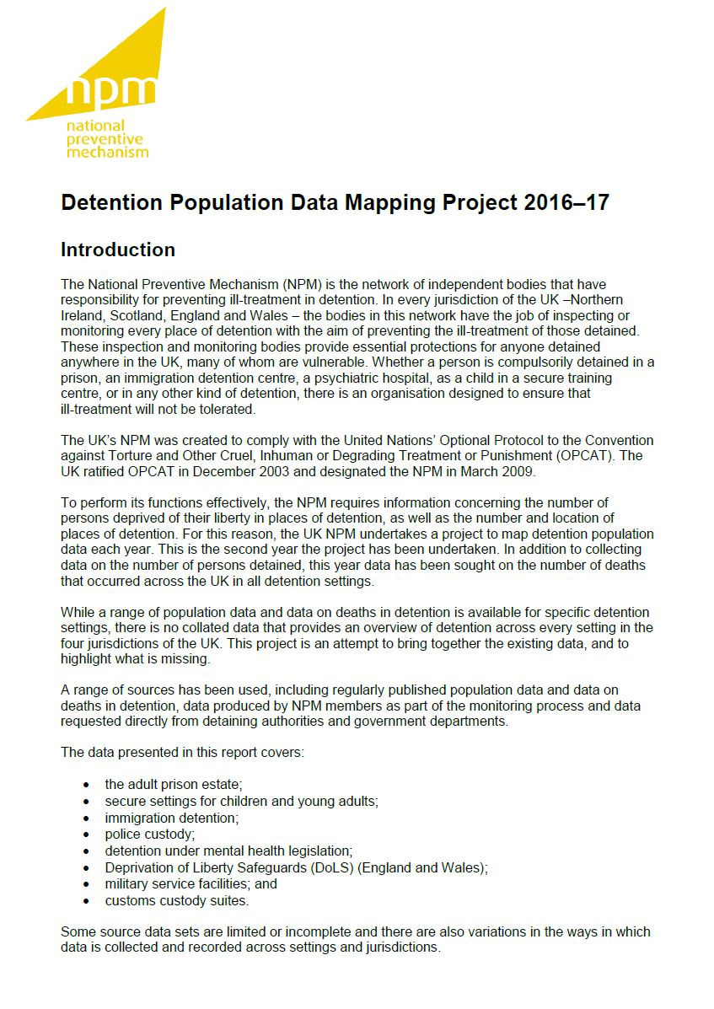

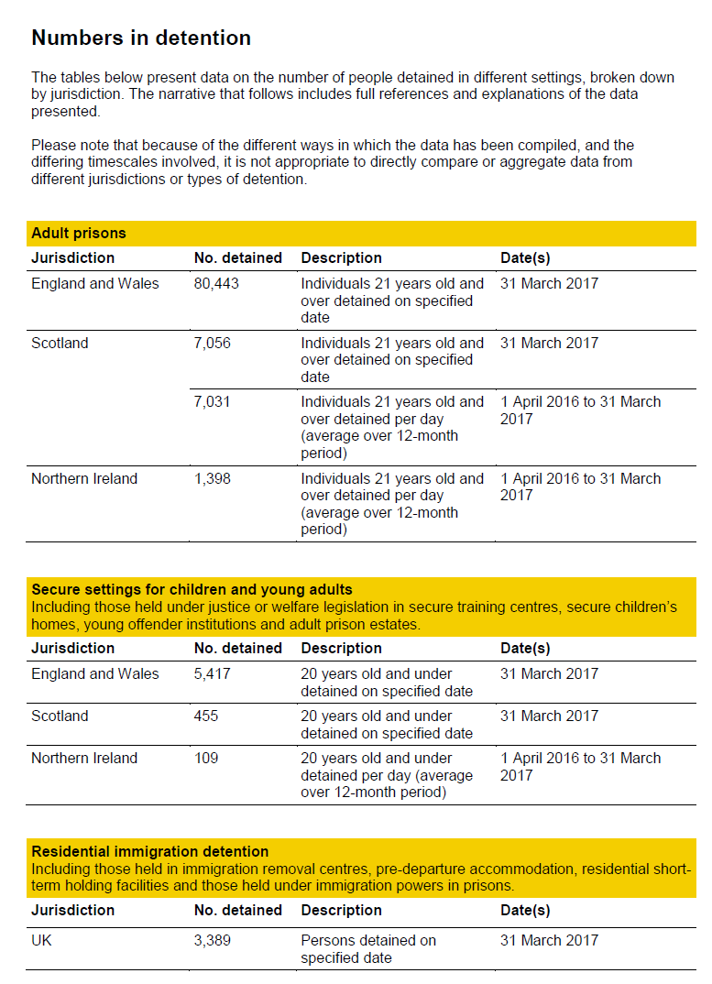

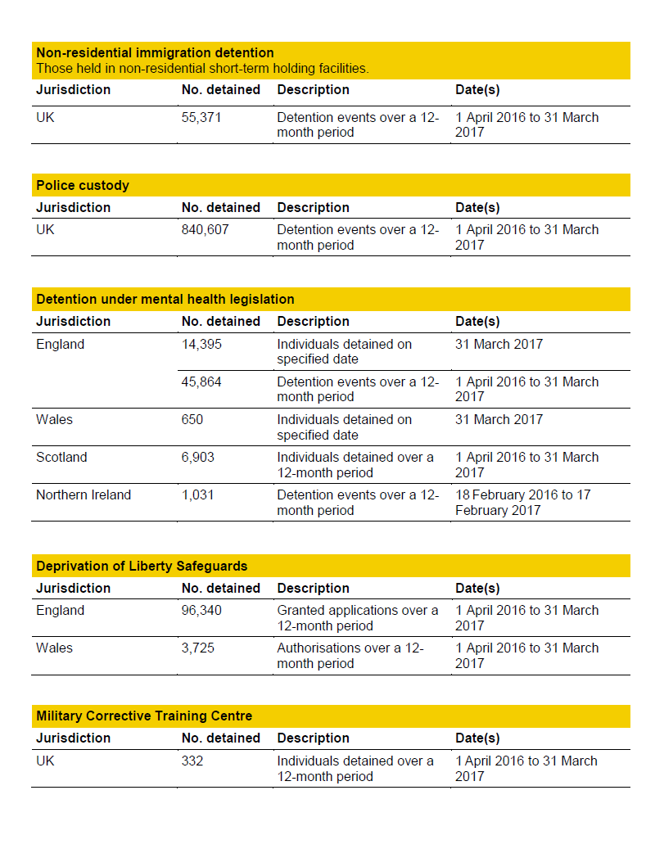
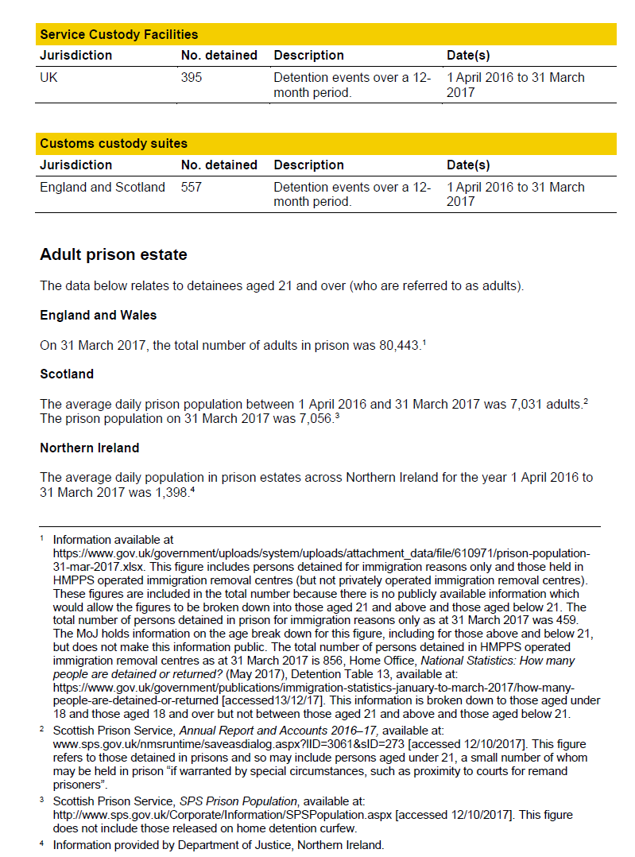
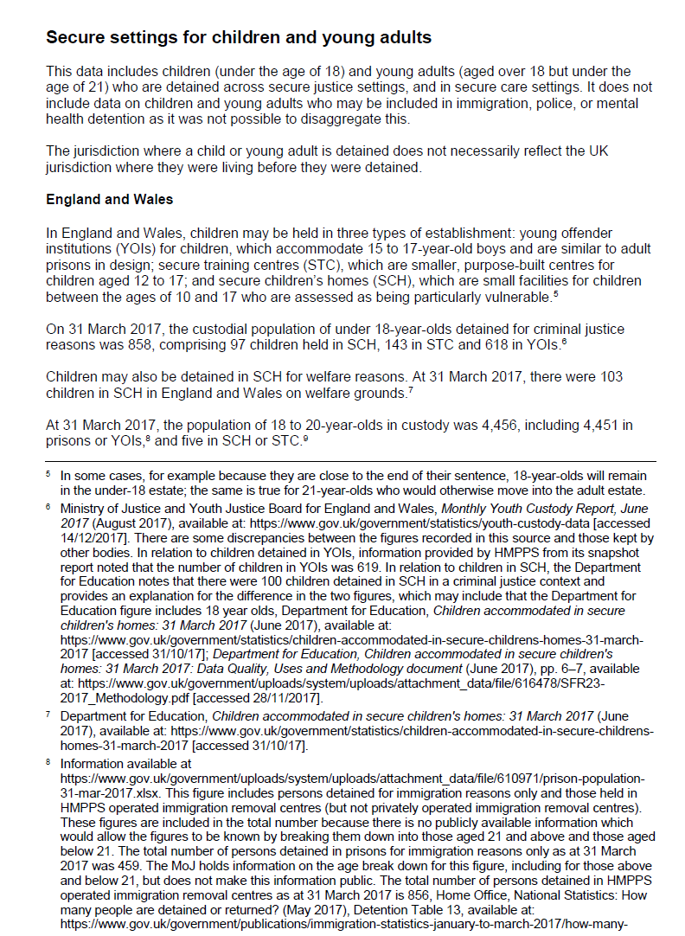
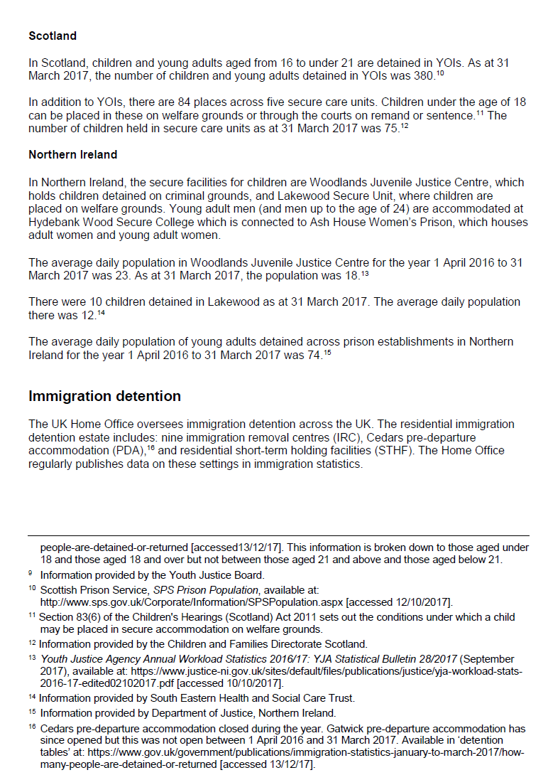
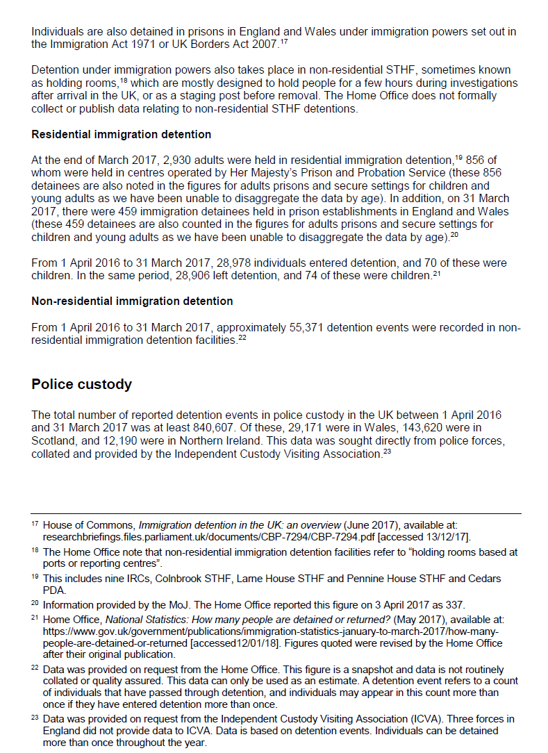
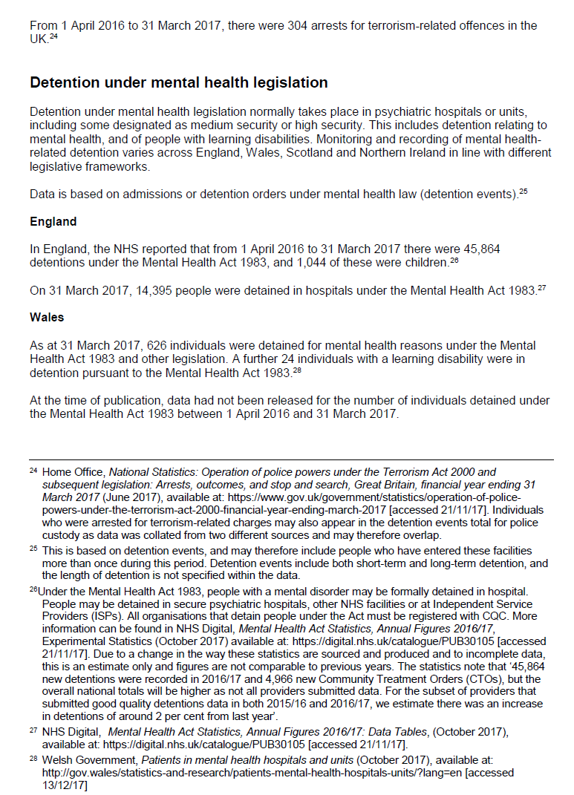
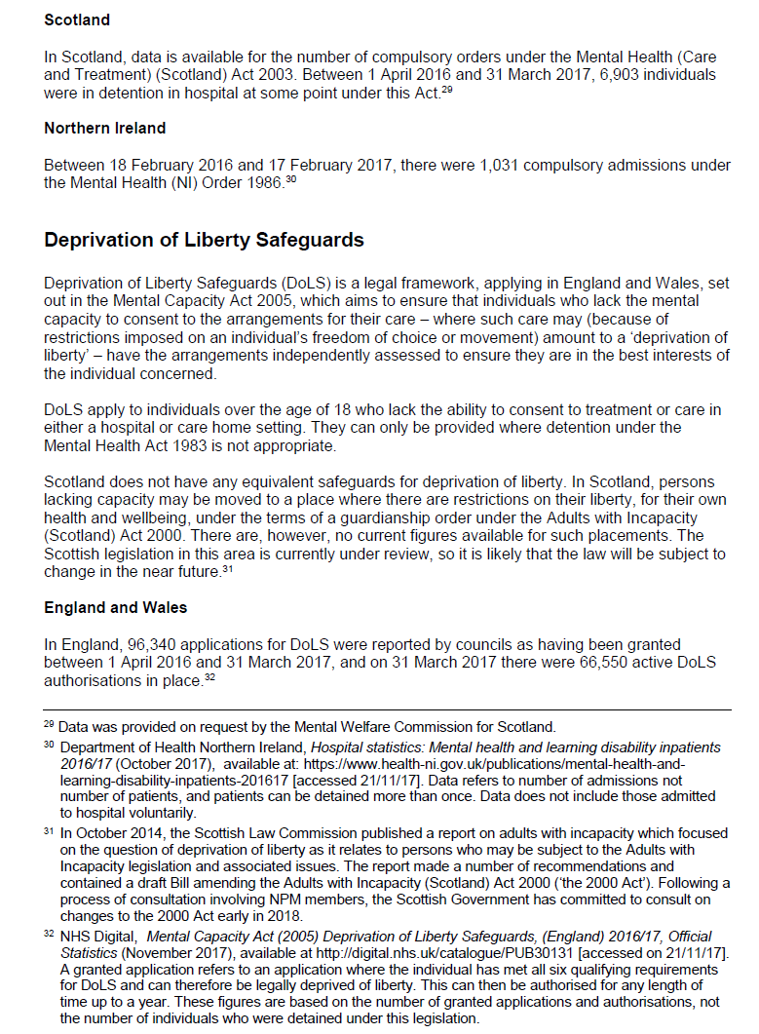
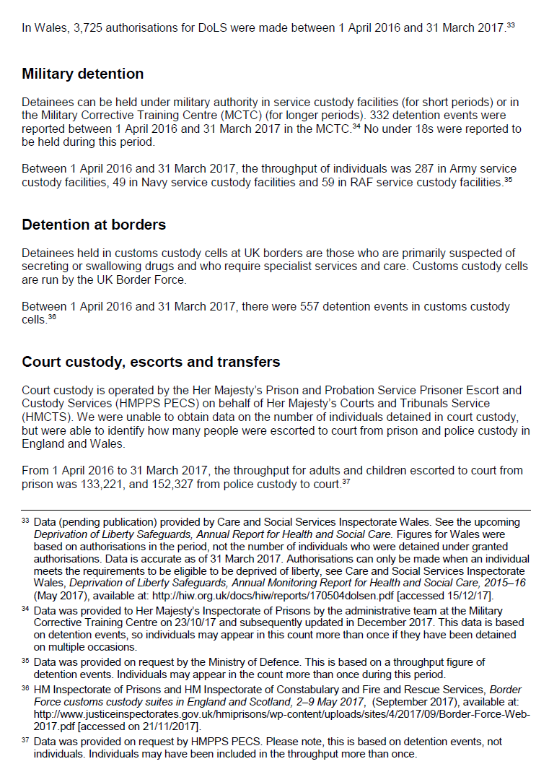
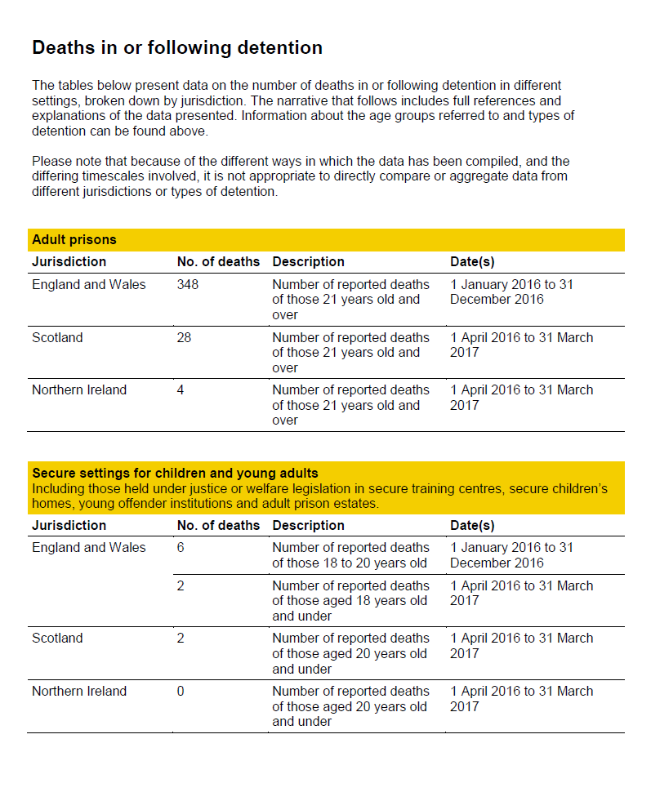
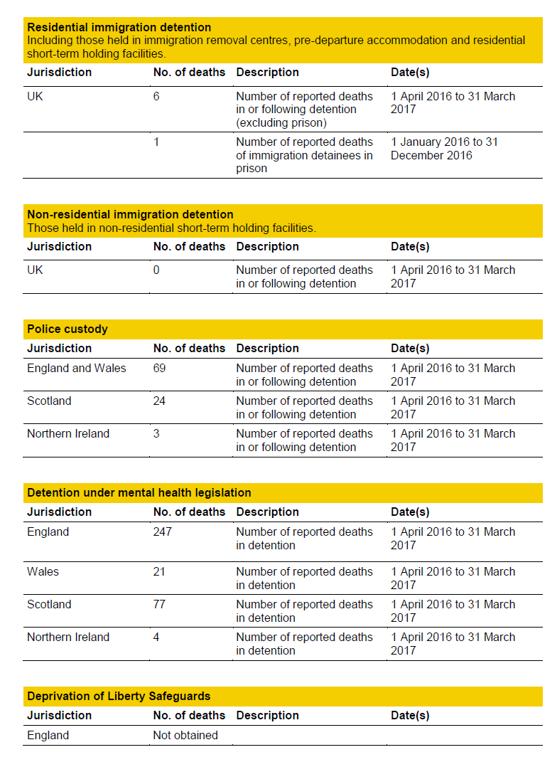
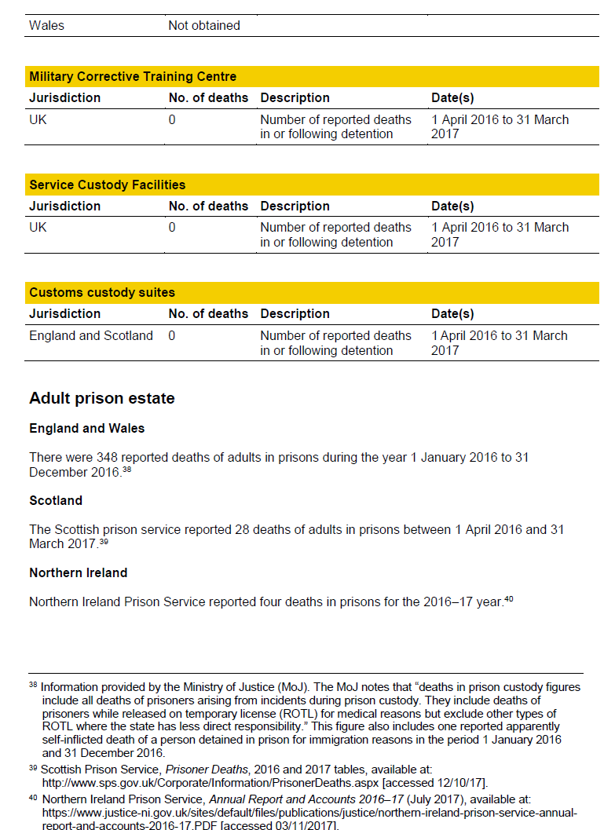
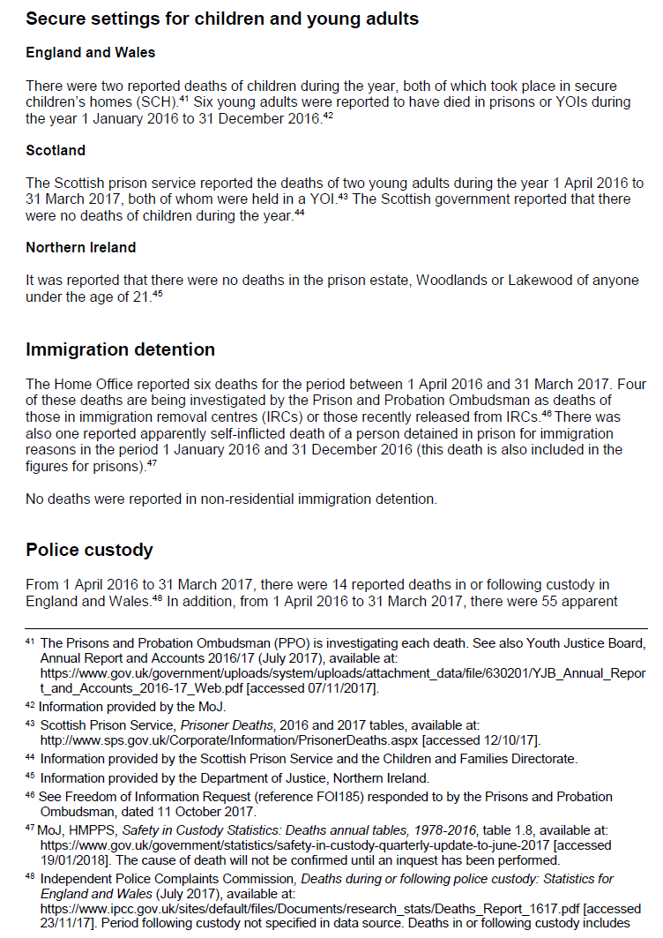
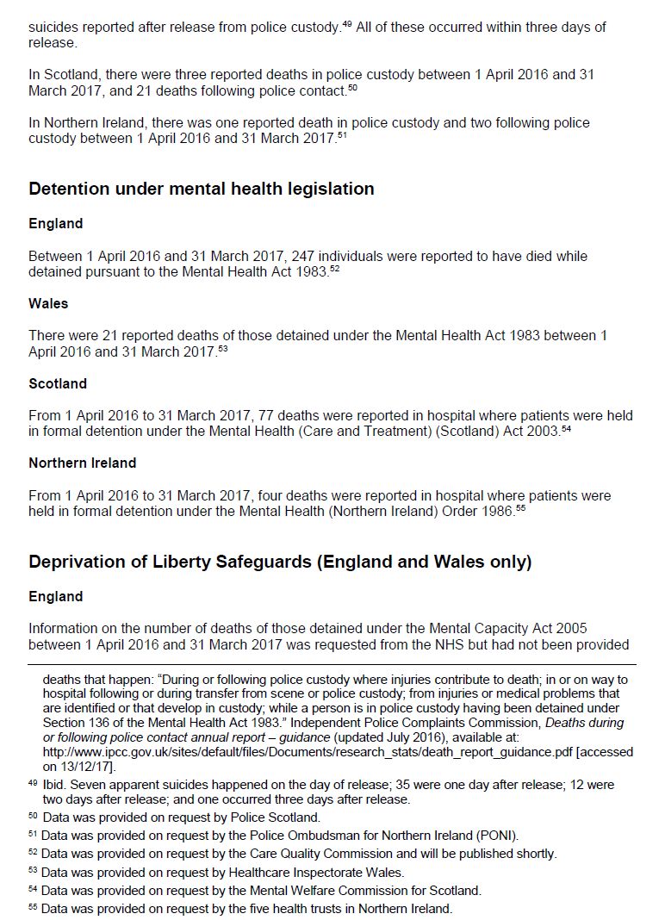
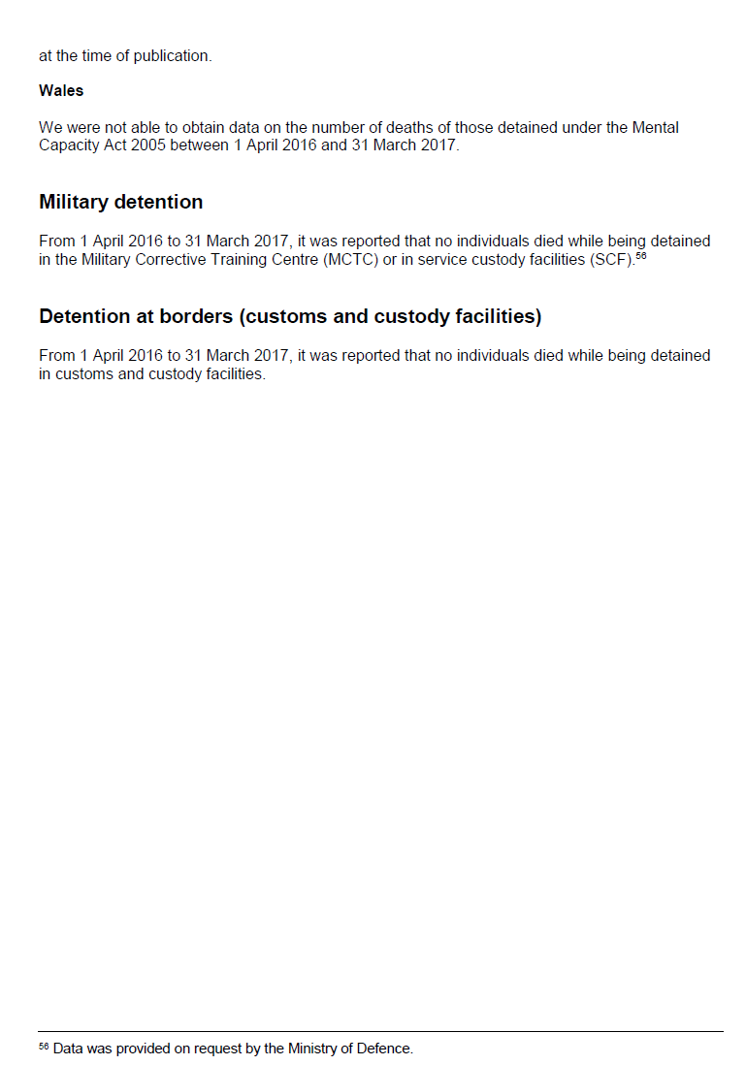

Appendix iii Correspondence from UN SPT on NPM independence, 29 January 2018

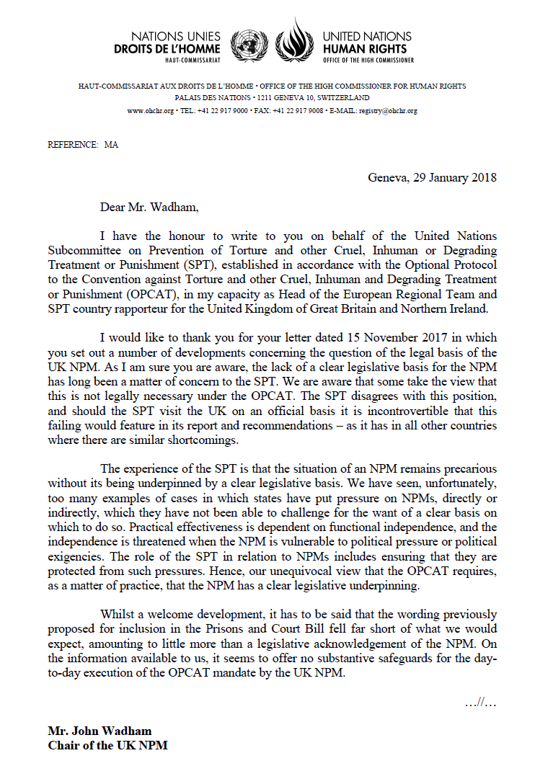

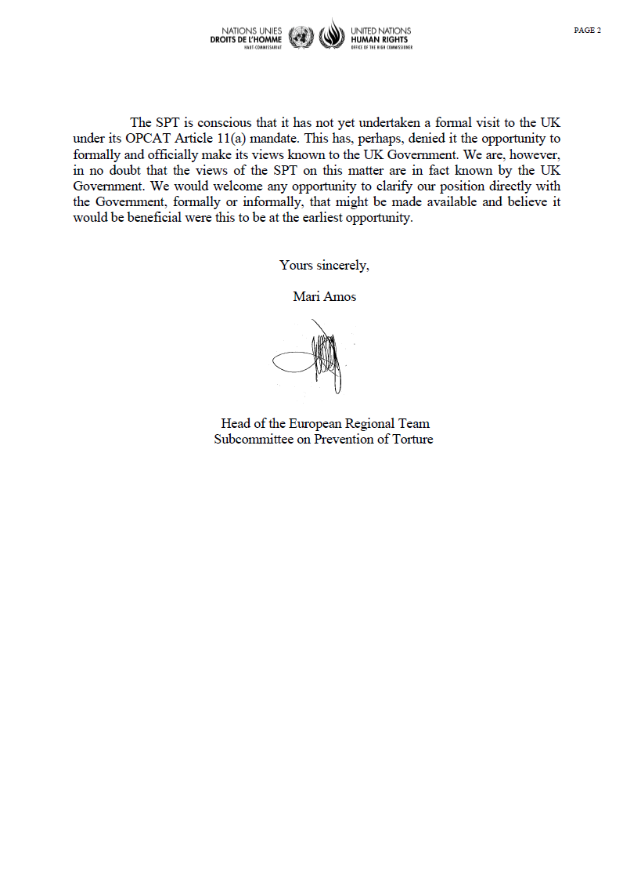
Appendix iv Glossary

ACCT Assessment, care in custody and teamwork
CAT Convention against Torture and other Cruel, Inhuman or Degrading Treatment or Punishment
CCE Children’s Commissioner for England
CI Care Inspectorate
CIW Care Inspectorate Wales
CJINI Criminal Justice Inspection Northern Ireland
(the) Committee Committee Against Torture
CPT European Committee for the Prevention of Torture and Inhuman or Degrading Treatment or Punishment
CSU Care and separation unit
CQC Care Quality Commission
DoLS Deprivation of Liberty Safeguards
ECHR European Convention on Human Rights
FAI Fatal Accident Inquiry
HIW Healthcare Inspectorate Wales
HMICFRS Her Majesty’s Inspectorate of Constabulary and Fire & Rescue Services
HMICS Her Majesty’s Inspectorate of Constabulary in Scotland
HMIP Her Majesty’s Inspectorate of Prisons
HMIPS Her Majesty’s Inspectorate of Prisons for Scotland
HMP Her Majesty’s Prison
HMPPS Her Majesty’s Prison and Probation Service
ICVA Independent Custody Visiting Association
ICVS Independent Custody Visiting Scotland
IICSA Independent Inquiry into Child Sexual Abuse
IMB Independent Monitoring Board
IMBNI Independent Monitoring Boards (Northern Ireland)
IPCU Intensive Psychiatric Care Unit
IRC Immigration removal centre
IRTL Independent Reviewer of Terrorism Legislation
JCHR Joint Committee on Human Rights
LAA Legal Aid Agency
LO Lay Observers
LoIPR List of Issues Prior to Reporting
MHA Mental Health Act 1983
MMPR Minimising and Managing Physical Restraint
MoJ Ministry of Justice
MWCS Mental Welfare Commission for Scotland
NHS National Health Service
NI Northern Ireland
NIPBICVS Northern Ireland Policing Board Independent Custody Visiting Scheme
NGO Non-governmental organisation
NPM National Preventive Mechanism
NRM National Referral Mechanism
OSCE Organization for Security and Co-operation in Europe
Ofsted Office for Standards in Education, Children’s Services and Skills
OPCAT Optional Protocol to the Convention against Torture and other Cruel, Inhuman or Degrading Treatment or Punishment
PACE Police and Criminal Evidence Act 1984
PPO Prisons and Probation Ombudsman
RQIA Regulation and Quality Improvement Authority
SHRC Scottish Human Rights Commission
SPT United Nations Subcommittee on Prevention of Torture and Other Cruel, Inhuman or Degrading Treatment or Punishment
SCH Secure children’s home
STC Secure training centre
STHF Short-term holding facility
UK United Kingdom
YOI Young offender institution

A new inspection framework was piloted at this inspection. The judgement structure used was: the overall experiences and progress of children and young people, taking into account; how well children are helped and protected, the quality of education and related learning activities, the health of children and young people and the effectiveness of leaders and managers. The assessment of how well children are helped and protected includes assessment of issues that were previously included in the of safety and promoting positive behaviour.
The UK NPM’s remit does not extend to any Crown Dependencies or Overseas Territories (which were not included in the initial ratification of OPCAT). Although some NPM members have visited or inspected places of detention outside the UK, this has been by invitation only.
Available at https://s3-eu-west-2.amazonaws.com/npm-prod-storage-19n0nag2nk8xk/uploads/2015/05/Written-Ministerial-Statement_Designating-NPM_2009.pdf accessed 20 March 2019.
Available at https://www.parliament.uk/business/publications/written-questions-answers-statements/written-statement/Lords/2017-01-12/HLWS412/ accessed 20 March 2019.
Available at https://www.justiceinspectorates.gov.uk/hmiprisons/wp-content/uploads/sites/4/2017/11/HMIP-MoJ-protocol-amend301117.pdf accessed 20 March 2019.
An overview of the NPM’s activities can be found in its annual reports at https://www.nationalpreventivemechanism.org.uk/publications-resources/ accessed 20 March 2019.
Available at https://www.justiceinspectorates.gov.uk/hmiprisons/wp-content/uploads/sites/4/2014/02/Protocol-for-working-arrangements-to-prevent-sanctions-with-Independent-Monitoring-Boards-and-the-Prisons-and-Probation-Ombudsman1.pdf accessed 20 March 2019.
Available at https://s3-eu-west-2.amazonaws.com/npm-prod-storage-19n0nag2nk8xk/uploads/2017/02/NPM-Isolation-Guidance-FINAL.pdf accessed 20 March 2019.
Public Bill Committee, Written evidence submitted by John Wadham, Chair of the UK National Preventive Mechanism (PCB 08), available at https://publications.parliament.uk/pa/cm201617/cmpublic/PrisonsCourts/memo/PCB08.htm accessed 20 March 2019.
Justice Committee, Oral evidence: Prison reform (Governor empowerment and prison performance), HC 548, available at http://data.parliament.uk/writtenevidence/committeeevidence.svc/evidencedocument/justice-committee/prisonreform/oral/46581.htm; Written evidence from the UK NPM to the Justice Committee, January 2017, available at http://data.parliament.uk/writtenevidence/committeeevidence.svc/evidencedocument/justice-committee/prisonreform/written/45906.htm; Written evidence from the UK NPM (MHP0031) to the Joint Committee on Human Rights, March 2017, available at http://data.parliament.uk/writtenevidence/committeeevidence.svc/evidencedocument/human-rightscommittee/mental-health-and-deaths-in-prison/written/48220.htm all accessed 20 March 2019.
Justice Committee’s 14th Report – Prison Reform: Part 1 of the Prisons and Courts Bill, HC 1150, 28 April 2017, available at https://publications.parliament.uk/pa/cm201617/cmselect/cmjust/1150/1150.pdf accessed 20 March 2019.
Available at https://s3-eu-west-2.amazonaws.com/npm-prod-storage-19n0nag2nk8xk/uploads/2015/05/NPM-guidance_Ensuring-the-independence-of-NPM-personnel.pdf accessed 20 March 2019.
The NPM is aware that there has been criticism by the SPT of the fact that some key decisions, such as advice to terminate IMB members’ appointments, were taken by staff in the IMB secretariat, who are Ministry of Justice (MoJ) civil servants. The IMB’s new governance structure is designed to ensure that these decisions are made independently from the MoJ within that structure, but it has no statutory basis. This also means that the national IMB structure cannot employ its own staff. The IMB has therefore asked for legislation.
HMIP, Report on an unannounced inspection of Dungavel House Immigration Removal Centre by HM Chief Inspector of Prisons, 2–5, 9–11, 16–19 July 2018 [1.64], available at https://www.justiceinspectorates.gov.uk/hmiprisons/wp-content/uploads/sites/4/2018/11/Dungavel-Web-2018.pdf accessed 20 March 2019.
See for example: HMIP, Report on an unannounced inspection of Heathrow Immigration Removal Centre Harmondsworth Site by HM Chief Inspector of Prisons, 2–20 October 2018 [1.59], available at https://www.justiceinspectorates.gov.uk/hmiprisons/wp-content/uploads/sites/4/2018/03/Harmondsworth-Web-2017.pdf and HMIP, Report on an unannounced inspection of Yarl’s Wood Immigration Removal Centre by HM Chief Inspector of Prisons, 5–7, 12–16 June 2017 [1.69], available at https://www.justiceinspectorates.gov.uk/hmiprisons/wp-content/uploads/sites/4/2017/11/Yarls-Wood-Web-2017.pdf both accessed 20 March 2019.
See, for example, HMIP, Report on an unannounced inspection of the short-term holding facility at Heathrow Airport Terminal 4 by HM Chief Inspector of Prisons, 29 October 2018 [1.27], available at https://www.justiceinspectorates.gov.uk/hmiprisons/wp-content/uploads/sites/4/2019/03/2018-HEATHROW-T4-STHF-final-report.pdf.
Paragraph 14.
Available at https://assets.publishing.service.gov.uk/government/uploads/system/uploads/attachment_data/file/719819/female-offender-strategy.pdf> accessed 20 March 2019.
There is no women’s prison in Wales.
This is an improvement from the position in 2016–17, when inspections in England found that the provision of support for women who had experienced sexual violence was not adequate to meet need. See HMIP Annual Report 2016–17, p.58, available at https://www.justiceinspectorates.gov.uk/hmiprisons/wp-content/uploads/sites/4/2017/07/HMIP-AR_2016-17_CONTENT_201017_WEB.pdf, HMIP Annual Report 2017–18, p. 57, available at https://www.justiceinspectorates.gov.uk/hmiprisons/wp-content/uploads/sites/4/2018/07/6.5053_HMI-Prisons_AR-2017-18_revised_web.pdf and HMIP inspection reports on Send (2018) [4.38], available at https://www.justiceinspectorates.gov.uk/hmiprisons/wp-content/uploads/sites/4/2018/11/Send-Web-2018.pdf Bronzefield (2015) [4.45], available at https://www.justiceinspectorates.gov.uk/hmiprisons/wp-content/uploads/sites/4/2016/04/Bronzefield-web2015.pdf, Peterborough (2017) [4.45], available at https://www.justiceinspectorates.gov.uk/hmiprisons/wp-content/uploads/sites/4/2018/01/HMP-YOI-Peterborough-Women-Web-2017-1.pdf , and Styal (2018) [4.43], available at https://www.justiceinspectorates.gov.uk/hmiprisons/wp-content/uploads/sites/4/2018/09/Styal-Web-2018-1.pdf HMIPS, Inspection of HMP/YOI Polmont, 2018, report forthcoming.
CJINI, Resettlement: An inspection of resettlement in the Northern Ireland Prison Service, May 2018, p.72, available at http://www.cjini.org/getattachment/1ded7a6c-034e-4a62-bf02-96ee30584645/report.aspx accessed 20 March 2019.
See, for example, Report on an unannounced inspection visit to police custody suites in Derbyshire by HM Inspectorate of Prisons and HM Inspectorate of Constabulary and Fire & Rescue Services, 9–19 April 2018 [3.8], available at https://www.justiceinspectorates.gov.uk/hmiprisons/wp-content/uploads/sites/4/2018/08/DERBYSHIRE-POLICE-Web-2018.pdf; Report on an unannounced inspection visit to police custody suites in Norfolk and Suffolk by HM Inspectorate of Prisons and HM Inspectorate of Constabulary and Fire & Rescue Services, 14–25 May 2018 [3.8] and [4.35], available at https://www.justiceinspectorates.gov.uk/hmiprisons/wp-content/uploads/sites/4/2018/10/Norfolk-and-Suffolk-police-Web-2018.pdf; and Report on an unannounced inspection visit to police custody suites in Thames Valley Police by HM Inspectorate of Prisons and HM Inspectorate of Constabulary and Fire & Rescue Services, 5–16 February 2018 [3.7] and [4.32], available at https://www.justiceinspectorates.gov.uk/hmiprisons/wp-content/uploads/sites/4/2018/06/Thames-Valley-Police-Web-2018.pdf> all accessed 20 March 2019.
HMICS, Inspection of custody centres at Aikenhead Road and London Road, Glasgow, July2016 [31]-[33], available at https://www.hmics.scot/publications/inspection-custody-centres-aikenhead-road-and-london-road-glasgow; and HMICS, Inspection of custody centres across Scotland, October2018 [51] and [55], available at https://www.hmics.scot/sites/default/files/publications/HMICS20181019PUB.pdf, accessed 20 March 2019.
See HMIP inspection reports on East Sutton Park (2016) [4.42], available at https://www.justiceinspectorates.gov.uk/hmiprisons/wp-content/uploads/sites/4/2016/12/East-Sutton-Park-Web-2016.pdf and Foston Hall (2016) [4.43], available at https://www.justiceinspectorates.gov.uk/hmiprisons/wp-content/uploads/sites/4/2016/10/HMP-YOI-Foston-Hall-Web-2016-1.pdf both accessed 20 March 2019.
See HMIP inspection reports on Styal (2018) [4.49], available at https://www.justiceinspectorates.gov.uk/hmiprisons/wp-content/uploads/sites/4/2018/09/Styal-Web-2018-1.pdf, Drake Hall (2016) [4.42], available at https://www.justiceinspectorates.gov.uk/hmiprisons/wp-content/uploads/sites/4/2016/11/Drake-Hall-Web-2016-2.pdf, and Eastwood Park (2016) [4.39], available at https://www.justiceinspectorates.gov.uk/hmiprisons/wp-content/uploads/sites/4/2017/03/Eastwood-Park-Web-2016.pdf all accessed 20 March 2019.
See HMIP inspection reports on Peterborough (2017) [4.48], available at https://www.justiceinspectorates.gov.uk/hmiprisons/wp-content/uploads/sites/4/2018/01/HMP-YOI-Peterborough-Women-Web-2017-1.pdf, Downview (2017) [4.37], available at https://www.justiceinspectorates.gov.uk/hmiprisons/wp-content/uploads/sites/4/2017/12/Downview-Web-2017.pdf and New Hall (2015) [4.49], available at https://www.justiceinspectorates.gov.uk/hmiprisons/wp-content/uploads/sites/4/2015/10/New-Hall-Web-2015.pdf all accessed 20 March 2019.
Available at http://www.cjini.org/getattachment/efa315e4-3288-47e1-85f6-2de9186916fc/report.aspx accessed 20 March 2019.
HMICFRS, Stolen freedom: the policing response to modern slavery and human trafficking, October 2017, p.10, available at https://www.justiceinspectorates.gov.uk/hmicfrs/wp-content/uploads/stolen-freedom-the-policing-response-to-modern-slavery-and-human-trafficking.pdf accessed 20 March 2019.
See [1.30], available at https://www.justiceinspectorates.gov.uk/hmiprisons/wp-content/uploads/sites/4/2018/03/Harmondsworth-Web-2017.pdf accessed 20 March 2019.
HMIP, HM Chief Inspector of Prisons for England and Wales Annual Report 2017–18, HC 1245, p.30, available at https://www.justiceinspectorates.gov.uk/hmiprisons/wp-content/uploads/sites/4/2018/07/6.5053_HMI-Prisons_AR-2017-18_revised_web.pdf accessed 20 March 2019.
IMB, Annual Report of the Independent Monitoring Board at HMP & YOI Downview for reporting Year to 30 April 2018 [5.6], available at https://s3-eu-west-2.amazonaws.com/imb-prod-storage-1ocod6bqky0vo/uploads/2018/11/Downview-2017-18.pdf accessed 20 March 2019.
CJINI, Report on an unannounced inspection of Ash House Women’s Prison Hydebank Wood, 9-19 May 2016, October 2016, p.14, and Report on an unannounced inspection of Hydebank Wood Secure College, 9-19 May 2016, p.14, both available at http://www.cjini.org/TheInspections/Inspection-Reports/2016 accessed 20 March 2019.
HMIP and HMIC, Report on an unannounced inspection visit to police custody suites in Lincolnshire by HM Inspectorate of Prisons and HM Inspectorate of Constabulary 23–29 September 2015 [4.3], available at https://www.justiceinspectorates.gov.uk/hmiprisons/wp-content/uploads/sites/4/2016/02/Lincolnshire-police-custody-web-2015.pdf accessed 20 March 2019.
CJINI, Report on an unannounced inspection of Ash House Women’s Prison Hydebank Wood, 9-19 May 2016, October 2016, p.19, available at http://www.cjini.org/getattachment/efa315e4-3288-47e1-85f6-2de9186916fc/report.aspx, as well as inspection reports on Ash House published in: 2013, p.xiv, available at http://www.cjini.org/getattachment/3fd65fc3-e0b0-40b8-a06d-4cfe7b8f3e2c/report.aspx; 2011, p.9, available at http://www.cjini.org/getattachment/13bb7dbe-b18e-406a-bc04-acd5ce4b071a/Hydebank-Wood-Womens-Prison.aspx; 2008,p.16, available at http://www.cjini.org/getattachment/3ca1e4a3-649a-491d-bb54-f59b80fff6b5/Ash-House-Hydebank-Wood-Nov-2007.aspx; 2004,p.15, available at http://www.cjini.org/getattachment/cf804842-2d36-43b5-949c-30891e55e15d/Ash-House-Hydebank-Wood-Prison-November-2004.aspx. All accessed 20 March 2019.
IMB, Annual Report to The Secretary of State covering the period 1st April 2015 to 31st March 2016, The Independent Monitoring Board HMP Pentonville , p.2, available at https://s3-eu-west-2.amazonaws.com/imb-prod-storage-1ocod6bqky0vo/uploads/2016/07/Pentonville-2015-16.pdf; Annual Report of the Independent Monitoring Board at HMP Pentonville for reporting year April 2016 – March 2017, p.10, available at https://s3-eu-west-2.amazonaws.com/imb-prod-storage-1ocod6bqky0vo/uploads/2017/07/IMB-Pentonville-2016-17.pdf; Annual Report of the Independent Monitoring Board at HMP Pentonville for reporting year April 2017 - March 2018, p.9, available at https://s3-eu-west-2.amazonaws.com/imb-prod-storage-1ocod6bqky0vo/uploads/2018/08/Pentonville-2017-18.pdf all accessed 20 March 2019.
See [1.38]-[1.44] available at https://www.justiceinspectorates.gov.uk/hmiprisons/wp-content/uploads/sites/4/2019/01/Bedford-Web-2018.pdf accessed 20 March 2019.
HMIP, HM Chief Inspector of Prisons for England and Wales Annual Report 2017–18, HC 1245, p.11, available at https://www.justiceinspectorates.gov.uk/hmiprisons/wp-content/uploads/sites/4/2018/07/6.5053_HMI-Prisons_AR-2017-18_revised_web.pdf accessed 20 March 2019
HMPPS sets out its standards for certification of prisoner accommodation in PSI 17/2012, which uses the measures of certified normal accommodation (CNA) and operational capacity. A cell’s CNA is determined by prisons group directors and noted on cell certificates. PSI 17/2012 states that ‘CNA represents the good, decent standard of accommodation that the Service aspires to provide all prisoners.’ Operational capacity is ‘the total number of prisoners that an establishment can hold without serious risk to good order, security and the proper running of the planned regime. It is determined and approved by DDCs using operational judgement and their knowledge of establishment regime and infrastructure.’ HMPPS refers to prisons which hold above their CNA but below their operational capacity as crowded. HMIP and the IMB consider CNA and operational capacity figures when inspecting and monitoring prisons but also form their own judgements about whether prisoners are held in safe and decent conditions when determining whether they consider a prison overcrowded. HMIP will refer to a prison as overcrowded when it considers that conditions for prisoners, assessed against its own inspection standards, are detrimentally impacted by the size of the prison population.
See, for example, Report on an unannounced inspection of HMP Holme House by HM Chief Inspector of Prisons 3–4, 10–13 July 2017 [1.31] available at https://www.justiceinspectorates.gov.uk/hmiprisons/inspections/hmp-holme-house/ accessed 20 March 2019.
IMB, Annual Report of the Independent Monitoring Board at HMP Brixton for reporting Year (1 September 2017 to 31 August 2018) [3.9], [3.29] and [7.1] available at https://s3-eu-west-2.amazonaws.com/imb-prod-storage-1ocod6bqky0vo/uploads/2019/01/Brixton-2017-18.pdf accessed 20 March 2019.
See generally HMIP, Life in prison: Living conditions. A findings paper by HM Inspectorate of Prisons , available at https://www.justiceinspectorates.gov.uk/hmiprisons/wp-content/uploads/sites/4/2017/10/Findings-paper-Living-conditions-FINAL-.pdf. See also IMB Annual Report of the Independent Monitoring Board at HMP Coldingley for reporting Year (1 August 2017 to 31 July 2018), Section 2, available at https://s3-eu-west-2.amazonaws.com/imb-prod-storage-1ocod6bqky0vo/uploads/2018/10/Coldingley-2017-18.pdf and Annual Report of the Independent Monitoring Board at HMP Long Lartin for reporting Year 1 February 2017 - 31 January 2018, Section 7.2, available at https://s3-eu-west-2.amazonaws.com/imb-prod-storage-1ocod6bqky0vo/uploads/2018/05/Long-Lartin-2017-18.pdf all accessed 20 March 2019.
See HMIP, Report on an unannounced inspection of HMP Birmingham by HM Chief Inspector of Prisons 30 July–9 August 2018 [2.6]-[2.12] available at https://www.justiceinspectorates.gov.uk/hmiprisons/wp-content/uploads/sites/4/2018/12/HMP-Birmingham-Web-2018.pdf. See also, for example, HMIP’s inspection reports on Bedford [2.6]-[2.14] available at https://www.justiceinspectorates.gov.uk/hmiprisons/wp-content/uploads/sites/4/2019/01/Bedford-Web-2018.pdf and Liverpool [2.6]-[2.8] available at https://www.justiceinspectorates.gov.uk/hmiprisons/wp-content/uploads/sites/4/2018/01/HMP-Liverpool-Web-2017.pdf all accessed 20 March 2019.
IMB, Annual Report of the Independent Monitoring Board at HMP Liverpool for reporting Year (1 January 2017 to 31 December 2017), Section 2i, available at https://s3-eu-west-2.amazonaws.com/imb-prod-storage-1ocod6bqky0vo/uploads/2018/10/Liverpool-2017.pdf.
NPM, Monitoring places of detention. Sixth Annual Report of the United Kingdom’s National Preventive Mechanism, 1 April 2014 – 31 March 2015, pp21-25, available at https://s3-eu-west-2.amazonaws.com/npm-prod-storage-19n0nag2nk8xk/uploads/2015/12/NPM-Annual-Report-2014-15-web.pdf accessed 20 March 2019.
HMIP, HM Chief Inspector of Prisons for England and Wales Annual Report 2017–18, p.38, available at https://www.justiceinspectorates.gov.uk/hmiprisons/wp-content/uploads/sites/4/2018/07/6.5053_HMI-Prisons_AR-2017-18_revised_web.pdf accessed 20 March 2019. A small number of those aged over 21 may remain in a YOI for a short period and so survey figures for this group include responses from some aged over 21. See also IMB, Annual Report of the Independent Monitoring Board at HMP/YOI Winchester for reporting Year (June 2017 to May 2018), Section 4, available at https://s3-eu-west-2.amazonaws.com/imb-prod-storage-1ocod6bqky0vo/uploads/2018/09/Winchester-Annual-Report-2017-2018.pdf accessed 20 March 2019.
See, for example, HMIP reports on Birmingham (2018) [3.1] available at https://www.justiceinspectorates.gov.uk/hmiprisons/wp-content/uploads/sites/4/2018/12/HMP-Birmingham-Web-2018.pdf; Liverpool (2017) [3.1] available at https://www.justiceinspectorates.gov.uk/hmiprisons/wp-content/uploads/sites/4/2018/01/HMP-Liverpool-Web-2017.pdf; and Channings Wood (2018) [1.12] available at https://www.justiceinspectorates.gov.uk/hmiprisons/wp-content/uploads/sites/4/2019/02/Channings-Wood-Web-2018.pdf all accessed 20 March 2019.
See various HMP Polmont inspection and monitoring reports, available at https://www.prisonsinspectoratescotland.gov.uk/publications accessed 20 March 2019.
HMIP, HM Chief Inspector of Prisons for England and Wales Annual Report 2016–17, pp.25–26 and HM Chief Inspector of Prisons for England and Wales Annual Report 2017–18, p.26, available at https://www.justiceinspectorates.gov.uk/hmiprisons/inspections?s&prison-inspection-type=annual-reports accessed 20 March 2019.
See HMIP report on Whitemoor (2017) [1.48]-[1.54] available at https://www.justiceinspectorates.gov.uk/hmiprisons/wp-content/uploads/sites/4/2017/07/Whitemoor-Web-2017.pdf and IMB Whitemoor Annual Report 2017/18, Section 6.2, available at https://s3-eu-west-2.amazonaws.com/imb-prod-storage-1ocod6bqky0vo/uploads/2018/10/Whitemoor-2017-18.pdf. See also, for example, reports on HMP Bedford (2018) by HMIP 1[26]-[1.30] available at https://www.justiceinspectorates.gov.uk/hmiprisons/wp-content/uploads/sites/4/2019/01/Bedford-Web-2018.pdf and IMB Bedford Annual Report 2017/18, Section 7.1, available at https://s3-eu-west-2.amazonaws.com/imb-prod-storage-1ocod6bqky0vo/uploads/2018/10/Bedford-2017-18-.pdf accessed 20 March 2019.
See IMB report on Lowdham Grange, p.13, available at https://s3-eu-west-2.amazonaws.com/imb-prod-storage-1ocod6bqky0vo/uploads/2018/06/Lowdham-Grange-2017-18-1.pdf accessed 20 March 2019.
HMIP, HM Chief Inspector of Prisons for England and Wales Annual Report 2017–18, p.26, available at https://www.justiceinspectorates.gov.uk/hmiprisons/inspections?s&prison-inspection-type=annual-reports accessed 20 March 2019.
See HMIP report on Leeds (2017) [1.29]-[1.30], available at https://www.justiceinspectorates.gov.uk/hmiprisons/wp-content/uploads/sites/4/2018/03/HMP-Leeds-Web-2017.pdf accessed 20 March 2019.
CJINI, Report on an unannounced inspection of Maghaberry Prison, 9-19 April 2018, p.21, available at http://www.cjini.org/getattachment/cedf8f4d-34e8-47e1-916d-8fb31c141b8d/report.aspx accessed 20 March 2019.
HMIP, HM Chief Inspector of Prisons for England and Wales Annual Report 2017–18, p.26 and HM Chief Inspector of Prisons for England and Wales Annual Report 2016–17, p.25, available at https://www.justiceinspectorates.gov.uk/hmiprisons/inspections?s&prison-inspection-type=annual-reports. See, for example, HMIP report on Manchester (2018) [1.26]-[1.29] available at https://www.justiceinspectorates.gov.uk/hmiprisons/wp-content/uploads/sites/4/2018/11/Manchester-Web-2018.pdf all accessed 20 March 2019.
HMIP, HM Chief Inspector of Prisons for England and Wales Annual Report 2017–18, Appendix five, available at https://www.justiceinspectorates.gov.uk/hmiprisons/wp-content/uploads/sites/4/2018/07/6.5053_HMI-Prisons_AR-2017-18_revised_web.pdf accessed 20 March 2019.
See HMIP report on Aylesbury (2017) [S9] and [1.42] available at https://www.justiceinspectorates.gov.uk/hmiprisons/wp-content/uploads/sites/4/2017/08/Aylesbury-Web-2017.pdf accessed 20 March 2019.
See HMIP report on Liverpool (2017) [S10] and [1.28]-[1.31] available at https://www.justiceinspectorates.gov.uk/hmiprisons/wp-content/uploads/sites/4/2018/01/HMP-Liverpool-Web-2017.pdf accessed 20 March 2019.
See HMIP report on Preston 92017) [1.40]-[1.42] available at https://www.justiceinspectorates.gov.uk/hmiprisons/wp-content/uploads/sites/4/2017/07/Preston-Web-2017.pdf accessed 20 March 2019.
Ibid [1.3]
CJINI, Report on an unannounced inspection of Hydebank Wood Secure College, 9-19 May 2016 [1.47]-[1.49] available at http://www.cjini.org/getattachment/deb7ee5a-50c8-4b01-8586-c0abf5a523a8/report.aspx accessed 20 March 2019.
See announcement at https://www.gov.uk/government/news/prison-officer-safety-equipment-rolled-out.
The report, PAVA in Prisons Project Evaluation Report, 2018, can be found as Annex C in Prison Reform Trust, PAVA spray a Prison Reform Trust position paper, 2019, available at http://www.prisonreformtrust.org.uk/Portals/0/Documents/PAVA%20PRT%20position%20paper.pdf accessed 20 March 2019.
HMIP submission to Health and Social Care Select Committee inquiry into prison health care, May 2018, [42], available at http://data.parliament.uk/writtenevidence/committeeevidence.svc/evidencedocument/health-and-social-care-committee/prison-health/written/83925.html. See also IMB report on Wakefield, Section 6.5, available at https://s3-eu-west-2.amazonaws.com/imb-prod-storage-1ocod6bqky0vo/uploads/2019/01/Wakefield-2017-18-1.pdf and Whitemoor [8.5] and [8.5] available at https://s3-eu-west-2.amazonaws.com/imb-prod-storage-1ocod6bqky0vo/uploads/2018/10/Whitemoor-2017-18.pdf all accessed 20 March 2019.
The findings of this work are detailed in Monitoring places of detention. Eighth Annual Report of the United Kingdom’s National Preventive Mechanism, 1 April 2016 – 31 March 2017, pp. 29-44 and see p.43 therein for figure cited. Report available at https://s3-eu-west-2.amazonaws.com/npm-prod-storage-19n0nag2nk8xk/uploads/2018/02/6.4122_NPM_AR2016-17_v4_web.pdf accessed 20 March 2019.
HMIP, HM Chief Inspector of Prisons for England and Wales Annual Report 2017–18, p.34 and HM Chief Inspector of Prisons for England and Wales Annual Report 2016–17, p.27, available at https://www.justiceinspectorates.gov.uk/hmiprisons/inspections?s&prison-inspection-type=annual-reports; HMIP submission to Health and Social Care Select Committee inquiry into prison health care, May 2018, [24]-[32], available at http://data.parliament.uk/writtenevidence/committeeevidence.svc/evidencedocument/health-and-social-care-committee/prison-health/written/83925.html all accessed 20 March 2019.
HMIP submission to Health and Social Care Select Committee inquiry into prison health care, May 2018, [49]-[51], http://data.parliament.uk/writtenevidence/committeeevidence.svc/evidencedocument/health-and-social-care-committee/prison-health/written/83925.html.See, for example, HMIP report on Oakwood (2014) [2.69] at https://www.justiceinspectorates.gov.uk/hmiprisons/wp-content/uploads/sites/4/2015/02/Oakwood-web-2014.pdf accessed 20 March 2019.
HMIP and CQC, Social care in prisons in England and Wales - A thematic report, October 2018, [1.1]-[1.2] available at https://www.justiceinspectorates.gov.uk/hmiprisons/wp-content/uploads/sites/4/2018/10/Social-care-thematic-2018-web.pdf; and HMIPS, Who Cares? The Lived Experience of Older Prisoners in Scotland’s Prisons, 2017, pp.1 and 17, available at https://www.prisonsinspectoratescotland.gov.uk/publications/who-cares-lived-experience-older-prisoners-scotlands-prisons accessed 20 March 2019.
HMIP, Court custody: urgent improvement required, October 2015, available at https://www.justiceinspectorates.gov.uk/hmiprisons/wp-content/uploads/sites/4/2015/11/Court-custody-urgent-improvement-required-corrected.pdf accessed 20 March 2019.
Ibid
HMIP, HM Chief Inspector of Prisons for England and Wales Annual Report 2017–18, p.88 and HM Chief Inspector of Prisons for England and Wales Annual Report 2016–17, p.86, available at https://www.justiceinspectorates.gov.uk/hmiprisons/inspections?s&prison-inspection-type=annual-reports; LO, Annual Report to the Secretary of State for Justice 2017-2018, pp.28-29, <available at https://s3-eu-west-2.amazonaws.com/layobservers-prod-storage-nu2yj19yczbd/uploads/2018/07/Lay-Observer-Annual-Report-17-18.pdf>. See, for example, HMIP reports on Thames Valley court custody (2018) [4.33]-[4.36] available at https://www.justiceinspectorates.gov.uk/hmiprisons/wp-content/uploads/sites/4/2018/07/2018-Thames-Valley-court-cells-final-report.pdf and West Midlands and Warwickshire court custody (2016) [5.45]-[5.48] available at https://www.justiceinspectorates.gov.uk/hmiprisons/wp-content/uploads/sites/4/2017/04/West-Mids-and-Warks-court-custody-Web-2016.pdf all accessed 20 March 2019.
See HMIP report on London North, North East and West court custody [5.33]-[5.55] available at https://www.justiceinspectorates.gov.uk/hmiprisons/wp-content/uploads/sites/4/2017/10/London-North-North-East-and-West-court-custody-Web-2017.pdf accessed 20 March 2019.
See HMIP report on North and West Yorkshire court custody [1.23] and [4.11] available at https://www.justiceinspectorates.gov.uk/hmiprisons/wp-content/uploads/sites/4/2018/12/N-W-YORKS-COURTS-WEB-2018.pdf. See also HMIP, HM Chief Inspector of Prisons for England and Wales Annual Report 2017–18, p.88 and HM Chief Inspector of Prisons for England and Wales Annual Report 2016–17, p.86, available at https://www.justiceinspectorates.gov.uk/hmiprisons/inspections?s&prison-inspection-type=annual-reports all accessed 20 March 2019.
CJINI, An inspection of Prisoner Escort and Court Custody arrangements in Northern Ireland, available at http://www.cjini.org/getattachment/cc81a484-6109-4d33-95db-5b9d71df3883/Prisoner-Escort-and-Court-Custody-arrangements-in.aspx accessed 20 March 2019.
CJINI, NICTS Courts Estate. A follow-up review of inspection recommendations, available at http://www.cjini.org/TheInspections/Action-Plan-Reviews-Inspection-Follow-Up-Revie/2015/Northern-Ireland-Courts-and-Tribunals-Service-Ade accessed 20 March 2019.
See Monitoring places of detention. Sixth Annual Report of the United Kingdom’s National Preventive Mechanism, 1 April 2014 – 31 March 2015, available at https://s3-eu-west-2.amazonaws.com/npm-prod-storage-19n0nag2nk8xk/uploads/2015/12/NPM-Annual-Report-2014-15-web.pdf> accessed 20 March 2019.
HMIP, HM Chief Inspector of Prisons for England and Wales Annual Report 2017–18, pp.83-84, available at https://www.justiceinspectorates.gov.uk/hmiprisons/wp-content/uploads/sites/4/2018/07/6.5053_HMI-Prisons_AR-2017-18_revised_web.pdf. See, for example, HMIP and HMICFRS report on Dyfed-Powys police custody suites (2017) [3.13]-[3.14] available at https://www.justiceinspectorates.gov.uk/hmiprisons/wp-content/uploads/sites/4/2018/03/Dyfed-Powys-Police-Web-2017.pdf accessed 20 March 2019.
See, for example, HMIP and HMICFRS report on West Midlands police custody suites (2017) p.13 available at https://www.justiceinspectorates.gov.uk/hmiprisons/wp-content/uploads/sites/4/2017/06/West-Midlands-police-Web-2017-1.pdf accessed 20 March 2019.
CJINI, Police Custody: The detention of persons in police custody in Northern Ireland, pp.33-34, available at http://www.cjini.org/getattachment/338df4a1-68d6-4bb8-9403-9888bed9ebd9/report.aspx accessed 21 March 2019.
See HMIP and HMICFRS report on Humberside police custody suites (2017) [6.10] available at https://www.justiceinspectorates.gov.uk/hmiprisons/wp-content/uploads/sites/4/2018/03/HUMBERSIDE-POLICE-Web-2017.pdf accessed 21 March 2019.
See HMIP and HMICFRS report on Thames Valley police custody suites (2018) [4.14] available at https://www.justiceinspectorates.gov.uk/hmiprisons/wp-content/uploads/sites/4/2018/06/Thames-Valley-Police-Web-2018.pdf accessed 21 March 2019.
HMIP, HM Chief Inspector of Prisons for England and Wales Annual Report 2017–18, pp.83-84 and HM Chief Inspector of Prisons for England and Wales Annual Report 2016–17, p.81, available at https://www.justiceinspectorates.gov.uk/hmiprisons/inspections?s&prison-inspection-type=annual-reports accessed 20 March 2019
Ibid Annual Report 2017–18, p. 84.
See HMIP and HMICFRS report on Humberside police custody suites (2017) [6.12] available at https://www.justiceinspectorates.gov.uk/hmiprisons/wp-content/uploads/sites/4/2018/03/HUMBERSIDE-POLICE-Web-2017.pdf accessed 21 March 2019.
See, for example, HMIP and HMICFRS reports on police custody suites in Staffordshire (2017) [6.11]-[6.13] available at https://www.justiceinspectorates.gov.uk/hmiprisons/wp-content/uploads/sites/4/2017/07/STAFFORDSHIRE-POLICE-Web-2017.pdf and Cambridgeshire (2017) [6.9]-[6.11] available at https://www.justiceinspectorates.gov.uk/hmiprisons/wp-content/uploads/sites/4/2018/02/2017-Cambridgeshire-police-cells-Web-2017.pdf accessed 21 March 2019.
See HMIP and HMICFRS reports on police custody suites in Avon and Somerset (2016) [6.10] available at https://www.justiceinspectorates.gov.uk/hmiprisons/wp-content/uploads/sites/4/2016/12/Avon-Somerset-Web-2016.pdf and Dyfed-Powys (2017) [6.13] available at https://www.justiceinspectorates.gov.uk/hmiprisons/wp-content/uploads/sites/4/2018/03/Dyfed-Powys-Police-Web-2017.pdf accessed 21 March 2019.
Taser is not in general use in Northern Ireland as its use is limited to a specific armed response unit.
See HMIP and HMICFRS reports on police custody suites in Wiltshire (2015) [2.23] available at https://www.justiceinspectorates.gov.uk/hmiprisons/wp-content/uploads/sites/4/2016/05/2015-Wiltshire-police-cells-web2015.pdf and Sussex (2016) [6.12] available at https://www.justiceinspectorates.gov.uk/hmiprisons/wp-content/uploads/sites/4/2017/03/Sussex-police-.pdf accessed 21 March 2019.
See, for example, HMICS, Inspection of custody centres across Scotland (2018), Recommendation 7, paragraphs 42-44, available at https://www.hmics.scot/sites/default/files/publications/HMICS20181019PUB.pdf accessed 21 March 2019.
For example, in Northern Ireland CJINI encountered problems in easily identifying the ultimate disposal location for detainees who have been in custody. This was particularly important when attempting to identify the numbers of young people who had been held in police cells, held in Woodlands Juvenile Justice Centre on remand or bailed prior to appearing in court.
See, for example, HMIP and HMICFRS report on Humberside police custody suites (2017) [8.9] available at https://www.justiceinspectorates.gov.uk/hmiprisons/wp-content/uploads/sites/4/2018/03/HUMBERSIDE-POLICE-Web-2017.pdf and CJINI, Police Custody: The detention of persons in police custody in Northern Ireland, (2016), p.29 available at http://www.cjini.org/getattachment/338df4a1-68d6-4bb8-9403-9888bed9ebd9/report.aspx accessed 21 March 2019 .
HMIP, HM Chief Inspector of Prisons for England and Wales Annual Report 2017–18, pp.82, available at https://www.justiceinspectorates.gov.uk/hmiprisons/wp-content/uploads/sites/4/2018/07/6.5053_HMI-Prisons_AR-2017-18_revised_web.pdf. See, for example, HMICS, Inspection of custody centres across Scotland (2018), Recommendation 5 and from paragraphs 19-35, available at https://www.hmics.scot/sites/default/files/publications/HMICS20181019PUB.pdf accessed 21 March 2019.
Rousing involves waking a detainee even if sleeping, and gaining a verbal response from them.
HMICS, Thematic inspection of police custody arrangements in Scotland (2014), Recommendation 7, available at https://www.hmics.scot/sites/default/files/publications/Thematic%20Inspection%20of%20Police%20Custody%20Arrangements%20in%20Scotland.pdf and Inspection of custody centres across Scotland (2018), paragraph 34, available at https://www.hmics.scot/sites/default/files/publications/HMICS20181019PUB.pdf accessed 21 March 2019.
HMIP, HM Chief Inspector of Prisons for England and Wales Annual Report 2017–18, pp.82 and HM Chief Inspector of Prisons for England and Wales Annual Report 2016–17, p.80, available at https://www.justiceinspectorates.gov.uk/hmiprisons/inspections?s&prison-inspection-type=annual-reports. See, for example, HMIP and HMICFRS report on Staffordshire police custody suites (2017) [5.13] available at https://www.justiceinspectorates.gov.uk/hmiprisons/wp-content/uploads/sites/4/2017/07/STAFFORDSHIRE-POLICE-Web-2017.pdf and CJINI, Police Custody March 2016, p.32, available at https://www.rqia.org.uk/RQIA/files/16/16b4138d-4716-4325-9a2a-382930cf615e.pdf accessed 21 March 2019.
HMIP, HM Chief Inspector of Prisons for England and Wales Annual Report 2016–17, p.80, available at https://www.justiceinspectorates.gov.uk/hmiprisons/wp-content/uploads/sites/4/2017/07/HMIP-AR_2016-17_CONTENT_201017_WEB.pdf accessed 20 March 2019.
See, for example, HMIP and HMICFRS reports on police custody suites in Dyfed-Powys (2017) [6.15] available at https://www.justiceinspectorates.gov.uk/hmiprisons/wp-content/uploads/sites/4/2018/03/Dyfed-Powys-Police-Web-2017.pdf, Staffordshire (2017) [5.13] available at https://www.justiceinspectorates.gov.uk/hmiprisons/wp-content/uploads/sites/4/2017/07/STAFFORDSHIRE-POLICE-Web-2017.pdf; Hampshire (2016) [5.11] and [6.21] available at https://www.justiceinspectorates.gov.uk/hmiprisons/wp-content/uploads/sites/4/2017/02/Hampshire-Police-Web-2016.pdf accessed 21 March 2019.
Ibid, Staffordshire police custody suites (2017) [5.13]
See, for example, HMIP, HM Chief Inspector of Prisons for England and Wales Annual Report 2016–17, p.80, available at https://www.justiceinspectorates.gov.uk/hmiprisons/wp-content/uploads/sites/4/2017/07/HMIP-AR_2016-17_CONTENT_201017_WEB.pdf accessed 20 March 2019..
See, for example, HMIP and HMICFRS reports on police custody suites in Dyfed-Powys (2017) [6.17] available at https://www.justiceinspectorates.gov.uk/hmiprisons/wp-content/uploads/sites/4/2018/03/Dyfed-Powys-Police-Web-2017.pdf; Metropolitan Police Service (2018) [4.14] available at https://www.justiceinspectorates.gov.uk/hmiprisons/wp-content/uploads/sites/4/2019/01/Metropolitan-Police-Service-Web-2018.pdf; West Midlands (2017) [6.12] available at https://www.justiceinspectorates.gov.uk/hmiprisons/wp-content/uploads/sites/4/2017/06/West-Midlands-police-Web-2017-1.pdf; Norfolk and Suffolk (2018)[4.16] available at https://www.justiceinspectorates.gov.uk/hmiprisons/wp-content/uploads/sites/4/2018/10/Norfolk-and-Suffolk-police-Web-2018.pdf accessed 21 March 2019.
Ibid, Metropolitan Police Service custody suites [S22] and [4.14].
HMIP and HMICFRS report on West Midlands police custody suites (2017) [6.12] available at https://www.justiceinspectorates.gov.uk/hmiprisons/wp-content/uploads/sites/4/2017/06/West-Midlands-police-Web-2017-1.pdf accessed 21 March 2019.
NHS Networks, available at https://www.networks.nhs.uk/nhs-networks/health-and-criminal-justice-liaison-and-diversion/police-healthcare-commissioning accessed 21 March 2019.
See, for example, HMIP and HMICFRS reports on police custody suites in Metropolitan Police Service (2018) [S25] available at https://www.justiceinspectorates.gov.uk/hmiprisons/wp-content/uploads/sites/4/2019/01/Metropolitan-Police-Service-Web-2018.pdf and Norfolk and Suffolk (2018) [S26] available at https://www.justiceinspectorates.gov.uk/hmiprisons/wp-content/uploads/sites/4/2018/10/Norfolk-and-Suffolk-police-Web-2018.pdf accessed 21 March 2019.
See, HMICS, Inspection of custody centres across Scotland, Recommendation 4, paragraph 14, available at https://www.hmics.scot/sites/default/files/publications/HMICS20181019PUB.pdf accessed 21 March 2019.
Section 136 of the Mental Health Act 1983 enables a police officer to remove (without a warrant or suspicion of a crime having taken place) someone who they believe to be ‘suffering from mental disorder and to be in immediate need of care or control’ to a place of safety, such as a hospital, or to keep them at such a place. Legislation available at http://www.legislation.gov.uk/ukpga/1983/20/section/136 accessed 21 March 2019.
See, for example, HMIP and HMICFRS report on Merseyside police custody suites (2018) [2.6] available at https://www.justiceinspectorates.gov.uk/hmiprisons/wp-content/uploads/sites/4/2018/11/Merseyside-police-custody-suites-Web-2018.pdf accessed 21 March 2019.
HMIP, HM Chief Inspector of Prisons for England and Wales Annual Report 2017–18, pp.85, available at https://www.justiceinspectorates.gov.uk/hmiprisons/wp-content/uploads/sites/4/2018/07/6.5053_HMI-Prisons_AR-2017-18_revised_web.pdf. Ibid, Merseyside police custody suites (2018) [S26].
Ibid, Annual Report 2017–18, p.5.
HMIP, Children in Custody 2017–18: An analysis of 12–18-year-olds’ perceptions of their experiences in secure training centres and young offender institutions, section 4, available at https://www.justiceinspectorates.gov.uk/hmiprisons/wp-content/uploads/sites/4/2019/01/6.5164_HMI_Children-in-Custody-2017-18_A4_v10_web.pdf accessed 21 March 2019.
Ibid.
See HMIP reports on Cookham Wood (2017) [1.74]-[1.90] available at https://www.justiceinspectorates.gov.uk/hmiprisons/wp-content/uploads/sites/4/2018/01/Cookham-Wood-Web-2017.pdf and Werrington (2018) [1.60] available at https://www.justiceinspectorates.gov.uk/hmiprisons/wp-content/uploads/sites/4/2018/06/Werrington-Web-2018-1.pdf accessed 21 March 2019.
See HMIP report on Feltham A (2018) [S42] and [1.62]-[1.65] available at https://www.justiceinspectorates.gov.uk/hmiprisons/wp-content/uploads/sites/4/2018/05/Feltham-A-Web-2018.pdf accessed 21 March 2019. In response to legal action, the Youth Custody Service decided to no longer use this unit for children.
See HMIP reports on Werrington (2017) [1.76] available at https://www.justiceinspectorates.gov.uk/hmiprisons/wp-content/uploads/sites/4/2017/07/Werrington-Web-2017.pdf and Wetherby and Keppel (2017) [1.79] available at https://www.justiceinspectorates.gov.uk/hmiprisons/wp-content/uploads/sites/4/2017/09/Wetherby-Keppel-Web-2017.pdf accessed 21 March 2019.
Full report available at https://www.childrenscommissioner.gov.uk/wp-content/uploads/2018/10/Segregation-report-final.pdf accessed 21 March 2019.
Evidence available at http://data.parliament.uk/writtenevidence/committeeevidence.svc/evidencedocument/human-rights-committee/youth-detention-solitary-confinement-and-restraint/written/85597.html accessed 21 March 2019.
See HMIP report on Wetherby and Keppel (2018) [3.1] available at https://www.justiceinspectorates.gov.uk/hmiprisons/wp-content/uploads/sites/4/2018/07/Wetherby-and-Keppel-Web-2018.pdf accessed 21 March 2019. HMIP, Report on an unannounced inspection of HMYOI Feltham (Feltham A – children and young people), January 2019, report forthcoming; and HMIP, Report on an unannounced inspection of HMYOI Cookham Wood, December 2018, report forthcoming.
HMIP, HM Chief Inspector of Prisons for England and Wales Annual Report 2017–18, p.67, available at https://www.justiceinspectorates.gov.uk/hmiprisons/wp-content/uploads/sites/4/2018/07/6.5053_HMI-Prisons_AR-2017-18_revised_web.pdf accessed 20 March 2019. Ibid, Wetherby and Keppel (2018) [3.1].
HMIP, Report on an unannounced inspection of HMYOI Cookham Wood, December 2018, report forthcoming.
HMIPS, Inspection of HMP/YOI Polmont, 2018, report forthcoming.
HMIP, HM Chief Inspector of Prisons for England and Wales Annual Report 2017–18, pp.57-58 and HM Chief Inspector of Prisons for England and Wales Annual Report 2016–17, p.55, available at https://www.justiceinspectorates.gov.uk/hmiprisons/inspections?s&prison-inspection-type=annual-reports accessed 20 March 2019.
See HMIP report on Peterborough (2017) [1.36] available at https://www.justiceinspectorates.gov.uk/hmiprisons/wp-content/uploads/sites/4/2018/01/HMP-YOI-Peterborough-Women-Web-2017-1.pdf accessed 21 March 2019.
Ibid [1.7].
HMIP, HM Chief Inspector of Prisons for England and Wales Annual Report 2017–18, pp.56-57, 60 and HM Chief Inspector of Prisons for England and Wales Annual Report 2016–17, p.57-58, available at https://www.justiceinspectorates.gov.uk/hmiprisons/inspections?s&prison-inspection-type=annual-reports accessed 20 March 2019.
See HMIP report on Peterborough (2017) [4.50] available at https://www.justiceinspectorates.gov.uk/hmiprisons/wp-content/uploads/sites/4/2018/01/HMP-YOI-Peterborough-Women-Web-2017-1.pdf accessed 21 March 2019.
HMIP, HM Chief Inspector of Prisons for England and Wales Annual Report 2017–18, p.56, available at https://www.justiceinspectorates.gov.uk/hmiprisons/wp-content/uploads/sites/4/2018/07/6.5053_HMI-Prisons_AR-2017-18_revised_web.pdf and HMIP report on East Sutton Park (2018) [4.16] available at https://www.justiceinspectorates.gov.uk/hmiprisons/wp-content/uploads/sites/4/2016/12/East-Sutton-Park-Web-2016.pdf accessed 21 March 2019.
Available at: https://assets.publishing.service.gov.uk/government/uploads/system/uploads/attachment_data/file/719819/female-offender-strategy.pdf accessed 21 March 2019.
On 8 March 2018, the Scottish Government announced a review of forensic mental health services, including links to prisons, but the terms of reference have not yet been confirmed. Announcement available at https://news.gov.scot/news/improving-mental-health-services-1.
HMIPS, Chief Inspector’s Annual Report 2017-18, p.19, available at https://www.prisonsinspectoratescotland.gov.uk/sites/default/files/publication_files/SCT07181362302.pdf accessed 21 March 2019.
CJINI, Report on an unannounced inspection of Ash House Women's Prison Hydebank Wood, 9-19 May 2016, p.19, available at http://www.cjini.org/getattachment/efa315e4-3288-47e1-85f6-2de9186916fc/report.aspx accessed 21 March 2019.
See, for example, HMIP report on Peterborough (2017) [1.1]-[1.4] available at https://www.justiceinspectorates.gov.uk/hmiprisons/wp-content/uploads/sites/4/2018/01/HMP-YOI-Peterborough-Women-Web-2017-1.pdf accessed 21 March 2019; and ibid Ash House Women’s Prison [1.1].
In Northern Ireland the five Health and Social Care Trusts, rather than local authorities, are responsible for delivering children’s services. However, there are not the same legislative requirements on children’s services in Northern Ireland to provide accommodation to young people who are charged under PACE as in England and Wales. In practice, therefore, CJINI found that many children remain in police custody or are transferred to Woodlands Juvenile Justice Centre for overnight PACE remands.
Available at https://www.gov.uk/government/publications/concordat-on-children-in-custody accessed 21 March 2019.
CJINI, Police Custody: The detention of persons in police custody in Northern Ireland, p.28, available at http://www.cjini.org/TheInspections/Inspection-Reports/2016/January---March/Police-Custody accessed 21 March 2019.
See HMIP report on Derbyshire police custody suites (2018), p.32, available at https://www.justiceinspectorates.gov.uk/hmiprisons/wp-content/uploads/sites/4/2018/08/DERBYSHIRE-POLICE-Web-2018.pdf accessed 21 March 2019.
There is a rebuttable presumption that constant observations will be carried out by an officer of the same gender as the detainee. For more detail, see HMICS, Inspection of custody centres across Scotland (2018) [51]-[55] available at https://www.hmics.scot/sites/default/files/publications/HMICS20181019PUB.pdf accessed 21 March 2019.
See, for example, HMIP and HMICFRS reports on police custody suites in Metropolitan Police Service (2018) [3.10] available at https://www.justiceinspectorates.gov.uk/hmiprisons/wp-content/uploads/sites/4/2019/01/Metropolitan-Police-Service-Web-2018.pdf and Merseyside (2018) [3.15] available at https://www.justiceinspectorates.gov.uk/hmiprisons/wp-content/uploads/sites/4/2018/11/Merseyside-police-custody-suites-Web-2018.pdf accessed 21 March 2019.
Ibid Merseyside [4.3] and [4.22] and Metropolitan Police Service [4.18]. Further information can also be found in the letter from ICVA to the then Home Secretary outlining concerns about women detainees, available at https://icva.org.uk/wp-content/uploads/2018/03/2018_01_03_Sanitary_Protection_Letter_FINAL4.pdf accessed 21 March 2019. The Home Office is working towards amending the PACE codes as they relate to the care of women, but changes have not yet been made due to a lack of parliamentary time.
MWCS, Young person monitoring report 2017-18, available at https://www.mwcscot.org.uk/media/437572/young_person_monitoring_report_2017-18.pdf accessed 21 March 2019.
Ministry of Justice and National Statistics, Safety in Custody Statistics, England and Wales: Deaths in Prison Custody to December 2018 Assaults and Self-harm to September 2018, January 2019, available at https://assets.publishing.service.gov.uk/government/uploads/system/uploads/attachment_data/file/774880/safety-in-custody-bulletin-2018-Q3.pdf accessed 21 March 2019.
See, for example, IMB Annual Reports for Deerbolt [4] available at https://s3-eu-west-2.amazonaws.com/imb-prod-storage-1ocod6bqky0vo/uploads/2019/01/Deerbolt-2017-18.pdf; Bedford [5.1]-[5.2] available at https://s3-eu-west-2.amazonaws.com/imb-prod-storage-1ocod6bqky0vo/uploads/2018/10/Bedford-2017-18-.pdf and Nottingham [5.3] available at https://s3-eu-west-2.amazonaws.com/imb-prod-storage-1ocod6bqky0vo/uploads/2018/07/Nottingham-Prison-IMB-Annual-Report-2017-18.pdf accessed 21 March 2019.
HMIP, HM Chief Inspector of Prisons for England and Wales Annual Report 2017–18, p.8, 24-25, available at https://www.justiceinspectorates.gov.uk/hmiprisons/wp-content/uploads/sites/4/2018/07/6.5053_HMI-Prisons_AR-2017-18_revised_web.pdf accessed 21 March 2019.
See HMIP report on Exeter (2018) [1.12]-[1.23] available at https://www.justiceinspectorates.gov.uk/hmiprisons/wp-content/uploads/sites/4/2018/10/Exeter-Web-2018.pdf accessed 21 March 2019.
For context, the detention population as at 31 March 2017 was at least 110,000 (excluding those detained in police custody as a figure was not available as at this date). We were not able to break down this data by cause of death at the time of publication, as there is often a long delay in confirming cause of death after initial notification.
Also available at https://s3-eu-west-2.amazonaws.com/npm-prod-storage-19n0nag2nk8xk/uploads/2018/01/20180123_NPM-Data-mapping-2016_17_FINAL.pdf accessed 21 March 2019.
See Prisons and Probation Ombudsman, Annual Report 2017-18, p.49, in relation to the deaths of the two children, available at https://s3-eu-west-2.amazonaws.com/ppo-prod-storage-1g9rkhjhkjmgw/uploads/2018/10/PPO_Annual-Report-2017-18_WEB_final.pdf, accessed 21 March 2019
We are also concerned about the increase in the incidence of self-harm, with 49, 565 reported incidents of self-harm (585 per 1,000 prisoners) in the 12 months to June 2018, up 20% from the previous year and a recorded high. The number of prisoners who self-harmed in the 12 months to June 2018 was 12,142 (143 prisoners per 1,000), up 10% from the previous year. Ministry of Justice and National Statistics, Safety in Custody Statistics, England and Wales: Deaths in Prison Custody to September 2018 Assaults and Self-harm to June 2018, October 2018, available at https://assets.publishing.service.gov.uk/government/uploads/system/uploads/attachment_data/file/750582/safety-in-custody-bulletin-2018-q2.pdf. A range of statistics relating to safety in custody are published by the Ministry of Justice and National Statistics and are available at https://www.gov.uk/government/statistics/safety-in-custody-quarterly-update-to-june-2018 accessed 21 March 2019.
See https://www.prisonsinspectoratescotland.gov.uk/news/review-mental-health-services-hmp-yoi-polmont accessed 21 March 2019.
HMIP, HM Chief Inspector of Prisons for England and Wales Annual Report 2017–18, p.75, available at https://www.justiceinspectorates.gov.uk/hmiprisons/wp-content/uploads/sites/4/2018/07/6.5053_HMI-Prisons_AR-2017-18_revised_web.pdf accessed 21 March 2019.
A review of 73 cases in 2012-13 found that 39 were natural deaths which were expected, 14 died suddenly of natural causes not related to mental health care and treatment, six were unexplained or could relate to mental health care, three related to delirium, and 11 were suicides. MWCS, Death in detention monitoring, pp.3-6, available at https://www.mwcscot.org.uk/media/175822/death_in_detention_final.pdf accessed 21 March 2019.
This problem has been noted by the PPO in written evidence to the parliamentary Home Affairs Committee, available at http://data.parliament.uk/writtenevidence/committeeevidence.svc/evidencedocument/home-affairs-committee/immigration-detention/written/82316.htm. See also the oral evidence given by Stephen Shaw in the same inquiry (at Q. 521), available at http://data.parliament.uk/writtenevidence/committeeevidence.svc/evidencedocument/home-affairs-committee/immigration-detention/oral/89713.htm accessed 21 March 2019.
CQC, Learning, candour and accountability. A review of the way NHS trusts review and investigate the deaths of patients in England, available at https://www.cqc.org.uk/publications/themed-work/learning-candour-and-accountability accessed 21 March 2019.
Oral statement to Parliament, available at https://www.gov.uk/government/speeches/cqc-review-of-deaths-of-nhs-patients accessed 21 March 2019.
The Chief Medical Officer and Crown Office have issued guidance to medical practitioners on reporting deaths, available at https://www.sehd.scot.nhs.uk/cmo/CMO(2015)20.pdf accessed 21 March 2019.
HIS guidance available at http://www.healthcareimprovementscotland.org/our_work/governance_and_assurance/learning_from_adverse_events/national_framework.aspx and http://www.healthcareimprovementscotland.org/our_work/mental_health/suicide_reviews/community_of_practice.aspx accessed 21 March 2019.
The Commission has a power under s11 of the Mental Health (Care and Treatment) (Scotland) Act 2003 to initiate investigations into cases of suspected ‘deficiency in care’ or ill-treatment of persons with a mental disorder. It is currently only resourced to do one or two of these a year. Some of these investigations involve deaths of detained patients.
Scottish Government, Review of the arrangements for investigating the deaths of patients being treated for mental disorder, available at https://www2.gov.scot/Resource/0054/00544242.pdf> accessed 21 March 2019.
See the 2015 analysis of its requirements by the Equality and Human Rights Commission, available at https://equalityhumanrights.com/en/publication-download/preventing-deaths-detention-adults-mental-health-conditions-report accessed 21 March 2019.
See https://www.justiceinspectorates.gov.uk/prisons/wp-content/uploads/sites/4/2014/02/ppo-hmcip-protocol.pdf
See CJINI report on Magilligan (2017) [1.24] available at http://www.cjini.org/getattachment/30135725-7a54-431e-85a0-d5ac80fe284c/picture.aspx accessed 20 March 2019.
See CJINI Report on Maghaberry Prison (2018) [1.42] at https://www.justiceinspectorates.gov.uk/hmiprisons/wp-content/uploads/sites/4/2018/11/CJINI-Maghaberry-Prison-unannounced-with-tables.pdf.
See CJINI report on Hydebank Wood (2016) p.13 available at http://www.cjini.org/getattachment/deb7ee5a-50c8-4b01-8586-c0abf5a523a8/picture.aspx accessed 21 March 2019.
HMIP, HM Chief Inspector of Prisons for England and Wales Annual Report 2017–18, p.24, available at https://www.justiceinspectorates.gov.uk/hmiprisons/wp-content/uploads/sites/4/2018/07/6.5053_HMI-Prisons_AR-2017-18_revised_web.pdf accessed 21 March 2019.
Ibid p.23
See, for example, HMIP reports on Holme House (2017) [2.3], available at https://www.justiceinspectorates.gov.uk/hmiprisons/wp-content/uploads/sites/4/2017/12/Holme-House-Web-2017.pdf; and Nottingham [1.48], available at https://www.justiceinspectorates.gov.uk/hmiprisons/wp-content/uploads/sites/4/2018/05/HMP-YOI-Nottingham-Web-2018-1.pdf accessed 21 March 2019.
For example, at HMP/YOI Portland, HMIP found that only around one-fifth of prison officers had attended mental health awareness training in the last three years. There were plans in place to improve this - see HMIP report on Portland (2017) [2.75] available at https://www.justiceinspectorates.gov.uk/hmiprisons/wp-content/uploads/sites/4/2017/09/Portland-Web-2017.pdf accessed 21 March 2019 .
HMIP, HM Chief Inspector of Prisons for England and Wales Annual Report 2017–18, p.75 and HM Chief Inspector of Prisons for England and Wales Annual Report 2016–17, p.72, available at https://www.justiceinspectorates.gov.uk/hmiprisons/inspections?s&prison-inspection-type=annual-reports accessed 20 March 2019.
Dame Elish Angiolini, Report of the Independent Review of Deaths and Serious Incidents in Police Custody, October 2017, available at https://www.gov.uk/government/publications/deaths-and-serious-incidents-in-police-custody accessed 21 March 2019.
See, for example, HMIP report on Merseyside police custody suites (2018) [3.25] available at https://www.justiceinspectorates.gov.uk/hmiprisons/wp-content/uploads/sites/4/2018/11/Merseyside-police-custody-suites-Web-2018.pdf accessed 21 March 2019.
Paragraph 197.
The adults at risk in immigration detention policy strengthens the presumption against the detention of those who are particularly vulnerable to harm in detention. However, according to Home Office guidance, detention may still be used in an individual case when immigration control considerations outweigh the presumption of release, even for a person considered to be at risk. Once an individual has been identified as being at risk, consideration is given to the level of evidence available to assess the likely risk of harm that detention would cause to the individual. The levels of evidence are: level one, self-declaration by the individual, or a legal representative on behalf of the individual; level two, professional evidence or official documentary evidence, which indicates that the individual is (or may be) an adult at risk; level three, professional evidence stating that the individual is at risk and that a period of detention would be likely to cause harm. Further information on the adults at risk policy is available at https://assets.publishing.service.gov.uk/government/uploads/system/uploads/attachment_data/file/721603/adults-at-risk-policy-guidance_v3.pdf. See also the Review into the welfare in detention of vulnerable persons, an independent review commissioned by the Home Secretary to be carried out by Stephen Shaw and published in January 2016 (commonly known as the Shaw review or Shaw report), available at https://www.gov.uk/government/publications/review-into-the-welfare-in-detention-of-vulnerable-persons accessed 21 March 2019.
See HMIP report on Harmondsworth (2017) [1.67], available at https://www.justiceinspectorates.gov.uk/hmiprisons/wp-content/uploads/sites/4/2018/03/Harmondsworth-Web-2017.pdf accessed 21 March 2019.
See HMIP report on Dungavel (2018) [1.16] available at https://www.justiceinspectorates.gov.uk/hmiprisons/wp-content/uploads/sites/4/2018/11/Dungavel-Web-2018.pdf accessed 21 March 2019.
Rule 35(3) of the Detention Centre Rules 2001 requires the medical practitioner of an IRC to report any case where the medical practitioner is concerned a person may have been a victim of torture. This report triggers a review of the person’s detention by the Home Office.
See, for example, HMIP report on Dungavel (2018) [2.53] available at https://www.justiceinspectorates.gov.uk/hmiprisons/wp-content/uploads/sites/4/2018/11/Dungavel-Web-2018.pdf accessed 21 March 2019.
See HMIP report on Campsfield (2018) [1.15] available at https://www.justiceinspectorates.gov.uk/hmiprisons/wp-content/uploads/sites/4/2019/01/Campsfield-House-IRC-Web-2018.pdf accessed 21 March 2019.
HMIP, HM Chief Inspector of Prisons for England and Wales Annual Report 2017–18, p.24, available at https://www.justiceinspectorates.gov.uk/hmiprisons/wp-content/uploads/sites/4/2018/07/6.5053_HMI-Prisons_AR-2017-18_revised_web.pdf accessed 21 March 2019.Page 74, HMIP, Annual Report 2017/18.
Paragraph 199.
IMB, Annual Report of the Independent Monitoring Board at Heathrow Immigration Removal Centre, 2018, [4.15], available at https://s3-eu-west-2.amazonaws.com/imb-prod-storage-1ocod6bqky0vo/uploads/2018/04/Heathrow-IRC-2017-AR.pdf accessed 21 March 2019.
IMB, Annual Report of the Independent Monitoring Board at Brook House Immigration Removal Centre, 2018, [4.9], available at https://s3-eu-west-2.amazonaws.com/imb-prod-storage-1ocod6bqky0vo/uploads/2018/04/Brook-House-2017.pdf accessed 21 March 2019.
IMB, Annual Report of the Independent Monitoring Board at Yarl’s Wood Immigration Removal Centre, 2018, [4.5], available at https://s3-eu-west-2.amazonaws.com/imb-prod-storage-1ocod6bqky0vo/uploads/2018/05/Yarls-Wood-2017.pdf accessed 21 March 2019.
HMIP, Report on an unannounced inspection of Colnbrook Immigration Removal Centre, December 2018, report forthcoming.
Current published government figures on lengths of detention do not include cumulative detention, which means that length of detention is underestimated. The NPM is aware that the government is reviewing how time limits work in other countries, but is not aware of government progress on this.
See HMIP report on Harmondsworth (2017) [1.43] available at https://www.justiceinspectorates.gov.uk/hmiprisons/wp-content/uploads/sites/4/2018/03/Harmondsworth-Web-2017.pdf accessed 21 March 2019. HMIP, Report on an unannounced inspection of Colnbrook Immigration Removal Centre, December 2018, report forthcoming.
Ibid Harmondsworth [1.52].
Robert Francis QC, The Mid Staffordshire NHS Foundation Trust Public Inquiry, p.87, available at https://webarchive.nationalarchives.gov.uk/20150407084003/http://www.midstaffspublicinquiry.com/ accessed 21 March 2019.
CQC response to the Francis report available at https://www.cqc.org.uk/news/releases/care-quality-commission-response-francis-report accessed 21 March 2019.
Legislation available at http://www.legislation.gov.uk/uksi/2014/2936/pdfs/uksi_20142936_en.pdf accessed 21 March 2019.
The Kark Review was commissioned following a report into Liverpool Community Health Trust revealed how poor managers were moved into new roles in the NHS. Tom Kark QC and Jane Russell (Barrister), A review of the Fit and Proper Person Test available at https://assets.publishing.service.gov.uk/government/uploads/system/uploads/attachment_data/file/777336/kark-review-on-the-fit-and-proper-persons-test.pdf. Dr Bill Kirkup CBE, Report of the Liverpool Community Health Independent Review available at https://improvement.nhs.uk/documents/2403/LiverpoolCommunityHealth_IndependentReviewReport_V2.pdf accessed 21 March 2019.
The remaining Kark Review recommendations under review by NHS Improvement are as follows: - A mandatory reference form should be used when a director moves from one trust to another and will require full, open and honest information about the director concerned, which could not lawfully be curtailed by the terms of a settlement or compromise agreement. - The fit and proper person test should be extended to commissioners and NHS national bodies. - The creation of a new body, the Health Directors’ Standards Council, which would have the power to bar directors where serious misconduct is proven. - Work to define what is meant by serious misconduct with a focus on deliberate or reckless but not inadvertent behaviour. Examples suggested by Kark include bullying, suppression of whistleblowers or discouraging staff to follow the duty of candour, and reckless mismanagement which endangers patients.
Available at http://freedomtospeakup.org.uk/the-report/ accessed 21 March 2019.
See CQC The state of care in mental health services 2014 to 2017, p.4 available at https://www.cqc.org.uk/sites/default/files/20170720_stateofmh_report.pdf accessed 21 March 2019.
See framework at https://www.cqc.org.uk/sites/default/files/20180921_9001100_trust-wide_well-led_inspection_framework_v5.pdf accessed 21 March 2019.
See data at https://digital.nhs.uk/data-and-information/publications/statistical/mental-health-act-statistics-annual-figures/2017-18-annual-figures accessed 21 March 2019.
CQC, Mental Health Act – The rise in the use of the MHA to detain people in England, available at https://www.cqc.org.uk/publications/themed-work/mental-health-act-rise-mha-detain-england accessed 21 March 2019.
MWCS, Mental Health Act monitoring report 2016-17, p.29, available at https://www.mwcscot.org.uk/media/409318/mha_monitoring_report2016-17_may2018.pdf, accessed 21 March 2019.
UKSC 19, 2014, available at http://www.bailii.org/uk/cases/UKSC/2014/19.html, accessed 21 March 2019.
NPM, Monitoring places of detention. Sixth Annual Report of the United Kingdom’s National Preventive Mechanism, 1 April 2014 – 31 March 2015 pp.14-15, available at https://s3-eu-west-2.amazonaws.com/npm-prod-storage-19n0nag2nk8xk/uploads/2015/12/NPM-Annual-Report-2014-15-web.pdf, accessed 21 March 2019.
NHS Digital, Mental Capacity Act 2005, Deprivation of Liberty Safeguards Official statistics, available at https://digital.nhs.uk/data-and-information/publications/statistical/mental-capacity-act-2005-deprivation-of-liberty-safeguards-assessments/annual-report-2017-18-england, accessed 21 March 2019.
CQC, The state of health care and adult social care in England, 2017/18, p.120, available at https://www.cqc.org.uk/sites/default/files/20171011_stateofcare1718_report.pdf, accessed 21 March 2019.
MWCS, https://www.mwcscot.org.uk/about-us/latest-news/unacceptable-levels-of-delayed-discharge-for-scotland’s-learning-disability-patients-28-june-2018/.
Mental Capacity (Amendment) Bill 2017-19, available at https://services.parliament.uk/bills/2017-19/mentalcapacityamendment.html, accessed 21 March 2019.
Community Care, ‘Majority of practitioners opposed to key aspects of DoLS replacement proposals’, available at https://www.communitycare.co.uk/2018/09/03/majority-practitioners-opposed-key-aspects-dols-replacement-proposals/ accessed 21 March 2019. ‘A cross-sector representation of issues and concerns relating to the Mental Capacity (Amendment) Bill HL’ available at https://www.vodg.org.uk/wp-content/uploads/20181008-LPS-cross-sector-briefing-with-logos-FINAL.pdf, accessed 21 March 2019.
See Scottish Government consultation, available at https://consult.gov.scot/health-and-social-care/adults-with-incapacity-reform/, accessed 21 March 2019.
MWCS, ‘Call for reform of Scotland's mental health laws’, available at https://www.mwcscot.org.uk/about-us/latest-news/call-for-reform-of-scotlands-mental-health-laws/, accessed 21 March 2019.
Department of Health, Transforming care: A national response to Winterbourne View Hospital. Department of Health Review: Final Report, available at https://assets.publishing.service.gov.uk/government/uploads/system/uploads/attachment_data/file/213215/final-report.pdf, accessed 21 March 2019.
Ibid.
Ibid and Scottish Government, Coming home: complex care needs and out of area placements 2018, available at https://www.gov.scot/publications/coming-home-complex-care-needs-out-area-placements-report-2018/pages/8/, accessed 21 March 2019.
The Ferret, ‘Rise in restraint of mental health patients causes concern’, available at https://theferret.scot/rise-restraint-mental-health-patients-concern/, accessed 21 March 2019.
HIS, ‘Scottish Patient Safety Programme: Mental Health’, available at https://ihub.scot/improvement-programmes/scottish-patient-safety-programme-spsp/spsp-mental-health/, accessed 21 March 2019.
Scottish Government, Coming Home. A Report on Out-of-Area Placements and Delayed Discharge for People with Learning Disabilities and Complex Needs, pp.46-47, available at https://www.gov.scot/binaries/content/documents/govscot/publications/research-publication/2018/11/coming-home-complex-care-needs-out-area-placements-report-2018/documents/00543272-pdf/00543272-pdf/govscot%3Adocument, accessed 21 March 2019.
The review will initially focus on wards for people of all ages with learning disabilities and/or autism; and child and adolescent mental health wards. It will then extend its focus to rehabilitation and low secure wards for treatment of mental health, residential care for people of all ages with learning disability and/or autism, and residential or secure children’s homes.
Mental Health Units (Use of Force) Act 2018, available at http://www.legislation.gov.uk/ukpga/2018/27/contents/enacted, accessed 21 March 2019.
Judy Laing and Rachel Murray, ‘Measuring the Incidence of Article 3 ECHR Violations in Places of Detention in the UK: Implications for the National Preventive Mechanism’, in: European Human Rights Law Review, 30.11.2017, p. 564, available at https://research-information.bristol.ac.uk/en/publications/measuring-the-incidence-of-article-3-echr-violations-in-places-of-detention-in-the-uk(fc3dd108-b8b6-4107-aba2-94e2017210f4)/export.html, accessed 21 March 2019.
A note of this visit is available at https://www.justiceinspectorates.gov.uk/hmiprisons/wp-content/uploads/sites/4/2016/01/Medway-Secure-Training-Centre-advice-note.pdf.
Judgements are made on a four-point scale: outstanding; good; requires improvement; inadequate.
A new inspection framework was piloted at this inspection. The judgement structure used was: the overall experiences and progress of children and young people, taking into account; how well children are helped and protected, the quality of education and related learning activities, the health of children and young people and the effectiveness of leaders and managers. The assessment of how well children are helped and protected includes assessment of issues that were previously included in the of safety and promoting positive behaviour.
Ofsted, Inspection of Medway Secure Training Centre, (2016) [21] and [34], available at https://files.api.ofsted.gov.uk/v1/file/50000025, accessed 21 March 2019.
Ofsted, Inspection of Medway STC (2017) [45]-[47], available at https://files.api.ofsted.gov.uk/v1/file/50000127, accessed 21 March 2019.
Ofsted, Inspection of Medway STC (2018) [20]-[27], available at https://files.api.ofsted.gov.uk/v1/file/50004467, accessed 21 March 2019.
Ofsted, Medway Secure training Centre Pilot Inspection [29]-[31], available at https://files.api.ofsted.gov.uk/v1/file/50052394, accessed 21 March 2019. See rule 38 of Secure Training Centre Rules.
Ofsted, Inspection of Medway Secure training Centre (2016) [1]-[5], available at https://files.api.ofsted.gov.uk/v1/file/50000025, and Inspection of Medway STC (2017) [18]-[22], available at https://files.api.ofsted.gov.uk/v1/file/50000127, accessed 21 March 2019.
Ofsted, Inspection of Medway STC (2018) [1]-[6], available at https://files.api.ofsted.gov.uk/v1/file/50004467, accessed 21 March 2019.
Ofsted, Medway Secure training Centre Pilot Inspection [25], available at https://files.api.ofsted.gov.uk/v1/file/50052394, accessed 21 March 2019.
Paragraph 225.
Ofsted, Inspection of Medway Secure training Centre (2016) p.4, available at https://files.api.ofsted.gov.uk/v1/file/50000025, accessed 21 March 2019.
IICSA, Sexual Abuse of Children in Custodial Institutions: 2009-2017 Investigation Report, p.99, available at https://www.iicsa.org.uk/reports/cici, accessed 21 March 2019.
See, for example, HMIP report on Feltham A (2018) [1.17]-[1.23], available at https://www.justiceinspectorates.gov.uk/hmiprisons/wp-content/uploads/sites/4/2018/05/Feltham-A-Web-2018.pdf, accessed 21 March 2019.
See, for example, HMIP report on Wetherby and Keppel (2018) [1.24]-[1.29], available at https://www.justiceinspectorates.gov.uk/hmiprisons/wp-content/uploads/sites/4/2018/07/Wetherby-and-Keppel-Web-2018.pdf, accessed 21 March 2019 and HMIP, Report on an unannounced inspection of HMYOI Cookham Wood, December 2018, report forthcoming.
HMIP, Report on an unannounced inspection of HMYOI Cookham Wood, December 2018, report forthcoming.
Available at https://www.iicsa.org.uk/reports/cici, accessed 21 March 2019. HMIP and Ofsted provided written and oral evidence to the inquiry and the IMB provided written evidence.
Ibid. See p.98 of the investigation report and more generally, pp.98-103.
HMIP, Incentivising and promoting good behaviour, available at https://www.justiceinspectorates.gov.uk/hmiprisons/wp-content/uploads/sites/4/2018/03/Incentivising-and-promoting-good-behaviour-Web-2018.pdf, accessed 21 March 2019.
HMIP, Children in Custody 2017–18: An analysis of 12–18-year-olds’ perceptions of their experiences in secure training centres and young offender institutions, pp.22 and 37, available at https://www.justiceinspectorates.gov.uk/hmiprisons/wp-content/uploads/sites/4/2019/01/6.5164_HMI_Children-in-Custody-2017-18_A4_v10_web.pdf, accessed 21 March 2019. The most recently published government figures (published by the Youth Justice Board, the Ministry of Justice and National Statistics) are available at https://assets.publishing.service.gov.uk/government/uploads/system/uploads/attachment_data/file/774866/youth_justice_statistics_bulletin_2017_2018.pdf, accessed 21 March 2019.
See HMIP report on Feltham A (2018) [1.57], available at https://www.justiceinspectorates.gov.uk/hmiprisons/wp-content/uploads/sites/4/2018/05/Feltham-A-Web-2018.pdf, accessed 21 March 2019.
See HMIP report on Cookham Wood (2017) [1.67], available at https://www.justiceinspectorates.gov.uk/hmiprisons/wp-content/uploads/sites/4/2018/01/Cookham-Wood-Web-2017.pdf, accessed 21 March 2019.
See HMIP report on Wetherby and Keppel (2018) [1.67], available at https://www.justiceinspectorates.gov.uk/hmiprisons/wp-content/uploads/sites/4/2018/07/Wetherby-and-Keppel-Web-2018.pdf, accessed 21 March 2019.
Ofsted, Inspection of Oakhill [32}, available at https://files.api.ofsted.gov.uk/v1/file/50000003, accessed 21 March 2019.
IICSA, Sexual Abuse of Children in Custodial Institutions: 2009-2017 Investigation Report, recommendation 5, p.102, available at https://www.iicsa.org.uk/reports/cici, accessed 21 March 2019. Prior to the publication of this report, the government had commissioned a review of the use of pain inducing techniques in the children’s estate, see letter at https://www.parliament.uk/documents/commons-committees/Justice/correspondence/Edward-Argar-pain-inducing-techniques-17-19.pdf, accessed 21 March 2019. HMIP does not consider that pain infliction techniques should be used on children in any circumstances, and this is clearly set out in its Expectations: Criteria for assessing the treatment of children and conditions in prisons, 2018, expectation 17, available at https://www.justiceinspectorates.gov.uk/hmiprisons/wp-content/uploads/sites/4/2018/11/Childrens-Expectations-FINAL-261118-2.pdf, accessed 21 March 2019.
See HMIP report on Wetherby and Keppel (2018) [1.67], available at https://www.justiceinspectorates.gov.uk/hmiprisons/wp-content/uploads/sites/4/2018/07/Wetherby-and-Keppel-Web-2018.pdf, accessed 21 March 2019.
Ofsted, Medway Secure training Centre Pilot Inspection [29]-[31], available at https://files.api.ofsted.gov.uk/v1/file/50052394, accessed 21 March 2019.
See, for example, Ofsted, Inspection of Medway STC (2018) [22]-[25], available at https://files.api.ofsted.gov.uk/v1/file/50004467 and Ofsted Inspection of Oakhill (2017) [30]-[33], available at https://files.api.ofsted.gov.uk/v1/file/50000003, accessed 21 March 2019.
See, for example, HMIP report on Wetherby and Keppel (2018) [1.68]-[1.70], available at https://www.justiceinspectorates.gov.uk/hmiprisons/wp-content/uploads/sites/4/2018/07/Wetherby-and-Keppel-Web-2018.pdf. See generally HMIP, Behaviour management and restraint of children in custody: A review of the early implementation of MMPR by HM Inspectorate of Prisons, November 2015, [5.15]-[5.28], available at https://www.justiceinspectorates.gov.uk/hmiprisons/wp-content/uploads/sites/4/2015/11/Behaviour-management-and-restraint-Web-2015.pdf, accessed 21 March 2019.
See, for example, HMIP reports on Feltham A (2018) [1.59] available at https://www.justiceinspectorates.gov.uk/hmiprisons/wp-content/uploads/sites/4/2018/05/Feltham-A-Web-2018.pdf and Cookham Wood (2017) [1.69], available at https://www.justiceinspectorates.gov.uk/hmiprisons/wp-content/uploads/sites/4/2018/01/Cookham-Wood-Web-2017.pdf, accessed 21 March 2019.
See, for example, Ofsted, Inspection of Oakhill (2017) [36], available at https://files.api.ofsted.gov.uk/v1/file/50000003, accessed 21 March 2019.
See, for example, Ofsted, Inspection of Medway STC (2018) [24], available at https://files.api.ofsted.gov.uk/v1/file/50004467, accessed 21 March 2019.
See, for example, HMIP report on Wetherby and Keppel 2018 [1.69], available at https://www.justiceinspectorates.gov.uk/hmiprisons/wp-content/uploads/sites/4/2018/07/Wetherby-and-Keppel-Web-2018.pdf, accessed 21 March 2019.
CJINI, An announced inspection of Woodlands Juvenile Justice Centre, p.26, available at http://www.cjini.org/getattachment/8b8f0c67-71c3-414d-b3f8-8aa9787d4efd/picture.aspx, accessed 21 March 2019.
Terrorism Act 2006, s. 36, available at https://www.legislation.gov.uk/ukpga/2006/11/contents, accessed 21 March 2019.
The three independent custody visiting associations (ICVA, ICVS and NIPBICVS) are all members of the NPM.
IRTL, The Terrorism Acts in 2017, [9.25]-[9.31], available at https://terrorismlegislationreviewer.independent.gov.uk/wp-content/uploads/2018/10/The_Terrorism_Acts_in_2017.pdf, and The Terrorism Acts in 2016, [6.31]-[6.43], available at https://terrorismlegislationreviewer.independent.gov.uk/wp-content/uploads/2018/01/Terrorism-Acts-in-2016.pdf, accessed 21 March 2019. As detailed in these two reports, the IRTL has raised issues relating to those detained under terrorism legislation in Scotland being woken hourly to check on their welfare, resulting in concerns about detainees being unable to sleep, and has also raised the importance of custody visitors in Northern Ireland being able to introduce themselves to detainees (rather than be introduced by custody staff). Steps have been taken to resolve both of these issues. In addition, the IRTL made a number of recommendations following the findings made by the European Committee for the Prevention of Torture and Inhuman or Degrading Treatment or Punishment during its visit (see report on 2016, [6.40]), which the government replied to by referring to its reply to the CPT, The Government Response to the Annual Report on the Operation of the Terrorism Acts in 2016 by the Independent Reviewer of Terrorism Legislation, p.9, available at https://terrorismlegislationreviewer.independent.gov.uk/wp-content/uploads/2018/09/CCS207_CCS0618781510-1_The-Government-Response_Web_Annex-B-Accessible.pdf, accessed 21 March 2019.
Kate Lampard, Ed Marsden, Independent investigation into concerns about Brook House immigration removal centre, available at http://www.g4s.uk.com/-/media/g4s/unitedkingdom/files/brook-house/brook_house__kate_lampard_report_november_2018.ashx?la=en&hash=768A56FE05691B1985E8EAD478065CBE, accessed 21 March 2019.
Cultural kitchens allow detainees to prepare food of their own choice for themselves.
The Lay Observers Annual Report to the Secretary of State for Justice 2017-2018 provides an overview of these concerns across England and Wales, pp.37-39, available at https://s3-eu-west-2.amazonaws.com/layobservers-prod-storage-nu2yj19yczbd/uploads/2018/07/Lay-Observer-Annual-Report-17-18.pdf. See also HMIP, HM Chief Inspector of Prisons for England and Wales Annual Report 2017–18, p.64, available at https://www.justiceinspectorates.gov.uk/hmiprisons/wp-content/uploads/sites/4/2018/07/6.5053_HMI-Prisons_AR-2017-18_revised_web.pdf; Monitoring places of detention. Ninth Annual Report of the United Kingdom’s National Preventive Mechanism, 1 April 2017 – 31 March 2018, p.15 available at https://s3-eu-west-2.amazonaws.com/npm-prod-storage-19n0nag2nk8xk/uploads/2019/01/6.5163_NPM_AR_2017-18_WEB.pdf and, for example, HMIP reports on Thames Valley court custody, [4.1], available at https://www.justiceinspectorates.gov.uk/hmiprisons/wp-content/uploads/sites/4/2018/07/2018-Thames-Valley-court-cells-final-report.pdf; London North, North East and West court custody, [5.1], available at https://www.justiceinspectorates.gov.uk/hmiprisons/wp-content/uploads/sites/4/2017/10/London-North-North-East-and-West-court-custody-Web-2017.pdf; and West Midlands and Warwickshire court custody, [5.1]-[5.2], available at https://www.justiceinspectorates.gov.uk/hmiprisons/wp-content/uploads/sites/4/2017/04/West-Mids-and-Warks-court-custody-Web-2016.pdf, all accessed 21 March 2019.
HMIP, HM Chief Inspector of Prisons for England and Wales Annual Report 2017–18, p.22, available at https://www.justiceinspectorates.gov.uk/hmiprisons/wp-content/uploads/sites/4/2018/07/6.5053_HMI-Prisons_AR-2017-18_revised_web.pdf; LO, Annual Report to the Secretary of State for Justice 2017-2018, pp.37-39, available at https://s3-eu-west-2.amazonaws.com/layobservers-prod-storage-nu2yj19yczbd/uploads/2018/07/Lay-Observer-Annual-Report-17-18.pdf. See, for example, CJINI report on Ash House Women’s Prison Hydebank Wood (2016), p.21, available at http://www.cjini.org/getattachment/efa315e4-3288-47e1-85f6-2de9186916fc/picture.aspx, all accessed 21 March 2019. Detainees will be able to use gel bags to go to the toilet while in escort vehicles.
See, for example, HMIP reports on Thames Valley court custody, [4.2], available at https://www.justiceinspectorates.gov.uk/hmiprisons/wp-content/uploads/sites/4/2018/07/2018-Thames-Valley-court-cells-final-report.pdf and London North, North East and West, [5.2], available at https://www.justiceinspectorates.gov.uk/hmiprisons/wp-content/uploads/sites/4/2017/10/London-North-North-East-and-West-court-custody-Web-2017.pdf, accessed 21 March 2019.
Known as prisoner escort forms in Northern Ireland.
HMIP, HM Chief Inspector of Prisons for England and Wales Annual Report 2016–17, p.86, available at https://www.justiceinspectorates.gov.uk/hmiprisons/wp-content/uploads/sites/4/2017/07/HMIP-AR_2016-17_CONTENT_201017_WEB.pdf; LO Annual Report to the Secretary of State for Justice 2017-2018, pp.19-21, available at https://s3-eu-west-2.amazonaws.com/layobservers-prod-storage-nu2yj19yczbd/uploads/2018/07/Lay-Observer-Annual-Report-17-18.pdf. See, for example, CJINI, Police custody. The detention of persons in police custody in Northern Ireland, p.21, available at http://www.cjini.org/getattachment/338df4a1-68d6-4bb8-9403-9888bed9ebd9/picture.aspx and CJINI, Report on an unannounced inspection of Maghaberry Prison, 9-19 April 2018, p.21, available at http://www.cjini.org/getattachment/cedf8f4d-34e8-47e1-916d-8fb31c141b8d/picture.aspx, all accessed 21 March 2019.
See, for example, CJINI reports on Hydebank Wood Secure College (2016) p.21, available at http://www.cjini.org/getattachment/deb7ee5a-50c8-4b01-8586-c0abf5a523a8/picture.aspx; and Ash House Women’s Prison Hydebank Wood (2016) p.21, available at http://www.cjini.org/getattachment/efa315e4-3288-47e1-85f6-2de9186916fc/picture.aspx, accessed 21 March 2019.
HMIP, Detainees under escort: Inspection of a Third Country Unit removal to France and Bulgaria, [3.18], available at https://www.justiceinspectorates.gov.uk/hmiprisons/wp-content/uploads/sites/4/2018/05/January-2018-TCU-escort-web-2018.pdf, accessed 21 March 2019.
IMB, Annual Report of the Independent Monitoring Boards’ Charter Flight Monitoring Team, [6.1.5], available at https://s3-eu-west-2.amazonaws.com/imb-prod-storage-1ocod6bqky0vo/uploads/2018/06/IMB-Charter-Flights-2017-annual-report.pdf, accessed 21 March 2019.
On 14 March 2019, the High Court granted an interim injunction preventing the Home Office from relying on this policy to remove people from the UK. A full hearing of the issue will take place in the summer.
See, for example, HMIP report on escort and removals to Nigeria and Ghana, [3.6] available at https://www.justiceinspectorates.gov.uk/hmiprisons/wp-content/uploads/sites/4/2018/11/Nigeria-and-Ghana-escort-and-removals-web-2018.pdf, accessed 21 March 2019.
Deprivation of liberty legal safeguards apply only to England and Wales as part of the Mental Capacity Act 2015, but organisations in Scotland and Northern Ireland visit and inspect health and social care facilities where people may be deprived of liberty.

