Additional Submission to the United Nations Committee on the Rights of the Child for the 101st Session Concerning the Combined Third to Seventh Periodic Report of Lesotho

01 August 2026

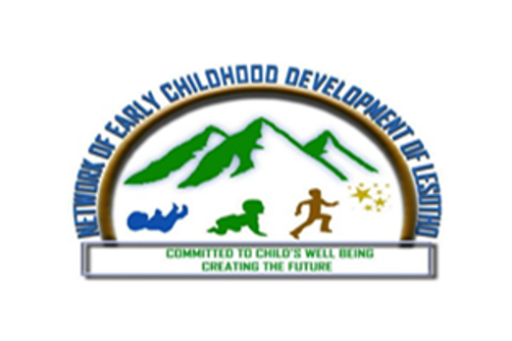
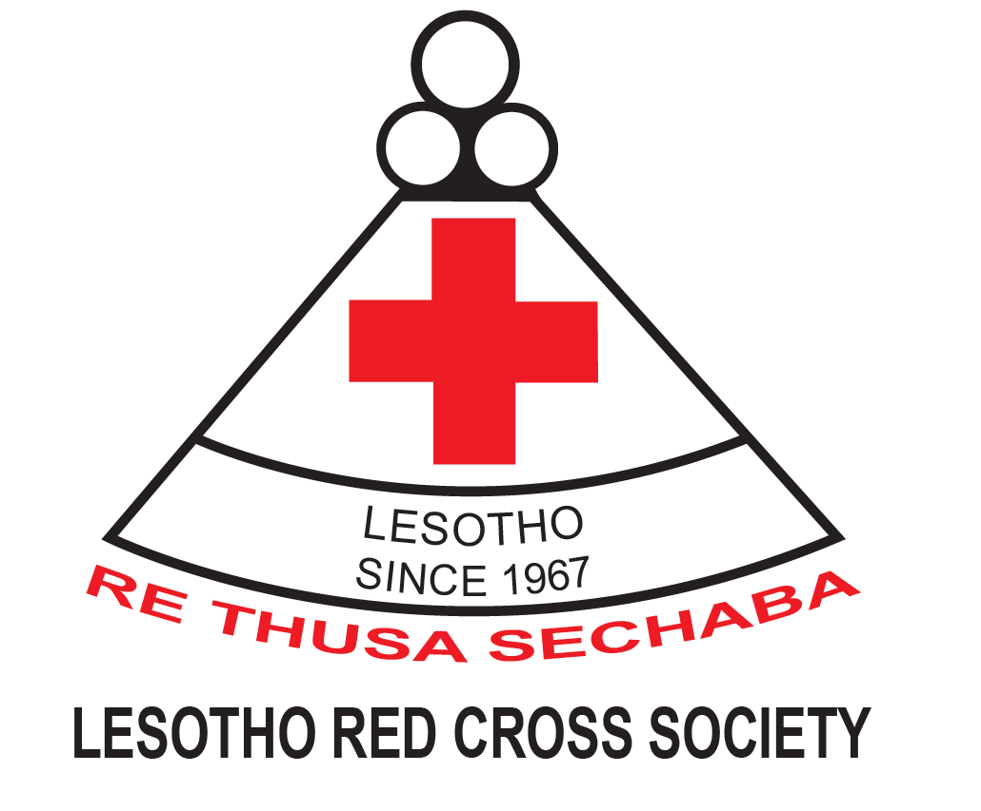
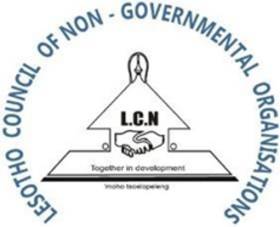

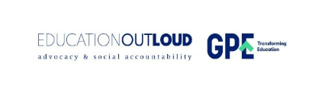


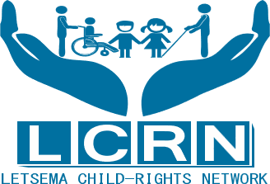
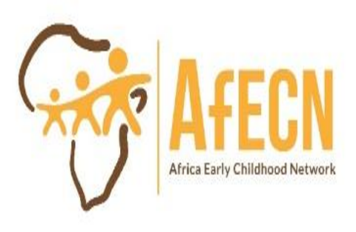

Submitted by
Network Of Early Childhood Development of Lesotho
Lesotho Council for NGOs
Letsema Child Rights Network
Lesotho Red Cross Society
Global Partnership for Education
Africa Early Childhood Network
Oxford Human Rights Hub

Introduction
This additional submission complements the thematic report on the realisation of the right to Early Childhood Care and Education in Lesotho, submitted in July 2025 to the United Nations Committee on the Rights of the Child (the Committee) by the Network of Early Childhood Development of Lesotho.

Prepared in response to the Committee's List of Issues concerning the Combined Third to Seventh Periodic Report of Lesotho, this submission provides additional, updated evidence on the implementation of Early Childhood Care and Education. The submission responds specifically to paragraphs 2(b), 5(a), 6(b), 8(a), 8(b), and 10(e) of the List of Issues (LOI).
We commend the State Party for a number of recent developments such as increasing the quarterly national child grant, securing a USD 5 million Global Partnership for Education multiplier grant to expand early childhood education, and absorbing the M-mama Emergency Transport System into national health structures. We nonetheless identify significant gaps in financing, data availability, and policy design and implementation affecting the realisation of early childhood rights, which we believe warrant the Committee's attention during the constructive dialogue with the State Party.

Implementation and Practice
Regarding LOI para.2b: The impact, implementation, monitoring, and resource allocation for various child-related policies
Despite developing progressive policy architecture to promote children’s rights to ensure equitable access to Early Childhood Care and Education, as noted by The International Commission of Jurists (2023), Lesotho continues to face substantial challenges in translating policy commitments into meaningful outcomes for children. Although the Inclusive Education Policy envisages the enrolment of orphans, vulnerable children and children with disabilities in both public and non-public pre-schools, information regarding its implementation remains limited, and progress has been uneven. The absence of a dedicated implementation framework has significantly constrained the operationalisation of these policies, leaving many of their commitments largely aspirational.
Research by Tiela (2023), in a Master's dissertation analysing the implementation of the National Policy for Integrated Early Childhood Care and Development in Mokhotlong, identifies several barriers to effective implementation, including shortages of qualified teachers, inadequate learning infrastructure, insufficient resource allocation, weak coordination between policymakers and frontline implementers, and the absence of a comprehensive implementation and monitoring framework. These challenges undermine efforts to provide inclusive and quality early childhood education, particularly for children with special educational needs.
Similarly, Rakolobe and Teisi (2024) argue that although the Curriculum and Assessment Policy (2009) aimed to localise the curriculum and improve educational quality through initiatives such as the Foundation Phase Curriculum, implementation gaps have limited its effectiveness.
Thus, inadequate child-sensitive resource allocation, weak institutional coordination and limited accountability mechanisms continue to hinder the realisation of children's rights in practice, underscoring the need for stronger implementation mechanisms, adequate financing and closer collaboration between policymakers and service providers.

Social Development & Child Protection
Regarding LOI para (5a): To explicitly prohibit corporal punishment in all settings and to promote positive and non-violent forms of child-rearing and discipline
Corporal punishment has not yet been explicitly prohibited in all settings, especially at home. While Section 19A(3) of the Children's Protection and Welfare Act (CPWA) 2011, as amended in 2023, states that there is no "justifiable" reason for corporal punishment, it does not expressly prohibit the practice. The Social Protection Brief (2023) further highlights that children, particularly orphans and vulnerable children (OVC), continue to face multiple and overlapping risks, including poverty, neglect, violence, abuse and limited access to essential services. Consequently, stronger legal safeguards, including an explicit prohibition of corporal punishment in all settings, are necessary to ensure the effective protection of all children.

Family Environment
Regarding LOI 6(b): To strengthen community-based child protection and family support services
Lesotho has made significant progress in strengthening community-based child protection and family support services through legislative reforms and their subsequent implementation. The country has increased its child grant from M360.00 per quarter to M1000.00 per quarter. However, even though this increase is commendable, it is very little compared to the grant provided to the elders above 70 years per month. This amount is insufficient to cater for all the needs of children in present economic circumstances. Furthermore, there are no special services provided for children under five.

Nutrition & Health
Regarding LOI .8(a) & 8(b): To address disparities in access to health services for children in rural and mountainous areas; To reduce infant, under-5 and child mortality rates, improve immunisation rates and to promote exclusive breastfeeding;
The Global Nutrition Report indicates that 59% of infants of 0-5months are exclusively breastfed. Lesotho has made some progress towards achieving the target for stunting, but 34.6% of children under 5 years of age are still affected, which is higher than the average for the Africa region (30.7%). Lesotho is 'on course' for the target for wasting, with 2.1% of children under 5 years of age affected, which is lower than the average for the Africa region (6.0%). The prevalence of overweight children under 5 years of age is 6.6% and Lesotho is 'on course' to prevent the figure from increasing.

However, there is a persisting high Maternal Mortality Rate, despite the increase of skilled health personnel from 55% in 2004 to 89% in 2023/24, meaning improved service coverage has not translated to improved quality of care. Immunisation coverage shows mixed trends. BCG coverage remains high (99.1% in 2023/24), but full vaccination coverage for children aged 12-23 months has declined from 68% in 2004 to 63% in 2023/2411. Polio and DPT3 coverage dropped due to COVID-19 disruptions and systemic weaknesses such as stockouts and poor supervision. Only 43% of children are fully vaccinated according to the expanded national schedule.¹¹ Lesotho continues to prioritise strengthening the EPI to achieve the Immunisation target of at least 90% for Agenda 2030. The proportion of children fully vaccinated against four basic antigens declined by six points from 68% in 2004 to 62% in 2009 before bouncing back to 68% in 2014.¹¹

Recognizing the geographical barriers to equitable access to quality health services for all children, the Government has strengthened primary health care (PHC) as the foundation of the national health system and expanded community-based service delivery to reach out children in remote areas.¹⁸ Nevertheless, transportation delays contribute significantly to maternal and newborn deaths. In response, the Government of Lesotho has implemented the m-mama Emergency Transport System.

Despite these significant efforts, disparities in access to health care persist due to difficult terrain, shortages of specialised health personnel and infrastructure constraints. Continued investment in community health systems, rural health infrastructure, digital health innovations and emergency referral mechanisms systems should remain a national priority.

Early Childhood Care and Education
Regarding LOI 10(e) To expand Early Childhood Education, especially in rural areas –
This submission builds on the information provided in our previous alternative report by highlighting additional data on children’s inadequate and inequitable access to Early Childhood Care and Education (ECCE) in Lesotho. According to UNICEF's analysis, the State operates only a limited number of ECCE centres, while many are managed by private entities, non-governmental organisations, local communities, and individuals. National ECCE coverage stands at only 35.2 per cent, with wide disparities between urban (48 per cent) and rural areas (22 per cent).
As per the UNICEF report, significant disparities in access persist for rural children and children from socio-economically deprived backgrounds. As per the MICS data 2018, children aged 3–4 years in urban areas (67 per cent) were almost twice as likely to attend ECCE centres as those in rural areas (34 per cent). Attendance was highest in the lowlands (55 per cent) and lowest in the foothills (29 per cent) and mountain regions (31 per cent). Children from the richest households (83 per cent) were four times more likely to attend ECCE programmes than children from the poorest households (20 per cent). Maternal education also strongly influenced enrolment: attendance among children whose mothers had higher education (89 per cent) was more than twice that of children whose mothers had primary education or less (34 per cent).
Challenges related to quality and infrastructure remain significant. Only 35 per cent of ECCE centres have adequate learning materials, while 60 per cent operate in inadequate facilities. Administrative delays, procurement bottlenecks and dependence on external funding continue to undermine programme implementation.
As per the budget analysis done by Education out Loud, ECCE funding increased from 1.14 per cent to 4.8 per cent of the Ministry of Education and Training budget between 2020 and 2025. However, 78.44 per cent of funding remains donor-dependent. Government recurrent expenditure increased only marginally, from 0.85 per cent to 1.45 per cent, raising concerns about sustainability. Moreover, the current allocation remains below UNESCO's recommended benchmark of 10 per cent. This insufficient investment in ECCE has long-term consequences for children's development, school readiness and future economic opportunities.

Recommendations
The Committee may recommend the State party:
- Increase domestic budget allocations for early childhood care and education, reduce reliance on donor funding, and prioritise the expansion of quality ECCE services in rural and disadvantaged communities to ensure equitable access for all children;

- Explicitly prohibit corporal punishment in all settings, including the home, alternative care settings, day-care centres and pre-primary schools;

- Establish a comprehensive implementation and monitoring framework, with clear indicators and accountability mechanisms, to ensure the effective implementation of policies and to assess their impact on the realisation of children's rights:
- Strengthen the regulation of private education providers by ensuring that all pre-primary schools and day care centres are licensed, registered, affordable and regularly monitored for compliance with national laws and quality standards

These efforts include, development of the National Policy for Integrated Early Childhood Care and Development, the Inclusive Education Policy, the Curriculum and Assessment Policy (2009), the Lesotho Basic Education Curriculum Policy, and the validation of the Free Primary Education Policy, high-level advocacy, including efforts of Her Majesty the Queen of Lesotho to promote social and behavioural change and combat violence against children.
International Commission of Jurists, (2023). Failed Implementation Lesotho’s Inclusive Education Policy and the continued exclusion of children with disabilities. A briefing paper 2023.
Tiela (2023) Analysis of the Challenges Hindering Implementation of the National Policy for Integrated Early Childhood Care and Development in the Pre-schools in Mokhotlong, Available at: Link accessed 30 July 2026 pgs. 24,25,34 &45
Rakolobe, K., & Teise, K (2024, Contextual Factors Obstructing the Effective Implementation of the Curriculum and Assessment Policy in the Lesotho Education Sector. Research in Educational Policy and Management, Volume: 6 Issue 1: 2024.
UNICEF (2023) ‘Social Protection for Children Brief’, Available at: Link accessed 15 July 2026 pgs. 3&4
Parliament of Lesotho. (2026). Budget speech to the Parliament of the Kingdom of Lesotho for the 2026/2027 Fiscal Year.
Though there are projects such as the School Readiness Initiative which the government has adopted and is expanding.See, UNICEF ‘Early Childhood Care and Development: Developing Young Minds, Available at : Link accessed 15 July 2026
Global Nutrition Report. (2023). Lesotho: ‘The burden of malnutrition’,Available at: Link accessed 15 July 2026
Ibid
LDHS. (2023). ‘Lesotho Demographic and Health Survey 2023-2024:Final Report’ Available at: Link , pg. 11; See also WHO. (2021). World Health Statistics 2021: Monitoring Health for the SDGs: Available at: Link pg.21
Ministry of Health. (2022). ‘Annual Joint Review Report’. See also NFPA. (2023). ‘UNFPA Lesotho 7th Country Programme Evaluation 2019-2023 Report’, Available at: Link, accessed 15 July 2026 pgs. 9,18
WHO & UNICEF. (2021). ‘WHO and UNICEF Estimates of National Immunization Coverage Available at: Link accessed 15 July 2026 pgs. 7-10
WHO. (2020). ‘Immunisation Agenda 2030: A Global Strategy to Leave No One Behind’Available at: Link accessed 15 July 2026
Government of Lesotho. (2023). ‘Health - Government of Lesotho’; See also WHO. (2022). ‘Lesotho Annual Report 2022’, Available at: Link accessed 15 July 2026
UNICEF (2023), 'Every Child Learns And Acquires Skills For The Future' Brief Lesotho 2023: Available at : Link accessed 30 July 2026
Ibid
UNICEF (2025),’ Igniting the Potential of Young Children: A statistical profile of early childhood development in Eastern and Southern Africa: Available at: Link accessed 30 July 2026
Ibid
Ibid
UNICEF (2023), 'Every Child Learns And Acquires Skills For The Future' Brief Lesotho 2023: Available at : Link accessed 30 July 2026
Education out Loud (2025) Five Year Budget Analysis of Early Childhood Care and Development in Lesotho (2020-2025); Available at : Link accessed 30 July 2026
Ibid

