BRIEFING ON GUATEMALA FOR THE COMMITTEE ON THE RIGHTS F THE CHILD, SESSION 90 PRE-SESSIONAL WORKING GROUP- October 2021
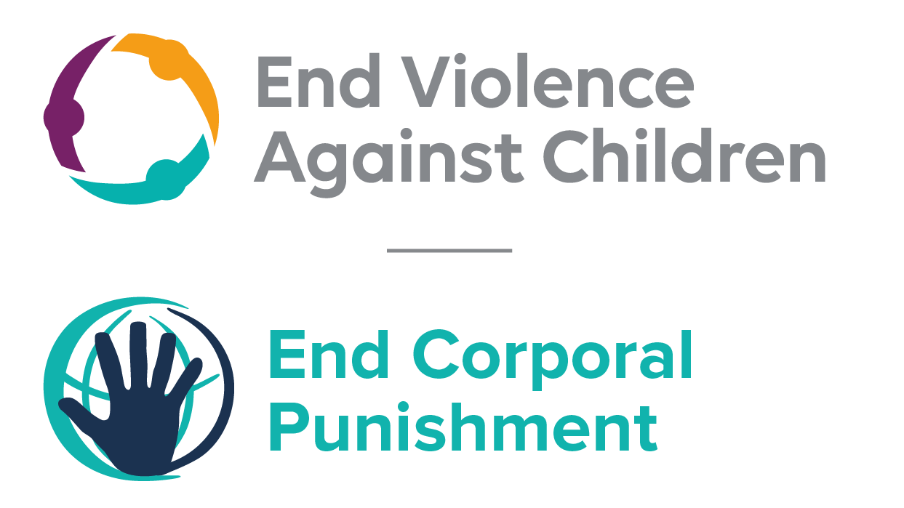
The Global Partnership to End Violence Against Children, June 2021

This briefing describes the legality of corporal punishment of children in Guatemala. In light of the Committee’s General Comment No. 8 on “The rights of the child to protection from corporal punishment of children and other cruel or degrading forms of punishment”, its repeated recommendations on the issue and the importance of eradicating this form of violence given by the UN Secretary General’s Study on Violence against Children. Considering the recommendations to prohibit all corporal punishment made to Guatemala by the Committee Against Torture, the Committee on the Rights of Persons with Disabilities and during the Universal Periodic Review in 2008, 2012 and 2017 (which the Government supported), as well as the global commitment to ending all violence against children in the context of the 2030 Agenda for Sustainable Development, we hope the Committee will:
• in its List of Issues Prior to Reporting for Guatemala, raise the issue of corporal punishment of children, in particular asking what steps are being taken to enact a legislation to prohibit corporal punishment of children in all settings; and
• in its concluding observations on the seventh report of Guatemala, recommend that a legislation is enacted as a matter of priority to explicitly prohibit corporal punishment of children, in all settings including the home.

Summary of necessary legal reform to achieve full prohibition
Prohibition is still to be achieved in the home, alternative care settings, day care and schools.
Article 13 of the Law on Integral Protection of Children and Adolescents 2003 and article 253 of the Civil Code 1963 confirm the right and duty of parents to guide, educate and correct their children. The near universal social acceptance of corporal punishment in childrearing necessitates clarity in law that no level of corporal punishment is acceptable. These provisions should be repealed and the law should prohibit all corporal punishment and other cruel or degrading forms of punishment, in the home and all other settings where adults have parental authority. In 2017, a Bill which would prohibit was introduced in the Congress.
Alternative care settings – Prohibition should be enacted in legislation applicable to all alternative care settings (foster care, institutions, places of safety, emergency care, etc).
Day care – Corporal punishment should be prohibited in all early childhood care (nurseries, crèches, kindergartens, preschools, family centres, etc) and all day care for older children (day centres, after-school childcare, childminding, etc).
Schools – Prohibition of corporal punishment in all education settings (public and private) is necessary.

- Current legality of corporal punishment in Guatemala
  - Home: Corporal punishment is lawful in the home. Article 13 of the Law on Integral Protection of Children and Adolescents 2003 provides for the rights and duties of parents to “guide, educate and correct the child or adolescent using prudent means of discipline that do not violate their dignity and integrity”. Article 253 of the Civil Code 1963 states that parents must “educate and correct” their children “using prudent means of discipline”. These provisions provide a legal defence for the use of corporal punishment in childrearing; the provision against violating a child’s dignity does not achieve prohibition of all corporal punishment. Article 53 of the Law on Integral Protection of Children and Adolescents confirms the right of the child not to be subjected to any form of violence, cruelty or oppression and to be protected from all forms of abuse but it does not explicitly prohibit all corporal punishment in childrearing. Provisions in the Criminal Code condemning assault and abuse of children are not interpreted as prohibiting corporal punishment. The Law on Integral Protection of Children and Adolescents 2003 is being amended.
  - The Government accepted a recommendation to explicitly prohibit corporal punishment in the home made during the Universal Periodic Review (UPR) of Guatemala in 2008, but also indicated that it considered existing legislation adequate in this respect. In 2012, the Government again accepted UPR recommendations to prohibit, and education and awareness programmes have been undertaken to address corporal punishment in the home. Reporting to the Committee on the Rights of the Child in 2016, the Government suggested that corporal punishment was prohibited under article 150 bis of the Criminal Code. This is inaccurate – article 150 bis prohibits causing children harm but does not explicitly refer to corporal punishment. The Government supported a recommendation to prohibit in all settings during the Universal Periodic Review in 2017 – we are seeking confirmation that it is committed to enacting an explicit prohibition of all corporal punishment.
  - In October 2016, a Bill “Against Corporal Punishment or Other Forms of Cruel Punishment, as a Method of Correction or Discipline Towards Children and Teenagers” was introduced in the Congress. The draft text aimed to prohibit all forms of physical and humiliating punishment of children in all settings. In October 2017, the Government reported that the Bill was still being examined by the Committee on Human Rights which would issue an opinion on its merits after studying it. The law reform process was later stopped. In June 2021, a Child Protection System Bill was under discussion. The Bill which would complete the existing Child Protection Law aims to harmonise the functioning of child protection systems across all government agencies.
  - Alternative care settings: There is no explicit prohibition of corporal punishment in alternative care settings, where corporal punishment is lawful as for parents under the right to “correct” in article 13 of the Law on Integral Protection of Children and Adolescents 2003 and article 253 of the Civil Code 1963 (see under “Home”).

  - Day care: There is no explicit prohibition of corporal punishment in early childhood care and in day care for older children. Corporal punishment is lawful under the right to “correct” in article 13 of the Law on Integral Protection of Children and Adolescents 2003 and article 253 of the Civil Code 1963 (see under “Home”).

  - Schools: Corporal punishment is lawful in schools, including military schools. Article 1 of the National Education Law 1991, Legislative Decree No. 12-91, recognises the child’s right to dignity in the educational system, but there is no explicit prohibition of corporal punishment.

  - Penal institutions: Corporal punishment is unlawful as a disciplinary measure in penal institutions under article 260 of the Law on Integral Protection of Children and Adolescents 2003: “During the implementation of sanctions, the adolescent will, at least, have the following rights: … (e) (8) Right not to be incommunicado in any case, nor to be subjected to solitary confinement or the imposition of corporal punishment….”

  - Sentence for crime: Corporal punishment is unlawful as a sentence for crime. There is no provision for judicial corporal punishment in the Law on Integral Protection of Children and Adolescents 2003. Article 255 of the Law states that the purpose of sanctions is to “set and promote social actions that allow adolescents, subject to some kind of sanction, their continued personal development and reintegration into family and society, as well as the development of their abilities and sense of responsibility” (unofficial translation). Article 260 of the Law explicitly prohibits corporal punishment (see under “Penal institutions”).

Corporal punishment is imposed as a sentence in Mayan justice but this appears to be unlawful. The use of the whip (Xik’ay’) as well as the shaving of heads and other humiliating punishments is, according to Mayan legal opinion, intended “not to inflict pain or scars, but to arouse public shame”. Under the Accord on the Identity and Rights of Indigenous Peoples, signed in 1995 as part of the Comprehensive Peace Accords, the Government must incorporate the customary law of the Maya population into the state through law reform. Article 10 of the Law on Integral Protection of Children and Adolescents 2003 confirms that children and adolescents belonging to ethnic and/or indigenous communities “have the right to live and develop forms of social organisation that correspond to their historical and cultural traditions” but it also states that these must “not be contrary to public order and respect for human dignity”; the prohibition of corporal punishment in article 260 (see under “Penal institutions”) presumably applies also in the context of Mayan justice.

Recommendations by human rights treaty bodies and during the UPR
  - CAT: In its 2010 concluding observations on the state party’s fifth-sixth report, the Committee Against Torture noted with concern the reports about the ill-treatment of minors in detention, including corporal punishment and recommended that measures are taken to prevent and punish any type of ill-treatment.

  - CRC: On four occasions, the Committee on the Rights of the Child has recommended to Guatemala that legislation be enacted to explicitly prohibit corporal punishment in all settings: in its concluding observations on the state party’s initial report in 1996, on the state party’s initial report on the Optional Protocol on the involvement of children in armed conflict report in 2007, on the third-fourth report in 2010 and on the fifth-sixth report in 2018.

  - CRPD: The Committee on the Rights of Persons with Disabilities recommended that the Government take measures to prohibit and eliminate corporal punishment of children in its concluding observations on the state party’s initial report in 2016.
2.4 UPR: At the first cycle of the Universal Periodic Review of Guatemala in 2008, recommendations to adopt legislation explicitly prohibiting corporal punishment were issued and accepted by the Government. Recommendations to prohibit all corporal punishment made in the second cycle UPR 2012 and in third cycle UPR in 2017 were also supported.

2 November 2017, CRC/C/GTM/Q/5-6/Add.1, Reply to list of issues, para. 79
29 May 2008, A/HRC/8/38, Report of the working group, paras. 52 and 17; 31 December 2012, A/HRC/22/8, Report of the working group, paras. 99(56) and 99(57)
28 February 2017, CRC/C/GTM/5-6, Fifth/sixth report, para. 186
2 January 2018, A/HRC/37/9, Report of the working group, para. 111(139)
2 November 2017, CRC /C/GTM/Q/5-6/Add.1, Reply to list of issues, para. 6
Information given to End Corporal Punishment in June 2021
Information provided by ChildFund International in June 2021.
Reported in “Mayan Justice in Guatemala: Shame, Property and Human Rights”, NACLA Report, 28 August 2007; see also Hessbruegge & Garcia, “Mayan Law in Post-Conflict Guatemala”, in Isser, D. (ed) (2011), Customary Justice and the Rule of Law in War-Torn Societies, Washington: US Institute of Peace, 77-112
21 June 2013, CAT/C/GTM/CO/5-6, Concluding observations on fifth/sixth report, para. 19
7 June 1996, CRC/C/15/Add.58, Concluding observations on initial report, paras. 8 and 33
12 June 2007, CRC/C/OPAC/GTM/CO/1, Concluding observations on initial report on the Optional Protocol on the involvement of children in armed conflict, paras. 16 and 17
1 October 2010, CRC/C/GTM/CO/3-4, Concluding observations on third/fourth report, paras. 53, 54 and 55
2 February 2018, CRC/C/GTM/CO/5-6 Advance unedited version, Concluding observations on fifth/sixth report, paras. 20 and 23
21 October 2019, CRPD/C/ECU/CO/2-3, Concluding observations on second-third report, paras. 31 and 32
29 May 2008, A/HRC/8/38, Report of the working group, para. 52
31 December 2012, A/HRC/22/8, Report of the working group, paras. 99(56) and 99(57)
2 January 2018, A/HRC/37/9, Report of the working group, para. 111(139)

