Written contribution to the
Human Rights Committee
From
All Human Rights for All in Iran
Siamak Pourzand Foundation
Impact Iran
In preparation for the List of Issues prior to Reporting (LOIPR) for the
ISLAMIC REPUBLIC OF IRAN
Discrimination and violence based on gender

Human Rights Committee, 136th session (Geneva)
10 October – 4 November 2022
 | All Human Rights for All in Iran is a non-governmental organization established in 2017, and based in Austria. All Human Rights for All in Iran is working with Iranian partners to try to draw international attention to the human rights situation in the Islamic Republic of Iran, at the local, regional, national, and international levels.

 | The Siamak Pourzand Foundation (SPF) promotes freedom of expression for artists, journalists, women and human rights defenders in contexts where the censorship apparatus is hard at work. Further, it curates collaborative platforms and alternative media to empower marginalized communities such as religious minorities and ethnic groups struggling against censorship and repression. SPF is a member of Impact Iran.

 | Impact Iran represents a coalition of 17 non-governmental organizations that draw attention to the situation of human rights in Iran, and encourage the Iranian government to address concerns expressed by the international community and international human rights bodies. We organize public advocacy campaigns aimed at the UN member states and lead high-level human rights discussions to collectively spark action by the international community to promote and protect the rights and dignity of all in Iran.
This submission is intended to update and replace Section IV) Women’s and Girls’ Rights from our previous submission to the Human Rights Committee ahead of the then scheduled adoption of the list of issues prior to reporting of the Islamic Republic of Iran. This submission from July 2020 can be found here:
https://tbinternet.ohchr.org/_layouts/15/treatybodyexternal/Download.aspx?symbolno=INT%2fCCPR%2fNGO%2fIRN%2f42317&Lang=en
This submission updates and replaces only Section IV of this initial report, and the rest of the submission (Section I - Human Rights of Religious Minorities, Section II – Human Rights of Ethnic and Linguistic Minorities, Section III – Human Rights of Lesbian, Gay, Bisexual and Trans persons) remains unchanged and is still submitted to the attention of the Committee ahead of the adoption of the list of issues.

TABLE OF CONTENT
WOMEN’S AND GIRLS’ RIGHTS 2
A) Women’s participation in public and political life 3
B) Women in the judiciary 4
C) Special training programmes for women 5
D) Sex and gender-based discrimination in the Civil Code 5
E) Criminalization of domestic violence 7
F) Protection and redress for victims of domestic violence 8
G) Impunity for killing in cases of adultery 9
H) Trafficking of women and children and modern slavery 10
I) Forced, early and temporary marriage of girls 11

WOMEN’S AND GIRLS’ RIGHTS
- The Iranian Constitution includes several provisions that obligate the government to guarantee equality for all, including non-discrimination between men and women. While these provisions seemingly safeguard the human rights of women and protect against sex and gender-based discrimination, such legal guarantees only exist insofar as they are in conformity with the “Islamic criteria,” a vague requirement with no definition under Iranian law. The room for interpretation allowed under the “Islamic criteria” qualifications to legal guarantees of non-discrimination have often resulted in provisions that discriminate or have a discriminatory impact on various grounds, including sex and gender.

A) Women’s participation in public and political life
- In 2011, the Human Rights Committee recommended that Iran take steps to increase the number of women in decision-making and judicial bodies at all levels and in all areas
- Women have a limited presence in decision-making bodies in the country:
- Women are completely prohibited from holding the position of Supreme Leader.
- Candidates for the presidency in Iran must be what the Constitution refers to as Rajol-E-Siasi (“political men”). Though many argue that the phrase as a whole could be understood as “political persons,” without a specification as to gender, the Guardian Council of the Constitution, a body of Islamic jurists responsible for vetting candidates for elections, has never approved a woman to stand in presidential elections or elections to the Assembly of Experts.
- Additionally, no woman has ever served on the Guardian Council (body mandated to bring parliamentary resolutions in line with Shari’a and the Constitution and to oversee elections and vet candidates)
- Nor on the Expediency Council (body which serves as the Supreme Leader's advisory arm, formulating "general policies for the state" and overseeing the implementation of those policies on the behalf of the Supreme Leader).
- There are no legal limits on the ability of women to vote or become a candidate for parliament or the City and Village Councils. However, the Guardian Council is known to arbitrarily disqualify women candidates from running for election. For example, in the run-up to the 2020 elections, the Guardian Council disqualified 60 percent of female candidates.
- Despite the existence of several mechanisms that ostensibly accept complaints regarding violations of citizens' rights, such as the Article 90 Commission of the parliament (established based on Article 90 of the Constitution, offering a mechanism to citizens to file complaint against any of three branch of power) and the Oversight Bodies for the exercise of Citizenship Rights in the country's provincial courts, there is no evidence to suggest that complaints to these bodies are independently reviewed and investigated. Regarding complaints related to election process or candidate vetting, election law designates the Guardian Council as the arbitrator, which itself is the body responsible for the impugned decisions.
- There are currently no female ministers in the Government’s cabinet. No provincial governors are women. Then President Hassan Rouhani’s government appointed three women as “county governor” out of 430 positions across the country. However, all three of them were replaced by current President Ebrahim Raisi. As of July 2022, only one woman is serving as county governor in the current government.
- Women currently occupy only 5.8 percent (16 out of 290) of parliamentary seats in the new parliament elected in February 2020, compared to 17 in the previous parliament.
- The percentage of women candidates who registered to run in the February 2020 city councils election increased from 6.3 in 2016 to 8 percent. The number of women elected in city and village councils increased from 4029 to 5990 following the 2020 election.

B) Women in the judiciary
- Under Iranian law, women cannot be appointed as judges. This rule is based on an interpretation of Shari’a according to which judging is done only by men, and women cannot issue rulings. While women can hold the position of ‘legal advisers,’ a role which allows them to oversee case proceedings or sit on three-person Appeals Court panels, they cannot render final verdicts, which must be signed by a judge. According to statements issued by the Deputy of Human Resources of the Judiciary, Alireza Amini, there are about 1,000 women legal advisers in the Iranian judiciary, who hold positions in family courts, appeals courts and the Supreme Court. Again, these positions are advisory and have no decision-making power. In its National Report to the Universal Periodic Review in 2019, the Government reported that “more than 970 female judges work in the Judiciary” while the total number of judges reportedly reached 10,000 in 2015. In 2016, Tehran’s general prosecutor appointed for the first time two women as investigators (investigating magistrates) in the juvenile court of Tehran.
- In its State party’s report to the Human Rights Committee, Iran’s Government shared the number of women employed as “administrative staff of the Judiciary” with a total number indicating 1077. As highlighted above, and as suggested by “adminsitrative staff”, women can only be employed in advisory or assisting positions in the Judiciary, and do not have decision-making power whatsoever.

C) Special training programmes for women
- In 2011, the Human Rights Committee recommended that Iran organize special training programmes for women and regular awareness campaigns to encourage women’s participation in public and political life
- The Charter on Citizen’s Rights, adopted under Rouhani’s administration in 2016, contains provisions according to which women should “have active and effective participation in policymaking, legislation, management, implementation and supervision, and shall be provided equal social opportunities in accordance with Islamic norms.” However, the Charter is not a legally-binding instrument and is not enforceable. There is no evidence that awareness campaigns or special training programmes to improve the number of women in decision- making and judicial bodies were designed or implemented.

Suggested Question
- Please explain what steps have been taken to increase the number of women in decision-making and judicial bodies at all levels and in all areas, in particular the number of women employed in positions with decisional power

D) Sex and gender-based discrimination in the Civil Code
- In 2011, the Committee recommended that Iran amend the Civil Code and the draft Family Protection Law to:
(a) abolish the requirement for a father’s or paternal grandfather’s approval to legalize a marriage;
(b) grant women equal rights to divorce;
(c) award equal custody rights to the mother, including after a child reaches the age of seven or if she remarries;
(d) award guardianship of a child to the mother in the case of the father’s death;
(e) grant women the same inheritance rights as men;
(f) remove the legal obligation for a woman to be obedient to her husband;
(g) remove the requirement for a husband’s approval when a woman intends to leave the country;
(h) prohibit polygamy;
(i) remove the power of a man to prohibit his wife from entering employment.
(f) give Iranian women the right to transmit their nationality to their children.
- As of July 2022, the State has taken action on just one of the Committee’s recommendations: in 2019 the State amended the Civil Code to give Iranian women who are married to non-Iranian men the right to transmit their nationality to their children. However, Iranian women and men are still not on equal footing with respect to their ability to confer nationality - men, regardless of the nationality of their wife, can automatically pass their nationality to their children. By contrast, women married to a non-national must apply to pass nationality to children and a security check done by the Ministry of Intelligence.
- In November 2021 the Guardian Council ratified the ‘Youthful Population and Protection of the Family’ law, which aims to boost the country’s fertility rate in Iran. The law has been denounced by UN experts as being clearly in “contravention of international law,” violating “the rights to life and health, the right to non-discriminaion and equality, and the right to freedom of expression.” Art. 61 of the new law vaguely stipulates that, if carried out on a large scale, abortion would fall under the crime of “corruption on earth” and would carry the death penalty.
Suggested Question
- With reference to the previous concluding observation paragraph 9, please provide information about steps taken to amend the Civil Code to ensure gender equality
- Please provide information about steps taken to repeal or amend the ‘Youthful Population and Protection Family’ law to ensure gender equality

E) Criminalization of domestic violence
- In 2011, the Committee recommended that Iran adopt a legislation criminalizing domestic violence and take steps to effectively combat domestic violence. It also recommended that acts of domestic violence be effectively investigated and that perpetrators be prosecuted and sanctioned.
- Iran does not have any laws which specifically criminalize domestic violence. Cases of domestic violence can be prosecuted as crimes of bodily assault. Rape is not classified as a distinct crime under Iranian law, but is considered as a crime of zina (sexual relations outside of marriage) without consent. The legal definition for ‘coerced zina’ is restricted to forced vaginal and anal penetration by a penis - therefore excludes other forms of penetration - and only when the perpetrator and the victim are unmarried - therefore explicitely excludes marital rape. Beyond rape, no other form of sexual assault is specifically criminalized under the Islamic Penal Code.
- Moreover, numerous articles in the country’s Civil Code effectively undermine the already limited legal protections for women against domestic violence:
- Article 1105 of Iran’s Civil Code states that “in relations between husband and wife, the position of the head of the family is the exclusive right of the husband.” ‘Disobedience’ to the husband can be used as a legal ground for battery.
- Article 1117 forbids a woman from leaving the matrimonial home without the husband’s permission unless she is able and willing to go to court to prove she is endangered. This leaves Iranian women deeply vulnerable to violence especially given the evidentiary requirement of witnesses and the fact that a female witness’s testimony is worth half that of a man’s.
- Article 1108 stresses that if a wife refuses to have sex with her husband without a ‘legitimate excuse,’ she is not entitled to ‘spousal maintenance.’ Married and minor girls are also subject to Article 1108’s obligation to fulfil the sexual needs of their husbands.
- There is a dearth of recent, official data on the prevalence of domestic violence in Iran. The last official and published study on domestic violence carried out in Iran dates back 2004. The study showed that about 66 percent of women sampled responded that they had been subjected to domestic violence in the first year of their marriage. Despite the lack of comprehensive official data, cases of domestic violence are regularly reported and considered widespread in the Islamic Republic of Iran. In July 2019, the head of the Medical Examiner’s Office of Tehran Province reportedly announced that more than 16,420 cases of domestic violence had been reported to the office, a number consistently increasing since at least 2017. In February 2019, deputy of social affairs of the State’s Welfare Organization, Habibollah Massoudi Farbod, reportedly announced that during 2018, about 10,000 calls relating to violence against women were made to the public social welfare hotlines. In April 2020, Mahmoud Aligoo, the head of the department of social harms of the State’s Welfare Organization reportedly announced a dramatic increase in the number of cases of domestic violence, as Iran was going through a governmental mandated lockdown to combat the spread of the virus COVID-19. Yet, cases of domestic violence are believed to be largely underreported.
- The Bill for the Protection, Dignity and Security of Women Against Violence is still under review.

F) Protection and redress for victims of domestic violence
- In 2011, the Committee recommended that Iran ensure that victims of domestic violence have access to means of redress and protection, including a sufficient number of safe houses for victims.
- In its July 2020 report, the Special Rapporteur on the situation of human rights in the Islamic Republic of Iran counted only 28 shelters for women victims of domestic violence, including 20 run by non-governmental organizations. According to the Government, “between 2015 and 2018, an average of 1,500 women, victims of domestic violence and their children, received specialized services, annually.” In comparison and as aforementioned, 16,420 cases of domestic violence have been reported in 2019, just in Tehran.
- Existing domestic violence shelters are generally located solely in major cities, are reportedly poorly resourced and advertised and unable to provide long-term support. Some are designed for sex workers and drug users rather than domestic violence victims while others reportedly focus heavily on reconciling and reuniting victims with their abusive spouses.
- Public shelters managed by the government only receive women for one month and children are taken from the mothers upon their arrival. Women who are victims of violence are not automatically provided with defense lawyers and must themselves prove the violence suffered or engage a lawyer at their own expense.

G) Impunity for killing in cases of adultery
- In relation to so-called “honor killings”, the Committee recommended that Iran ensure that a husband is not exempted from punishment for voluntary manslaughter, in the event that he murders his wife on suspicion of adultery.
- The Islamic Penal Code provides various exemptions for husbands, fathers and grandfathers who kill or assault their female relatives. Article 630 of the Islamic Penal Code (2013) exempts husbands from criminal liability and qisas if he commits murder, assault and/or battery against his wife, if the husband catches their wife committing a zina offence (adultery) with another man. There also exist exemptions in the Islamic Penal Code for fathers and grandfathers who kill their children. Moreover, adultery can be sentenced with the death penalty in Iran, including the death penalty by stoning.
Suggested Question
- Please provide information about steps the state party has taken to adopt legislation criminalizing domestic violence and take steps to effectively combat domestic violence

H) Trafficking of women and children and modern slavery
- In 2011, the Committee recommended that Iran take steps to combat and prevent the trafficking and sale of persons under 18 years of age and requested that Iran provide statistics on the number of arrests and convictions under the 2004 law to combat trafficking.
- Since 2004, Iran criminalises the trafficking of persons by means of threat or use of force or coercion, abuse of power, abuse of a victim’s position of vulnerability for purposes of prostitution, slavery or forced marriage. Penalties can reach up to 10 years imprisonment for perpetrators.
- The Judiciary drafted a bill to amend the law which, as of July 2022, is under parliament’s review. The draft bill includes higher penalties for crimes of human trafficking involving children, adolescents, women, persons with disabilities, victims of floods and earthquakes, and for cases where the perpetrator is the legal guardian of the victim. The current draft also exempts women, children, and adolescents who have been trafficked by their husbands or legal guardians from criminal liability for the illegal crossing of the border.
- The current draft, if adopted, does not amend the 2004 law’s definition of trafficking, which is currently inconsistent with international law. For instance, the law and the draft do not protect persons against all forms of trafficking as defined under the 2000 Protocol to Prevent, Suppress and Punish Trafficking in Persons, Especially Women and Children. The draft also does not address the absence of an independent mechanism mandated to monitor acts of human trafficking and that is competent to receive complaints from victims.
- The State does not publish official and comprehensive statistics of victims of human trafficking, or numbers of investigations, prosecutions, convictions and sentences for perpetrators. However, reports suggest that human trafficking is an issue in Iran, and that it targets women and children in particular.
- There are no national procedures or measures to proactively identify victims of trafficking in Iran. Additionally, while the State Welfare Organization provides some level of protection to victims of abuse, it does not offer special protection services to victims of trafficking, including special shelters or medical, psycho-social, and legal assistance.
- Women victims of human trafficking face serious difficulties accessing justice in Iran. One of the reasons is that a woman’s legal testimony is only given half the weight of that of a man. Furthermore, women victims of sexual abuse, including victims of sex trafficking, may face prosecution for act of adultery, defined as sexual relations outside of marriage under Iranian law and punishable by death.
Suggested Questions
- With reference to the previous concluding observations (para. 20), please provide statistics about the number of arrests and convictions under the 2004 law to combat trafficking
- Please provide information about steps the state party has taken to eliminate to combat and prevent the trafficking and sale of persons under 18 years of age
- Please provide information about steps the state party has taken to gather, and make publicly available, the number of arrests and convictions for human trafficking

I) Forced, early and temporary marriage of girls
- In 2011, the Human Rights Committee recommended that Iran eliminate discrimination on the basis of sex with regard to the minimum age for marriage, ensure that the minimum age complies with international standards and adopt measures to prevent forced, early and temporary marriage of girls.
- In 2016, the Committee on the Rights of the Child stated that the legal age of marriage in the Islamic Republic of Iran “gravely violated rights under the Convention [on the Rights of the Child] and placed children, in particular girls, at risk of forced, early and temporary marriages, with irreversible consequences on their physical and mental health and development.”
- Child marriage continues to be permitted under Iranian law. The legal minimum age for marriage is 13 years old for girls and 15 years old for boys. However, younger children who have reached puberty can marry with parental consent and court approval. The predefined age of puberty under Iranian law, and the age of legal majority, is 9 lunar years for girls and 15 lunar years for boys.
- Under Shari’a law in Iran, marriages (Aghd in Persian) of girls as young as 9 lunar years are permitted, and such marriages cannot be officially registered. Young girls are also subjected to temporary religious marriages in Iran, which do not need to be registered, known as sigheh. In some cases, such marriages is a way for impoverished families to obtain shir-baha (payment). To skirt the restriction on marriage for girls under 13, some impoverished families arrange temporary marriages for girls in order to receive shir-baha (a payment).
- With the permission of the court, the legal guardian has the right to marry for, and on behalf of, a minor daughter - legally sanctioning compulsory marriage. Iran’s Government affirmed in 2019 that when a case of forced marriage is reported to the Judiciary and a judicial case is filed, the forced marriage can be dissolved and those who facilitated the forced marriage are prosecuted. However, in law and practice, children lack access to legal recourse as they cannot file law suits without the representation of their legal guardian when under 15 years old.
- Official data provided by the National Organization for Civil Registration shows that the number of child marriages is increasing each year in Iran. Since the Committee's previous report, more than one million child marriages have reportedly been registered. Since 2018, a total of 474,946 child marriages have been recorded. Among them, 458,566 marriages involved girls under 18, and 51,521 of them were 13 years old or younger. . Numbers, however, are likely to be higher as many child marriages go unregistered.
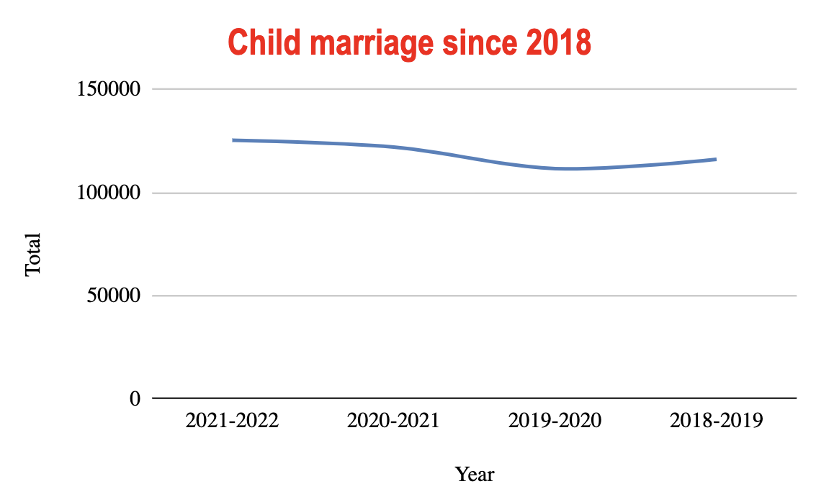
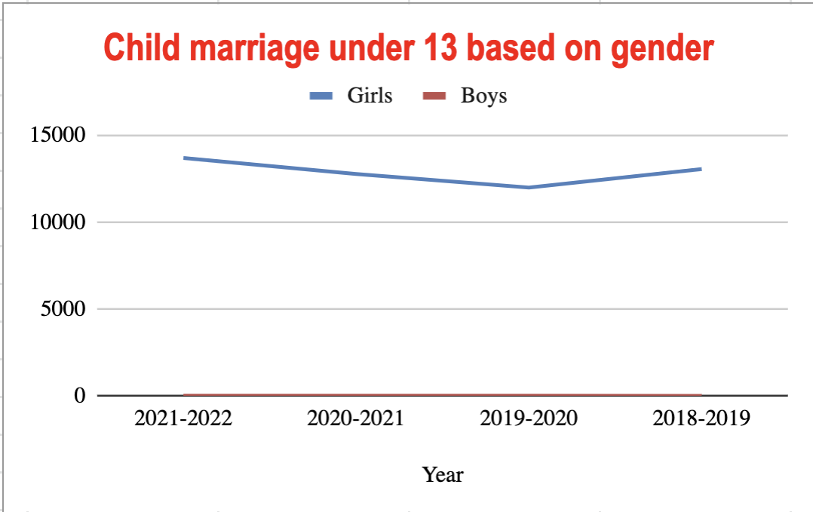
- The statistics published by the Iranian Statistics Center show that 9,753 girls aged 10 to 14 were married in the spring of 2021, which is the highest seasonal number of marriages for girls aged 10 to 14 compared to the seasonal statistics of the previous two years.

Suggested question
- Please provide information about steps the state party has taken or intend to take to eliminate forced, early and temporary marriage of girls?

Article 20 of the Constitution emphasizes that all people of the nation, both men and women, are equally protected by law, and enjoy all human, political, economic, social and cultural rights, in accordance with “Islamic standards.” Article 21 of the Constitution obliges the government to guarantee the rights of women in all respects, in accordance with “Islamic standards.”
Human Rights Committee, Concluding observations: Islamic Republic of Iran, 29 November 2011, CCPR/C/IRN/CO/3, para. 8
Art 115, Constitution of Iran.
The Assembly of Experts is a constitutional body with authority to appoint or dismiss the Supreme Leader.
In addition, the Guardian Council is responsible for overseeing elections and vetting candidates.
The body, whose members are all appointed by the Supreme Leader, was initially established as an arbitration body between parliament and the Guardian Council.
Executive rankings at the provincial level: 1) Governor, 2) County Governor, 3) District Governor, 4) Village President.
https://www.donya-e-eqtesad.com/fa/tiny/news-3837523
https://newspaper.hamshahrionline.ir/id/104282/
https://irna.ir/xjD4b9
The law of conditions for the election of judges of the judiciary: https://rc.majlis.ir/fa/law/show/90547
The law of conditions for the election of judges of the judiciary: https://rc.majlis.ir/fa/law/show/90547
See; http://www.iribnews.ir/009NnJ ; and https://www.yjc.ir/00QghG
UPR 2019, National Report, Islamic Republic of Iran, https://undocs.org/A/HRC/WG.6/34/IRN/1
Hiring 3,700 Judges During The Fifth Development Plan, 700 Women Active In Judiciary,” Mizan News, September 16, 2015, https://www.mizanonline.com/fa/news/77228/جذب-سه-هزار-و-700-قاضی-در-طول-برنامه-پنجم-توسعه-فعالیت-700-زن-در-امور-قضائی
Fourth periodic report submitted by the Islamic Republic of Iran, CCPR/C/IRN/4, para. 164
Human Rights Committee, Concluding observations: Islamic Republic of Iran, 29 November 2011, CCPR/C/IRN/CO/3, para. 8
The Islamic Republic of Iran, Charter on Citizens’ Rights, 2016, article 11 http://media.president.ir/uploads/ads/148214250789390200.pdf
Human Rights Committee, Concluding observations: Islamic Republic of Iran, 29 November 2011, CCPR/C/IRN/CO/3, para. 9
http://nazarat.shora-rc.ir/Forms/frmShenasname.aspx?id=Bffc3DPSti0=&TN=l7tLyhyOobj0SooAFUE3m68PnpG7MruN
https://www.ohchr.org/en/press-releases/2022/01/iran-repeal-crippling-new-anti-abortion-law-un-experts?LangID=E&NewsID=27817
Human Rights Committee, Concluding observations: Islamic Republic of Iran, 29 November 2011, CCPR/C/IRN/CO/3, para. 11
Article 221 of the Islamic Penal Code (2013), Iran Human Rights Documentation Centre, https://iranhrdc.org/english-translation-of-books-i-ii-of-the-new-islamic-penal-code/
Iran Human Rights Documentation Center, 2020, https://iranhrdc.org/access-to-justice-for-victims-of-sexual-violence-in-iran/
Iran Human Rights Documentation Centre https://iranhrdc.org/wp-content/uploads/pdf_en/LegalCom/Womens_Rights_Commentary_389929723.pdf
Article 1114 outlines that, “the wife must stay in the dwelling that the husband allots for her unless such a right is reserved to the wife.”
A reasonable and valid excuse for a wife to refuse sexual relations is when the husband has contracted a venereal disease. Iran Human Rights Documentation Centre, https://iranhrdc.org/wp-content/uploads/pdf_en/LegalCom/Womens_Rights_Commentary_389929723.pdf
The study was undertaken by the Women’s Centre for Presidential Advisory, the Interior Ministry and the Ministry of Higher Education of the Islamic Republic of Iran and published in 2004. The study was conducted based on questionnaires and only main cities were visited. Moradian, A., Domestic Violence against Single and Married Women in Iranian Society, The Chicago School of Professional Society, August 2009 https://iranian.com/2009/09/10/domestic-violence-against-single-and-married-women-in-iranian-society/ ; Ceasefire Centre for Civilian Rights, Centre for Supporters of Human Rights and Minority Rights Group International September 2019, https://www.justice.gov/eoir/page/file/1203136/download ; See also https://www.isna.ir/news/8307-07024/نتايج-طرح-ملي-بررسي-خشونت-خانگي-عليه-زنان-در-28-استان-اعلامA
Human Rights Activists News Agency, 2019, https://www.en-hrana.org/increase-in-domestic-violence-in-tehran-more-than-16-thousand-cases-were-filed
Human Rights Activists News Agency, 2020, https://www.en-hrana.org/domestic-violence-increased-during-coronavirus-quarantines-and-stay-at-home-orders
Human Rights Activists News Agency, 2020, https://www.en-hrana.org/domestic-violence-increased-during-coronavirus-quarantines-and-stay-at-home-orders ; IRNA, 2020, https://bit.ly/2VRztcz
Human Rights Committee, Concluding observations: Islamic Republic of Iran, 29 November 2011, CCPR/C/IRN/CO/3, para. 11
See www.irna.ir/news/83656641/ ; Report of the Special Rapporteur on the situation of human rights in the Islamic Republic of Iran, July 2020, https://undocs.org/A/75/213
UPR 2019, National Report, Islamic Republic of Iran, https://undocs.org/A/HRC/WG.6/34/IRN/1
Human Rights Activists News Agency, 2019, https://www.en-hrana.org/increase-in-domestic-violence-in-tehran-more-than-16-thousand-cases-were-filed
Ceasefire Centre for Civilian Rights, Centre for Supporters of Human Rights and Minority Rights Group International September 2019, https://www.justice.gov/eoir/page/file/1203136/download
Human Rights Committee, Concluding observations: Islamic Republic of Iran, 29 November 2011, CCPR/C/IRN/CO/3, para. 11
Islamic Penal Code, 2013, Art. 301
Islamic Penal Code, arts. 221-32.
Human Rights Committee, Concluding observations: Islamic Republic of Iran, 29 November 2011, CCPR/C/IRN/CO/3, para. 20
https://rc.majlis.ir/fa/law/show/94178
https://rc.majlis.ir/fa/law/show/94178
http://cabinetoffice.ir/fa/print/4997
http://cabinetoffice.ir/fa/print/4997
https://www.ohchr.org/sites/default/files/Documents/Publications/FS36_en.pdf
https://www.radiofarda.com/a/Trafficking-in-Persons-Report-2018-iran/29327230.html ; http://shargh.jrl.police.ir/article_95328_95254e66a74f7c5ce3e74fe16f286e21.pdf
Human Rights Committee, Concluding observations: Islamic Republic of Iran, 29 November 2011, CCPR/C/IRN/CO/3, para. 28
CRC/C/IRN/CO/3-4, para. 27-28 https://undocs.org/en/CRC/C/IRN/CO/3-4
Article 1041 of the Civil Code as amended up until December 2000
Iran Human Rights Documentation Center, https://iranhrdc.org/wp-content/uploads/pdf_en/LegalCom/Womens_Rights_Commentary_389929723.pdf
Committee on the Rights of the Child, 2016, CRC/C/IRN/CO/3-4, paras. 27–28 https://undocs.org/en/CRC/C/IRN/CO/3-4
The marriage may not be consummated until the girls reach puberty.
Iran Human Rights Documentation Center, https://iranhrdc.org/wp-content/uploads/pdf_en/LegalCom/Womens_Rights_Commentary_389929723.pdf
Universal Periodic Review, 2019, Reply of the Islamic Republic of Iran, https://undocs.org/en/A/HRC/43/12/Add.1
Islamic Penal Code, Book 2, arts. 146 and 147.
The National Institution of Registry www.sabteahval.ir/avej/tab-1499.aspx
https://www.sabteahval.ir/avej/Page.aspx?mId=49826&ID=3256&Page=Magazines/SquareshowMagazine
https://www.isna.ir/news/1400083023744/

