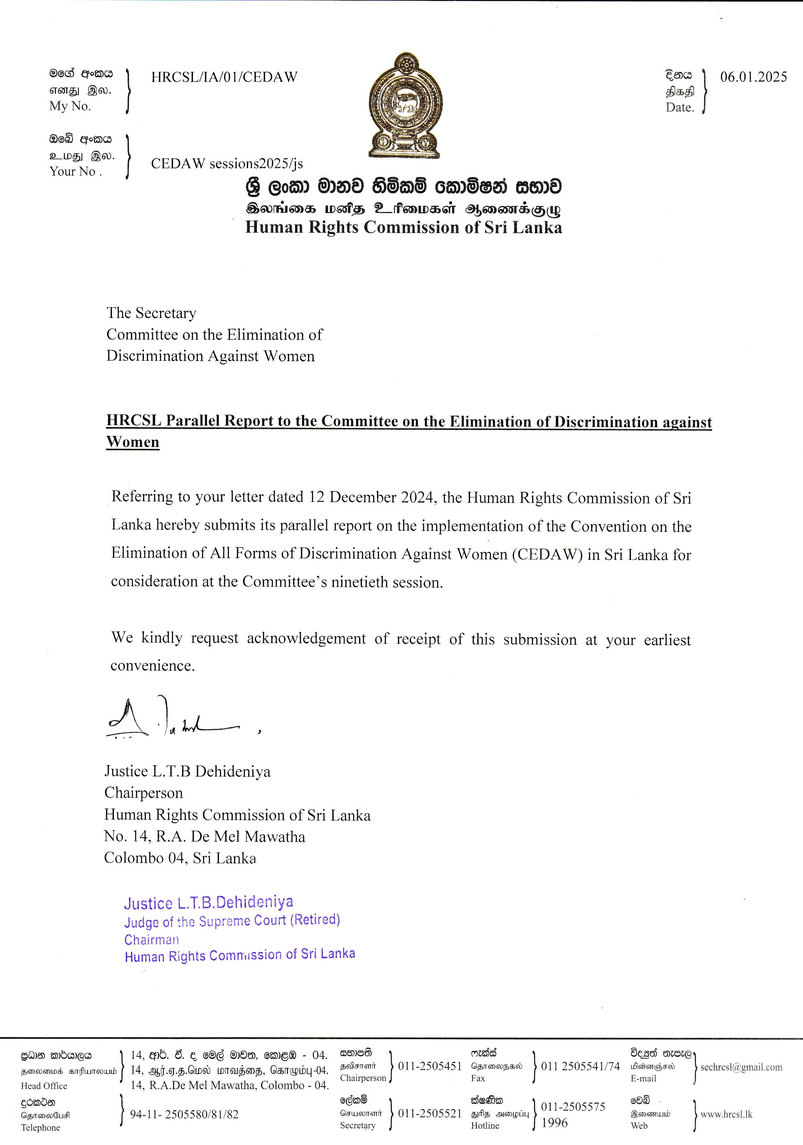

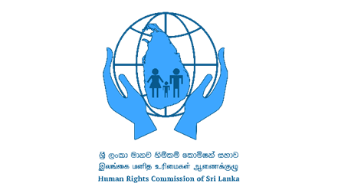

Parallel Report to the Committee on the Elimination of Discrimination against Women

Human Rights Commission of Sri Lanka

Submitted to the 90th Session, 3-21 February 2025

6 January 2025

Introduction

- The Human Rights Commission of Sri Lanka (HRCSL) is an independent commission established under the Human Rights Commission of Sri Lanka Act, No. 21 of 1996. The President appoints members of the Commission on the recommendation of the Constitutional Council established under the Constitution of Sri Lanka. In May 2024, the Global Alliance of National Human Rights Institutions (GANHRI) Sub-committee on Accreditation (SCA) recommended that the HRCSL be reaccredited with ‘A’ status.
- The HRCSL notes Sri Lanka’s Ninth Periodic Report submitted under Article 18 of the Convention on the Elimination of All Forms of Discrimination against Women (CEDAW). The Commission hence submits this parallel report to the Committee on the Elimination of Discrimination Against Women.

- This report relies on the information collected by the HRCSL during its inquiries and investigations based on individual complaints and on its own initiative. Relevant information was also gathered through monitoring visits, civil society meetings at the regional and national levels, and discussions with relevant government authorities. Additionally, the HRCSL participated in national consultations and meetings organized by relevant stakeholders and has incorporated information gathered through such engagement.

- This report focuses on developments during the period between 2016 and 2022. However, where relevant, post-2022 updates are also included.

National machinery for fulfilling obligations under CEDAW

- The HRCSL acknowledges the efforts of the Government of Sri Lanka (GoSL) to fulfill its obligations under CEDAW and implement the recommendations in the Committee’s Concluding Observations in its eighth periodic report. However, the HRCSL notes with concern that the National Action Plan on Human Rights (2017-2021) expired in 2021, and no steps have been taken to launch a new action plan.

Post-2022 update

- In 2024, the Women Empowerment Act, No. 37 of 2024 was enacted with the aim of empowering women and promoting gender equality in Sri Lanka. Importantly, the Act provides that ‘every woman shall be entitled to women’s rights and no women shall be denied of such rights’ and defines ‘women’s rights’ to mean the ‘rights of women to equality and non- discrimination as enumerated in…the goals described in [CEDAW]’. The Act also provides for the establishment of a new independent commission – the Women’s Commission, and the Constitutional Council has initiated the application process for appointments to the Commission. Meanwhile, the GoSL recently launched a Multi-Sectoral National Action Plan to Address Sexual and Gender-Based Violence (SGBV) for the period 2024–2028.

Legal status of the Convention

- Up until 2022, the rights enshrined in CEDAW were included in various Sri Lankan laws, including the Sri Lankan Constitution, only partially.

Post-2022 update

- The Women Empowerment Act of 2024 aims to establish a mechanism to give effect to CEDAW, and therefore, formally recognizes CEDAW as part of Sri Lanka’s domestic legal system.

Legal framework for prohibiting discrimination

- Article 12 of the Sri Lankan Constitution recognizes that all persons are equal before the law and equally protected by the law and prohibits discrimination on the basis of sex. Moreover, the Article authorizes affirmative action to further the rights of women. The HRCSL observes that these constitutional provisions need to be strengthened further.

- In 2016, the HRCSL submitted a proposal on constitutional reform and recommended that ‘gender’ be included in the list of grounds on which a person may not be discriminated against under Article 12(2) of the Constitution.

- The HRCSL also recommends reforming Article 16 of the Constitution, which preserves all written and unwritten law that pre-existed the current Constitution of 1978, despite being inconsistent with the fundamental rights chapter of the Constitution.

Discriminatory laws, policies and practices

- Several laws in Sri Lanka contain discriminatory provisions against women. In particular, provisions in the Muslim Marriage and Divorce Act, No. 13 of 1951 (MMDA), the Kandyan Marriage and Divorce Act, No. 44 of 1952, the Matrimonial Rights and Inheritance Ordinance, No. 10 of 1911, and the Vagrants Ordinance, No. 4 of 1841 contain discriminatory provisions. The HRCSL recommends that these provisions be repealed or amended to align with CEDAW.

- The GoSL has made periodic efforts to address these issues by appointing various committees to review these laws and propose amendments. These committees have consistently recommended repealing or amending discriminatory provisions. One notable development is the amendment of the Kandyan Marriage and Divorce Act in 2022 through the Kandyan Marriage and Divorce (Amendment) Act, No. 37 of 2022. This amendment is a progressive step, as it repealed the provisions with respect to the marriage of a minor with the consent of the father (or mother etc. in the father’s absence). However, other discriminatory provisions, including those with respect to divorce (e.g., adultery by the wife is a ground for divorce, whereas adultery by the husband must be coupled with incest or gross cruelty) under the Kandyan Marriage and Divorce Act remain.

- The HRCSL observes that the MMDA violates the rights of Muslim women and limits access to justice, due process and redress. Under the Act, women are not permitted to be marriage registrars or jurors or serve on the Board of Quazis. There are also other deeply problematic and discriminatory provisions in the MMDA, such as permitting marriage of persons under the age of 18 years, the absence of any requirement for the woman to sign the marriage registration document, setting different conditions for divorce for men and women, and permitting polygamy without the consent of the existing wife.

- The Third Schedule of the Land Development Ordinance, No. 19 of 1935 contained discriminatory provisions against women in terms of succession to state land permits. The HRCSL welcomes the fact that the GoSL amended this law in 2022 to remove such discriminatory provisions.
- The HRCSL observes discrimination of women within the criminal justice system. For example, archaic laws such as the Vagrants Ordinance are still used to incarcerate women, including sex workers. A number of such women are detained in the Methsevana, State House of Detention, and the Ruhunu Ridigama Detention Centre.

- Additionally, the HRCSL observes that persons from the LGBTIQ community continue to face harassment, and cruel, inhuman and degrading treatment under the Penal Code, No. 2 of 1883 (sections 365, 365A, and 399 in particular), and the Vagrants Ordinance.

- Existing laws including the Public Security Ordinance, No. 25 of 1947 have been relied on to impose discriminatory rules on the attire of Muslim women. For instance, following the Easter Sunday terrorist attacks of 2019, emergency regulations were issued under the Public Security Ordinance prohibiting all attire that covered the face. The regulations had a disparate impact on Muslim women who wore face coverings such as niqab and led to the general harassment and discrimination of Muslim women and girls who wore head coverings. The HRCSL received numerous complaints and also initiated its own investigations into the matter. On 10 May 2019, it wrote to the Ministry of Education clarifying the legality of religious attire and recommending that emergency law be interpreted in accordance with the principle of non- discrimination.
- On occasion, discriminatory practices with respect to religious attire have lacked any legal basis. For instance, in 2018, the HRCSL received a complaint from four assistant teachers at Sri Shanmuga Hindu Ladies College. They claimed that the school had prohibited them from wearing abaya, a traditional dress worn by Muslim women. The HRCSL found that the school authorities’ actions violated the fundamental rights of the complainants and issued a recommendation accordingly.

- The HRCSL observes that transgender persons continue to face discrimination under Sri Lankan law. In this context, it has held several discussions with the Ministry of Health, the Registrar General’s Department, and civil society organizations regarding the recognition of transgender names and sex changes in birth certificates. As a result of the HRCSL’s recommendations, the Ministry of Health issued special circulars in 2016 on issuing gender recognition certificates and enabling transgender persons to obtain official documents.

Although certain challenges were experienced in terms of implementing these circulars, the HRCSL observes that important progress has been made with respect to recognising transgender rights. The HRCSL recommends that the GoSL enact legislation on transgender rights, including the amendment of the Birth and Death Registration Act, No. 17 of 1951 to formally require the Registrar General to issue updated birth certificates to transgender persons.
Post-2022 update

- Discrimination with respect to religious attire has continued in Sri Lanka. In 2024, the HRCSL launched a suo motu investigation into the decision of the Department of Examinations to withhold the results of over 70 female students of Zahira College, Trincomalee who sat for the GCE A/L Examination in 2023 on the alleged grounds that the students had violated the examination rules with respect to ensuring that their ears were visible during the examination. The investigation revealed that the students had worn shawls wrapped around their heads in a manner ensuring that their ears were visible and that they had not violated any examination rules. Due to the HRCSL’s intervention, the Department released the examination results.

- In 2023, a Private Member’s Bill was introduced to repeal/amend sections 365 and 365A of the Penal Code to decriminalize same sex conduct. The Supreme Court endorsed the Bill as consistent with the Sri Lankan Constitution. However, the GoSL is yet to adopt this Bill. In 2024, the HRCSL wrote to the Minister of Justice on two occasions recommending that the Bill be enacted.

- The Women Empowerment Act of 2024 formally recognizes ‘gender’ and ‘sexual orientation’ as grounds of discrimination. The HRCSL views this legislative development as a positive step towards alignment with CEDAW but recommends that these grounds be explicitly included in the Sri Lankan Constitution.

- In 2023, the HRCSL issued guidelines to Sri Lanka Police on the protection of transgender persons.

Access to justice

- Sri Lanka Police has established the Women and Children Bureau in each police station in Sri Lanka. However, the HRCSL observes that cultural practices, patriarchal structures, economic vulnerabilities, and language barriers continue to impede women’s access to justice. Sri Lanka Police lacks adequate representation of minorities in its’ cadre and despite cabinet approval to ensure 15% women cadre in specific grades, female officer vacancies continue to exist. These inadequacies particularly affect women in the North and East of Sri Lanka and Malaiyaha Tamil women. It is also observed that, in general, women experience challenges in accessing justice with respect to sexual and gender-based violence, including domestic violence. The HRCSL recommends that gender-responsive training continue to be provided for all police officers.

- In this context, the HRCSL has conducted human rights awareness programmes, including those focused on gendered discrimination, for police officers and security forces across Sri Lanka. These programmes were held through Police Training Colleges, the Police Academy, and the Human Rights and Humanitarian Directorate of the Security Forces. Since 2016, the HRCSL has commemorated International Women’s Day annually.

Post-2022 update

- In 2024, the HRCSL established a Gender Focal Point to provide support to women and sexual and gender minorities seeking redress for rights violations. It also launched the thematic sub- committee on Gender and Sexual Orientation and Gender Identity, which includes the participation of civil society organisations and experts.

Women, peace and security

- The Office on Missing Persons (OMP) was established by the Office on Missing Person Act, No. 14 of 2016 and operationalized in 2017. Thereafter, the Office for Reparation was established under the Office for Reparation Act, No. 34 of 2018. The Convention on the Protection of All Persons from Enforced Disappearance Act, No. 5 of 2018 was enacted in 2018. Each of these mechanisms were designed to promote aspects of transitional justice in Sri Lanka.
- The HRCSL observes that women, including mothers and spouses, continue to demand truth and accountability for human rights violations and crimes committed during previous insurrections, and during and in the aftermath of the armed conflict that ended in 2009. The HRCSL observes that many among these activists, victims and survivors appear to have lost faith in formal mechanisms designed to deliver truth and accountability.

- Moreover, it is observed that women, and particularly those in the Northern and Eastern Provinces advocating for truth and accountability with respect to disappearances, face threats, harassment, and arbitrary arrest and detention by law enforcement authorities. The HRCSL has received numerous complaints alleging that officers from the Criminal Investigation Department (CID) and Terrorist Investigation Division (TID) engage in threats and harassment of women who engage in advocacy efforts. Meanwhile, women Human Rights Defenders (HRDs) also continue to face threats and harassment from law enforcement officials with respect to carrying out their activities on behalf of vulnerable persons, including women.
Post 2022 update

- In July 2024, the HRCSL received a complaint regarding the harassment of women HRDs working with vulnerable women. The HRDs’ organisation provides livelihood assistance to women beneficiaries. It was alleged that officers from the TID visited the beneficiaries’ homes to inquire about the livelihood assistance project, and threatened and harassed the beneficiaries, prompting them to consider withdrawing from the programme.

- In this overarching context, in 2024, the HRCSL issued a set of General Guidelines and Recommendations on the Protection of Human Rights Defenders. The guidelines and recommendations highlight the specific vulnerability of women HRDs.

Participation in political and public life and decision-making

- A 25% quota for women representatives in local authorities was ensured through the Local Authorities Elections (Amendment) Act, No. 1 of 2016. As a result of this amendment, approximately 2,200 women political representatives were elected to local authorities in 2018.

- There is currently no similar quota with respect to provincial council and parliamentary elections. At the 2020 parliamentary elections, only around five percent of elected members were women.

- The HRCSL observes that women politicians and political activists continue to face verbal abuse and harassment both by members of the public and their peers.

Post-2022 update
- At the 2024 parliamentary elections, 21 women representatives were elected to parliament, marking the highest percentage of women parliamentarians in Sri Lanka’s history.

Budget allocations for women’s economic empowerment
- From 2016 to 2021, Sri Lanka's budget allocations for women’s development programmes fluctuated, with total funding peaking in 2016 (Rs. 233.56 million) and in 2018 (Rs. 231.43 million) before declining sharply in 2020 (Rs. 101.56 million). A recovery in funding occurred in 2021 (Rs. 204.55 million) with a focus on entrepreneurship development. Key programmes, such as ‘Diriya Kantha’ and ‘Kantha Saviya’ consistently received funding during this period, although the allocations decreased significantly in later years.
- Funding allocation for the prevention of violence against women has also declined since 2018. An allocation of Rs. 50 million in 2018 declined to Rs. 25 million in 2021.

Employment

- In 2018, the HRCSL published a report titled ‘Empowering Women in the Informal Sector: A Human Rights Agenda’, outlining several recommendations to address challenges, including discrimination, faced by women in the informal sector. The report recommended promoting equal access to credit through a National Credit Policy, with a focus on agriculture and informal sectors, and the establishment of daycare centres and skill development programmes for women.
- Migrant workers play a crucial role in Sri Lanka’s economy, significantly contributing to the country’s economic stability, poverty reduction, and overall development. In 2016, the HRCSL established a thematic subcommittee on Migrant Workers. This sub-committee

comprised civil society representatives and aimed to engage a range of critical issues faced by migrant workers, including concerns related to pre-departure training, employment agreements, and the impact of migration on families, especially mothers with young children. The HRCSL recommends that Sri Lanka ratify the International Labour Organization (ILO) Convention No. 181 to implement measures that protect both national and migrant workers from abuse while ensuring that legitimate agencies are not undermined by rogue operations.
- The HRCSL also emphasizes the need for concrete measures to ensure decent work for domestic workers, many of whom are women. It recommends the ratification of ILO Convention No. 189, which specifically deals with the rights of domestic workers.

Women and development

- The microfinance loan system in Sri Lanka has operated in a distorted manner, often bypassing regulatory frameworks and targeting marginalized women, leading many into severe debt traps and causing a widespread social crisis. In response, the HRCSL made several recommendations to the Central Bank of Sri Lanka, including the immediate enactment of the proposed Credit Regulatory Act, revisiting existing microfinance regulations, and respecting language rights in regulatory guidelines.

Post-2022 update

- In April 2024, the then government proposed a Microfinance and Credit Regulatory Authority Bill, which it later withdrew along with a commitment to engage in wider consultations.

Women in detention

- Women face particular vulnerabilities in the context of incarceration, including vulnerability to abuse, including sexual abuse, and the lack of access to adequate healthcare facilities and products, including sanitary napkins. In 2020, the HRCSL conducted a comprehensive study on prisons, focusing on the imprisonment of women and highlighting various issues they face within the prison system. The HRCSL published a detailed report with recommendations for relevant authorities.

- The Commission also carried out several surprise visits to detention centres, including the Methsevana State House for Detention, and the Foreign National Holding Centre in Mirihana. These visits aimed to address concerns related to healthcare, security, the specific needs of breastfeeding mothers, infant meals, and child development.
- In 2022, the HRCSL began operations as the designated National Prevention Mechanism on Torture (NPM) following Sri Lanka’s ratification of the Optional Protocol to the Convention Against Torture in 2017. Since then, the HRCSL has conducted numerous NPM visits, including to women’s detention centres.

Malaiyaha Tamil Women

- Malaiyaha Tamil women, many of whom work in Sri Lanka’s plantation sector, face multiple forms of discrimination, including intersectional discrimination on the basis of their ethnicity, preferred language, and economic status. The structural marginalization they have experienced due to impact of exclusionary citizenship legislation, the inadequate provision of state services to the plantations, and the economic isolation of the plantations further exacerbated the above conditions. Many such women work as tea pluckers and rubber tappers, where their daily wages are extremely low.

- The HRCSL observes that discriminatory and exploitative practices by private companies contribute towards the violation of the rights of these women, including their right to decent work, right to health, including reproductive health, and right to adequate housing. The high rate of school dropouts among girls in this community is linked to their responsibility for caring for younger siblings in the absence of older family members who engage in fulltime employment. It is also observed that many women and girls in this community are vulnerable to trafficking in persons.

Post-2022 update

- In 2024, the HRCSL established a thematic sub-committee on the Malaiyaha Tamil Community to engage issues related to the community, including challenges faced by women. This sub-committee also includes civil society representatives from the community and aims to engage both state and private actors on the protection and promotion of the rights of the Malaiyaha Tamil Community.

Elimination of prejudicial customary and other practices
33. In July 2017, a group of affected families filed a complaint with the HRCSL regarding the harmful effects of female genital mutilation (FGM). The HRCSL organized a meeting between medical practitioners and the complainants to address the issue and sought input from the Family Health Bureau under the Ministry of Health. The HRCSL then recommended that a circular be issued to medical professionals. As a result of this intervention, the Director General of Health Services issued a circular in 2018, stating that disciplinary action would be taken against any medical professional involved in FGM.

