Assessment of CEDAW Rights Fulfilment in Fiji
Submission from the Human Rights Measurement Initiative to the United Nations Committee on the Elimination of Discrimination Against Women, Pacific Technical Cooperation Session, 2025.
This submission can be made public.
I. Reporting Organisation
1. The Human Rights Measurement Initiative (HRMI) measures the human rights performance of countries, including Fiji. HRMI is an independent, not-for-profit NGO with a primary base of operations in New Zealand, and a second base in the United States at the University of Georgia’s Center for the Study of Global Issues (GLOBIS).
II. Assessment Methodology
2. HRMI uses the award-winning and peer-reviewed SERF Index methodology to measure the fulfilment of economic and social rights (ESR), and an expert survey methodology to produce data on civil and political rights (CPR), and violations against a range of vulnerable groups, including women, girls, children, and single parent families.
3. Since 2019, HRMI has also produced expert survey data from Pacific countries and territories about specific human rights themes including violence against women, children, and other specific groups; the effects of the climate crisis on human rights; and Indigenous and cultural rights.
4. In 2021, HRMI produced an extra report on the effect of the Covid-19 pandemic and government responses on human rights conditions in a sample of countries, including Fiji.
5. For more details on HRMI’s methodology, please refer to the resources on our website. All HRMI’s data are published annually on the Rights Tracker and are freely available for non-commercial use under a Creative Commons License. HRMI’s Rights Tracker is a certified Digital Public Good with the Digital Public Good Alliance.
III. Discrimination Against Women in Economic and Social Rights in Fiji
6. Fiji scores 83.1% on HRMI’s overall income-adjusted Economic and Social Rights assessment. This score takes into account Fiji's resources and how well it is using them to make sure its people’s rights are fulfilled.
7. This score tells us that Fiji is only doing 83.1% of what should be possible right now with the resources it has. Since anything less than 100% indicates that a country is not meeting its current duty under international human rights law, our assessment is that Fiji has a long way to go to meet its immediate economic and social rights duty.
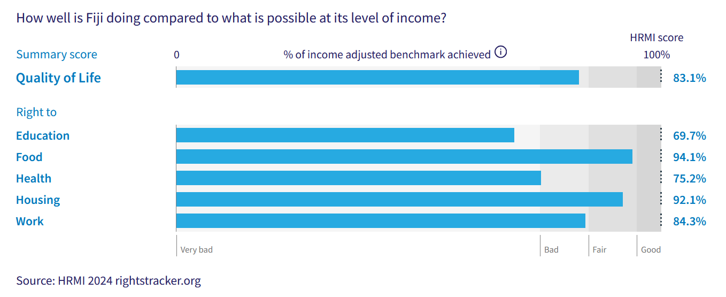
Right to education = 69.7% (‘very bad’)
Right to food = 94.1% (‘fair’)
Right to health = 75.2% (‘bad’)
Right to housing = 92.1% (‘fair’)
Right to work = 84.3% (‘bad’)
This poor performance affects women and girls in the following specific ways.
Right to Education
8. While Fiji scores well for primary school enrolment, its scores for secondary school enrolment and the quality of education provided in schools both fall in the ‘very bad’ range.
9. Also, when comparing Fiji’s scores for fulfilling the rights of boys with its scores for fulfilling the rights of girls, there is a significant disparity. This disparity has been observed since 2015.
10. Expert respondents also noted that girls were particularly likely not to enjoy their right to education.
Right to Health

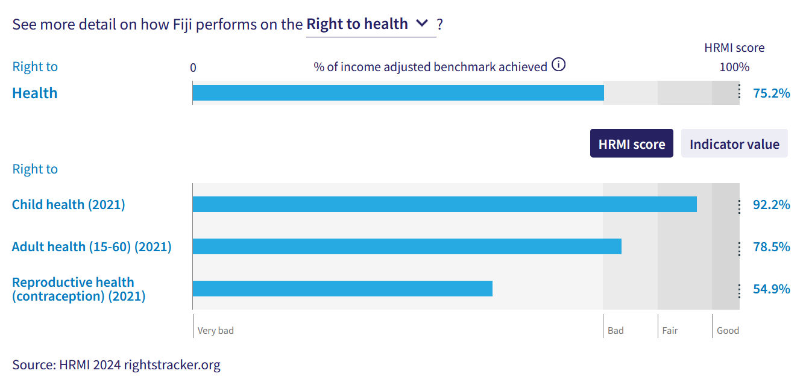
11. Fiji’s score for the right to child health, based on the number of children surviving to age five, is in the ‘fair’ range, indicating considerable room for improvement.

12. The score for right to adult health is in the ‘bad’ range, affecting both men and women.

13. Expert respondents identified the following relevant groups at being at extra risk of not enjoying their right to health: women and girls; sex workers; single parent families; LGBTQIA+ people.

Right to Reproductive Health
14. Fiji’s scores for reproductive health are particularly poor.

15. Fiji’s rates of modern contraceptive use (according to data published by the United Nations Population Division) are at a very low 43.5%, leading to an income-adjusted HRMI score of 54.9%, in the ‘very bad’ range. This means that other countries with the same level of resources as Fiji have achieved very much higher rates of modern contraceptive use.

16. There has been only very shallow progress in modern contraceptive use over the last two decades.

17. Many Pacific countries have low scores on this indicator. The graph below shows HRMI’s income-adjusted right to reproductive health scores for 12 Pacific countries and territories, all in the ‘very bad’ range.

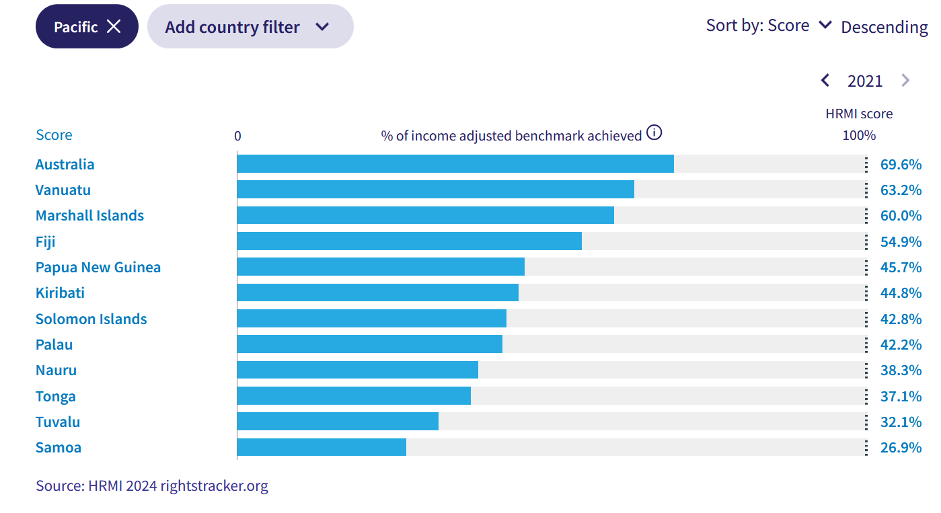

18. HRMI’s second indicator for reproductive health is based on the numbers of babies born at a healthy birth weight. Fiji’s income-adjusted score for this falls in the ‘fair’ range. According to the Organisation for Economic Cooperation and Development (OECD) and World Bank World Development Indicators data for 2020, 92.6% of babies were born at a healthy birth weight, leading to an income-adjusted HRMI score of 88.7%, indicating significant progress is possible at Fiji’s level of income.

Right to housing, water, and sanitation

19. Fiji’s scores for the rights to housing, water, and sanitation are in the ‘fair’ range, indicating some room for improvement. Expert respondents identified the following relevant groups at being at extra risk of not enjoying their right to housing: women and girls; sex workers; single parent families; LGBTQIA+ people.

Civil and Political Rights

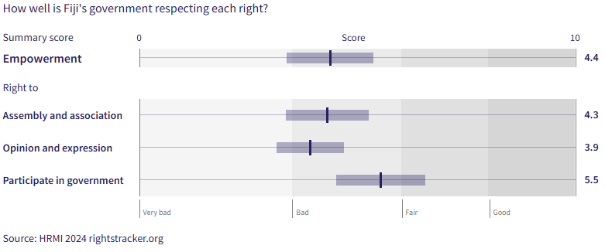

20. Fiji’s low scores for civil and political rights are particularly concerning. The overall empowerment score of 4.4 out of 10 suggests that many people are not enjoying their civil liberties and political freedoms. Many human rights expert respondents in HRMI’s research identified women/and or girls as being at a particular risk of not enjoying the right to participation in government, along with single parent families and young people experiencing homelessness.

Intersectionality

21. HRMI’s data for Fiji documents poor rights outcomes for a range of groups, including Indigenous people, disabled people, and LGBTQIA+ people. Indigenous women and girls, disabled women and girls, and LGBTQIA+ women and girls face compounding challenges to their rights.

Covid-19

22. In 2021 HRMI conducted research into the effect of the Covid-19 pandemic, and government responses to it, on human rights conditions in Fiji and other countries. The full report is available from our website.
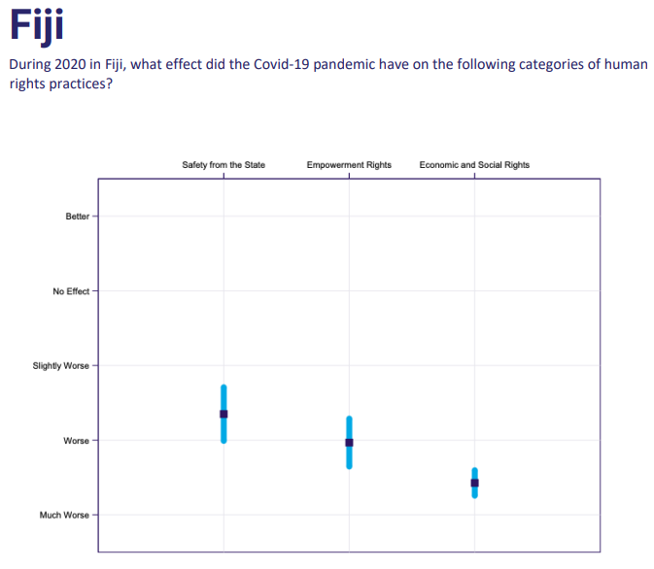

23. We found that the Covid-19 pandemic greatly worsened human rights issues across all areas within Fiji. The above graph demonstrates that the upholding of Safety from the State and Empowerment Rights became worse during the pandemic. Concerningly, the upholding of Economic and Social Rights practices became much worse.
24. The right to work was strongly impacted during the Covid-19 pandemic, along with all other economic and social rights.

25. Human rights experts also said that the rate of women experiencing violence increased with the Covid-19 pandemic, which caused a widespread loss of jobs and greater uncertainties.

Climate Crisis
26. In 2019, in response to direct requests from Pacific human rights defenders, including those from Fiji, HRMI began producing data annually to document the effect of the climate crisis on human rights.

27. When asked in 2023 to describe the situation in Fiji in 2022, expert respondents noted that the effects of climate change have a disproportionate impact on women, Indigenous people, and other vulnerable groups.

Violence
28. Again, in response to direct requests from communities in the Pacific, HRMI has been measuring rates of violence against four specific vulnerable groups since 2019: children; people with disabilities; MVPFAFF+/LGBTQIA+ people; women. The scores appear on the graph below.

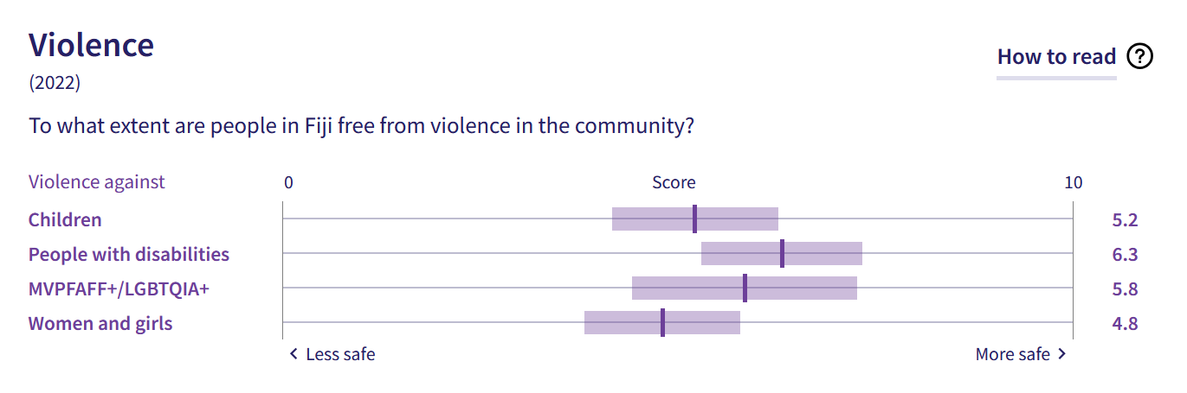

29. When asked to provide more context about violence against children in 2022, respondents said the following:

- Sexual violence against girls is horrific in Fiji
- Many families continue to equate 'discipline' with smacking and beating
- Many children who are physically punished at school (despite it being against the law), will get physically punished again at home if their parents find out.

30. When asked to provide more context about violence against people with disabilities in 2022, respondents mentioned the following:

- General levels of violence in Fiji were already high before the pandemic and only increased with Covid-19, widespread loss of jobs, and greater uncertainty
- People with disabilities may often be viewed as burdens and face resentment when families are struggling.

31. When asked to provide more context about violence against MVPFAFF+ and LGBTQIA+ people in 2022, respondents mentioned the following:

- Transwomen are targeted for their gender identity and subjected to violent rhetoric online
- The level of gender-based violence is very high; the Covid-19 pandemic increased tensions
- A survey carried out by an NGO showed that 84% of MVPFAFF+/LGBTQIA+ people have faced abuse
- There is violence outside night clubs against transgender people
- There is psychological torture from parents.

32. When asked to provide more context about violence against women in 2022, respondents mentioned the following:

- A prevalence study found that 2 out of 3 women experienced some form of violence at some point in their lives
- The rate of women experiencing violence increased with the Covid-19 pandemic, which caused a widespread loss of jobs and greater uncertainties
- Research by an NGO found that 64% of women and girls surveyed had faced abuse
- Violence against women and girls includes intimate partner violence, and sexual harassment by politicians, businessmen, and the police.

X. Concluding Remarks

33. HRMI respectfully submits its data and findings on elimination of discrimination against women in Fiji.

34. We hope that this Submission will serve as a useful resource to the Committee for drafting specific and meaningful questions to Fiji during the Pacific Technical Cooperation Session in Suva, April 2025.

Prepared by:
Thalia Kehoe Rowden
Sarah Bakewell

Visit HRMI’s website to learn more about our mission and work, https://humanrightsmeasurement.org/.
This content represents the opinions of the Human Rights Measurements Initiative. It carries no endorsement of the University of Georgia.
See HRMI’s methodology for measuring economic and social rights: https://humanrightsmeasurement.org/methodology and https://rightstracker.org/page/methodology.
Ibid
HRMI 2024 Rights Tracker, https://rightstracker.org/
See Human Rights Measurement Initiative (HRMI) Digital Public Good Certificate, https://app.digitalpublicgoods.net/a/11781 The Digital Public Goods Alliance is endorsed by the UN Secretary General’s “Roadmap for Digital Cooperation,” https://www.un.org/en/content/digital-cooperationroadmap/assets/pdf/Roadmap_for_Digital_Cooperation_EN.pdf. It defines digital public goods as: “open source software, open data, open AI models, open standards and open content that adhere to privacy and other applicable laws and best practices, do no harm, and help attain the SDGs,” https://digitalpublicgoods.net/standard/.
See https://humanrightsmeasurement.org/wp-content/uploads/2021/06/Human-Rights-During-the-Pandemic.pdf

