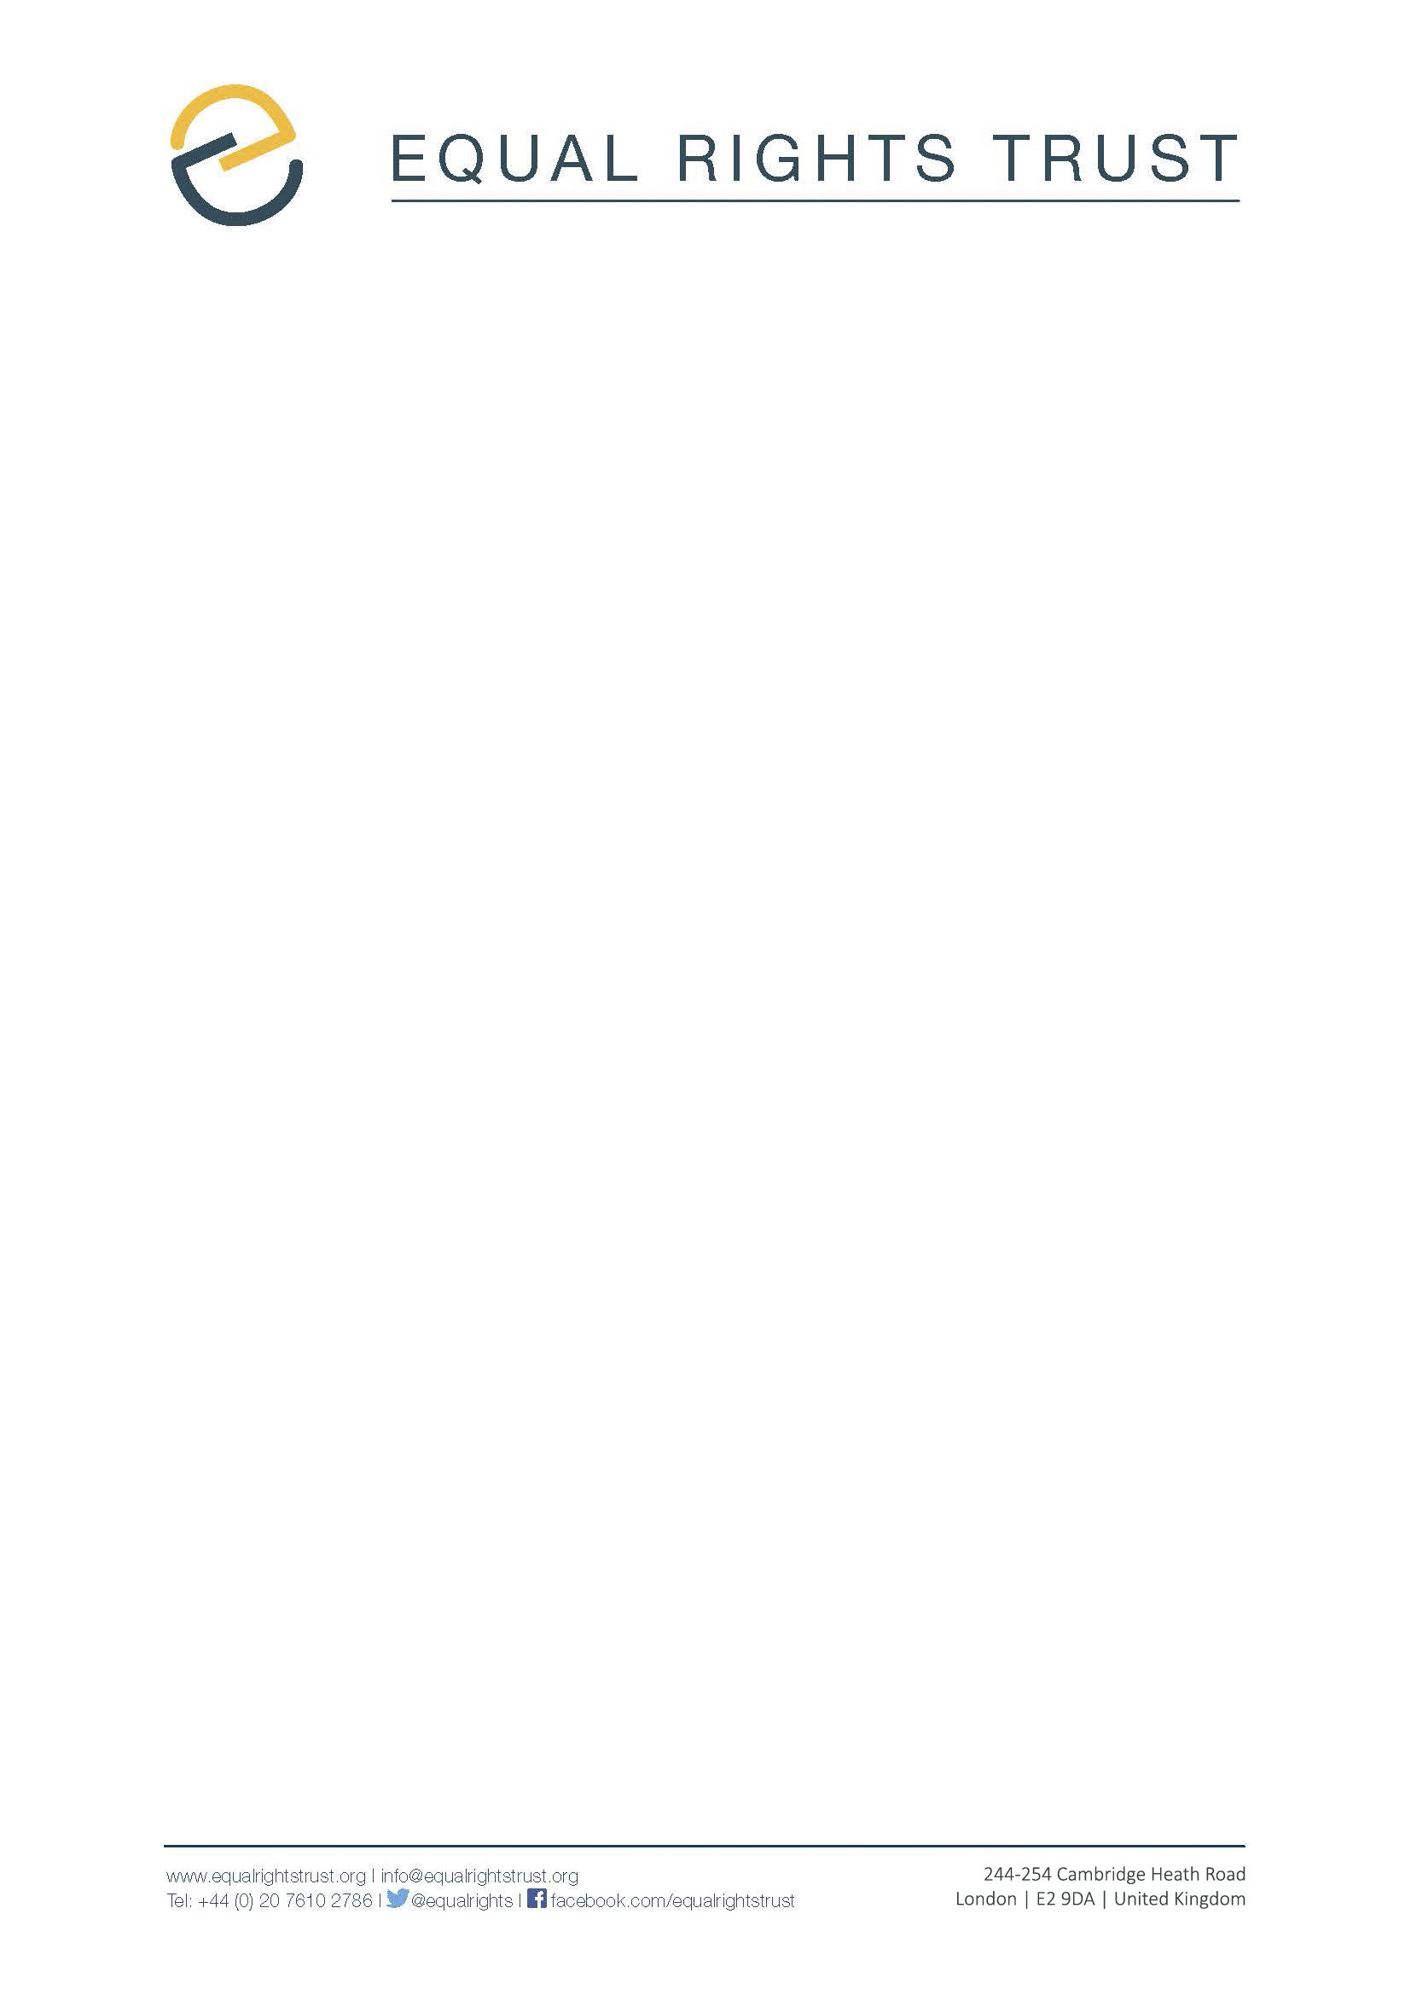

Submission to the 128th session of the Human Rights Committee in relation to the fifth Periodic Report of

The Philippines
January 2020

1. The Equal Rights Trust (the Trust) makes this submission to the 128th session of the Human Rights Committee (the Committee) in advance of its consideration of a list of issues to be raised with the Philippines.

2. The Equal Rights Trust (ERT) is an independent international organisation whose mission is to eliminate discrimination and ensure that everyone can participate in society on an equal basis. Over the course of the last decade, we have worked in partnership with civil society in more than 40 different countries, supporting efforts to secure the adoption and implementation of comprehensive equality laws. In the Philippines, we are working in partnership with the Stop the Discrimination Coalition, an alliance of civil society organisations which have come together to promote the adoption of comprehensive anti-discrimination law.

3. This submission focuses on the enjoyment of the rights to equality and non-discrimination in the Philippines, as protected under Articles 2(1) and 26 of the International Covenant on Civil and Political Rights (the Covenant). In particular, we focus on the state’s obligations, under these Articles, to enact specific, comprehensive anti-discrimination law, if it is to effectively guarantee non-discrimination, both in respect of the enjoyment of other rights protected by the Covenant and as a free-standing, fundamental right in itself.

Obligations under Articles 2(1) and 26 of the Covenant

5. Under Article 2(1) of the Covenant, state parties are required to respect and ensure the enjoyment of all rights provided in the Covenant without distinction. This Article is complemented by Article 26 ICCPR, which the Committee has stated provides an “autonomous right” to non-discrimination which “prohibits discrimination in law or in fact in any field regulated and protected by public authorities (…) [and] is not limited to those rights which are provided for in the Covenant”.
6. As Article 26 of the Covenant states, protection of the right to non-discrimination necessitates the adoption of specific legislation: this is the only way in which states can meet their obligation to ensure that “the law shall prohibit any discrimination and guarantee to all persons equal and effective protection against discrimination on any ground”. Moreover, as the Committee has noted in its recommendations to various states, compliance with these obligations necessitates, inter alia, the adoption of specific, comprehensive anti-discrimination legislation.

7. In order to be genuinely comprehensive, such legislation should inter alia: define and prohibit direct and indirect discrimination, harassment and failure to make reasonable accommodation; on a comprehensive and open-ended list of characteristics; in respect of all areas of life regulated by law; establish the procedural safeguards necessary for the effective functioning of equality law, including provision for the transfer of the burden of proof; and require that states take positive action measures to accelerate progress towards equality for particular groups. The Declaration of Principles on Equality, developed in 2008 by 128 experts from more than 40 different states, with the assistance of the Equal Rights Trust, sets out the principles which states should follow when developing such legislation, in order to ensure compliance with their obligations under international law.

Concerns

8. Contrary to its obligations under the Covenant and other international human rights instruments to which it is party, the Philippines has not adopted comprehensive anti-discrimination legislation. This is despite the fact that draft anti-discrimination legislation has been under consideration since 2014, and despite the recommendations made by the Committee’s sister bodies, such as the Committee on Economic, Social and Cultural Rights.

9. In the absence of such legislation, the state is in contravention of its specific obligation under Article 26 to ensure that “the law (…) prohibit[s] any discrimination”, and is also unable to meet its obligations, arising under both Article 26 and Article 2, to ensure enjoyment of the right to non-discrimination in practice. As a result of the gap in legislative protection, certain groups – LGBTI persons for example – do not benefit from legislative protection from discrimination. Although some laws, such as the Magna Carta for Public Social Workers, ostensibly prohibit discrimination on the grounds of sexual orientation, such protections are limited in scope and undermined by discriminatory provisions in other laws.

10. More broadly, in the absence of comprehensive equality law, members of other groups experiencing discrimination are forced to rely on a patchwork of non-discrimination provisions which, together, fail to provide comprehensive protection both between and within groups. Thus, for example, ethnic minorities have limited protection from discrimination in employment, as there is no specific law on race or ethnic discrimination, and the Labour Code – which prohibits discrimination against women – does not cover ethnic discrimination.

11. Where specific anti-discrimination laws have been enacted, some are not consistent with relevant international standards. For example, the Committee on the Rights of Persons With Disabilities has noted that the Magna Carta for Persons With Disabilities uses a medical, rather than a social, model of disability and is limited in its material scope.

12. A further problem is the inadequate implementation and enforcement of existing laws: the CESCR has expressed concern about the poor implementation of the Indigenous Peoples’ Rights Act, and the limited powers of the National Commission on Indigenous Peoples, while the Committee on the Elimination of Discrimination Against Women has noted the absence of implementing measures in the 2009 Magna Carta of Women.

13. More broadly, in the absence of specific, comprehensive legislation, the legal framework on equality and non-discrimination is incomplete and inconsistent. Both duty-bearers and rights-holders lack clarity as to the appropriate definition of discrimination, the forms of prohibited conduct and the personal and material scope.

Proposed Questions

14. In view of the above, the Equal Rights Trust urges the Committee to ask the Philippines:

a) What progress has been made by the state in adopting comprehensive equality legislation in line with its obligations under Articles 2(1) and 26 of the Covenant?

b) To what extent do other national laws provide protection from forms of direct and indirect discrimination, failure to make reasonable accommodations and harassment? On which grounds is discrimination prohibited?

c) What concrete measures has the State Party taken to ensure access to justice for survivors of discrimination?

d) What monitoring mechanisms have been put in place by the state to identify inequalities, discriminatory practices and patterns of disadvantage?

Human Rights Committee, General Comment No. 18: Non-Discrimination, 1989, Para 12.
International Covenant on Civil and Political Rights, Article 26.
See, for instance, Human Rights Committee, Concluding Observations: Iceland, UN Doc. CCPR/C/ISL/CO/5, 31 August 2012, Para 6.
See, for example, Committee on the Rights of Persons with Disabilities (CRPD), General Comment No. 6 on the Right of Persons with Disabilities to Equality and Non-Discrimination, UN Doc. CPRD/C/ GC/6, 2018, Para 18.
See, for example, Committee on Economic, Social and Cultural Rights, General Comment No. 20: Nondiscrimination in economic, social and cultural rights (Article 2, Para. 2, of the International Covenant on Economic, Social and Cultural Rights) UN Doc. E/C.12/GC/20, 2009, Paras. 15-35.
The Committee has interpreted Article 26 of the Covenant as “prohibit[ing] discrimination in law or in fact in any field regulated and protected by public authorities” (See above, note 1).
See, for example, above, note 4, Para 31.
Ibid., Paras 28 and 29. See also, above note 5, Para 9..
Declaration of Principles on Equality, The Equal Rights Trust, London, 2008.
Committee on Economic, Social and Cultural Rights (CESCR), Concluding Observations: Philippines, UN Doc. E/C.12/PHL/CO/5-6, 26 October 2016.
Magna Carta for Social Workers, 2006, Section 17.
Committee on the Elimination of Racial Discrimination, Concluding Observations: Philippines, UN Doc. CERD/C/PHL/CO/20, 23 September 2009, Para 15.
Committee on the Rights of Persons With Disabilities, Concluding Observations: Philippines, UN Doc. CRPD/C/PHL/CO/1, 16 October 2018, Paras 6-7, and 10-11.
Committee on Economic, Social and Cultural Rights, Concluding Observations: Philippines, UN Doc. E/C.12/PHL/CO/5-6, 26 October 2016, Paras 13-14.
Committee on the Elimination of Discrimination Against Women, Concluding Observations: Philippines, UN Doc. CEDAW/C/PHL/CO/7-8, 25 July 2016, Paras 19-22.

