Citizens` Labour Rights Protection League (Azerbaijan)

CRPD - Convention on the Rights of Persons with Disabilities
Committee on the Rights of Persons with Disabilities (CRPD)

The information (submission) has been prepared based on the list of issues on Azerbaijan adopted at the 10th session of the UN Committee on the Rights of Persons with Disabilities (CRPD)
held on September 2-13, 2013 (CRPD/C/AZE/Q/1, 30 September 2013).

11th Session (31 March 2014 - 11 April 2014)

This submission is made possible by the generous support of the American people through the United States Agency for International Development (USAID). The contents are the responsibility of Citizens` Labour Rights Protection League and do not necessarily reflect the views of USAID or the United States Government.

Submitted, January 2014, Baku

Women with disabilities (Article 6)
- Please explain whether the Law on ensuring gender equality is expressly clear about women and girls with disabilities. If not, what has the State done to ensure that women and girls with disabilities are included in the provisions of this law? (para. 14 of the initial report). What steps is the State party taking towards a twin-track approach to women and girls with disabilities and to systematically collecting data disaggregated not only by gender but also by disability?
- What steps are being taken to ensure that women and girls with disabilities are consulted on an equal basis with other women and girls? How will the State party ensure that they are enabled to participate in the legislative and political spheres? What endeavours has the State Committee on Family, Woman and Child Problems undertaken to specifically serve women with disabilities, and what sort of cases has it handled? (para. 15).

The Law on provision of Gender (men and women) Equality is effective since October 10, 2006. The Law does not have any provision regarding women with disabilities (WWD).
The Labor Code envisages numerous benefits for people with disabilities (PWD). Articles 38, 66, 91.1., 119,130, 131 and 133 of the Law include all mentioned benefits for PWD. That said, there are no separate provisions or definitions related to WWD.
Level of representation of WWD (especially those with locomotory limitations) in public administration system is zero. Discrimination norms during employment are in place. Employment of the persons, who are indicated as “incapable” in the opinion issued by the Medical Social Expert Commission, creates administrative liability. Although the Collegium of the Ministry of Labor and Social Protection has adopted a decision on elimination of the rule that creates discrimination against PWD, the decision is not enforced in practice. There is indirect discrimination in employment of PWD. This discrimination is especially strong towards WWD.
The State Committee on Family, Women and Children Affairs undertakes a number of positive activities covering women. The objectives of the Committee indicated in its Charter include the following: “Solicit before relevant public agencies for solution of problems of families of martyrs who lost the head of the family, single mothers, especially women with disabilities and children. However, there is no information about concrete activity of the Committee regarding WWD. The Committee held an event on December 4, 2013 dedicated to International Day of People with Disabilities and discussed the problems of children with disabilities.

According to the Law on Social Service adopted on December 30, 2011, PWD without care are included in the list of people in difficult life conditions. WWD without care also fall within the category and the provision of the law, and can get necessary allowances. Presently, the Ministry of Labor and Social Protection has “Nursing Home” fully meeting modern requirements with high-standard conditions. WWD are placed in the House as well. The elders living in this house, including WWD, are under full public security, but they receive pensions as well. They also have full right of disposal over their property.

Accessibility (Article 9)
- Has the Government adopted an accessibility plan which covers all facets of accessibility including the physical environment, transportation, information and communications, including information and communications technologies and systems, to eliminate all existing barriers within a reasonable time frame in both urban and rural zones across the country? If so, does this plan have adequate budget allocation and intermediate benchmarks to allow for the monitoring of progress, and is the plan anchored in law? Do formal accessibility standards exist?
- How have persons with disabilities and their representative organizations been involved in the development of accessibility laws, plans and policies – for example, the pedestrian crossings in Baku? Are there plans to extend these physical access services beyond Baku to other parts of Azerbaijan and to consult with DPOs in those regions? (para. 40).

Despite adoption of the Urban Planning and Construction Code in June 2012 and its entering into force from January 2013, as well as adoption of other legal-normative acts on implementation of the Code, there are no substantial innovations in urban planning and construction activities. Standards and rules for making public buildings and social infrastructure facilities accessible for PWD have not been defined yet. During last 5 years public buildings, social infrastructure facilities, streets, sidewalks in the capital and other towns of the country have been reconstructed or rehabilitated. That said, except occasional cases, no conditions have been created to ensure unobstructed access of PWD to and movement in those buildings and facilities.

Public transport

Buses (bus terminals and bus-stops)

None of the buses in Baku and other towns of the country, as well as those connecting people to distant destinations are equipped with necessary conditions for accessibility of PWD. There are no buses, bus-stops and bus terminals in the country adjusted to the needs of PWD. Purchase of buses won’t solve the problem. The reconstructed and rehabilitated bus-stops do not have platforms or they are not suitable for PWD.

Metro (access and trains)

There are no PWD-friendly escalators, stairs and elevators in metro stations, especially those located deep underground. The situation hasn’t change after the reconstruction of the metro stations. Only in few metro stations in Baku some partial infrastructure is installed. There are no parking lots in metro cars for PWD to park their wheel-chairs and no seats for PWD available.

Railway trains (train stations and platforms)

No train station in the country, including Baku main train terminal has platforms with relevant infrastructure for PWD. There are n paths and ramps for PWD wheel-chairs on steps, sidewalks, in the train station buildings. There are no passenger cars in the country adjusted to serve PWD.

Airplane (conditions in airports and airplanes)

Airports are partially adjusted for PWD needs. However, there are some difficulties to access airport buildings with wheel-chair. Electric cars and service to help PWD to access airplanes are available, but the level of the service is not high.

Other transport means (funicular, water transport)

Infrastructure for PWD in other transport means, including funicular, pleasure cruiser boats are not available.

Accessibility cities for PWD

Article 57 of the Urban Planning and Construction Code, entered into force in July 2012, on requirements towards construction site indicate that “necessary infrastructure must be available for PWD and other persons with locomotory limitations to access and use construction facilities (especially the construction facilities of general use)”.

Article 70.2.3.of the Code requires installment of ramps for PWD in residential buildings.

There were no available legislative requirements and standards before the adoption of the Code. More than 95% of the residential and non-residential buildings constructed prior to the adoption of the Code does not have any infrastructure for PWD. Designs of the majority of the buildings being constructed and constructed after adoption of the Code do not envisage relevant conditions for access of PWD. The relevant governmental bodies that deal with acceptance of the constructed buildings do not consider the lack of infrastructure for PWD as a big deficiency. Only modern and elite residential blocks of flats in the downtown capital have partial infrastructure for PWD access.

No ramps or other structures to ease PWD access are installed in general entrances, yards, elevators of big blocks of flats in towns (and other residential areas). Even internaldesign of the flats are not suitable for PWD using wheel-chair.

Public buildings

One can note only few public buildings in Baku fully suitable for and accessible by PWD. They are the following: ASAN Public Service Centers, Heydar Aliyev Center, Heydar Aliyev Palace and etc. Buildings of central executive power bodies, including the building of the Ministry of Labor and Social Protection do not have PWD infrastructure. The slanting road in front of the main entrance of the building of the Ministry of Labor and Social Protection serves for the access of service cars only. Reception rooms of the central executive power bodies (including the Cabinet of Ministers), as well as majority of court buildings, police departments and notary offices are not suitable for PWD. It must be taken into consideration that majority of the buildings has been constructed or capitally rehabilitated after Azerbaijan acceded to the UN Convention on the Rights of Persons with Disabilities. The country’s Parliament as well is not suitable for PWD (the building has been capitally rehabilitated several years ago).

Movement in cities

Baku and other cities of the country can be called “social traps” for PWD. In most of the cases, the roads, sidewalks, underground and above-the-ground passages, parking lots, traffic lights are not designed to facilitate access and movement of PWD in cities (on wheel-chair, with walking stick, those having eye-sight problems and etc.). Although in some places conditions are locally good, PWD do not have chance to reach those localities without outside help. No traffic lights with sounds and grooves are installed in cities.

Sidewalks: Sidewalks in most of the streets are not suitable for movement.Narrow sidewalks have numerous obstacles (basement entrances, high steps in front of shops and etc.). Even ordinary people have difficulties to walk in such sidewalks. On top of this, cars park on the sidewalks. Edges of relatively wider sidewalks are paved with 25-30 cm height granite road kerbs. In the pedestrian passages those kerbs are laid on flat. In such cases, the height of the passage is about 10 cm. There are no grooves for people with eye-sight problems.

Pedestrian passages

After Azerbaijan ratified the Convention on the Rights of Persons with Disabilities, the number of constructed and rehabilitated pedestrian passages in Baku reached 54. Except few passages, other constructed or rehabilitated passages are not accessible for PWD (people with locomotory, eye-sight and hearing limitations). Only famous 5-star hotels have passages accessible for PWD. Despite some pedestrian passages have special stairs and ramps for wheelchairs, they are not usable. There are 15-20-cm barriers in front of those stairs and ramps, and the slope is more than 30 degrees. This is too dangerous for wheelchairs and they cannot be used. Above-the-ground pedestrian passages do not have infrastructure for movement of wheelchairs. No infrastructure is available in any pedestrian passages constructed in other cities of the country.
You can see images of pedestrian passages and underground parking lots recently constructed in Baku in the link below.
http://www.minera.az/index.php?option=com_content&view=article&id=266&Itemid=368

Recreation facilities

Recreation facilities (parks, alleys, boulevards and etc.) are not suitable for PWD. The rehabilitated parks, boulevards and alleys have ramps installed; however, access of wheelchairs to those facilities without outside help is impossible. Infrastructure for people with eye-sight limitations is not available at all. That said, it is possible to move with wheelchair in the National Park (seaside boulevard – currently more than 7-km long) once entered it.

Traffic lights

No traffic lights installed in Baku and other cities have sound signals or grooves for pedestrians. People with eye-sight limitations are not able to use pedestrian passages without outside help. Persons with colorblindness can figure out the traffic light color only by stoppage of cars.

Trade and catering facilities, hotels

Ramps are designed in new trade centers and catering facilities constructed in Baku and other big cities. However, majority of other trade and catering facilities are not accessible for PWD. Hotels of famous brands have all necessaryinfrastructure for PWD. Areas around such hotels (small parks, pedestrian passages, parking lots and etc.) are relatively adjusted to allow movement of wheelchairs. Mid-level hotels mostly limit their infrastructure to ramps at their entrances. Slope of the ramps in some hotels is bigger than 30% and cannot be used without outside help.

Parking lots

Although modern parking lots are constructed, there are no places for PWD to park their cars (with few exceptions). Also, pedestrian entrances and exits of underground parking lots are not suitable for PWD.

Workplaces (plants, factories, offices)

The level of employment of PWD in Azerbaijan is pretty low. There both objective and subjective reasons for this situation. They are the following:
- The relevant legislative framework is not perfect and from this standpoint, their practical implementation is impossible;
- Special infrastructure for PWD in workplaces does almost not exist. Employers are not interested in creation of such infrastructure and the State does not suggest serious incentives to raise their interest;
- There is no comprehensive and holistic education system to help PWD obtain specialties and change their existing ones in order to assist them to access the labor market.
- PWD can’t get information about vacancies;
- The number of workplaces are limited;
- PWD have problems in accessing open (competitive) labor market;
- Alternative employment system for PWD is not developed.

Workplaces in Azerbaijan, as far as PWD concerned, can be characterized as follows:

Workplaces suitable for PWD (people with locomotory, eye-sight, hearing and comprehensive limitations) are not available;
Workplaces accessible for PWD (people with locomotory, eye-sight, hearing and comprehensive limitations) are not available;
No safe work conditions are provided for PWD;
In many cases sanitary and hygienic conditions are not suitable for PWD.

Access to justice (Article 13)
- Can persons with disabilities factually and legally appear and act in courts in Azerbaijan? Is there training for judges, lawyers and court staff, and police on the rights of persons with disabilities in accessing justice, including the obligation to provide reasonable accommodation?

Criminal, civil, as well as criminal procedure and civil procedure legislation in the Republic of Azerbaijan specifies rules and procedures of participation PWD in court and investigation proceedings. The legislation includes provisions regulating participation of the people with eye-sight, hearing, speaking and comprehensive limitations (psychosocial limitations) in the court cases in the capacity of the accused, witness, and in the civil proceedings as litigator. It should be noted that all terms used in these legislative pieces regarding PWD are stigmatic and insulting. Thus, words like “blind”, “deaf”, “mute”, “retarded”, “defective” re used throughout the laws. The norms applied to PWD in investigation and court proceedings do not comply with the requirements of the Convention. The norms are not strictly followed in investigation and judicial practice.
Access to court houses, investigation and defense institutions
With few exceptions, no infrastructure is available for PWD in court houses throughout the country.The same situation is in prosecutor and internal affairs bodies. There are no possibilities to approach, enter, move up and down (through stairs and elevators) in the buildings of these agencies. Despite construction or capital reconstruction of the most of the buildings, water closets adjusted for PWD are not available. PWD (people with locomotory, eye-sight, hearing and comprehensive limitations) cannot use services of such buildings. PWD with locomotory limitation also cannot work in such offices. Although mechanical arrangements are installed at the entrance areas of newly bilt court houses, they are not used.
Guards when asked about their experience with PWD said: “we take them in arms”
Advocate institution in the country is in very bad shape. No basic opportunities exist for use of advocate services by PWD. Advocate offices are inaccessible for PWD.
Measures for increase of knowledge of courts, investigation bodies and advocates on PWD
Judges, prosecutors, lawyers in Azerbaijan are regularly involved in trainings and participate in exchange programs. Measures directed to development of capacity of staff of law-enforcement and judicial bodies are reflected in the State programs, including the State Program on Development of Judicial System. The trainings are organized both by the relevant governmental bodies(Judicial-Legal Council, Prosecutor’s Office, Ministry of Justice, Ministry of Internal Affairs and etc.), non-governmental organizations (Azerbaijan Lawyers Confederation), international and foreign agencies (USAID, US Department of Justice, American Bar Association, OSCE and etc.).
In response to the inquire submitted to the Judicial-Legal Council with regard to conduct of trainings on the rights of PWD, terms used in connection with them and other relevant topics the Council stated that education of judges in Azerbaijan is carried out in compliance with international norms and principles. Thus, judges are sent inquiries regarding their educational needs and trainings are organized in relevance to their demands.The Judicial-Legal Council also stated that no specific trainings on PWD had been conducted so far. The Judicial-Legal Council expressed its readiness to organize such trainings in cooperation with NGOs having experience in this sphere.
In response to the question about accessibility of court houses for PWD, the Judicial-Legal Councilsaid that up to 30 modern court houses have been designed within the project called “Modernization of the Judicial System” implemented in cooperation with the World Bank and construction of new court houses in Baku (Yasamal district), Oguz, Ganja (Nizami district) and Gedabey district has been finalized. Also, constructions of Sabunchu and Sheki court houses to accommodate several courts, as well as court houses in Guba and Imishli districts has started. In compliance with the requirements of the UN Convention on the Rights of Persons with Disabilities, all newly constructed and designed court houses have all conditions for free access of PWD. Arrangements for lifting wheel-chairs are installed in the entrances, floors are coated with special layer (groove) for easy movement of the people with eye-sight limitations and Braille alphabet is used for all scripts in the public areas.
Recommendations
Employees of investigative, judicial bodies, judges, police, State migration service and other law-enforcement bodies should be involved in trainings on the UN Convention on the Rights of Persons with Disabilities, other international norms on protection of PWD and current practices in this sphere.
Buildings where investigative, judicial and advocate services are rendered should be monitored concerning suitability and accessibility for PWD, special State programs should be adopted to deal with adaptation of those buildings for PWD of different categories and corresponding funds should be allocated.
Standard rules for PWD to access public and social infrastructure facilities must be defined.
Standards must be specified to make buses, trains, metro and other public transport in cities accessible for PWD. New legal-normative acts must be adopted to implement requirements coming forward from the Urban Planning and Construction Code.

Underground pedestrian passages

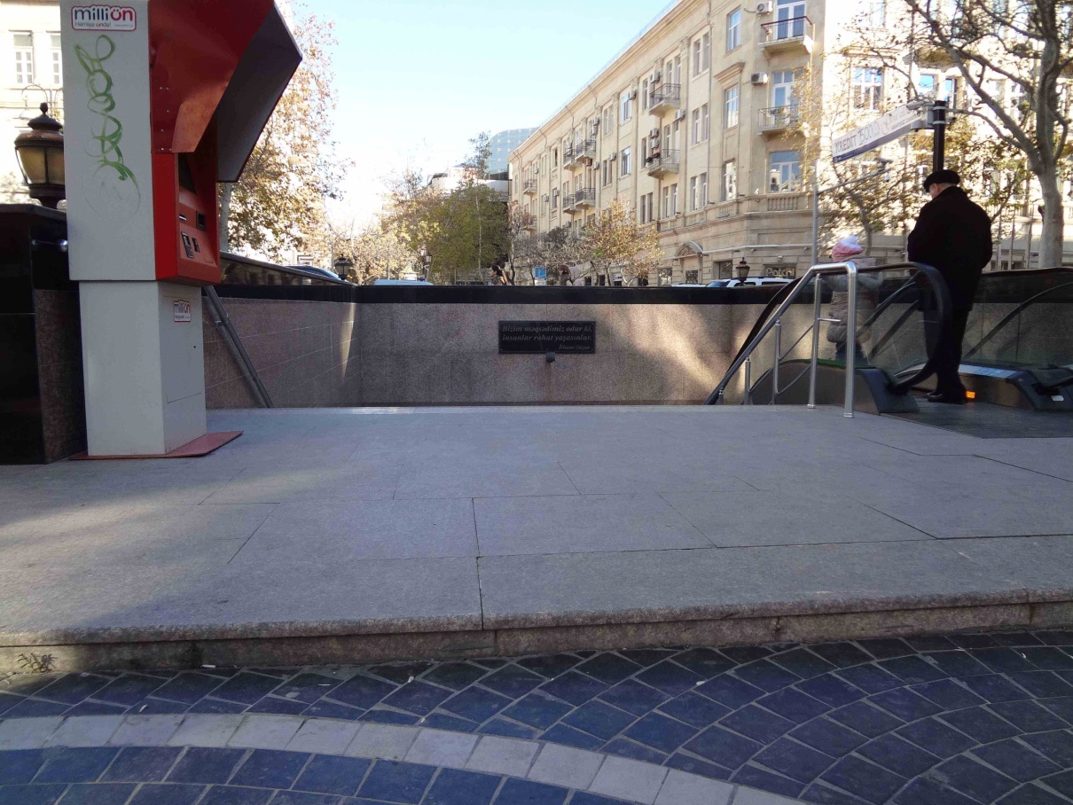

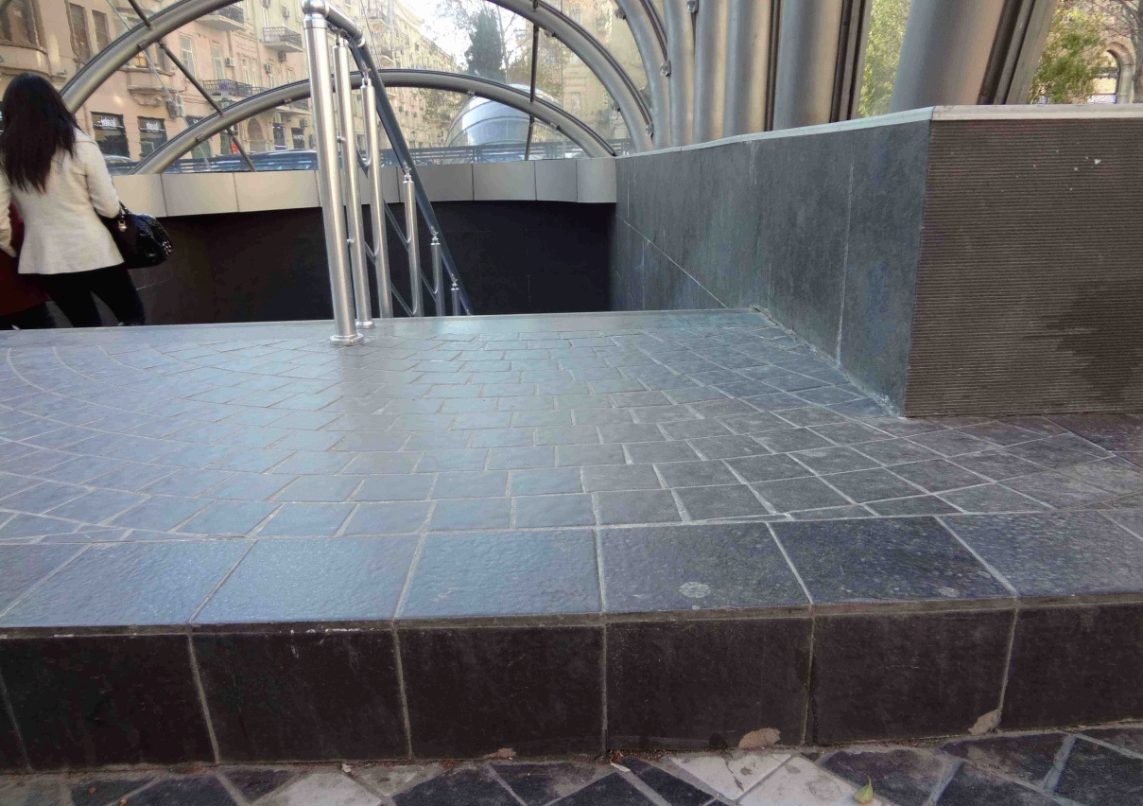
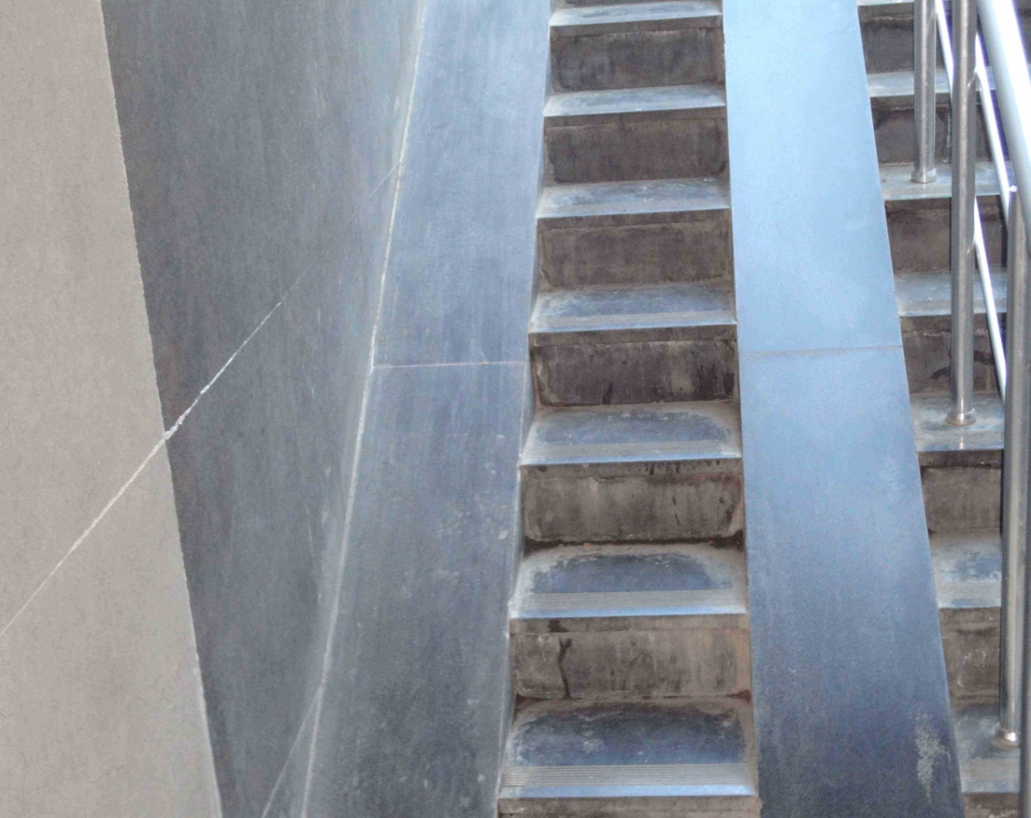

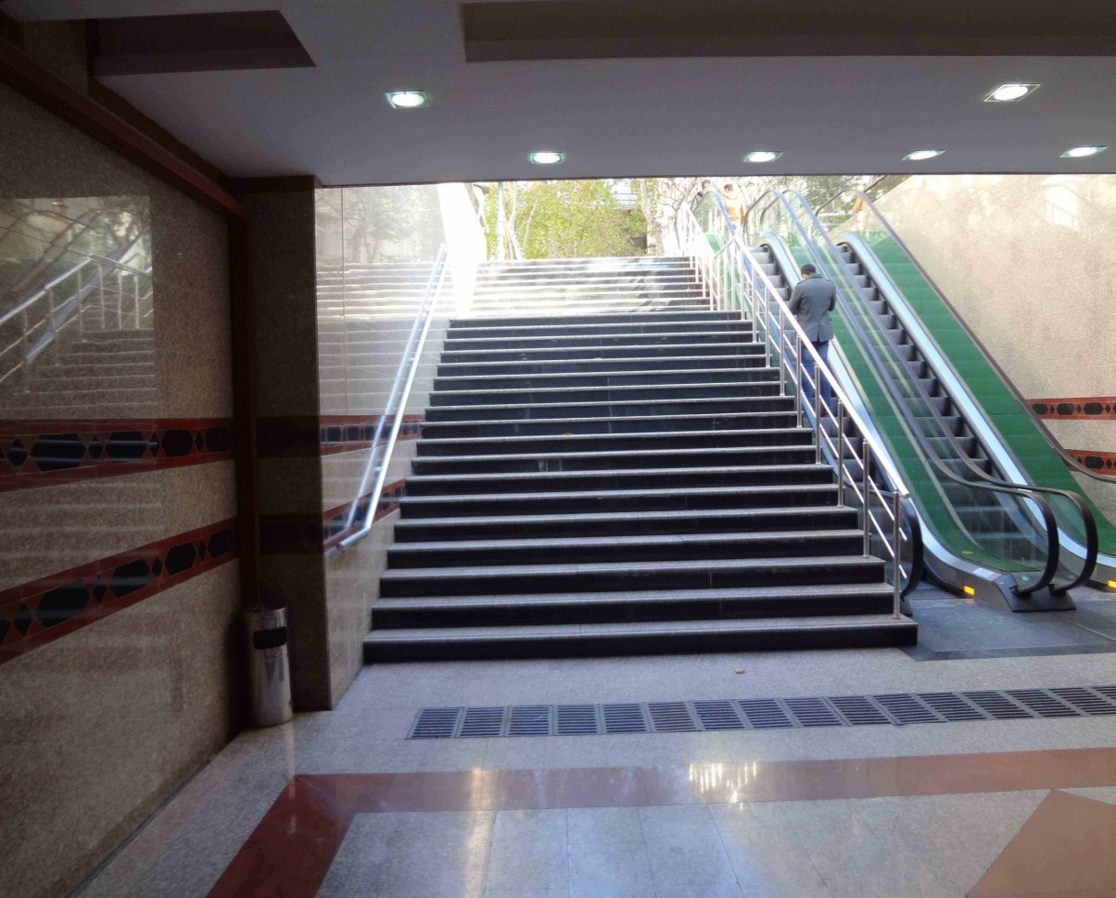

Above-the-ground pedestrian passages

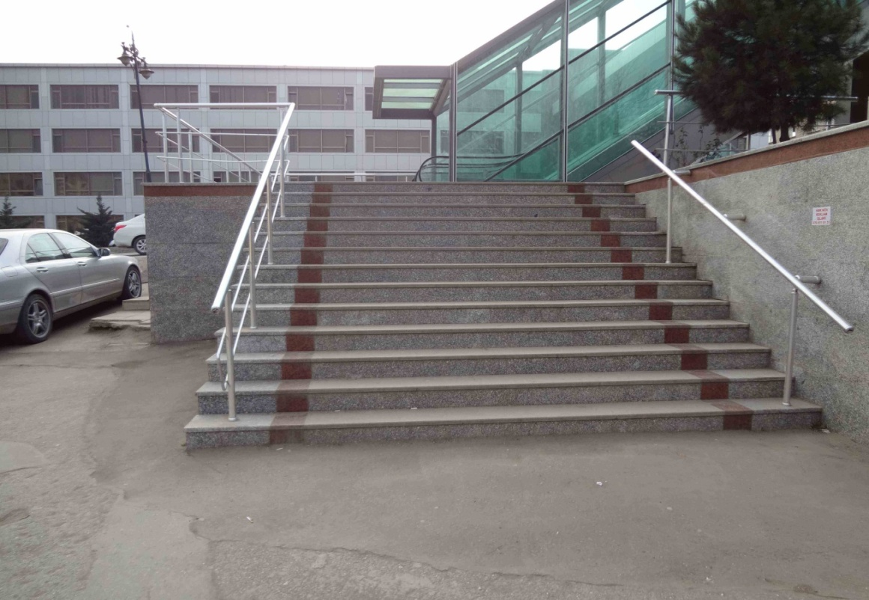

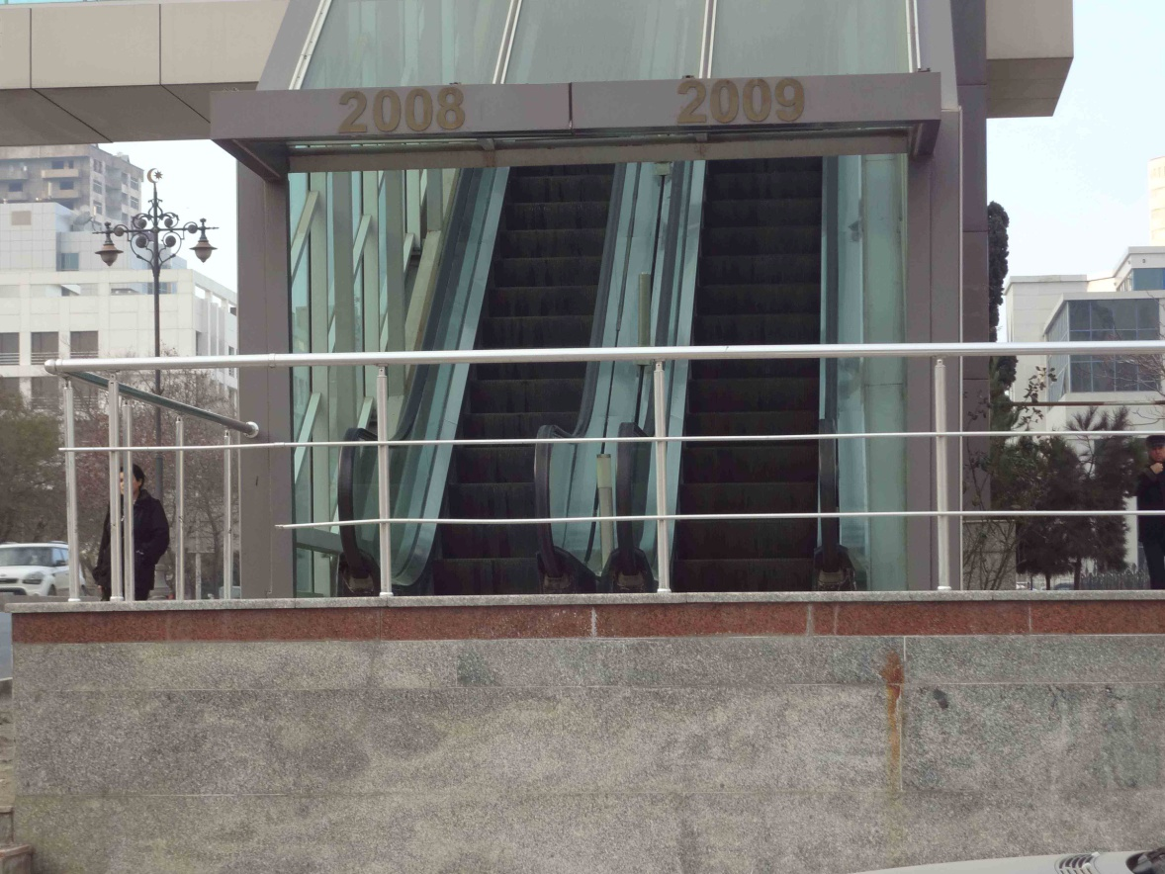
Reception room of the Ministry of Labor and Social Protection
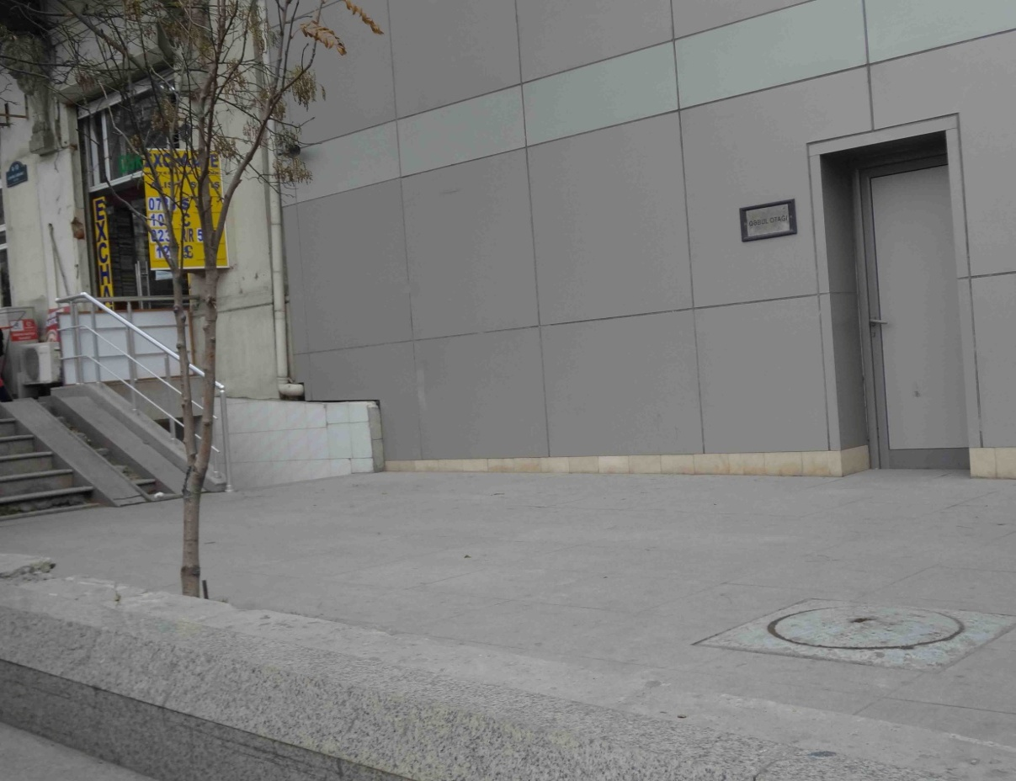

Entrances to the Supreme Court
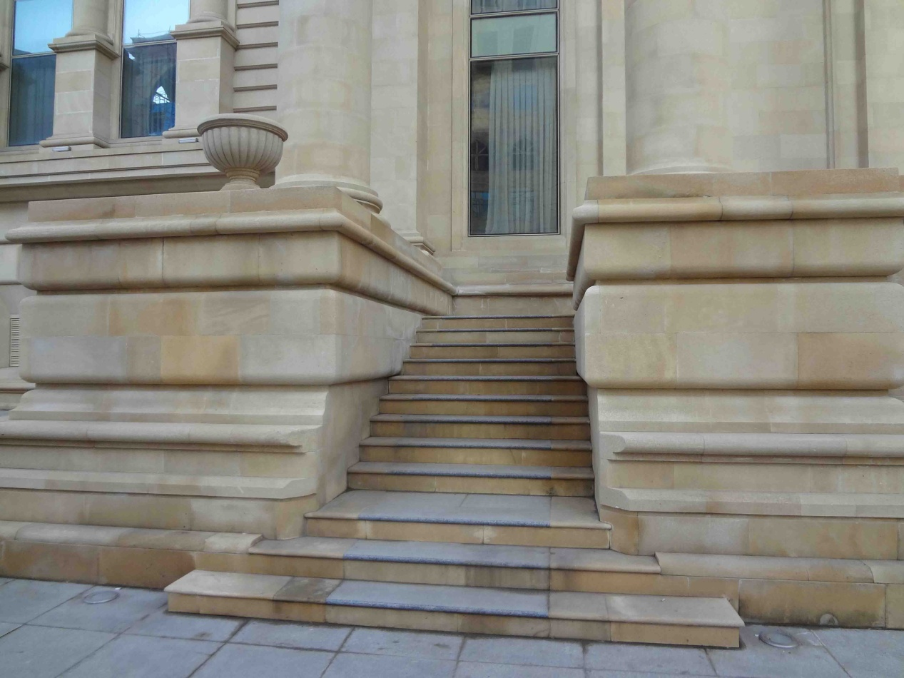
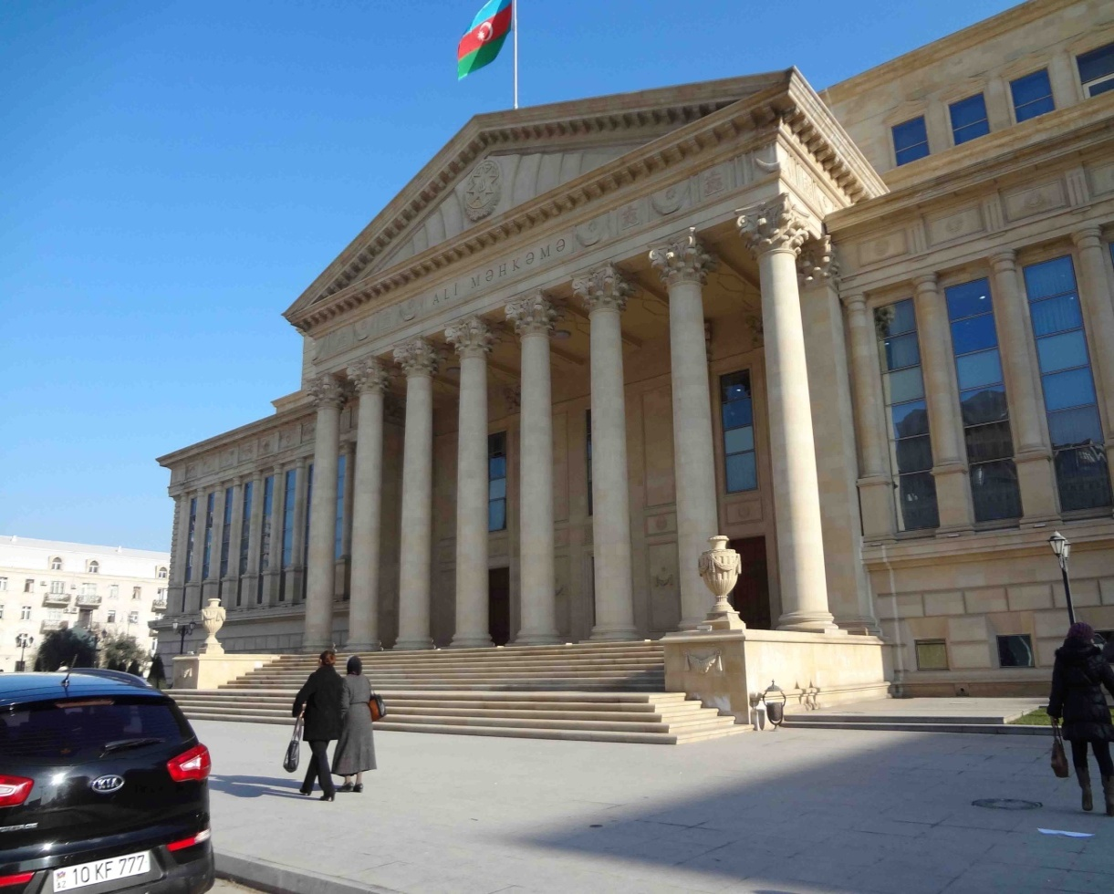

Entrance to the Yasamal District Court constructed using the World Bank loan

Entrance to the National Library

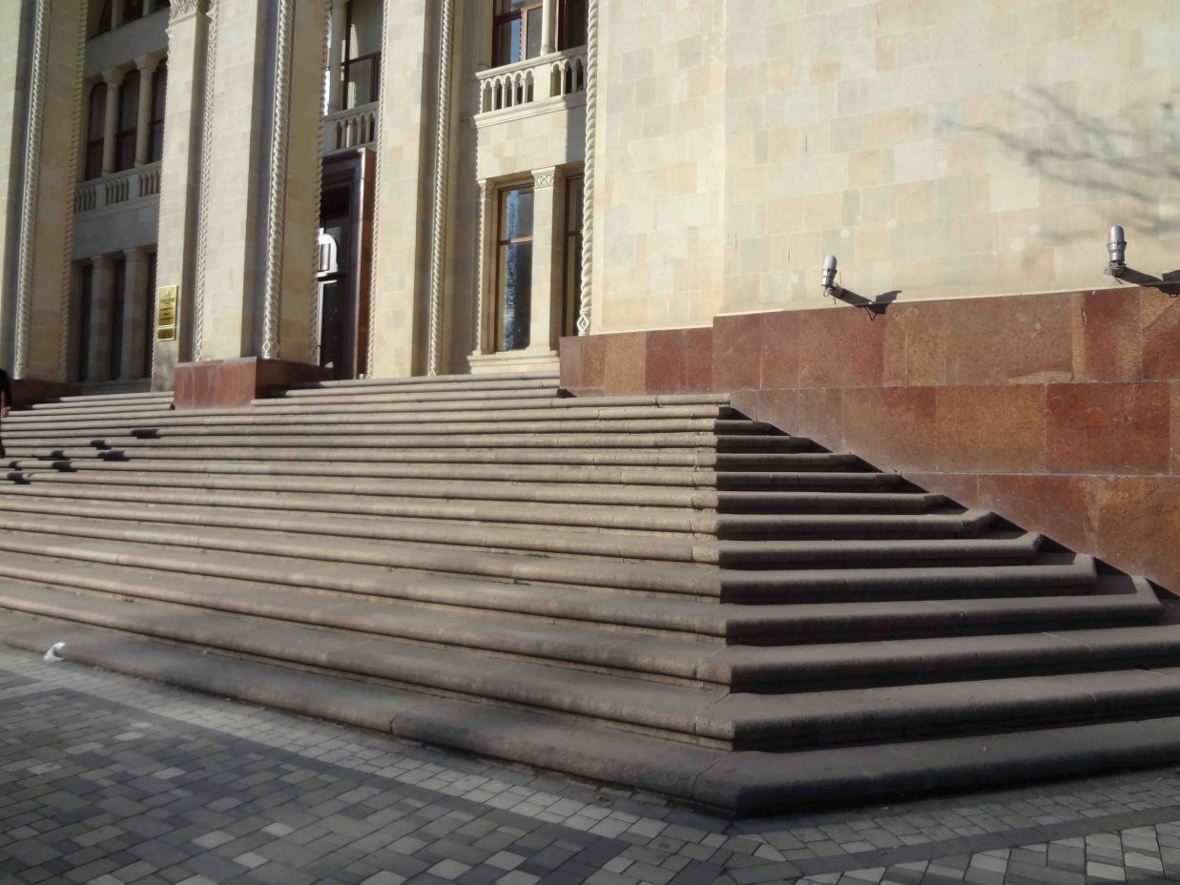
Entrance to the Park


