Annex 2

Reply to List of Issues in relation to
the seventh periodic report of the Kingdom of the Netherlands
-
Curaçao

Table 1

Table 2

Table 3: Statistical information on domestic violence

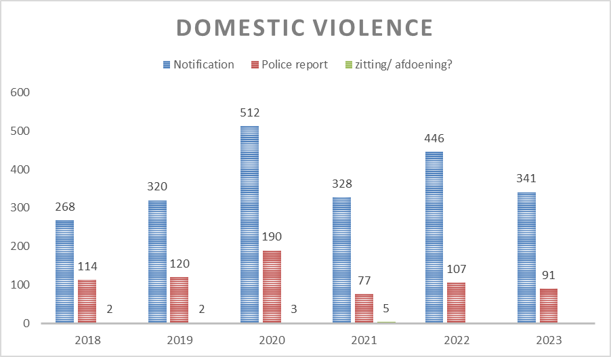

Table 4 : Information about the 12 government provisions for unemployed persons and other vulnerable groups (disabled persons):

Old-age pension supplemental allowance (AOV-toelage) increased as of 14 July 2023

As of 14 July 2023, the old-age pension supplemental allowance was increased from ANG 136 to ANG 169. (Amendment of A.B. 2005 no. 115 & A.B. 2008 no. 71).

- Welfare benefit increased as of 14 July 2023:
In 2022 there were approximately 7,951 welfare recipients, of whom 60% were men and 40% women; most are over 50 years of age. On 14 July 2023, article 14 of the Decree on Welfare Assistance (Eilandsverordening verlening Bijstand Curaçao 2008), AB 2009 no. 135, was increased by 30%.
1. Singles: biweekly payment of ANG 211.12 instead of ANG 162.40 (ANG 422.24 monthly);
2. Couples: biweekly payment of ANG 365.43 instead of ANG 281.10 (ANG 730.86 monthly).

Family/child benefit
This benefit is reserved for the most vulnerable groups in society, such as the children of welfare recipients. An extra biweekly sum of ANG 21.00 is added for each minor below the age of 21 years. (A.B. 2009 no. 135).
- Government rent subsidy through Fundashon Kas Popular (FKP) (social housing)

Water and electricity subsidy
In order to justify the continuation of this subsidy, recipients are subject to a periodic means test, in accordance with the stipulations laid down in A.B. 2009 no. 135. The governmental budget reserved for this provision in 2021 was ANG 1,327,364. In 2021 1,989 and in 2022 1,850 welfare recipients benefited from these provisions.
- Debt counselling
There are legal provisions in place to guarantee immediate reconnection if welfare recipients and persons from other vulnerable groups have their water and/or electricity cut off due to unpaid debts (water: A.B. 1978 no. 19 and electricity: A.B. 1985 no. 22). Depending on the size of the household concerned, the government provides compensation in the amount of ANG 2.65 per cubic metre of water and covers the costs of up to 300kWh of electricity. The total maximum compensation per month is ANG 55.00.

Uniform benefit for children and school transport

School-going children of vulnerable families receive yearly compensation in the amount of ANG 100.00 for school uniforms. In 2021, 1,965 children received this allowance. The total budget was ANG 201,500.00. Furthermore, arrangements for school transport are made at the beginning of each school year.

- Dietetic provision for the chronically ill:
Elderly and chronically ill welfare recipients can apply for a biweekly allowance of ANG 42.00 for specific, diet-related necessities.

- Exemption from the obligatory garbage collection fee: An exemption from the garbage collection fee (ANG 35.00) is another provision for unemployed and vulnerable persons. In 2021 1,100 welfare recipients and in 2022 1,029 welfare recipients applied for and were granted this exemption.

- Funeral expenses: The family of a deceased welfare recipient is entitled to request ANG 2,500.00 to cover basic funeral expenses. In 2019, 35 applications were granted, and 32 were granted in 2020. In 2022 a total of 16 applications were granted. (Funeral Decree, 13 September 1918)

Free legal assistance: By law (P.B. 1959 no. 198), those who qualify on financial grounds and meet the legal requirements are entitled to free legal assistance. The duty lawyer service assigns lawyers to vulnerable clients to provide assistance in judicial cases or lawsuits. Duty lawyers are paid approximately ANG 1,000.00 per case. For the years 2022 and 2023 a total of 50 free legal assistance cards for labour issues and 68 other cards for civil issues (alimony, inheritance, neighbour disputes) were issued.

Basic health card: All residents (excluding migrants who arrived after November 1st, 2014) are entitled to the provisions of Basic Health Insurance (P.B. 2013 no.43). These provisions include visits to a general practitioner, primary psychological care, medical care, hospital care (patient transportation), special care, paramedic care, dental care, pharmaceutical care, auxiliaries, obstetrics, maternity care and medical care abroad (P.B. 2014, no. 97, National Decree on medical care abroad).

- National Regulation on General Insurance for Special Illness Expenses (P.B.1996, no. 211, AVBZ): This insurance applies to individuals who, according to registration under a legally valid residence permit, are listed in the population register and is currently a resident of Curaçao. It covers those who, due to illness, complications arising from illness, or old age, have becomes so dependant on nursing or care that they are no longer able to maintain themselves as independent individuals within society, both socially and economically. It also applies to individuals experiencing psychological distress due to a combination of personal and social factors, as well as to those disadvantaged by a disorder or a disability that limits or prevents the normal fulfilment of their societal role. A disorder is defined as any absence or deviation of a psychological, physiological, or anatomical structure of function, while a limitation refers to any reduction or absence of the ability to perform activities considered normal for humans.

Budget of Curaçao, Ministry of Social Development, Labour and Welfare, page 11, paragraph 31 ‘Min- en onvermogenden maken gebruik van financiële en materiële voorzieningen’ (Those who qualify on financial grounds make use of financial and material provisions).

