Assessment of Economic and Social Rights Fulfilment in the Russian Federation
Submission from the Human Rights Measurement Initiative to the United Nations Committee on Economic, Social and Cultural Rights for the 78th Pre-Sessional Working Group, Geneva, September 2025.
I. Reporting Organisation
1. The Human Rights Measurement Initiative (HRMI) measures the human rights performance of countries, including the Russian Federation (Russia). HRMI is an independent, not-for-profit NGO with its primary base of operations in New Zealand, and a second base in the United States of America at the University of Georgia’s Center for the Study of Global Issues (GLOBIS).
II. Assessment Methodology
2. HRMI uses the award-winning and peer-reviewed SERF Index methodology to measure the fulfilment of economic and social rights (ESRs).
3. This methodology uses bellwether indicator data from international organisations—such as the World Health Organization and UNICEF—and compares each country’s achievement to what other countries at the same level of income have achieved. In this way, HRMI measures progressive realisation of economic and social rights as defined in the International Covenant on Economic, Social, and Cultural Rights (ICESCR). A country’s ‘income adjusted’ HRMI score is a measure of how well its government is converting its resources into good human rights outcomes for its people.
4. HRMI supplements these scores with qualitative information sourced by a secure, online survey of on-the-ground human rights experts, such as NGO researchers, journalists, and human rights lawyers and advocates. For more details on HRMI’s methodology, please refer to the resources on our website.
5. All HRMI’s data are published annually on the Rights Tracker and are freely available for non-commercial use under a Creative Commons License. HRMI’s Rights Tracker is a certified Digital Public Good with the Digital Public Good Alliance.
III. Overview of Economic and Social Rights Fulfilment in the Russian Federation
6. HRMI’s most recent ESR scores for Russia measure its achievement as of 2022 and indicate significant room for improvement. They are shown in the graph below.
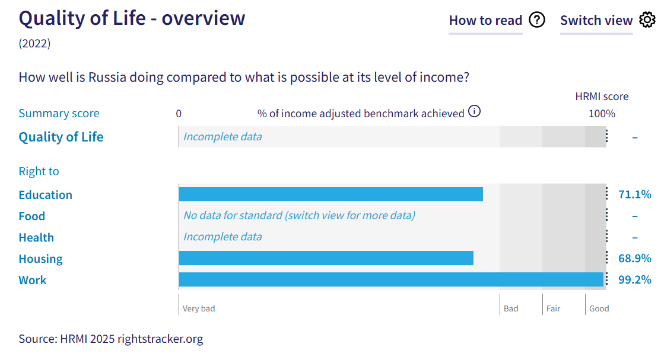
7. Russia’s scores for 2022 are as follows:
- Right to education = 71.1% (in the ‘very bad’ range)
- Right to food = 96.0% [when switched to ‘high-income’ assessment standard] (‘good’)
- Right to health = There is insufficient international data for HRMI to produce an overall score, but scores are available for some component rights.
- Right to housing = 68.9% (‘very bad’)
- Right to work = 99.2% (‘good’)
8. These scores fall into either the ‘good’ or ‘very bad’ categories, highlighting the contrasting fulfilment of economic and social rights in Russia.
9. We do not have an overall ‘Quality of Life’ score for Russia as there are some gaps in the international data necessary to produce all the scores. The available scores are measured against an ‘income adjusted’ benchmark, which means that they take into account Russia's resources and how well it is using them to make sure that the ‘Quality of Life’ rights of its people are fulfilled.
10. Some of these scores indicate that Russia is not achieving what ought to be possible with its current level of resources. Some of these scores may seem positive; however, on an ‘income adjusted’ benchmark, any score less than 100% indicates that a country is underperforming, and not meeting its current obligations under international human rights law. Therefore, our assessment is that Russia still has a long way to go to meet its immediate economic and social rights obligations.
IV. Right to Education
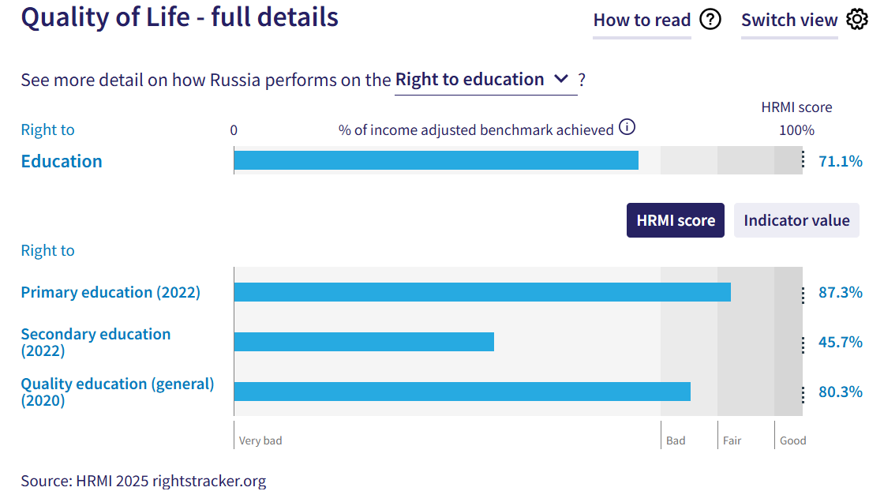
11. HRMI defines the right to education in accordance with ICESCR Article 13 and CESCR General Comments 11 and 13. For low- and middle-income countries such as Russia, HRMI further breaks down the right to education into three areas of measurement: primary school enrolment, secondary school enrolment, and quality of education. Our scores (adjusted for income) indicate the need for significant improvement across the three areas, especially on the right to secondary education and the right to quality education.
12. Russia scores an ‘income adjusted’ 71.1% on the right to education, which means that it is achieving only 71.1% of what is possible with its available resources. This score falls in the ‘very bad’ performance range. The fulfilment of the right to education in Russia has shown a steep and concerning decline, falling from 94.8% in 2019 to its current score of 71.1% in 2022. Notably, Russia ranks third lowest among 16 low- and middle-income countries in Europe and Central Asia on the right to education.
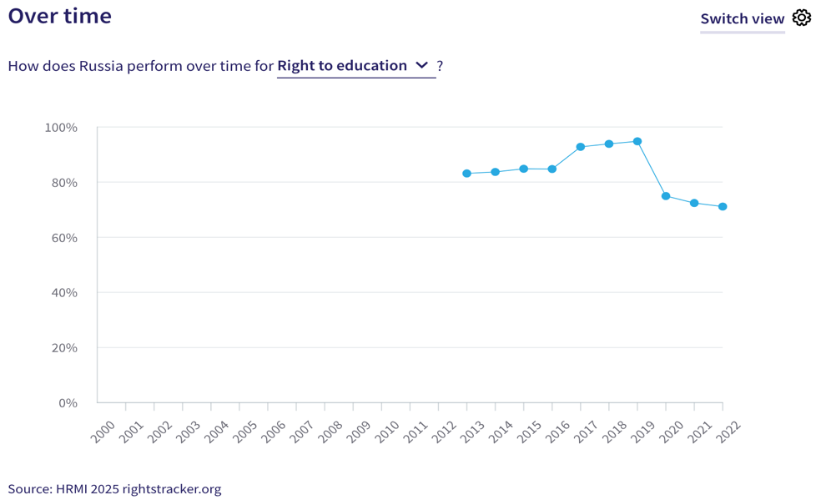
13. Russia’s score for the right to primary education (adjusted for income) is 87.3%, indicating that it is achieving only 87.3% of what should be possible with its available resources. Although this score falls within the ‘fair’ range, it has declined consistently since its 2018 peak of 99.6%. Russia ranks 11th out of 19 low- and middle-income countries in Europe and Central Asia on the right to primary education.
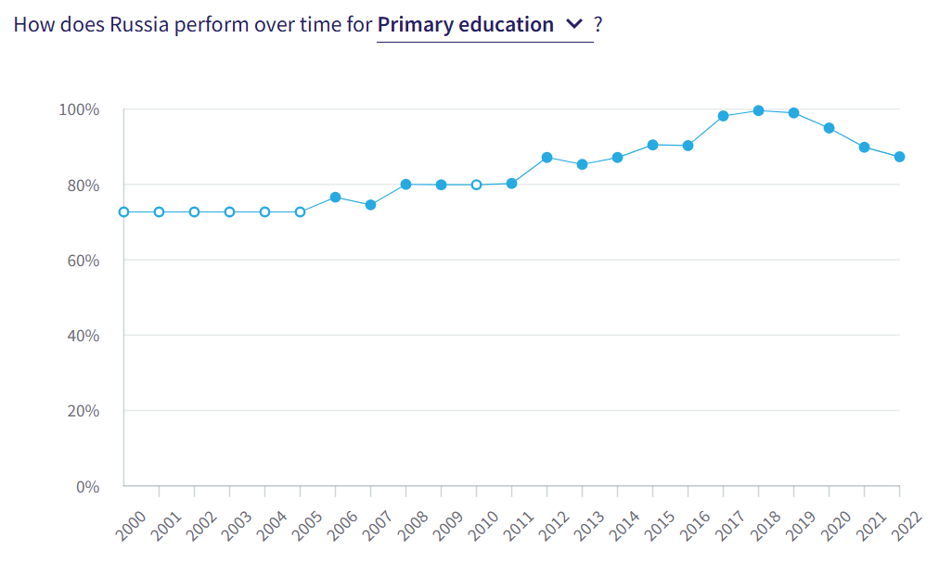
14. Our data show that immediate action is required to address the challenges to the right to secondary education in Russia, which has a low ‘income adjusted’ score of 45.7%. According to UNESCO data, only 56.3% of upper secondary school-aged children were enrolled in school in 2022. This score peaked at 88.9% in 2019, dropped drastically to 49.6% in 2020, and declined further to 45.7% in 2022. Notably, Russia ranks lowest among 17 low- and middle-income countries in Europe and Central Asia on the ‘income adjusted’ score for secondary education.
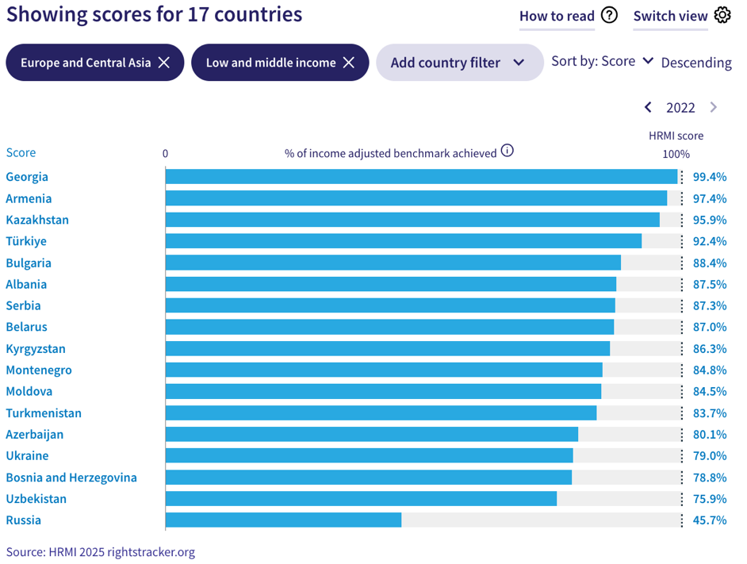
15. Russia’s ‘income adjusted’ score for the quality of education is 80.3%, placing it in the ‘bad’ performance range. This suggests that Russia is not achieving what should be possible given its available resources, and is falling short of meeting its immediate obligations under this right.
V. Right to Food
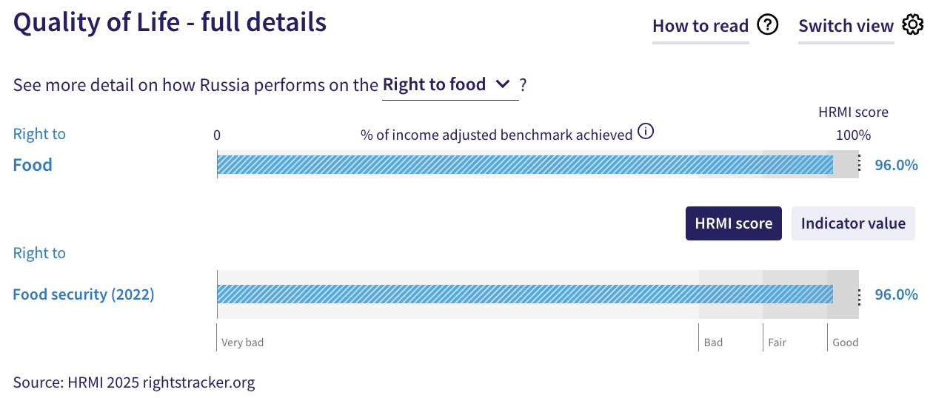
16. HRMI defines the right to food in accordance with ICESCR Article 11 and CESCR General Comment 12. For low- and middle-income countries, HRMI typically measures this right using the bellwether indicator of child stunting rates, which is not available for Russia in the UNICEF-WHO-World Bank: Joint child malnutrition (JME) database. Instead, the indicator that HRMI uses to measure the right to food for high-income countries—namely, the percentage of individuals in the population who have not experienced moderate or severe food insecurity during the reference period—is available for Russia in the FAOSTAT database. Russia’s ‘income adjusted’ score for the right to food security is 96.0%, which falls in the ‘good’ range.
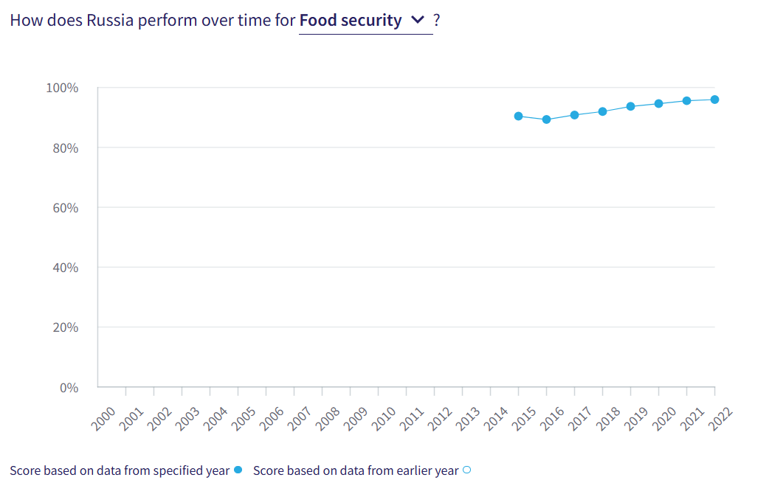
17. The overtime trend indicates that Russia has been making slow but steady progress towards fulfilment of the right to food security (adjusted for income) from 2016 to 2022. Russia ranks third among 15 low- and middle-income countries in Europe and Central Asia on this right.
VI. Right to Health
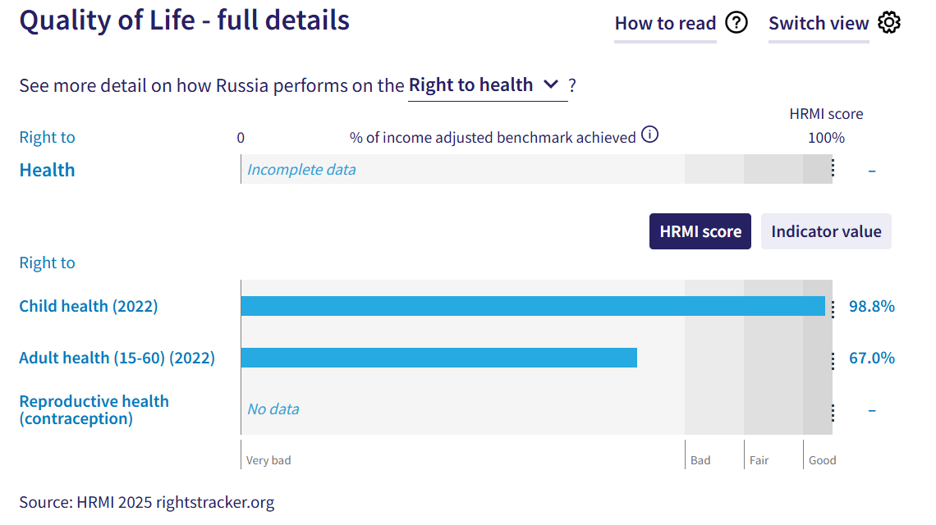
18. HRMI defines the right to health in accordance with ICESCR Article 12.1 and CESCR General Comment 14. For low- and middle-income countries such as Russia, HRMI uses three indicators to measure the country’s achievement in child health, adult health, and reproductive health. However, due to lack of international data on Russia’s fulfilment of the right to reproductive health—based on modern contraceptive use rate—we cannot calculate the overall HRMI score for the right to health. However, HRMI scores are available for the other two components, i.e., the right to child health and the right to adult (15-60) health.
19. For low- and middle-income countries, HRMI measures the right to child health using the indicator of survival to age five. Russia’s ‘income adjusted’ HRMI score on this right is 98.8%, and falls in the ‘good’ range. Over time, this score has consistently remained in the ‘good’ range, improving steadily from 92.0% in 2000 to a peak of 98.8% in 2022. This upward trend is a positive sign. Currently, Russia ranks 6th among 20 low- and middle-income countries in Europe and Central Asia for the right to child health.
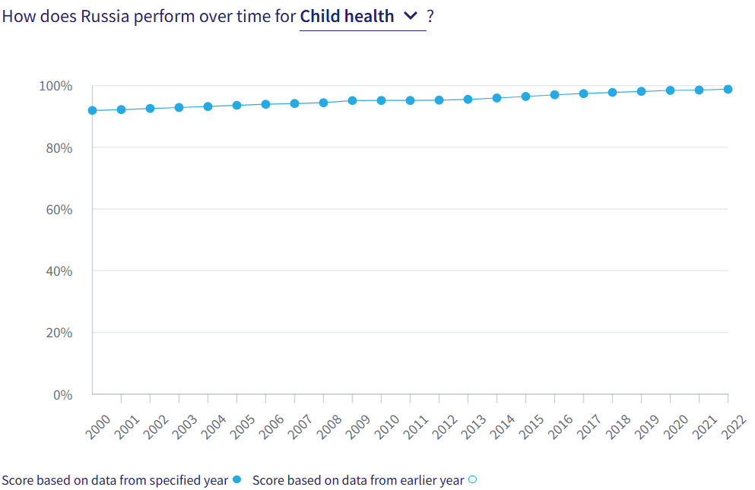
20. In contrast with the right to child health, Russia’s score for the right to adult (15-60) health is notably lower at 67.0%, and falls in the ‘very bad’ range. This score has experienced only minor fluctuations over the past two decades, indicating no marked improvement. This suggests that further progress is needed for Russia to meet its immediate obligations in relation to this right. Notably, Russia ranks lowest among 20 low- and middle- income countries in Europe and Central Asia on the ‘income adjusted’ right to adult (15-60) health.
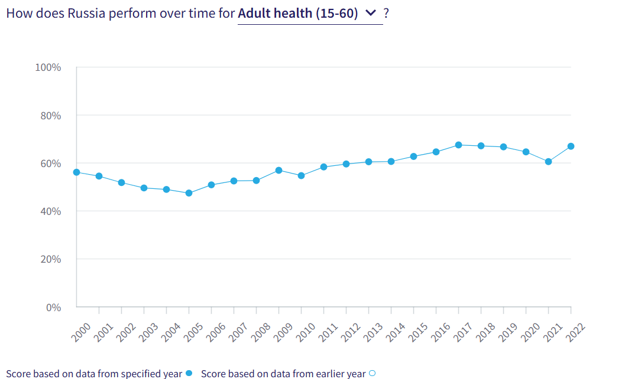
VII. Right to Housing
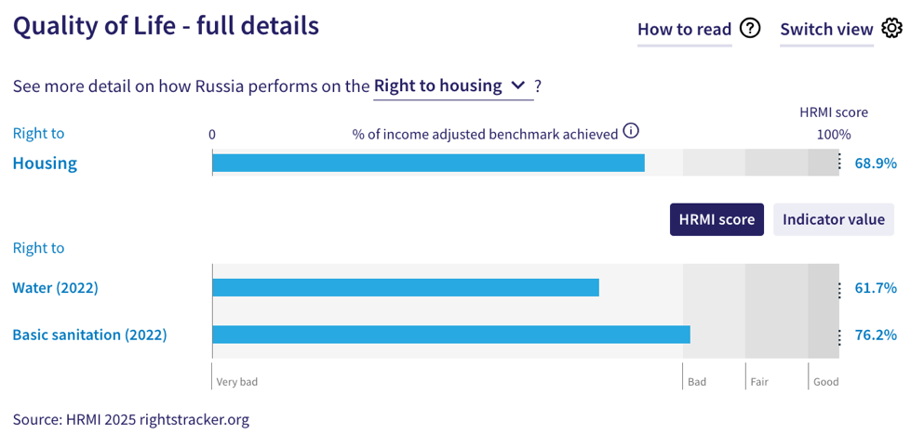
21. HRMI defines the right to housing in accordance with ICESCR Article 11.1 and CESCR General Comment 4. For low- and middle-income countries such as Russia, HRMI measures this right using the indicators of access to water on premises and access to basic sanitation (each household having its own improved toilet facilities). Russia has a HRMI score of 68.9% for the right to housing based on these two indicators, and it falls in the ‘very bad’ range. The score for the right to water is 61.7%, while that for the right to basic sanitation is 76.2%.
22. Trends over time suggest that Russia’s scores for the right to water and the right to basic sanitation—and consequently, its overall score for the right to housing—have stagnated, showing no significant improvement or decline over the two-decade period from 2000 to 2022. Notably, Russia ranks lowest among 19 low- and middle-income countries in Europe and Central Asia in fulfilling the right to housing.
VIII. Right to Work
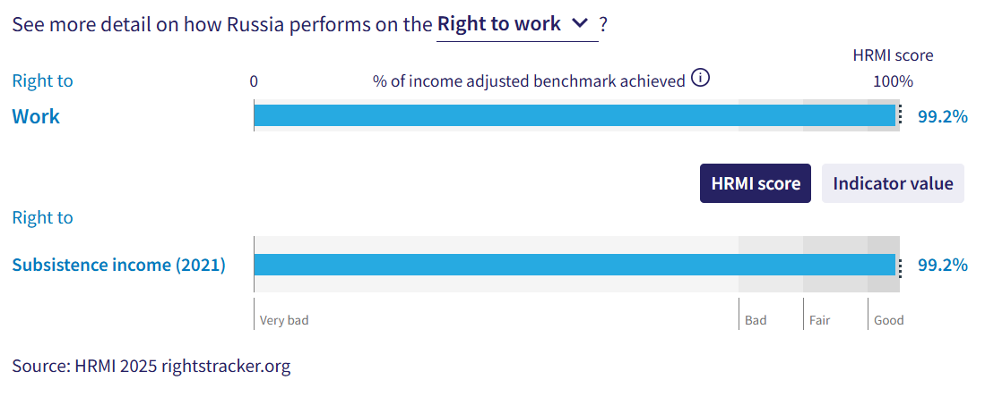
23. HRMI measures the right to work in accordance with ICESCR Articles 6 and 7. For low- and middle-income countries such as Russia, this right is assessed using a subsistence income indicator. According to World Bank Povcalnet data, 99.6% of people in Russia were classified as ‘not absolutely poor’ in 2021. This translated into an ‘income adjusted’ HRMI score of 99.2% for the right to subsistence income, which falls in the ‘good’ range.
24. Russia’s score for this right has consistently remained in the ‘good’ range, improving slightly from 98.6% in 2014 to 99.2% in 2021. This indicates that Russia is on track to meet its immediate obligations in relation to this right. Currently, Russia ranks 6th among 17 low- and middle-income countries in Europe and Central Asia for the right to subsistence income.
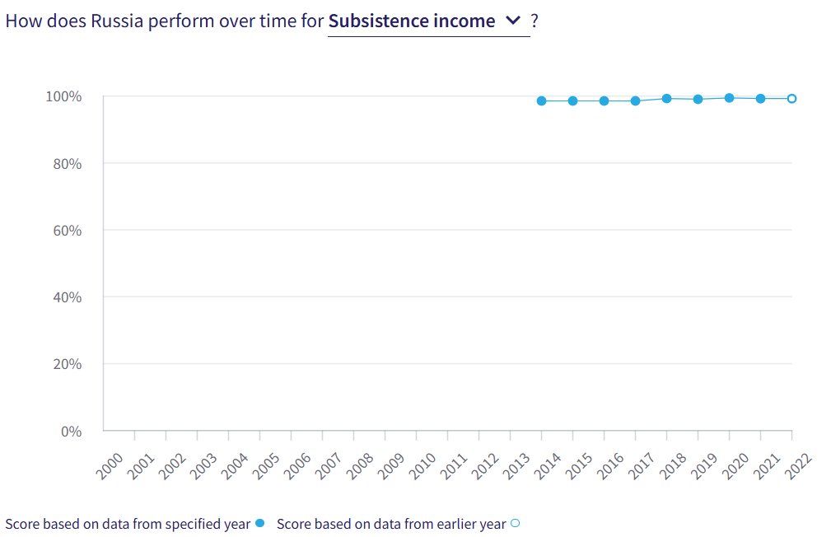

IX. Concluding Remarks
25. The Russian Federation’s strongest ‘income adjusted’ HRMI scores are for the rights to child health, subsistence income, and food security (the latter typically measured for high-income countries). All three rights fall within the ‘good’ performance range and reflect a positive trajectory towards fulfilling immediate human rights obligations.
26. The Russian Federation’s lowest ‘income adjusted’ scores are for the right to secondary education, the right to adult (15-60) health, and the right to housing, including access to water on premises and access to basic sanitation. Russia ranks lowest among low- and middle-income countries in Europe and Central Asia for each of these rights. The score for secondary education has shown a marked decline in recent years, while the scores for the right to housing and its component rights have stagnated over the past two decades.
27. Our analysis is that the Russian Federation is not constrained by resources from making improvements in areas with low scores. Rather, it has the income available, and can prioritise to put it to use to improve its people’s economic and social rights. We recommend that the Committee assure the State Party that it has the available resources to make progress, especially in the areas of secondary education, adult health, access to water, and access to basic sanitation.
28. We also recommend the following questions:
- What steps will the State Party take to improve access to and enrolment rates in upper secondary education?
- What measures will the State Party take to improve adult (15-60) health?
- What actions will the State Party take to lift access to water on premises and basic sanitation?
- What actions will the State Party take to provide data on contraceptive use to the UNPD?
29. HRMI respectfully submits its data and findings on the fulfilment of economic and social rights in the Russian Federation. We hope that this submission will serve as a useful resource to the Committee on Economic, Social and Cultural Rights for drafting specific and meaningful questions to the Russian Federation during the CESCR’s 78th Pre-Sessional Working Group.

Visit HRMI’s website to learn more about our mission and work, https://humanrightsmeasurement.org/.
This content represents the opinions of the Human Rights Measurement Initiative. It carries no endorsement of the University of Georgia.
See HRMI’s methodology for measuring economic and social rights: https://humanrightsmeasurement.org/methodology and https://rightstracker.org/page/methodology.
Ibid.
HRMI 2025 Rights Tracker, https://rightstracker.org/
See Human Rights Measurement Initiative (HRMI) Digital Public Good Certificate, https://app.digitalpublicgoods.net/a/11781 The Digital Public Goods Alliance is endorsed by the UN Secretary General’s “Roadmap for Digital Cooperation,” https://www.un.org/en/content/digital-cooperationroadmap/assets/pdf/Roadmap_for_Digital_Cooperation_EN.pdf. It defines digital public goods as: “open source software, open data, open AI models, open standards and open content that adhere to privacy and other applicable laws and best practices, do no harm, and help attain the SDGs,” https://digitalpublicgoods.net/standard/.
HRMI 2025 Rights Tracker, https://rightstracker.org/country/RUS?tab=snapshot&qolFdScore=indicator
The labels on the country charts of good, fair, bad, and very bad are used to give a general indication of how to understand the scores. HRMI’s income adjusted Quality of Life scores can be broadly interpreted as showing the percentage of the country’s obligation it has met, compared to what the best performing countries have achieved at each income level. A country scoring below 75% with a label of “Very bad” is failing to put in place the kinds of structures and policies that help people claim the right concerned, but the structures and policies in place most likely prevent many people from claiming their rights. See HRMI’s methodology for measuring human rights, https://rightstracker.org/page/methodology.
HRMI 2025 Rights Tracker, https://rightstracker.org/country/RUS?tab=report-esr
Please note that the latest scores show achievement as of 2022, when the Russian Federation was temporarily classified as an ‘upper-middle income country’ by the World Bank. Accordingly, for the purposes of this report, we use the World Bank’s 2022 income classification.
HRMI 2025 Rights Tracker, https://rightstracker.org/country/RUS?tab=snapshot&qolFdScore=indicator
Ibid.
HRMI 2025 Rights Tracker, https://rightstracker.org/metric/education?region=europe-central-asia&income=lmi
HRMI 2025 Rights Tracker, https://rightstracker.org/country/RUS?tab=snapshot&qolFdScore=indicator
HRMI 2025 Rights Tracker, https://rightstracker.org/metric/tot-net-primary?region=europe-central-asia&income=lmi
HRMI 2025 Rights Tracker, https://rightstracker.org/country/RUS?tab=snapshot&qolFdScore=indicator
HRMI 2025 Rights Tracker, https://rightstracker.org/metric/tot-sec-enrol?region=europe-central-asia&income=lmi
HRMI 2025 Rights Tracker, https://rightstracker.org/country/RUS?tab=snapshot&qolFdScore=indicator
HRMI 2025 Rights Tracker, https://rightstracker.org/country/RUS?tab=report-esr&qolFdScore=hrmi&as=hi
HRMI 2025 Rights Tracker, https://rightstracker.org/metric/food-security?region=europe-central-asia&income=lmi
HRMI 2025 Rights Tracker, https://rightstracker.org/country/RUS?tab=report-esr&qolFdScore=hrmi&as=core
Ibid.
HRMI 2025 Rights Tracker, https://rightstracker.org/metric/under-5-survival?region=europe-central-asia&income=lmi
HRMI 2025 Rights Tracker, https://rightstracker.org/country/RUS?tab=report-esr&qolFdScore=hrmi&as=core
HRMI 2025 Rights Tracker, https://rightstracker.org/metric/adult-survival?region=europe-central-asia&income=lmi
HRMI 2025 Rights Tracker, https://rightstracker.org/country/RUS?tab=report-esr&qolFdScore=hrmi&as=core
Ibid.
HRMI 2025 Rights Tracker, https://rightstracker.org/metric/housing?region=europe-central-asia&income=lmi
HRMI 2025 Rights Tracker, https://rightstracker.org/country/RUS?tab=report-esr&qolFdScore=hrmi&as=core
Ibid.
HRMI 2025 Rights Tracker, https://rightstracker.org/metric/work?region=europe-central-asia&income=lmi

