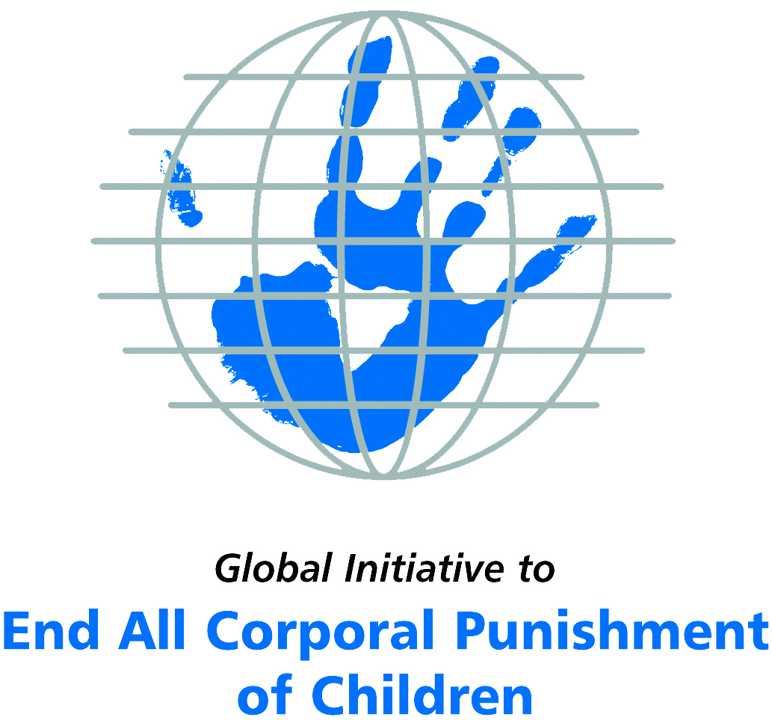
Briefing on Australia for the Committee on the Rights of Persons with Disabilities, 18th session, August/September 2017
From the Global Initiative to End All Corporal Punishment
of Children, June 2017
(a) About the Global Initiative to End All Corporal Punishment of Children
1. The Global Initiative (www.endcorporalpunishment.org) promotes universal prohibition and elimination of corporal punishment in fulfilment of states’ obligations under the UN Convention on the Rights of the Child and other international treaties. Our aims are supported by UNICEF, UNESCO, human rights institutions and international and national NGOs. Since 2002, the Global Initiative has regularly briefed the Committee on the Rights of the Child on this issue, and since 2004 has similarly briefed the Committee Against Torture, the Committee on the Elimination of Discrimination Against Women, the Committee on Economic, Social and Cultural Rights, the Human Rights Committee and the Human Rights Council; we have briefed the Committee on the Rights of Persons with Disabilities since the beginning of its work.

(b) Summary
2. Corporal punishment of children in Australia is not yet prohibited in the home, alternative care and day care settings, schools and penal institutions, in violation of the fundamental right of all children to protection from corporal punishment and other cruel or degrading forms of punishment. It is unlawful as a sentence for a crime.
3. With reference to articles 7, 15, 16 and 17 of the Convention on the Rights of Persons with Disabilities, and in light of the particular vulnerability of children with disabilities to corporal punishment by adults, the jurisprudence of the UN treaty bodies, the emphasis on eradicating this form of violence given by the UN Secretary General’s Study on Violence against Children and the importance of the issue to achieving target 16.2 on ending violence against children in the 2030 Sustainable Development Goals, we hope the Committee on the Rights of Persons with Disabilities will:
- include the issue of corporal punishment in its List of Issues Prior to Reporting for Australia, in particular asking: “what steps are being taken to ensure that legislation fully protect children with disabilities from all violent punishment, including through the explicit repeal of the right of “reasonable chastisement” and similar provisions?”;
- recommend to the Government of Australia, in the Committee’s concluding observations on the second/third report, that “legislation is enacted to explicitly prohibit corporal punishment of all children in all settings – including the home and throughout the territory – and that measures are put in place to ensure the law is properly implemented”.
(c) Detailed briefing
The right of children with disabilities not to be subjected to corporal punishment
4. The Convention on the Rights of Persons with Disabilities confirms that children with disabilities should enjoy all human rights and fundamental freedoms on an equal basis with other children (art. 7). The Convention also states that all persons have the rights to freedom from torture or cruel, inhuman or degrading treatment or punishment (art. 15), to freedom from exploitation, violence and abuse within and outside the home (art. 16) and to respect for their physical and mental integrity (art. 17). The jurisprudence of treaty monitoring bodies, led by the Committee on the Rights of the Child monitoring the Convention on the Rights of the Child, is clear that these rights put an obligation on states parties to prohibit and eliminate all corporal punishment of children, including within the family.
5. As confirmed in the UN Secretary General’s Study on Violence against Children, children with disabilities are particularly vulnerable to violence, including corporal punishment, and corporal punishment is a significant cause of impairment among children. Yet the obligation to prohibit corporal punishment is frequently ignored or evaded by governments. The near universal acceptance of violence in childrearing together with deeply held views that parents and other adults have a “right” to physically punish children can challenge efforts to achieve prohibition. It also means that corporal punishment – at least to some degree – is not readily perceived as violence in the same way as, for example, sexual and other socially unacceptable forms of violence.
6. The newly adopted Sustainable Development Goals under the 2030 Agenda include target 16.2 on ending all forms of violence against children. Violent punishment is the most common form of violence against children: ending it through the adoption and implementation of legislation prohibiting it in all settings including the home is critical.

The legality of corporal punishment of children with disabilities in Australia
7. Corporal punishment of children in Australia is unlawful as a sentence for a crime, but children with disabilities may lawfully be subjected to physical punishment in the home, alternative care and day care settings, schools, and in penal institutions in Western Australia.

State/territory | Prohibited in the home | Prohibited in alternative care settings | Prohibited in day care | Prohibited in schools | Prohibited in penal institutions | Prohibited as sentence for crime
Australian Capital Territory | NO | YES | [YES] | YES | YES | YES
New South Wales | NO | YES | [YES] | YES | YES | YES
Northern Territory | NO | NO | SOME | SOME | YES | YES
Queensland | NO | YES | [YES] | NO | YES | YES
South Australia | NO | YES | [YES] | YES | YES | YES
Tasmania | NO | NO | SOME | YES | YES | YES
Victoria | NO | NO | [YES] | YES | YES | YES
Western Australia | NO | NO | [YES] | SOME | NO | YES

8. Corporal punishment is lawful in the home. Corporal punishment in the home is regulated at state level, and is lawful throughout Australia under the right of “reasonable chastisement” and similar provisions: in Australian Capital Territory and in Victoria under common law, in Northern Territory under the Criminal Code Act (s27), in Queensland under the Criminal Code Act 1899 (s280), in South Australia under the Criminal Law Consolidation Act 1935 (s20), in Tasmania under the Criminal Code Act 1924 (s50), in New South Wales under the Crimes Act (s61AA, amended 2001), and in Western Australia under the Criminal Code 1913 (s257). The Australian Family Violence Law 1975 protects a child from being exposed to family violence but not from direct suffering of violence in the form of physical punishment.
9. Corporal punishment is lawful in some alternative care settings. Corporal punishment is prohibited in New South Wales, in Queensland, in South Australia and in Australian Capital Territory. It is lawful in the Northern Territory under provisions for the use of force “to discipline, manage or control” a child in the Criminal Code Act (s27), in Tasmania and Western Australia under the authority to use force “by way of correction” in the respective Criminal Code Acts (s50 and s257) and in Victoria under common law.
10. Corporal punishment is lawful in some early childhood care and in some day care for older children, including for children with disabilities. Corporal punishment is prohibited in child care centres in Australian Capital Territory, in New South Wales, in Queensland, in South Australia, in Victoria and in Western Australia. Corporal punishment is lawful in the Northern Territory and in Tasmania. It is also prohibited for some but not all education and care settings and for children under 13 only, in South Australia, Northern Territory, Tasmania, Victoria, New South Wales and Western Australia.
11. Corporal punishment is lawful in some schools. It is prohibited in government and independent schools in Australian Capital Territory, in New South Wales, in Tasmania, in South Australia, and in Victoria. It is prohibited in government schools in Western Australia but the use of force “by way of correction” is lawful for schoolteachers under the Criminal Code Act and provisions for caning have yet to be repealed. In Queensland, corporal punishment is lawful in schools under the provisions for reasonable force “by way of correction, discipline, management or control” in section 280 of the Criminal Code Act. In Northern Territory corporal punishment is prohibited in some but not all education settings.
12. Corporal punishment is unlawful as a disciplinary measure in penal institutions. Corporal punishment is unlawful as a disciplinary measure in penal institutions in New South Wales, in Northern Territory, in Queensland, in South Australia, in Tasmania and in Victoria. In Australian Capital Territory, corporal punishment is not among permitted disciplinary measures in the Children and Young People Act 2008 but is not explicitly prohibited. It is not prohibited in Western Australia.
13. Corporal punishment is unlawful as a sentence for crime. Corporal punishment is prohibited as a sentence for crime in all states and territories.

Disabled children’s vulnerabilities to corporal punishment in Australia
14. Numeral research studies and reports attest to the prevalence and widespread social acceptance of corporal punishment of children with disabilities. For example, a 2012 report by the Victorian Equal Opportunity and Human Rights Commission reported 514 educators – around 60% of the 883 educators involved in total – having used restraints on children with disabilities. Restraints included tying children up, forcing them to the floor and other physical force. In 2012, the Education Department of Western Australia approved confining 19 primary school children, most of whom had intellectual disabilities, in unfurnished “time-out” rooms. Also in 2012, a civil society report to the Committee on the Rights of Persons with Disabilities documented evidence of the use of “restrictive practices”, including being thrown to the ground and pinned down, solitary confinement and chemical restraint, against children with disabilities in mainstream and special schools.

Recommendations by human rights treaty monitoring bodies and during the UPR
15. The Committee on the Rights of the Child has recommended that corporal punishment of children in Australia be prohibited in the home and other settings on three occasions – in its concluding observations on the initial report in 1997, on the second/third report in 2005 and on the fourth report in 2012.
16. In 2008, the Committee Against Torture recommended to Australia that it should “adopt and implement legislation banning corporal punishment at home and in public and private schools, detention centres, and all alternative care settings in all States and Territories”.
17. At the first cycle Universal Periodic Review of Australia in 2011, the Government rejected the recommendation to prohibit corporal punishment in the family in all states and territories. At the second cycle UPR in 2015, recommendations were made to “remove the reservation to the Convention on the Rights of the Child, and prohibit corporal punishment of children in the home and all other settings” and to “reinforce the measures to improve conditions of detention, especially for persons with disabilities and the young, as well as to eliminate corporal punishment”. The Government accepted the second of these but rejected the first.

Briefing prepared by the Global Initiative to End All Corporal Punishment of Children
www.endcorporalpunishment.org; info@endcorporalpunishment.org

Pinheiro, P. S. (2006), World Report on Violence against Children, Geneva: United Nations. See also Krug E. G. et al (eds) (2002), World Report on Violence and Health, Geneva: World Health Organisation
Prohibition in childminding unconfirmed
But no explicit prohibition
Prohibition in childminding unconfirmed
Prohibited in some education and care settings for under 13s
Prohibited in some education settings under NT Education and Care Services (National Uniform Legislation) Act 2011
Prohibition in childminding unconfirmed
Prohibited in government schools as a matter of policy
2016 South Australian Supreme Court ruling found in favour of “reasonable” corporal punishment by parents
Prohibition in childminding unconfirmed
Prohibited in some education and care settings for under 13s
Prohibition in childminding unconfirmed
Prohibition in childminding unconfirmed
Prohibited in government schools
(Victorian Equal Opportunity and Human Rights Commission (2012), Held back: the experiences of children with disabilities in Victorian schools, Victoria: Victorian Equal Opportunity and Human Rights Commission)
(Reported in The Sunday Times, 12 January 2013)
(Australian Centre for Disability Law et al (2012), Disability Rights Now: Civil Society Report to the United Nations Committee on the Rights of Persons with Disabilities)
10 October 1997, CRC/C/15/Add.79, Concluding observations on initial report, paras. 15 and 26
20 October 2005, Concluding observations on second and third report, CRC/C/15/Add.268, paras. 5, 35 and 36
28 August 2012, CRC/C/AUS/CO/4, Concluding observations on fourth report, paras. 7, 8, 43, 44, 45, 46 and 47
22 May 2008, CAT/C/AUS/CO/1, Concluding observations on third report, para. 31
31 May 2011, A/HRC/17/10/Add.1, Report of the working group: Addendum
13 January 2016, A/HRC/31/14, Report of the working group, paras. 136(165) and 136(193)
29 February 2016, A/HRC/31/14/Add.1, Report of the working group: Addendum, paras. 47 and 48

